**Jenkins Task-2**

**Task Description:**

Create a simple script file and push it to repo. Create a project in Jenkins connected to your GitHub repository. When a commit is made to your repo, automatically build must get triggered from Jenkins and the output must be shared to me via email.

**Step 1:**

* Create a simple script file in ec2 instance. (script.sh)

**Output:**

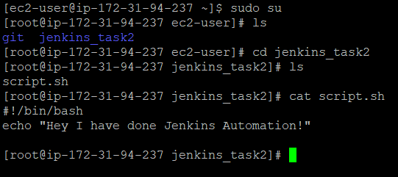

**Step 2:**

* Push this script file to GitHub repository.

**Output:**

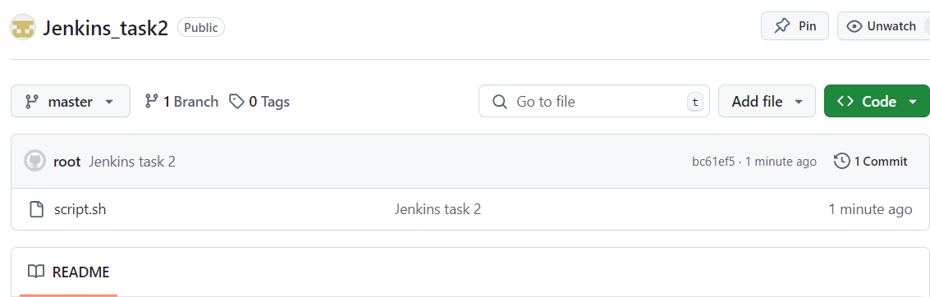

**Step 3 – Create Jenkins project:**

* Create Jenkins project. (Autobuild)
* Select free style project.
* In source code management, select git and enter git url.
* In the build triggers section, select GitHub hook trigger for GITScm polling for Jenkins build whenever there is a push to the repository.

**Output:**

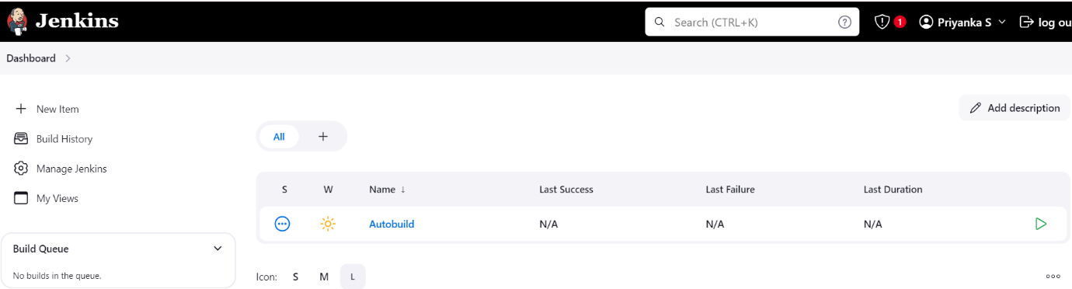

**Step 4 – Configure Email notification:**

* Go to manage Jenkins >> System >> E-mail Notification
* Enter the following details.
* Enable Test configuration by sending test e-mail >> We can receive test email to the provided email.
* Go to Jenkins configuration >> Post build action >> Select Editable Email Notification
* Add email address and customize the subject and content as required.

**Output:**

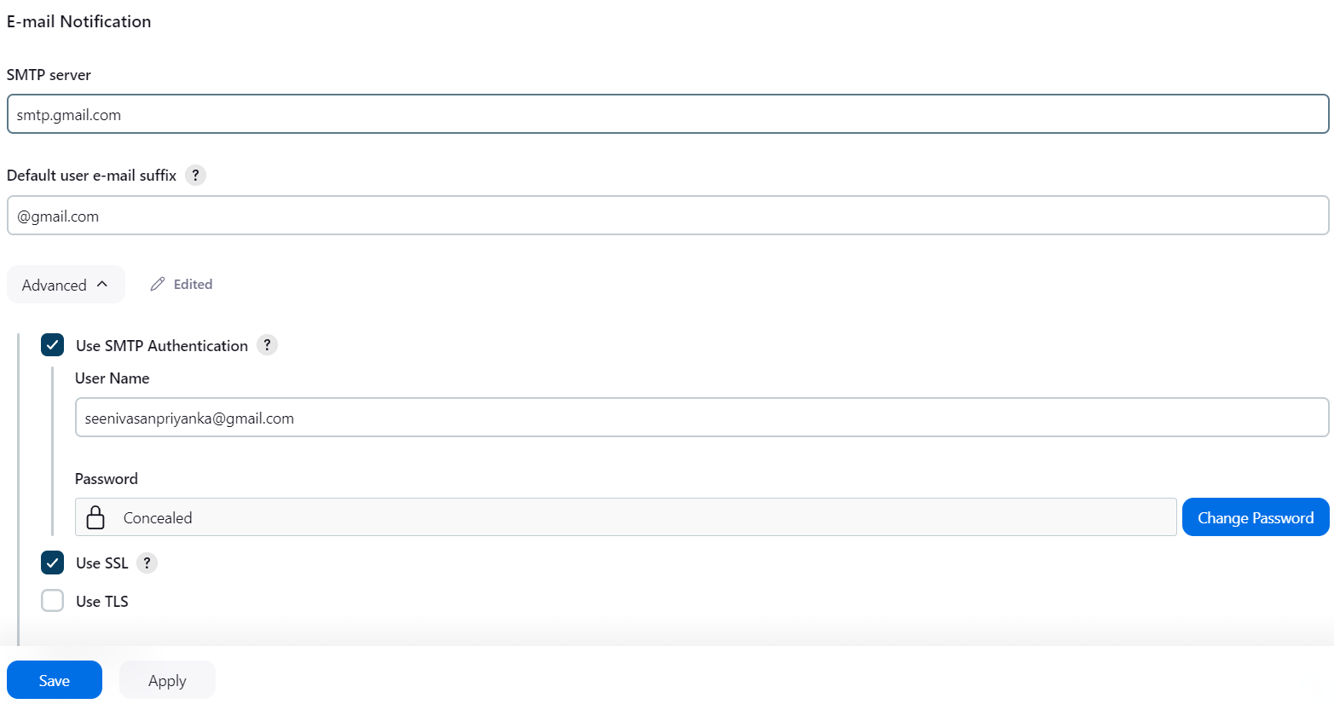

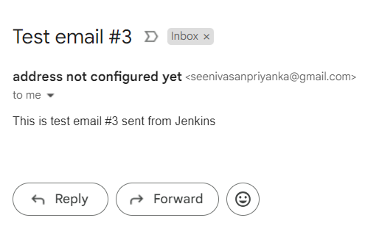

**Step 5 – Setting up Webhooks in Github:**

* Go to GitHub repository >> settings >> Webhooks >> Add Webhooks
* Payload url - <http://54.162.255.197:8080/github-webhook/>
* Content type – application/json
* Select Just the push event
* Click Add webhook

**Output:**

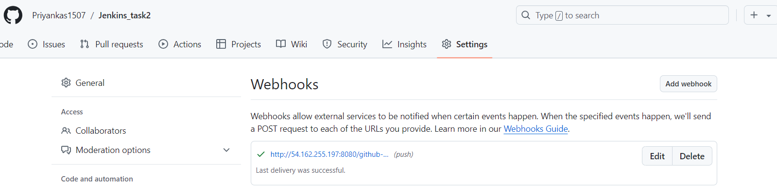

**Step 6**

* Make changes in script file
* Again, git add and commit the changes
* Push to master branch

**Output:**

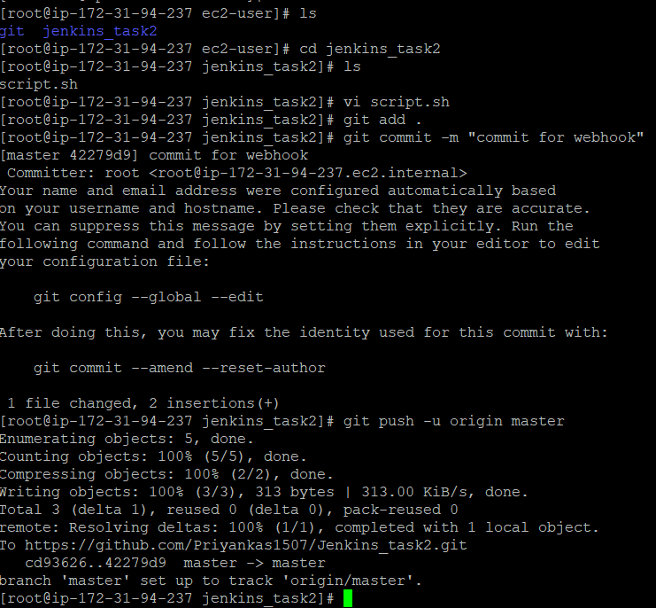

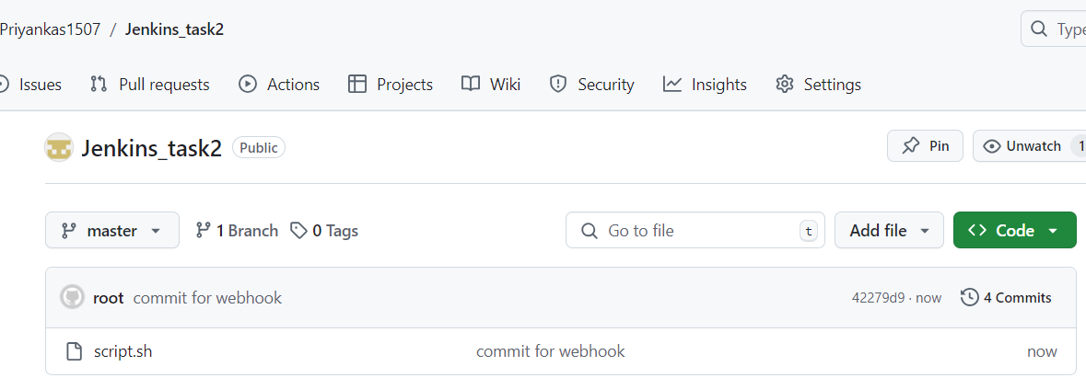

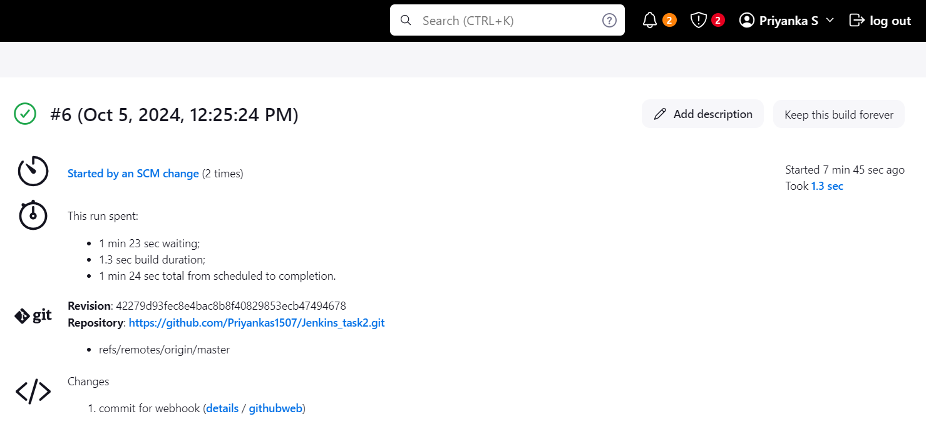

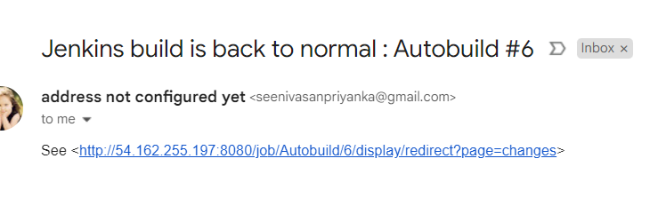

Now whenever the commit is made to our repo, the build has happened and the output is shared to email.