**Kubernetes Task**

**Task Description:**

Setup minikube at your local and explore creating namespaces (Go through official documentation).

**Step 1 – Setup minikube at local machine:**

* Install kubectl in windows using chocolatey - **choco install kubernetes-cli**
* To ensure the version is up to date - **kubectl version –client**
* Navigate to home directory – **cd ~**
* Create .kube directory – **mkdir .kube**
* Change to the .kube directory – **cd .kube**
* Install minikube

[Note: I have already installed minikube in my local machine. So I can’t take the screenshot of these commands]

**Step 2 – Start minikube:**

* Start kubernetes cluster – **minikube start**
* To verify minikube is running – **minikube status**
* To ensure kubectl is working – **kubectl get pods**

**Output:**

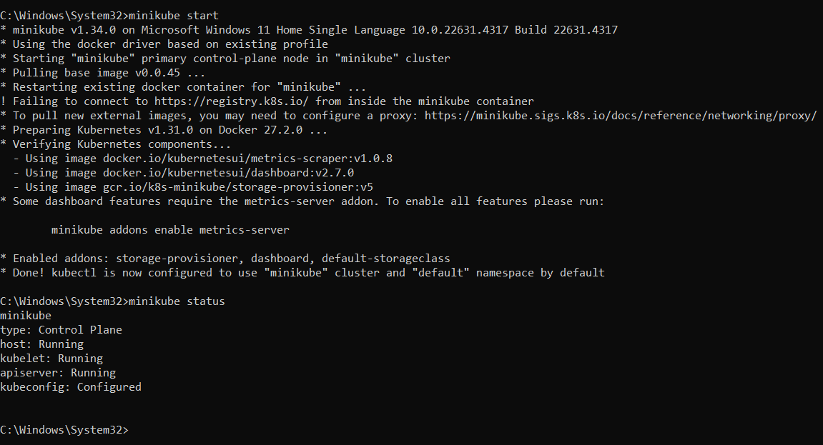

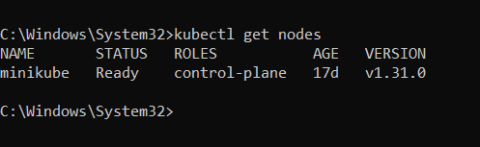

**Step 3 – Exploring namespace Commands:**

* Create namespace – **kubectl create namespace <name>**
* To view namespaces – **kubectl get namespaces**

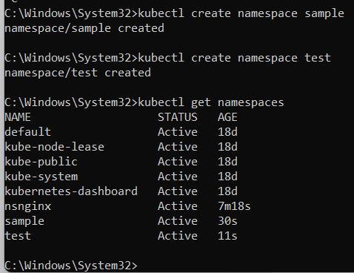

* To get the summary of the specific namespace – **kubectl get namespace <name>**
* To get detailed information of namespace – **kubectl describe namespace <name>**

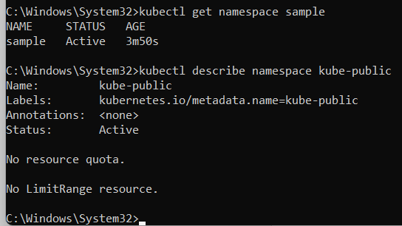

* Delete namespace – **kubectl delete namespace <name>**

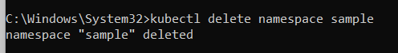

* Setting the namespace for a request:

**kubectl run nginx --image=nginx --namespace=<name>**

**kubectl get pods --namespace=<name>**

