**Monitoring Task**

**Task Description:**

Install Prometheus and Grafana on a Linux EC2 machine, connect Prometheus to Grafana, and create a dashboard to view metrics.

**Step 1 – Setup the Prerequisites:**

Create an ubuntu machine with a following port allowed in security group.

* Prometheus – 9090
* Grafana – 3000
* Node exporter – 9100

**Step 2 – Prometheus Installation:**

* Create a script file and paste the following scripts – **vi prometheus.sh**

**Script file to install Prometheus**

#!/bin/bash

PROMETHEUS_VERSION="2.52.0"

wget https://github.com/prometheus/prometheus/releases/download/v${PROMETHEUS_VERSION}/prometheus-${PROMETHEUS_VERSION}.linux-amd64.tar.gz

tar -xzvf prometheus-${PROMETHEUS_VERSION}.linux-amd64.tar.gz

cd prometheus-${PROMETHEUS_VERSION}.linux-amd64/

# if you just want to start prometheus as root

#./prometheus --config.file=prometheus.yml

# create user

useradd --no-create-home --shell /bin/false prometheus

# create directories

mkdir -p /etc/prometheus

mkdir -p /var/lib/prometheus

# set ownership

chown prometheus:prometheus /etc/prometheus

chown prometheus:prometheus /var/lib/prometheus

# copy binaries

cp prometheus /usr/local/bin/

cp promtool /usr/local/bin/

chown prometheus:prometheus /usr/local/bin/prometheus

chown prometheus:prometheus /usr/local/bin/promtool

# copy config

cp -r consoles /etc/prometheus

cp -r console_libraries /etc/prometheus

cp prometheus.yml /etc/prometheus/prometheus.yml

chown -R prometheus:prometheus /etc/prometheus/consoles

chown -R prometheus:prometheus /etc/prometheus/console_libraries

# setup systemd

echo '[Unit]

Description=Prometheus

Wants=network-online.target

After=network-online.target

[Service]

User=prometheus

Group=prometheus

Type=simple

ExecStart=/usr/local/bin/prometheus \

--config.file /etc/prometheus/prometheus.yml \

--storage.tsdb.path /var/lib/prometheus/ \

--web.console.templates=/etc/prometheus/consoles \

--web.console.libraries=/etc/prometheus/console_libraries

[Install]

WantedBy=multi-user.target' > /etc/systemd/system/prometheus.service

systemctl daemon-reload

systemctl enable prometheus

systemctl start prometheus

* Change the ownership – **chmod +x prometheus.sh**
* Run the file – **sudo ./prometheus.sh**
* Hit the ip in browser – **http:// 52.40.198.48:9090**

**Output:**

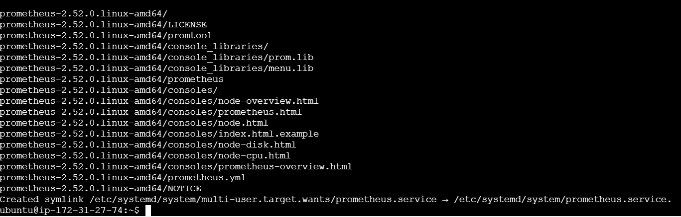

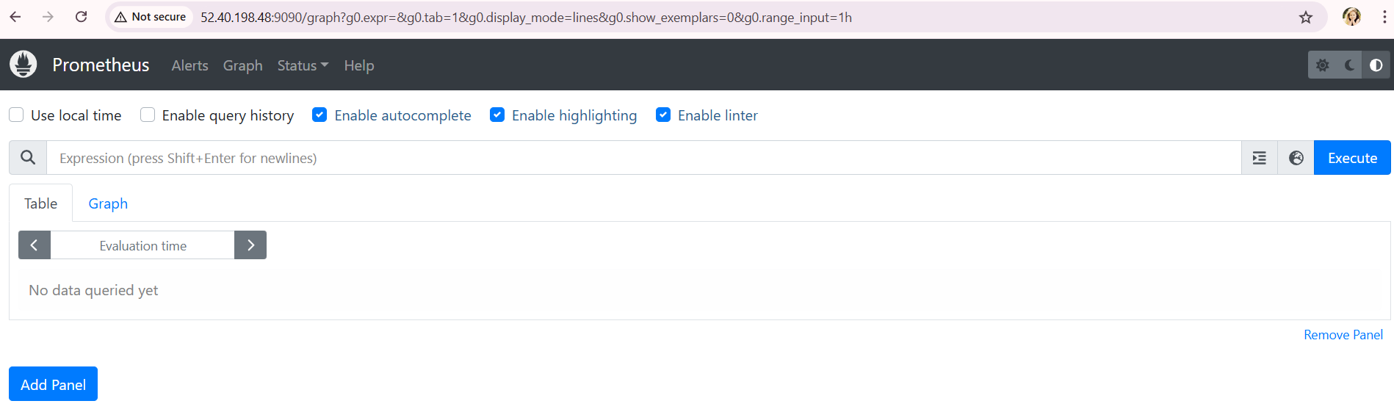

**Step 3 – Grafana Installation:**

* Create a script file and paste the following scripts – **vi grafana.sh**

**Script file to install Grafana**

#!/bin/bash

echo 'deb https://packages.grafana.com/oss/deb stable main' >> /etc/apt/sources.list

curl https://packages.grafana.com/gpg.key | sudo apt-key add -

sudo apt-get update

sudo apt-get -y install grafana

systemctl daemon-reload

systemctl start grafana-server

systemctl enable grafana-server.service

* Change the ownership – **chmod +x grafana.sh**
* Run the file – **sudo ./grafana.sh**
* Hit the ip in browser – **http:// 52.40.198.48:3000**

**Output:**

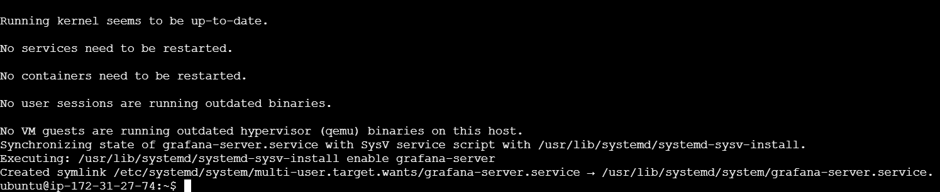

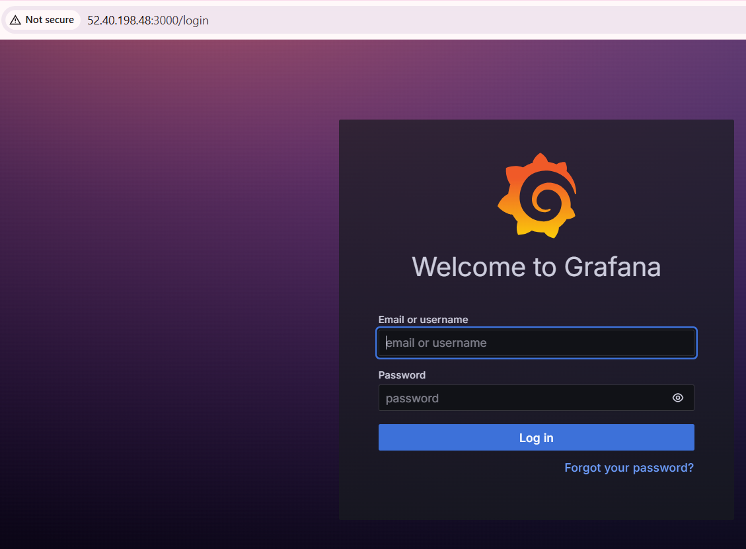

**Step 4 – Connect Prometheus to Grafana:**

* Login to Grafana
* In data source add prometheus server url and enter save&test

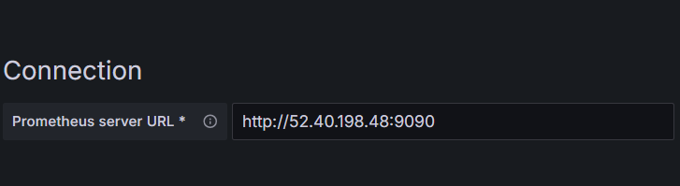

**Step 5 – Create dashboard:**

* Go to dashboard 🡪 Select Import
* In Find and import dashboards for common applications at [grafana.com/dashboards](https://grafana.com/grafana/dashboards/) 🡪 give 3662 and load
* In Prometheus 🡪 Select default Prometheus and give import

**Output:**

