**Task:**

Establish a new directory, populate it with script files, initiate an empty repository on GitHub, convert the local directory into a Git repository, and link it to GitHub for pushing the code into the repository.Perform merge, rebase, stash commands in following github repo.

**Step 1:**

Create directory - **mkdir task_vcs**

Change to the directory - **cd task_vcs**

Create script file **- vi test.txt**

“ Hi

Welcome to the git”

**Output:**

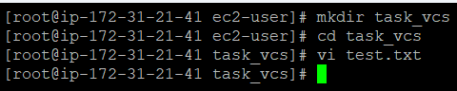

**Step 2:**

Create new repo in github:

1. Go to github home
2. Click → Create a new repository
3. Give → Repository name
4. Click public
5. Create repository

**Output:**

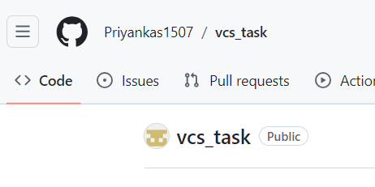

**Step 3:**

Convert local directory into git repository - **git init**

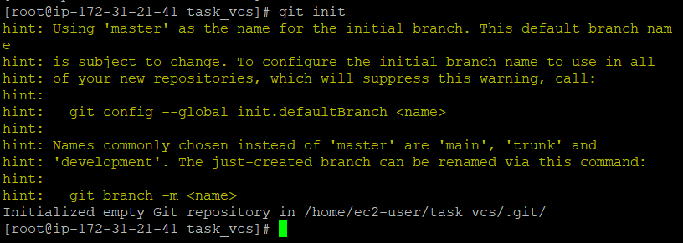

**Step 4:**

Link local repo to Github - **git remote add origin https://github.com/Priyankas1507/vcs_task.git**



For authentication we have to generate a token from github and have to run the following command in cli:



**Step 5: Merge**

Add file from working directory to staging area - **git add .**

To commit the changes - **git commit -m “ 1st commit”**

Check the branch - **git branch**

Push files from local repo to remote repo - **git push -u origin master**

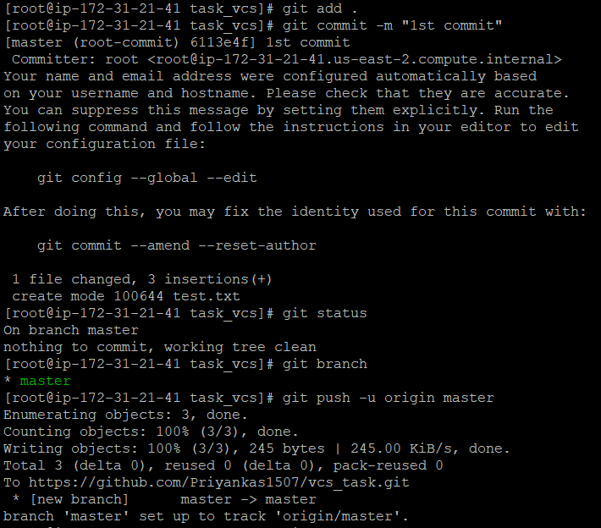

Create new branch - **git branch dev**

Switch to dev branch - **git checkout dev**

List the content - **ls**

Edit same file - **vi test.txt [“This content from dev branch”]**

Add file from working directory to staging area - **git add .**

To commit the changes - **git commit “commit from dev”**

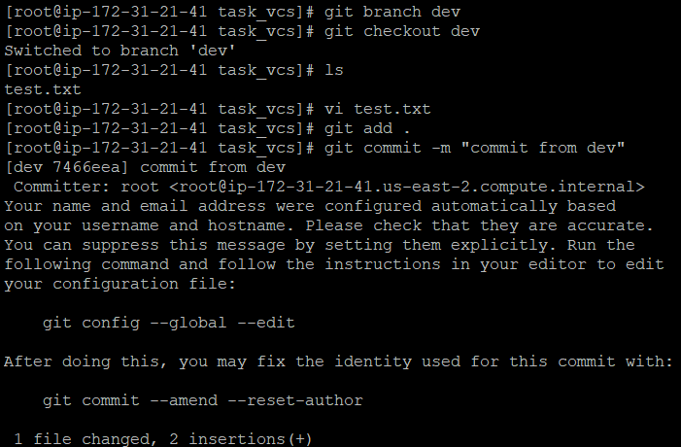

Switch to master branch - **git checkout master**

Updating latest version from master remote repo - **git pull origin master**

Merge dev branch to master - **git merge dev**

Add file from working directory to staging area - **git add .**

To commit the changes - **git commit -m “adding dev branch ”**

Push files from local repo to remote repo - **git push origin master**

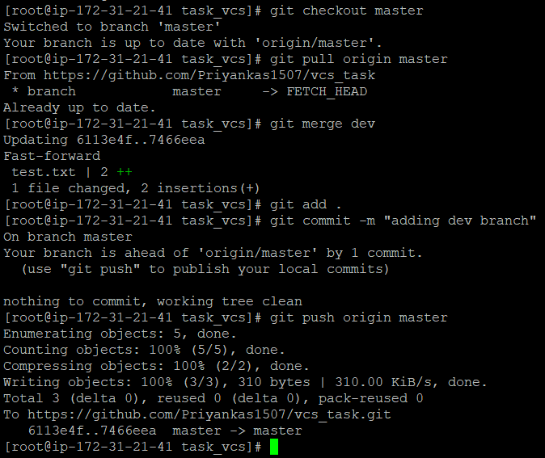

**Step 6: Rebase**

1. From local repo’s master branch create a file (test.txt)
2. Add and commit this file
3. Push this file to remote repo

Switch to dev branch **- git checkout dev**

List the files - ls

Fetch the latest changes from remote repo - **git fetch**

Update current branch with the latest changes from the master branch of a remote repo -

**git rebase origin/master**

**Output:**

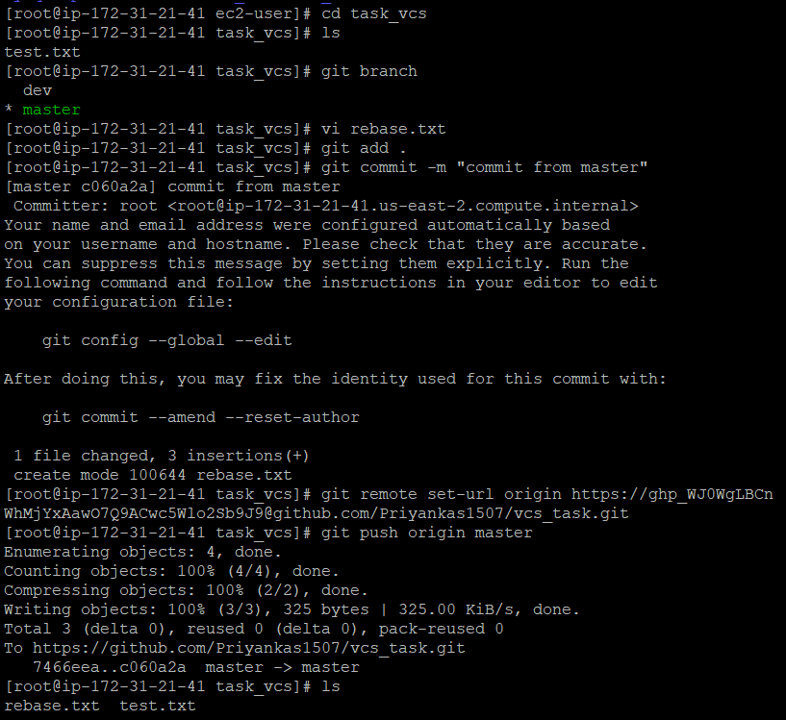

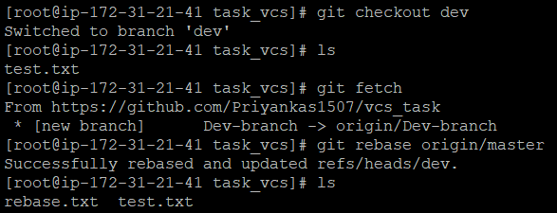

**Step 7: Stash**

1. From local repo’s master branch create a file (stashfile.txt)
2. Add and commit this file
3. Push this file to remote repo
4. Again add codes in stashfile.txt and add to the staging area.

To temporarily stores uncommitted changes - **git stash**

To apply the most recent stash to your working directory - **git stash apply**

Then add and commit the file.

**Output:**

