**CLI REQUIREMENT OUTLINE:-**

1. Display a message welcoming the user and ask him/her to login with their credentials to proceed.

a). If the entered LoginID and password matches with the registered one, display the instructions as:

1. Enter “HELP” to get the list of all available commands and its details.

2. Enter “SET <param_name> <value>” to set a parameter.

3. Enter “GET <param_name> <value>” to get a parameter.

a.i.) If the user enters “HELP” all the available commands should be displayed.

a.ii.) elseIf the user enters “SET <param_name> <value>”:

If the parm number matches from the list of expected number of parameters then the cmd should be processed and display ”cmd processed successfully”.

else display error “Unknown cmd or parameter”.

a.iii) Elseif the user enters “GET <param_name> <value>,

If the parm number matches from the list of expected number of parameters then the cmd should be processed.

else display error “Unknown cmd or parameter”.

b). Else display the error message “INCORRECT LOGIN CREDENTIALS”.

HIGH LEVEL DESIGN OF THE REQUIREMENT: -

USE CASE DIAGRAM:-

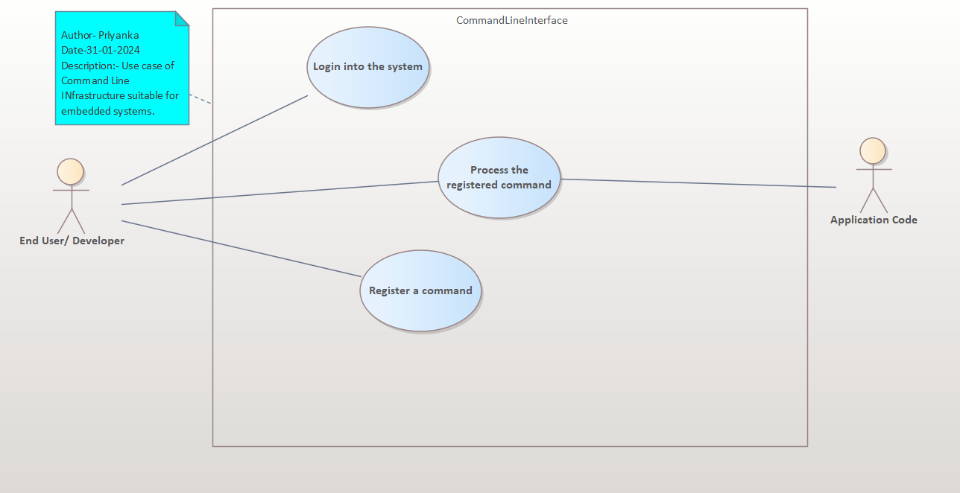

Low Level Design of the requirement:-

Sequence diagram: -

1. Login in the system

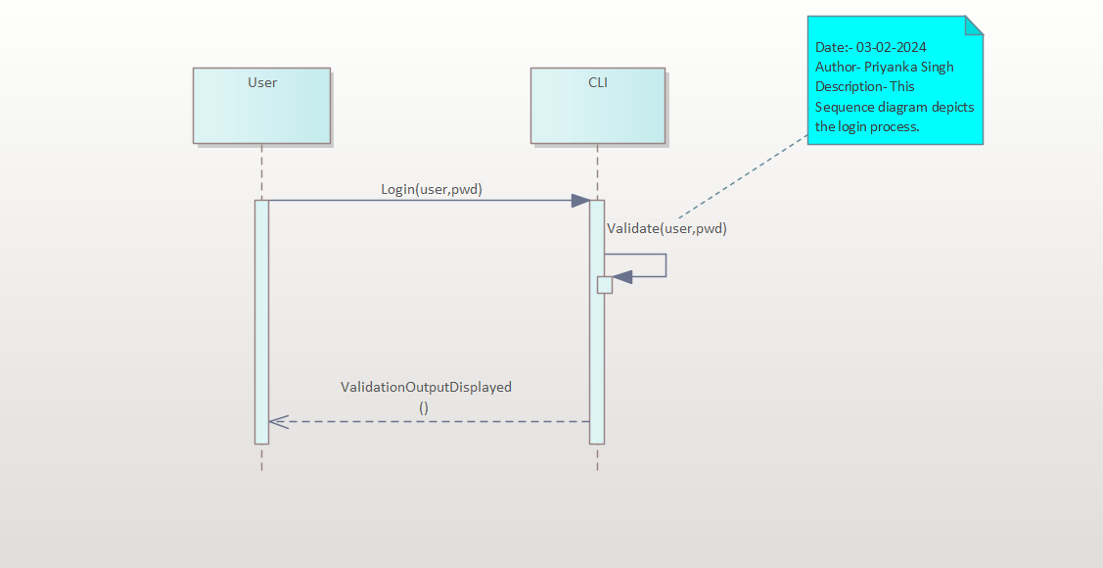

1. Command registration:

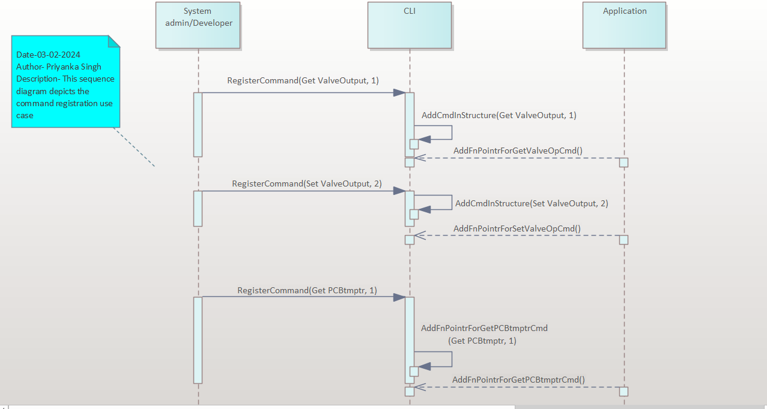

1. Command processing

