CRUD Bootstrap + Express + Mysql

Server.js
const mysql = require("mysql");
const mysqlconnection = mysql.createConnection({
host: 'localhost',
user: 'root',
password: 'root',
database: 'university'

});

mysqlconnection.connect((err) => {
if (err) {
console.log(err);
}
else {
console.log("Connected to mysql");
}
})

const express = require("express");
//const schema=require("./schema");
//const database=require("./database");
//db = "mongodb://localhost:27017/manan";
const app = express();
app.use(express.json());
app.use(express.urlencoded({ extended: false }));

app.set("view engine", "ejs");

app.get("/", (req, res) => {
res.render("Homepage");
})

app.post("/", (req, res) => {

const cId = req.body.cId;
const dName = req.body.dName;
const cName = req.body.cName;
const insName = req.body.insName;

// const insName2=req.body.inssName2;
const uniName = req.body.uniName;
console.log(cId);

mysqlconnection.query("INSERT INTO `unischema`(`courseId`, `courseName`, `insName`, `uniName`) VALUES (?,?,?,?)", [cId, cName, insName, uniName], (err, rows, field) => {
if (err) {
console.log(err);
}
else {
//console.log("Rows "+rows);
//console.log("field "+field);
res.render("Homepage");
}
});

})

app.get("/showData", (req, res) => {
// res.render("showData",{error: false});
mysqlconnection.query("SELECT * FROM `unischema` WHERE 1", (err, rows, field) => {
if (err) {
console.log(err);
res.send(err);
}
else {
console.log(rows[0].courseName);
res.render("showData", { data: rows });
}
})

})

app.post("/showData", (req, res) => {
// res.render("showData",{error: false});
const cId = req.body.cId;
console.log(req.body.cId);

mysqlconnection.query("SELECT `courseId`, `courseName`, `insName`, `uniName` FROM `unischema` WHERE courseId=?", [cId], (err, rows, field) => {
if (err) {
console.log(err);
}
else {
res.render("edit", { data: rows });

}

})

});

app.get("/edit", (req, res) => {
//res.render("update");
// const id=req.params.id;
//console.log(req.params.id);
res.send("okayy");

})

app.post("/showData/edit", (req, res) => {
// console.log(req);

mysqlconnection.query("UPDATE `unischema` SET `courseId`=?,`courseName`=?,`insName`=?,`uniName`=? WHERE 1", [cId, cName, insName, uniName], (err, rows, fields) => {

if (err) {
console.log(err);
}
else {
console.log("Updated");
// res.render("showData",{data:rows});
res.send("okay");
}

});

})

app.get("/showData/Homepage", (req, res) => {
res.render("Homepage");
})

app.post("/showData/Homepage", (req, res) => {
const cId = req.body.cId;
const dName = req.body.dName;
const cName = req.body.cName;
const insName = req.body.insName;

// const insName2=req.body.inssName2;
const uniName = req.body.uniName;
console.log(cId);

//const quee="INSERT INTO `unischema`(`courseId`, `courseName`, `insName`, `uniName`) VALUES (?,?,?,?)",[cId,cName,insName,uniName],
mysqlconnection.query("INSERT INTO `unischema`(`courseId`, `courseName`, `insName`, `uniName`) VALUES (?,?,?,?)", [cId, cName, insName, uniName], (err, rows, field) => {
if (err) {
console.log(err);
}
else {
console.log(cId);
console.log(cName);
res.render(insName);
}
});
})

app.listen("3000", () => {
console.log("listening to the port on 3000...");
})

Homepage.ejs

<html>

<head>
<link href="https://cdn.jsdelivr.net/npm/bootstrap@5.1.1/dist/css/bootstrap.min.css" rel="stylesheet"
integrity="sha384-F3w7mX95PdgyTmZZMECAngseQB83DfGTowi0iMjiWaeVhAn4FJkqJByhZMI3AhiU" crossorigin="anonymous">
<title>
CRUD Operations
</title>

</head>

<body style="background-color: rgb(243, 238, 224) ">
<h1 style="background-color: aqua; width: fit-content; margin-left: 20%;"><b>WELCOME TO CHARUSAT REGISTRATION PAGE</b>
</h1>

<form method="POST" action="/"
style="border: 10px solid rgb(215, 235, 39);border-radius: 10px; width: 40%; margin-left: 30%; margin-top: 10%; background-color: rgba(199, 226, 80, 0.959);">
<h2><b style="margin-left: 35%; font-family:Arial, Helvetica, sans-serif; color: #e95146;">⚡Form⚡</b></h2>
<div class="form-group">
<label for="exampleInputEmail1">Course-id</label>
<input type="text" class="form-control" id="cId" name="cId" aria-describedby="emailHelp" placeholder="">

</div>

<div class="form-group">
<label for="exampleInputEmail1">Course Name</label>
<input type="text" class="form-control" id="cName" name="cName" aria-describedby="emailHelp" placeholder="">

</div>

Department Name
<div class="form-check">
<input class="form-check-input" type="radio" name="dName" id="dName" value="CE">
<label class="form-check-label" for="exampleRadios1">
CE
</label>
</div>
<div class="form-check">
<input class="form-check-input" type="radio" name="dName" id="exampleRadios2" value="IT">
<label class="form-check-label" for="exampleRadios2">
IT
</label>
</div>
<div class="form-check">
<input class="form-check-input" type="radio" name="dName" id="exampleRadios3" value="EC">
<label class="form-check-label" for="exampleRadios3">
EC
</label>
</div>

Institute Name
<div class="form-check">
<input class="form-check-input" type="checkbox" name="insName" value="CSPIT" id="defaultCheck1">
<label class="form-check-label" for="defaultCheck1">
CSPIT
</label>
</div>
<div class="form-check">
<input class="form-check-input" type="checkbox" name="insName" value="DEPSTAR" id="defaultCheck2">
<label class="form-check-label" for="defaultCheck2">
DEPSTAR
</label>
</div>

<select class="btn btn-danger" name="uniName">
<option value="CHARUSAT">CHARUSAT</option>

</select>

<input type="submit" style=" background-color: #e95146;
color: white;
padding: 5px 20px;
text-align: center;
text-decoration: none;
display: inline-block;">

<a href="showData" style=" background-color: #e95146;
color: white;
padding: 7px 20px;
text-align: center;
text-decoration: none;
display: inline-block;">Show data</a>
</form>
<!-- <input type="submit" onclick="window.location='ShowData'" value="Show Data"> -->

<div
style="border: 7px solid black; margin-top:50px; height: 90px; background-color: rgb(55, 131, 104); border-radius: 15px;">
<b style="margin-left: 45%;">⚡PREPARED by 19CE032⚡</b><br>
<b style="margin-left: 45%;">
<large>⚡DO NOT TRY TO COPY⚡</large>
</b>
</div>

</body>

</html>

showData.ejs

<html>
<head>
<title>Update</title>
<link rel="stylesheet" href="https://stackpath.bootstrapcdn.com/bootstrap/4.1.3/css/bootstrap.min.css" integrity="sha384-MCw98/SFnGE8fJT3GXwEOngsV7Zt27NXFoaoApmYm81iuXoPkFOJwJ8ERdknLPMO" crossorigin="anonymous">
</head>
<body style="background-color: rgb(243, 238, 224);">
<h1 style="margin-left: 37%; background-color: rgb(4, 187, 126); width:fit-content;"><i>LIST OF STUDENTS</i></h1>

<form method="POST" style="width: 50%; margin-left: 25%; border: 2px solid rgba(111, 134, 6, 0.959);">

<table class="table" style="background-color: rgb(255, 255, 253); ">
<thead>
<tr>

<th scope="col" style="border: 2px solid rgba(111, 134, 6, 0.959);">Course-Id</th>
<th scope="col" style="background-color: rgba(199, 226, 80, 0.959); border: 2px solid rgba(111, 134, 6, 0.959);">Course Name</th>
<th scope="col" style="border: 2px solid rgba(111, 134, 6, 0.959);">University</th>
<th scope="col" style="background-color: rgba(199, 226, 80, 0.959); border: 2px solid rgba(111, 134, 6, 0.959);">Edit</th>
<th scope="col" style="border: 2px solid rgba(111, 134, 6, 0.959);">Delete</th>
</tr>
</thead>
<tbody>

<% if(data.length>0){%>

<% data.forEach(x => {%>
<tr >
<form action="edit" method="POST">

<td scope="row" name="cId" value="<%= x.courrseId %>"><%= x.courseId %><input type="hidden" name="cId" value="<%= x.courseId %>"></td>
<td scope="row" name="cName" value="<%= x.courrseName %>"><%= x.courrseName %></td>
<td scope="row" name="uniName"><%= x.universityName %></td>
<!-- <td><a class="ui purple button" href="edit/<%= x._id%>">Edit</a></td> -->
<td><input type="submit" value=EDIT style=" background-color: #e95146;
color: white;
padding: 3px 5px;
text-align: center;
text-decoration: none;
display: inline-block;"></td>
<td><a href="delete/<%= x._id %>">Delete</td>
</form>
</tr>
<%})%>

<%} %>

</tbody>
</table>
</form>

<div style="border: 3px solid ; margin-top:50px; background-color: rgb(55, 131, 104); border-radius: 10px; position: sticky;">
<b style="margin-left: 45%;">PREPARED by 19CE032</b><br>
<b style="margin-left: 43%;"><large>⚡⚡DO NOT TRY TO COPY🔥🔥</large></b>
</div>
</body>
</html>

Package.json

{
"name": "pr8",
"version": "1.0.0",
"description": "",
"main": "index.js",
"scripts": {
"test": "echo \"Error: no test specified\" && exit 1"
},
"author": "",
"license": "ISC",
"dependencies": {
"ejs": "^3.1.6",
"express": "^4.17.1",
"mysql": "^2.18.1",
"nodemon": "^2.0.12",
"validator": "^13.6.0"
}
}
<html>
<head>
<title>

</title>

<link rel="stylesheet" href="https://stackpath.bootstrapcdn.com/bootstrap/4.1.3/css/bootstrap.min.css" integrity="sha384-MCw98/SFnGE8fJT3GXwEOngsV7Zt27NXFoaoApmYm81iuXoPkFOJwJ8ERdknLPMO" crossorigin="anonymous">
</head>
<body>

<form method="POST" action="/">
<div class="form-group">
<label for="exampleInputEmail1">Course-id</label>
<input type="text" class="form-control" name="cId" id="exampleInputEmail1" aria-describedby="emailHelp" placeholder="" value=<%= data[0].courseId %> >

</div>

<div class="form-group">
<label for="exampleInputEmail1">Course Name</label>
<input type="text" class="form-control" name="cName" id="exampleInputEmail1" aria-describedby="emailHelp" placeholder="" value=<%= data[0].courseName %>>

</div>

Department Name
<div class="form-check">
<input class="form-check-input" type="radio" name="exampleRadios" id="exampleRadios1" value="CE" >
<label class="form-check-label" for="exampleRadios1">
CE
</label>
</div>
<div class="form-check">
<input class="form-check-input" type="radio" name="exampleRadios" id="exampleRadios2" value="IT">
<label class="form-check-label" for="exampleRadios2">
IT
</label>
</div>
<div class="form-check">
<input class="form-check-input" type="radio" name="exampleRadios" id="exampleRadios3" value="EC" >
<label class="form-check-label" for="exampleRadios3">
EC
</label>
</div>

Institute Name
<div class="form-check">
<input class="form-check-input" name="insName" type="checkbox" value="CSPIT" id="defaultCheck1">
<label class="form-check-label" for="defaultCheck1">
CSPIT
</label>
</div>
<div class="form-check">
<input class="form-check-input" type="checkbox" value="DEPSTAR" id="defaultCheck2" >
<label class="form-check-label" for="defaultCheck2">
DEPSTAR
</label>
</div>

<select class="btn btn-danger" name="uniName">
<option value="CHARUSAT">CHARUSAT</option>

</select>

<input type="submit" value="Update">
</form>
</body>

</html>

Screenshot
FileStructure
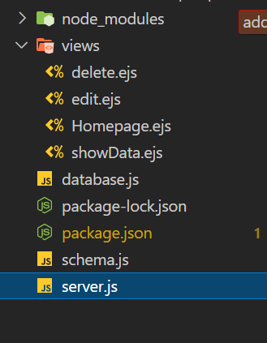

Homepage
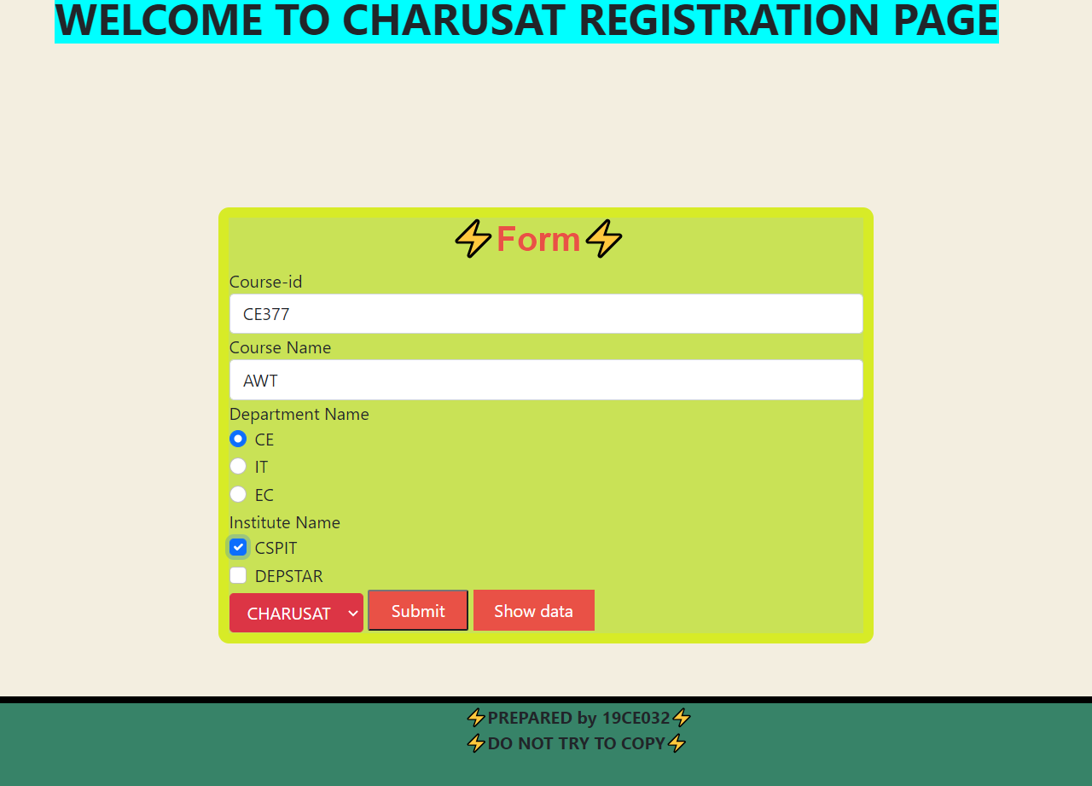

View page

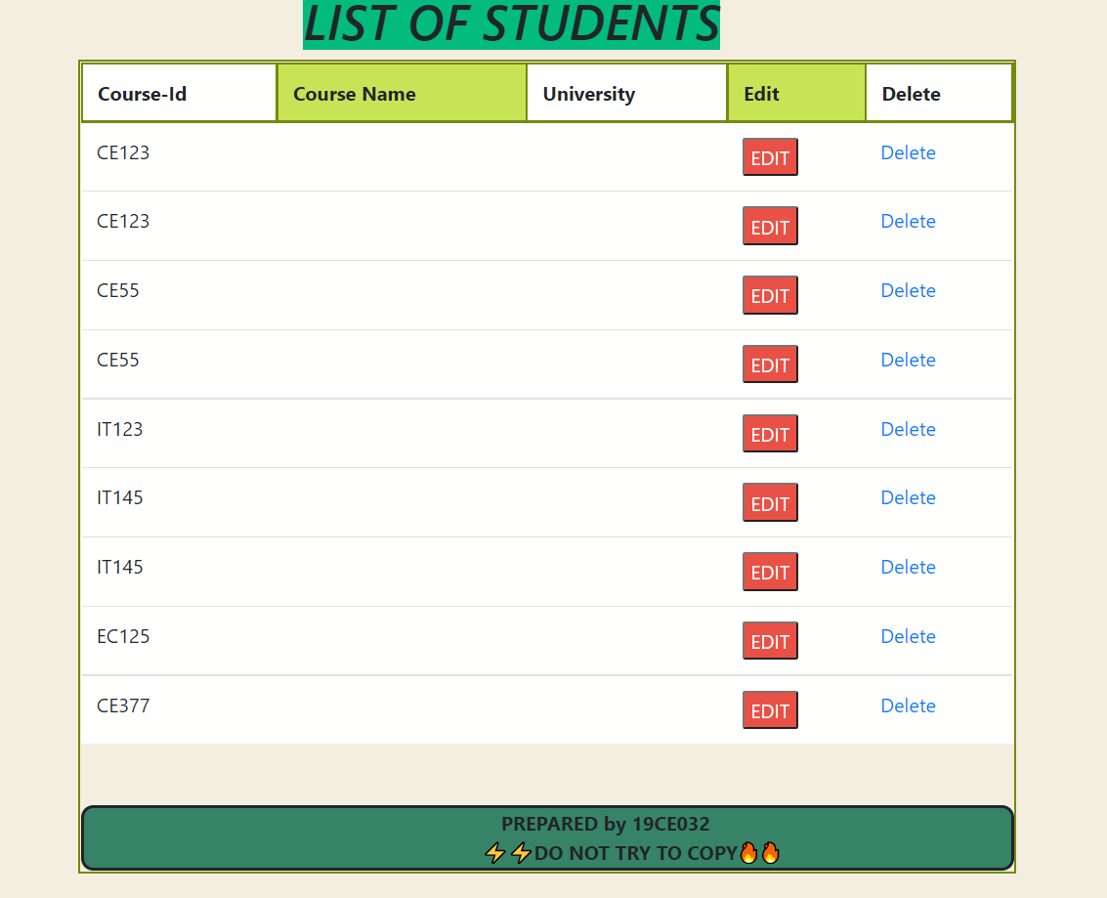

Edit page
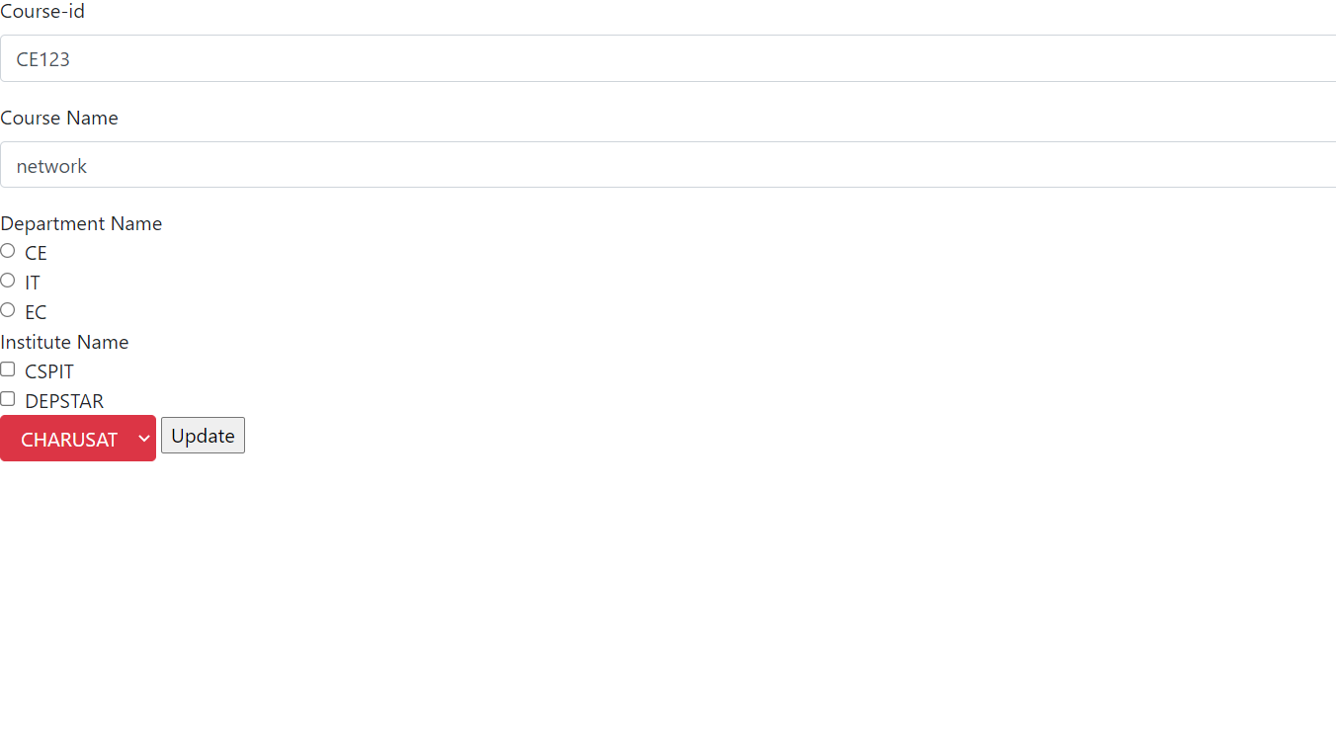

MySQL Table
