ABC Corporation

Insurance Declaration

**12/12/2019**

ABC ABC

Table of Contents

CONTENTS READ and APPROVED (Client Use Only):

Name:

Position:

Signed: Dated:

Start|PolicyGroup

**Our Ref:**

Insured:

Location:

Underwriter:

UW Policy Number:

Policy Inception:

Policy Expiry:

## Carefully check the information below, which currently applies, particularly limits, sub-limits and declared values. If any changes are required for the next insured period please indicate these by amending the Schedule.

## Schedule

**NOTE:** Where a coverage heading incorporates provision for an amount to be inserted (e.g. Sub-Limit) but no amount is recorded, no cover is provided under this policy.

**UNREPORTED CLAIMS** After reasonable enquiry by you are there any claims or incidents/circumstances which could give rise to a claim which have not been reported to us or any insurer?

Yes / No

If yes, please provide details.

End|PolicyGroup

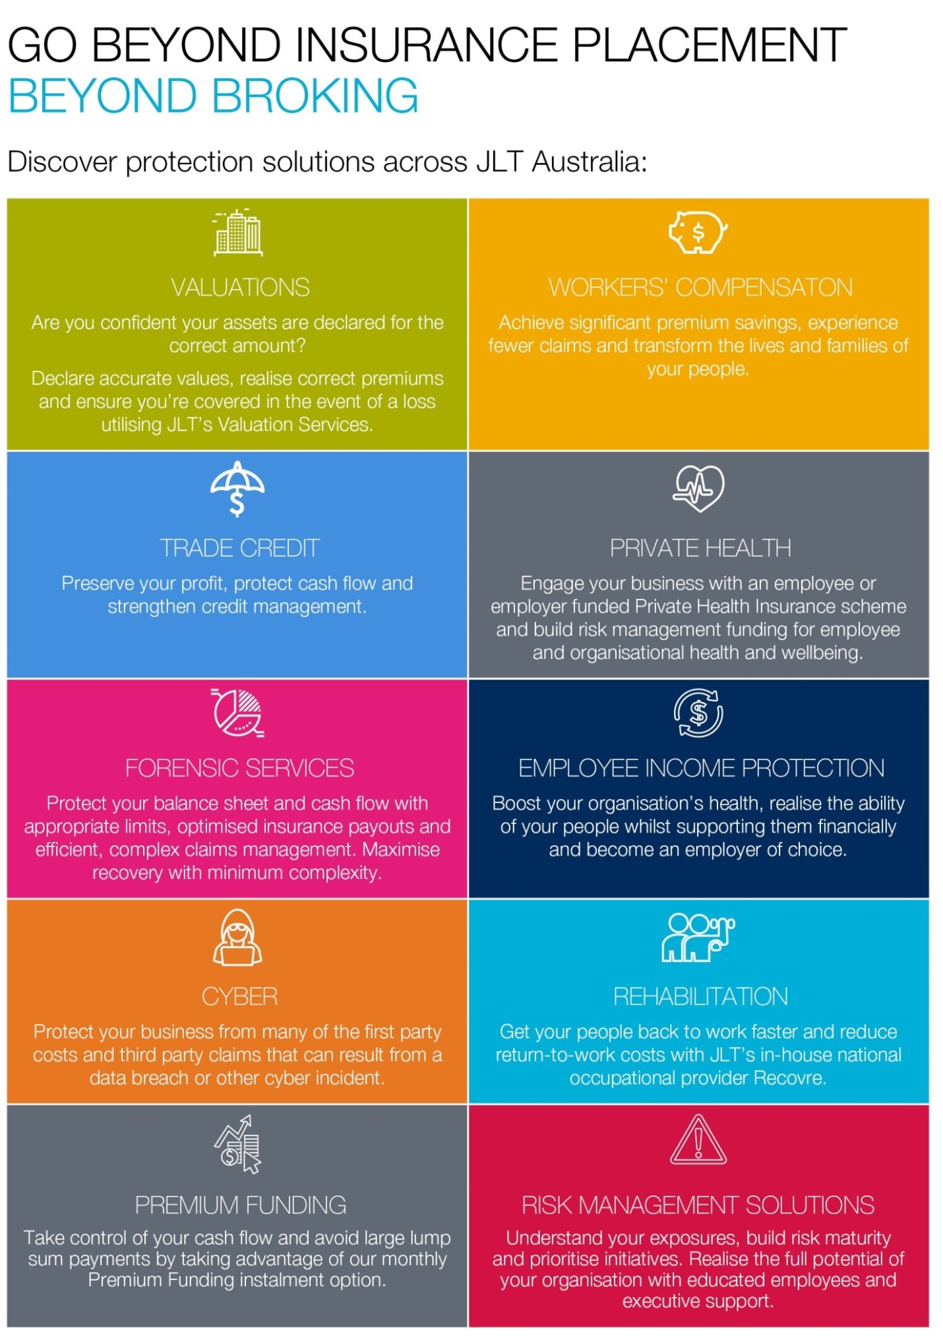

CONTACTS

Tel

Mob

Tel

Mob

A member of the Jardine Lloyd Thompson Group.