Issue1:On successful creation of working class hero msg is coming null in response

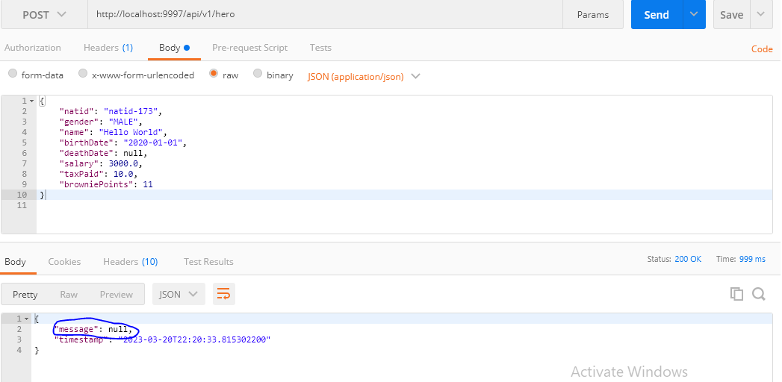

Issue2:Natid is accepting number beyond 9999999

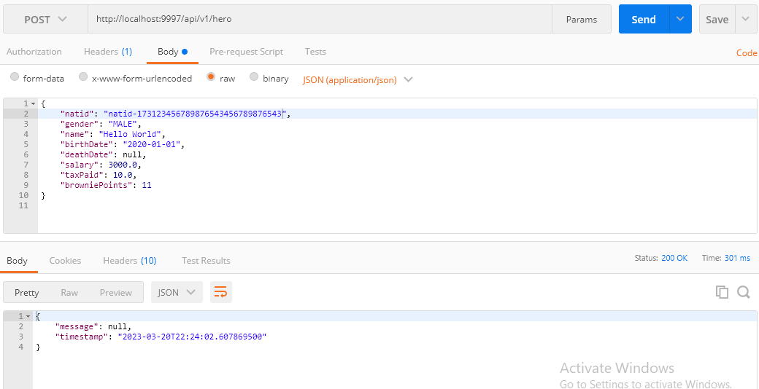

Issue3: Name is accepting length of name beyond 100

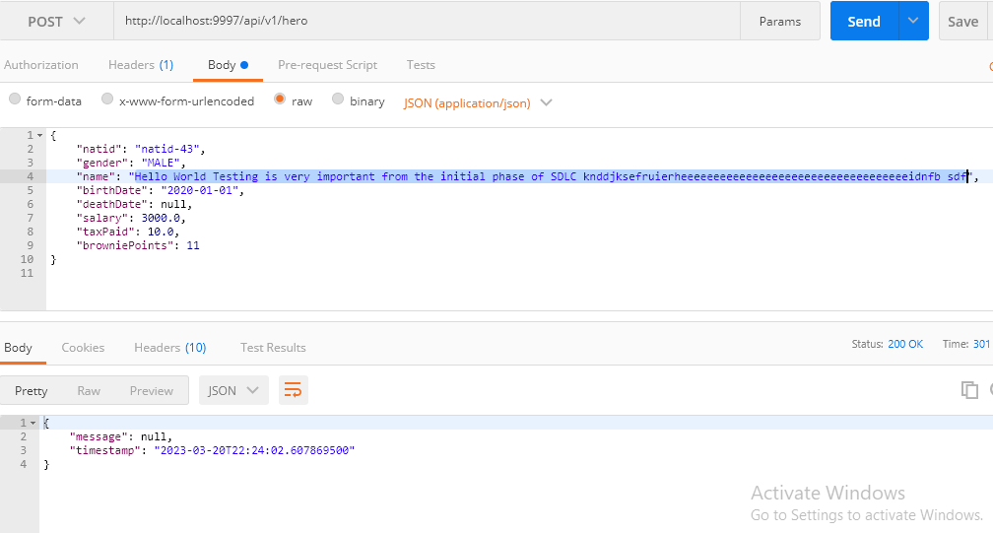

Issue 4: Death date is allowed to be less than birth date

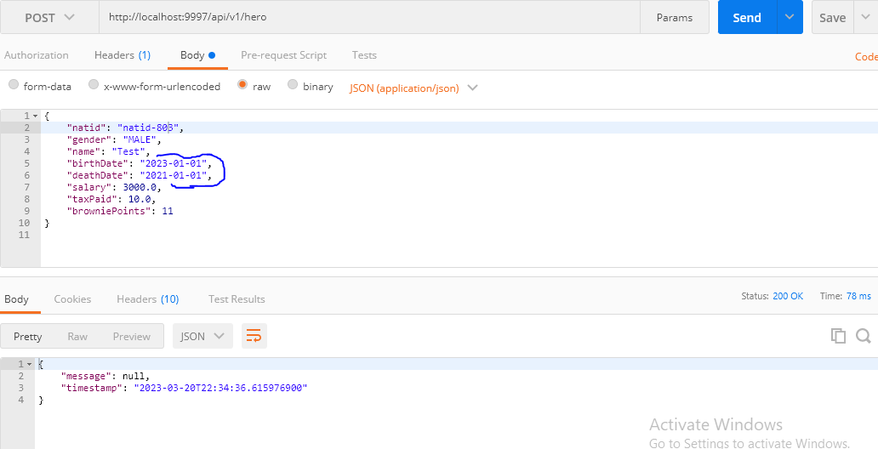

Issue 5:Salary is allowed to be an integer

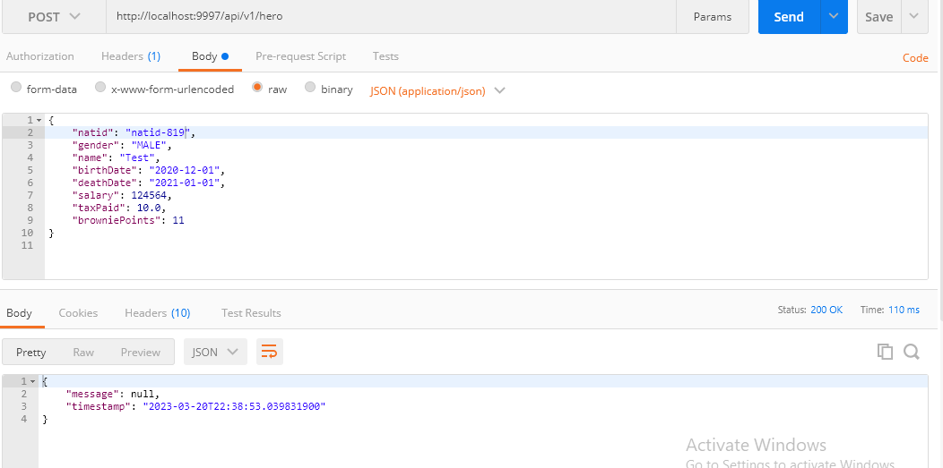

Issue 6:TaxPaid is allowed to be an integer

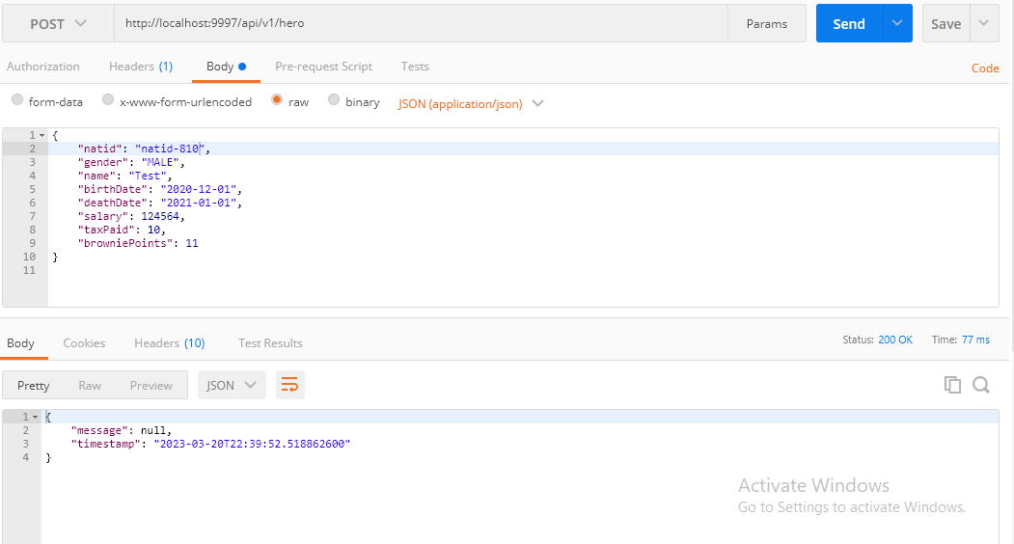

Issue 7: Birthdate is saved in array format rather date format

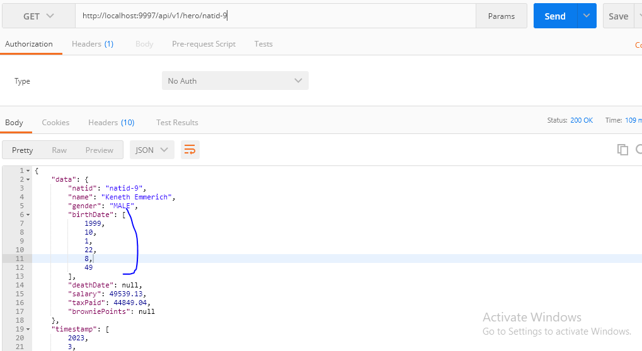

Issue 8:Natid,gender,birthdate,name,salary,taxpaid all are allowed to be null no specific error msg with 400 bad request

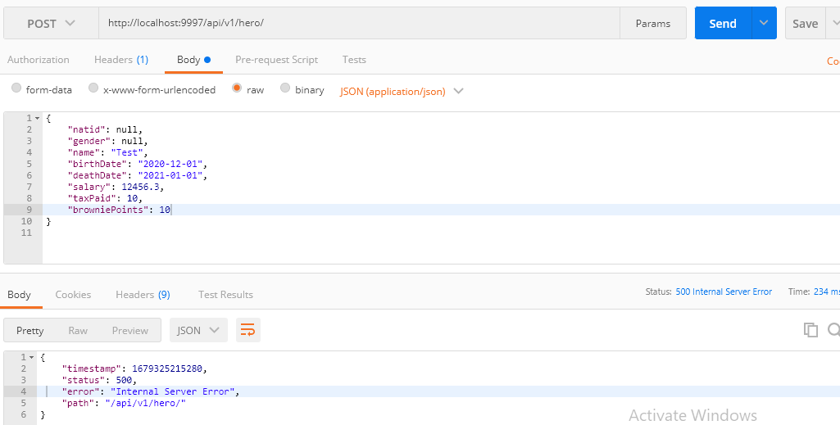

UI Issues:

Issue 1:

When session expires it shows unexpected screen

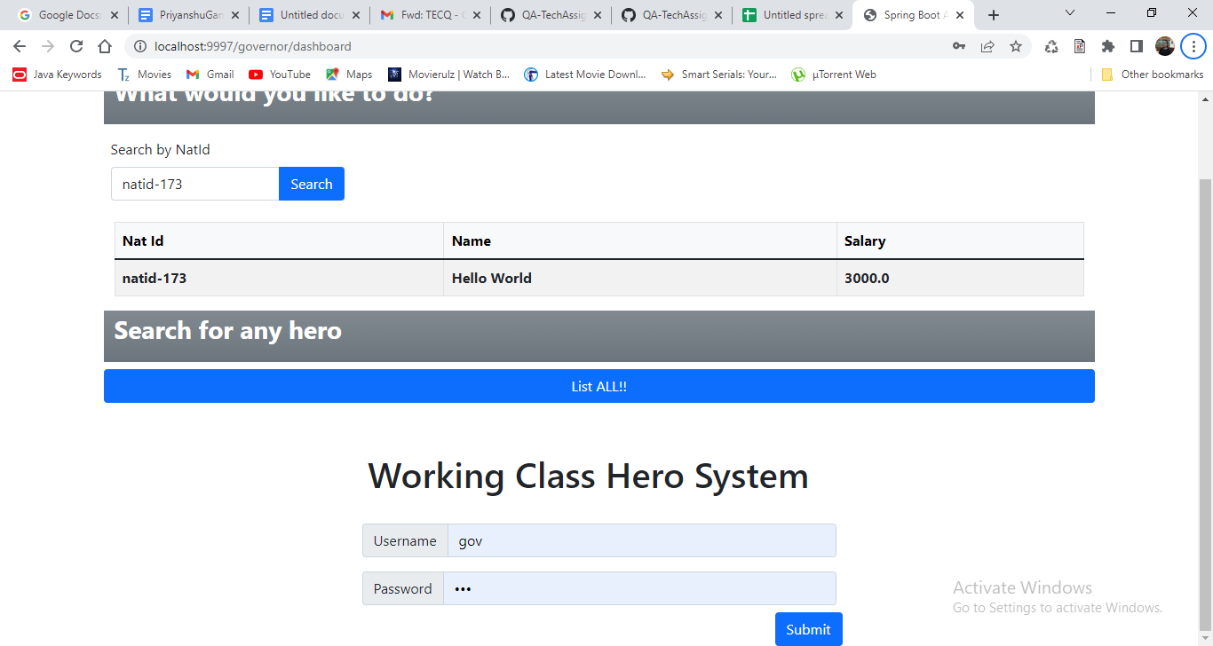

Issue 2:Upload CSV file successfully functionality is not working

While login with clerk user

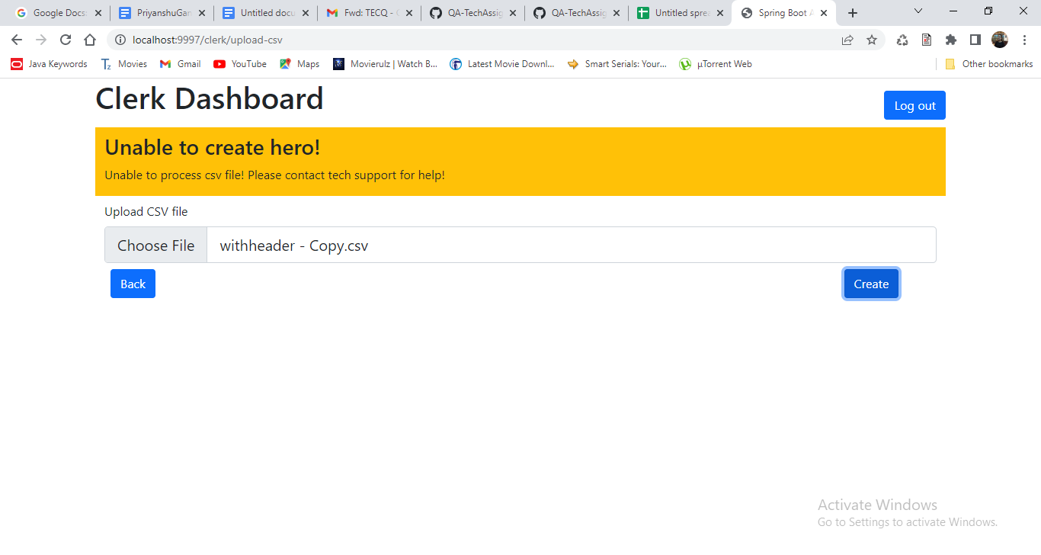

Issue 3: Tax relief egress file is not being generated

While login with bk user

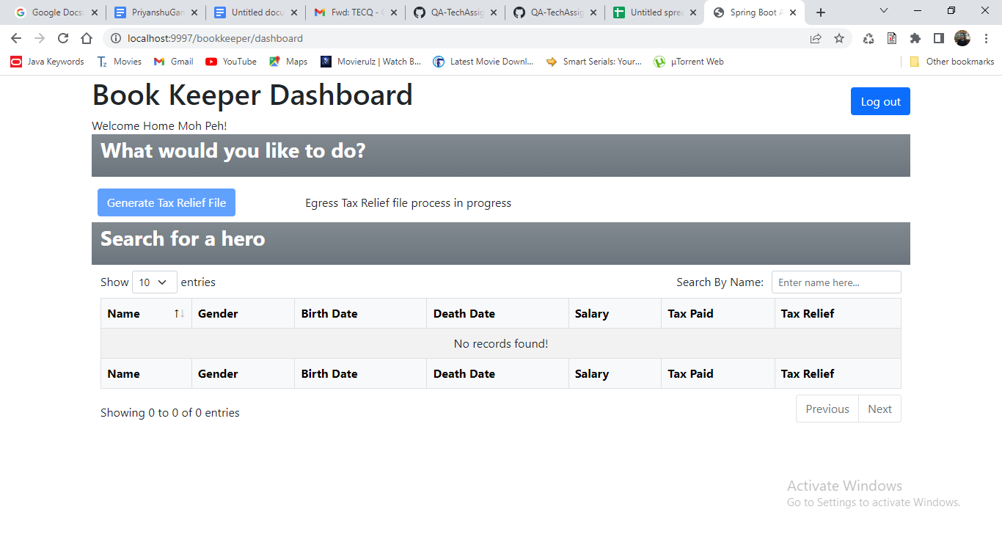

Issue 4: Tax Paid field shows enter Salary

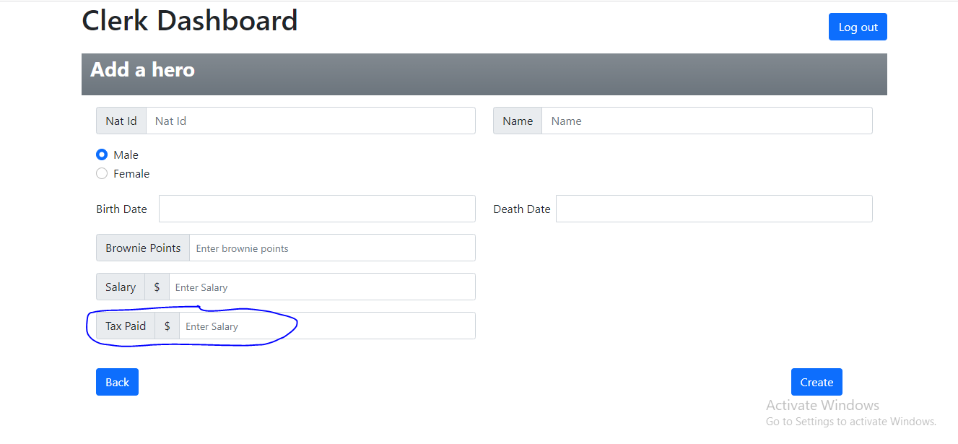

Issue 5: User is able to create hero with invalid salary and taxPaid info

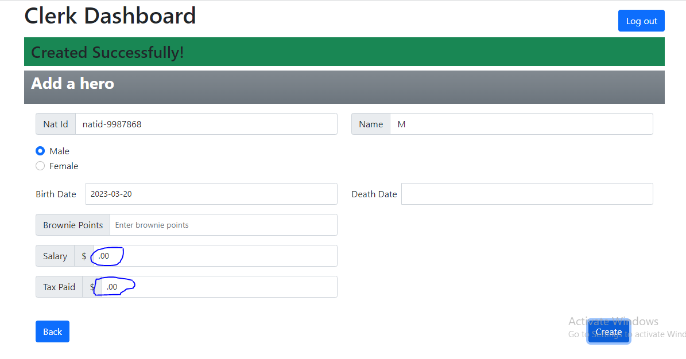

Issue 6:There should be some intuitive information for how natid format should be given

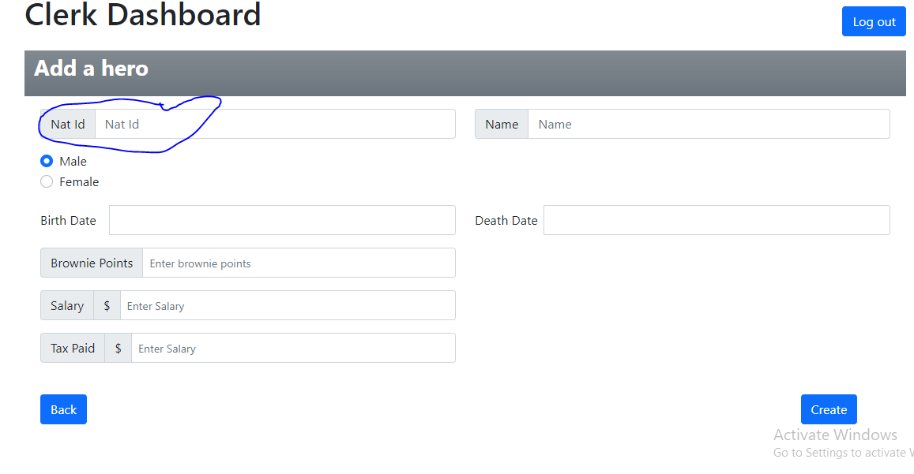

Issue 7: Getting no UI validation on entering special chars in salary/taxPaid

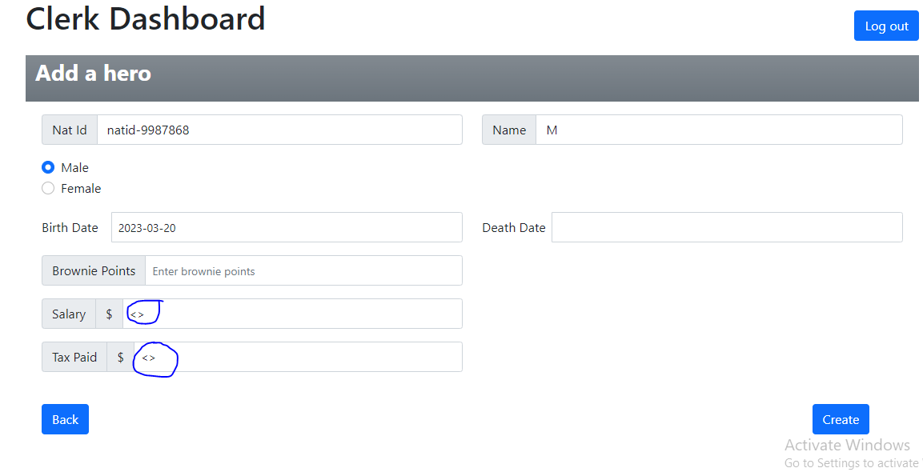

Issue 8: Natid sorting is not working

