**CS 6360 Database Design**

**Project Report**

**Group 15**

**Harish Srinivasan**

**Pratik Deepak Naik**

**Jay Virendra Soni**

**a. Project Description**

Dallas Area Road Transport or DART would like one relational database to store the information about their bus transportation system to be able to carry out their work in an organized way. The DART has some major modules such as Bus, Person (Employee and Passenger) and Ticket Sales.

A Person can be an Employee or an A-class Passenger. A person can be both an employee and an A-Class passenger. Details of a person such as Person ID, Name (First, Middle, Last), Address, Gender, Date of Birth (Must be 16 years or older), and Phone number (one person can have more than one phone number) are recorded. The Person ID should have the format “PXXX” where X is a number from 0 to 9. (Hint: you can use regexp_like() function).

Employee can only be one of following three types: classified as Bus Drivers, Staff (sells tickets or passes) and Ticket checkers. The start date of the employee is recorded. One bus driver can drive multiple buses and multiple drivers can drive one bus but on different dates. But for each day, a driver can only drive one particular bus. One bus will always have one particular ticket checker.

Payment information such as ID, method (cash or card), amount and other information are recorded. Ticket details such as Ticket ID, Bus ID, seat number and price are stored. The staff sells daily tickets to a person and the staff details, ticket details, person details and payment details are stored.

An A-Star passenger is someone who has some extra privileges than an A-Class passenger. An A-Star Passenger can be an Employee or an A-Class passenger or both. Different passes are issued by DART. An A-Class passenger can buy only one pass in a month, but an A-Star Passenger can buy multiple passes in a month.

Each A-Star Passenger is issued a travel card. The travel card details such as card ID, date of issue and other information are stored. Card ID is not unique and is associated with A-Star Passenger.

Sometimes promotional discounts are offered on the travel cards and details such promotion ID and promotion description are recorded. The Promotional IDs are not unique and different travel cards may have discounts with the same Promotional IDs.

A-Star passengers can have guests who travel for free with them four times a month. A Guest info log is maintained which stores information such as passenger ID, guest ID, guest name, guest address, and guest contact information. Guest IDs are temporary IDs that a person gets when they travel as a guest of an A-Star passenger. Each guest ID is not unique and cannot be used to identify a guest.

Bus details such as Bus Number, License plate number, number of seats and other information are stored. Each route has many bus stops. One bus stop is part of only one route. The route and bus stop details are stored. Each bus is parked in a terminal and the information of the terminal such as Terminal ID, Location, Date and Time are stored.

Each bus drives on one particular route and follows a particular timetable. The timetable information such as day and start time, end time and intervals (15 min, 20 min, 30 min) are recorded. Values for ‘day’ can be {M,T,W,Th,F,Sat,Sun}. A unique ID in the form of “DTXX” is given to each unique record in the timetable. For example, Day-{M}, StartTime- 10:00, EndTime – 20:00, Interval - 15m can have ID DT01 and so on. A bus may have different StartTime, EndTime or Interval for different days.

**b. Project Questions**

**1. Is the ability to model superclass/subclass relationships likely to be important in a transportation system environment such as DART? Why or why not?**

* Yes, using the superclass/subclass relationships allows us to define common relations and attributes for the super classes reducing redundancy as described below:
* We can see in EER that it is very necessary to divide person class into different types. Also, employee class is divided into 3 types which is needed separate roles of different employees.
* It becomes easy to manage different entities with different roles using superclass/subclass relationships.

**2. Can you think of 5 more business rules (other than those explicitly described above) that are likely to be used in a DART environment? Describe how your EER will change to represent the rules.**

* Separate Student Passes can be issued based on student id => Add “pass_type” attribute in pass class.
* Group Bookings can also be added => Add new class “group_booking” is to be associated with “staff” and “bus” classes.
* Special Buses on festivals => Add “special_bus” weak entity with particular dates.
* Free tickets for children below age of 10, senior citizens and handicap persons => Add “ticket_type” attribute with values child, normal, senior, disable.
* Advertisements on buses to generate revenue => Add new class “Ads” and relate to “bus” class.

**3. Justify using a Relational DBMS like Oracle for this project (Successfully design a relational database system, show the design in the final report).**

* We use MySQL as our RDBMS due to its speed, security, and ease of use. We design our Relational database system in the third normal form. The design is shown in the “RDB.png” file submitted along with this report.

**c. EER diagram with all assumptions (Solution for Phase II).**

**ASSUMPTIONS for EER Diagram:**

* We have assumed that employees do not take any holidays from work. Therefore, all employees do work each day.
* Promotional discounts on travel cards are offered only for a particular day and not for an entire week or month. Therefore, if promotions are offered for three simultaneous dates, there will be three entities in the promotional entity type.
* Each guest belongs to only one A-star passenger. Two or more A-star passengers cannot have the same guest.
* A ticket is valid for the entire day and the passenger can use the ticket for travel at any time of the day.
* All A-Star passengers are A-class passengers
* All bus stops have unique bus stop numbers which can be used to identify them.
* Buses parked in the terminal can be parked for specific durations of time.

**d. Relational Schema after normalization**

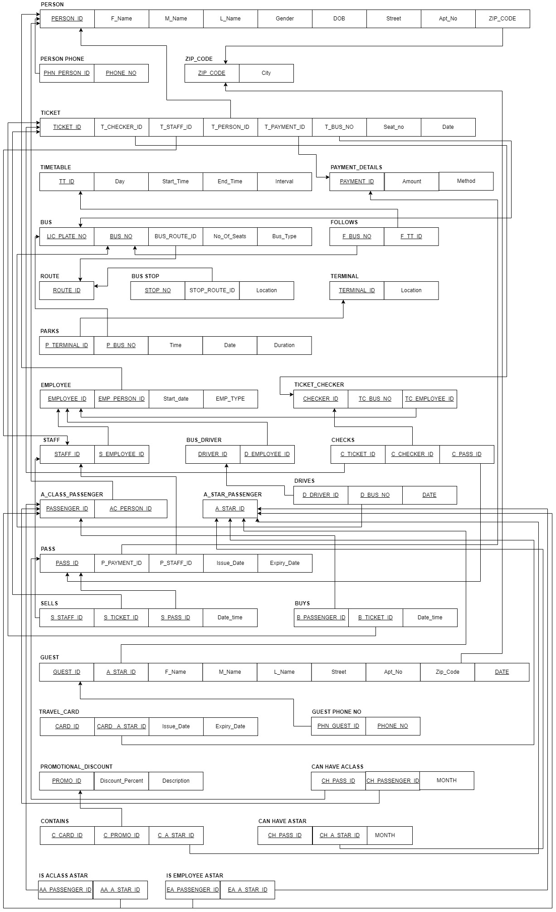

**e. Dependency diagram**

