VoIP Configuration
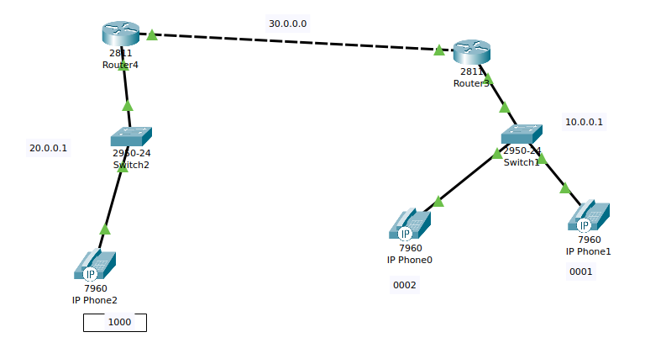
Note: Use router 2811 for VoIP connected network.

Single router configuration: https://www.packettracernetwork.com/tutorials/voipconfiguration.html

Router 3

Router3>enable
Router3#configure terminal
Router3(config)#interface FastEthernet0/0
Router3(config-if)#ip address 10.0.0.1 255.0.0.0
Router3(config-if)#no shutdown
Router3(config-if)#exit
Router3(config)#
Router3(config)#interface FastEthernet0/1
Router3(config-if)#ip address 30.0.0.1 255.0.0.0
Router3(config-if)#no shutdown
Router3(config-if)#exit
Router3(config)#router rip
Router3(config-router)#network 10.0.0.0
Router3(config-router)#network 30.0.0.0

Router 4
Router4>enable
Router4#configure terminal
Router4(config)#interface FastEthernet1/0
Router4(config-if)#ip address 20.0.0.1 255.0.0.0
Router4(config-if)#no shutdown
Router4(config-if)#exit
Router4(config)#
Router4(config)#interface FastEthernet1/1
Router4(config-if)#ip address 30.0.0.2 255.0.0.0
Router4(config-if)#no shutdown
Router4(config-if)#exit
Router4(config)#router rip
Router4(config-router)#network 20.0.0.0
Router4(config-router)#network 30.0.0.0

DHCP configuration
Router3(config)#ip dhcp pool VOICE1
Router3(dhcp-config)#network 10.0.0.0 255.0.0.0
Router3(dhcp-config)#default-router 10.0.0.1
Router3(dhcp-config)#option 150 ip 10.0.0.1
Router4(config)#ip dhcp pool VOICE2
Router4(dhcp-config)#network 20.0.0.0 255.0.0.0
Router4(dhcp-config)#default-router 20.0.0.1
Router4(dhcp-config)#option 150 ip 20.0.0.1

Configure the Call Manager Express telephony service on Router3 and Router4
Router3(config)#telephony-service
Router3(config-telephony)#max-dn 5
Router3(config-telephony)#max-ephones 5
Router3(config-telephony)#ip source-address 10.0.0.1 port 2000
Router3(config-telephony)#auto assign 4 to 6
Router3(config-telephony)#auto assign 1 to 5
Router3(config-telephony)#exit
Router3(config)#ephone-dn 1
Router3(config-ephone-dn)#number 0001
Router3(config-ephone-dn)#exit
Router3(config)#ephone-dn 2
Router3(config-ephone-dn)#number 0002

Router4(config)#telephony-service
Router4(config-telephony)#max-dn 5
Router4(config-telephony)#max-ephones 5
Router4(config-telephony)#ip source-address 20.0.0.1 port 2000
Router4(config-telephony)#auto assign 4 to 6
Router4(config-telephony)#auto assign 1 to 5
Router4(config-telephony)#exit
Router4(config)#ephone-dn 1
Router4(config-ephone-dn)#number 1000
Router4(config-ephone-dn)#exit

Configure a voice Vlan on Switch 1 and 2
Switch1(config)#interface range fa0/1 – 5
Switch1(config-if-range)#switchport mode access
Switch1(config-if-range)#switchport voice vlan 1

Switch2(config)#interface range fa0/1 – 5
Switch2(config-if-range)#switchport mode access
Switch2(config-if-range)#switchport voice vlan 1

Verify the configuration
Ensure that the IP Phone receives an IP Address and a the phone number 0001 from Router3 (this can take a short while). Check for rest two IP Phones
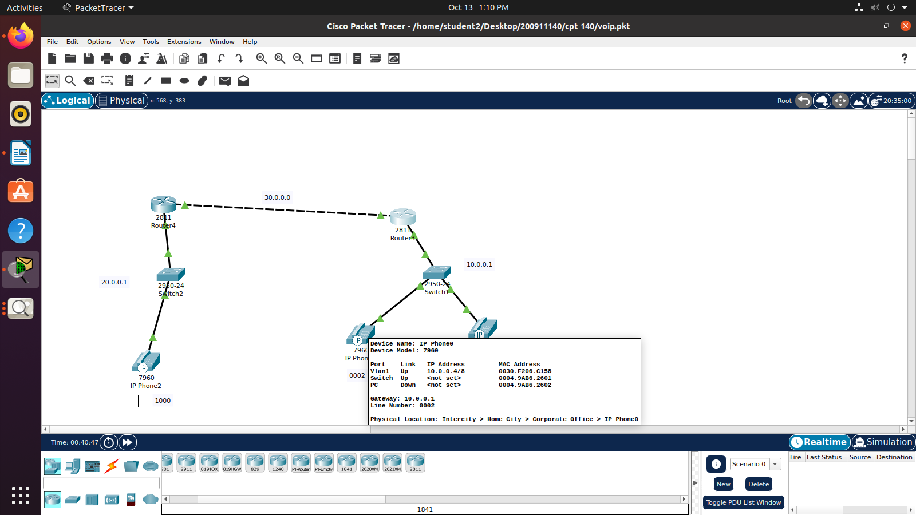

Double Click on IP phone 1 and go to GUI in its menu bar. Click on reciever and dial the phone number 0002 of IP Phone 0.
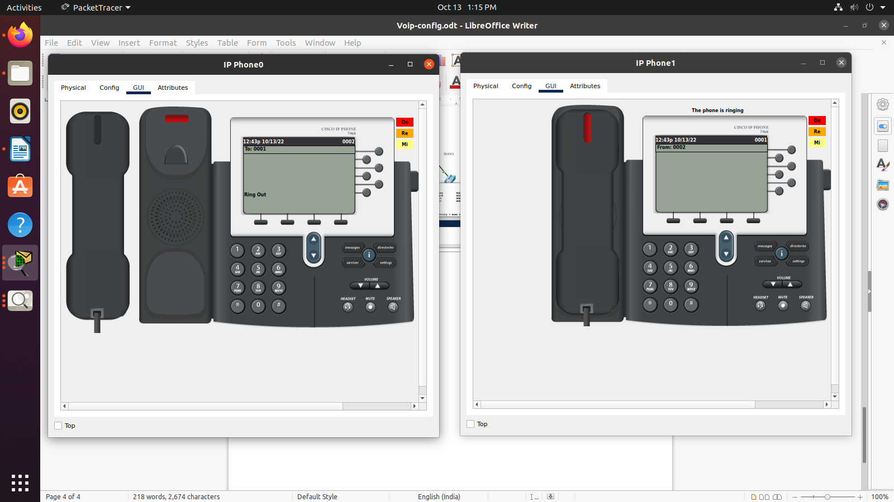
We have checked the VoIP phones which is connected in the same network id. In Next step, We have check the VoIP phones connected in different network id. Click on receiver of IP Phone 1 and dial the phone number 1000 of IP Phone 2.

Configure the telephony service on Router3 and Router4
Router3(config)#dial-peer voice 1 voip
Router3(config-dial-peer)# destination-pattern [0-9][0-9][0-9][0-9] # To represent IP Phone number 0001 or 0002
Router3(config-dial-peer)# session target ipv4:30.0.0.2

Router4(config)#dial-peer voice 1 voip
Router4(config-dial-peer)# destination-pattern [0-9][0-9][0-9][0-9] # To represent IP Phone number 0001 or 0002
Router4(config-dial-peer)# session target ipv4:30.0.0.1
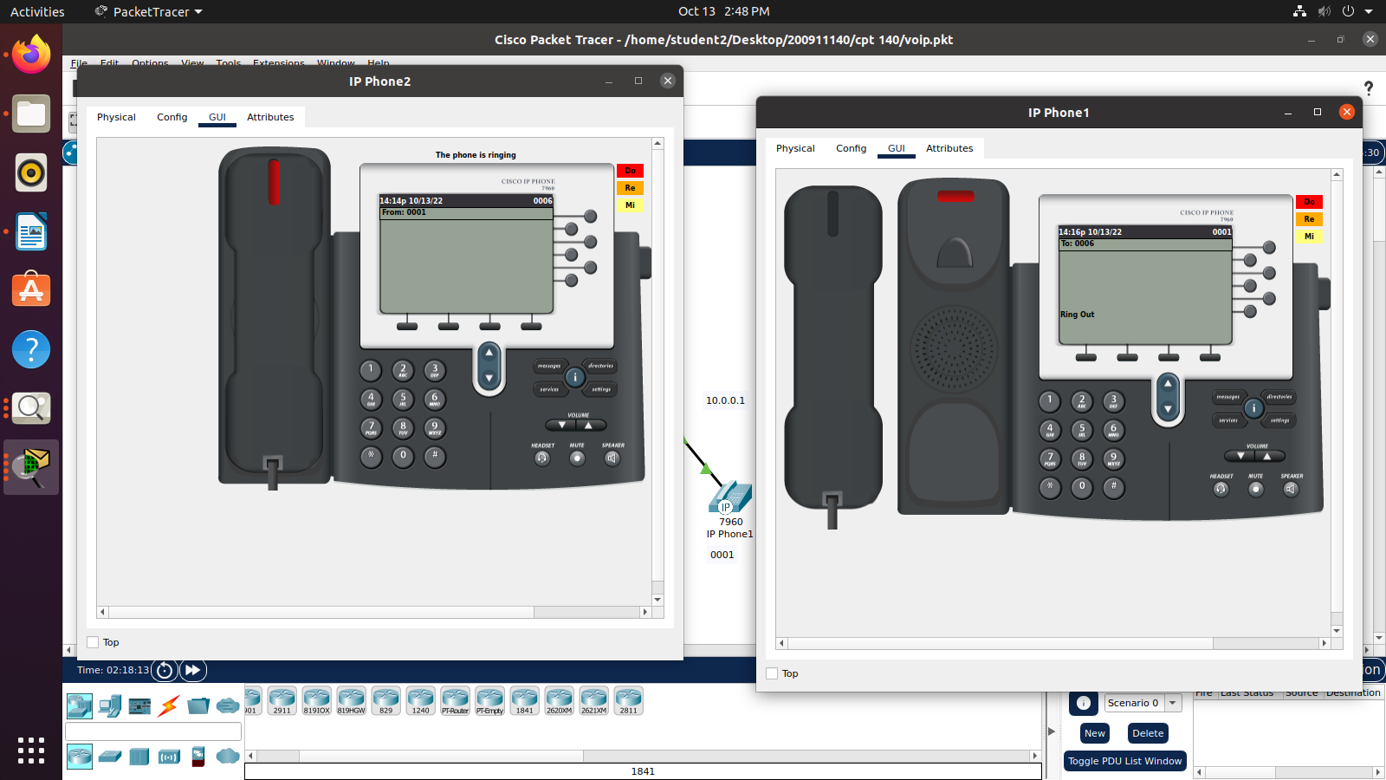
Double Click on IP phone 1 and go to GUI in its menu bar. Click on reciever and dial the phone number 1000 of IP Phone 2.

