**Alzheimer’s Disease and Healthy Aging**

Team 11

Priyansh Jajoo

**Executive Summary**

This report consists of the findings from an academic course project conducted by Aditya Dhole and Priyansh Jajoo as part of the "Data Visualization and Storytelling" course at Clark University. The dataset used was "Alzheimer's Disease and Healthy Aging," which included survey questions about cognitive function, memory loss, nutrition, and behaviour. The study found significant disparities in mental health conditions and cognitive decline among older adults across different regions and demographic groups.

States in the South experienced higher rates of mental distress and limitations in daily activities, while the Northeast region reported lower incidences. The male population of older adults experienced more activity limitations than the female population, while Native Americans and Alaskans were the most affected with mental distress and activity limitations. Older adults in the Northeast reported more interventions in social activities and household chores due to subjective cognitive decline, while the South had more people with preceding cognitive decline or memory loss. In both cases the Native American/Alaskan, Hispanic and Black non-Hispanic were more affected. There is a significant gap between the Northeast and South regions regarding older people reporting cognitive decline or memory loss to healthcare professionals. More detailed findings related to the analysis are mentioned further in this report.

**Introduction**

Alzheimer’s Disease (AD) is a progressive neurodegenerative disorder that affects cognitive function, memory and behavior. It is a very common form of dementia affecting millions of individuals worldwide. It has a significant impact on patients, caregivers and healthcare systems. In the United States, AD and Alzheimer’s Disease and its Related Dementias (ADRD) affects as many as 5 million people, and nearly 40% of the population aged 85 and older. By 2050, approximately 13.2 million older Americans are projected to have AD/ADRD. Early Detection, accurate management and comprehensive management are crucial for improving outcomes and quality of life for individuals with Alzheimer’s disease.

The dataset that we used for our course project is “Alzheimer’s Disease and Healthy Aging” which consists of various survey questions asked to older adults regarding their cognitive function, behaviour, nutrition and behaviour via the Behavioral Risk Factor Surveillance System (BRFSS) under the Centres for Disease Control and Prevention (CDC). The dataset is extensive, comprising 250,937 entries and 39 columns, which were collected in the timespan of 2015 to 2021. It consists of a total thirty-one different survey questions across seven different classes including Caregiving, Cognitive Decline, Mental Health, Nutrition/Physical Activity/Obesity, Overall, Health, Screenings and Vaccines, and Smoking and Alcohol use. These questions were asked to a group of older adults of varied age group, gender and race/ethnicity across all the states and territories of the USA. The data value related to these questions was recorded in the form of Percentage and Mean. The main aim through the analysis is to get an understanding how cognitive decline and other behavioral activities vary in the older people of various race/ethnicity and genders all over the USA.

**Methodology**

The data was gathered from data.gov website which is the official government data repository for federal, state and local government information which makes it a very reliable source of data. Then the dataset was explored in Microsoft Excel which showed us that it contains 250,937 rows and 39 columns which makes it a very vast dataset. It was then uploaded into Tableau Prep which is a software for data cleaning and preprocessing. The null values in the data were handled here and the data types of some columns were set according to our requirement.

Based on the data explored, it was decided to consider the following research questions in order to conduct an analysis;

1. How do the demographic and behavioral characteristics of older adults with and without Alzheimer’s disease and related dementias differ in the USA?
2. How does the prevalence of Alzheimer’s disease and related dementias vary by state in the USA?
3. What are the associations between cognitive decline, caregiver status, and health-related quality of life among older adults in the USA?

The dataset is very vast and consists of a total 31 survey questions. Based on our research questions we have selected the top 5 survey questions that align well with them. They are as follows;

1. Percentage of older adults who are experiencing frequent mental distress.
2. Mean number of days with activity limitations in the past month.
3. Percentage of older adults who reported subjective cognitive decline or memory loss that interferes with their ability to engage in social activities or household chores.
4. Percentage of older adults who reported subjective cognitive decline or memory loss that is happening more often or is getting worse in the preceding 12 months.
5. Percentage of older adults with subjective cognitive decline or memory loss who reported talking with a healthcare professional about it.

We uploaded the processed data on Tableau software to perform the analysis based on sheets and dashboards. We created 3 different sheets based on geographic data based on regions and states in the USA and the demographic data of age, gender and race/ethnicity of the older adults. These 3 sheets then presented in one dashboard with selected filters according to the questions mentioned above. After looking into the dashboard, it was analyzed and the findings were note down through our understanding. The findings of the visualizations are further mentioned in the report.

**Findings**

*Cognitive Decline and Memory Loss*

Puerto Ricans demonstrate having the highest percentage of older adults with subjective cognitive decline and or memory loss. Reports from medical professional suggest 65.56, followed by Rhode Island 53.55 and Maine 52.18, Hawaii showing the lowest with 33.15, followed by Iowa 36.91 and North Dakota 36.90. The Northeast region has the highest with 45.17 followed by West having 43.796, South region having 41.433. Also, another significant observation being Females experiencing more memory loss and cognitive decline in contrast to males. Likewise in terms of ethnic background and race Native Americans/Alaskans demonstrate are significantly lower with Asian/ Pacific Islanders being the lowest in all the demographics.

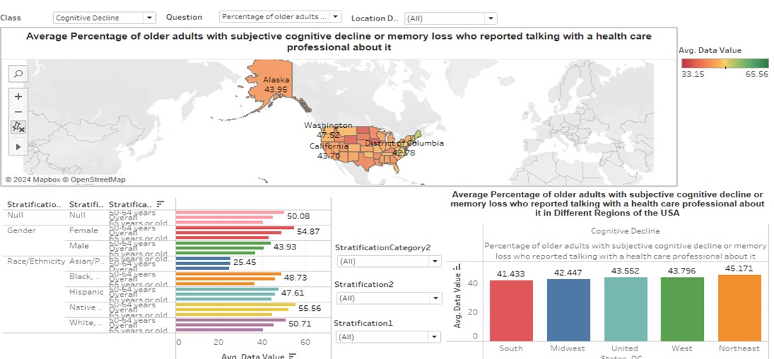

*Mental Distress*

The analysis shows that state of West Virginia demonstrates having the highest number older how frequently experience mental distress 15.37, along with Oklahoma and Arkansas 14.32 and 13.78 respectively, with the lowest being the Virgin Islands 5.78, followed by North Dakota 7.20 and South Dakota 7.29. With respect to region the South having the highest 11.74, followed by Mid-west 11.20 while the northeast is significantly lower with 10.76. Now with respect to gender, race and ethnicity, females and Native Americans/Alaskans encounter far more mental distress than any other gender or race.

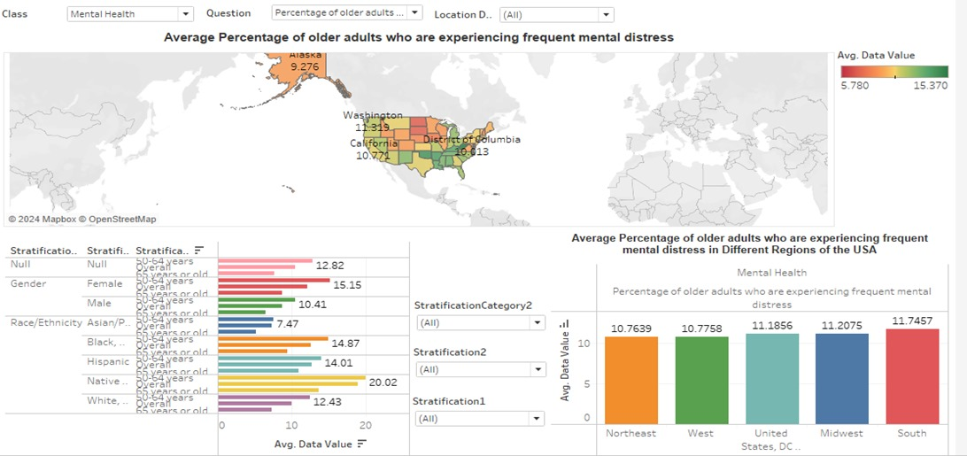

*Activity limitations*

The analysis shows that the people in West Virginia had the highest mean number of days with activity limitations in the previous month, 8.61, followed by Kentucky 7.82 and Oklahoma 7.67, with the lowest being from the Virgin Islands 3.94, along with states of Iowa 5.33 and Utah 5.38. In terms of region the entire region of South has the highest 6.93 and the Northeast has the lowest 6.21. In term of Gender, Ethnic background, males and Native Americans/Alaskans respectively are seeing more days with limitations in their activity than any other gender or race.

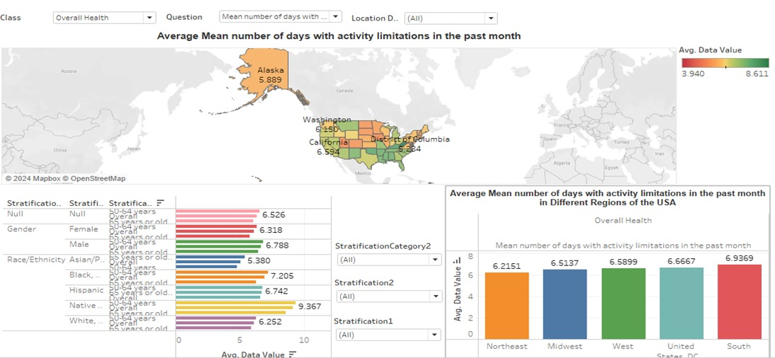

*Interference with social activity and household chores*

The analysis shows that Puerto Ricans have the highest percentage of older adults who reported subjective cognitive decline or memory loss that interfere with their ability to engage in social activities or household chores 65.35, followed by Mississippi 49.34 and Tennessee 47.03, and the lowest from Iowa 26.24, followed by Maine 27.68 and North Dakota 27.30. The region of Northeast has the highest 47.116 while the West has the lowest 37.337. With respect to Gender Females spend more days with activity limitations and in terms of Race and or ethnic groups Hispanics demonstrate limitations in daily activity.

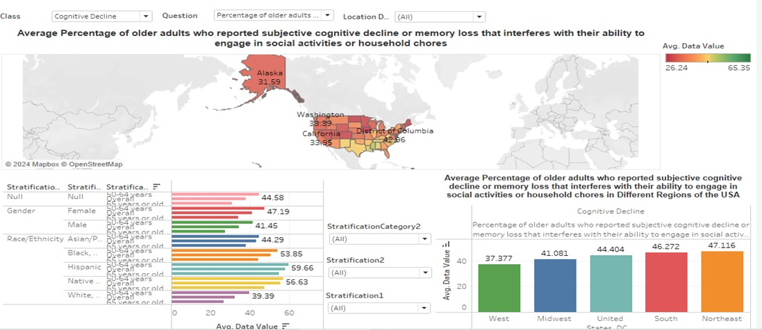

*Trends in Subjective Cognitive Decline: 12-Month Change*

The analysis show that state of Tennessee having the highest percentage of older adults who reported subjective cognitive decline or memory loss that is occurring more frequently or worsening in the preceding 12 months 15.60, followed by Oklahoma 14.87 and Louisiana 47.03, and the lowest from Puerto Ricans 6.24, followed by New Hampshire 7.87 and Vermont 8.24. The Southern region demonstrates having the highest 13.10, while the Midwest has the lowest 11.50. In the aspect of gender and race respectively Males and Native Americans/Alaskans have more days with reported subjective cognitive decline or memory loss than any other gender or race.

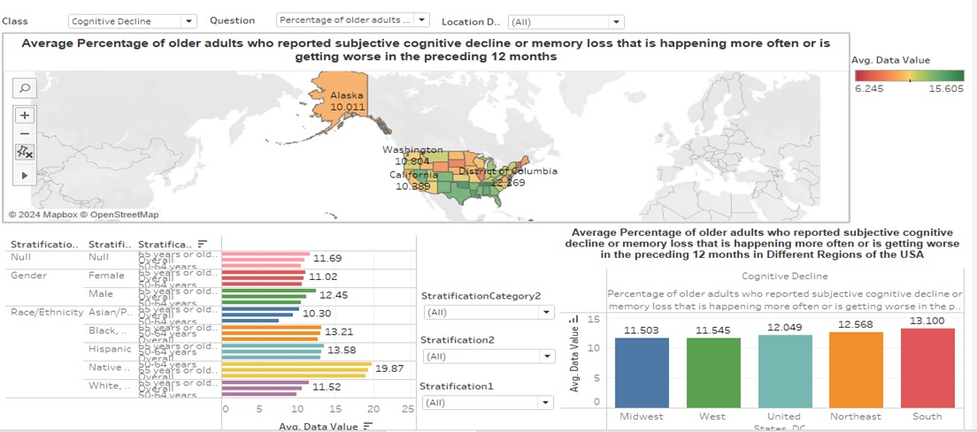

**Recommendations**

*Individualized Approaches to Public Health*

This calls for policy makers to devise and launch public health interventions and initiate training programs for healthcare professionals that are specifically focused on the mental health and cognitive well-being of older adults, with a focus on regions with higher rates of mental distress and cognitive decline, such as West Virginia, Oklahoma, Arkansas, and Puerto Rico.

*Research and Policy Development*

Encourage research into regional and demographic disparities in mental health among older adults to inform policymakers, along with campaigning to bring about awareness resulting in effective strategies and policies that address the needs of high-risk groups, such as women and Native Americans/Alaskans. This can guide them in formulating policies and interventions to address these issues. For instance, states like West Virginia, Oklahoma, and Arkansas, which are experiencing higher rates of mental distress and activity limitations, may need different policies and stratagies when compared to areas such as the Virgin Islands, North Dakota, and South Dakota, which report lower incidences.

*Awareness & Communication*

This analysis also draws light on the need to esclate public awareness and bridge communication between older adults and healthcare providers about Alzheimer's disease and cognitive impairments, especially in areas where there is less engagement in cognitive health discussions, such as Hawaii and the Midwest.

**Intended Audience**

*Healthcare professionals*

The findings in this analysis highlight the need for healthcare providers and health institutes to be aware and accommodate the regional and demographic factors that may influence mental health and cognitive well-being of older adults. This information provide them with specific approaches and resources to address issues regarding this populations.

*Policy Makers*

The findings can inform policy makers in the healthcare sector about the regional and demographic factors influencing mental health and cognitive well-being of older adults. This can guide them in formulating policies and interventions to address these issues.

*Researchers and Academics*

This analysis can be useful for researchers and academics studying Alzheimer's Disease, cognitive decline, and aging, providing insights into the disparities in mental health and cognitive decline among older adults across different regions and demographics.

**Conclusion**

The analysis of data on "Alzheimer’s Disease and Healthy Aging" reveals significant disparities in mental health and cognitive decline among older adults across different regions and demographics. States like West Virginia, Oklahoma, and Arkansas are experiencing higher rates of mental distress and activity limitations, while areas such as the Virgin Islands, North Dakota, and South Dakota report lower incidences. These variations are not only geographical but extend across gender and racial lines, with females and Native Americans/Alaskans being particularly affected. The South region consistently shows higher averages suggesting a regional trend that warrants further investigation and targeted interventions. Moreover, the Northeast and Puerto Rico report concerning levels of subjective cognitive decline, impacting the ability to engage in social activities and household chores. The findings in this analysis underscore the need for healthcare professionals to be aware of the regional and demographic factors that may influence the mental health and cognitive well-being of older adults. This also calls for proper approaches and resources to address the specific needs of these populations. By recognizing and responding to these patterns, healthcare providers can improve the quality of life for older adults suffering from Alzheimer’s Disease and related cognitive impairments.

**Citation**

1. U.S. Department of Health & Human Services - Alzheimer’s Disease and Healthy Aging Data. (2024, April 23). https://catalog.data.gov/dataset/alzheimers-disease-and-healthy-aging-data
2. CDC’s Alzheimer’s Disease and Healthy Aging Program. (2023, November 3). Centres for Disease Control and Prevention. https://www.cdc.gov/aging/index.html
3. Data Sharing Resources for Researchers. (n.d.). National Institute on Aging. <https://www.nia.nih.gov/research/data-sharing-resources-researchers>