|  |
| --- |
| LockedMe.com  Application Screenshots |

**Version History:**

|  |  |
| --- | --- |
| Author | Priyansh Rastogi |
| Purpose | Screenshot of the Application |
| Date | 14th August 2021 |
| Version | 1.0 |

**Contents:**

**1: Main Menu Screenshot……………………………………………………..3**

**2: To get all the files Screenshot…………………………………………….3**

**3: All the files present in the folder Screenshot………………………3**

**4: To add a new file Screenshot………………………………………………4**

**5: New file is added in the folder…………………………………………….4**

**6: To delete a file Screenshot…………………………………………………..5**

**7: File deleted in a folder Screenshot……………………………………….5**

**8: To Search a file Screenshot…………………………………………………...6**

**9: File is there in folder Screenshot…………………………………………..6**

**10: Runnable jar file Screenshot…………………………………………………6**

**11: Runnable jar file running in Command Prompt……………………..7**

**12: Executing Runnable jar file in CMD……………………………………….7-9**

**1: Main Menu Screenshot**

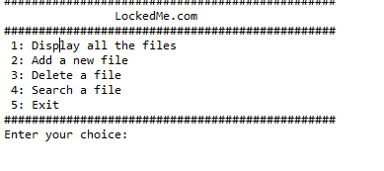

**2: To get all the files Screenshot**

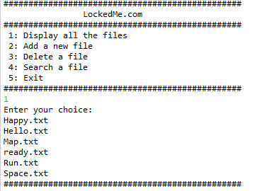

**3: All the files present in the folder Screenshot**

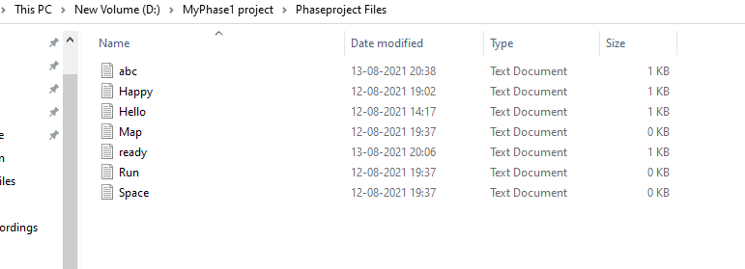

**4: To add a new file Screenshot**

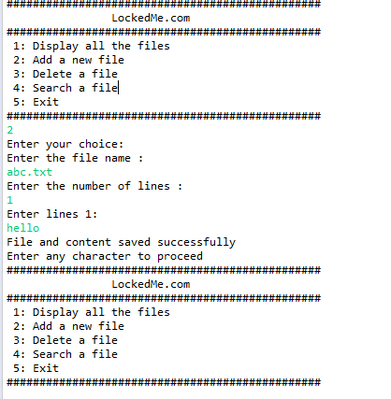

**5: New file is added in the folder**

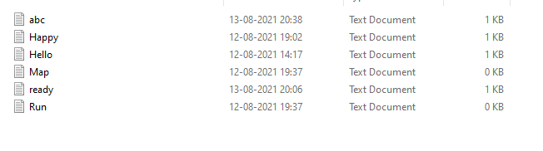

**6: To delete a file Screenshot**

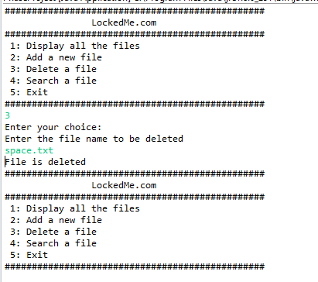

**7: File deleted in a folder Screenshot**

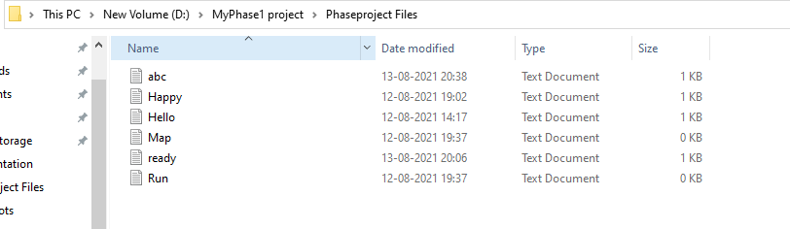

**8: To Search a file Screenshot**

**running in Command Prompt** 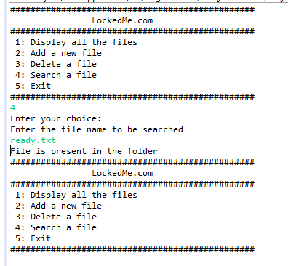

**9: File is there in folder Screenshot**

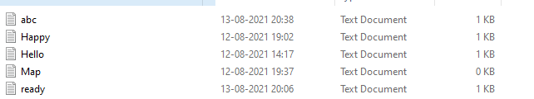

**10: Runnable jar file Screenshot**

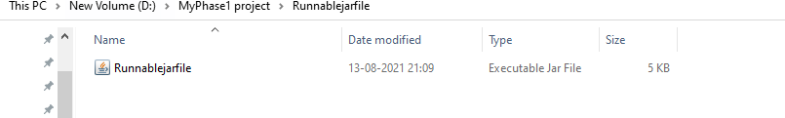

**11: Runnable jar file running in Command Prompt**

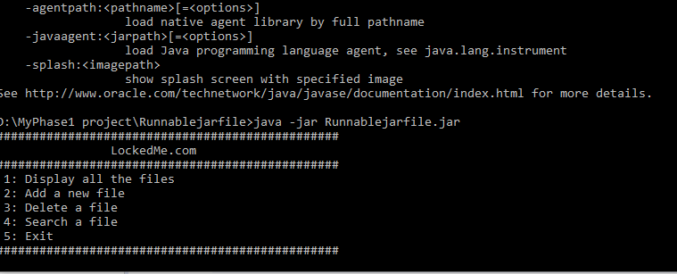

**12: Executing Runnable jar file in CMD**

