PIZZA SALES PROJECT SQL QUERIES
- Data Ingestion and Normalization

- Raw Data Ingestion (Staging Layer)
The raw pizza sales dataset was first loaded into a staging table without any transformations.
This ensures traceability, reproducibility, and allows all data cleaning and modeling to be performed downstream using SQL.
- Staging Table Creation
CREATE TABLE pizza_sales_raw (
row_id INT, order_id INT, pizza_name_id VARCHAR(50), quantity INT, order_date VARCHAR(20), order_time VARCHAR(20),
unit_price DECIMAL(6,2), total_price DECIMAL(8,2), pizza_size VARCHAR(10), pizza_category VARCHAR(50), pizza_ingredients TEXT, pizza_name VARCHAR(100) );
- Bulk Data Load
To efficiently ingest ~48k rows, MySQL’s bulk loader was used instead of GUI-based imports.
LOAD DATA INFILE
'C:/ProgramData/MySQL/MySQL Server 8.0/Uploads/pizza_sales.csv'
INTO TABLE pizza_sales_raw FIELDS TERMINATED BY ',' ENCLOSED BY '"'
LINES TERMINATED BY '\r\n' IGNORE 1 LINES;
- Validation Check
SELECT COUNT(*) FROM pizza_sales_raw;
Result: 48,620 rows successfully loaded.

2. Orders Table (Transaction Header)
Stores one record per order, capturing order date and time.
- Table Creation
CREATE TABLE orders (
order_id INT PRIMARY KEY, order_date DATE, order_time TIME );
- Data Population
INSERT INTO orders (order_id, order_date, order_time)
SELECT DISTINCT
CAST(order_id AS UNSIGNED),
CASE
WHEN order_date LIKE '%-%'
THEN STR_TO_DATE(order_date, '%d-%m-%Y')
WHEN order_date LIKE '%/%'
THEN STR_TO_DATE(order_date, '%d/%m/%Y')
END,
STR_TO_DATE(order_time, '%h:%i:%s %p')
FROM pizza_sales_raw;
- Validation
SELECT COUNT(*) FROM orders;
Result: 21,350 orders

3. Pizzas Table (Product / SKU Dimension)
Stores unique pizza SKUs along with descriptive and pricing information.
- Table Creation
CREATE TABLE pizzas (
pizza_id VARCHAR(50) PRIMARY KEY,
pizza_name VARCHAR(100), pizza_category VARCHAR(50),
pizza_size VARCHAR(10), unit_price DECIMAL(6,2),
pizza_ingredients TEXT );
- Data Population
INSERT INTO pizzas (
pizza_id, pizza_name, pizza_category, pizza_size, unit_price, pizza_ingredients
)
SELECT
pizza_name_id, MIN(TRIM(pizza_name)),
MIN(TRIM(pizza_category)), MIN(TRIM(pizza_size)),
CAST(MIN(unit_price) AS DECIMAL(6,2)), MIN(TRIM(pizza_ingredients))
FROM pizza_sales_raw GROUP BY pizza_name_id;
- Validation
SELECT COUNT(*) FROM pizzas;
Result: 91 unique pizza SKUs

4. Order Items Table (Transaction Line Items)
Captures individual pizza items within each order.
- Table Creation
CREATE TABLE order_items (
order_item_id INT AUTO_INCREMENT PRIMARY KEY,
order_id INT, pizza_id VARCHAR(50), quantity INT, total_price DECIMAL(8,2),
FOREIGN KEY (order_id) REFERENCES orders(order_id), FOREIGN KEY (pizza_id) REFERENCES pizzas(pizza_id) );
- Data Population
INSERT INTO order_items (order_id, pizza_id, quantity, total_price)
SELECT
CAST(order_id AS UNSIGNED), pizza_name_id,
CAST(quantity AS UNSIGNED), CAST(total_price AS DECIMAL(8,2))
FROM pizza_sales_raw;
- Validation
SELECT COUNT(*) FROM order_items;
Result: 48,620 order line items

5. Final Data Consistency Check
SELECT
(SELECT COUNT(*) FROM pizza_sales_raw) AS raw_rows,
(SELECT COUNT(*) FROM orders) AS orders,
(SELECT COUNT(*) FROM pizzas) AS pizzas,
(SELECT COUNT(*) FROM order_items) AS order_items;

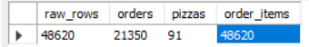

- KPI’S
- Total Revenue

select sum(total_price) as Total_Revenue from order_items;

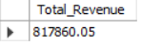

- Average Order Value
select sum(total_price)/count(distinct(order_id)) as Average_Order_Value from order_items;
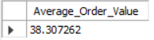

- Total Pizzas Sold

select sum(quantity) as Total_Pizza_Sold from order_items;

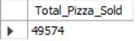

- Total Orders

select count(distinct(order_id)) as Total_Orders from order_items;

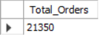

- Average Pizzas Per Order

select cast((sum(quantity)/count(distinct(order_id))) as decimal(10,2)) as Average_Pizzas_Per_Order from order_items;

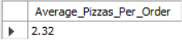

- CHARTS
- DAILY TREND FOR TOTAL ORDERS

Query-

select dayname(order_date) as Weekdays, count(order_id) as Total_orders from orders group by Weekdays;

Output-

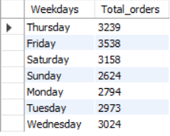

- HOURLY TREND FOR TOTAL ORDERS

Query-

select hour(order_time) as order_hour, count(order_id) as Total_orders from orders group by order_hour order by order_hour;

Output-

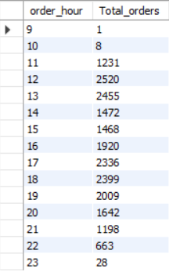

- PERCENTAGE OF SALES BY PIZZA CATEGORY

Query-

SELECT
p.pizza_category,
ROUND(SUM(oi.total_price), 2)
AS category_revenue,
ROUND(
SUM(oi.total_price) * 100.0
/ SUM(SUM(oi.total_price)) OVER (),
2
) AS revenue_percentage
FROM order_items oi
JOIN pizzas p
ON oi.pizza_id = p.pizza_id
GROUP BY p.pizza_category
ORDER BY category_revenue DESC;

Output-
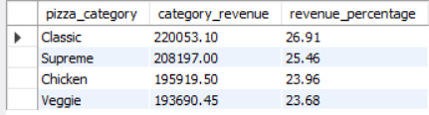

- PERCENTAGE OF SALES BY PIZZA SIZE

Query-

SELECT
p.pizza_size,
ROUND(SUM(oi.total_price), 2) AS size_revenue,
ROUND(
SUM(oi.total_price) * 100.0 /
SUM(SUM(oi.total_price)) OVER (),
2
) AS revenue_percentage
FROM order_items oi
JOIN pizzas p
ON oi.pizza_id = p.pizza_id
GROUP BY p.pizza_size
ORDER BY size_revenue DESC;

Output-

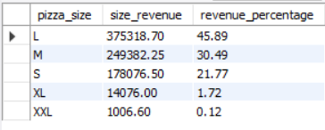

- TOTAL PIZZAS SOLD BY PIZZA CATEGORY

Query-

SELECT
p.pizza_category,
SUM(oi.quantity) AS total_pizzas_sold
FROM order_items oi
JOIN pizzas p
ON oi.pizza_id = p.pizza_id
GROUP BY p.pizza_category
ORDER BY total_pizzas_sold DESC;

Output-

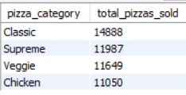

- TOP 5 BEST SELLING PIZZAS

Query-
SELECT
p.pizza_name,
SUM(oi.quantity) AS total_pizzas_sold
FROM order_items oi
JOIN pizzas p
ON oi.pizza_id = p.pizza_id
GROUP BY p.pizza_name
ORDER BY total_pizzas_sold DESC
LIMIT 5;
Output-

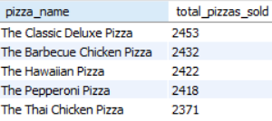

- BOTTOM 5 WORSE SELLING PIZZAS

Query-

SELECT
p.pizza_name,
SUM(oi.quantity) AS total_pizzas_sold
FROM order_items oi
JOIN pizzas p
ON oi.pizza_id = p.pizza_id
GROUP BY p.pizza_name
ORDER BY total_pizzas_sold ASC
LIMIT 5;

Output-

