Software Requirements Specification
for
Spendee: Expense Tracker and Budget Manager
Version 1.0 approved
Prepared by: Harshil Rana, Hemit Rana, Jainil Rana, Manan Shah, Priyansh Shah
24-4-2021
Table of Contents

1. Introduction 1
1.1 Purpose 1
1.2 Intended Audience and Reading Suggestions 1
1.3 Project Scope 1
2. Overall Description 2
2.1 Product Perspective 2
2.2 Product Features 2
2.3 Operating Environment 2
3. System Features 3
3.1 User Registration Feature 3
3.1.1 Description and Priority …………………………………………………………..3
3.1.2 Stimulus/Response………………………………………………………………...3
3.1.3 Functional Requirements………………………………………………………….3
3.2 Login Feature 3
3.2.1 Description and Priority …………………………………………………………..3
3.2.2 Stimulus/Response………………………………………………………………...4
3.2.3 Functional Requirements………………………………………………………….4
3.3 Forgot Password Feature 4
3.3.1 Description and Priority …………………………………………………………..4
3.3.2 Stimulus/Response……………………………………………………………….. 4
3.3.3 Functional Requirements……………………………………………………….....4
3.4 Dashboard 5
3.4.1 Description and Priority …………………………………………………………..5
3.4.2 Stimulus/Response……………………………………………………………….. 5
3.4.3 Functional Requirements……………………………………………………….....5
3.5 Income Management 6
3.5.1 Description and Priority …………………………………………………………..6
3.5.2 Stimulus/Response……………………………………………………………….. 6
3.5.3 Functional Requirements……………………………………………………….....6
3.6 Expense Management 6
3.6.1 Description and Priority …………………………………………………………..6
3.6.2 Stimulus/Response……………………………………………………………….. 6
3.6.3 Functional Requirements……………………………………………………….....7
3.7 Search Income/Expense 7
3.7.1 Description and Priority …………………………………………………………..7
3.7.2 Stimulus/Response……………………………………………………………….. 7
3.7.3 Functional Requirements……………………………………………………….....7
3.8 Tax Calculator 8
3.8.1 Description and Priority …………………………………………………………..8
3.8.2 Stimulus/Response……………………………………………………………….. 8
3.8.3 Functional Requirements……………………………………………………….....8
3.9 EMI calculator 8
3.9.1 Description and Priority …………………………………………………………..8
3.9.2 Stimulus/Response……………………………………………………………….. 8
3.9.3 Functional Requirements……………………………………………………….....8
3.10 Alert of Low Balance 9
3.10.1 Description and Priority …………………………………………………………..9
3.10.2 Stimulus/Response……………………………………………………………….. 9
3.10.3 Functional Requirements……………………………………………………….....9
4. External Interface Requirements 10
4.1 User Interfaces 10
5. Other Nonfunctional Requirements 23
5.1 Software Quality Attributes 23
Appendix A: Glossary 24

Introduction

Purpose
In today’s era, subscription services are common. Also you have the usual array of rent and utilities to pay. Plus, money these days is a little tighter than it used to be comparatively speaking.

Therefore, we decided to find an easier way to get rid of this problem. So as the name itself suggests, this project is an attempt to manage our daily expenses in a more efficient and manageable way. Sometime we can’t remember where our money goes. And we can’t handle our cash flow.

Our application allows people to eliminate any unnecessary expenses and figure out if they are able to survive themselves or do they really need to ask help. Typically people are able to optimize their spending by doing some correct decisions.

Instead of keeping a diary or a log of the expenses, this application enables the user to not just keep the control on the expenses but also to generate and save reports. So, this application attempts to free the user with as much as possible the burden of manual calculation and to keep the track of the expenditure.

Intended Audience and Reading Suggestions
- For Domestic purposes.

- Retailers.

Project Scope
Our application is for domestic use and for small retailers only. Our application does not meet all the requirements of higher-level businesses. Our application can take a good market as it is usable by anyone who are willing to manage their expenses and aiming to save for the future investments and many more.

Overall Description

Product Perspective
- Our product will play a vital role in budget management. Our product solves the problem of managing the budget on pen and paper and can help users to manage their future savings.

Product Features
- Login
- Registration
- Insert and retrieve income data
- Insert and retrieve expense data
- Update data
- Search income/expense data by date
- Calculation of total income data
- Calculation of total expenses data
- Graphical representation of expense data
- Change password and delete account
- Tax and EMI calculator
- Simple calculator
- About us and Rate us
- Logout

Operating Environment

 | Development Environment | Operational Environment
HARDWARE REQUIREMENTS | Processor: intel core i5  RAM: 8 GB or more  Hard disk: 80 GB or more | RAM: 1 GB or more  ROM: 4 GB or more  Processor: 1 Ghz Dual Core or Higher
SOFTWARE REQUIREMENTS | Android Studio 4.1.2 or higher  Android Application Package (.apk) | Network connectivity  Android 4.0 or higher

3. System Features

3.1 User Registration Feature
3.1.1 Description and Priority
- This feature will collect and manage information of users like E-mail and Password.
- Priority of this feature is High.

3.1.2 Stimulus/Response Sequences
Stimulus: User requests to enter their e-mail and password.
Response: account verification link sent to their registered e-mail. (users need to verify their mail account for login to the application.)

3.1.3 Functional Requirements

Feature ID | Feature Name | Description
FR-UR-1 | Insert User e-mail and set a password | The application shall allow user to insert a new user email and password details. Password should be atleast 6 characters long
FR-UR-2 | Email verification | The application shall allow user to verify their email account for security perpose.

3.2 Login Feature
3.2.1 Description and Priority
- This feature will let the users to login into the application by checking their credentials.
- Priority of this feature is High.

3.2.2 Stimulus/Response Sequences
Stimulus: User requests to enter their registered e-mail and password.
Response: if correct credentials then login successful otherwise login failed.

Stimulus: User have a choice for “Remember Me” option.
Response: If option is checked then user need not to enter credentials again when entering the app.

3.2.3 Functional Requirements

Feature ID | Feature Name | Description
FR-LF-1 | Insert Credential Details of user. | The application shall allow user to insert a their credentials for login.
FR-LF-2 | Remember me | If option is checked then user need not to enter credentials again when entering the app.

3.3 Forgot Password Feature
3.3.1 Description and Priority
- This feature will provide facility to set password again to user if they forgot their password.
- An email is will be sent to their registered mail account and then they can change their password.
- Priority of this feature is High.

3.3.2 Stimulus/Response Sequences
Stimulus: User is requested to enter their registered email for sending the reset password link
Response: password successfully changed.

3.3.3 Functional Requirements

Feature ID | Feature Name | Description
FR-FP-1 | Reset password | The application shall allow user to reset their password through link sent to their registered mail id incase they forgot their password.

3.4 Dashboard
3.4.1 Description and Priority
- This feature will display the total income, expense, navigation drawer, navigation toolbar, history of income and expenses and floating button for entering data in income and expense.
- Priority of this feature is High.
3.4.2 Stimulus/Response Sequences
Stimulus: User requests to add a new income information.
Response: System provides a layout to enter amount, Type and note of income to add it in income fragment layout.

Stimulus: User requests to add a new expense information.
Response: System provides a layout to enter amount, Type and note of income to add it in income fragment layout.

3.4.3 Functional Requirements

Feature ID | Feature Name | Description
FR-DB-1 | “+” floating button | Allow user to select if they want to enter income or expense details.
FR-DB-2 | Add Income details | Application provides a layout to enter amount, Type and note of income to add it in income fragment layout.
FR-DB-3 | Add Expense details | Application provides a layout to enter amount, Type and note of expense to add it in expense fragment layout.
FR- DB -4 | Navigation toolbar | The application shall allow user to navigate through different fragments like income, expense and dashboard by bottom toolbar
FR- DB -5 | Navigation drawer | The application shall allow user to navigate through different fragments like income, expense and dashboard by drawer.
FR- DB -6 | Income scroll view | The application shall display a scroll view of all previous income details.
FR- DB -7 | Expense scroll view | The application shall display a scroll view of all previous expense details.

3.5 Income Management
3.5.1 Description and Priority
- This feature will collect and manage all information of income and display total income. User can also update and delete their income data.
- Priority of this feature is High.

3.5.2 Stimulus/Response Sequences
Stimulus: User requests to modify income details.
Response: System provides a dialog box for user to modify the details.

Stimulus: User requests to delete income details.
Response: System provides a dialog box for user to delete the details and system will remove details from .

3.5.3 Functional Requirements

Feature ID | Feature Name | Description
FR-IM-1 | Update income details | The application shall allow user to make changes to an existing income detail.
FR-IM-2 | Delete income details | The application shall allow user to delete an existing income detail.

3.6 Expense Management
3.6.1 Description and Priority
- This feature will collect and manage all information of expense and display total expense. User can also update and delete their expense data.
- Priority of this feature is High.

3.6.2 Stimulus/Response Sequences
Stimulus: User requests to modify expense details.
Response: System provides a dialog box for user to modify the details.

Stimulus: User requests to delete expense details.
Response: System provides a dialog box for user to delete the details and system will remove details from .

3.6.3 Functional Requirements

Feature ID | Feature Name | Description
FR-EM-1 | Update expense details | The application shall allow user to make changes to an existing expense detail.
FR-EM-2 | Delete expense details | The application shall allow user to delete an existing expense detail.

3.7 Search Income/Expense
3.7.1 Description and Priority
- This feature will search information of income/expense and display all details of income/expense.
- Priority of this feature is High.

3.7.2 Stimulus/Response Sequences
Stimulus: User requests to search income/expense details by date.
Response: System provides the details of income/expense on provided date.

Stimulus: User requests to search income/expense details by month (first three letters of that month ie. “mar” for march).
Response: System provides the details of income/expense on provided month.

Stimulus: User requests to search income/expense details by year.
Response: System provides the details of income/expense on provided year.

3.7.3 Functional Requirements

Feature ID | Feature Name | Description
FR-SIE-1 | Search Income/Expense | The application shall allow user to search existing income/expense detail.

3.8 Tax Calculator
3.8.1 Description and Priority
- This feature will calculate income tax and display gross taxable and deductions.
- Priority of this feature is medium.

3.8.2 Stimulus/Response Sequences
Stimulus: User requests to calculate income tax.
Response: System provides the layout to enter basic information to calculate total tax i.e. basic salary, HRA, allowances, deductions etc. and displays total tax.

3.8.3 Functional Requirements

Feature ID | Feature Name | Description
FR-TC-1 | Tax Calculator | The application shall allow user to calculate the total tax of their basic income.

3.9 EMI Calculator
3.9.1 Description and Priority
- This feature will calculate EMI and display total interest.
- Priority of this feature is medium.

3.9.2 Stimulus/Response Sequences
Stimulus: User requests to calculate total interest.
Response: System provides the layout to enter principle amount, interest rate and year and displays EMI and total interest.

3.9.3 Functional Requirements

Feature ID | Feature Name | Description
FR-EC-1 | EMI Calculator | The application shall allow user to insert principle amount, rate and year and should display total interest.

3.10 Alert of Low balance
3.10.1 Description and Priority
- This feature will alert the user with a message if balance is less than 10% or 5% of total income.
- Priority of this feature is High.

3.10.2 Stimulus/Response Sequences
Stimulus: User has exceeded the limit of expense (balance<10% or 5% of income).
Response: System alerts the user with a dialog box that he/she has exceeded limit of expense and displays message that user needs to control their expenses.

3.10.3 Functional Requirements

Feature ID | Feature Name | Description
FR-ALB-1 | Alert of Low balance | The application shall alert user if he/she exceeded the limit for expense.

4. External Interface Requirements

4.1 User Interfaces
UI name | UI image | Description
Splash screen |  | Introduction screen of our application
Login | 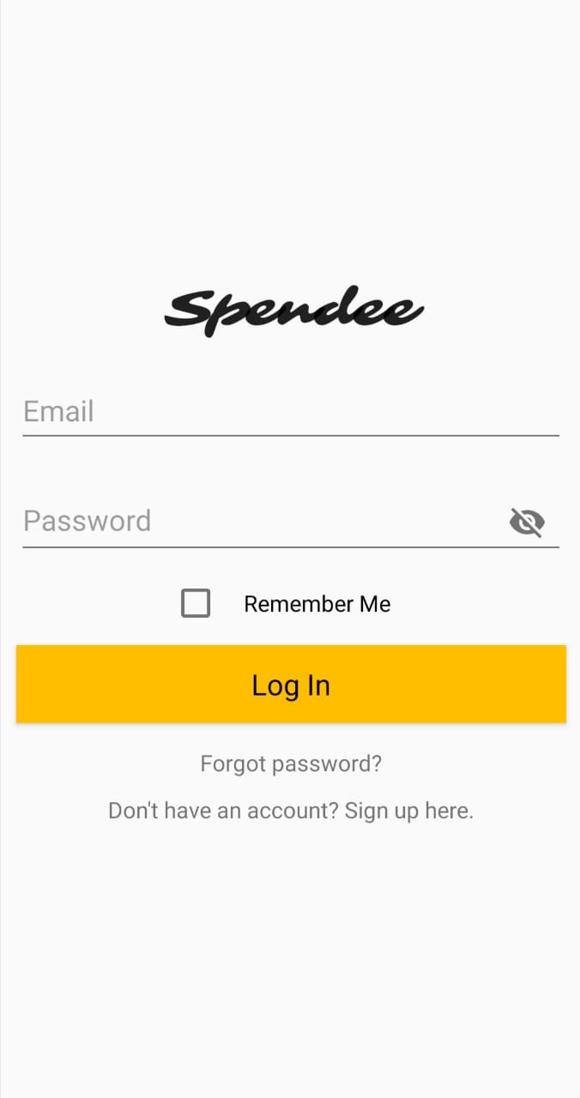 | User may enter the credentials for login and also have facility of “remember me”.
Registration |  | User may register and set a password.
Forgot password | 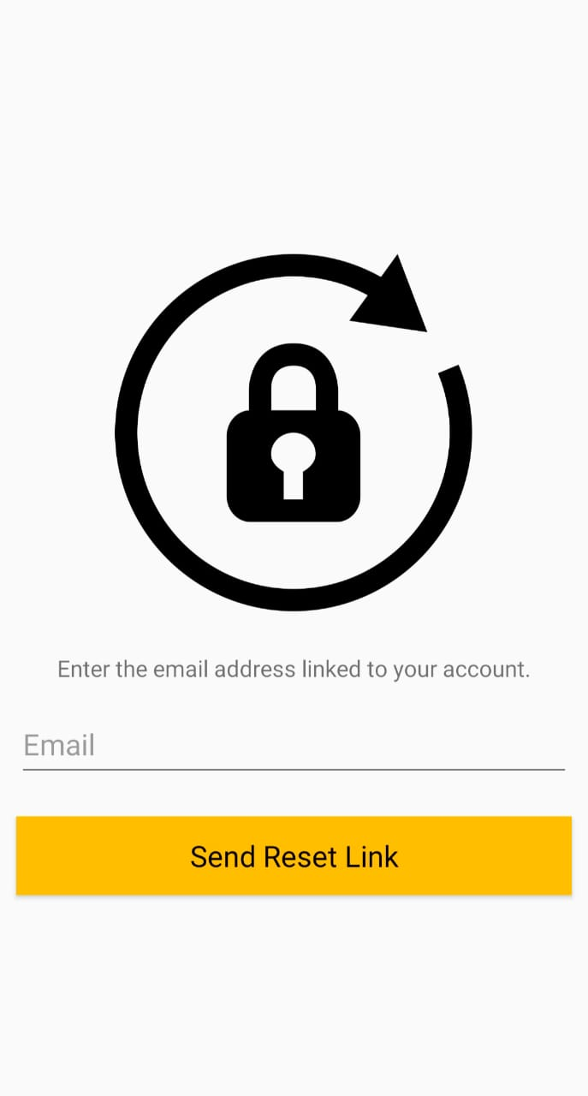 | User may reset their password incase they forgot their password.
Dashboard | 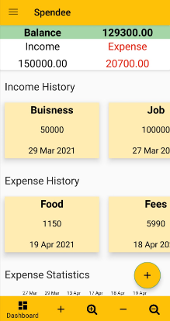 | In dashboard, user can navigate through dashboard, income and expense fragment. Displays total income and expense. User can add details of new income and expense through clicking on floating button.
Drawer layout | 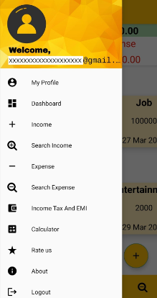 | Drawer layout has options to navigate through income, expense and dashboard fragments.
Insert data layout | 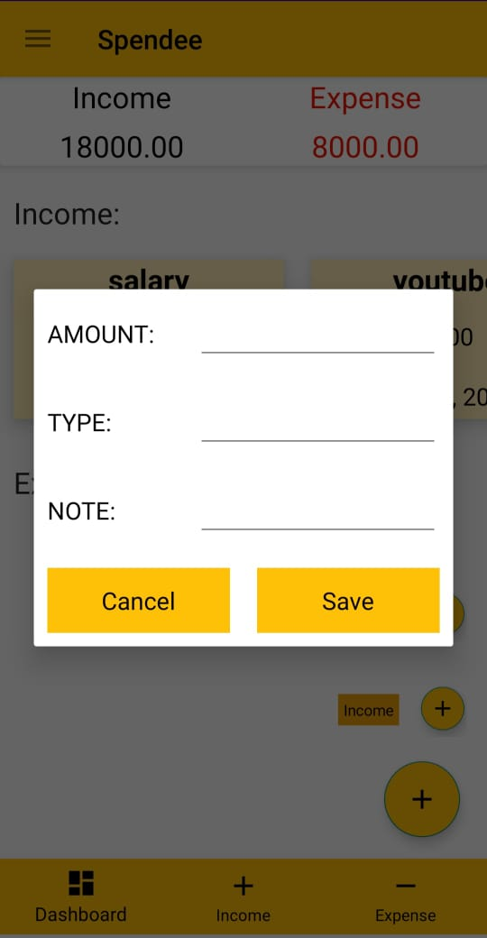 | User can insert details of new income and expense like amount, type and note.
Income fragment | 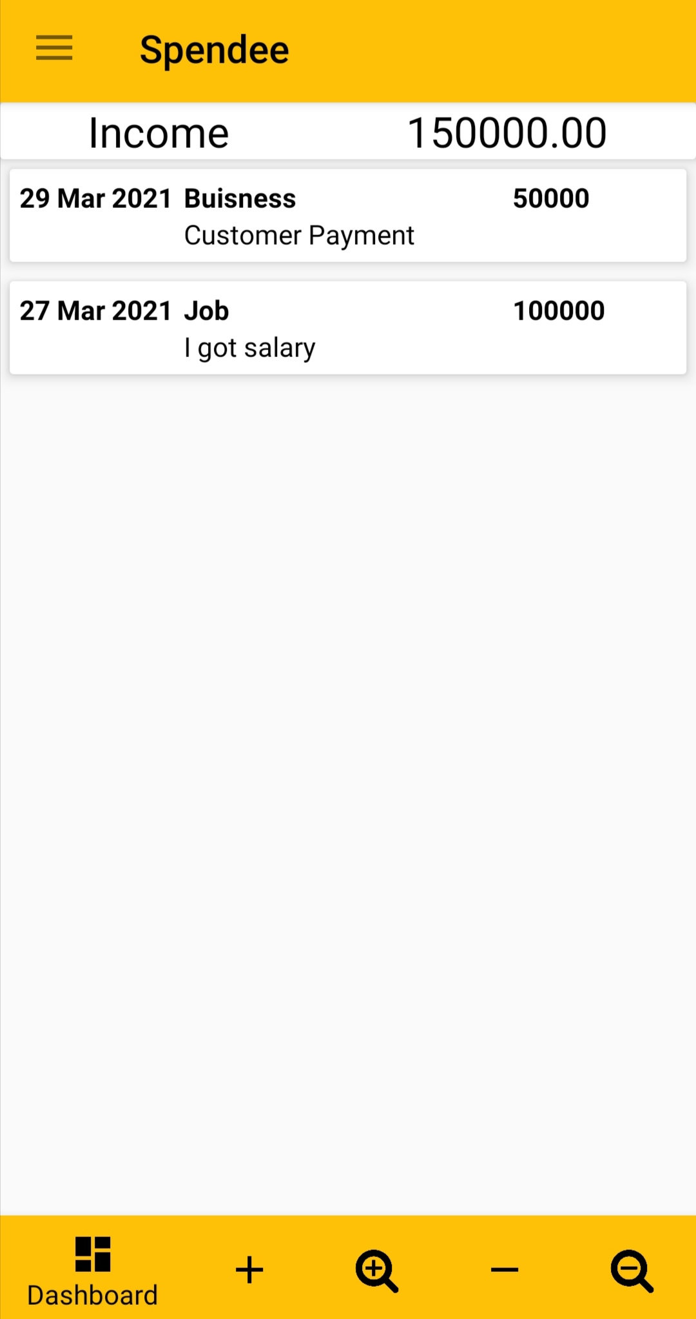 | Displays data of total income and separate details of each income.
Expense fragment | 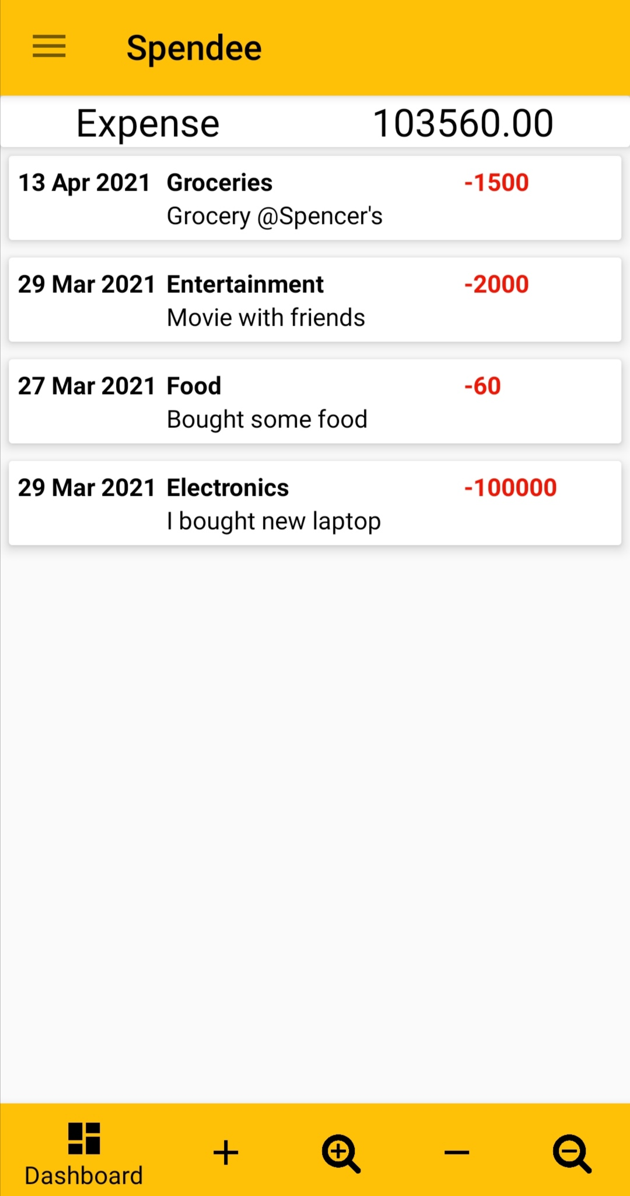 | Displays data of total expense and separate details of each expense.
Update details layout | 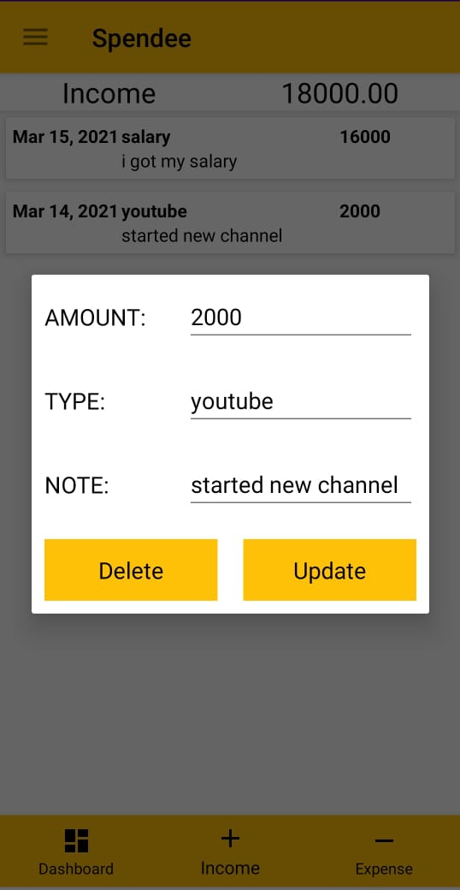 | this screen will appear by clicking on them and then user can update details of income and expense.
Layout of Profile | 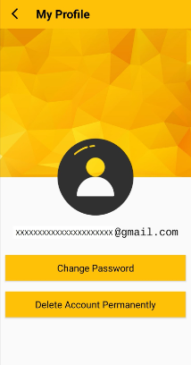 | This feature helps the user to change his login password and also helps in deleting account from Spendee permanently.
Delete Account Alert | 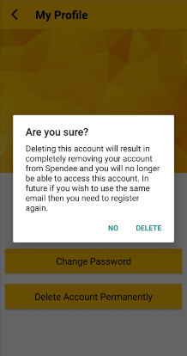 | This feature helps user to delete his/her account. Deleting the account results in completely removing our account from Spendee and we will no longer be able to access this account. If we want to use the same email then we need to register again
Layout of Change Pass | 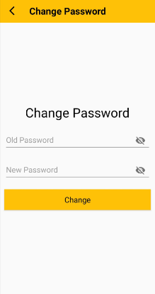 | Layout of Change Password:- This feature provides user to Change Password. If user wants to change password he can do using this function.
Layout of Search data |  | This feature helps the user to find a particular income/expense data modified by date(i.e either Day, Month or Year).
Layout of Rate Us | 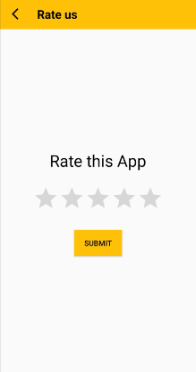 | This feature allows the user to give rating to this application based on their liking and interest.
Layout of About Us | 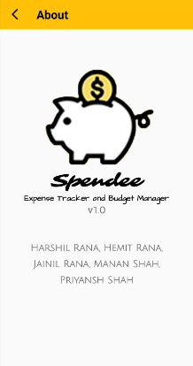 | This displays the App's current version and the names of the developers of this Application.
Logout Alert | 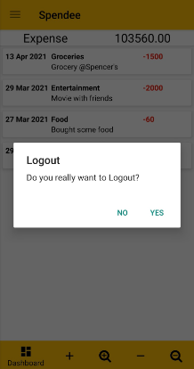 | This displays the App's current version and the names of the developers of this Application.
Layout of Tax & EMI (1st Page) | 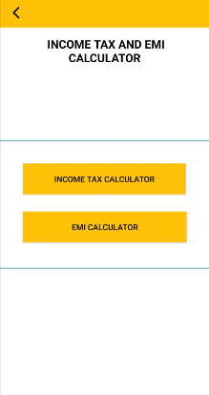 | User may choose if they want to calculate their income tax or EMI/total interest.
Layout of EMI Calculator | 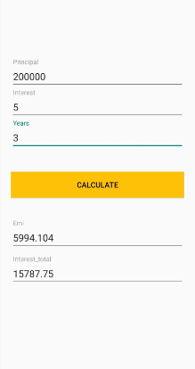 | User may insert details like Principle amount, interest rate and duration. Then diplays total interest and EMI.
Layout of Tax Calc. (1st Page) | 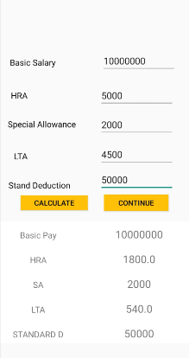 | User may insert details like basic salary and allowances. Then may choose for calculate total tax or continue.
Layout of Tax Calc. (2nd Page) | 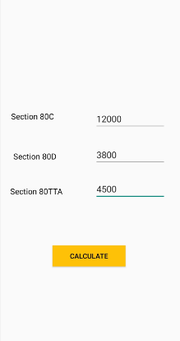 | User may insert details like amount for different sections. Then may choose calculate for total tax or continue.
Layout of Tax Calc. (Final Page) | 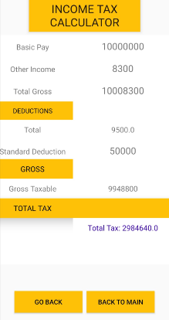 | This layout displays the information that were inserted by user and displays total tax.
Alert for low balance (less than 5%) | 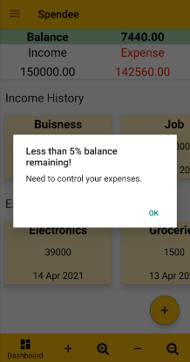 | This feature alert user that, user has less than 5% balance remaining that means user has very high expense compare with his income. user has to control his expense.
Alert for low balance (less than 10%) | 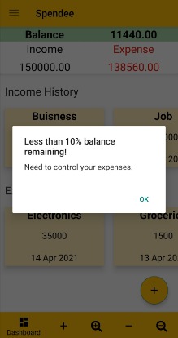 | This feature alert user that, user has less than 10% balance remaining that means user has high expense compare with his income. user should control his expense.
Dashboard Fragment (Per day Expenses Bar Chart) | 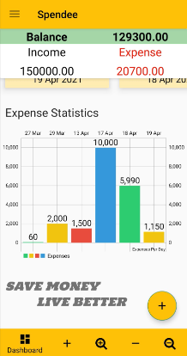 | This displays the bar chart of per day expenses on Dashboard Fragment that is expensed by the user. Viewing it, user comes to know how much he is expensing and now how he needs to control his expenses.

5. Other Nonfunctional Requirements

5.1 Software Quality Attributes
The quality attributes of the software are as follows:

- Availability: Our application is operational, functional and usable for completing or fulfilling a user's requirements.

- Maintainability: Our application is understandable, repairable, or enhanced.

- Reliability: Our Application is completely defect free, does not create downtime, and performs correctly in every scenario.

- Usability: Our application is effective, efficient and satisfactory for all the users.

- Portability: Our application is portably installed, deployed, accessed and managed - regardless of delivery model, when used on multiple platforms or instantly accessed.

- Correctness: When our application is used correctly, users are able to interact with system.

Appendix A: Glossary
TBD – To Be Done
UI – User Interface
FR – Functional Requirements
UR – User Registration
LF – Login Feature
FP – Forgot Password
DB – Dash Board
IM– Income Management
EM– Expense Management
SIE– Search Income/Expense
TC– Tax Calculator
EC– EMI Calculator
ALB– Alert of Low Balance

