# Online Watch Shopping

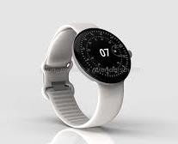

Submitted By

Sorathia Nishit Jagdish (22002170220047)

Priyansh Sandipkumar Bhavsar (22002171220002)

Jivani Baldev Arvindbhai (21002170510012)

B. E. Semester-V

(CS/IT Department)









# CERTIFICATE

This is to certify that Sorathia Nishit Jagdish (22002170220047), Priyansh Sandipkumar Bhavsar (22002171220002) and Jivani Baldev Arvindbhai (21002170510012) has satisfactorily completed the project work entitled “**Online Watch Shopping**” project submission of SE during 5th semester of academic year 2023-24.

Subject Faculty & Guide

**Mr. Kishan Pala**

Lecturer in CS/IT Department

# ACKNOWLEDGEMENT

We express our cavernous sense of obligation and gratitude to our guide

**Mr. Kishan Pala** his genius guidance and constant encouragement throughout this project work.

We are highly obliged as our honorable guide has devoted his valuable time and shared his experience knowledge. We extend our thanks to **Miss. Shruti Raval** (HOD), of department of CS / IT Engineering and **Mr. Nimish Dass** (Dean of LJ University of Engineering and Technology) for providing me such an opportunity to do our project work in our college.

We also wish to express our heartfelt appreciation to our friends, colleagues and many who have rendered their support for the successful completion of the project, both explicitly and implicitly.

**ABSTRACT**

The goal of our project is to design an Online Watch Shopping.

Customers can access the watch store web application through the World Wide Web. Customers can search database to find the watch as per their requirements and make online payments. Our Goals and Features: Always Updating app, provides all information about watches, User has option to searching their particular watch, provide a watch store so users can also find stores locations, Multiple payment options

# Index

1. INTRODUCTION - 7
   1. Project Summary 8
   2. Purpose 9
   3. Scope 10
2. PROJECT MANAGEMENT - 11
   1. Project Planning and Scheduling 12
      1. Process Paradigm and Justification 14
      2. Project Plan 14
      3. Milestone and Deliverables 15
3. LITERATURE SURVEY - 17
   1. Technologies and Literature 18
4. SYSTEM REQUIREMENTS STUDY - 19
   1. User Characteristics 20
   2. Hardware and Software Requirements 20
      1. Constraints 21
5. SYSTEM ANALYSIS - 23
   1. Study of Current System 24
   2. Requirement of New System 24
   3. Function of the System 26
   4. Data Modeling 27
      1. The Class Diagram 27
      2. The ER Diagram 28
   5. Activity Diagram 29
   6. Sequence Diagram 31
   7. Data Flow Diagram………………………………………………………………….32
6. **System Design** 34
   1. Database design 34
7. **Testing 37**
   1. Testing Strategy 37
   2. Test cases 39
8. **User Manual 41**
9. **Limitation and Future Enhancement 42**

### CHAPTER: 1

**INTRODUCTION**

### CHAPTER-1 : INTRODUCTION

An online watch Shopping that allows user to check for various variety available at the online shop and buy online.

The project consists of the list of watch products displayed in various varieties and designs. The user may browse through these products that she/he may add it in their shopping cart.

Here we use Android to make the entire fronted. The middle tier is designed in Android. And MySQL as a backend to store watch items lists and inventory data thus the online watch shopping project brings an entire watch shop online and makes it easy for both buyer and seller to make watch deals.

Once user wishes to checkout, she/he must register on the site first. She/He can then login using same id password next time. Now she/he may pay through a Google pay, Paytm, credit card, debit card or cash on delivery. Once the user makes a successful transaction, she/he gets a copy of the shopping receipt on their email.

### PROJECT SUMMARY

#### Project title: -

#### Online Watch Shopping

#### Platform: -

* + - Android

#### Documentation Tools: -

* + - Microsoft Word

#### Organization: -

* + - LJ University

### PURPOSE

**GOALS:-**

The goal of our project is to design an Online Watch Shopping platform that allows user to check for variety of watches available at the online shop and buy online. In which customers can search to find the watch as per their requirements and make online payments. The project consists of the list of watch products displayed in various varieties and designs. The user may browse through these products that she/he may add it in their shopping cart.

**OBJECTIVES:-**

* + Reviews and ratings available here.
  + There are multiple payment options.
  + Many Referrals and rewards are available here.
  + Users can easily make registrations.
  + We have our daily Delivery Schedule.
  + Quick re-order or repeat order.
  + Users can add items in their shopping cart.

### SCOPE

The Online Watch Shopping is an website stored in the user server. The purpose of the website is to resolve the client to allow website users to perform tasks related to purchase a watch online. The system enables to perform the following functions:

* + - Product Variety
    - User-friendly Interface
    - Secure Payment Options
    - Customer support
    - Feedback and Improvement

### CHAPTER: 2

**PROJECT MANAGEMENT**

### CHAPTER-2 : PROJECT MANAGEMENT 2.1 PROJECT PLANNING AND SCHEDULING :

**SPIRAL MODEL:-**

* **SPIRAL MODEL** was defined by Barry Boehm in his 1988 article, A spiral Model of Software Development and Enhancement.
* This model was not the first model to discuss iterative development, but it was the first model to explain why the iteration models.
* As originally envisioned, the iterations were typically 6 months to 2 years long. Each phase starts with a design goal and ends with a client reviewing the progress thus far.
* Analysis and engineering efforts are applied at each phase of the project, with an eye toward the end goal of the project.
* A second prototype is evolved by a fourfold procedure:
* Evaluating the first prototype in terms of its strengths, weakness, and risks.
* Defining the requirements of the second prototype.
* Planning a designing the second prototype.
* Constructing and testing the second prototype.
* The steps for Spiral Model can be generalized as follows:
* The new system requirements are defined in as much details as possible. This usually involves interviewing a number of users representing all the external or internal users and other aspects of the existing system.
* A preliminary design is created for the new system.
* A first prototype of the new system is constructed from the preliminary design. This is usually a scaled-down system, and represents an approximation of the characteristics of the final product.
* At the customer option, the entire project can be aborted if the risk is deemed too great.
* Risk factors might involve development cost overruns, operating-cost miscalculation, or any other factor that could, in the customer’s judgment, result in a less-than-satisfactory final product.
* The existing prototype is evaluated in the same manner as was the previous prototype, and if necessary, another prototype is developed from it according to the fourfold procedure outlined above.
* The preceding steps are iterated until the customer is satisfied that the refined prototype represents the final product desired.
* The final system is constructed, based on the refined prototype. The final system is thoroughly evaluated and tested.

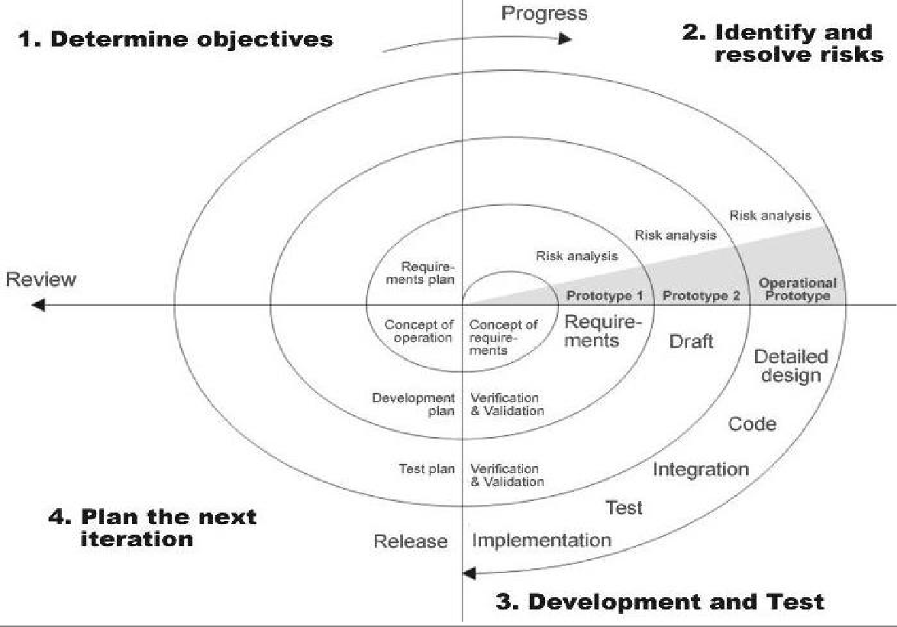

FIGURE1.SPRIAL MODEL

#### Advantages:

* Additional functionality or changes can be done at a later stage.
* Continuous or repeated development helps in risk management.
* Development is fast and features are added in a systematic way.
* There is always a space for customer feedback.

### Process paradigm and justification: -

A software process model is a simplified abstract representation of a software process, which is presented from a particular perspective. A process model for software engineering chosen based on the nature of the project and application, the method and tools to be used, and the controls and deliverables that are required. All software development can be characterized as a problem ¡V Solving loop which in for distinct stages is encountered:

* + - * Problem Definition
      * Requirement analysis
      * Integration and Testing
      * Technical Development

### Project Plan: -

* A plan is drawn up at the start of the project, should be used us the driver of the project. The project planning consists of:
* Selection of suitable software development process model which I have selected Spiral process model.
* Risk management plan, which involves the risk identification and risk assessments.
* Project scheduling, which involves the tasks and duration required for performing tasks. This is described by task representation and the time line chart representation.
* Cost and Effort estimation, which involves estimation of cost as well as effort applied by the developers

### Milestone and Deliverables:

* **Milestones**
  + - * Milestone is an end-point of the software process activity.
      * At each milestone there should be formal output, such as report, that can represent the management.
      * Milestone report need not be large document; they are the short report of achievements in software project activity.
      * Milestone represents the end of the distinct, logical stage in the project.
* **Deliverables**
  + - * Deliverable is a project report that is deliverable to customer.
      * Deliverable are delivered to the customer at the end.
      * Same major project phase such as specification, design, etc.
      * Milestones may be internal project results that are used by the project manager to check progress but which are not delivered to the customer.

**CHAPTER: 3**

### LITERATURE SURVEY

**CHAPTER 3: LITERATURE SURVEY**

An online Watch Shopping Application that allows user to check for various Watches available at the online store and purchase online.

The project consists of the list of products displayed in various models and designs. The user may browse through these products he may add in his shopping cart.

Once user wishes to check-out, he must register on the site first. He can then login using same id password next time. Now he may pay through a credit card or cash on delivery. Once the user makes a successful transaction, he gets a copy of the shopping receipt on his email id.

Here we use Android to make the entire fronted. The middle tier or ode behind model is designed in Android. And MySQL as a backend to store information lists and inventory data thus the online Watch Shopping Application shopping project brings an entire Watch Shopping Shop online and makes it easy for both buyer and seller to make affordable deals.

**3.1 TECHNOLOGIES AND LITERATURE:**

**ANDROID: -**

Android is an open source and Linux-based Operating System for mobile devices such as smart phones and tablet computers. Android was developed by the Open Handset Alliance, led by Google, and other companies.

As of early 2016, there are well over a billion people actively using Android, a Unix-like mobile operating system that runs on phones, tablets, smart TVs, smart watches, and a slew of other devices. Although developed and maintained by Google, it’s free and open-source software that can be used and customized by anybody. As a result, Android devices are manufactured by several major device manufactures, like Samsung, LG, Sony, and HTC.

Let’s understand android overview in technical language. Android offers a unified approach to application development for mobile devices which means developers need only develop for Android, and their applications should be able to run on different devices powered by Android.

One of the primary factors that drives Android’s success is Google Play, an Android app distribution platform users can use to download and install apps on their devices. With over a million apps and billions of downloads, Google Play is larger and sees more traffic than similar platforms for iOS and Windows 10.

Android delivers a complete set of software for mobile devices: Operating System, Middleware and Key mobile applications.

### MySQL: -

MYSQL is the world’s most popular open-source database. With its proven performance, reliability and ease of use, MYSQL has become the leading database choice for web-based applications, used by high profile web properties including Facebook, twitter, YouTube, yahoo and many more.

Oracle drives MYSQL innovation, delivering new capabilities to power net generation web, cloud, mobile and embedded applications.

### CHAPTER: 4

**SYSTEM REQUIREMENTS STUDY**

**CHAPTER - 4 SYSTEM REQUIREMENTS STUDY**

### USER CHARACTERISTIC:

There are two types:

* + - Admin
    - User

#### ADMINISTRATOR:

* Manages whole application.
* Manages system database.
* Develop, implement, and manage departmental policies, procedures, standards and strategies.
* Resolve user complaints and answer user’s questions regarding organizational policies and procedures.
* Prepare or oversees the preparation of reports and statistics related user activities and operations for upper management.
* Updates on our latest watch collections, offers, designs etc.

#### USER:

* User are those people who uses our application.
* Here users can be parents and students also.
* User can observe whole application (only allowed items for user).
* User can check any info about watches and their brands and special features.
* View results (User: Public)

#### HARDWARE AND SOFTWARE REQUIREMENTS

CLIENT SIDE

#### HARDWARE REQUIREMENTS:

* + - Processor: CORE i3
    - RAM: 4GB
    - Hard disk: 80 GB
    - Mobile: Android 10.0 Supported mobile

#### SOFTWARE REQUIREMENTS:

* + Language: JDK 16, Android SDK
  + Platform: Android 8.1 API 27
  + IDE: Android Studio

#### CONSTRAINTS:

* + - * **Regulatory policies:**

It is a mandatory that no text box must be left empty or contains insufficient data. For the user’s email address, address and mobile number is mandatory field. Because in case of managing by the administrator of the application must inform the user’s that contact information is necessary.

#### Hardware limitations:

1. Firstly due to this number of users and the requests sent by the user increases, the server may get overloaded and may crash.
2. Secondly, if we do not provide data replication Facility, we may lose our whole data if one of the hard disk crashes. Replication is a way of keeping data synchronized in multiple databases.
3. Increasing the number of databases available for user access is the first one. This reduces the load on individual servers containing the database and is referred to as load balancing.
4. Replication is also necessary if the client is going to be doing any offline processing. If your client or user wants to access data on a system that he/she wants to buy can be bought physically from nearby store.
5. Sometimes disconnected from the network, they will still be able to access the database and the information it holds.
6. Redundancy is the other major reason for replication. Using replications creates an exact copy of the database for backup so that it can be picked-up and used immediately if there is a problem with one of the other servers or databases.

#### Parallel operations:

This application is online. So, many users can use it simultaneously by using internet.

So, many users check results parallelly. For example, one user check result and another can check specific product’s information.

#### Reliability requirements:

For a reliable application certain point should be taken under consideration.

* + Better thread management.
  + Utilization of a good OS.
  + Multithreading should be supported.

#### Criticality of the application:

The application must be very user-friendly and display appropriate error messages if any error occurs during login. For example, if user enters wrong username or wrong password system gives appropriate message. When any package is not available between specified source to destination place, then according to the situation system gives appropriate messages.

#### Safety/Security considerations:

The application must be exited always normally. All the members who are using the particular application can logout from the system normally. Also provide better authentication.

### CHAPTER: 5

**SYSTEM ANALYSIS**

### CHAPTER-5 SYSTEM ANALYSIS

### STUDY OF CURRENT SYSTEM

* + - Provide Watch Information.
    - Provide Old Watch, Latest Watch and Fancy Watch Information.
    - There are short videos of watch.
    - Its Provides a Watch Name, Watch Company and Its Cost etc.

#### Problem identification / Definition

1. Operating systems problems
2. Difficulty in maintenance of records
3. Editing of data becomes a tedious job
4. Telecommunications groups phones problems
5. Mistakes occurring in long calculations
6. Programming tool problem
7. Lake of efficiency and man power
8. Software utilities problem

### REQUIREMENT OF NEW SYSTEM

* + - Use of dedicated and powerful machines or servers.
    - User download permitted only at important information.
    - Cache results for queries. As the number of queries is huge and the pre- processing is a one – time affair.

### Functional requirements

* + - To reduce work complexity
    - Maintain user detail security
    - User will be given different privileges by admin

### Non-functional requirements

* Supportability
  + The system will display meaningful errors messages to the user of the system that will help user to resolve the problem.
  + for that we have used validation controls to achieve client-side validations
* Performance
  + The system will perform well, and according to its specified requirements.
  + for better performance we used asp.net because it helps to increase the automation.
* Security
  + The system will be secure as each user of the system has its own access permission, and access permission can only be changed by the admin.
  + The system will be secure as backup of all data is being carried out regularly.
* Readability
  + The project will be divided into different modules so as to provide easy understanding and debugging of the system.
  + In the project different modules are connected with each other directly or indirectly.
* Fault tolerance/error reporting
  + Since the application will be used by users and by developers it might be possible that
  + Operation might result into errors.
  + The application should provide the user-friendly error messages and fault tolerance facility whenever any errors occur.
  + In case the system proposal is acceptable to the management, the next phase is to examine the feasibility the proposed system in the light of its workability, meeting users-requirements, effective use of resources and of course, the cost effectiveness.
  + These are categorized as technical, operational, economic and schedule feasibility. The result is a feasibility report submitted to the management.
  + This may be accepted or accepted with modifications or rejected. The system cycle proceeds only if the management accepts it

### FUNCTION OF SYSTEM Use case diagram:

**Online Watch Shopping**

Login

Registration

View Items

Make Order

Make Payment

Add Categories

User

Add Items

Manage Order

Admin

Change Price of any Item

Log Out

### DATA MODELING

## Class diagram:

-End3-End4

1

1

-Admin_Name : string

-Admin_Email : string

**Admin**

1

-

*

-End2

**Shopping Cart**

+Login()

+Resistration()

-Cus_Name

-Cus_Email

-Mobile No.

**Customer**

End1

-End8

**Orders**

-End9 -End10

-Watch_Id

-Watch_Type

-Watch-Price

**Shopping info**

*

-End7

-Product_Id

-Product_Price

-Quality

+Login()

+Resistration()

-Order_Id

-Date

-

* *

*

-Order_Id : int

-Product_Id : int

-Quality : string

**Order Details**

-End5

-End6

*

*

+Add Item To Cart()

+View Cart Items()

### 5.4.2 E-R diagram:

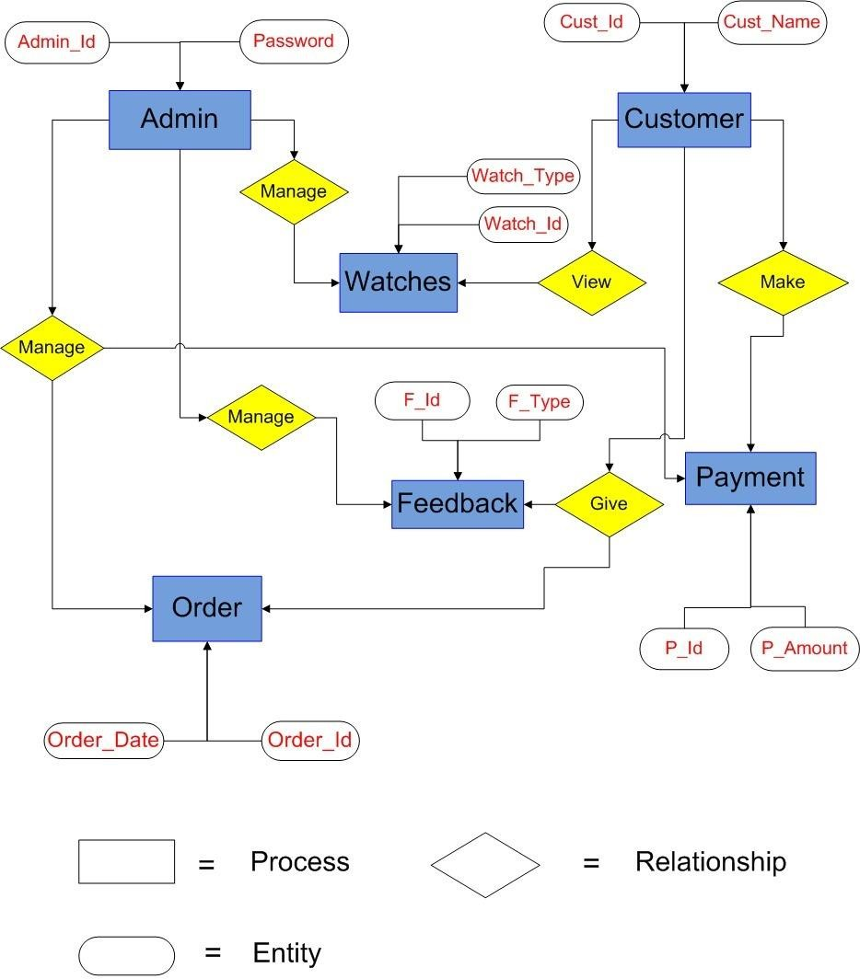

### Activity Diagram

### 

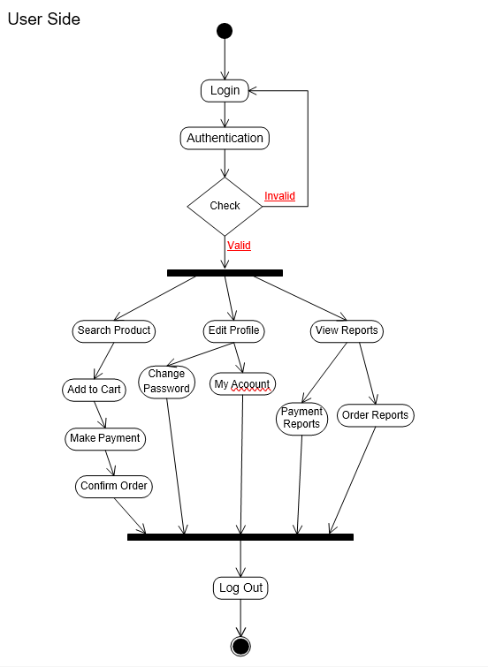

* 1. **Sequence Diagram:**



Actor1 Login

View Categories

View Details And Price

Add to Cart

Place Order

Log Out

Message2

Message1

**5.7 Data Flow Diagram:**

**Level 0:**

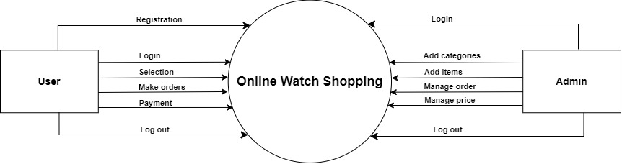

**Level 1:**

### 

**Level 2:**

### 

### CHAPTER-6 SYSTEM DESIGN

**6.1 DATABASE DESIGN:** Login:

|  |  |  |  |
| --- | --- | --- | --- |
| Field name | Data type | Size | Constrain |
| Id | Numeric | 20 | Primary key |
| User name | varchar | 12 | Not null |
| Password | Varchar | 50 | Not null |

### Registration Table:

|  |  |  |  |
| --- | --- | --- | --- |
| Field name | Data type | Size | Constrains |
| Id | Numeric | 10 | Primary key |
| F_name | Varchar | 20 | Not null |
| L_name | Varchar | 20 | Not null |
| Address (City) | Varchar | 150 | Not null |
| Gender | Char | 15 | Not null |
| Email | Varchar | 30 | Not null |
| Password | Varchar | 100 | Not null |

Phone NO.

### Add Categories:

|  |  |  |  |
| --- | --- | --- | --- |
| Field name | Data type | Size | Constrains |
| Id | Varcahr2 | 30 | Primary Key |
| Cat_name | Varchar2 | 30 | Not null |

Add Item:

|  |  |  |  |
| --- | --- | --- | --- |
| Field name | Data type | Size | Constrains |
| Watch name | Char | 50 | Not null |
| Watch Id | Numeric | 10 | Not null |
| Watch price | Numeric | - | Not null |
| Image | Varchar2 | 100 | Not null |
| Color | Varchar2 | 20 | Not null |
| Company | Varchar2 | 20 | Not null |
| Descriptions | Char | 100 | Not null |

### Make Order:

|  |  |  |  |
| --- | --- | --- | --- |
| Field name | Data type | Size | Constrains |
| Field name | Numeric | 5 | Primary key |
| Order_no | Numeric | 5 | Foreign key |
| Watch_id | Numeric | 10 | Not null |
| Order price | Numeric | 30 | Not null |
| Total amount | Numeric | 20 | Not null |

Admin:

|  |  |  |  |
| --- | --- | --- | --- |
| Field name | Data type | Size | Constrains |
| Admin_id | Varchar2 | 50 | Primary key |
| Admin_password | Varchar2 | 20 | Not null |
| Admin_email | Varchar | 10 | Not null |

|  |  |  |  |
| --- | --- | --- | --- |
| Make Payment: |  | | |
| Field name | Data type | Size | Constrains |
| Payment_id | Numeric | 10 | Primary Key |
| Payment_type | Varchar | 10 | Not null |
| Payment_ammount | Numeric | 15 | Not null |

### CHAPTER-7 TESTING

#### 7.1 TESTING STRATEGY

A strategy for website testing integrates website case design method into a well-planned series of steps that result in the successful construction of the website. The strategy provides the roadmap that describes the steps to be conducted as a part of testing, then these steps are planned and then undertaken, and how much effort, time and resource will be required.

#### Black box testing

The technique of testing without having any knowledge of the interior workings of the application is Black Box testing. The tester is oblivious to the system architecture and does not have access to the source code. Typically, when performing a black box test, a tester will interact with the system's user interface by providing inputs and examining outputs without knowing how and where the inputs are worked upon.

Advantages:

* + Well suited and efficient for large code segments.
  + Code Access not required.
  + Clearly separates user's perspective from the developer's perspective through visibly Defined roles.
  + Large numbers of moderately skilled testers can test the application with no knowledge of implementation, programming language or operating systems.

Disadvantages:

* Limited Coverage since only a selected number of test scenarios are actually performed.
* Inefficient testing, due to the fact that the tester only has limited knowledge about an application.
* Blind Coverage, since the tester cannot target specific code segments or error prone Areas.
* The test cases are difficult to design.

#### White box testing

White box testing is the detailed investigation of internal logic and structure of the code. White box testing is also called glass testing or open box testing. In order to perform white box testing on an application, the tester needs to possess knowledge of the internal working of the code.

The tester needs to have a look inside the source code and find out which unit/chunk of the code is behaving inappropriately.

Advantages:

* + As the tester has knowledge of the source code, it becomes very easy to find out which type of data can help in testing the application effectively.
  + It helps in optimizing the code.
  + Extra lines of code can be removed which can bring in hidden defects.
  + Due to the tester's knowledge about the code, maximum coverage is attained during test scenario writing.

Disadvantages:

* + Due to the fact that a skilled tester is needed to perform white box testing, the costs are increased.
  + Sometimes it is impossible to look into every nook and corner to find out hidden errors that may create problems as many paths will go untested.
  + It is difficult to maintain white box testing as the use of specialized tools like code Analyzers and debugging tools are required.

|  |  |  |  |  |  |  |  |
| --- | --- | --- | --- | --- | --- | --- | --- |
| **7.2 TEST CASES** | | | | | | | |
|  | **TEST CASE ID** | **DESCRIPTION** | **INPUT** | **EXPECTED OUTPUT** | **ACTUAL OUTPUT** | **STATUS** |  |
| **CASE1.1** | User login | 1.username | appropriate message for invalid use | message generated  for invalid user | unsuccessful |
| **CASE 1.2** |  | 2.password | valid user should be directed to intended page after logging | directed to intended page after logging | successful |
| **CASE2:** | User home page | selected the option to proceed | test case would open the appropriate page as per option selected by user | Displays desired page | successful |
| **CASE 3.1** | check list | select criteria | Will display criteria. | Option for criteria  displayed. | Successful |
| **CASE 3.2** | display lists |  | list should be displayed according to criteria | list should be displayed according to criteria | Successful |
| **CASE 4** | special offers |  | Special offers should be displayed. |  | Successful |

Page | 39

|  |  |  |  |  |  |  |  |  |
| --- | --- | --- | --- | --- | --- | --- | --- | --- |
|  | **CASE 5.1**  **CASE5.2** | Registration  validate address | Mobile no.  address | an error msg “mobile no. must be 10 digits”  enter the address field with character  say(“jhfjd**”)** | insert number from 8  digits  does not generate any error message | unsuccessful  successful |  | |
|  | **Step:** After User enters username and password it is going to be verified with database and allows User to access system if both matches correctly. | | | | | |  | |
|  | | | | | | | |  |

Page | 40

### CHAPTER-8 USER MANUAL

#### Installation and Login:

Prior to see watches the Watch Shopping App, please be sure that you have into the Watch Shopping “My Support” Portal at least once.

After the Mobile App has been installed and opened, the app will prompt you to accept the full Mobile App Terms and Conditions.

#### Email and Password:

Enter the Email and password combination you use to enter the Watch Shopping “My Support” Portal.

### CHAPTER-9 LIMITATION AND FUTURE ENHANCEMENT

#### Limitation:

* Inability to Physically Inspect Watches.
* Admin have choices to confirm Watch Information before posting on app.

#### Comparison

**Future Enhancements:**

* + - We can connect our application with social media Application.
    - Connect with different Shops.
    - We will try to make application more attractive.