INNOVATIVE ASSIGNMENT REPORT
3CS103ME24 – Data Analysis and Visualisation
SteelScope
Visual Analytics of 1,389 Steels and Iron Alloys
Python notebooks · KNIME · Tableau · Power BI · Web application
Submitted by
Name | Roll No.
Yug Manvar | 24BTM014
Ishita Patel | 24BTM015
Priyansh Patel | 24BTM040

Submitted to
Vrajesh Chawra
Faculty, 3CS103ME24 – Data Analysis and Visualisation
October 2026

Abstract
This project analyses a public table of steels and iron alloys (2,672 rows, 34 columns: grade designation, the weight-percent of 30 chemical elements, tensile strength, liquidus temperature and a strength class) with the aim of answering three engineering questions: which elements drive strength, which grades can substitute for one another, and which families can deliver a required strength and melting range. A logged cleaning pipeline found that the data hid three problems: 62 exact duplicate rows, 1,221 grades listed twice under two spellings of the same name, and 469 strength values (18 %) that were the column mean copied into empty cells. After cleaning, the analysis works on 1,389 canonical grades, 1,382 of them with a measured strength.
The cleaned data is explored in three Python notebooks with 39 figures covering every technique of the course: the five-number summary, binning, chi-square tests with Cramér's V, correlation and linear regression, principal component analysis (PCA), and radar, chord, ring, treemap, ridgeline and waterfall charts. The same statistics are rebuilt as a KNIME workflow, which also holds all machine learning (k-means clustering, decision tree, k-nearest neighbours and random forest on a group-safe train/test split). Interactive dashboards were built in Tableau and Power BI, and a web application (SteelScope) lets any user explore the grades, inspect one grade, find chemically similar substitutes and search for grades that meet a target.
The main findings are: the family decides the strength range (median strength from about 260 MPa for grey cast iron to about 1,790 MPa for spring steel); carbon is the strength dial of plain steels (+43 MPa per 0.1 % carbon, R² = 0.51) although pooled across all steels it shows no correlation (a Simpson's paradox); the family–strength link is strong (χ² = 548.7, Cramér's V = 0.45); and composition alone predicts strength with R² = 0.73 (random forest) while the remainder is due to heat treatment, which the data does not record.
Contents
Abstract 2
1. Introduction 4
1.1 Motivation 4
1.2 Objectives 4
1.3 Tools and division of work 4
2. Domain background 5
2.1 Steel and cast iron 5
2.2 Role of the alloying elements 5
2.3 The six family groups 5
2.4 Engineered indices 6
3. Dataset 7
4. Data cleaning pipeline 8
5. Exploratory data analysis 11
6. Statistical analysis and visual story 14
6.1 Descriptive statistics 14
6.2 Binning 16
6.3 Chi-square tests of independence 17
6.4 Correlation and regression 18
6.5 Principal component analysis 19
6.6 Composition portraits and circular charts 20
6.7 The carbon-equivalent waterfall 23
7. KNIME workflow 24
7.1 Clustering 25
7.2 Machine learning 26
8. Tableau dashboards 28
9. Power BI report 29
10. Web application: SteelScope 30
11. Key findings 35
12. Limitations and future work 36
13. Conclusion 37
References 38
Appendix A: Repository structure 39

1. Introduction

1.1 Motivation
Engineers and buyers choose steel from thousands of standard grade names (EN, SAE-AISI, ASTM, UNS, AWS, ACI). A grade name does not show its chemistry or strength, two names can describe the same steel, and the same chemistry can appear under several names. A data-driven view of many grades at once makes these choices faster and more transparent. The course asks for a visualization-intensive analysis carried across several tools; this project applies it to a real engineering dataset.

1.2 Objectives
Table 1: The three questions the project answers
# | Question | Where it is answered
1 | Drivers: which elements make a steel strong, and what controls its melting point? | Notebook 02 (Q1–Q5), notebook 03 (Acts IV–V), KNIME sections E–F
2 | Substitution: which grades have a similar chemistry, so one can replace another? | PCA map (notebook 03), k-means and k-NN in KNIME, web app substitute finder
3 | Target design: for a required strength and melting range, which families deliver it? | Notebook 02 (Q5), Power BI target finder, web app target designer

1.3 Tools and division of work
Table 2: Tools used and their role
Tool | Role in the project
Python (pandas, NumPy, SciPy, scikit-learn, matplotlib, seaborn) | Cleaning, statistics and 39 figures in three notebooks; exports for the other tools
KNIME Analytics Platform 5 | The statistics rebuilt as a node workflow, plus all machine learning
Tableau | Three interactive workbooks (dashboards) on the exported data
Power BI | A six-page interactive report on a star-schema model
Web application (Next.js, React, shadcn/ui, Recharts) | SteelScope: explorer, grade inspector, substitute finder, target designer

Data flows in one direction: raw data → notebook 01 (cleaning) → processed data → notebooks 02 and 03 → exported tables → KNIME, Tableau, Power BI and the web application. Nothing downstream is edited by hand; a correction is made in the notebook and the chain is re-run.

2. Domain background

2.1 Steel and cast iron
Steel is iron alloyed with a small amount of carbon (typically up to about 2.1 wt%) and other elements. Carbon atoms sit between iron atoms and hinder the movement of crystal defects, which raises strength and hardness. Above about 2.1 % carbon the alloy is a cast iron: the excess carbon forms graphite (flakes in grey iron, nodules in ductile iron), which makes casting easy but usually lowers strength and ductility.
Properties depend not only on chemistry but on the microstructure produced by heat treatment: soft ferrite, tough austenite (stable at room temperature when enough nickel is present, as in 304 and 316 stainless steels), pearlite, and hard martensite formed by rapid quenching. Processes such as quenching, tempering, ageing and precipitation hardening change strength without changing composition. The dataset records composition but not heat treatment; this sets a limit on what any composition-based model can achieve.

2.2 Role of the alloying elements
Table 3: Effect of the main alloying elements
Element | Main effect
C (carbon) | Main strengthener of plain steels; raises hardenability and lowers weldability
Mn (manganese) | Deoxidiser; adds strength and hardenability
Si (silicon) | Deoxidiser; promotes graphite in cast irons
Cr (chromium) | From about 10.5 % forms a protective oxide film (stainless steel); raises hardenability
Ni (nickel) | Stabilises austenite; improves toughness and corrosion resistance
Mo (molybdenum) | Hardenability, high-temperature strength, pitting resistance
V, W (vanadium, tungsten) | Form hard carbides; tool and high-speed steels keep hardness when hot
Co (cobalt) | Hot hardness in high-speed steels; strengthening in maraging steels
N (nitrogen) | Austenite stabiliser and strengthener in stainless steels
Cu, B, Nb, Ti | Weathering resistance (Cu); hardenability at ppm level (B); grain refinement (Nb, Ti)

2.3 The six family groups
The 17 families in the data are combined into six groups used in every tool (the same rule in Python, the KNIME Rule Engine, Tableau, Power BI and the web application):
Table 4: Family groups (all 1,389 grades)
Group | Families | Grades
Carbon & low-alloy | Carbon/non-alloy, alloy, boron, bearing, spring, nitriding, weathering | 583
Stainless | Stainless steel (austenitic, ferritic, martensitic, duplex, precipitation hardening) | 546
Cast iron | Grey, ductile, malleable and austenitic (Ni-Resist) cast iron | 67
Tool & high-speed | Tool steel, high-speed steel | 82
Weld metal | AWS filler and electrode deposits | 83
Other | Maraging steel, Fe-Ni/Co special alloys | 28

2.4 Engineered indices
Carbon equivalent (CE). The International Institute of Welding (IIW) formula combines the elements that raise hardenability into one number: CE = C + Mn/6 + (Cr + Mo + V)/5 + (Ni + Cu)/15. A high CE means the heat-affected zone of a weld can turn into brittle martensite and crack. Bands used: CE ≤ 0.40 readily weldable, 0.40–0.60 preheat advised, above 0.60 difficult. The bands are meaningful only for carbon and low-alloy steels; in stainless steels chromium is present for corrosion resistance and the CE overstates hardenability.
Chromium and nickel equivalents (Schaeffler). Cr_eq = Cr + Mo + 1.5·Si + 0.5·Nb sums the ferrite formers and Ni_eq = Ni + 30·C + 0.5·Mn the austenite formers; their balance predicts whether a stainless steel is austenitic, ferritic, martensitic or duplex. Alloying total = 100 − Fe, the weight-percent of everything that is not iron.

3. Dataset
The source file Alloys.csv has 2,672 rows and 34 columns: the grade designation, the weight-percent of 30 elements (Al, As, B, C, Ca, Ce, Co, Cr, Cu, Fe, La, Mg, Mn, Mo, N, Nb, Ni, O, P, Pb, S, Se, Si, Sn, Ta, Ti, V, W, Zn, Zr), the tensile strength in MPa, the liquidus temperature in °C and a three-level strength class. The schema check found no missing values and no negative percentages; iron ranges from 29.3 % to 99.97 %.
At first sight the table is complete, but three problems were hidden in it (Section 4): duplicate rows, the same grade listed twice under two spellings of its name, and strength values that had been filled in with the column average. A fourth issue concerns the liquidus: 1460 °C is used for 524 grades as a placeholder rather than a measured value.
Table 5: Key variables
Term | Meaning
Tensile strength (TS) | Maximum stress before the material breaks in a tension test, in MPa (1 MPa = 1 N/mm²)
Liquidus | Temperature above which the alloy is completely liquid
Strength class | Rebuilt from measured TS: Low < 300 MPa, Medium 300–600 MPa, High > 600 MPa
wt% | Weight percent of an element in the alloy

4. Data cleaning pipeline
Cleaning is implemented in notebook 01 as a sequence of small steps; every step records the number of rows before and after and a one-line explanation in a cleaning log (reports/cleaning_log.json).
Table 6: Cleaning steps and their effect
Step | Finding | Action | Rows after
Load and validate | 34 columns, numeric, no nulls, no negative wt% | Accepted | 2,672
Exact duplicates | 62 identical rows | Removed | 2,610
Imputed strength | 469 rows (18 %) have TS = 652.482978, exactly the raw column mean | Flagged as not measured | 2,610
Twin listings | 1,221 grades appear twice (name with spaces and with hyphens), 168 once | Canonical grade key; merged | 1,389
Recover strength | 459 grades had an imputed listing whose twin carries the measured value | Measured value kept | 1,389
No measured strength | 7 grades have no measured TS at all | Kept, excluded from strength statistics | 1,382 measured
Strength class | Class rebuilt from measured TS (edges 300 and 600 MPa); agrees 100 % with the original on measured listings | Counts Low/Medium/High = 23 / 648 / 711 | –
Liquidus 1460 °C | Does not fall with carbon as a measured liquidus should; tied to families and name formats | Flagged as placeholder (524 grades) | –
Features | – | Alloying total, CE, Cr_eq, Ni_eq added | –

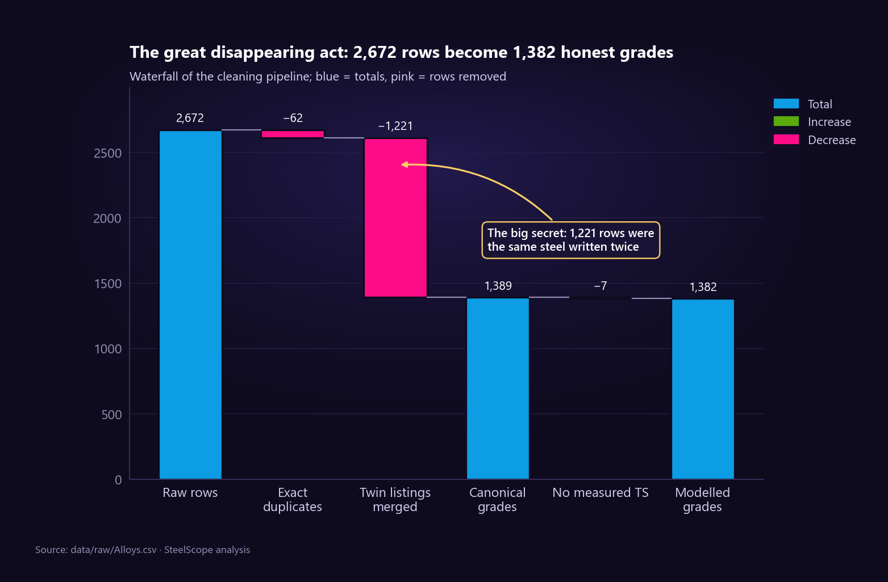
Figure 1: Cleaning waterfall: 2,672 raw rows shrink to 1,382 grades with a measured strength; the twin listings are the largest drop.
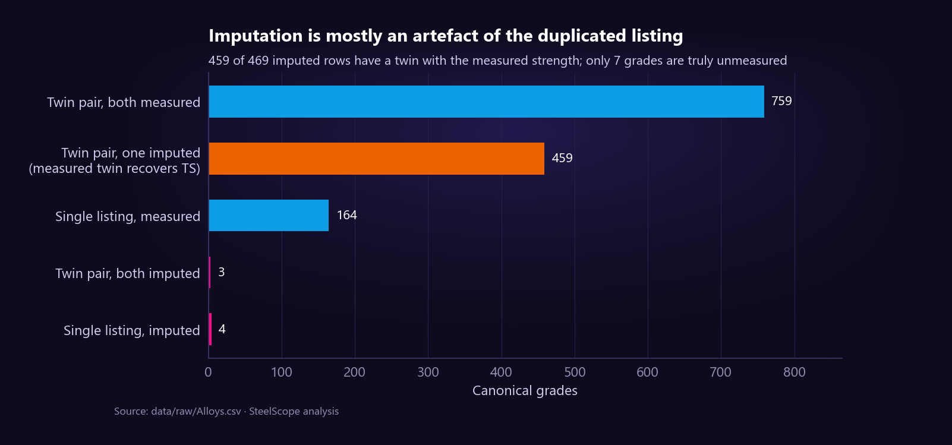
Figure 2: Twin listings and the imputed value: the fake 652 MPa values sit mostly in one listing of a twin pair.
Irreducible error. Some compositions occur with several strengths: maraging steel aged and annealed, the CB7Cu cast stainless in its H900…H1150 tempers, cast irons poured from one nominal chemistry. Their strength depends on processing, which is not in the data, so no composition-based model can separate them. After removing the imputed constant, 28 composition groups still carry different measured strengths at grade level. These grades define the ceiling of every strength model built later.
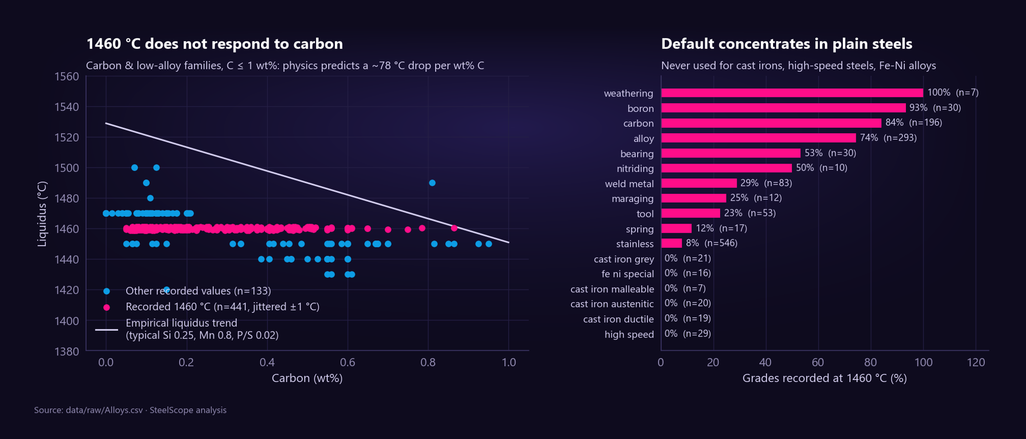
Figure 3: The 1460 °C liquidus: a placeholder rather than a measurement (it does not follow carbon content).

5. Exploratory data analysis
Notebook 02 asks seven questions an engineer would ask; each is answered with one statistic and one figure rather than many unfocused charts.
Table 7: The seven exploratory questions
Q | Question | Answer
Q1 | How much does family alone decide strength? | Family is the first-order factor: family medians span about sevenfold, from grey cast iron to spring steel
Q2 | Which elements drive strength? Does pooling mislead? | Pooled, carbon looks irrelevant (Spearman ρ = −0.03); inside plain steels it is the main driver (ρ = 0.43): Simpson's paradox
Q3 | Stainless: does more alloy mean more strength? | No; the microstructure set by the Cr–Ni balance matters. High-nickel austenitic grades are not the strong option
Q4 | Is the carbon equivalent a strength index? | A reasonable proxy for plain and tool steels; meaningless for stainless and cast irons
Q5 | Strength versus liquidus | Nearly independent design axes; liquidus mostly separates families
Q6 | What separates the strength classes? | Family, not a single element; the low class is almost entirely cast iron
Q7 | What if the imputed rows were kept? | A fake peak at 652 MPa, family medians equal to the imputed value, weaker element correlations

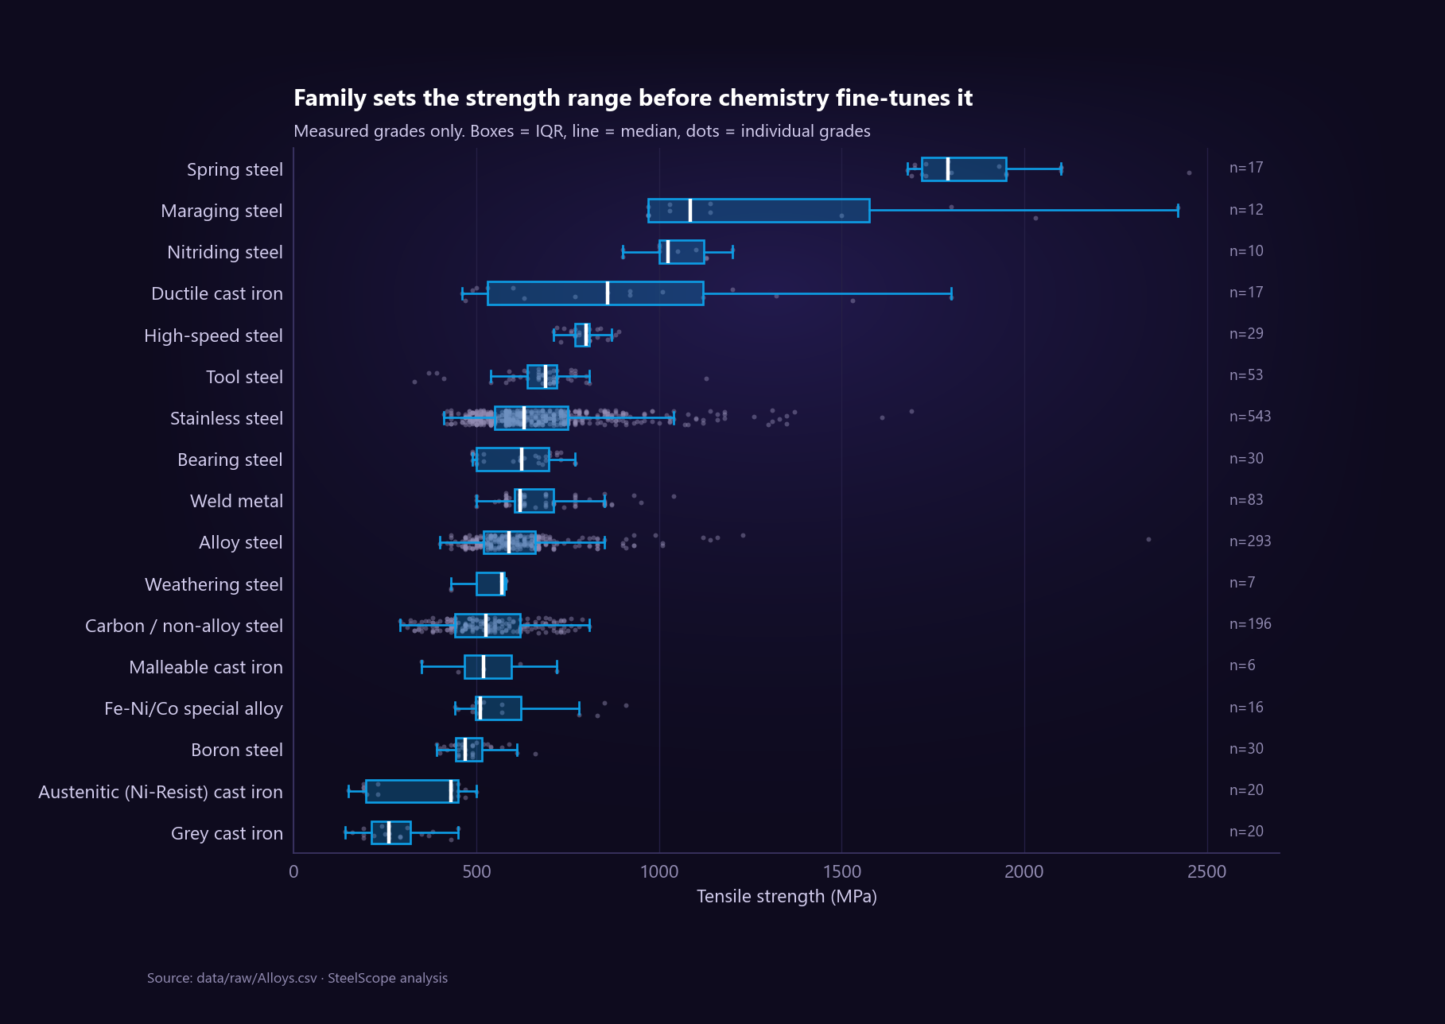
Figure 4: Q1: tensile strength by family; the family sets the strength range.
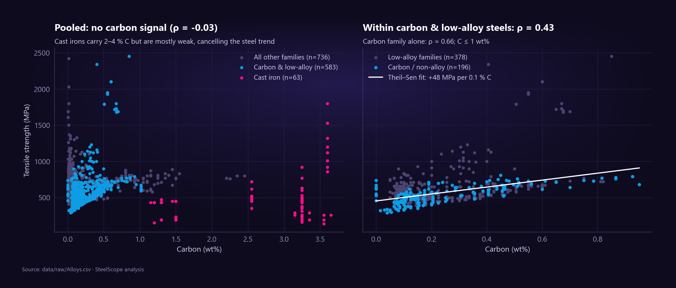
Figure 5: Q2: Simpson's paradox. Pooled over all steels carbon shows no trend; within carbon and low-alloy steels it is the main strengthener.
Why the paradox happens. Cast irons contain 2–4 % carbon (as graphite) yet are mostly weak, while plain steels gain strength with carbon. Mixing the two groups cancels the trend. Every element–strength statement therefore has to be made within a family, and every strength model needs the family as an input.
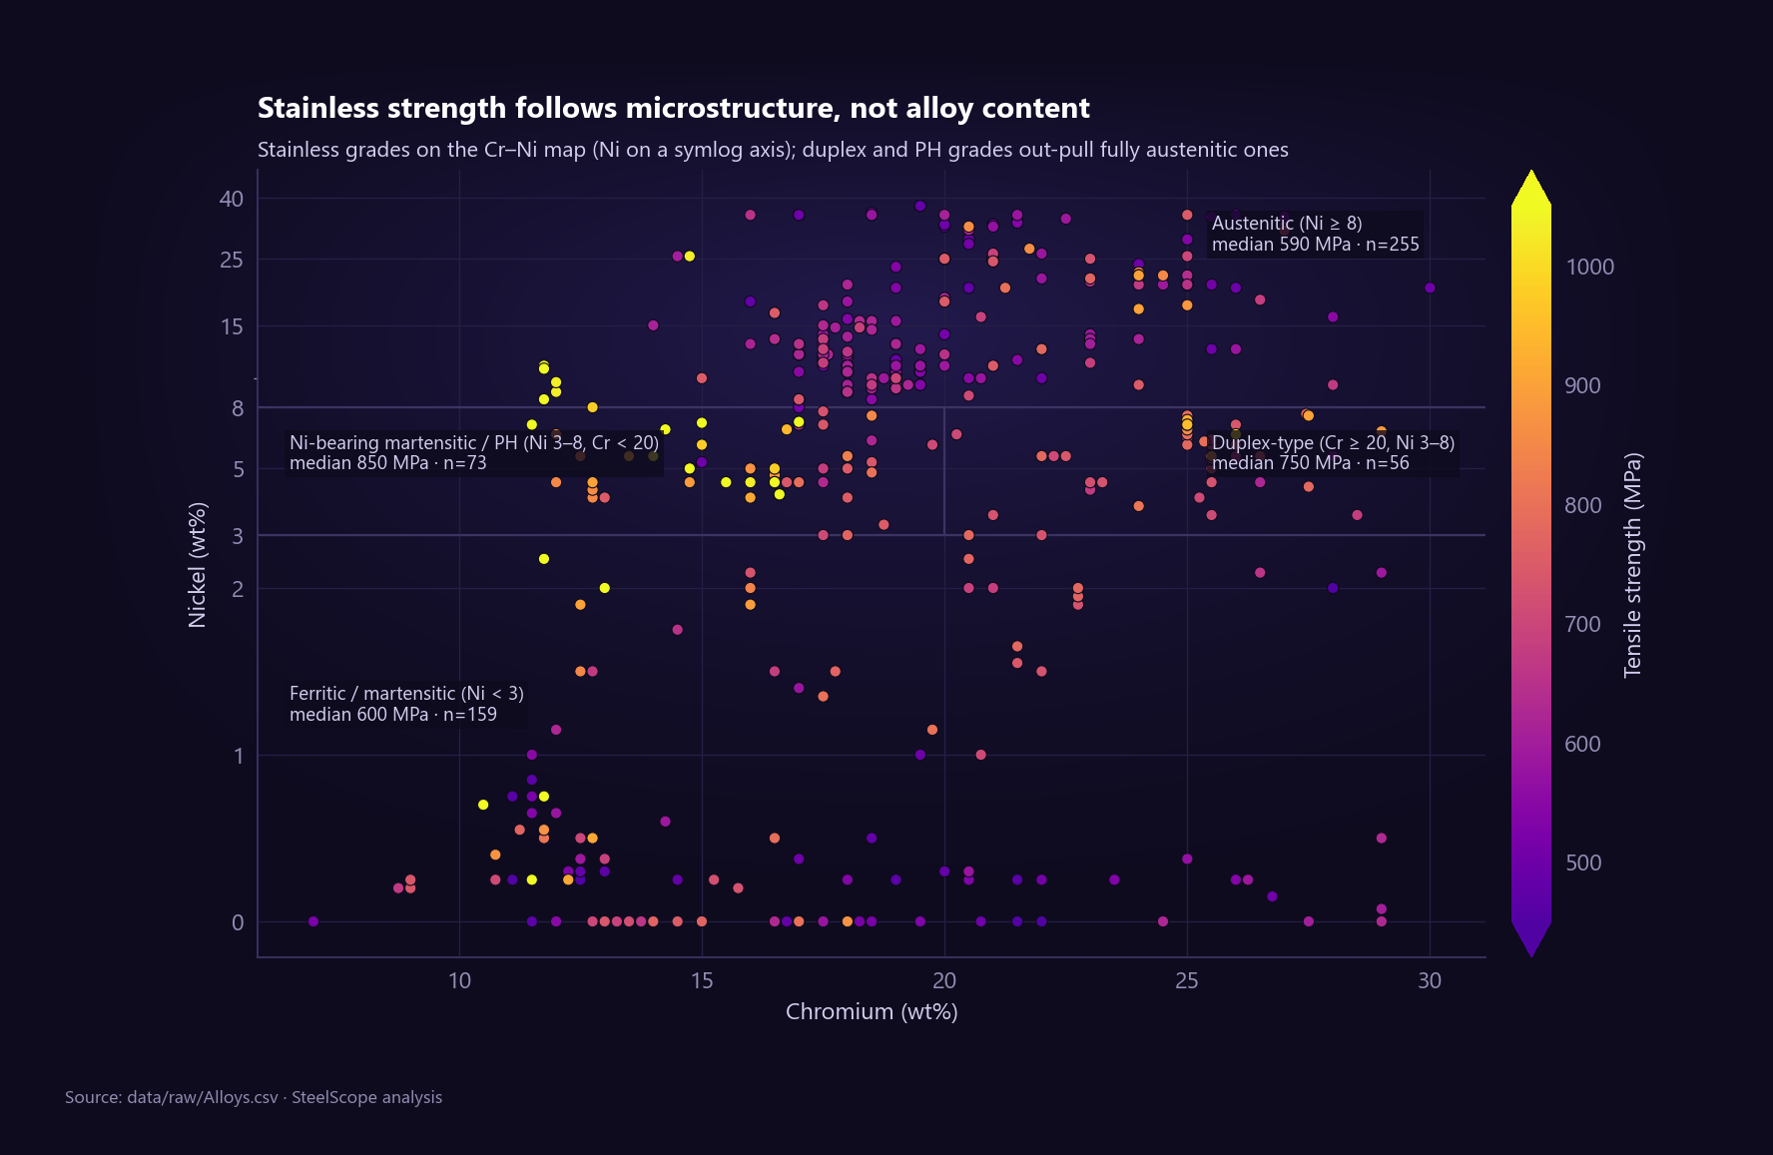
Figure 6: Q3: chromium and nickel equivalents of stainless grades. Strength follows the microstructure, not the amount of alloy.
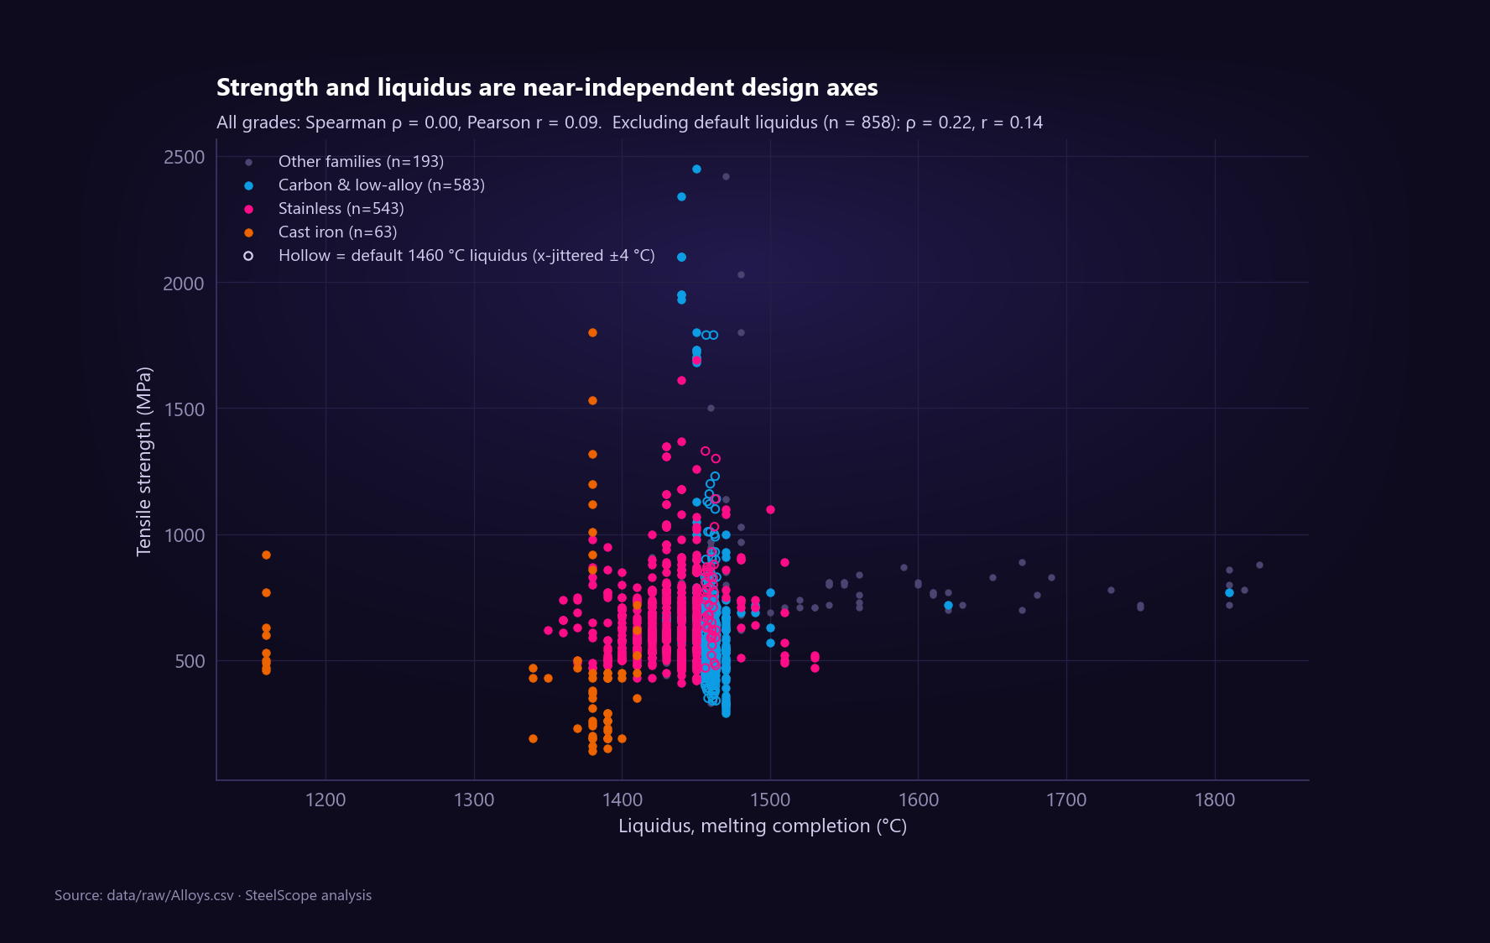
Figure 7: Q5: strength versus liquidus; the two are nearly independent, so a target search must filter on both.

6. Statistical analysis and visual story
Notebook 03, "The Secret Lives of 1,389 Steels", tells the analysis as a story in a prologue, seven acts and an epilogue with 27 figures, and finishes by exporting the tables used by Tableau, KNIME and Power BI.

6.1 Descriptive statistics
Table 8: Five-number summary and moments of tensile strength
Statistic | Tensile strength (1,382 grades)
Minimum / Q1 / median / Q3 / maximum | 140 / 510 / 610 / 720 / 2,450 MPa
Mean / standard deviation | 651.6 MPa / 242.5 MPa
Skewness / kurtosis | 2.89 / 13.7 (long right tail, many extreme grades)
Outliers (1.5 × IQR rule) | 75: 65 above 1,035 MPa (spring, maraging, high-strength alloy steels), 10 below 195 MPa (weakest cast irons)

Because the distribution is strongly right-skewed (mean above median, skewness 2.89), the project reports medians and interquartile ranges rather than means and standard deviations. The outliers are real steels and are kept.
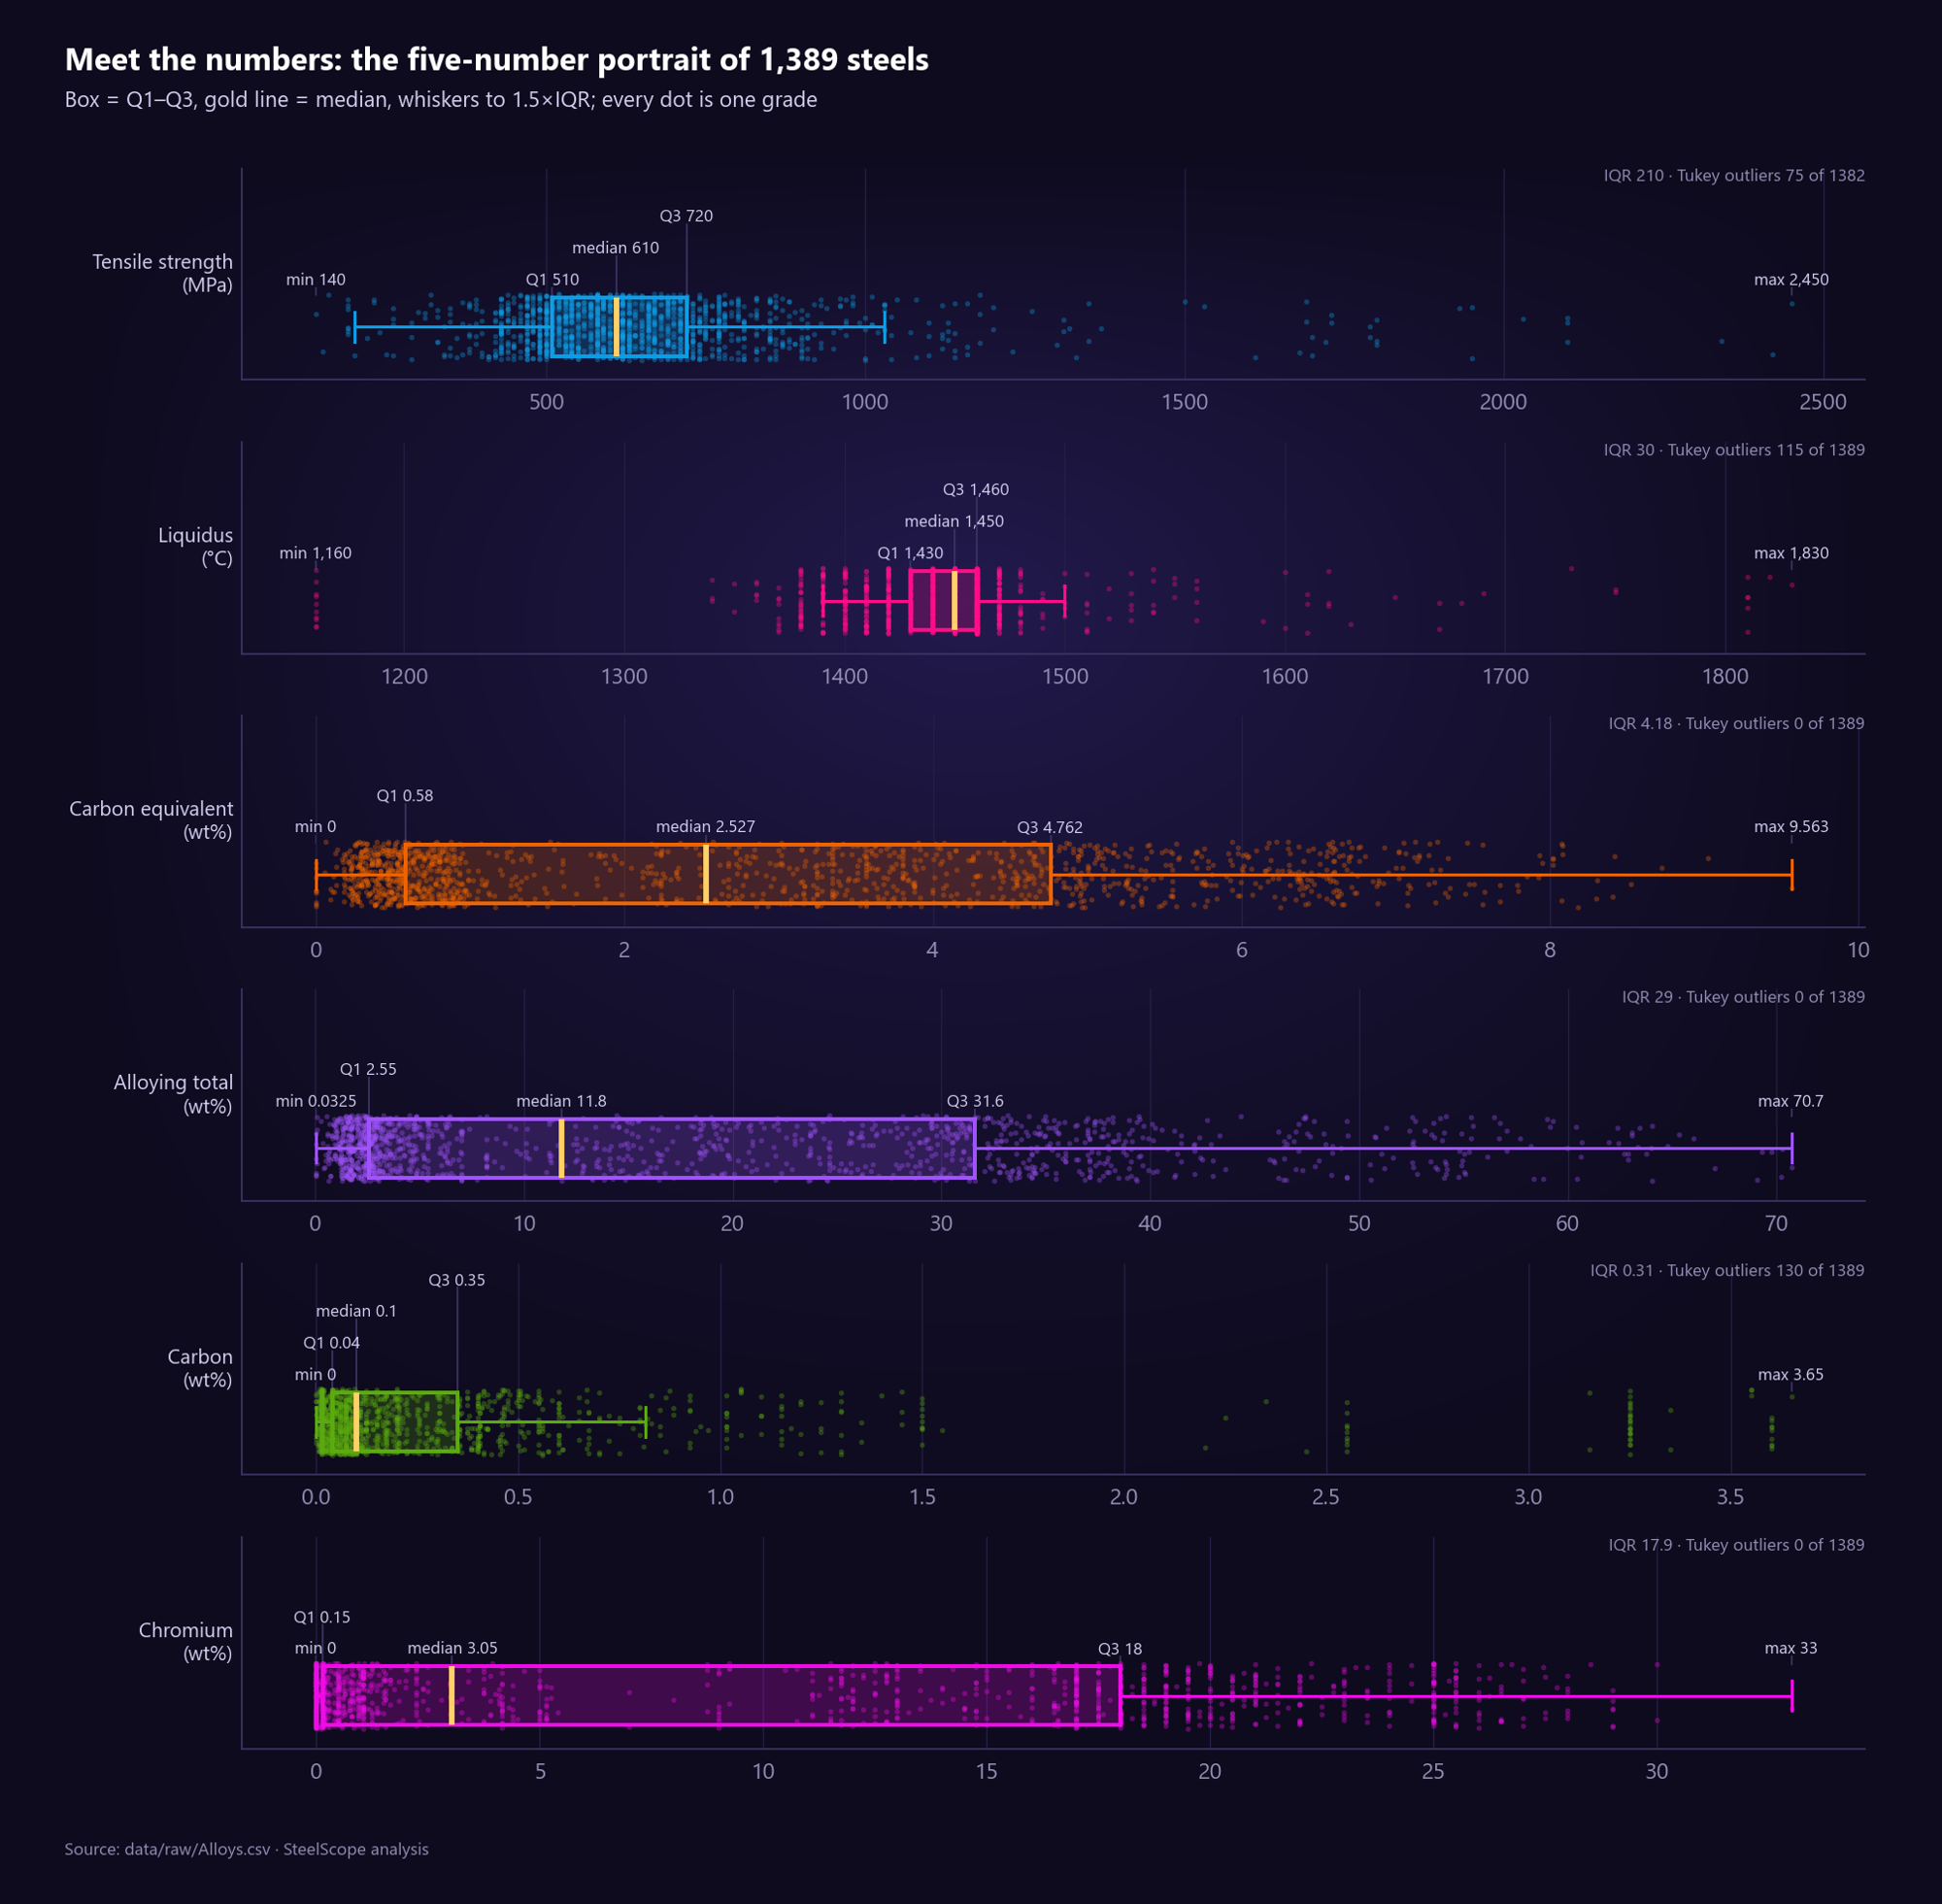
Figure 8: Five-number summaries of the main variables.
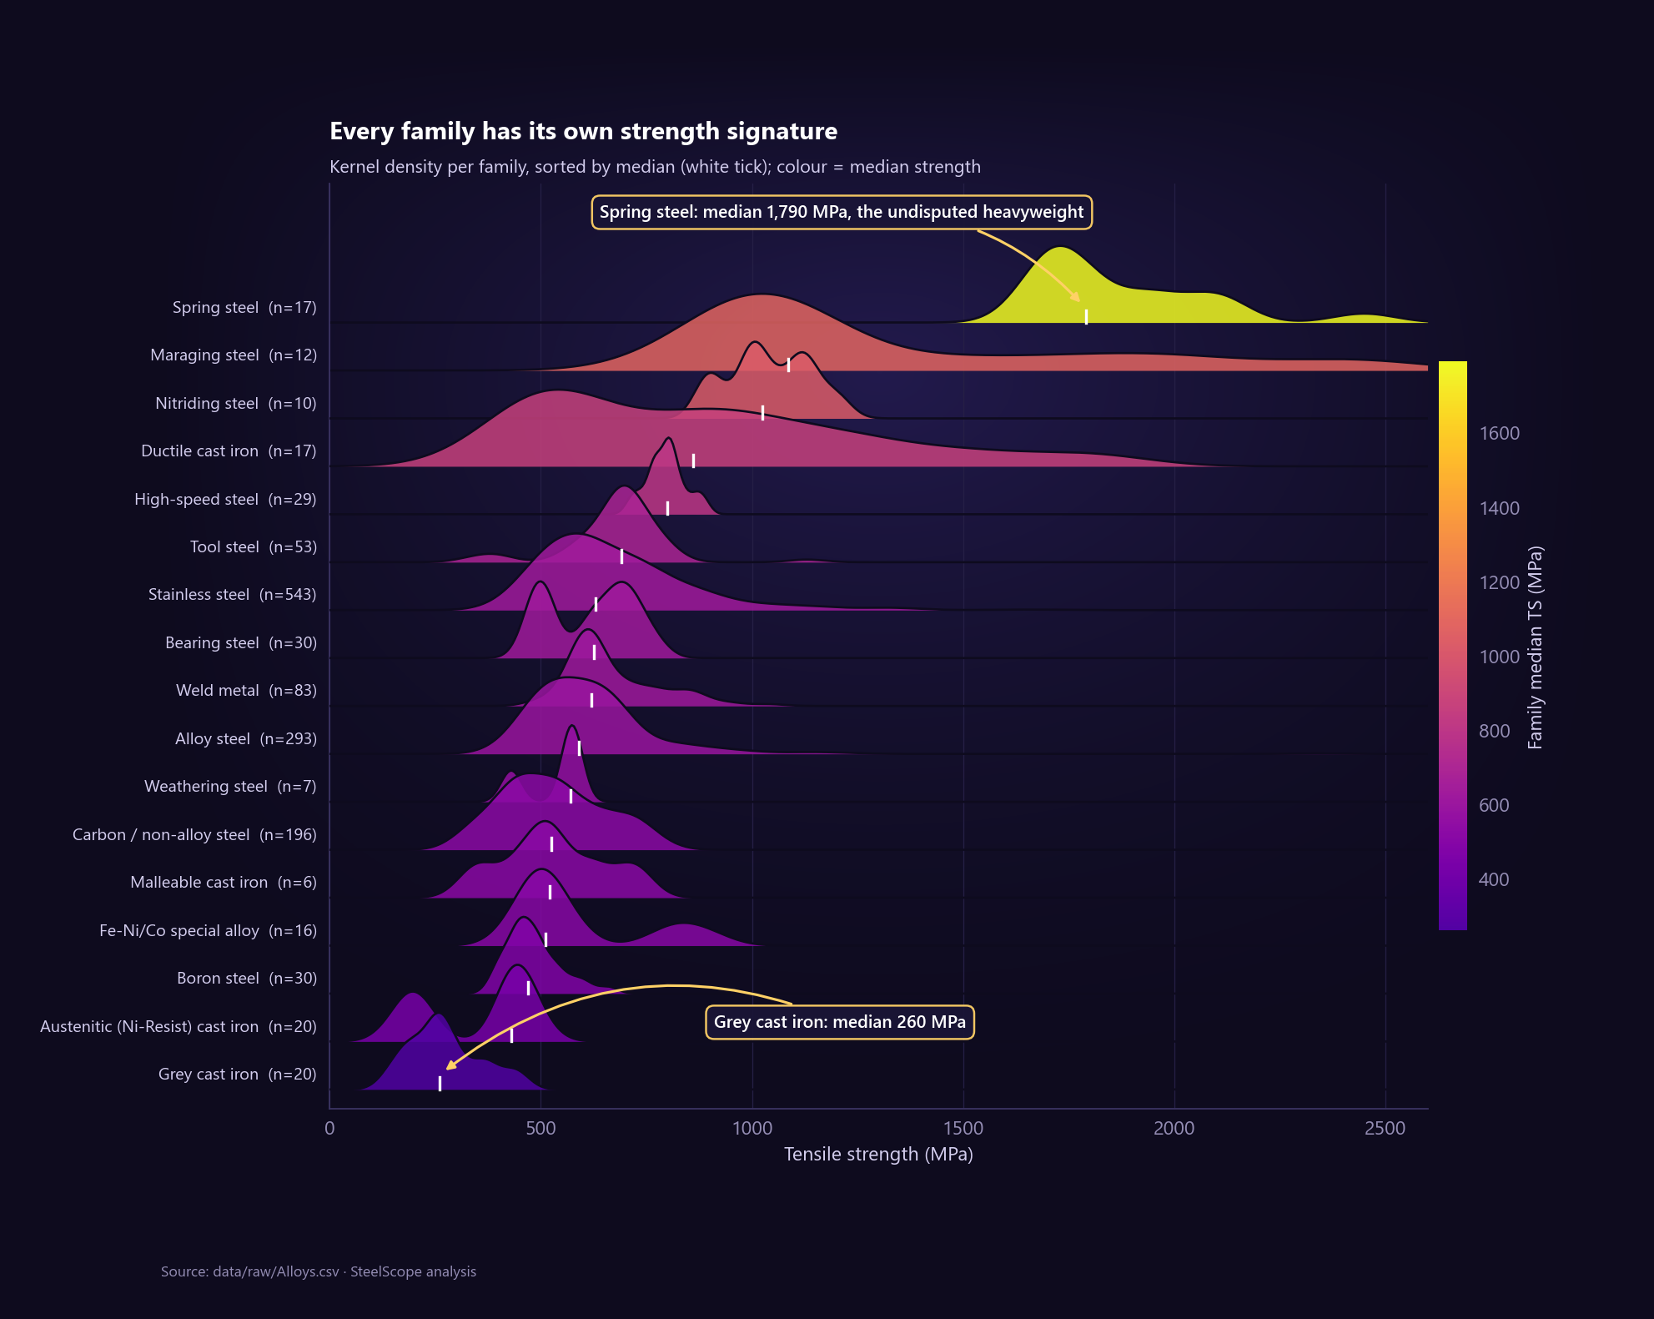
Figure 9: Ridgeline of strength per family: every family has its own strength signature.

6.2 Binning
Three binning strategies were compared on tensile strength. Equal width (5 bins of 462 MPa) puts 96 % of the grades into the first two bins (671 / 650 / 36 / 18 / 7) because of the skew. Equal frequency (quantile edges at 500, 580, 650 and 750 MPa) gives 318 / 284 / 240 / 268 / 272; the counts are not identical because many grades share round values such as 500 or 580 MPa. Domain bins carry metallurgical meaning: carbon bands (low ≤ 0.25 %, medium 0.25–0.60 %, high 0.60–2.1 %, cast-iron range > 2.1 %) with 967 / 254 / 112 / 49 grades, and the CE weldability bands (173 / 163 / 247 among the 583 plain steels).
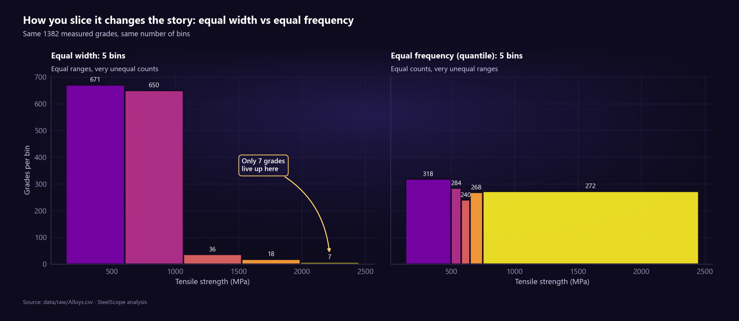
Figure 10: Equal-width versus equal-frequency binning of tensile strength.

6.3 Chi-square tests of independence
For each pair of categorical variables the null hypothesis is that they are unrelated. The chi-square statistic compares observed counts with the counts expected under independence (row total × column total ÷ n); Cramér's V rescales it to 0–1 as a measure of association strength. Because the low-strength class has only 23 grades, four tables have more than 20 % of expected counts below 5 (Cochran's rule), so each result was confirmed with a Monte-Carlo permutation test (labels shuffled thousands of times); chance never produced an association as strong.
Table 9: Chi-square tests
Pair | χ² | df | p-value | Cramér's V | n
Family group × strength class | 548.73 | 10 | 1.7 × 10⁻¹¹¹ | 0.45 | 1,382
Product form × strength class | 117.37 | 4 | 2.0 × 10⁻²⁴ | 0.21 | 1,382
Carbon band × strength class | 315.85 | 6 | 3.3 × 10⁻⁶⁵ | 0.34 | 1,382
CE band × strength class (plain steels) | 198.22 | 4 | 9.1 × 10⁻⁴² | 0.41 | 583
Family group × default liquidus | 631.97 | 5 | 2.5 × 10⁻¹³⁴ | 0.67 | 1,389

All five null hypotheses are rejected. The largest standardized residual is cast iron × low class: 22 grades where independence predicts about one (residual +20.5). The strongest association is family × default liquidus (V = 0.67), confirming that the 1460 °C value is a family habit, not a measurement.
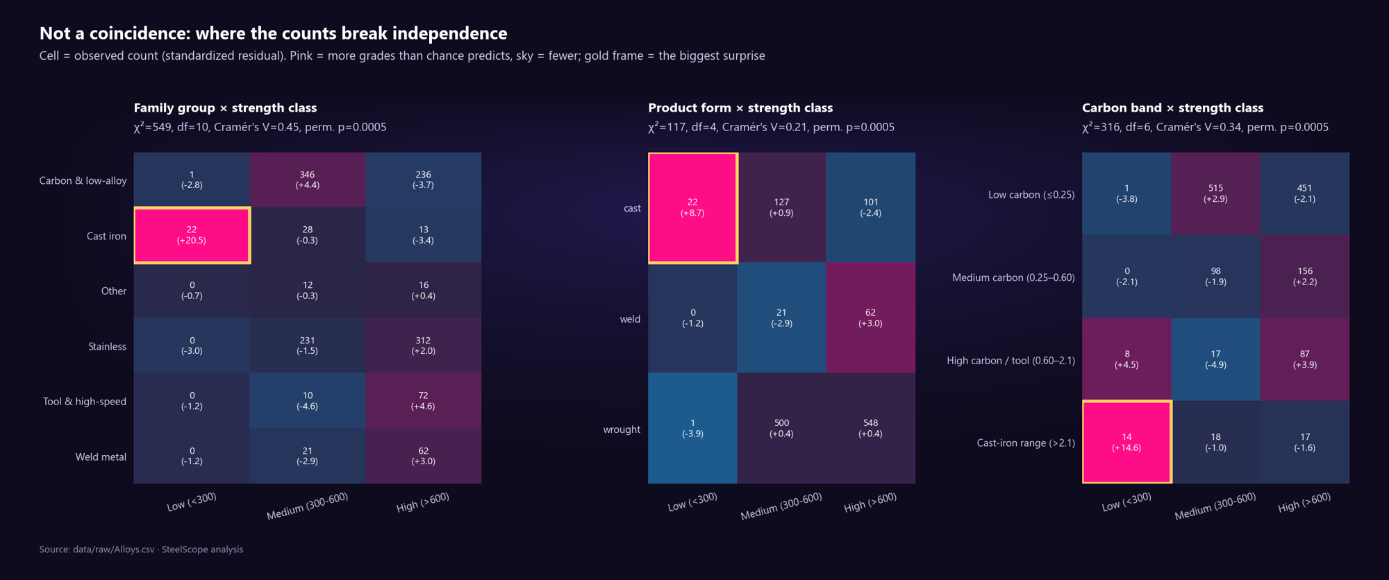
Figure 11: Standardized residuals of the chi-square tests; red cells hold more grades than independence predicts.
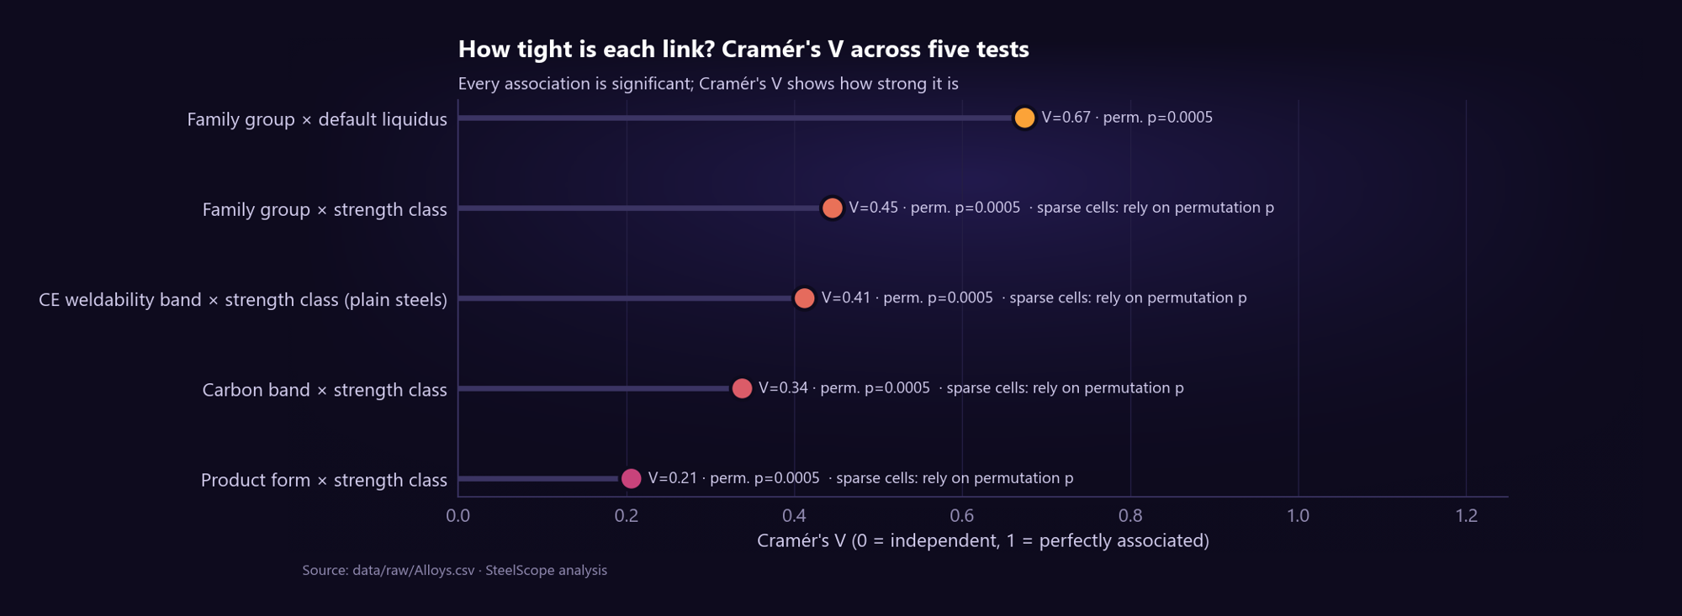
Figure 12: Cramér's V ranks the strength of each association.

6.4 Correlation and regression
Pearson correlations between strength and any single element are weak across all 1,382 grades (all below 0.19 in absolute value; carbon −0.02), while strong blocks appear among the elements themselves: carbon equivalent with alloying total (0.94), chromium with carbon equivalent (0.92), and the vanadium–tungsten pair of tool steels (0.55).
Table 10: Linear regression results
Model | Data | Result
Simple: TS ~ C | Carbon steels (n = 196) | TS = 429.2 + 428.6 × C; R² = 0.508; p(C) ≈ 10⁻³¹ → about +43 MPa per 0.1 % carbon
Multiple: TS ~ C, Mn, Si, Cr, Ni, Mo, V | Carbon & low-alloy, C ≤ 1 % (n = 574) | Coefficients (MPa per wt%): intercept 404.0, C 648.5, Mn −19.6, Si 193.3, Cr 19.7, Ni 23.8, Mo −74.2, V 362.2; R² = 0.326, adjusted R² = 0.317

Carbon alone explains about half of the strength variance in carbon steels; seven elements together explain only a third across plain steels, because heat treatment is missing from the data. This motivates the non-linear models built in KNIME.
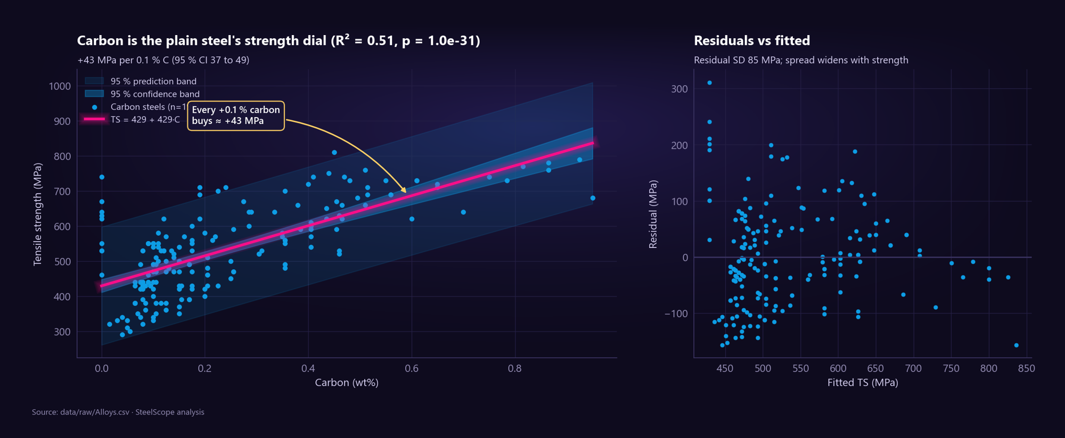
Figure 13: Simple regression of strength on carbon in carbon steels, with confidence and prediction bands.

6.5 Principal component analysis
The 20 non-rare composition features (all elements except iron and ten rare traces, plus their summed trace total) were transformed with log(1 + x), because a few grades hold very large amounts of chromium, tungsten or nickel, and standardised to z-scores so that each element has equal weight. PCA then finds new axes of maximum variance.
Table 11: Variance explained by the first five components
Component | PC1 | PC2 | PC3 | PC4 | PC5
Variance explained | 15.0 % | 11.8 % | 9.5 % | 7.6 % | 5.9 %

Twelve components are needed to reach 80 % of the variance and eight have an eigenvalue above 1 (Kaiser rule): steel chemistry is genuinely high-dimensional. PC1 is driven by chromium (+0.80), nickel (+0.77) and nitrogen (+0.69) against carbon (−0.58), so stainless steels stretch along it; tool and high-speed steels rise along PC2. Differently named plain steels crowd together in the centre of the map: names are not chemistry.
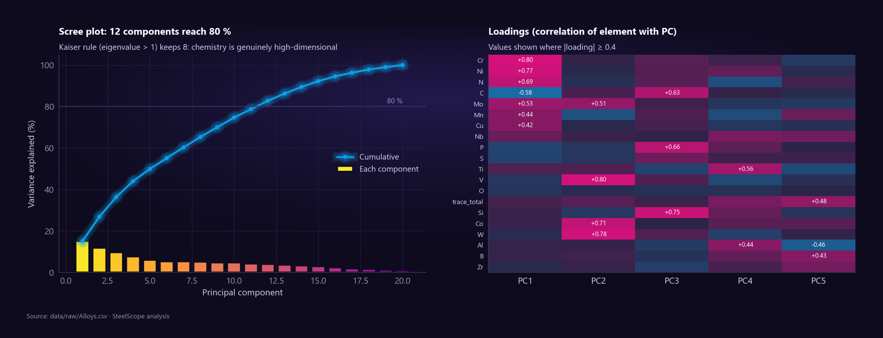
Figure 14: Scree plot and loadings of the principal components.
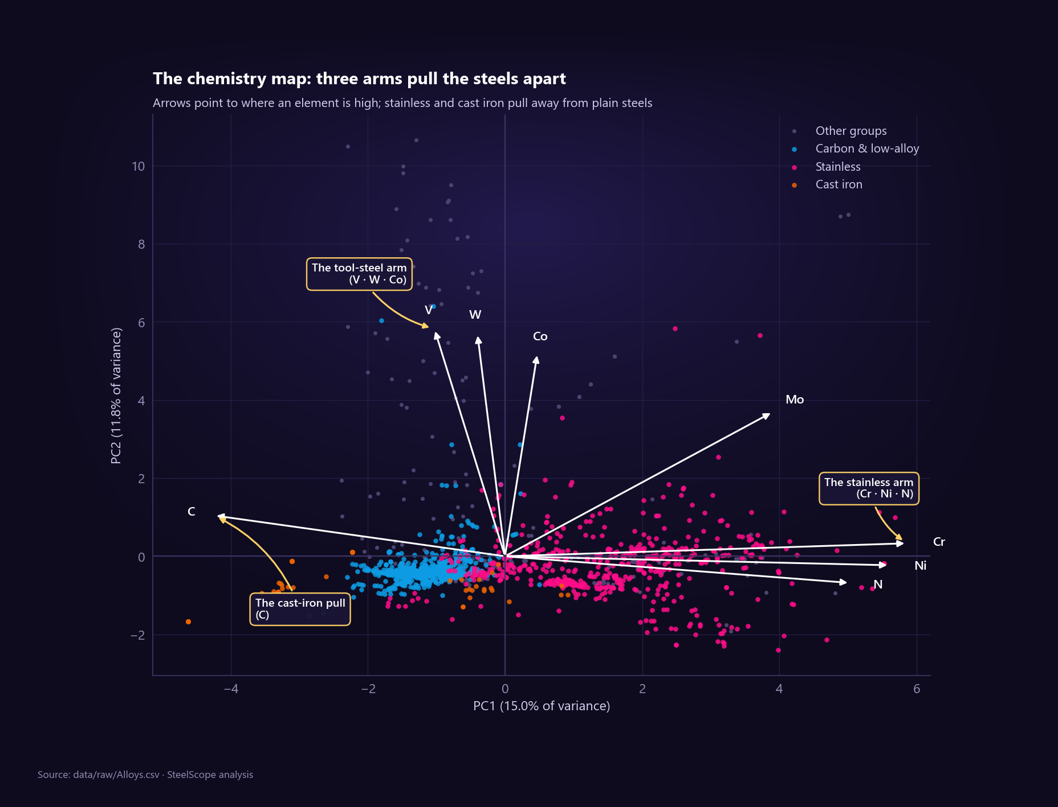
Figure 15: The chemistry map: PCA biplot of 1,389 grades coloured by family group.

6.6 Composition portraits and circular charts
Radar charts give each alloy or group a composition fingerprint. Nine showcase grades (AISI 1018, 1045, 4140, 304, 316, 17-4 PH, M2 high-speed steel, grey iron 250 and aged maraging 300) are compared on strength, liquidus, CE, alloying total and key elements. The stainless overlay shows that 17-4 PH reaches a higher strength than nickel-rich 304 and 316 with less nickel: strength is not bought by the kilogram of alloy. The treemap and chord diagram summarise the population and the effect of cleaning.
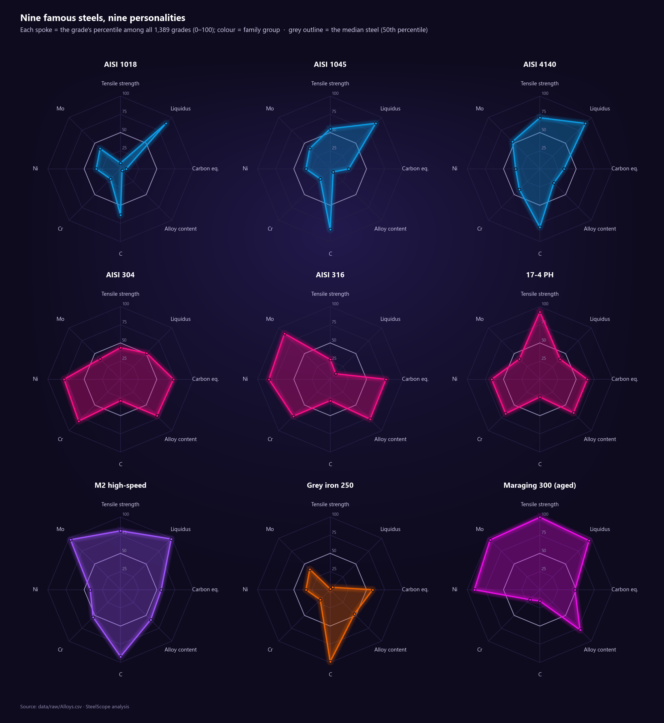
Figure 16: Radar portraits of nine showcase alloys.
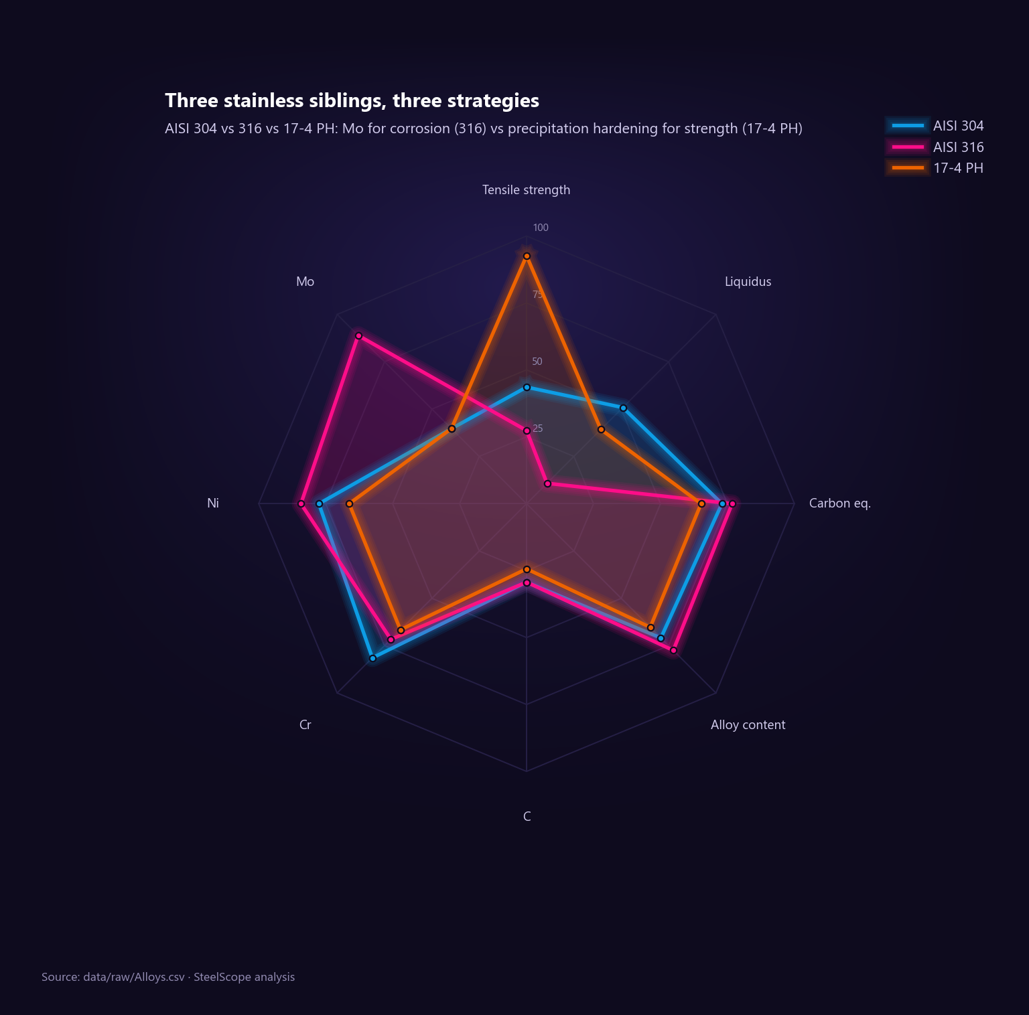
Figure 17: Stainless overlay: 17-4 PH versus 304 and 316.
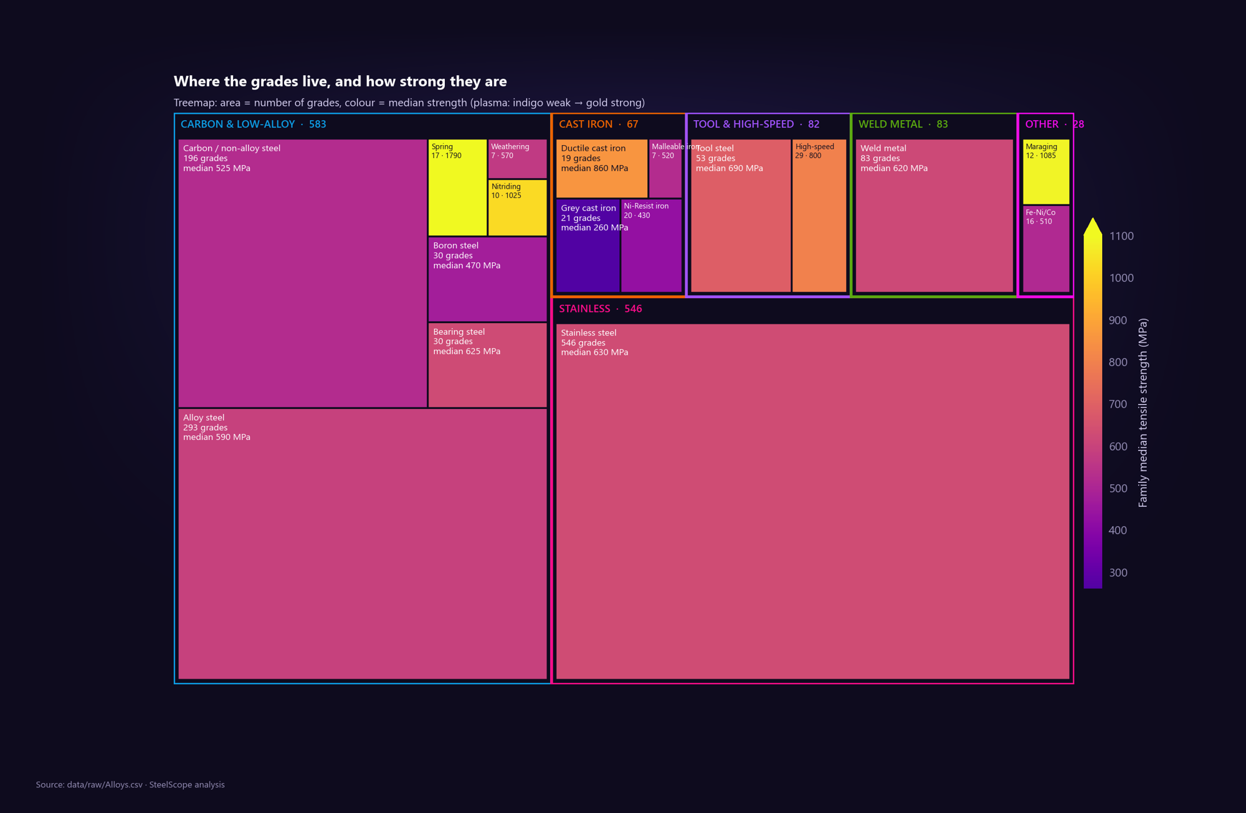
Figure 18: Treemap of families: tile size = number of grades, colour = median strength.
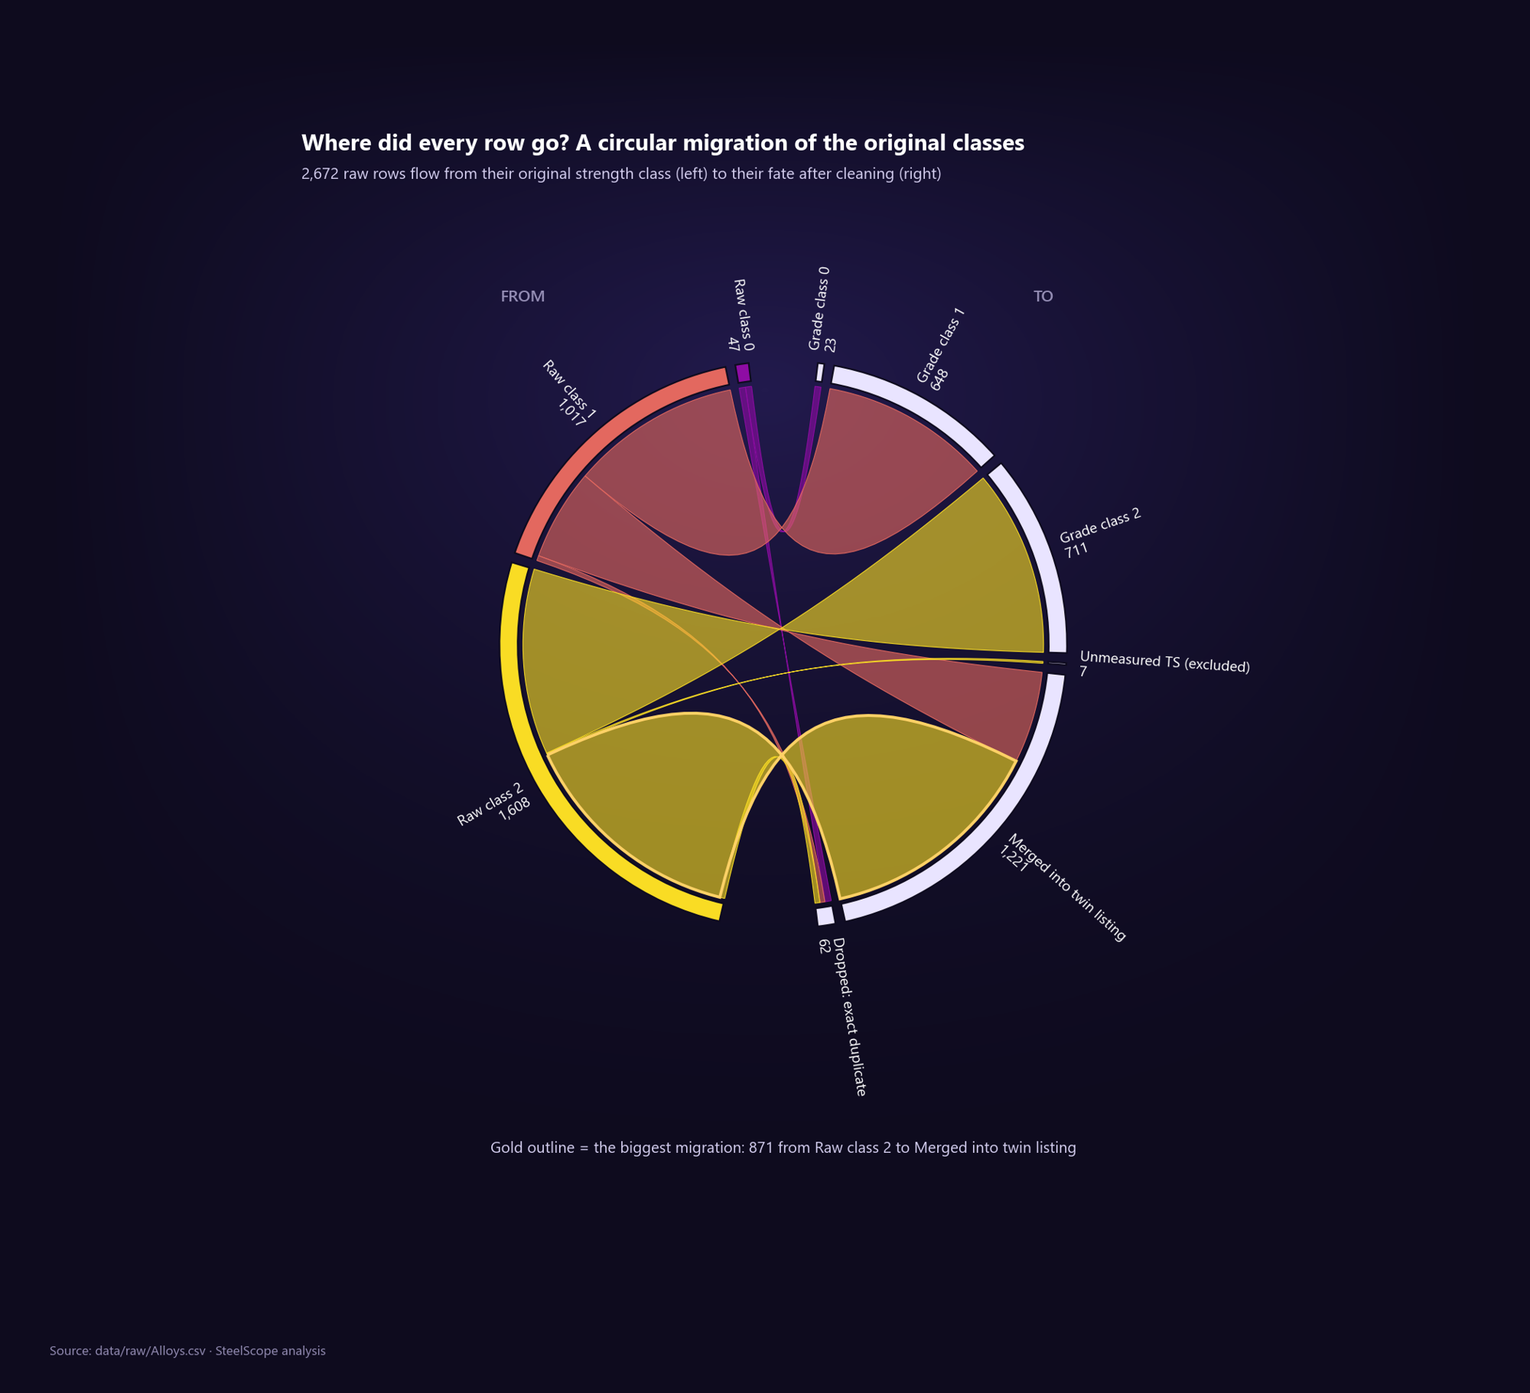
Figure 19: Chord diagram of how the original strength-class labels move after cleaning.

6.7 The carbon-equivalent waterfall
For SAE-AISI 4140 (a Cr-Mo steel) the waterfall adds the CE terms one by one: carbon 0.405 + Mn/6 0.146 + Cr/5 0.190 + Mo/5 0.040 = 0.78, in the "difficult" band. Carbon and chromium contribute most, so a welder must preheat.
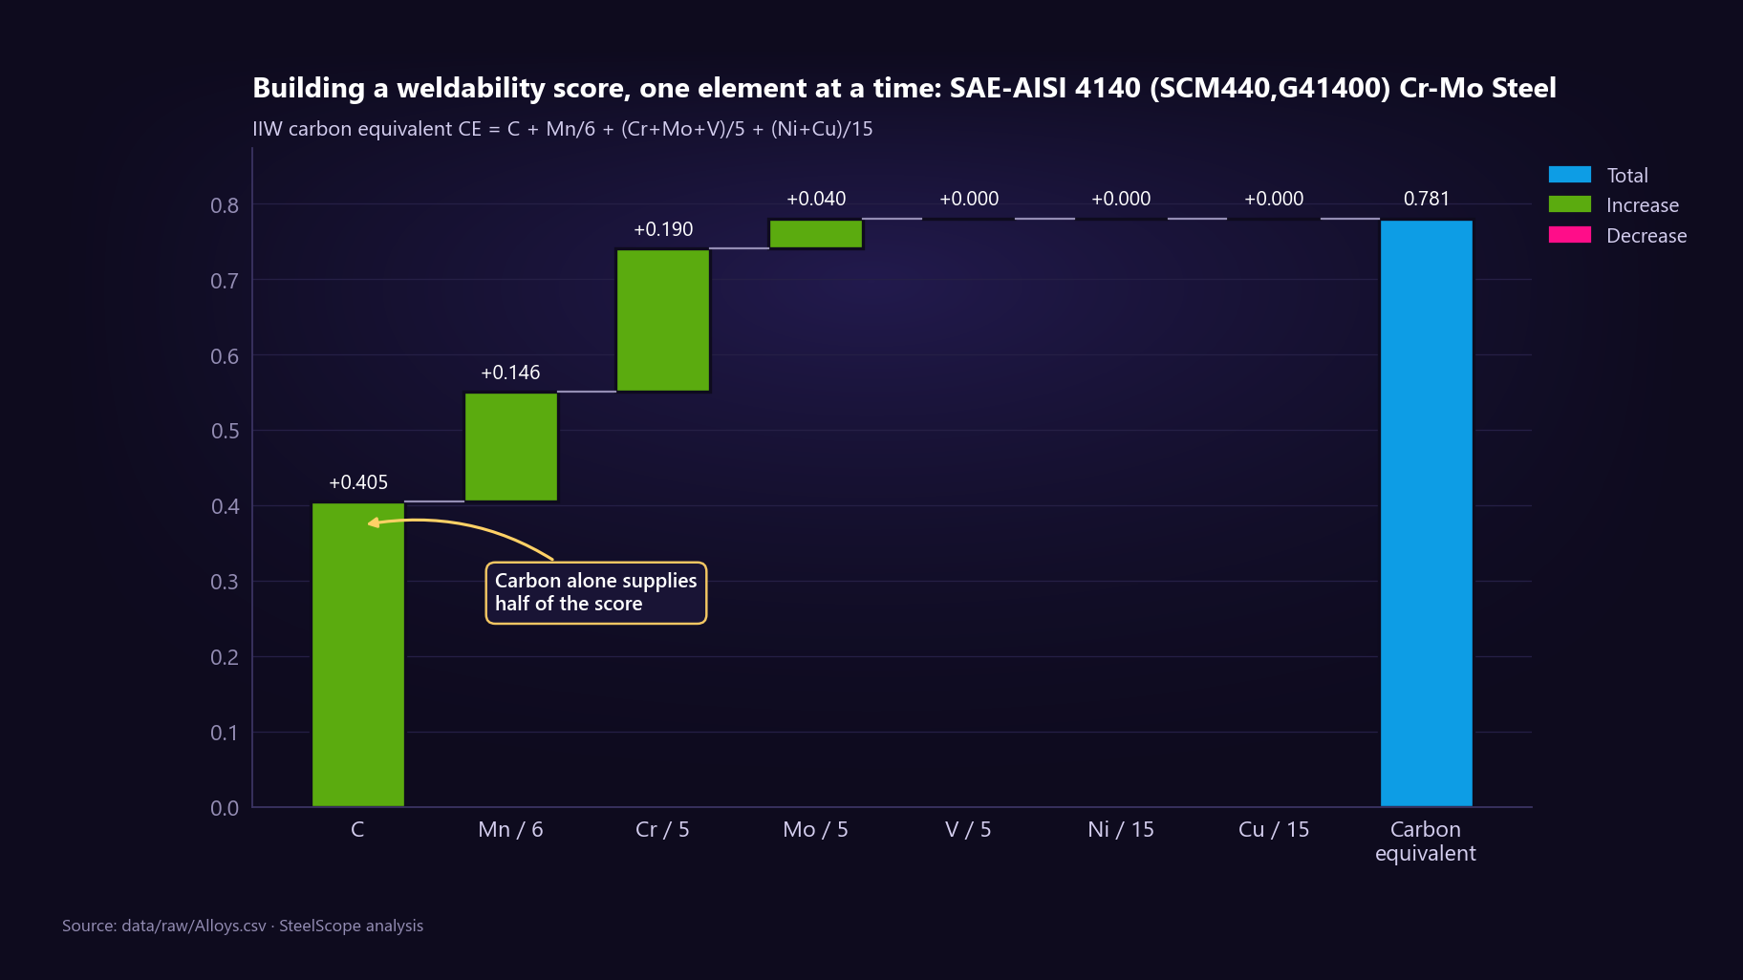
Figure 20: Carbon-equivalent waterfall for AISI 4140.

7. KNIME workflow
The KNIME workflow (knime/workflow/SteelScope_Visual_Analytics.knwf) rebuilds the statistics as nodes and holds all machine learning. It reads knime_input.csv (1,389 grades with a group-safe train/test split column) from its own workflow data area, so it runs unchanged on another computer.
Table 12: Sections of the KNIME workflow
Section | Nodes | Result
A · Read, clean, enrich | CSV Reader, Row Filter, Rule Engine, Math Formula ×5, Color Palette Designer, Color Designer (Apply) | 1,382 measured grades; six family groups; KNIME's CE equals Python's exactly (maximum difference 0)
B · Five-number summary | GroupBy, Statistics View, Box Plot, Histogram, Numeric Outliers | 140 / 510 / 610 / 720 / 2,450 MPa; 75 outliers
C · Binning | Binner (equal width, custom quantiles), Numeric Binner, Bar Chart | 671/650/36/18/7 and 318/284/240/268/272 ("to lower bin" tie rule)
D · Chi-square | Crosstab, Python View residual heatmap | χ² = 548.7, df = 10
E · Correlation, regression | Linear Correlation, Linear Regression Learner, Regression Predictor, Scatter and Line Plot | Slope 428.6 MPa per wt% C, R² 0.51
F · PCA | Math Formula (Multi Column) log, Normalizer z-score, PCA Compute/Apply, scree Bar Chart | PC1 15.0 %, PC2 11.8 %
G · K-means | k-Means (k = 6), GroupBy + Unpivot + Heatmap, cluster Scatter Plot, chord Python View | Chemistry clusters compared with family names
H · Circular visuals | Sunburst Chart, radar Python View | Group → family hierarchy
I · Machine learning | Number to String, Row Splitter, Column Filter, Decision Tree, Normalizer + K Nearest Neighbor, Random Forest (Regression), Scorers | See Table 13

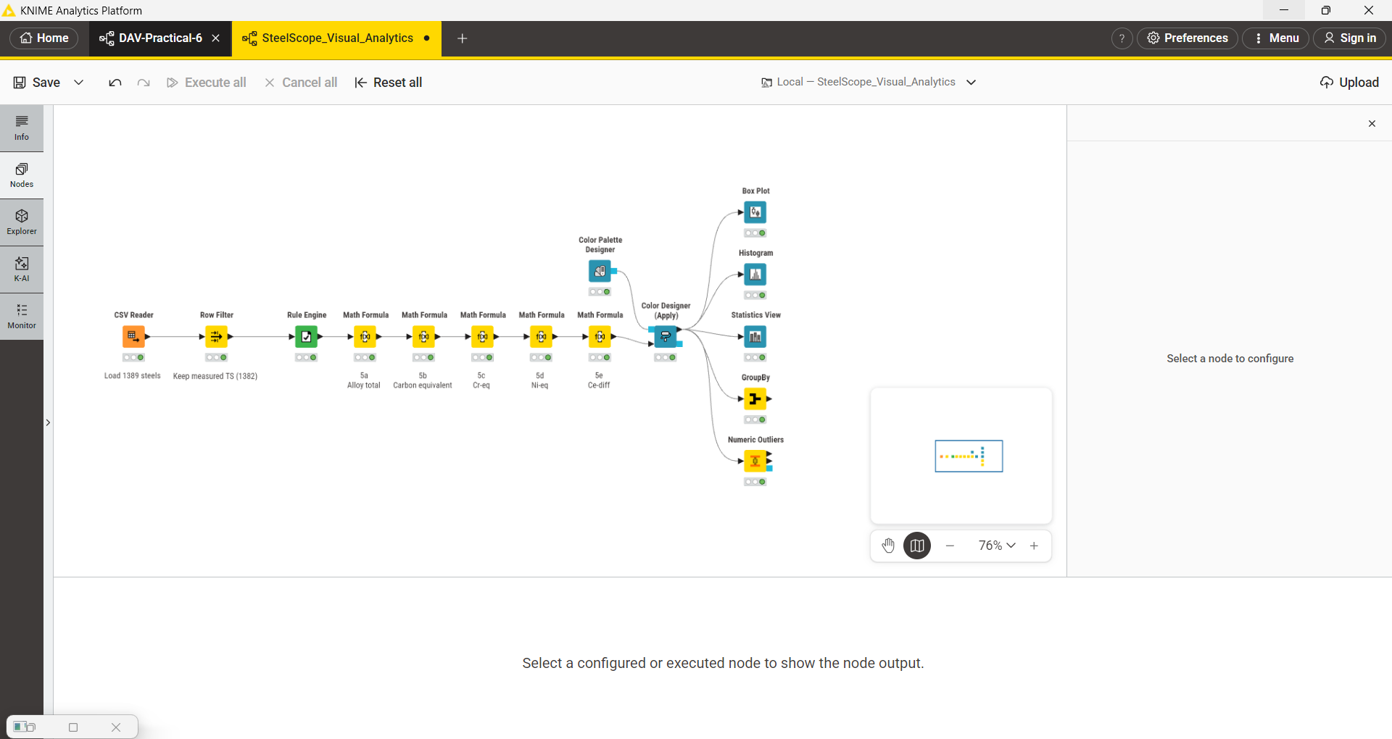
Figure 21: Part of the KNIME canvas: reading, cleaning and enrichment (section A) feeding the five-number summary views (section B).
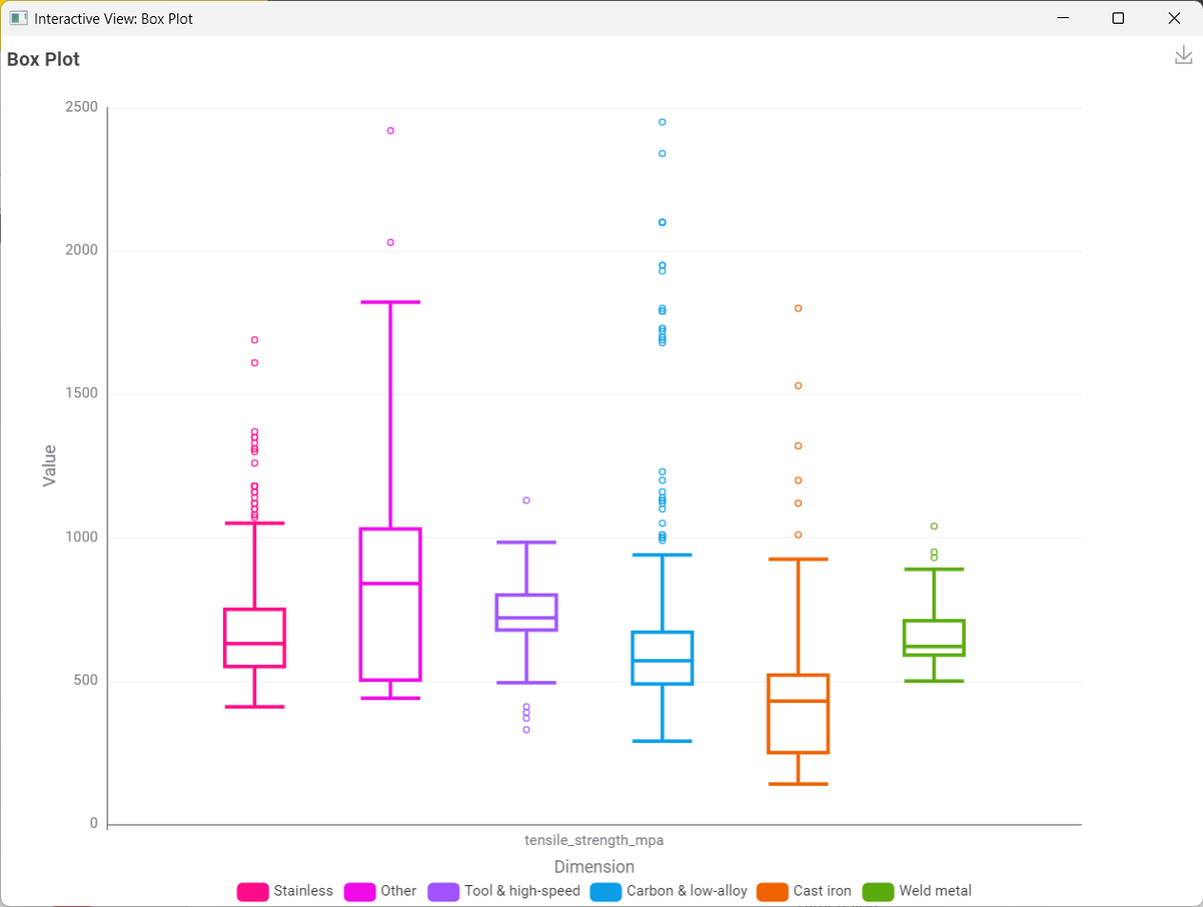
Figure 22: KNIME Box Plot view: tensile strength by family group.
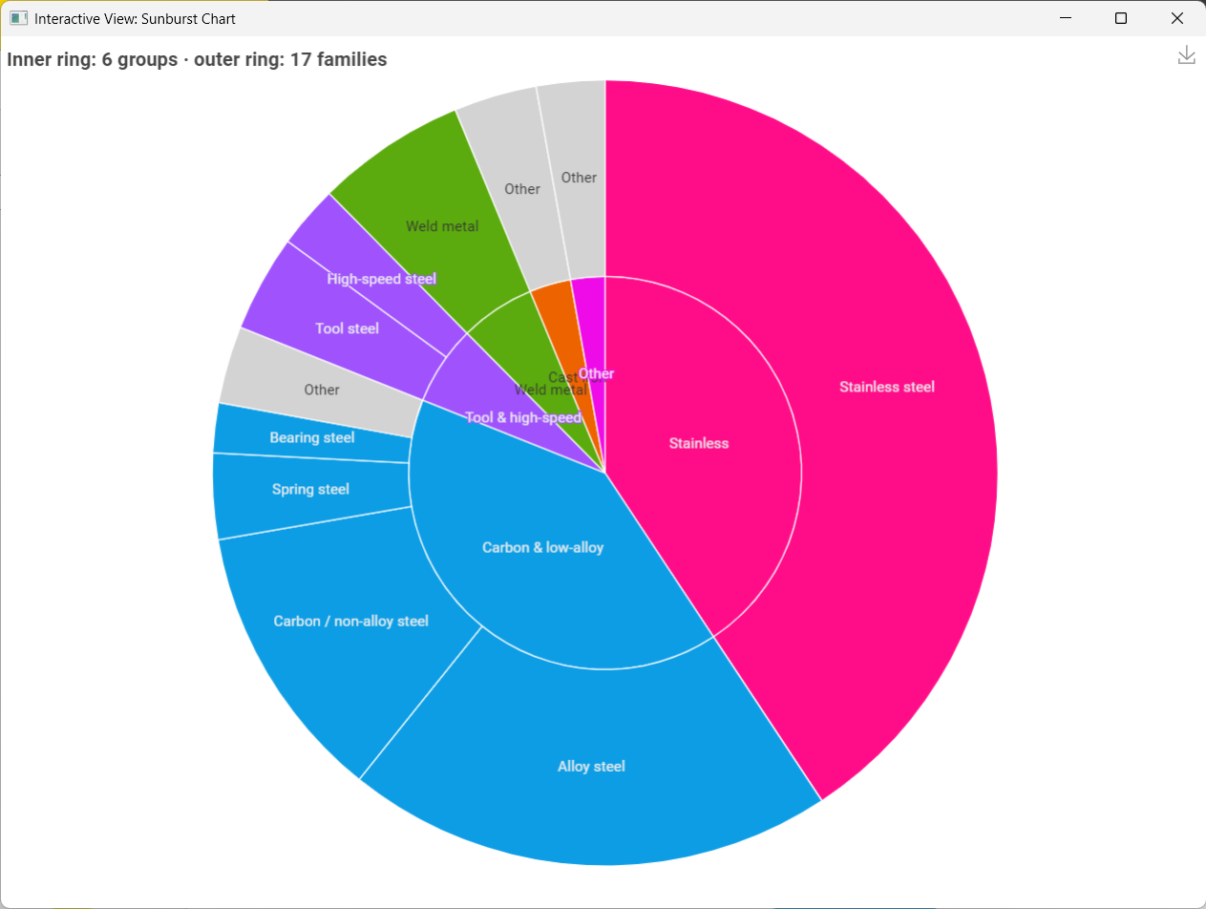
Figure 23: KNIME Sunburst view: family groups (inner ring) and families (outer ring).

7.1 Clustering
k-means was run on the same 20 log-transformed, standardised composition columns used for PCA, with six clusters to match the six family groups. A silhouette check in Python on the same data rises slowly from 0.23 (k = 2) to 0.34 (k = 12) with a local peak of 0.30 at k = 6, supporting the choice. The cluster heatmap (median z-score per element) shows distinct fingerprints: a large lean cluster of plain steels, Cr–Ni austenitic stainless, Cr-only stainless, W–V–Mo–Co tool steels and C–Si cast irons. The chord diagram from family group to cluster shows that plain steels form one chemistry under many names while stainless steels split into several chemistries under one name.

7.2 Machine learning
All models use composition, the engineered indices, family and product form as inputs. The split is group-safe: grades with an identical chemistry never appear in both training and test data (1,117 training and 265 test grades), so the models cannot score by memorising a twin. Tensile strength is excluded from the classifiers' inputs because the strength class is defined from it, and the strength class is excluded from the random forest for the same reason. For k-NN the inputs are Min-Max scaled, fitted on the training set only and applied to the test set.
Table 13: Machine-learning results in KNIME
Model | Task | Test result (265 grades) | Baseline
k-nearest neighbours (k = 5, distance-weighted) | Strength class | Accuracy 0.842, Cohen's κ ≈ 0.70 | Always "High": accuracy 0.502
Random forest (100 trees) | Tensile strength | R² 0.731, MAE 66.5 MPa, RMSE 95.8 MPa, MAPE 11.6 % | Predict the mean: MAE 134.4 MPa
Decision tree (Gini, MDL pruning) | Strength class | Read from the workflow's Scorer node after the train/test correction below | Accuracy 0.502

All k-NN errors fall between the medium and high classes near the 600 MPa boundary, where heat treatment rather than chemistry decides; no low-strength grade was classed as high. The random forest halves the error of the mean predictor.
Lessons from building the models. (1) The first decision tree scored 100 % because tensile strength was still among its inputs; a perfect score on unseen data revealed target leakage, fixed with a Column Filter. (2) A single Column Filter initially fed both the learner and the predictor, so the model was tested on its own training rows; separate filters for the training and test outputs fixed it. (3) Without scaling, large-range columns such as Ni_eq (0–110) dominate the k-NN distance; scaling raised accuracy from 0.815 to 0.845 in a Python check. (4) The Normalizer warned that some test values fall outside the training range, which is expected when the test data is genuinely unseen.
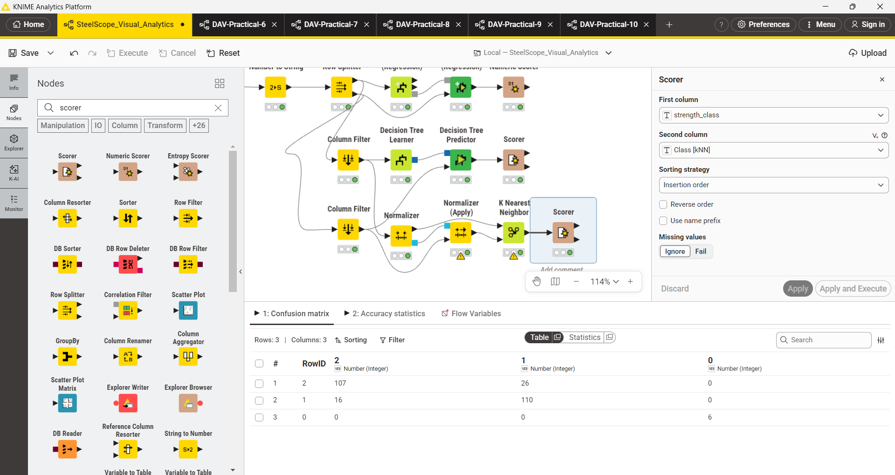
Figure 24: KNIME machine-learning section: separate training and test branches, and the k-NN confusion matrix.

8. Tableau dashboards
The Tableau workbooks (tableau/workbooks) connect to the CSV files exported by notebook 03 (tableau/data). Charts that Tableau cannot draw natively, such as chord, radar and waterfall charts, are supplied as ready-made x/y shapes computed in Python, so Tableau only connects the points.
Table 14: Tableau workbooks
Workbook | Sheets | Data
DAV_D1 | Six sheets and a dashboard | steels_wide.csv
DAV_D2 | Attribute vs Cramér's V, PCA analysis, regression line, term vs beta (coefficients), treemap, and a dashboard | steels_wide.csv and the chi-square, PCA and regression tables
DAV_D3 | Box plot MP, Box plot TS, MP vs Al, TS in Alloys, TS vs MP, two further sheets and a dashboard | Synthetic_Alloys_Tableau.csv

9. Power BI report
The Power BI report (powerbi/SteelScope.pbip) is built on a star schema generated from the cleaned data: a grades fact table (1,389 rows) with composition (13,376 grade–element rows), families (17) and elements (30) as related tables. Power Query loads the tables through a DataFolder parameter, DAX measures compute the statistics (for example grades 1,389, median strength 610 MPa, middle 50 % 510–720 MPa, median CE 2.53), and a theme applies the project's family-group colours.
Table 15: Pages of the Power BI report
Page | Question | Visuals
Overview | What is in the data and how strong is it? | Slicers, KPI cards, strength histogram, family treemap, quartiles by group
Families & classes | Does family decide strength? | 100 % stacked bars, class matrix heatmap, decomposition tree
Carbon is the dial | What makes a plain steel stronger? | Carbon scatter with trend line, pooled scatter, weldability bands
Chemistry map | Which steels are chemically alike? | PCA scatter, element heatmap matrix
Grade inspector | What is this one grade? | Drillthrough page: cards, composition bars and table
Target finder | Which grades meet my requirement? | Range slicers, matches per family, candidate table

10. Web application: SteelScope
The notebooks tell the story once; the web application lets any user ask their own question of the same data in a browser. It is built with Next.js, React, TypeScript, Tailwind CSS, shadcn/ui and Recharts, pre-renders 2,787 pages and can be deployed on Vercel. A Python script prepares its data from the cleaned dataset with the same PCA as notebook 03. The application does not predict properties; machine learning stays in KNIME.
Table 16: Pages of the web application
Page | What it does | Why it is useful
Explorer | Filters by family, form, strength and name; stat cards, stacked histogram, sunburst, box plots, treemap, chord diagram, sortable table | Shows the whole dataset at a glance and recomputes every chart for the user's filter
Grade inspector | Percentile of a grade within its family and overall, composition radar against the family median, composition bars, CE waterfall with weldability verdict, five closest grades | Puts a single strength number in context in seconds
Substitute finder | Ten grades with the closest chemistry, distance, strength difference, PCA map | Shortlists substitutes when a grade is unavailable or named in a foreign standard
Target designer | Strength and liquidus windows, product form, placeholder switch; candidates per family | Turns a requirement into a list of candidate grades
About the data | Cleaning log, methods and limits | Makes every number traceable

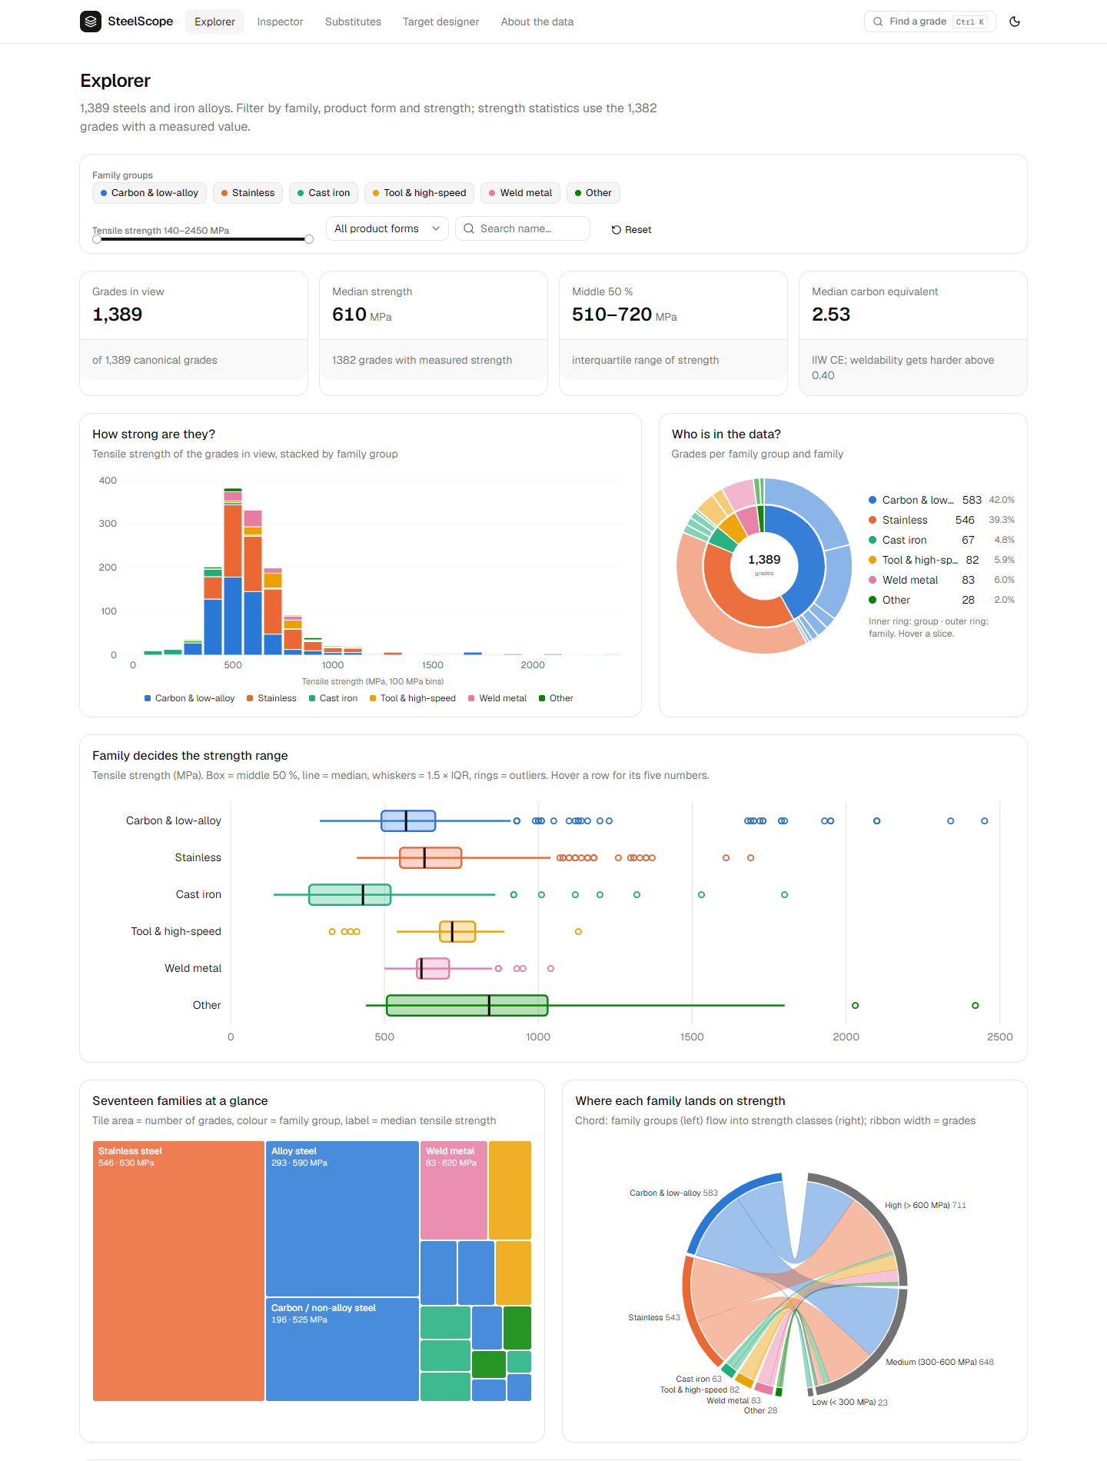
Figure 25: SteelScope Explorer: filters, statistics, histogram, sunburst and box plots.
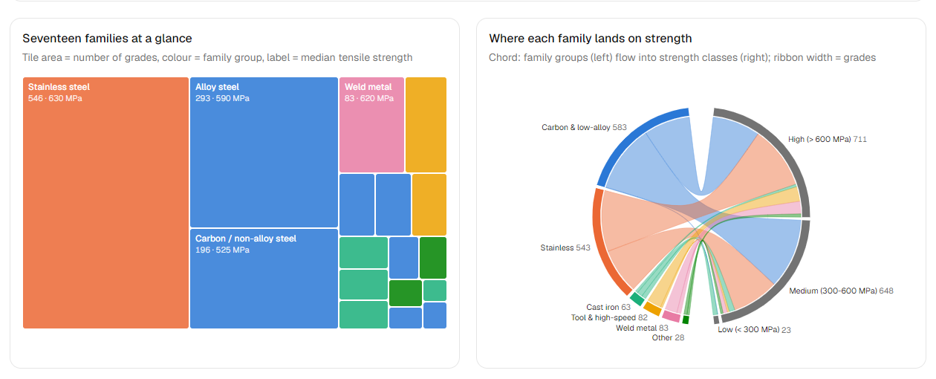
Figure 26: Explorer: treemap of the 17 families and chord diagram from family group to strength class.
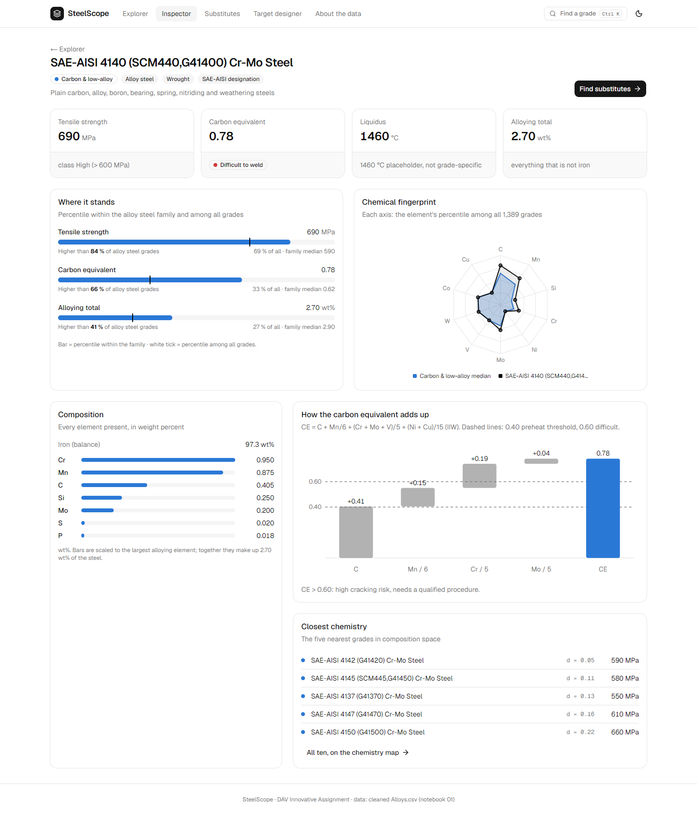
Figure 27: Grade inspector for SAE-AISI 4140: 690 MPa, stronger than 84 % of alloy steels, CE 0.78 (difficult to weld).
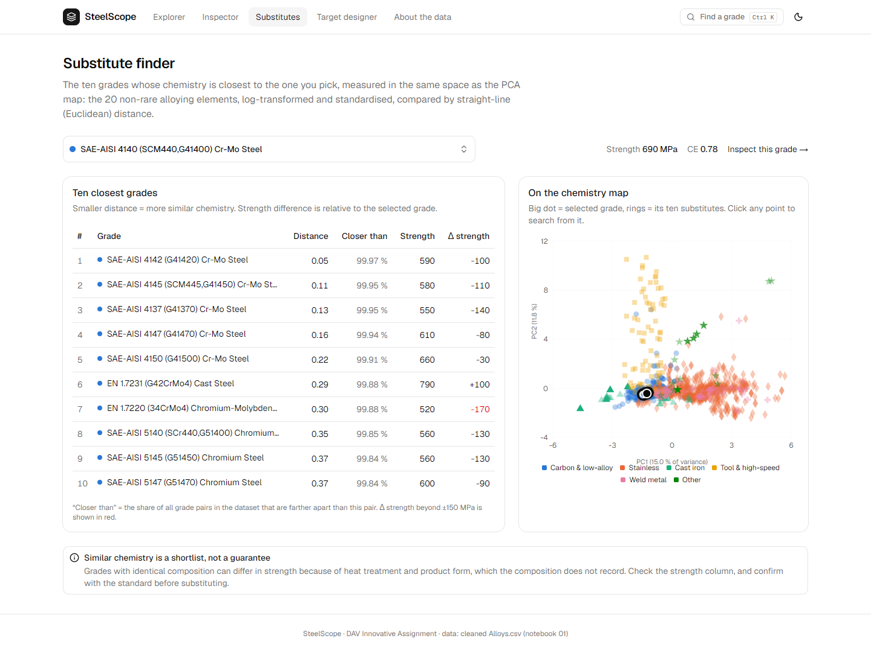
Figure 28: Substitute finder for AISI 4140: 4142, 4145, 4137, 4147 and 4150 first, then European equivalents.
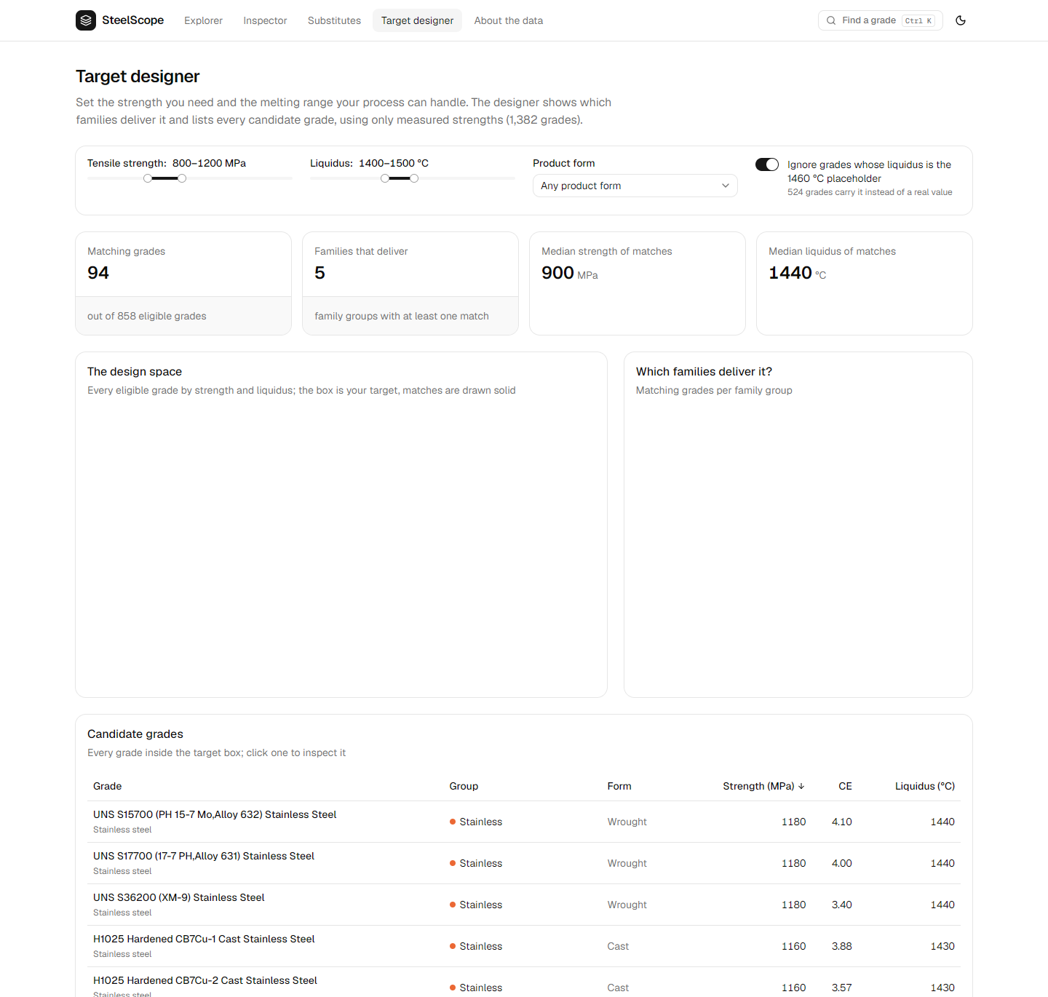
Figure 29: Target designer: 800–1200 MPa and 1400–1500 °C give 94 candidate grades, 68 of them stainless.

11. Key findings
- Clean before you count. 2,672 rows were really 1,389 steels; the fake 652 MPa values hid inside duplicate listings.
- Think in medians. Strength is right-skewed; the typical grade has 610 MPa, and the middle half lies between 510 and 720 MPa.
- Family first, chemistry second. The family sets the strength range (χ² = 548.7, Cramér's V = 0.45); elements fine-tune it.
- Carbon is the plain steel's dial: about +43 MPa per 0.1 % carbon (R² = 0.51), but only within plain steels (Simpson's paradox).
- Names are not chemistry. On the PCA map and in the k-means clusters, many plain-steel names share one chemistry while stainless splits into several.
- Strength is not bought by the kilogram. 17-4 PH beats nickel-rich 304 and 316 on strength with less nickel.
- Composition tells most of the story; processing writes the rest. A random forest explains 73 % of the strength variance on unseen chemistries; the remainder is heat treatment.

12. Limitations and future work
- Heat treatment and product condition are not recorded, so identical chemistries can differ in strength; this limits every composition-based model.
- Seven grades lack a measured strength and 524 liquidus values are a placeholder; both are flagged and excluded where they would bias results.
- The low-strength class has only 23 grades, so class-level results for it are uncertain; permutation tests backed the chi-square results where expected counts were small.
- Future work: add processing data (temper, ageing condition) to separate processing variants, add further properties (yield strength, hardness, elongation) and cost, and extend the substitute finder with property constraints.

13. Conclusion
The project shows that an honest cleaning step changes the conclusions of a dataset: the raw table double-counted most grades and contained hundreds of invented strength values. On the cleaned data, a combination of descriptive statistics, binning, chi-square tests, regression and PCA establishes that the family decides the strength range, that carbon controls strength within plain steels, and that grade names group chemistries imperfectly. The same results are reproduced independently in KNIME, where the machine-learning models reach a test accuracy of 0.84 (k-NN) and an R² of 0.73 (random forest) on chemistries they never saw. Tableau and Power BI dashboards and the SteelScope web application make the analysis usable for engineers and buyers who need to explore grades, find substitutes and select materials for a target.

References
- International Institute of Welding, carbon-equivalent formula CE = C + Mn/6 + (Cr + Mo + V)/5 + (Ni + Cu)/15.
- A. L. Schaeffler, constitution diagram for stainless steel weld metal, Metal Progress, 1949.
- W. D. Callister and D. G. Rethwisch, Materials Science and Engineering: An Introduction, Wiley.
- F. Pedregosa et al., Scikit-learn: Machine Learning in Python, Journal of Machine Learning Research 12, 2011.
- KNIME Analytics Platform documentation, KNIME AG, knime.com.
- H. Cramér, Mathematical Methods of Statistics, Princeton University Press, 1946 (Cramér's V).
- Microsoft Power BI documentation; Tableau documentation; Next.js and shadcn/ui documentation.

Appendix A: Repository structure
Table 17: Repository folders
Folder | Contents
data/raw, data/processed | Original Alloys.csv (never edited) and the cleaned tables written by notebook 01
notebooks/ | 01_cleaning, 02_eda, 03_visual_analytics
reports/ | 39 figures and the cleaning log
knime/ | Guides, the .knwf workflow, its data and the Python View scripts
tableau/ | Guide, workbooks DAV_D1–D3 and their data
powerbi/ | Power BI project (.pbip), star-schema data, Power Query, DAX measures, theme and guide
app/ | The SteelScope web application and its data script
docs/ | Guide index, project journey (decision log), reusable prompt

