PROJECT REPORT
StudySync
A Real-Time Collaborative Study Workspace
React · Node.js · MongoDB · Socket.IO · Yjs CRDT · Redis · Gemini AI
Submitted by
Priyansh Patel
Kaivalya Bhatt
Full Stack Development — Innovative Assignment
B.Tech, Semester 5
Live application: study-sync-up.vercel.app
October 2026

Abstract
Students preparing for exams together typically spread their work across chat apps, shared documents, cloud drives and AI chatbots, so answers get lost, notes drift away from the discussions that produced them, and late joiners cannot catch up. StudySync addresses this with a single shared "study space" per subject or exam that combines collaboratively edited notes, live discussion, shared resources, pins, typed highlights, version history, search and an AI study assistant, all updating live for every member.
The system is a full-stack JavaScript application: a React 19 single-page application (deployed on Vercel as an installable PWA) and a Node.js/Express 5 server (deployed on Render) backed by MongoDB Atlas and Upstash Redis. Conflict-free collaborative editing is achieved with the Yjs CRDT over a dedicated WebSocket channel, persisted locally in IndexedDB for offline editing and merged automatically on reconnect. Socket.IO with a Redis adapter delivers chat, presence and live updates through three room types. Security is built on short-lived in-memory access tokens and rotating, hashed refresh-token sessions with reuse detection, role-based access control on every REST route and socket channel, and per-route rate limits. A Google Gemini integration answers questions, summarises discussions, generates quizzes and writes revision notes from the group's own material, with safeguards against prompt injection.
This report describes the requirements, architecture, data model, implementation of each module, security design, testing and deployment, and concludes with a critical evaluation of the system's limitations (horizontal scaling of the collaborative editor, ephemeral file storage and the absence of a committed automated test suite) and a prioritised plan to address them.
Keywords: real-time collaboration, CRDT, Yjs, WebSockets, Socket.IO, MERN stack, offline-first, PWA, JWT refresh-token rotation, Gemini AI

Table of Contents
1. Introduction 3
1.1 Background 3
1.2 Problem Statement 3
1.3 Objectives 3
1.4 Scope 3
2. Existing Systems and Motivation 3
3. Requirements Analysis 4
3.1 Target Users 4
3.2 Functional Requirements 4
3.3 Non-Functional Requirements 5
4. System Architecture 5
4.1 High-Level Design 5
4.2 Three Communication Channels 5
4.3 Request Lifecycle 6
4.4 Project Structure 6
5. Technology Stack 6
6. Database Design 7
7. Module Implementation 8
7.1 Authentication and Sessions 8
7.2 Study Spaces, Membership and Invites 9
7.3 Real-Time Collaborative Notes (CRDT) 9
7.4 Offline-First Editing and PWA 9
7.5 Discussion and Live Updates 10
7.6 Knowledge Capture: Resources, Pins, Highlights and Search 10
7.7 Version History 10
7.8 AI Study Assistant 10
7.9 User Interface 11
8. Security Design 11
9. API and Real-Time Interface 11
10. Testing and Validation 12
11. Deployment 13
12. Limitations and Critical Evaluation 13
13. Future Enhancements 13
14. Conclusion 14
References 14
List of Figures
Figure 1: High-level architecture of StudySync 5
Figure 2: Entity-relationship diagram (simplified) 7
Figure 3: Login, silent refresh and refresh-token reuse detection 8
Figure 4: Collaborative editing and offline persistence with Yjs 9

1. Introduction

1.1 Background
Group study has moved online, but the tools students use for it were never designed for studying. A typical study group for one exam keeps its discussion in WhatsApp, its notes in Google Docs, its files in Google Drive, its calls in Discord or Meet, and its questions in ChatGPT. Each tool is good at one thing, and none of them knows about the others.
StudySync is a real-time collaborative study workspace built to close that gap. A group creates a study space for one subject, exam or project, invites classmates with a link or code, and then edits shared notes together, chats, shares resources, pins the answers that matter and asks an AI tutor that has read their notes, all in one place that updates live for every member.
The project was built as the innovative assignment for the Full Stack Development course (Semester 5, B.Tech) and is deployed publicly at study-sync-up.vercel.app. This report documents its requirements, architecture, implementation, security model, testing and deployment, and closes with a frank evaluation of its limitations.

1.2 Problem Statement
Splitting one study workflow across five or six tools causes recurring, concrete failures:
- Important answers and resources disappear into long chat histories.
- Notes and the discussions that produced them are disconnected.
- Late joiners cannot catch up without scrolling through hundreds of messages.
- No tool links conversations, notes and resources to the same exam or topic.
- Students need a lightweight, temporary workspace for a single exam, not a full productivity suite.

1.3 Objectives
- Provide a shared study space that bundles notes, discussion, resources, pins, highlights and members.
- Allow several students to edit the same notes simultaneously without conflicts or lost edits.
- Deliver every change (messages, members, pins, files) to all open tabs live, without refreshing.
- Make joining frictionless through invite links, short join codes and email invitations, with owner-controlled limits.
- Preserve knowledge: pins, typed highlights, version history and search so nothing important is lost.
- Add an AI assistant grounded in the group's own notes rather than a generic chatbot.
- Keep working through unreliable connections: offline editing, automatic re-sync and an installable PWA.
- Apply production-grade security: short-lived tokens, rotating refresh sessions, role-based access and rate limiting.

1.4 Scope
StudySync is deliberately positioned as a study-specific collaboration environment. The product thesis is: "Don't build another generic notes app. Build a shared digital study room." It is explicitly not a Notion replacement, a learning management system, a video-conferencing tool, a social network, a Google Drive clone or a generic AI chatbot. Keeping the scope narrow allowed the team to build the core loop (create, invite, collaborate, capture, revisit) to a high standard instead of shipping many shallow features.

2. Existing Systems and Motivation
Each tool students currently use solves one part of group study well. The table below compares them against the needs identified in Section 1.2.
Table 1: Comparison of tools commonly used for group study
Tool | Strength | Gap for group study
WhatsApp / Telegram | Fast, familiar chat | Answers get buried; no shared notes; no structure per topic
Google Docs | Excellent real-time co-editing | Discussion lives elsewhere; no pins, highlights or study context
Google Drive | File storage and sharing | Files are detached from the conversation about them
Discord / Meet | Voice, video, screen share | Text history is hard to mine; not built for notes
Notion | Powerful organisation | Heavy for a two-week exam group; collaboration is not its focus
ChatGPT / Gemini | On-demand explanations | Knows nothing about the group's notes or discussion
StudySync | All of the above in one space | Narrow by design: no video, no LMS features

The differentiator is not any single feature; it is the shared context. Because notes, chat, resources and AI live in the same space, a pin can point at a message, search can find a solution image, and the AI can answer from the notes the group wrote together.

3. Requirements Analysis

3.1 Target Users
The primary users are college students working in small study or project groups (typically 2 to 15 people). Three personas from the product requirements document guided design decisions:
- Group Study Leader: creates the space, invites classmates, organises material and wants control over who can join.
- Collaborator: edits notes, asks and answers questions, shares solutions and resources.
- Late Joiner: joins days later and needs to catch up quickly through pins, highlights, activity history and AI revision notes.

3.2 Functional Requirements
Table 2: Functional requirements and their implementation status
ID | Requirement | Status
FR-1 | Register and log in with email/password or Google; manage profile and avatar | Implemented
FR-2 | Create, edit and delete study spaces with name, description, icon and colour | Implemented
FR-3 | Invite via link, 6-character code or email; owner sets expiry, member limit, pause, regenerate | Implemented
FR-4 | Real-time collaborative rich-text notes with live cursors | Implemented
FR-5 | Live discussion with typing indicators, edit/delete and unread counts | Implemented
FR-6 | Share links, images, PDFs, documents and code snippets (≤ 10 MB) | Implemented
FR-7 | Pin items; highlight content as important, exam-important, doubt, solution, reference or to-do | Implemented
FR-8 | Activity feed and in-app notifications | Implemented
FR-9 | Search across messages, resources, pins, highlights and spaces | Implemented
FR-10 | Note version history with save and restore | Implemented
FR-11 | AI assistant: ask, summarise, quiz, explain, revision notes | Implemented
FR-12 | Offline editing with automatic merge on reconnect; installable PWA | Implemented

3.3 Non-Functional Requirements
- Consistency: concurrent edits must converge to the same document on every client with no lost input.
- Latency: chat messages and note edits should appear for other members in well under a second.
- Security: every REST call, socket room and document channel must verify identity and space membership.
- Resilience: a dropped connection must not lose work or sign the user out.
- Responsiveness: usable on phones, tablets (both orientations) and desktops, in light and dark themes.
- Scalability path: real-time messaging must be able to move to multiple server instances.
- Cost: run entirely on free or low-cost managed tiers (Vercel, Render, MongoDB Atlas, Upstash).

4. System Architecture

4.1 High-Level Design
StudySync is a three-tier web application: a React single-page application served from Vercel, a Node.js/Express server on Render, and managed data services (MongoDB Atlas, Upstash Redis, Google Gemini). Figure 1 shows the components and how they communicate.
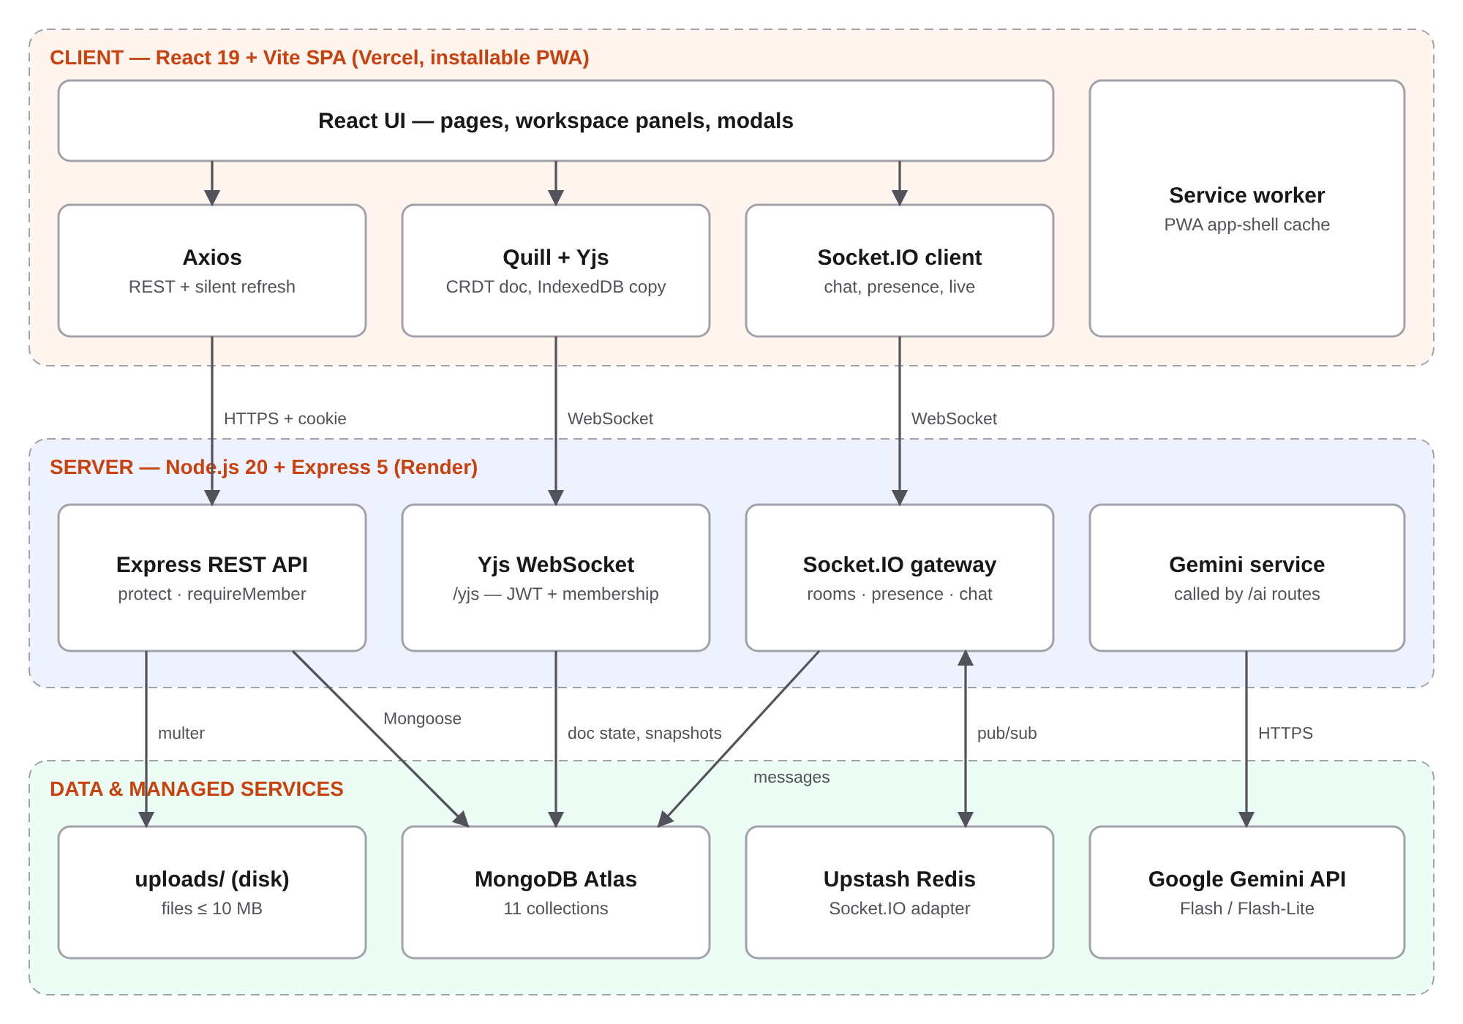
Figure 1: High-level architecture of StudySync

4.2 Three Communication Channels
The client talks to the server over three separate channels, each chosen for the kind of data it carries:
- REST over HTTPS (Axios) for request/response operations: authentication, creating spaces, uploading files, loading history, AI requests. Axios interceptors attach the access token and refresh it silently.
- Socket.IO for event-style real-time features: chat, typing indicators, presence, and "live updates" such as member counts, pins and notifications. Socket.IO provides rooms, acknowledgements and automatic reconnection.
- A raw Yjs WebSocket (/yjs) for the shared notes. Yjs exchanges compact binary CRDT updates, which do not fit Socket.IO's JSON event model well, so the editor uses the standard y-websocket protocol on its own endpoint.
Both WebSocket channels authenticate with the same short-lived access token and check space membership before joining a room, so the security model is identical to the REST API.

4.3 Request Lifecycle
Every protected REST request passes through a fixed middleware chain before reaching a controller: rate limiter, protect (verifies the JWT access token), requireMember (loads the caller's membership for the space in the URL), optionally requireOwner (checks the role), input validation with express-validator, then the controller. Errors from any stage are handled by a single global error middleware, which keeps controllers free of repetitive try/catch formatting.

4.4 Project Structure
The repository is a monorepo with two independent packages. The client (client/, about 9,900 lines of JavaScript/JSX) is organised into pages, feature components (space/, auth/, landing/, layout/), a small UI library, React contexts for authentication and sockets, and hooks. The server (server/, about 5,600 lines) follows a conventional MVC-style layout: config/ (database, Redis, Socket.IO, Yjs, mailer), middleware/, models/ (11 Mongoose schemas), controllers/ (13 controllers), routes/, services/ (Gemini) and utils/ (sessions, notifications, activity logging, join codes).

5. Technology Stack
Technologies were chosen for fit with real-time collaboration and for availability on free hosting tiers. The table lists each major choice and the reason it was selected over alternatives.
Table 3: Technology choices and rationale
Layer | Technology | Why it was chosen
Frontend | React 19, Vite 8, React Router 7 | Component model suits a panel-based workspace; Vite gives fast builds and HMR
Styling | Tailwind CSS 4, GSAP 3 | Design tokens for light/dark themes; GSAP for landing-page motion
Editor | Quill 2 + quill-cursors | Mature rich-text editor with an official Yjs binding (y-quill)
Collaboration | Yjs 13.6, y-websocket, y-indexeddb | CRDT guarantees convergence without a central lock; IndexedDB enables offline
Real-time | Socket.IO 4.8 + Redis adapter | Rooms, acks and reconnection out of the box; Redis adapter for multi-instance
Backend | Node.js 20, Express 5 | Single language across stack; non-blocking I/O suits many open sockets
Database | MongoDB Atlas, Mongoose 9 | Flexible documents for varied resource/pin types; stores binary Yjs state
Cache / pub-sub | Upstash Redis (ioredis) | Serverless Redis with TLS; backs Socket.IO rooms and presence
Auth | jsonwebtoken, bcryptjs, google-auth-library | Stateless access tokens plus server-side refresh sessions; Google sign-in
AI | Google Gemini (Flash, Flash-Lite fallback) | Fast, low-cost model with a generous free tier
Uploads / mail | multer, NodeMailer | Standard, well-understood libraries for files and SMTP invites
PWA | vite-plugin-pwa | Generates manifest and service worker for offline app shell
Hosting | Vercel (client), Render (server) | Free tiers; Render supports persistent WebSockets, unlike serverless hosts

6. Database Design
The data model has eleven MongoDB collections. The study space is the aggregate root: almost every other collection is scoped to a space through a spaceId reference, which makes authorisation simple (one membership check per request) and makes deleting a space a clean cascade. Figure 2 shows the main entities and relationships.
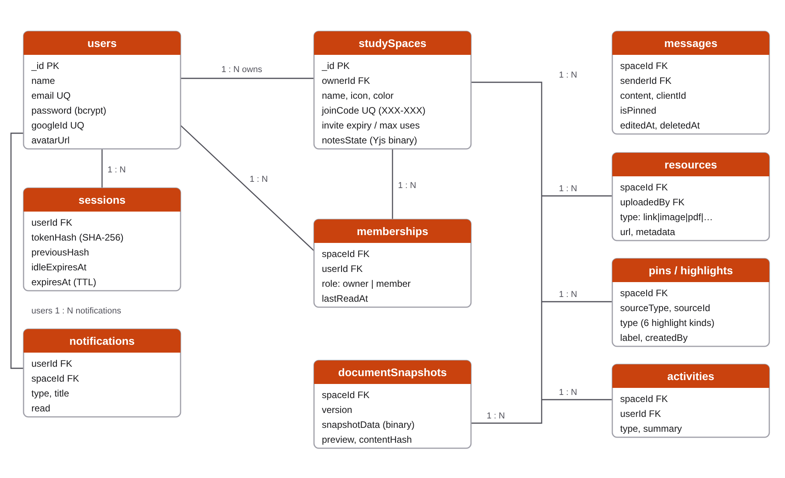
Figure 2: Entity-relationship diagram (simplified)
Table 4: Collections and their purpose
Collection | Purpose | Notable design decisions
users | Accounts | Password hashed with bcrypt and excluded from queries by default; optional googleId
sessions | Refresh-token sessions | Stores only a SHA-256 hash of the secret; TTL index deletes expired sessions automatically
studySpaces | Spaces and invite settings | Holds the Yjs document as binary (notesState) plus an HTML copy for search and AI
memberships | User ↔ space join table | Unique (spaceId, userId) index; role and lastReadAt drive permissions and unread counts
messages | Discussion | clientId for optimistic de-duplication; soft delete via deletedAt
resources | Links, files, snippets | Type-specific metadata in a flexible object
pins / highlights | Knowledge capture | Polymorphic reference (sourceType + sourceId) to messages, resources or notes
activities | Activity feed | Indexed by (spaceId, createdAt) for fast reverse-chronological reads
documentSnapshots | Note versions | Unique (spaceId, version); content hash prevents duplicate versions
notifications | In-app notifications | Indexed by (userId, read, createdAt) for the unread badge

MongoDB was a good fit because resources, pins and highlights have heterogeneous shapes, and because the CRDT state is an opaque binary blob that a document store handles naturally. The trade-off is that integrity rules a relational database would enforce (foreign keys, cascading deletes) are implemented in application code, so the delete-space path in particular must remove dependent documents explicitly.

7. Module Implementation

7.1 Authentication and Sessions
Authentication uses a two-token design that balances security against user experience. On login the server returns a 15-minute access token (JWT), which the client keeps in memory only, and sets a refresh token in an httpOnly cookie scoped to /api/auth that page scripts cannot read. The database stores only the SHA-256 hash of the refresh secret. Figure 3 shows the flow.
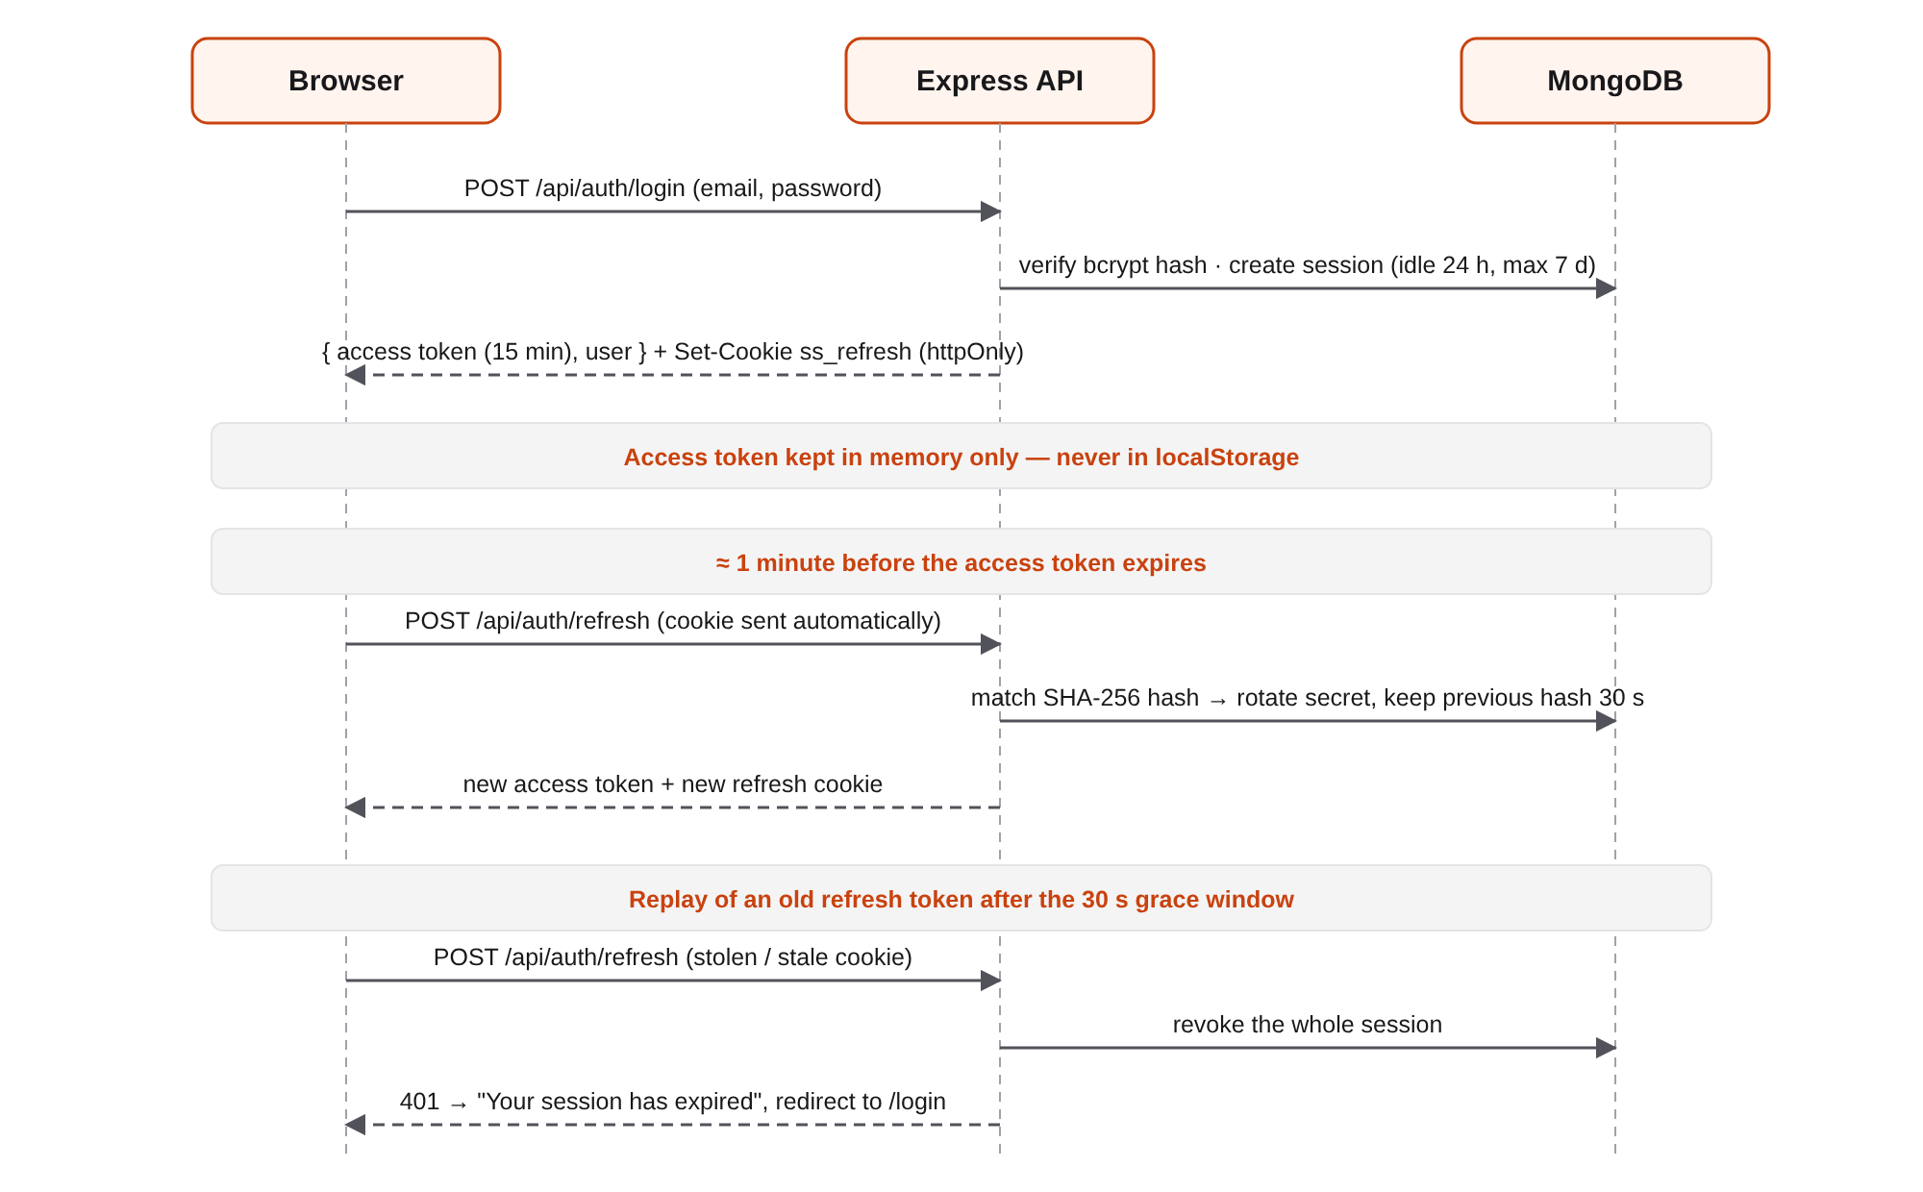
Figure 3: Login, silent refresh and refresh-token reuse detection
About one minute before the access token expires, the client calls /api/auth/refresh. The server rotates the secret on every refresh, so a stolen refresh token is useful for at most one use. Two browser tabs refreshing at the same moment would normally look like token theft, so the previous hash is honoured for a 30-second grace window. A replay outside that window revokes the entire session. Sessions also expire after 24 hours idle and 7 days absolute. Changing a password signs out every other device. Google sign-in verifies the ID token server-side with google-auth-library and links or creates the account.

7.2 Study Spaces, Membership and Invites
Creating a space makes the creator its owner and generates a join code in XXX-XXX format using an alphabet without look-alike characters (O/0, I/1/L). Codes are accepted in any case, with or without the dash, or as a pasted full link. The owner controls invitations: they can pause joining without changing the code, set an expiry (presets or 1 to 365 days), cap the number of joins (1 to 1,000), regenerate the code to invalidate old links, and send email invitations through NodeMailer. On every join the server checks, in order, that invites are enabled, the code exists, it has not expired and the use limit has not been reached.
The permission model is a simple two-role RBAC. Members can read, edit notes, chat, share, pin, highlight, use the AI and manage versions. Owners can additionally edit or delete the space, remove members, manage invite settings and delete anyone's content.

7.3 Real-Time Collaborative Notes (CRDT)
Collaborative editing is the hardest technical problem in the project. The naive approach (broadcast the whole document or raw editor operations) fails under concurrency: if two students type at the same position at the same time, one edit overwrites the other. StudySync uses Yjs, a CRDT (Conflict-free Replicated Data Type) library. Every client holds a full replica of the document; edits are encoded as operations with unique identifiers that can be applied in any order and still produce the same result. Replicas therefore converge mathematically without locks or a central arbiter.
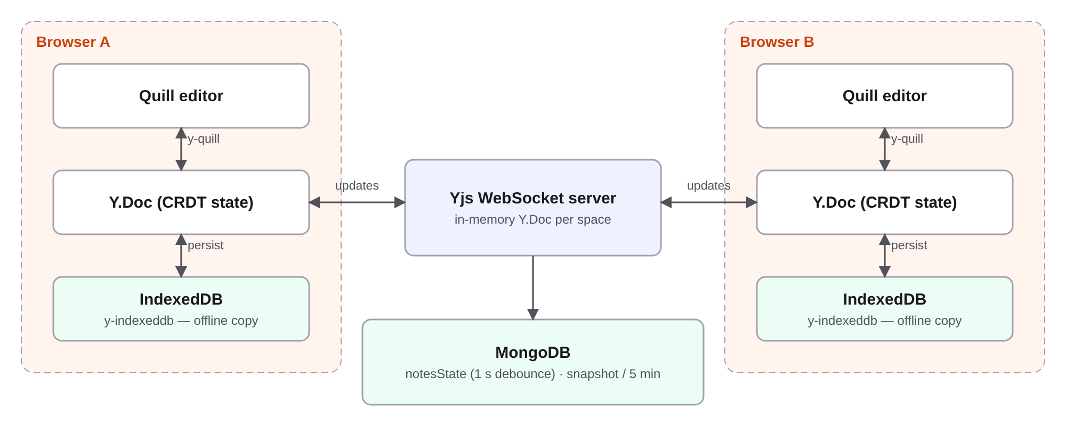
Figure 4: Collaborative editing and offline persistence with Yjs
Quill is bound to the Yjs document through y-quill, and quill-cursors shows each collaborator's cursor and selection. The server runs the y-websocket protocol on /yjs, authenticating the token and membership during the WebSocket upgrade. It keeps one in-memory document per active space, writes the binary state to MongoDB with a one-second debounce, and records a version snapshot at most every five minutes (keeping the latest 50) so history stays readable rather than recording every keystroke.

7.4 Offline-First Editing and PWA
The most recent iteration made the application offline-first. The Yjs state is persisted to the browser's IndexedDB with y-indexeddb, so edits made offline survive page reloads. When the connection returns, the client and server exchange state vectors and send only the missing updates; the CRDT merges them automatically. The editor shows its status as Live Sync, Offline or Syncing, plus "Saved on this device".
Several edge cases were handled explicitly: a dropped connection (WebSocket close code 1006) is no longer misreported as an authentication failure; an expired access token is renewed before reconnecting; a reload while the server is unreachable keeps the user signed in from a cached profile, and only a real 401 from the server signs them out. The dashboard, workspace and recent chat fall back to a per-user cache that is cleared on logout. vite-plugin-pwa adds an installable manifest and a service worker that precaches the app shell, so the application loads with no network at all.

7.5 Discussion and Live Updates
Messages are sent over Socket.IO with a client-generated clientId. The sender renders the message optimistically and the server's acknowledgement replaces it, using the clientId to avoid duplicates. Edits, deletions and typing indicators are broadcast to everyone viewing the space. Unread counts are computed from each membership's lastReadAt.
Live updates use three kinds of Socket.IO room, which together ensure every open tab, including the dashboard, stays current without refreshing:
Table 5: Socket.IO room types
Room | Who is in it | Events delivered
space:<id> | Tabs that currently have the space open | Chat, typing, presence, pins, files, highlights, activity
watch:<id> | Every open tab of every member of the space | Member joined/left, space edited or deleted, new-message ping for unread badges
user:<id> | All tabs of one user | Notifications, added/removed from a space, read state across tabs

After a reconnect, the dashboard and workspace re-fetch their data, so events missed while offline are not lost.

7.6 Knowledge Capture: Resources, Pins, Highlights and Search
Resources can be links, images, PDFs, office documents or code snippets. Uploads go through multer with an explicit MIME allow-list, a 10 MB limit and server-generated random filenames, which prevents path traversal and misleading double extensions. Pins surface the definitive answer to a question, and highlights classify content as important, exam-important, doubt, solution, reference or to-do, which is what lets a late joiner catch up in minutes. Every significant action is written to the activity feed.
Search runs across spaces, messages, resources, pins and highlights, always restricted to spaces the caller belongs to. The implementation deliberately uses escaped, case-insensitive substring matching instead of MongoDB's $text search, because students searching "normal" expect to find "normalization", which stemmed text search misses.

7.7 Version History
Members can save a version on demand or rely on automatic snapshots. Each snapshot stores the binary Yjs state, a plain-text preview and a SHA-256 hash of the Quill delta (text plus formatting). The hash means "Save now" only creates a version when the content actually changed, while formatting-only changes such as making a word bold still count. Restoring a version applies it to the live document so every connected editor sees the restored text immediately.

7.8 AI Study Assistant
The assistant uses Google Gemini Flash, falling back to Flash-Lite when the main model is overloaded. It offers five modes, all grounded in the space's own content:
Table 6: AI assistant modes
Mode | What it does | Input
Ask | Answers questions about the space; general-knowledge answers are labelled as such | Shared notes
Summarize | Summarises the discussion | Recent chat messages
Quiz | Generates a 5-question multiple-choice quiz | Shared notes
Explain | Explains a selected passage in context | Selection + surrounding notes
Revision Notes | Turns notes into a structured revision sheet | Shared notes

Because the notes and chat are written by users, they are a prompt-injection vector. The service wraps all member content in XML-style tags (<notes>, <messages>) and the system instruction tells the model to treat tagged text purely as study material and never follow instructions inside it. Inputs are clipped to a maximum length, each request has a timeout, and the AI routes are rate-limited to 30 requests per user per 15 minutes to control cost.

7.9 User Interface
The interface offers Light, System and Dark themes built on shared design tokens (neutral zinc greys, one orange accent, Geist for body text and Instrument Serif for headings). The workspace adapts to five layouts: a scrolling tab strip on phones, a hidden top bar on landscape phones, an icon rail with a slide-over chat on portrait tablets, a docked chat on landscape tablets, and a labelled sidebar with a wide chat column on desktops. On touch screens, actions that normally appear on hover are always visible.

8. Security Design
Security was treated as a first-class requirement rather than an afterthought. The table maps each threat to the control that addresses it.
Table 7: Threats and mitigations
Threat | Mitigation
Token theft via XSS | Access token kept in memory only; refresh token in an httpOnly cookie unreadable by scripts
Stolen refresh token | Rotation on every refresh; reuse after the 30 s grace window revokes the whole session
Database leak exposing sessions | Only SHA-256 hashes of refresh secrets are stored; passwords hashed with bcrypt
Unauthorised access to a space | requireMember / requireOwner on REST; membership checked on Socket.IO join and Yjs upgrade
Brute force / abuse | Per-route rate limits: auth 20/15 min, API 200/15 min, uploads 30/15 min, AI 30/15 min, email 15/hour
Malicious uploads | MIME allow-list, 10 MB cap, random server-side filenames
Injection via search | User queries are regex-escaped before matching
Invalid input | express-validator rules on every write route
Prompt injection through notes | Member content tagged as material; model instructed never to follow it
Cross-site cookie misuse | Secure; SameSite=None; Partitioned cookies in production; CORS restricted to the client origin

9. API and Real-Time Interface
The REST API exposes around 50 endpoints grouped by resource. All space-scoped routes are nested under /api/spaces/:spaceId/…, which lets one membership middleware protect the whole subtree.
Table 8: REST API overview
Group | Representative endpoints | Access
Auth | POST /api/auth/register, /login, /google, /refresh, /logout; GET /me; PATCH /profile, /password | Public / cookie / JWT
Spaces | POST /api/spaces, GET /api/spaces, POST /join, PATCH /:id, DELETE /:id | JWT, member, owner
Members & invites | GET /members, POST /leave, DELETE /members/:userId, POST /invites, /invites/regenerate, /invites/email | Member / owner
Content | /messages, /resources, /pins, /highlights, /activity | Member; delete by author or owner
Versions | GET /versions, POST /versions/save, POST /versions/:v/restore | Member
AI | POST /ai/ask, /summarize, /quiz, /explain, /revision-notes | Member, rate-limited
Search & notifications | GET /api/search?q=, GET /api/notifications, PATCH /read-all | JWT

Over Socket.IO the client emits a small set of events (join_space, leave_space, send_message, typing_start/typing_stop, presence_request), and the server pushes around twenty event types covering presence, messages, pins, resources, highlights, activity, membership changes, space edits and notifications.

10. Testing and Validation
Testing focused on the areas where bugs are most expensive: session security, real-time delivery and layout across devices.
Table 9: Testing performed
Area | Method | Result
Sessions | Scripted HTTP tests against a test server and temporary database: rotation, two-tab race, reuse detection, expiry, logout, idle and max age, password change, cookie flags | 24 / 24 passing
Live updates | Two users with two real Socket.IO connections: join/leave counts, rename, message pings, read sync, removal, delete delivered once, invite codes in any case | 17 / 17 passing
Collaboration | Two users typing simultaneously; disconnect for 10 s and reconnect; editing different parts of the document | Converged correctly
Authorisation | Non-member attempts to open a space, Socket.IO room and Yjs document | Rejected
UI | Manual browser checks at phone, tablet (both orientations) and desktop sizes, in light and dark | Passed
Build | npm run build and oxlint on the client for every change | Clean

Honest assessment
The session and live-update test scripts were run during development but are not committed to the repository, and npm test in server/ is still a placeholder. The results above therefore cannot be reproduced by a reviewer or run in CI. Committing those scripts as an automated suite is the single most valuable next step for code quality.

11. Deployment
StudySync runs entirely on managed services. The frontend and backend are deployed separately because they have different hosting needs: the client is static files, while the server must hold long-lived WebSocket connections.
Table 10: Production deployment
Component | Platform | Configuration notes
Frontend | Vercel | Root client/; vercel.json rewrites every path to index.html so deep links and refreshes work
Backend | Render | Root server/, npm start; CLIENT_URL must match the Vercel origin exactly for CORS and invite links
Database | MongoDB Atlas | Render's outbound IPs allowed in Network Access
Realtime | Upstash Redis | rediss:// (TLS) URL; separate pub and sub clients with retry back-off
AI | Google Gemini API | API key on Render; model and fallback configurable by environment variable

Render's free tier sleeps after inactivity, which would make the first request after idle take up to a minute. The server pings its own health endpoint every five minutes in production to stay awake. Because the frontend and backend are on different sites, the refresh cookie is a cross-site cookie; Chrome, Edge and Firefox accept it, but Safari and Brave block it, so users of those browsers must log in again when the 15-minute access token expires.

12. Limitations and Critical Evaluation
The project meets its functional goals, but several design decisions do not hold up beyond a single small deployment. They are listed here plainly because they define what must change before StudySync could serve real traffic.
- The collaborative editor does not scale horizontally. Socket.IO uses the Redis adapter, so chat and live updates would work across several server instances. The Yjs server, however, keeps each document in process memory and does not share updates through Redis. With two instances, two users of the same space connected to different servers would edit diverging copies, and each server would overwrite the other's state in MongoDB. Scaling requires sticky routing by space ID or a shared Yjs backend (for example y-redis or Hocuspocus).
- Uploaded files are stored on the server's local disk. Render's filesystem is ephemeral, so uploaded files are lost on every redeploy or restart while the database still references them. Files should move to object storage such as S3, Cloudflare R2 or Cloudinary.
- No committed automated tests. As noted in Section 10, the passing test runs cannot be reproduced and nothing prevents regressions. There is also no CI pipeline.
- Search does not cover the shared notes and uses unindexed regular-expression scans. This is acceptable for small groups but will degrade as message volume grows.
- Cross-site cookies are fragile. Safari and Brave block the refresh cookie. Serving the API from a subdomain of the frontend's domain would make it first-party and remove the problem.
- Free-tier hosting means cold starts, limited memory and no uptime guarantees; the self-ping is a workaround rather than a solution.
- Two roles only. There is no moderator role, so an owner cannot delegate management.

13. Future Enhancements
Ordered by impact relative to effort:
- Commit an automated test suite and CI (Jest/Vitest plus Supertest and socket.io-client), starting from the existing session and live-update scripts.
- Move uploads to object storage with signed URLs, removing data loss on redeploy.
- Make collaboration horizontally scalable with a Redis-backed Yjs provider or sticky sessions keyed by space.
- Include notes in search and add proper indexes or Atlas Search for larger groups.
- Moderator role and finer-grained permissions (read-only members, locked notes).
- Spaced-repetition flashcards generated from highlights tagged exam-important.
- Retrieval-augmented AI over resources (PDF text) as well as notes, with citations back to the source.
- Observability: structured logging, error tracking and basic usage metrics.

14. Conclusion
StudySync shows that the fragmented group-study workflow can be consolidated into a single focused workspace without sacrificing the real-time quality students expect from dedicated tools. The project goes well beyond a typical CRUD application: it combines CRDT-based collaborative editing, an offline-first client with automatic merge, three coordinated real-time channels, a rotating refresh-token session model with reuse detection, and an AI assistant grounded in the group's own material with prompt-injection safeguards.
The main lessons were architectural. Choosing the right data structure (a CRDT) eliminated an entire class of concurrency bugs that would otherwise dominate the project. Treating security and failure handling as requirements from the start produced a noticeably more robust system than adding them later would have. Equally, the limitations in Section 12 show where a working prototype differs from a production system: horizontal scaling of stateful components, durable file storage and reproducible automated testing. Addressing those three items is the clear path from a strong course project to a deployable product.

References
- Shapiro, M., Preguiça, N., Baquero, C., Zawirski, M. (2011). Conflict-free Replicated Data Types. Proc. 13th Int. Symp. on Stabilization, Safety, and Security of Distributed Systems.
- Nicolaescu, P., Jahns, K., Derntl, M., Klamma, R. (2016). Near Real-Time Peer-to-Peer Shared Editing on Extensible Data Types. Proc. ACM GROUP. (The Yjs algorithm.)
- Yjs documentation: https://docs.yjs.dev
- Socket.IO documentation and Redis adapter: https://socket.io/docs/v4/
- Express 5 documentation: https://expressjs.com
- Mongoose documentation: https://mongoosejs.com/docs/
- OWASP Cheat Sheet Series: JSON Web Token and Session Management. https://cheatsheetseries.owasp.org
- IETF RFC 6749: The OAuth 2.0 Authorization Framework (refresh-token rotation guidance in the OAuth 2.0 Security BCP).
- Google Gemini API documentation: https://ai.google.dev
- StudySync Product Requirements Document (StudySync_PRD.md) and README, project repository.

