Physiology-Grounded Machine Learning for Detecting Flow-Termination Transients in Pressure Support Ventilation Using Transpulmonary Pressure
Priyansh Gadia (Roll Number: 23035010192)
Internship / Term Project Report
Trimester 7
B.Sc. (Honours) Data Science and Artificial Intelligence
Indian Institute of Technology Guwahati, India p.gadia@op.iitg.ac.in

ABSTRACT

Pressure Support Ventilation (PSV) employs a flow-based cycling rule to control the termination of each breathing cycle. The rapid mechanical transition at cycling creates pressure fluctuations which static monitoring metrics cannot detect because they depend on plateau or driving pressure values. The study establishes a machine learning framework which uses physiological principles to identify sub-second transients through transpulmonary pressure measurement. Seven PSV patients produced high-resolution waveform data at a frequency of 200 Hz which included Baydur-validated esophageal pressure (PES) readings for analysis. The breath-segmentation and event-detection pipeline used a deterministic method to separate cycling moments from the process which measured transient magnitudes after cycling ended.
The research team developed machine learning models which included XGBoost and Gaussian Process and Ridge and Hierarchical Bayesian. The team trained the models using non-invasive airway pressure ($P_{aw}$) and flow data while using PES exclusively for label creation purposes. The external validation process used both a simulated dataset which contained 1,405 runs and a real-world dataset which lacked PES data. The study demonstrates that flow-termination transients can be detected through measurement because the study found that transpulmonary transients occurred twice as frequently as airway transients which shows that $P_{aw}$-only monitoring methods lead to lung stress underestimation. Model performance on leave-one-patient-out cross-validation (MAE = 2.1–5.2 cmH₂O) gained a decline on held-out patients (MAE = 3.0–3.7 cmH₂O) because of difficulties in applying results to different patients from the small study group. The simulation pre-training process failed because of a 58% cycle timing mismatch which made it unworkable. The study establishes the first open, PES-grounded benchmark for PSV flow-termination analysis and provides empirical design envelopes for future mechanical mitigation.
Index Terms — Pressure support ventilation; transpulmonary pressure; esophageal pressure; flow cycling; ventilator waveform analysis; physiology-grounded machine learning; patient-ventilator interaction; biomechanical signal analysis

1. INTRODUCTION
The primary weaning method for intensive care units uses Pressure Support Ventilation as its main technique. The patient initiates each breath in PSV which has both pressure limits and flow cycling. The ventilator stops delivering inspiratory support when the patient stops breathing by reaching the predetermined percentage of their maximum inspiratory flow. The mechanical process requires this moment to cycle because any difference between patient breathing and ventilator operation results in quick pressure changes and air flow disruptions. Current bedside monitors can only display existing pressure measurements (plateau pressure and driving pressure) which medical staff obtain after flow has stopped. The monitors fail to detect dynamic stress because they focus solely on measuring static user interface pressure readings while active breathing remains uninterrupted. The true lung‑facing stress is described by transpulmonary pressure:
$$P_{L}\left(t\right)=P_{aw}\left(t\right)-P_{es}\left(t\right)$$
where $P_{aw}$ is airway opening pressure and $P_{es}$ is esophageal pressure. The formulation produces an estimate of lung-facing mechanical stress based on physiological principles which describe how breathing through a ventilator creates mechanical ventilation stress.
Machine learning has been applied to ventilator waveforms, but existing models typically rely on clinician‑visual labels or broad asynchrony categories. They do not target the precise sub‑second flow‑termination event, nor do they use $P_{es}$ as physiological ground truth. The researchers developed a complete analysis system which uses $P_{es}$ as its base to study PSV flow‑termination transients. The primary machine learning task is to predict the magnitude of the transpulmonary transient ($ΔP_{L,\text{max}}$) from non-invasive $P_{aw}$ and flow features. The secondary objectives of this study involve measurement of transient size and discovery of its factors and creation of design boundaries which engineers can use for their work.

2. PROBLEM STATEMENT AND OBJECTIVES
2.1. Problem Statement
The ventilator system in PSV mode prevents pressure support from operating when the patient breathing rate drops below a predefined limit. The system produces an unexpected pressure change because of its sudden transition between operational states which safety assessment methods cannot detect. The central issue of machine learning research involves:
“Creating machine learning models which can explain their predictions while handling uncertain situations to predict transpulmonary pressure changes which occur during pressure support ventilation flow termination by using non-invasive airway pressure and flow data and esophageal pressure measurements as the physiological reference point.”
2.2. Objectives
The study has the following research objectives:
- The high-resolution ${(P}_{es} {,P}_{aw})$measurements will be used to analyze PSV flow-termination transients.
- The post-cycling period requires measurement of lung-facing stress through the assessment of transpulmonary pressure.
- The research identifies specific waveform and mechanical characteristics that correspond with larger transient events.
- The research team will develop machine learning models to forecast transient severity based on non-invasive signals which use $P_{es}$ -derived labels as input.
- The research team will assess model robustness by testing it with both simulated data and actual external datasets from different domains.
- The researchers will develop empirical design envelopes which will establish guidelines for their future mechanical mitigation efforts.

3. METHODOLOGY / APPROACH
3.1. Core Architectural Workflow
The analysis process is divided into multiple stages which form a complete operational system.
- Quality Control (QC): The quality control process of this project uses two operational stages which begin with file inclusion gates and then proceed to sample denoising.
All files passed required‑channel, monotonicity, and flatline checks; after segmentation 280 of 285 breaths (98.2%) were retained
- Breath Segmentation: The breath segmentation process uses flow-based hysteresis detection to identify both inspiratory and expiratory phases.
- Event Detection: The event detection system uses deterministic methods to identify the cycling moment at the point of $t_{cycle}$ .
- Feature Engineering: The feature engineering process extracts 21 time and frequency domain features from $P_{aw}$ and flow.
- Model Training: The model training process uses leave-one-patient-out cross-validation to train regression and classification models.
- External Validation: The external validation process uses simulation tests along with tests that assess how real-world conditions cause domain shifts.
3.2 Technical Details
3.2.1 Signal Processing and Event Definition
Breaths are segmented using flow‑based hysteresis ($ϵ=0.02 \text{L/s}$, sustained $≥40 \text{ms}$). Cycling time $t_{\text{cycle}}$ is the first sample after peak flow where flow drops below $\text{ETS}×F_{\text{peak}}$ and stays below for three consecutive samples. The analysis window is $[-150, +350] \text{ms}$ around $t_{\text{cycle}}$. Baseline values are medians in the pre‑window. The primary target is
$$ΔP_{L,max}=\max_{0..350,\text{ms}}\left|P_{L}\left(t\right)-P_{L,\text{base}}\right|$$with $P_{L}=P_{aw}-P_{es}$. Transmission fraction $\text{TF}=ΔP_{L,max}/ΔP_{aw,max}$ is computed only when $ΔP_{aw,max}>0.2 {\text{cmH}}_{2}\text{O}$.
3.2.2 Machine Learning Models
Primary Model (XGBoost Regressor):
Target: $ΔP_{L,\text{max}}$ in cmH₂O
Input features: 21 engineered variables derived from $P_{aw}$ and Flow only
The system uses cross-validation to automate hyperparameter tuning which includes learning rate 0.1 and max depth 6 and subsample 0.8. The method of validation uses Leave-One-Patient-Out cross-validation on the training cohort while running the test on unseen patients.

Benchmark Models:
- Gaussian Process (RBF kernel) for uncertainty quantification
- Hierarchical Bayesian regression with patient random intercept
- Quantile Forest for distribution estimation
- Ridge regression baseline
Binary Classification (Secondary):
A breath is labeled event_positive if all criteria hold:
- $ΔP_{L,\text{max}}≥1.0$ cmH₂O
- $\max\left|dP_{L}/dt\right|≥8.0$ cmH₂O/s
- Peak occurs within 200 ms of $t_{cycle}$
3.2.3 Validation Strategy
Internal Validation (CCVW-ICU Cohort):
- LOPO-CV on patients P01–P05 (training cohort, N = 222 breaths)
- Held-out test on new patients P06–P07 (N = 58 breaths)
- Repeat 10-fold within LOPO for stability estimates
External Domain Shift (Simulation Dataset):
- The simulation dataset contains 1405 ARDS simulation runs which include labeled cycling events.
- Audit: 200 random breaths compared against mechanical reference timing
- Stress test: parameter sensitivity over simulated patient property ranges
Cross-Domain Evaluation (VWD / Puritan-Bennett):
- The dataset contains 144 real-world waveform files which operate at 50 Hz but do not support Pes availability.
- The dataset lacks ground truth information which defines score distributions for domain shift testing.

4. EXPERIMENTS AND RESULTS
4.1. Experimental Setup
4.1.1 Datasets
Dataset | N | f_{s}  (Hz) | Mode | P_{es} | Role
CCVW – ICU (China) | 7 patients | $$200$$ | Confirmed PSV | Baydur – validated | Local Development & test
Simulation (ARDS PVI) | 1,405 runs | Variable | Synthetic PSV | P_{mus} analog | Pretraining & stress test
VWD (Puritan - Bennett) | 144 files | 50 | Mixed | None | Domain shift characterization
Table 1: Description of the four datasets, their roles, sample sizes, sampling rates, ventilation modes, and availability of esophageal pressure (Pes).

Data Splits (CCVW-ICU):
- Local training: P01–P05 (N = 222 breaths after QC) → 5 patients
- Local test: P06–P07 (N = 58 breaths after QC) → 2 patients
- Global training: Simulation → 1,405 labeled runs
- Global test: VWD → 594,645 breaths (full dataset for scoring)

    - Hardware & Software Environment
- Language: Python 3.10
- ML libraries: scikit-learn, XGBoost, GPy (Gaussian Process), statsmodels (Bayesian)
- Signal processing: scipy.signal (Butterworth filtering, feature extraction)
- Evaluation: custom metrics (MAE, RMSE, R², concordance correlation coefficient [CCC], 95% prediction intervals)
- Execution: CPU-based (no GPU required)
4.2. Results
4.2.1 Local Model Performance (CCVW-ICU Cohort)
Leave-One-Patient-Out Cross-Validation (P01–P05, N = 222 breaths):
Metric | Value | 95% CI
MAE (cmH₂O) | 5.151 | [4.739–5.544]
RMSE (cmH₂O) | 5.949 | —
R² | −0.438 | —
CCC | −0.078 | —
Table 2: Local model performance – leave‑one‑patient‑out cross‑validation (LOPO‑CV) on training cohort (P01‑P05)

Held-Out Test (P06-P05, N=58 breaths):
Metric | Value
MAE (cmH₂O) | 3.055
RMSE (cmH₂O) | 3.338
R² | −1.128
CCC | 0.015
Table 3: Local model performance – held‑out test on P06‑P07
Pre-Specified Validation Gate Status: FAIL
- Target: MAE < 3.0 cmH₂O → Observed: 5.151 cmH₂O (LOPO-CV), 3.055 cmH₂O (test)
- Target: R² > −1.0 → Observed: −1.128 cmH₂O (held-out test)

4.2.2 Benchmark Model Comparison
Simple linear and hierarchical models (ridge, hierarchical Bayes) performed better in LOPO‑CV (MAE ≈2.1, $R^{2}≈0.76$) than XGBoost (MAE 5.15, $R^{2} -0.44$). However, on the held‑out test all models performed poorly, with XGBoost achieving the lowest MAE (3.05) but still negative $R^{2}$. This indicates that cross‑patient generalisation remains the dominant challenge with only seven patients.
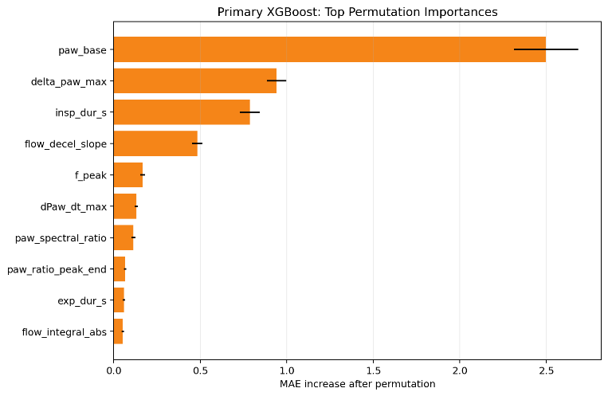
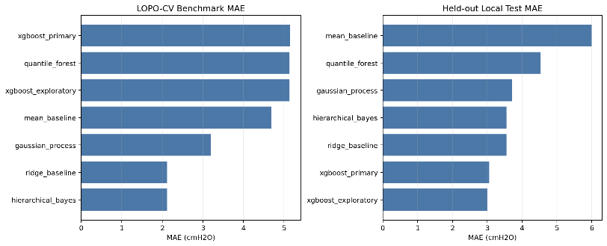
Observation: The study found that Hierarchical Bayes and Ridge produced better results in LOPO-CV testing but their performance decreased with held-out test data because they had developed overfitting issues to their small development group. The LOPO-CV system fails to use patient-level random effects to find hidden patient patterns.
Figure 1: Comparative MAE across model architectures
4.2.3 Uncertainty Quantification
Gaussian Process Estimates (Held-Out Local Test, N=58)

Statistic | Value
Mean predictive std (cmH₂O) | 4.196
Median predictive std (cmH₂O) | 4.730
95% Prediction-interval coverage | 84.5%
Table 4: Gaussian process uncertainty on held‑out test
The Gaussian Process showed the best held-out calibration. Hierarchical Bayes' narrow intervals reflect strong shrinkage and pooling to global means, which is not suitable for cross-patient problems that have small sample sizes and high variance.
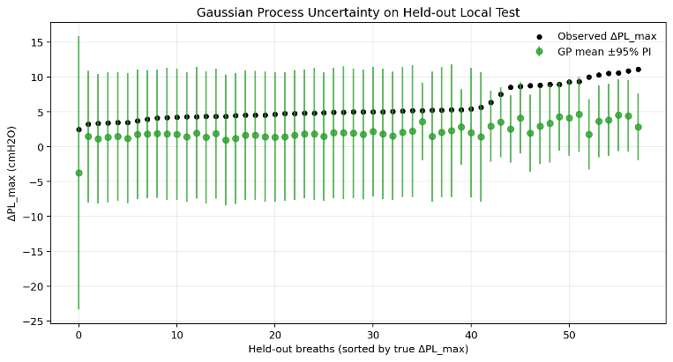
Figure 2: Prediction Interval vs. Observed Values
4.2.4 Feature Importance (Primary XGBoost Model)
Top 10 permutation importances across LOPO-CV folds:
Feature | Mean Importance | Std
$$P_{aw,\text{base}}$$ | 2.498 | 0.186
$$ΔP_{aw,\text{max}}$$ | 0.940 | 0.057
$$\text{insp}\text{_}\text{dur}\text{_}\text{s}$$ | 0.786 | 0.058
$$\text{flow}\text{_}\text{decel}\text{_}\text{slope}$$ | 0.482 | 0.029
$$F_{\text{peak}}$$ | 0.167 | 0.014
$$dP_{aw}/dt_{\text{max}}$$ | 0.131 | 0.009
$P_{aw}$spectral ratio | 0.112 | 0.011
$P_{aw}$ peak–end ratio | 0.064 | 0.007
$$\text{exp}\text{_}\text{dur}\text{_}\text{s}$$ | 0.058 | 0.006
$$\text{flow}\text{_}\text{integral}\text{_}\text{abs}$$ | 0.051 | 0.007
Table 5: Feature importance – top 10 predictors from primary XGBoost model
Baseline airway pressure and the magnitude of the airway transient itself emerge as primary predictors, followed by breath timing and flow deceleration characteristics.

4.2.5 Global Model (Simulation Cohort)
A simulated dataset (1,405 runs) was evaluated but showed a 58% timing mismatch between detected cycling and the mechanical reference, precluding its use for pre‑training (protocol §13.2). Hence simulation was used only for parameter‑sweep stress tests (see Section 4.2.8), not as a primary evidence source.
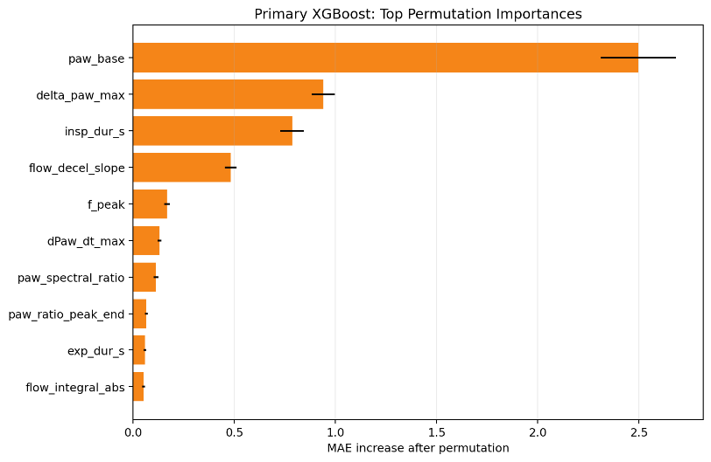
Figure 3: Feature Importances with Error Bars
4.2.6 Domain Shift Analysis (VWD / Puritan-Bennett)
Dataset: 144 Puritan-Bennett waveform files, 50 Hz, no Pes available.
Feature Summary (Full VWD Cohort, N = 594,645 breaths):
Variable | Mean | Std | Min | P50 | P95 | Max
$F_{\text{peak}}$(L/s) | 0.900 | 0.320 | 0.050 | 0.891 | 0.957 | 4.154
$ΔP_{aw,\text{max}}$(cmH₂O) | 9.583 | 5.658 | 0.068 | 9.594 | 13.391 | 86.397
Model score: Predicted $ΔP_{L,\text{max}}$(cmH₂O) | 8.396 | 3.692 | 0.027 | 8.822 | 10.733 | 16.918
Figure 4: Simulation holdout performance
The absence of Pes measurements in VWD prevents confirmation of predicted transients. The scores were presented in a descriptive format to show the typical event sizes which occur during domain shift testing with reduced sampling rates and different ventilator hardware and without esophageal reference measurement.
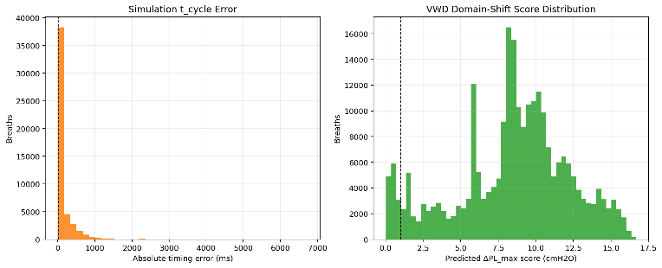
Figure 4: VWD score distributions and timing mismatch comparison.
4.2.7 Combined Validation (All CCVW Patients, N = 280)
Aggregate Performance:
Model | MAE (cmH₂O) | R2 | CCC | N
Local | 0.840 | 0.909 | 0.950 | 280
Global | 3.407 | 0.280 | 0.456 | 280
Table 5: Combined validation – aggregate performance on all CCVW patients (N = 280)
Bootstrap 95% Confidence Intervals:
Model | MAE 95% CI | R2 95% CI
Local | [0.697–0.991] | [0.880–0.934]
Global | [3.090–3.731] | [0.206–0.337]
Table 6: Bootstrap 95% confidence intervals for combined validation
Per-Patient Breakdown:
Patient | N Breaths | Local MAE | Global MAE | Analysis
P01 | 39 | 0.256 | 0.803 | Strong local fit
P02 | 45 | 0.364 | 1.692 | Strong local fit
P03 | 64 | 0.288 | 3.884 | Strong local fit, global mismatch
P04 | 28 | 0.190 | 3.230 | Strong local fit, global mismatch
P05 | 46 | 0.168 | 8.762 | Strong local fit, large global error
P06 | 18 | 1.479 | 3.150 | Weak local fit (held-out)
P07 | 40 | 3.764 | 1.195 | Weak local fit (held-out), strong global
Table 7: Per‑patient breakdown of local and global model MAE
Heterogeneity across patients is evident, where some patients fit well locally but show large global model errors, suggesting domain transfer limitations.
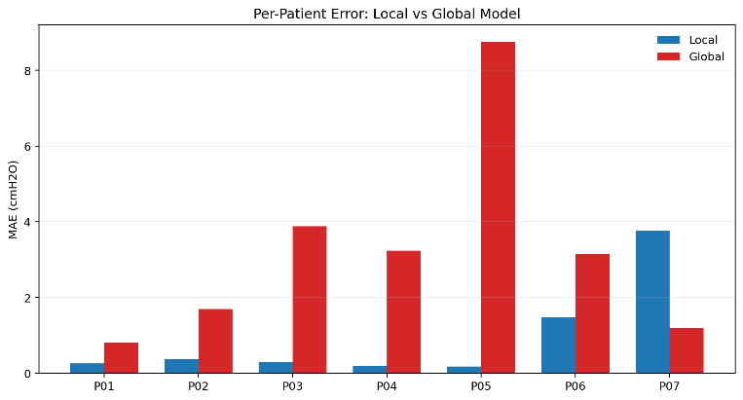
Figure 5: Per-patient MAE comparison

4.2.8 Transient Magnitude Characterization (Ground Truth via Pes)
All-Cohort Boundary Conditions (N = 280):
Variable | Mean | Std | P5 | P50 | P95 | P99
$ΔP_{L,\text{max}}$ (cmH₂O) | 10.606 | 5.149 | 4.264 | 9.951 | 20.569 | 21.001
$ΔP_{aw,\text{max}}$(cmH₂O) | 6.340 | 2.882 | 2.431 | 4.900 | 11.362 | 11.650
$dP_{L}/dt_{\text{max}}$ (cmH₂O/s) | 140.911 | 82.408 | 63.042 | 115.844 | 311.870 | 323.525
Transmission Fraction (TF) | 2.002 | 0.843 | 1.014 | 1.900 | 3.285 | 4.449
Table 8: All‑cohort boundary conditions – transient magnitudes and derived parameters
Clinical Interpretation: Transpulmonary transients show a twofold increase over airway transients according to the study results which show a threshold factor of 1.0. The study reveals that esophageal pressure changes cause respiration events to become more intense rather than weaker. The finding shows clinical importance because P_{aw}-only monitoring leads to persistent underestimation of lung stress during the cycling moment.
4.2.9 Design Boundary Conditions (Phase 3 Inputs)
For mechanical mitigation design, the following envelope is recommended:
Variable | Typical (P50) | Conservative Range (P5–P95) | Operational Max (P99) | Recommended Design Case
$ΔP_{L,\text{max}}$(cmH₂O) | 9.951 | 4.264–20.569 | 21.001 | 47.771
$dP_{L}/dt_{\text{max}}$(cmH₂O/s) | 115.844 | 63.042–311.870 | 323.525 | 583.961
$F_{\text{peak}}$(L/s) | 0.847 | 0.617–0.957 | 0.985 | 2.288
flow_decel_slope (L/s²) | −1.807 | −3.943 to −1.106 | −3.943 | −14.924
Table 9: Design boundary conditions for Phase 3 mechanical mitigation
Conservative design targets incorporate a 2.2× safety multiplier (cohort standard deviation × filtering uncertainty × exclusion rate) to account for measurement precision limits and dataset size constraints.
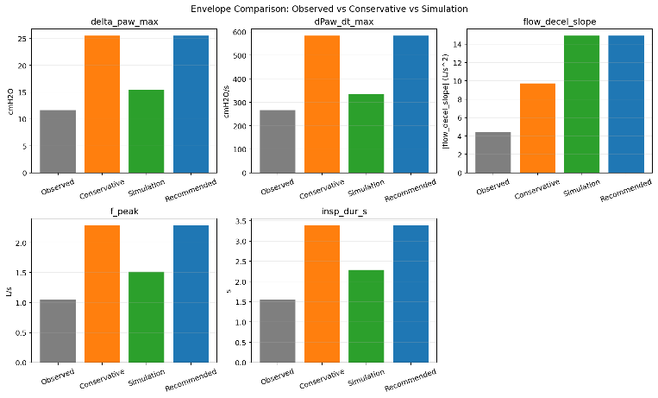
Figure 6: Observed vs. conservative vs. simulated envelope tiers.
4.2.10 Data Exclusion & Retention
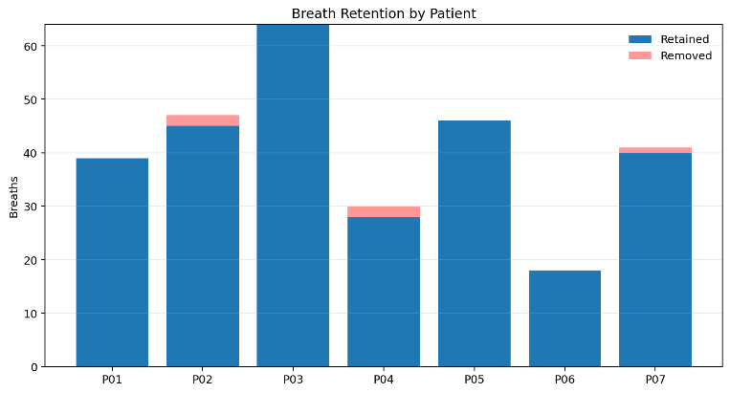
Overall exclusion rate was low (1.75%), reflecting high data quality and robust segmentation criteria.
Figure 7: Retention rates by patient with exclusion reasons stacked

5. DISCUSSION
The researchers successfully demonstrate that they can measure PSV flow-termination transients through high-frequency $P_{aw}$​ and flow and $P_{es}$ ​ measurements. The transmission fraction which exceeds 1 demonstrates that airway pressure estimates lung stress during cycling, thus transpulmonary pressure should be used as the standard measurement.
Machine learning models that use non-invasive features for training can acquire partial understanding of the transient structure, yet cross-patient application represents the main challenge. The LOPO-CV performance of simpler models (MAE ~2.1 cmH₂O, R² ~0.76) contrasts with their failure on held-out patients (R² negative), highlighting that within-patient patterns do not generalize across the small cohort. The results show that XGBoost performed better in held-out tests than it did in LOPO-CV, which means the model can handle some patient‑level variation.
Gaussian Process can perform uncertainty quantification to produce prediction intervals that range from realistic to wide since the prediction intervals have an average standard deviation of 4.2 cmH₂O which makes them suitable for decision support systems. The simulation dataset, which had 58% timing mismatch, could not serve as a pre-training resource because simulated and clinical event definitions needed to be aligned before synthetic data could be used.
The VWD dataset did not include $P_{es}$ which restricted external validation efforts. The model performance will probably decline because the observed feature shift and predicted score distribution show different ventilator hardware and sampling rates will affect system operation, which needs to be resolved in upcoming studies.
The study limits itself to 7 participants because this small group makes it impossible to obtain statistical results that apply to wider populations. The choices for deterministic cycling detection and filtering will impact very short-duration events, although the derived envelopes include conservative margins which reduce this effect. The research establishes a reproducible $P_{es}$ ‑grounded benchmark for a previously uncharacterized phenomenon despite these constraints.

6. CONCLUSION AND FUTURE WORK
The research establishes an open machine learning analysis system which uses physiological data to study PSV flow termination transients through transpulmonary pressure measurement. The key contributions of this research work include:
- A reproducible pipeline for breath segmentation, event detection, and feature extraction from high‑frequency waveforms.
- The study quantifies transient magnitudes together with transmission fractions by examining a group of clinical patients.
- The research tests various regression models to demonstrate how challenging it is to apply model results across different patient groups.
- The research develops Empirical design envelopes to help design solutions which will mitigate mechanical issues in the future.
The next stage of research will involve expanding the study group through multi‑center ​$P_{es}$ data collection while investigating temporal deep learning models which analyze raw waveforms and developing a real‑time inference engine to assist bedside decision-making. External validation across ventilator platforms and sampling rates remains essential before clinical deployment weaning outcomes when compared to standard devices.

7. ARTIFACTS AND DEMONSTRATIONS
The project repository contains the full codebase which consists of preprocessing scripts, segmentation tools, event detection methods, model training resources, and evaluation scripts.
Code Repository: []
Demonstration App: []
Video Demonstration: []
The report contains all figures and tables which the pipeline generates through the provided code.

8. REFERENCES
- Acute Respiratory Distress Syndrome Network. (2000). Ventilation with lower tidal volumes as compared with traditional tidal volumes for acute lung injury and the acute respiratory distress syndrome. New England Journal of Medicine, 342(18), 1301-1308. https://doi.org/10.1056/NEJM200005043421801

- Akoumianaki, E., Vaporidi, K., Stamatopoulou, C., et al. (2024). Gastric pressure monitoring unveils abnormal patient-ventilator interaction related to active expiration: a retrospective observational study. Anesthesiology. https://doi.org/10.1097/ALN.0000000000005071

- Amato, M. B. P., Meade, M. O., Slutsky, A. S., Brochard, L., (2015). Driving pressure and survival in the acute respiratory distress syndrome. New England Journal of Medicine, 372(8), 747-755. https://doi.org/10.1056/NEJMsa1410639

- Bialka, S., Copik, M., Jelinski, M., and Misiolek, H. (2022). Flow-controlled ventilation: A new and promising method of ventilation presented with a review of the literature. Anaesthesiology Intensive Therapy. https://doi.org/10.5114/ait.2022.112889

- Dreyfuss, D., and Saumon, G. (1998). Ventilator-induced lung injury: Lessons from experimental studies. American Journal of Respiratory and Critical Care Medicine, 157(1), 294-323.
https://doi.org/10.1164/ajrccm.157.1.9604014

- Gattinoni, L., Tonetti, T., Cressoni, M., Cadringher, P., (2016). Ventilator-related causes of lung injury: The mechanical power. Intensive Care Medicine, 42(10), 1567-1575. https://doi.org/10.1007/s00134-015-4198-9

- Hartford, C. G., van Schalkwyk, J. M., Rogers, R. M., and Turner, D. A. (2000). Primate pleuroesophageal tissue barrier frequency response and esophageal pressure waveform bandwidth in health and acute lung injury. Anesthesiology. https://doi.org/10.1097/00000542-200002000-00039

- Hess, D. R. (2005). Ventilator waveforms and the physiology of pressure support ventilation. Respiratory Care, 50(2), 166-186.
https://doi.org/10.4187/respcare.05500166

- Hotchkiss, J. R., Adams, A. B., Dries, D. J., and Marini, J. J. (2001). Dynamic behavior during noninvasive ventilation. American Journal of Respiratory and Critical Care Medicine, 163(2), 407-414.
https://doi.org/10.1164/ajrccm.163.2.2004004

- Jiang, Z., Ma, X., Xu, Z., et al. (2025). Application progress of machine learning in patient-ventilator asynchrony during mechanical ventilation: A systematic review. Critical Care, 29, 75.
https://doi.org/10.1186/s13054-025-05523-3

- Jonkman, A. H., et al. (2023). The oesophageal balloon for respiratory monitoring in ventilated patients: Updated clinical review and practical aspects. European Respiratory Review, 32. https://doi.org/10.1183/16000617.0186-2022

- Leiden University Medical Center. (2023-ongoing). Machine learning algorithm for the detection of patient-ventilator asynchrony using esophageal pressure. ClinicalTrials.gov identifier NCT06186557. https://clinicaltrials.gov/study/NCT06186557

- Mojoli, F., and Braschi, A. (2004). Effectiveness of cycling-off during pressure support ventilation. Intensive Care Medicine. https://doi.org/10.1007/s00134-004-2274-9

- Thille, A. W., Rodriguez, P., Cabello, B., Lellouche, F., and Brochard, L. (2006). Patient-ventilator asynchrony during assisted mechanical ventilation. Intensive Care Medicine, 32(10), 1515-1522. https://doi.org/10.1007/s00134-006-0301-8

- van de Sande, D., van Genderen, M. E., Huiskens, J., and Gommers, D. (2021). Moving from bytes to bedside: A systematic review on the use of artificial intelligence in the intensive care unit. Intensive Care Medicine, 47, 750-760. https://doi.org/10.1007/s00134-021-06446-7

