Group – 15
[THE GIG ECONOMY] [Swiggy ‘delivery partners’ and the Algorithm]
Algorithmic Influence: Unveiling SWIGGY’S DELIVERY WORKERS SATISFACTION
Table of Contents
Sr No. | Topic | Page No.
1 | Survey Results | 3
2 | Detailed Interview - Delivery Rider | 10
3 | Detailed Interview – Expert | 17
4 | Detailed Interview – Consumer | 25
5 | Write Up | 31
6 | Network Map Motivation | 33
7 | Contribution List | 34

Survey Results

Question 1: How long have you been working for Swiggy?
Result: 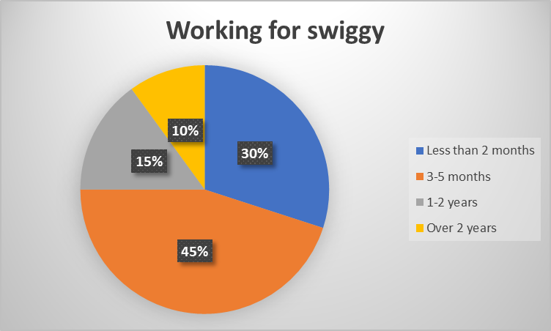
Conclusion:
It can be concluded from the above chart that the majority of the workers we interviewed, 75% to be precise, have been working for Swiggy for less than 6 months, justifying the use of the term "gig workers", as they are commonly referred to as. Only 10% have been working for Swiggy for more than 2 years, which questions the sustenance of the job as a permanent means of livelihood.

Question 2: What’s your age?
Result: 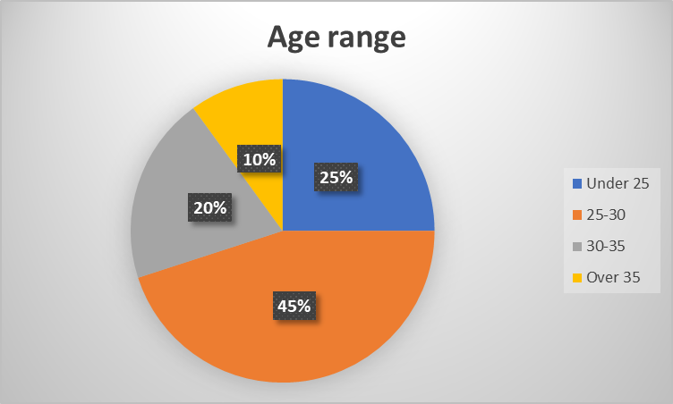
Conclusion:
We can infer from the above chart that 70% of the respondents are under 30, suggesting that this job is more preferred by young workers. There may be several reasons for this. The flexibility of working hours, the constant rushing between orders and the unstable nature of the job may be a few of the reasons that the job is taken up by the youth.

Question 3: Do you work at night or on weekends or during festivals?
Result:
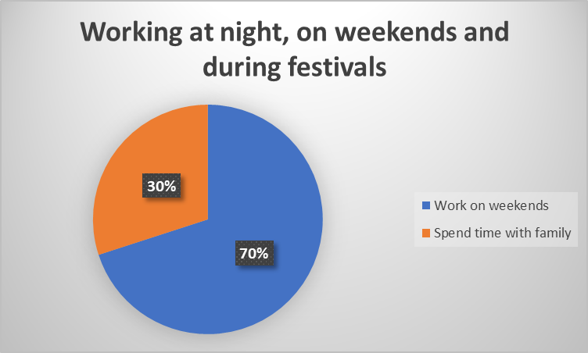
Conclusion:
From the above chart, we can conclude that a vast majority of the respondents work on the weekends or during any festival as there are more orders coming in during these occasions, which in turn helps them to earn more. This is an accurate depiction of how the algorithm controls their lives. They have to work tirelessly even during weekends and festivals, a time where people with white collar jobs unwind a bit whereas they don’t have the luxury to do that. They have to work according to the algorithm and more often than not, there’s no easy way out of it.

Question 4: Have you faced technical issues while working on the app?
Result: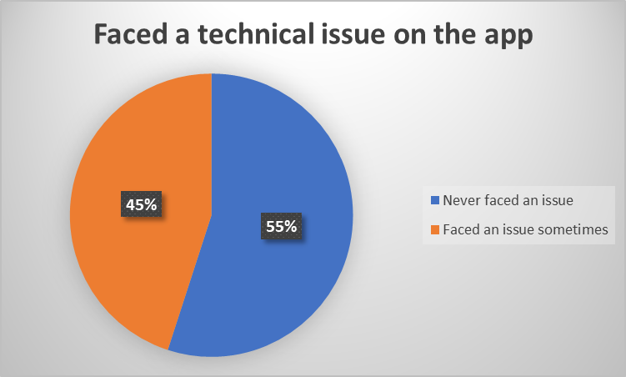
Conclusion:
What we can derive from the above chart is that close to half of the delivery people have faced technical issues while working on the app. This shows that technology, which is something so primary and basic for companies like Swiggy, has certain inefficiencies on its part. We also observed that in a lot of cases, there were discrepancies in showing the exact location, which delayed them in getting the orders delivered at the right place and right time which is perhaps the most crucial to them.

Question 5: Is this job better or do you wish to go back to your old job?
Result:
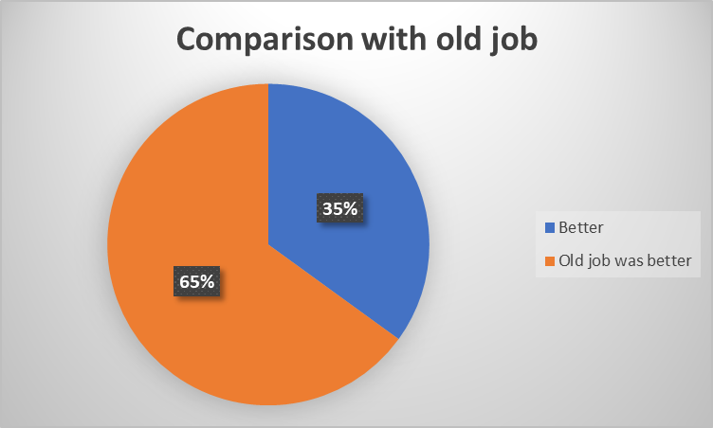
Conclusion:
From the above graph, we can conclude that a solid 65% of the people believe that their old job was better than working for Swiggy but are still working with them due to their own personal reasons. This significantly high number highlights the dissatisfaction amongst these delivery workers. The struggles they face while working a job that might not seem so gloomy from the outside are also reflected by this data.

Question 6: Do you plan to work full time in the long run or just part time?
Result:
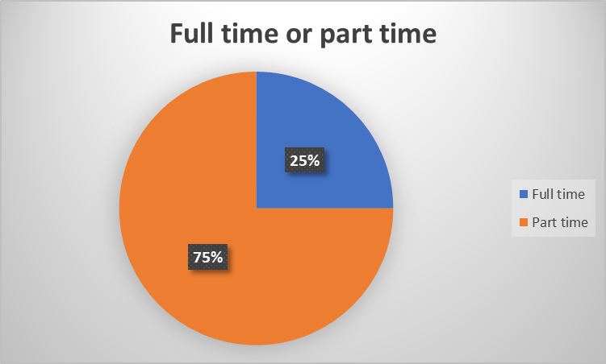
Conclusion:
From the above graph, we can conclude that around 75% of people wish to continue with Swiggy as a part time job and don’t plan to switch to a full-time job. This is also an extension of the previous conclusion that they don’t prefer their job as a delivery worker over the other jobs they have had in the past. They do it just as a side hustle which helps them to earn a little extra. This again paints a very dire picture of the gig work and the lack of security it provides which restricts them from viewing it as something more long term.

Question 7: Do you have access to any medical insurance schemes or other compensation provided by Swiggy in case of accidents?
Result:
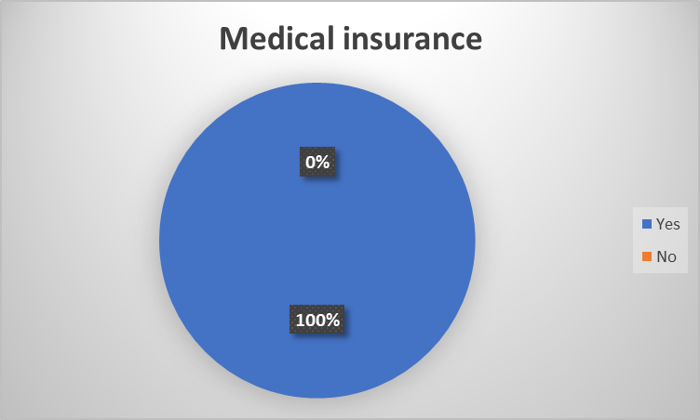
Conclusion:
From the above chart, we can conclude that everyone working with Swiggy has been provided with medical insurance schemes and other compensations from the company itself and that no one is left out in this domain.

Detailed Interview - Delivery Rider
Delivery Rider Profile:
We decided to interview Nikunj Patel for the rider’s interview after going through multiple profiles and multiple interviews, as we felt that he was the most experienced out of all and also had spent the most time working for Swiggy. While interviewing, we felt like he wanted us to ask more questions, was genuinely interested in helping us out with this interview, and felt like a very passionate person for his work. We conducted the interview in Hindi and then translated it into English.
Question 1: What’s your name?
Answer: My name is Nikunj Patel.

Question 2: What’s your age, and how long have you been working for Swiggy?
Answer: I am 26 years old, and I have been working with Swiggy for 3 years.

Question 3: Has COVID changed your work life? How was it before and after COVID? Was your business affected by COVID?
Answer: Yes, COVID has changed my work life. There have been several changes post-COVID, like the extra pay we used to get after each delivery has been reduced, the charges have become low, and our incentive has also been reduced. In short, we have incurred loss post-covid.

Question 4: Have you faced any technical issues while using the app during delivery? If yes, then what happened?
Answer: Yes, I have faced technical issues while using the app. Most of the times, it is because the customer didn't put in the right address. But in case there is any other technical issue, and/or the order gets cancelled, I contact the help manager in customer care and do as they ask me to do. Now if they don't respond, I usually just give the order to the poor people on the streets, click a picture of it, and send it to the WhatsApp group we have for Swiggy.

Question 5: What features, according to you, should be added to the delivery app to help improve the platform for customers and employees?
Answer: I feel like the app is perfect in its way. If I have any issues with the app, I contact the help manager, and it usually gets resolved, so I don't wish to add any new features from my side.

Question 6: According to our research, Swiggy provides insurance and other benefits. What are those other benefits that delivery partners get?
Answer: Yes, they do provide us with insurance when we sign up to work for Swiggy on the application. We have to pay some 1400 or 1500 rupees for that insurance, and other benefits they provide us with aid and help in case of any accidents or anything that happens on the road to us.

Question 7: Are there any time limitations for delivering your food? Do you get charged or fined for late deliveries?
Answer: Yes, we have to deliver the food we take from the restaurant within 30 minutes of the order. If any delay is caused, we get charged from our pay cut. In case there is some minor delay due to traffic or any other related things, we don’t get charged; but if there is a major delay, we are charged, and we get the penalty on our account.

Question 8: What if the one on the receiving end of the order arrives late? Do you wait for them, and if yes, how long do you wait?
Answer: It depends on the situation, to be very honest. If I arrive at the location and I call the customer, if he picks up the phone and informs me that it will take 5–10 minutes from his side, then I wait for him, or else I wait for a while and then contact my help manager and do as they advise me to do.

Question 9: How do you feel about your work? Are you happy, or is it stressful?
Answer: I find it stressful, as the pay and incentives have reduced.

Question 10: How would you compare this job with your previous job? Is it better, or do you wish to go back?
Answer: The first 6 months I used to work full time for Swiggy, then I started doing half time around 7–11 pm because I find this time more comfortable, and it’s not really worth working full time now. I just need to do a minimum of 10 orders a day, and I can call it a day.

Question 11: Do you plan to work with Swiggy for a longer period or is it just a part-time gig for you?
Answer: I don't wish to work for Swiggy for long, I just see it as a part-time gig for me right now.

Question 12: How does Swiggy handle issues related to theft, accidents, and order cancellations, and is there any compensation available for the delivery workers?
Answer: In case any such things happen to us on the road, we usually just contact the help manager, and they provide us with the assistance we require, but since nothing like this has happened to me, I am not completely aware of what the actual procedure is.

Question 13: How does your company handle a dispute between delivery partners and customers? Is there any hierarchy between you and your superiors in Swiggy? Is HR helpful?
Answer: If there is any dispute between us and the customers, what we usually do is call our help manager through our call center, explain the whole situation to them, and then leave it to them. In most cases, if it is not our fault, the call center helps us and usually compensates us for it.

Question 14: Are you satisfied with how people view your work? Do they judge you, and how do you react to those judgments?
Answer: Till date, for every delivery I have done, the customers have been nice, and only sometimes do we meet rude customers, but that is very rare, so overall, I feel like I am satisfied with how people view our work and the respect they give us.

Question 15: Do your own family and friends use Swiggy to order food? Has it ever happened that you ended up delivering food to someone you knew and weren't aware of it beforehand?
Answer: Yes, my family members and my friends too use the Swiggy app. Nothing as such has happened so far as I cannot recall such an incident happening to me.

Question 16: How much control do you have over your working timeline? Can you choose to work in any given time slot, and how would those choices affect you?
Answer: I have almost full control over my working timeline, I can choose the hours I wish to work for, and apart from the fact that I don't have to work, I can choose the specific hours I wish to work for.

Question 17: How does your work affect your personal life? Do you work at night, on weekends, or during festivals?
Answer: Yes, I do work at night and sometimes on weekends and festivals, as the app offers some special deals and special offers during those days, so it's worth grabbing.

Question 18: How often do the customers tip you?
Answer: It depends on the area. Since it is a VIP area, the customers usually tip us.

Question 19: Can you share a memorable or challenging customer experience that has stuck with you? This could really help us with the interview.
Answer: The most challenging customer experience, according to me, would be once I had to deliver in the GIFT city area. In that area, they don't usually allow us delivery riders to go beyond a certain point or enter buildings, so it’s quite hard to coordinate with customers in that area.

Question 20: What would you like the general public to know about your working conditions? And what are the changes you desire to see in your working environment that can make your life more convenient?
Answer: The public in general is respectful to us, and we don't expect much from them, but we wish they would just be less rude to us in case we are late by a few minutes because sometimes the traffic gets very bad in the city during peak hours. Apart from that, the customers are usually nice to us.

Detailed Interview – Expert
Expert Profile:
We interviewed Shaik Salauddin as the expert interview. He is the elected Secretary and co-founder of Indian Federation of App-based Transport Workers (IFAT) since 2019. This includes the workers from various platforms such as Ola, Uber, Swiggy, Zomato, Rapido and Dunzo. He has coordinated with various political parties especially Indian National Congress during the Bharat Jodo Yatra to discuss the struggles faced by gig workers.
Background:
We got the contact details of Shaik Salauddin from Harshit Rakheja [1]. We got in touch with Mr. Salauddin via WhatsApp and discussed about his availability to do the interview. As soon as he reached back to us and told us that he is available, we called him and did the interview. He was incredibly helpful and answered the questions as best as he could. The interview was done in Hindi having few of the technical terms in English. We translated from Hindi to English to the best of our ability and then did a quick grammar check with the help of ChatGPT.

Question 1: Greetings, sir. I am delighted to have you here. My group and I are currently working on a project concerning gig workers and the impact of algorithms used by delivery companies. Our primary focus is Swiggy. We were referred to you by Harshit Rakheja, who informed us that you are the head of the gig workers' union. To begin, could you introduce yourself and describe your work?
Answer: Hello, I am Shaik Salauddin. I am the secretary and co-founder of the Indian Federation of App-based Transport Workers (IFAT) [2]. I established the Telangana Gig and Platform Workers Union (TGPWU) [3]. I began my journey as an Uber driver, a role I still continue to fulfil today. It has been 10 years since I started out.

Question 2: Could you elaborate on the activities the union undertakes, and have these activities brought about any changes in the lives of gig workers in India?
Answer: Our union is dedicated to addressing gig workers' concerns and finding resolutions to their issues to the best of our abilities. We have WhatsApp and Telegram groups with the help of which we stay in touch with gig workers across the country. Recently, we advocated for the passage of a social security bill in Telangana, based on a successful model that was implemented previously in Rajasthan [4], which would benefit gig workers across the state. Unfortunately, the Telangana government did not allow us to pass this bill. It was an honour for me to walk alongside Rahul Gandhi for 20 minutes. We discussed the struggles faced by gig workers. One of our significant achievements was the successful protest of over a month that led Uber and Ola to display the drop location to drivers after years of resistance.

Question 3: You mentioned the social security bill in your response. Can you please explain what are those social security benefits and how are they not granted to gig workers?
Answer: In our country, traditional employees have direct access to social security schemes. However, there are no laws that protect the rights of gig workers and even the labour laws don’t apply to them. They are often exploited under the guise of gig work, which is sometimes falsely advertised as part-time employment when, in reality, it is not.

Question 4: Are there any insurance schemes or compensation policies provided to gig workers and their families by Swiggy?
Answer: Swiggy does offer insurance benefits to its workers, including medical insurance to cover accidental injuries. However, these benefits do not extend to the families of gig workers.

Question 5: How does your company manage disputes between delivery partners and customers? Is there a hierarchy between you and your superiors at Swiggy, and does the HR department provide assistance in such situations?
Answer: The HR department is generally not very helpful to delivery workers. In some cases, HR personnel were not even available a few years ago. In instances of disputes or arguments, the delivery partner is often deemed at fault, resulting in the deactivation or blocking of their IDs. Even when disputes with customers arise where the delivery worker is not at fault, a negative review from the customer can affect the worker's future order assignments.

Question 6: Could you also shed light on the pre-COVID and post-COVID scenarios for gig workers at Swiggy?
Answer: Before the COVID-19 pandemic, gig workers faced the usual challenges of low wages and long working hours. However, the pandemic led to a decrease in earnings as orders declined. As the economy recovers, orders and ride requests are returning to pre-pandemic levels, but pay for gig workers remain low.

Question 7: Additionally, delivery companies often promise customers timely delivery of their orders. Does this promise pose a danger to the lives of delivery workers, as they may engage in risky behaviors to meet delivery time targets? Are they penalized for late deliveries?
Answer: Yes, this is indeed a concern. There is intense competition to deliver orders as quickly as possible, and this pressure falls on the delivery workers. Various statistics [5] indicate that delivery workers are at a higher risk of road accidents compared to other average drivers. Late deliveries can result in fines, and customers leaving negative ratings can further affect the workers. To avoid such situations, some delivery workers resort to reckless driving, jeopardizing their safety.

Question 8: Do gig workers have the freedom to choose their working hours, and are there any minimum time requirements they must meet in terms of staying logged in?
Answer: While gig workers have the flexibility to select their working hours, there isn't significant freedom in this regard. The incentive structure often compels them to work long hours. Rather than providing incentives for completing 5-6 orders a day, companies may set targets as high as 20-30 orders per day. This again supports the fact that gig work is not part-time, and workers often have to put in exhaustive hours to achieve promised incentives. Additionally, most orders are received during peak hours, such as during lunch and dinner, leaving little choice in terms of working hours.

Question 9: How are the personal lives of delivery workers impacted by their roles? Do they have the opportunity to spend time with their families, or are they required to work during festivals, late nights, and weekends?
Answer: The personal lives of delivery workers are significantly affected by their roles. They often have to work during festivals, late nights, weekends, and other non-traditional hours, which can make it challenging for them to spend time with their families. Quoting him, “Ab aap ya toh eid celebrate karo ya ghar waalo ka pet bharo.”

Question 10: Can you share a memorable or challenging experience that has left a lasting impression on you? Is there a particular interaction with a gig worker that stands out in your memory?
Answer: In one of my WhatsApp groups, I learnt about an instance where a customer ordering from Swiggy specifically requested for a Hindu delivery worker rather than a Muslim delivery worker. This specific instance really blew up all over the Twitter and everyone got to know about it. I asked Swiggy to take strict action against such bigotry to ensure the safety and security of delivery workers.

Question 11: What message would you like to convey to the general public regarding the working conditions of gig workers to foster better understanding and empathy for their circumstances?
Answer: Well, I would just say that having a voice is important. Speaking for what you feel is right without having the fear of consequences can go a long way. It’s important to fight for your rights in instances where you feel they are violated.

Question 12: Are there any laws you would like to see implemented to improve the working conditions of gig workers and secure their basic rights?
Answer: As I already mentioned, we as a Union fight for the rights of gig workers to empower them and grant them their much-deserved rights. The fight to grant them social security benefits is already ongoing and its still in process. For now, the only thing we require from the people across the nation is to just show some empathy towards the workers as that itself can go a long way.

Appendix:
[1] Harshit Rakheja is a journalist from Inc42. We found him through one of his articles that he wrote on protests done by gig workers. We searched for him on various social media platforms and ended up finding his Instagram profile. We texted him there and familiarized him about the project and asked if he would be willing to do an interview. He said yes but then told us that it would be better if we interviewed Shaik Salauddin as he was the head of the Union of gig workers and provided us with his contact details. So, we contacted Shaik Salauddin and he was willing to do an interview.

Link for the article - From Swiggy to Ola — A Year Of Protests By India’s Gig Workers (inc42.com)

[2] The Indian Federation of App-based Transport Workers (IFAT) (Hindi: इंडियन फेडरेशन ऑफ ऐप-आधारित ट्रांसपोर्ट वर्कर्स, Indiyan phedareshan oph aip-aadhaarit traansaport varkars)
is a trade union federation of ride-sharing and other gig transport workers. In India, this includes the workers on platforms such as Ola, Uber, Swiggy, Zomato, Rapido and Dunzo. The federation is affiliated with the International Transport Workers Federation.
(The above information source is taken from Wikipedia)
[3] The Telangana Gig and Platforms Workers Union (TGPWU) is an independent, worker-led union that was founded in 2021, to advance the interests of gig and platform workers in Telangana, India. We fight for higher pay, fair and dignified working conditions, and benefits for gig and platform workers.
[4] Shaik Salauddin along with TGPWU urged Congress in Telangana to launch the social security bill in Telangana. The Rajasthani government recently approved the legislation which ensured the social security benefits to gig workers across the state. The Rajasthan Assembly passed a bill for the formation of a board and creation of a fund for gig workers in India.

Detailed Interview - Consumer
Consumer Profile:
We interviewed a friend of our group member, Khushi. After going through a list of people who we could possibly interview as consumers, we decided to choose Priyansh Jain as the best candidate for this interview as we felt like we got better-framed answers and better responses from him than those from the other interviews, and he was willing to share more information and was pretty interactive too. He is a 20-year-old college student in his 3rd year studying in Jaipur and was able to create time for us from his busy schedule.

Question 1: How often do you use Swiggy as a food delivery app?
Answer: I use Swiggy quite frequently, approximately twice a week.

Question 2: How many members of your family also use Swiggy as a delivery app?
Answer: Other than me, my mother and my brother use the app, but my mother uses it more frequently than my brother.

Question 3: Do you order through other food delivery apps as well? Do you or do you not prefer Swiggy while ordering? Give reasons.
Answer: Oh yes, I use other apps as well, including Zomato and Domino's. It all depends on what I am craving. If I am in the mood for a pizza, I prefer ordering directly from Domino's. They just have a better tracking feature that Swiggy lacks. In the end, even if I order Domino's pizza from Swiggy, the delivery man is still from Domino's.

Question 4: Have you started ordering more post-covid, or was it always the same pre- and post-covid?
Answer: Yes, I've definitely increased my food orders post-Covid. (On being asked why, there is no specific reason for it.) It is just that I've started ordering more frequently post-Covid.

Question 5: Have you, as a customer, faced any technical issues with the application? If yes, what was the issue, and how did you resolve it?
Answer: No, I have never encountered any technical issues with the app.

Question 6: Do you believe Swiggy has made your life easier and more convenient? How do you see yourself in a world without food delivery apps?
Answer: Absolutely! Swiggy has made my life a lot easier. Sometimes, even when I'm craving restaurant food, I don't feel like going out to pick it up. Swiggy comes in really handy in these cases. Also, in our house, we tend to have dinner quite late. Most restaurants nearby are closed by then, but it does not affect us since we can just order in and eat comfortably at home! Without these apps, I would have to fetch food myself and not enjoy meals at home in my comfort zone. In the worst case, I would have to prepare my meal myself.

Question 7: Have you ever received a late delivery so far while ordering through Swiggy? What is the maximum delay that has occurred till now? How do you usually tend to react in those situations?
Answer: Oh yes, I've had my fair share of late deliveries. The worst one was when I received my order 40 minutes past the estimated time, taking a total of 1 hour and 10 minutes! Another time, my order came in after 50 minutes, even though the estimated time was 25 minutes. I do not say anything to the delivery workers in such cases. I just reported the issue. Both times, I got discount coupons. It is an easy process, as I don't have to call anyone. It only takes 2 or 3 clicks.

Question 8: Have you ever been late to receive an order, or have any such instances happened to you where the rider had to wait for you instead of you waiting for him? Did the driver wait for you in those situations, and did he have any sort of reaction while you received the order?
Answer: The longest I've made a delivery worker wait is like 2 minutes. But there was this one time when I messed up my address and put it in a different location, 2km away from my house. I called the delivery guy, and he was very understanding about it. He came all the way to my house to deliver my food. Of course, I had to pay an extra charge, but other than that, he was surprisingly cool about it.

Question 9: Have you ever felt like your order was misplaced or you've been served cold food? How do you deal with such situations?
Answer: Yes, it has happened quite a few times. When my order was 25 minutes late, the food arrived cold. Another time, I only received 8 pieces instead of 12. It was not a big deal because I just reported the incident and got a full refund.

Question 10: Have you or have you not encountered a rude delivery worker who hasn’t been the nicest to you? How have you reacted in such a situation?
Answer: Once, I had a delivery guy who did not even come to my society. He just waited outside, about 300 meters away, asking me to come get it. I refused to do so, and he got grumpy about it. His expression showed that he was annoyed, and he even rudely told me he had no change.

Question 11: Do you leave tips for the delivery worker while ordering food? How often do you do that?
Answer: I tip quite often, but I don't if the charges are high.

Question 12: As a customer, do you feel some feature is missing? Would you like to suggest an additional feature for the application?
Answer: It is not a feature, but nowadays, delivery workers are hesitant about accepting cash. Apparently, there is some limit to the number of times they can accept cash. So, they keep asking me to pay online, even when I select cash. I think they should increase the limit or remove it.

Question 13: Can you recall and share any specific experience with the delivery rider that could help us understand the relationship between a customer and a delivery guy in a better way?
Answer: There was this one time when the delivery man's phone was about to die when he came to my house. He asked me if we had a power outlet outside. We do, so I let him charge his phone there. While it was charging, we had a fun chat about cricket. It turned into a really nice conversation.

Question 14: Can you please comment on the behavior that you and your family or friends show towards the delivery workers? And do you have any preconceived notions regarding them?
Answer: We keep our interactions simple and polite. We just accept the delivery, say thank you, and that is about it. However, back when food delivery apps were still new, we were a little skeptical of them because of the videos circling around of the delivery workers messing with the food or eating it. So, we used to double-check the seals. Nowadays, though, we just trust the apps more and cannot imagine our lives without them!

Write up
Our group was tasked with studying the impact of Swiggy's algorithms on the lives of its delivery workers in the context of the gig economy. To achieve this, we began with Task One, which involved interviewing delivery workers and conducting fieldwork. In the initial stages, we collaboratively developed a questionnaire, considering input from the entire group. After refining it to ensure its effectiveness we came up with the questionnaire. This exercise not only helped us prepare for the work ahead but also familiarized us with each other as a group.
For the fieldwork, we divided the group into teams of three to four members to efficiently distribute the tasks. Each team conducted fieldwork on assigned days, documenting their experiences in fieldwork journals. We encountered situations where some team members had prior commitments, necessitating slot swaps with other available teams. This taught us to adapt to various situations and enhanced our group coordination.
Through our fieldwork, we gained valuable insights into the lives of delivery workers. We observed that these workers often operated under time constraints and faced challenges during interviews. We had to approach them in a friendly and non-suspicious manner. While we encountered dead ends and moments of exhaustion, we learned to persevere and adapt. Even when unable to secure interviews, we documented these experiences, using them as learning opportunities to improve our approach.
Our group also had the tasks of summarizing two relevant articles and selecting a feature film, along with explaining our choice. Regrettably, we initially underestimated the importance of these tasks, focusing primarily on maintaining fieldwork journals. As a result, our summaries of articles and the choice of a feature film suffered. We realized the need for a more thorough review of the articles to gain deeper insights into the lives of gig workers.
In selecting a feature film, we began by having group members suggest films related to our topic. While many options were short films, we found that they didn't provide the necessary information. Aware of the "Zwiggato" film, we decided to watch it, ultimately selecting it due to the limited alternatives available. We compiled all documents, added a table of contents, a list of contributions, and made necessary formatting changes before submission.
Task Two included the survey, three detailed interviews, the Actor-Network Theory (ANT) map, and the write-up. In preparing the survey questions, we followed our instructor's guidance to ensure clarity and precision. We maintained the same teams as in our fieldwork, instructing them to survey delivery workers. Collecting 23 survey results, although initially asked for 20, was a deliberate buffer to enhance the validity of our findings. We created charts to visualize and analyze the collected data, drawing conclusions from the results.
For the detailed interviews, we formulated questionnaires for consumers, delivery drivers, and experts by drawing inspiration from existing questionnaires and research from articles. The team members conducted three consumer and two delivery driver interviews. We selected one from each category and translated the audio recordings as they were conducted in Hindi (for consumers) and Gujarati (for delivery drivers). We also created respondent profiles and provided background information to ensure a comprehensive understanding of the interviews.
We initially struggled to secure an expert for the interview. Our initial plan was to interview Swiggy employees, but this proved challenging to execute. Faced with this roadblock, we reached out to the authors of articles we had read. S.H. Salman expressed willingness to participate in an interview but was preoccupied with other commitments. Despite our repeated attempts, we were unable to coordinate an interview due to his tight schedule, which was completely understandable.
Harshit Rakheja, on the other hand, responded more promptly. He, too, was willing to participate but expressed uncertainty about his ability to provide valuable insights since he had written the article several years ago and couldn't recall it in great detail. However, he graciously provided us with the contact information of Shaik Salauddin, the head of the Union of gig workers, who he believed would be more helpful for our study. We extended our thanks to Harshit and reached out to Shaik Salauddin, who agreed to conduct a thorough interview with us. We translated the audio recording, built up his profile, background information, and compiled it all. One thing Shaik said that really stood out to us is that, “Yaa toh aap eid celebrate karo yaa toh ghar waalo ka pet bharo.” This again highlighted the struggles of delivery workers and how their time with their families is robbed away just to earn a “quick” buck. The exercise also highlighted the difference between the discussions we had with delivery worker and the journalist or the head of the Union. How power dynamics work and how different parties hold power in a conversation in different situations.
This exercise not only shed light on the lives of delivery workers but also enhanced our ability to persuade and communicate effectively when seeking information.
In conclusion, our exploration into the gig economy, with a specific focus on Swiggy's delivery workers, was a multifaceted endeavor. It required planning, adaptability in the face of challenges, and effective coordination within our group. The valuable insights we gained from our interactions with delivery workers, the assistance of journalists, the information gathered from surveys, interviews all contributed in building a deeper understanding. Through this research, we have not only gained a deeper understanding of the lives of delivery workers but have also enhanced our skills in research, data collection, and effective communication. All we can do is hope that the gig economy continues to evolve fortunately for the betterment of gig workers.

Network theory Motivation

For the ANT map, we conducted group meetings to gather prompts from all members and discuss our choice of the object of study. After careful consideration, we chose "restaurants" as the object, as it encompassed the prompts we received as well as the information collected during our survey and fieldwork. All the field trips we had were centered at a restaurant, and our observations included studying the activities happening around us. We can also efficiently differentiate the dine-in and take-out experiences and how they vary. The attributes help us understand the dine-in experience more effectively. We also considered both customer and delivery partner views to study the processes they engage themselves in.

Contribution List
Student ID | Name | Contribution
202201091 | KATHAN DIPAK KHUMAN | Shared the experiences learnt from this project and helped with the write up and discussing the possible objects for ANT.
202201143 | VEGAD RUTVIK RAKESHBHAI | Shared the experiences learnt from this project and helped with the points to be added in write up and discussed the possible objects for ANT.
202201158 | RAMANI JANVI BIPINBHAI | Shared the experiences learnt from this project, also discussed the possible objects for ANT and the possible things that could be mentioned in the 2 pages write up
202201187 | PATEL JAYKUMAR KISHORBHAI | Shared the experiences learnt from this project, also interviewed a possible rider for the detailed interview and helped with the discussions of the possible objects for ANT and the possible things that could be mentioned in the 2 pages write up
202201197 | VAGHELA VIVEK GAUTAMBHAI | Shared the experiences learnt from this project, also interviewed a possible rider for the detailed interview and helped with the discussions of the possible objects for ANT and the possible things that could be mentioned in the 2 pages write up
202201219 | CHAUDHARI CHIRAGKUMAR MOTIBHAI | Shared the experiences learnt from this project, also interviewed a possible rider for the detailed interview and helped with the discussions of the possible objects for ANT and the possible things that could be mentioned in the 2 pages write up
202201239 | SOLANKI ARYAN SANJAYKUMAR | Shared the experiences learnt from this project, also interviewed a possible rider for the detailed interview and helped with the discussions of the possible objects for ANT and the possible things that could be mentioned in the 2 pages write up
202201311 | GODHANI DHARMIK HARESHBHAI | Shared the experiences learnt from this project, helped with the making of ANT using figma and graphical implementation of ANT, helped with the discussions of possible things that could be mentioned in the 2 pages write up

202201332 | KHUSHI R VORA | Shared the experiences learnt from this project, helped with the making of ANT and drafted how the ANT would look like with the help of Rohan, also worked with the consumer for the interview and helped with the possible things that could be added on the 2 pages write up and helped in summing up all the points mentioned by all group members for the write up
202201404 | SWAPNIL SHUKLA | Shared the experiences learnt from this project, also discussed the possible objects for ANT and the possible things that could be mentioned in the 2 pages write up
202201421 | KKAVY KAPIL DAVE | Shared the experiences learnt from this project, contacted the expert using LinkedIn, discussed the possible points that could be added as objects in ANT, compiled the survey results and made the conclusions from the charts, mentioned the possible points that could be added in the write up
202201449 | LATHIGARA PRIYANSH HARESHBHAI | Shared the experiences learnt from this project, discussed the possible points that could be added as objects in ANT, mentioned the points that could be noted down for write up
202201452 | DETROJA AVI ASHISHBHAI | Shared the experiences learnt from this project, also interviewed a possible rider for the detailed interview and helped with the discussions of the possible objects for ANT and the possible things that could be mentioned in the 2 pages write up
202203007 | ROHAN JASANI | Shared the experiences learnt from this project, contacted the expert using Instagram, interviewed the expert, discussed the possible points that could be added as object for ANT and drafted out how the ANT would look like on paper along with Khushi and Dharmik and helped in writing the write up summing up all the points of all group members.

202203040 | JAYSWAL KRISHIL ALPESHBHAI | Shared the experiences learnt from this project, discussed the possible points that could be added as objects in ANT, mentioned the points that could be noted down for write up
202203042 | RATHVA KIRTANKUMAR BAHADURBHAI | Shared the experiences learnt from this project, discussed the possible points that could be added as objects in ANT, mentioned the points that could be noted down for write up

