TOPIC - SOCIAL SEARCH APPLICATION and MANAGEMENT SYSTEM for COLLEGE

Project Name : NFS(Need For Socialization)

TEAM MEMBERS -
Mohit Kadyan (187237)
Priyansh Maheshwari (187246)
Snigdh (187260)

Submission to: T.Ramakrishnudu Sir

Problem Statement : Students many times are introverts or need a partner with whom they can study or play their favorite sport. There is currently no such way in college by which they can find someone who has the same preferences as theirs and also finding for a partner. Develop a database for the people of the college and allow such people to find about each other and interact.

Idea : To let people search for others who have the similar purpose. The system will manage the data of all those who registered and make people who have the similar purpose know each other and allow them to converse.The app will also sort them on the basis of the interests that is stored in the database.

Purposes : Sports, Studies, Dating.

ENTITIES :-
1) USER
2) DATING
3) STUDIES
4) SPORTS
5) SUGGESTIONS
6) MATCHED-TABLE
7) PLACES-TO-VISIT
8) SHOPS
9) BOOKS FOR REFRENCE
10) COURSES
11) Dating_Ideas
12) Sport_Ideas
13) Study_Ideas

SCHEMA :-

1) USER (Login_Id, Name(First_Name, Last_Name), Age, Gender, Phone_Number, Email-Id)
2) DATING (Login_Id, Dating_Interests, Height, Eating_Habits)
3) STUDIES (Login_Id, Course_code, Year, Stud_Time)
4) SPORTS (Login_Id, Preferred_Sport, Play_Time, Skill_Level)
5) COURSES (Course_Code, Course_Name, Year, Branch)
6) SUGGESTIONS (User1, User2, User1_Choice, User2_Choice)
7) MATCHED_TABLE (MatchNo, User1, User2, Interest)
8) PLACESTOVISIT (Place_No, Place_Name, Purpose, Address)
9) SHOPS (Shop_Id, Shop_Name, Genre, Website_Link,Address)
10) BOOKS_FOR_REFERENCE (Book_Id, Book_Name, Course_Code)
11) DATING_IDEAS(Match_No, Shop_No, Place_No)
12) SPORT_IDEAS(Match_No, Shop_No, Place_No)
13) STUDY_IDEAS(Match_No, Common_Course, Place_No)
14) LANGUAGESKNOWN(Login_Id, Languages)

ABOUT TABLES :-

1) USER
User table will hold all the basic personal data of all the members which are logging in the application. We are assuming that a person isn't registering more than one. Moreover, as soon as one person registers he/she is assigned a unique login_id.

2) DATING
Dating will hold the data of the people that are much more specialized in the dating genre. A person doesn't need to enter these details if he has entered details in any other purpose like study or sports.

3) STUDIES
This table will hold the data of people which is apecialized in studies genre. Basically, it will contain details like year and course which you want to study.

4) SPORTS
Like the other two tables it will have the data specialized in sports like the for which sport you want to find.

5) COURSES
This is a database which holds the data of all the courses present in the college. It will hold all the data about the course whose primary key is course_id.

6) SUGGESTIONS
This table holds login_id of both of the person who is given suggestions of each other. Now, each user is given a choice about the other user and if both accept each other, they are declared as a match and assigned a matching number and hence given to the matched table.

7) MATCHED_TABLE
Matched Table holds the login_id of all those who are matched and each of these pairs is assigned a matching number along with the purpose on which mainly they are matched.

8) PLACESTOVISIT
This table holds the data of all the places that a person can visit in the city. Each of the place is assigned a purpose with which they can visit it.

9) SHOPS
Shops table holds the data of many shops present in the city along with the genre about what ithems they are specifiaclly selling and for which peoples it is useful.

10) BOOKS_FOR_REFERENCE
This table is connected to library and holds the book_id and name of the books along with which course they are specifically related to.

11) DATING_IDEAS
After a pair is matched with interest dating, this table will be connected to shops and places and suggest the specific match which places they can visit or which shops they can use to give gift to the partner.

12) SPORT_IDEAS
This is just similar to dating_ideas, but, the difference is it will suggest the pairs those have common interest as sports.

13) STUDY_IDEAS
Like the above two tables it is also for the same reason i.e. suggestions for the pair eith common interest of study.

14) LANGUAGESKNOWN
This is a part of the table user. It basically hols the data of languages with which a person is comfortable in speaking with. Since, it is a multivalued attribute it was made in another table.

FUNCTIONAL DEPENDENCIES :-
The tables are breoken into BCNF form on the basis of the given functional dependencies.

1) USER TABLE
Login_Id -> First_Name
Login_Id -> Last_Name
Login_Id -> Age
Login_Id -> Gender
Login_Id -> Phone_Number
Login_Id -> Email_Id

2) DATING
Login_Id -> Dating_Interests
Login_Id -> Height
Login_Id -> Eating_Habits

3) STUDIES
Login_Id -> Course_Code
Login_Id -> Year
Login_Id -> Stud_Time

4) SPORTS
Login_Id -> Preferred_Sport
Login_Id -> Play_Time
Login_Id -> Skill_Level

5) COURSES
Course_Code -> Course_Name
Course_Code -> Year
Course_Code -> Branch

6) SUGGESTIONS
User1,User2 -> User1_Choice
User1,User2 -> User2_Choice

7) MATCHED_TABLE
MatchNo -> User1
MatchNo -> User2
MatchNo -> Interest

8) PLACESTOVISIT
Place_No -> Place_Name
Place_No -> Purpose
Place_No -> Address

9) SHOPS
Shop_Id -> Shop_Name
Shop_Id -> Genre
Shop_Id -> Website_Link
Shop_Id -> Address

10) BOOKS_FOR_REFERENCE
Book_Id -> Book_Name
Book_Id -> Course_Code

11) Dating_Ideas
Match_No -> Shop_No
Match_No -> Place_No

12) Sport_Ideas
Match_No -> Shop_No
Match_No -> Place_No

13) Study_Ideas
Match_No -> Common_Course
Match_No -> Place_No

14) LanguagesKnown
Login_Id -> Languages

ENTITY RELATIONSHIP :-
An entity relationship diagram (ERD), also known as an entity relationship model, is a graphical representation that depicts relationships among people, objects, places, concepts or events within an information technology (IT) system. An ERD uses data modelling techniques that can help define business processes and serve as the foundation for a relational databse.
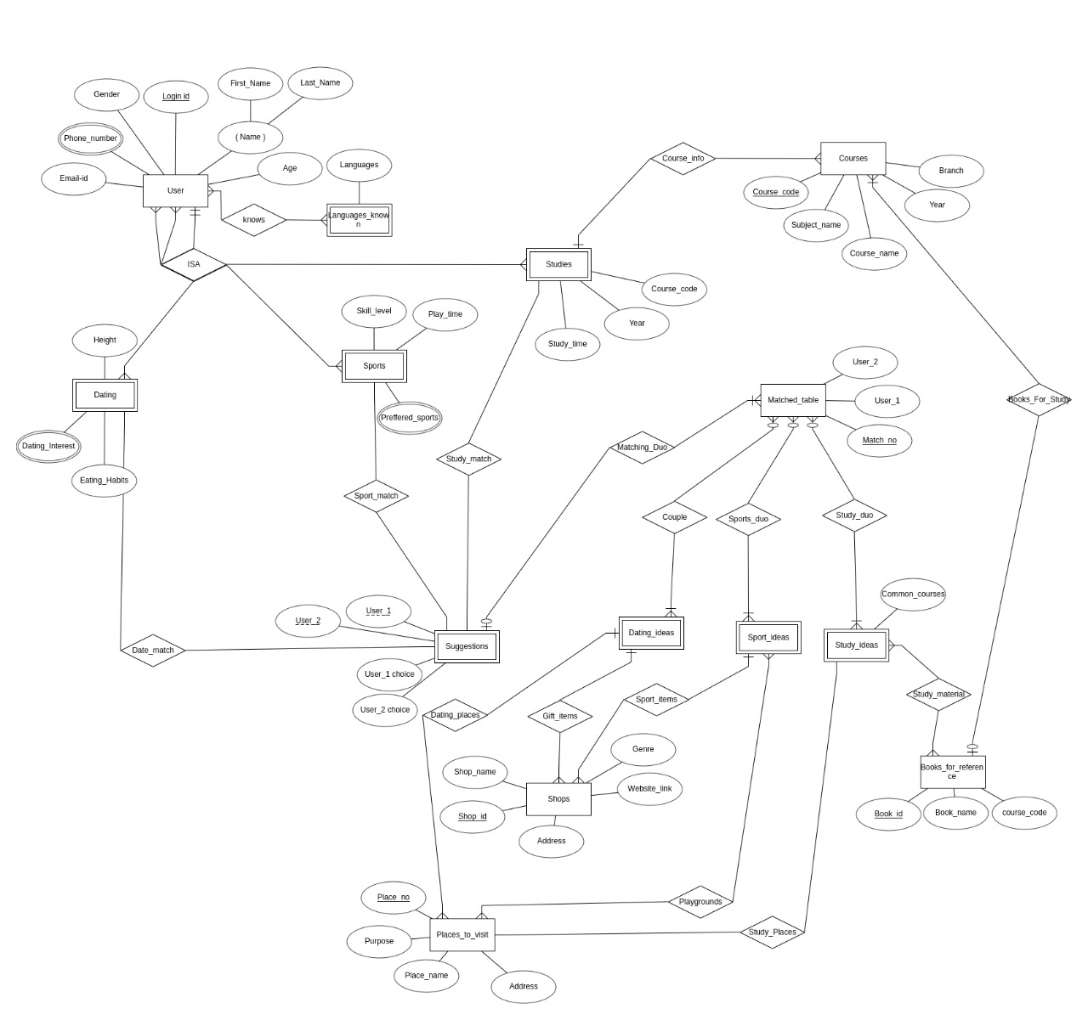

RELATIONAL SCHEMA:-
The relational schema is the primary element of the relational database. These databases are managed using language and structure that is consistent with first-order logic. This allows for database management based on entity relationships, making them easy to organize according to volume.

