 | MASTER REPORT · HEALTH TECHNOLOGY  AAPL Ltd  AAPL | USD | 2026-11-10 | NEUTRAL  Model view 59/100

PRICE  $343.83  -9.9% 1Y | MARKET CAP  $5.02T  Health Technology | P/E (TTM)  43.3×  peers 38.0×
EV/EBITDA  9.4×  peers 6.1× | HEALTH SCORE  96/100  Financially strong | DIV. YIELD  1.73%  beta 0.71
HIGHLIGHTS
- AAPL Ltd generated revenue of $416.00B (+10.9% YoY) at a 26.9% net margin, converting into $136.00B of free cash flow. Its cash-flow pattern (CFO +, CFI −, CFF −) places it in the Mature stage of the corporate life cycle (Dickinson 2011). Key strengths: strong cash conversion (1.29×); low leverage (0.17× ebitda); strong piotroski f-score (8/9); fcf margin 32.7%. No major red flags were triggered by the screening rules. Overall financial-health score: 96/100 — Financially strong.
- Strength: Strong cash conversion (1.29×)
- Strength: Low leverage (0.17× EBITDA)
- Strength: Strong Piotroski F-score (8/9)
- Technical trend: Bearish (-3 net signals of 8).
KEY DATA
Ticker / exchange | AAPL · NASDAQ
Sector / industry | Health Technology / Telecommunications Equipment
Country | United States
Price (close) | $343.83 · 2026-11-10
52-week range | $336.37 – $401.90
Shares outstanding | 14.59B
Beta (5Y) | 0.71
Consensus target | $373.38 (59 analysts, +8.6%)
Next earnings | 2026-12-04
Reporting currency | USD
Prepared by Test Author | CONFIDENTIAL

1 Investment summary
Model view: NEUTRAL (59/100)
Financial health: 96 · Valuation vs peers (P/E 43.3 vs 38.0): 42 · Technical trend: 26. A disclosed rule-based composite (see methodology) — not a recommendation.

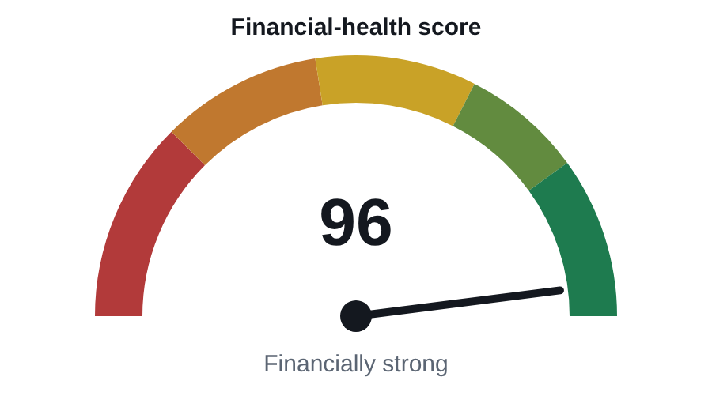

2 Company overview
Mock company summary. (Wikipedia)
Legal / listed name | AAPL Ltd
Founded | 1976
Headquarters | Cupertino
Chief executive | Tim Cook
Founders | —
Industry (Wikidata) | —
Employees | 7,872,124,385
Website | https://www.apple.com
ISIN | —
Sector (TradingView) | Health Technology
Latest fiscal year | FY2025

Business verticals / segments
Segment revenue is not published by the free sources used. Add the company's business verticals (from its annual report) in the report options and they will appear here.

Date | Recent headline
2026-11-10 | Apple Inc. headline 0
2026-11-10 | Apple Inc. headline 1
2026-11-10 | Apple Inc. headline 2
2026-11-09 | Apple Inc. headline 3
2026-11-09 | Apple Inc. headline 4
2026-11-09 | Apple Inc. headline 5
Source: CNBC news search.

3 Financial performance
Revenue grew +10.9% in FY2025; 4-year CAGR +3.3%. Net income rose +24.3%, diluted EPS +14.8% — EPS grew slower than profit, meaning new shares diluted owners. Free cash flow fell -4.0%. Latest quarter revenue $25.55B: -1.1% vs the same quarter last year, -3.3% vs the previous quarter (QoQ is affected by seasonality). Latest quarter net income $26.47B (+2.6% YoY).
(USD) | FY2021 | FY2022 | FY2023 | FY2024 | FY2025
Revenue | $366.00B | $394.00B | $383.00B | $391.00B | $416.00B
growth | — | +7.7% | -2.8% | +2.1% | +6.4%
Gross profit | $153.00B | $171.00B | $169.00B | $181.00B | $195.00B
EBITDA | $120.00B | $131.00B | $125.00B | $135.00B | $144.00B
Net income | $95.00B | $100.00B | $97.00B | $94.00B | $112.00B
growth | — | +5.3% | -3.0% | -3.1% | +19.1%
EPS (diluted) | 5.61 | 6.11 | 6.13 | 6.08 | 7.46
Operating cash flow | $122.00B | $120.50B | $110.00B | $117.50B | $145.00B
Capital expenditure | −$11.00B | −$10.50B | −$11.00B | −$9.50B | −$9.00B
Free cash flow | $111.00B | $110.00B | $99.00B | $108.00B | $136.00B
Total debt | $125.00B | $120.00B | $111.00B | $107.00B | $98.00B
Gross margin | 41.8% | 43.4% | 44.1% | 46.3% | 46.9%
EBITDA margin | 32.8% | 33.2% | 32.6% | 34.5% | 34.6%
Net margin | 26.0% | 25.4% | 25.3% | 24.0% | 26.9%
Cash conversion (CFO/NI) | 1.28× | 1.21× | 1.13× | 1.25× | 1.29×
Source: TradingView fundamentals (company filings). Operating cash flow = free cash flow + capex (exact identity).
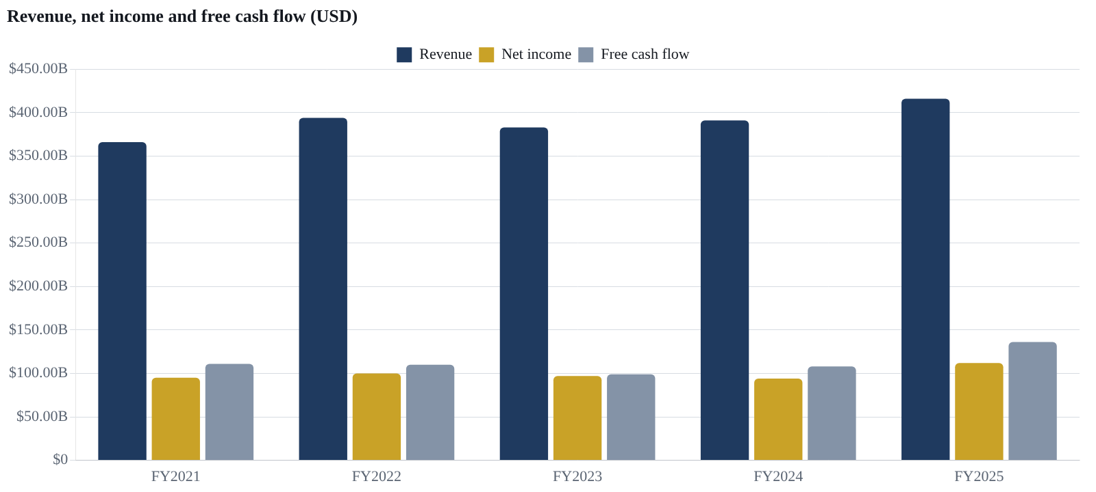

4 Profitability & returns
Gross margin expanded by 0.6 pp to 46.9%. Revenue grew faster than the direct cost of goods — usually pricing power, a richer product/service mix, scale purchasing or lower input costs. EBITDA margin rose 0.1 pp. Stripping out the gross-margin effect, operating expenses (selling, admin, R&D) cost 0.5 pp — overheads grew faster than revenue (investment in growth, wage inflation, marketing, or falling sales against fixed costs). Net margin rose 2.9 pp. Items below EBITDA (depreciation, interest, tax, one-offs) helped by 2.8 pp — e.g. lower interest cost, a lower tax rate or a one-time gain. Operating leverage this year: EBITDA +5.8% on revenue +10.9% = 0.53×. Profits are growing slower than sales — costs are catching up. Gross-margin range over 5 years: 41.8%–46.9% (volatile — sensitive to costs, pricing or cycle). DuPont: ROE 19.0% ≈ net margin 26.9% × asset turnover 1.25× × equity multiplier 0.60×. Driven mainly by high profitability. ROIC of 0.1% is below a typical cost of capital — growth at these returns destroys value.
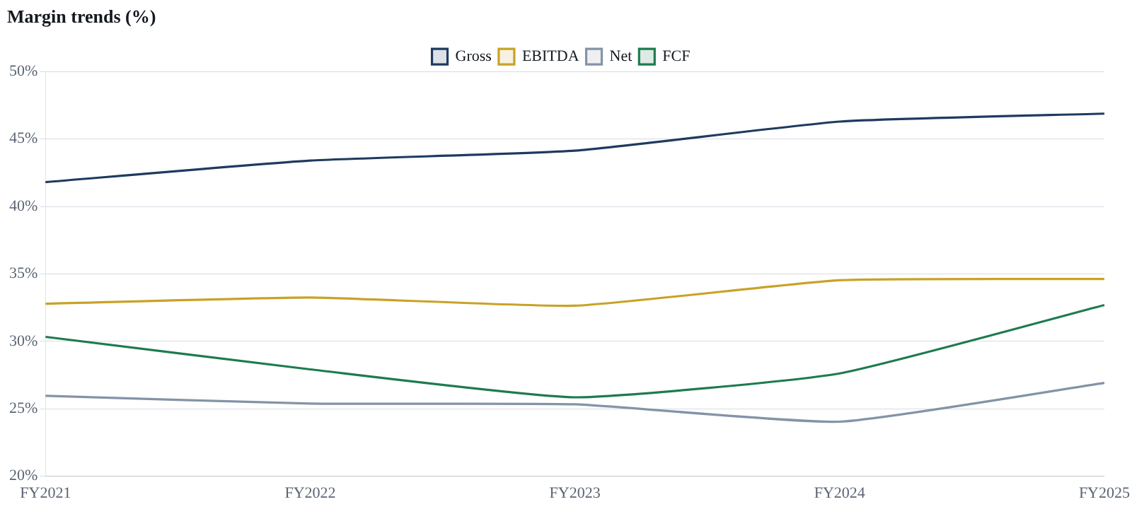
Ratio | Value | Formula | Assessment
Gross margin | 46.9% | Gross profit ÷ Revenue | Strong
EBITDA margin | 34.6% | EBITDA ÷ Revenue | Strong
Operating (EBIT) margin | 32.0% | Operating income ÷ Revenue | Strong
Net margin | 26.9% | Net income ÷ Revenue | Strong
FCF margin | 32.7% | Free cash flow ÷ Revenue | Strong
R&D intensity | 8.2% | R&D expense ÷ Revenue | Neutral
Return on equity (ROE) | 19.0% | Net income ÷ Average shareholders' equity | Strong
Return on assets (ROA) | 12.5% | Net income ÷ Average total assets | Strong
Return on invested capital (ROIC) | 0.1% | NOPAT ÷ (Debt + Equity − Cash) | Weak
Return on capital employed (ROCE) | 29.5% | EBIT ÷ (Total assets − Current liabilities) | Strong
DuPont: equity multiplier | 0.60× | Total assets ÷ Shareholders' equity | Neutral

5 Cash-flow analysis
Operating activities
Operating cash flow was positive at $145.00B in FY2025: the core business generated cash. Where it came from: net income of $112.00B; $11.00B of depreciation & amortisation added back (a non-cash charge that reduced profit but not cash); $22.00B released from working capital and other non-cash items (e.g. collecting receivables, paying suppliers later, stock-based pay). Cash conversion (CFO ÷ net income) is 1.29× — profits are well backed by cash. Operating cash flow has been positive in each of the last 5 years, moving from $122.00B to $145.00B.

Investing activities
Investing cash flow was negative at −$16.00B — the company spent cash on its future. This is normal for a healthy firm. Capital expenditure (new plant, equipment, technology) used $9.00B (2.2% of revenue, 6% of operating cash). A further −$7.00B went into acquisitions, investments or securities purchases.

Financing activities
Financing cash flow was negative at −$120.00B — more cash was returned to shareholders and lenders than raised. Main uses: dividends of $15.00B; net share buybacks of about $85.00B (trailing 12 months); debt reduced by $9.00B. Total debt moved from $107.00B to $98.00B over the year. Net change in cash from the three activities: $9.00B (before FX effects).

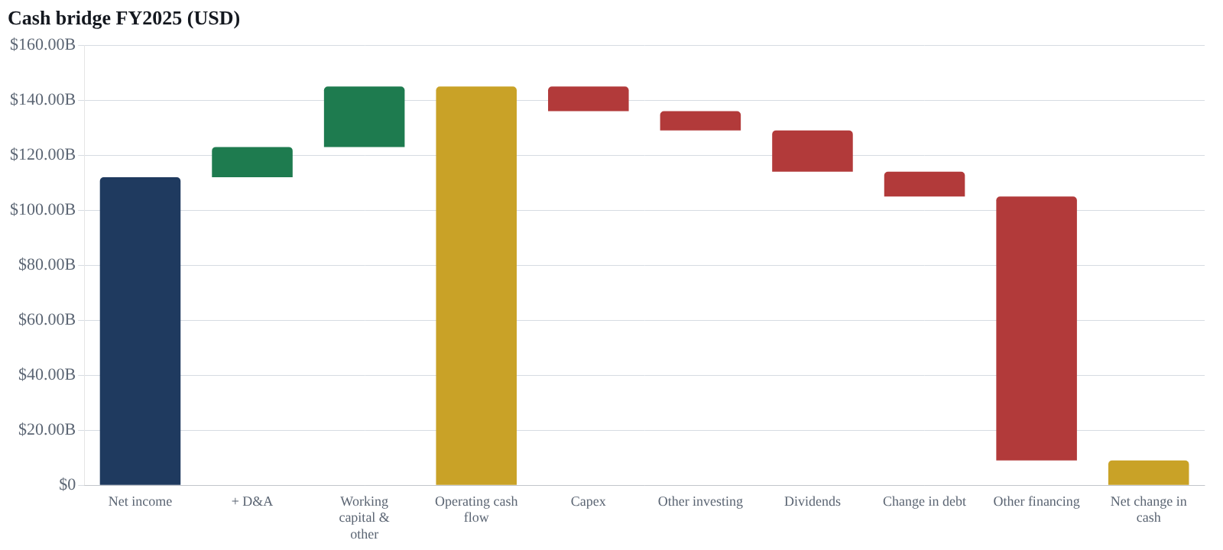
Cash bridge FY2025 | USD | Basis
Net income | $112.00B | reported
Depreciation & amortisation | $11.00B | EBITDA − EBIT
Working capital & other | $22.00B | CFO − NI − D&A
Cash from operations | $145.00B | reported
Capital expenditure | −$9.00B | reported
Other investing | −$7.00B | CFI − capex
Cash from investing | −$16.00B | reported
Dividends paid | −$15.00B | reported
Change in total debt | −$9.00B | debt history
Other financing incl. buybacks | −$96.00B | CFF − dividends − Δdebt
Cash from financing | −$120.00B | reported
Net change in cash | $9.00B | CFO + CFI + CFF
Life-cycle stage (Dickinson 2011): Mature — Operations fund all investment and the surplus is returned to shareholders and lenders.
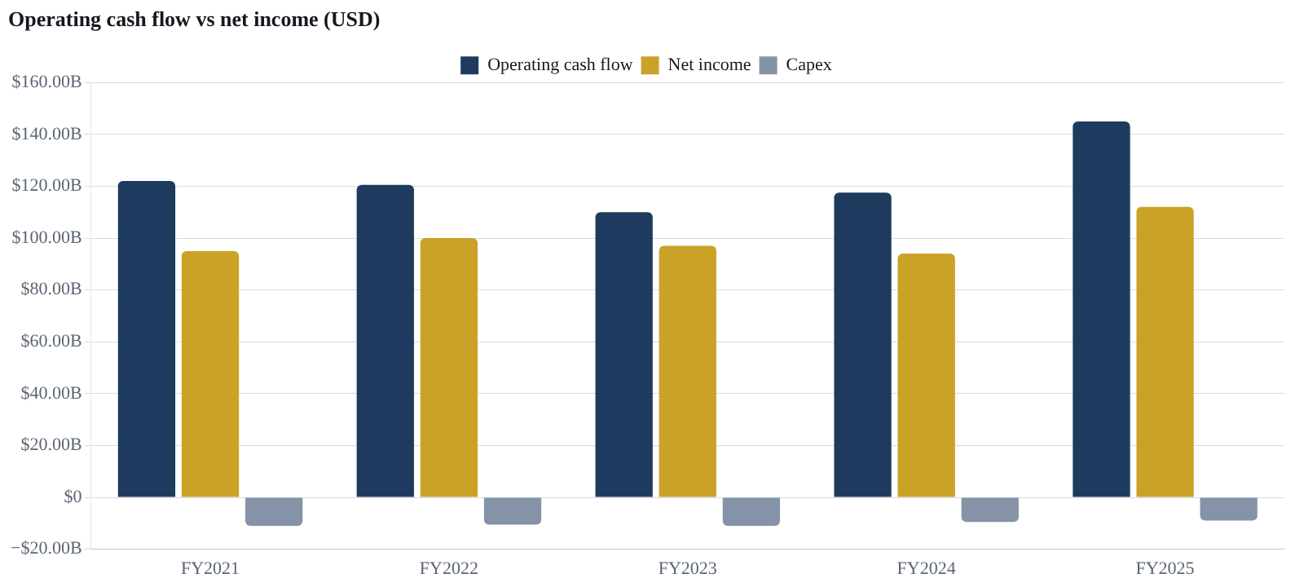

6 Balance sheet & solvency
Liquidity: current ratio 1.02×, quick ratio 0.94× — adequate; short-term obligations are covered but not by a wide margin. Net debt is $7.95B = 0.17× EBITDA (low leverage). Debt-to-equity 0.77×.
Ratio | Value | Formula | Assessment
Current ratio | 1.02× | Current assets ÷ Current liabilities | Neutral
Quick ratio | 0.94× | (Current assets − Inventory) ÷ Current liabilities | Neutral
Working capital | $2.57B | Current assets − Current liabilities | Neutral
Debt / Equity | 0.77× | Total debt ÷ Shareholders' equity | Neutral
Net debt / EBITDA | 0.17× | (Total debt − Cash) ÷ EBITDA | Strong
Debt / Assets | 21.0% | Total debt ÷ Total assets | Neutral
Asset turnover | 1.25× | Revenue ÷ Average total assets | Neutral
Days sales outstanding (DSO) | 60 days | 365 ÷ Receivables turnover | Neutral
Days inventory outstanding (DIO) | 15 days | 365 ÷ Inventory turnover | Strong
Fixed-asset turnover | 7.70× | Revenue ÷ Net PP&E | Neutral
Cash conversion (CFO ÷ Net income) | 1.29× | Operating cash flow ÷ Net income | Strong
Accruals ratio (balance-sheet free) | -624.4% | (Net income − CFO) ÷ Total assets | Strong
Capex intensity | 6.2% | Capex ÷ Operating cash flow | Neutral
FCF yield | 4.0% | Free cash flow ÷ Market cap | Neutral
Piotroski F-score | 8 / 9 | Nine binary tests: profitability (4), leverage/liquidity (3), efficiency (2) | Strong
Altman Z-score | 7.20 | 1.2·WC/TA + 1.4·RE/TA + 3.3·EBIT/TA + 0.6·MVE/TL + 1.0·Sales/TA | Strong
Zmijewski score | -1.70 | −4.3 − 4.5·NI/TA + 5.7·TL/TA − 0.004·CA/CL | Strong
Graham number | $39.40 | √(22.5 × EPS × Book value per share) | Neutral

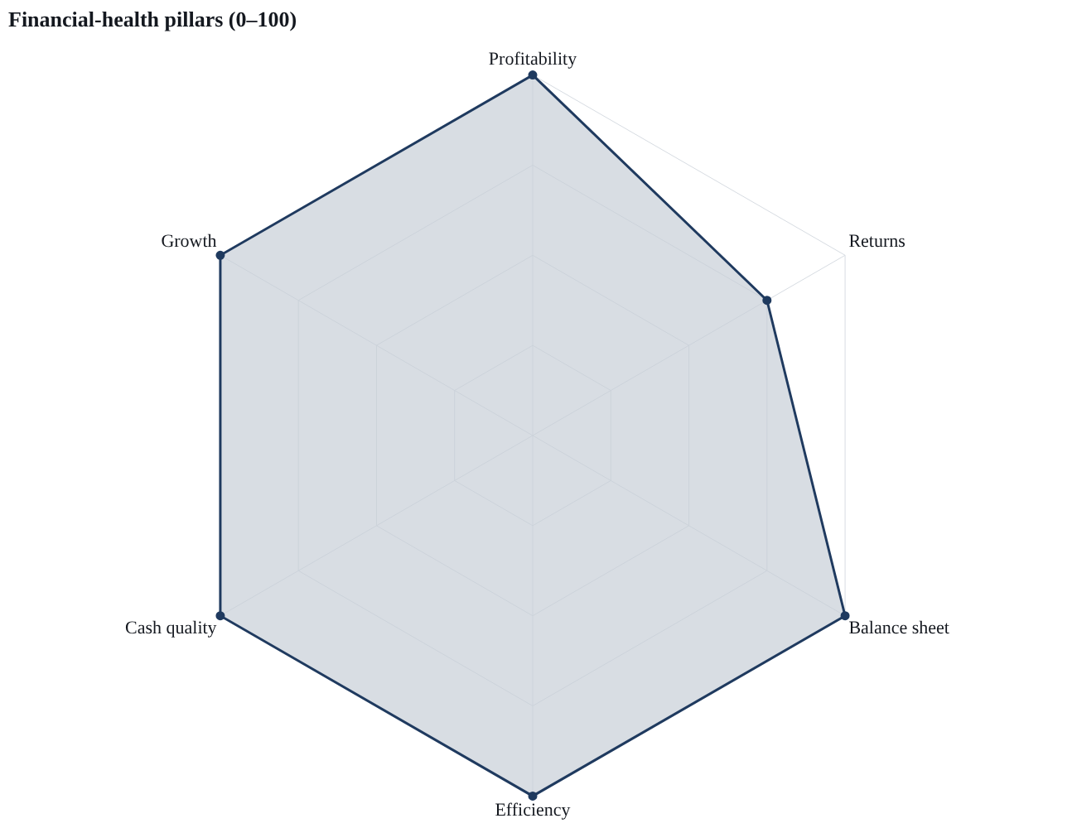

7 Red flags & strengths
Red flags (0)
None triggered by the screening rules.

Strengths (5)
Strong cash conversion (1.29×) · Low leverage (0.17× EBITDA) · Strong Piotroski F-score (8/9) · FCF margin 32.7% · Shareholder returns via buybacks

Pillar | Score
Profitability | 100/100
Returns | 75/100
Balance sheet | 100/100
Efficiency | 100/100
Cash quality | 100/100
Growth | 100/100

8 Valuation
Multiple | AAPL | Peer median (10)
P/E (TTM) | 43.3× | 38.0×
Forward P/E | 25.0× | —
P/B | 2.7× | 4.6×
P/S | 10.7× | 8.0×
EV/EBITDA | 9.4× | 6.1×
PEG | 0.61× | —
Dividend yield | 1.73% | 1.86%
Peers: largest primary listings in Health Technology (United States); medians exclude negative multiples.
At 43.3× trailing earnings the shares trade at a 14% premium to the peer median of 38.0×. A premium is justified only by superior growth, returns or lower risk — compare ROIC and growth with peers.
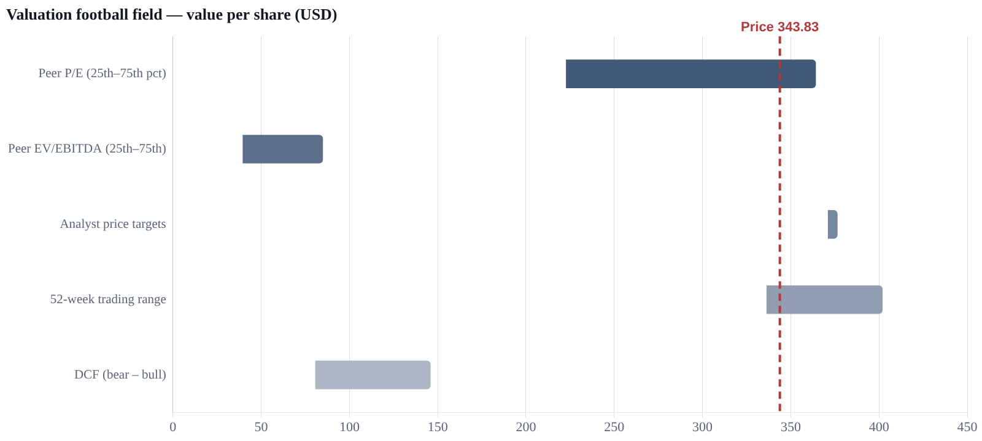
DCF value — bear / base / bull | $80.72 / $107.64 / $145.85
Upside to base case | -68.7%
Inputs | FCF growth 1.8%, WACC 9.1%, terminal growth 3%

Consensus target (mean) | $373.38
Target range | $371.15 – $376.40
Consensus rating | HOLD (2.64 on 1–5)
Analysts | 59

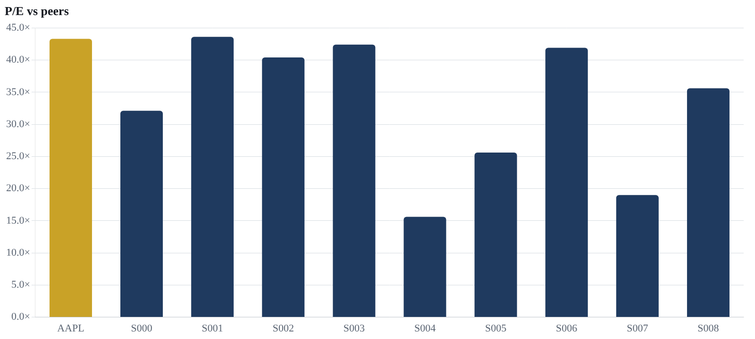

9 Peer comparison
Company | Market cap | P/E | P/B | EV/EBITDA | P/S | Revenue growth | Gross margin | Operating margin | Net margin | ROE | ROIC | Debt/Equity | Div. yield | 1-year return
AAPL — AAPL Ltd | $3.44T | 43.3× | 2.7× | 9.4× | 10.7× | 28.2% | 37.1% | 22.8% | 20.8% | 32.9% | 24.7% | 1.35 | 1.7% | -5.4%
S000 — S000 Ltd | $2.06T | 32.1× | 6.6× | 7.5× | 4.2× | 23.2% | 29.5% | 26.8% | 31.7% | 34.0% | 39.0% | 0.55 | 2.4% | 12.6%
S001 — S001 Ltd | $3.47T | 43.6× | 10.3× | 13.1× | 9.8× | 8.5% | 8.0% | 12.6% | 20.9% | 7.9% | 39.6% | 1.49 | 0.2% | -9.8%
S002 — S002 Ltd | $3.08T | 40.4× | 3.5× | 4.7× | 14.7× | 17.0% | 21.3% | 14.1% | 6.5% | 21.5% | 22.8% | 1.42 | 0.3% | 5.1%
S003 — S003 Ltd | $2.94T | 42.4× | 3.9× | 2.6× | 14.7× | 9.1% | 33.3% | 4.5% | 32.4% | 25.0% | 19.8% | 1.05 | 1.2% | -12.6%
S004 — S004 Ltd | $4.56T | 15.6× | 8.9× | 4.1× | 6.3× | 34.9% | 24.8% | 38.5% | 29.7% | 0.0% | 6.3% | 1.48 | 2.9% | -13.4%
S005 — S005 Ltd | $4.02T | 25.6× | 5.3× | 3.7× | 5.5× | 13.9% | 33.5% | 26.1% | 6.7% | 22.8% | 36.8% | 0.69 | 2.0% | -6.5%
S006 — S006 Ltd | $5.67T | 41.9× | 1.5× | 14.8× | 4.0× | 28.1% | 21.3% | 27.1% | 32.3% | 38.8% | 25.5% | 1.13 | 1.7% | 40.0%
S007 — S007 Ltd | $1.85T | 19.0× | 6.6× | 4.1× | 15.5× | 21.2% | 15.3% | 15.5% | 29.4% | 38.2% | 27.1% | 0.39 | 2.5% | -10.6%
S008 — S008 Ltd | $4.85T | 35.6× | 1.2× | 8.7× | 3.5× | 35.8% | 18.8% | 26.8% | 1.0% | 6.5% | 0.7% | 1.37 | 2.0% | -17.6%
Peer median | $3.45T | 38.0× | 4.6× | 6.1× | 8.0× | 22.2% | 23.1% | 24.4% | 25.2% | 23.9% | 25.1% | 1.24 | 1.9% | -8.1%
AAPL rank (1 = best) | 6/10 | 9/10 | 3/10 | 8/10 | 7/10 | 3/10 | 1/10 | 6/10 | 7/10 | 4/10 | 6/10 | 6/10 | 6/10 | 4/10
Largest 10 primary listings in Health Technology (United States) by market value · TradingView.
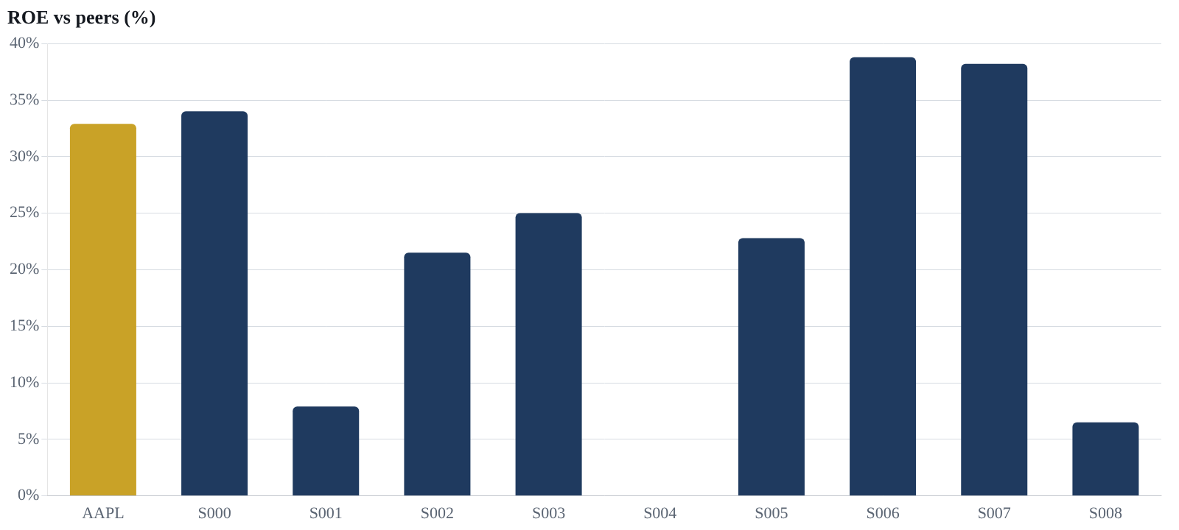

10 Share-price performance & technicals
1W | 1M | 3M | 6M | YTD | 1Y | 3Y | 5Y
-1.5% | -1.5% | -7.1% | -11.8% | -6.3% | -9.9% | -26.0% | -44.5%
Price returns to 2026-11-10. Source series: 2016-11-09 → 2026-11-10.
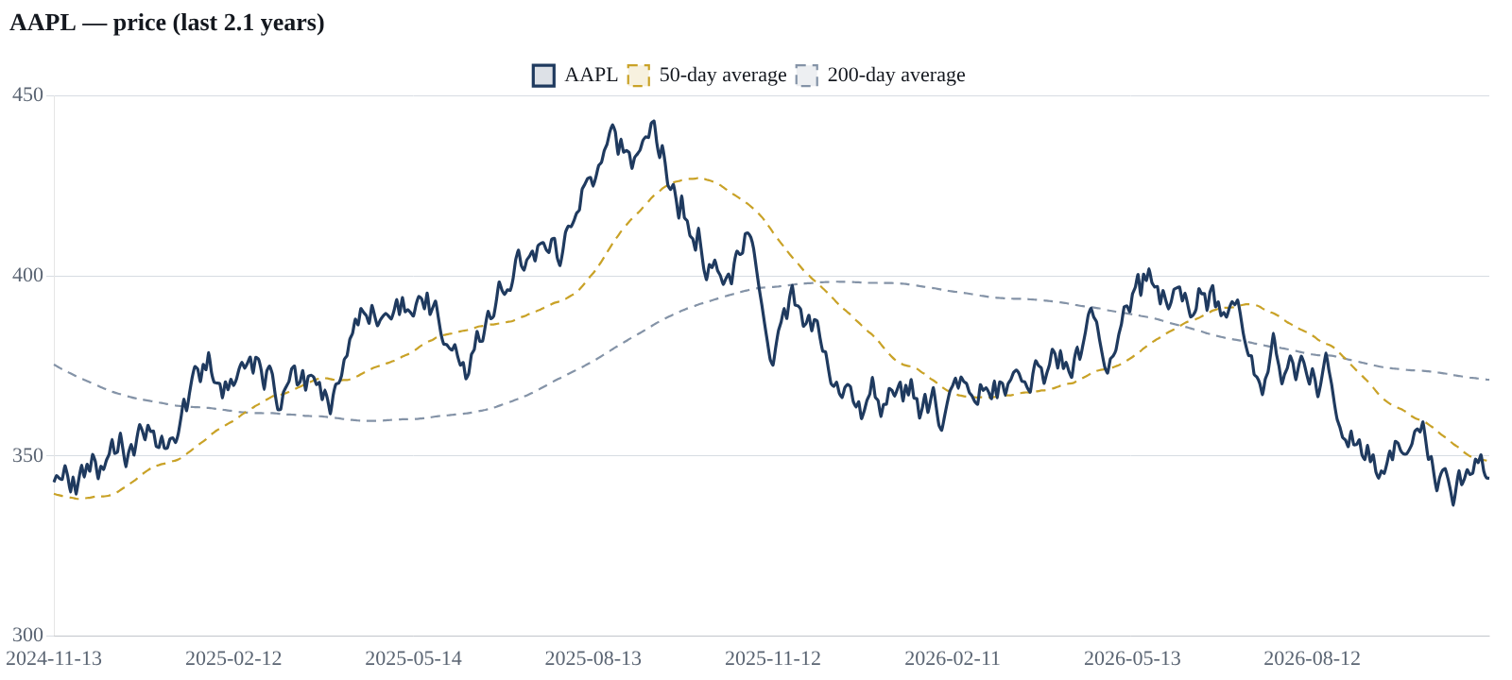
Annualised volatility | 13.8%
Maximum drawdown | -53.5% (2021-03-08 → 2024-10-11)
Sharpe ratio (rf = 0) | -0.98
Sortino ratio | -1.32
Calmar ratio | 0.04
Daily VaR 95% / Expected shortfall | -1.40% / -1.44%
Best / worst day | +1.49% / -1.50%
% positive days | 46%
CAGR (full history) | +2.2%
Rolling 1-year returns | min -28.6% · median -1.7% · max +56.8% · 48% positive

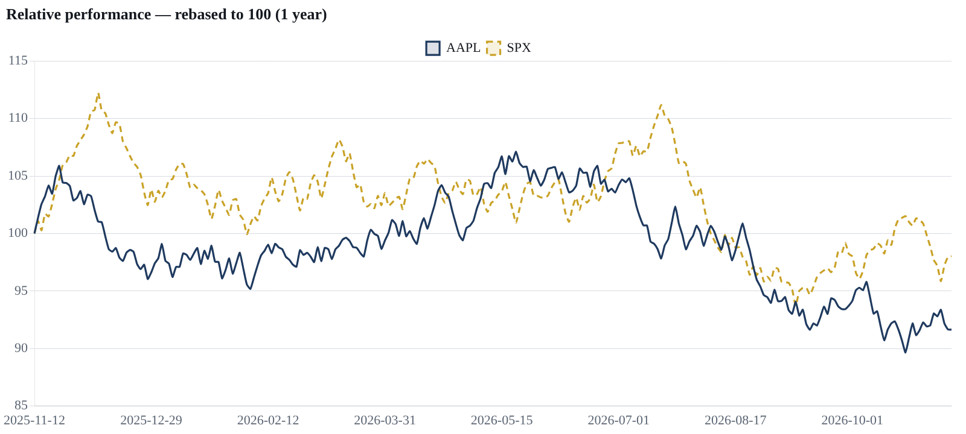
Signal | Reading | Bias
Price vs 50-day average | below (348.43) | Bearish
Price vs 200-day average | below (371.12) | Bearish
50-day vs 200-day (golden/death cross) | death-cross structure | Bearish
RSI(14) | 45.3 — neutral | Neutral
MACD vs signal | bullish (MACD above signal) | Bullish
Supertrend(10,3) | down-trend | Bearish
ADX(14) trend strength | 11.2 — range-bound | Neutral
Bollinger position | inside bands | Neutral
Net signal score -3 → Bearish. ATR(14) = 2.11% of price.
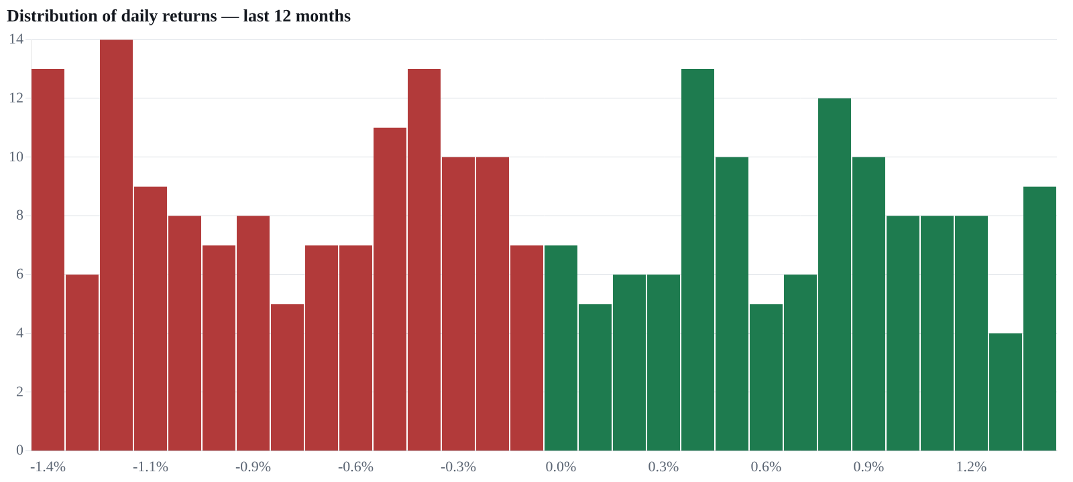

11 Risk assessment
Annualised volatility | 13.8%
Beta vs SPX | -0.08
Daily VaR 95% (historical) | -1.40%
Expected shortfall 95% | -1.44%
Maximum drawdown | -53.5% (2021-03-08 → 2024-10-11)

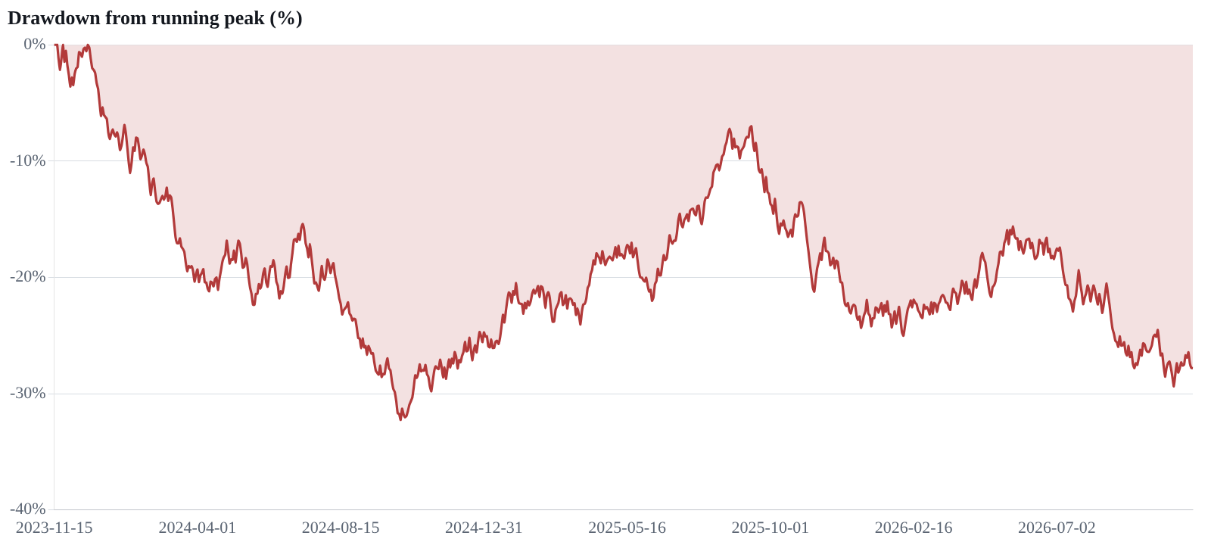
Financial-risk measure | Value | Reading
Current ratio | 1.02× | Moderate
Quick ratio | 0.94× | Moderate
Debt / Equity | 0.77× | Moderate
Net debt / EBITDA | 0.17× | Low risk
Accruals ratio (balance-sheet free) | -624.4% | Low risk
Piotroski F-score | 8 / 9 | Low risk
Altman Z-score | 7.20 | Low risk
Zmijewski score | -1.70 | Low risk

- No quantitative risk flags triggered. Assess qualitative risks (competition, regulation, governance, execution, macro) from the annual report.

12 Conclusion
AAPL Ltd scores 96/100 on financial health (financially strong) and sits in the mature stage of the corporate life cycle. Its main strengths are strong cash conversion (1.29×), low leverage (0.17× ebitda), strong piotroski f-score (8/9). On valuation it trades at 43.3× earnings against a peer median of 38.0×. The price trend is bearish on our technical checklist. Combining these, the disclosed model view is NEUTRAL (59/100).

13 Appendix — ratio library
Group | Metric | Formula | Inputs | Value
Profitability | Gross margin | Gross profit ÷ Revenue | $195.00B ÷ $416.00B | 46.9%
Profitability | EBITDA margin | EBITDA ÷ Revenue | $144.00B ÷ $416.00B | 34.6%
Profitability | Operating (EBIT) margin | Operating income ÷ Revenue | $133.00B ÷ $416.00B | 32.0%
Profitability | Net margin | Net income ÷ Revenue | $112.00B ÷ $416.00B | 26.9%
Profitability | FCF margin | Free cash flow ÷ Revenue | $136.00B ÷ $416.00B | 32.7%
Profitability | R&D intensity | R&D expense ÷ Revenue | $34.00B ÷ $416.00B | 8.2%
Returns | Return on equity (ROE) | Net income ÷ Average shareholders' equity | reported | 19.0%
Returns | Return on assets (ROA) | Net income ÷ Average total assets | reported | 12.5%
Returns | Return on invested capital (ROIC) | NOPAT ÷ (Debt + Equity − Cash) | reported | 0.1%
Returns | Return on capital employed (ROCE) | EBIT ÷ (Total assets − Current liabilities) | reported | 29.5%
Returns | DuPont: equity multiplier | Total assets ÷ Shareholders' equity | $5.29B ÷ $8.88B | 0.60×
Liquidity | Current ratio | Current assets ÷ Current liabilities | $4.30B ÷ $6.83B | 1.02×
Liquidity | Quick ratio | (Current assets − Inventory) ÷ Current liabilities | reported | 0.94×
Liquidity | Working capital | Current assets − Current liabilities | $4.30B − $6.83B | $2.57B
Leverage | Debt / Equity | Total debt ÷ Shareholders' equity | $9.69B ÷ $8.88B | 0.77×
Leverage | Net debt / EBITDA | (Total debt − Cash) ÷ EBITDA | $7.95B ÷ $144.00B | 0.17×
Leverage | Debt / Assets | Total debt ÷ Total assets | $9.69B ÷ $5.29B | 21.0%
Efficiency | Asset turnover | Revenue ÷ Average total assets | reported | 1.25×
Efficiency | Days sales outstanding (DSO) | 365 ÷ Receivables turnover | 365 ÷ 6.10× | 60 days
Efficiency | Days inventory outstanding (DIO) | 365 ÷ Inventory turnover | 365 ÷ 24.20× | 15 days
Efficiency | Fixed-asset turnover | Revenue ÷ Net PP&E | reported | 7.70×
Cash quality | Cash conversion (CFO ÷ Net income) | Operating cash flow ÷ Net income | $145.00B ÷ $112.00B | 1.29×
Cash quality | Accruals ratio (balance-sheet free) | (Net income − CFO) ÷ Total assets | ($112.00B − $145.00B) ÷ $5.29B | -624.4%
Cash quality | Capex intensity | Capex ÷ Operating cash flow | $9.00B ÷ $145.00B | 6.2%
Cash quality | FCF yield | Free cash flow ÷ Market cap | $136.00B ÷ market cap | 4.0%
Growth | Revenue growth (YoY) | Revenueₜ ÷ Revenueₜ₋₁ − 1 | reported | +10.9%
Growth | Revenue CAGR (4y) | (Revenueₜ ÷ Revenueₜ₋ₙ)^(1/n) − 1 | FY2021 → FY2025 | +3.3%
Growth | Net income growth (YoY) | Net incomeₜ ÷ Net incomeₜ₋₁ − 1 | reported | +24.3%
Growth | EPS CAGR (4y) | (EPSₜ ÷ EPSₜ₋ₙ)^(1/n) − 1 | diluted EPS history | +7.4%
Growth | Operating leverage | %Δ EBITDA ÷ %Δ Revenue | +5.8% ÷ +10.9% | 0.53×
Growth | Sustainable growth rate | ROE × (1 − Payout ratio) | 19.0% × (1 − 3.7%) | 1.2%
Scores | Piotroski F-score | Nine binary tests: profitability (4), leverage/liquidity (3), efficiency (2) | reported | 8 / 9
Scores | Altman Z-score | 1.2·WC/TA + 1.4·RE/TA + 3.3·EBIT/TA + 0.6·MVE/TL + 1.0·Sales/TA | reported | 7.20
Scores | Zmijewski score | −4.3 − 4.5·NI/TA + 5.7·TL/TA − 0.004·CA/CL | reported | -1.70
Scores | Graham number | √(22.5 × EPS × Book value per share) | reported | $39.40

14 Methodology & data sources
- Derived items: D&A = EBITDA − EBIT; working-capital & other = CFO − net income − D&A; other investing = CFI − capex; other financing = CFF − dividends − Δdebt.
- Financial-health score: share of rated ratios passing standard benchmarks (good = 1, neutral = ½, weak = 0), averaged across pillars.
- Model view: 40% financial health, 30% relative P/E vs peer median (50 + (1 − P/E ÷ median) × 60, capped 0–100), 30% technical checklist (50 + 8 × net signals).
- Risk statistics from daily closes: volatility = st. dev. × √252; historical VaR = 5th percentile of daily returns; expected shortfall = mean of returns below it.
- Source — TradingView fundamentals & screener (statements, ratios, peers)
- Source — CNBC market data (prices, split-adjusted)
- Source — Wikidata & Wikipedia (company facts)
- Source — CNBC news search
- Source — Your statement API key (FMP / Alpha Vantage / Finnhub) where configured

15 Disclosures
Generated on Tue, 10 Nov 2026 11:06:50 GMT from publicly available data with automated, rule-based analysis. This document is for information and education only; it is not investment advice, an offer or a recommendation to buy or sell any security. Figures can contain errors from upstream sources — verify against primary filings before acting. Past performance does not guarantee future results.
Confidential
Prepared solely by Test Author. All rights reserved to Test Author. This document may not be copied, shared or distributed, in whole or in part, without the prior written permission of Test Author.

