Architectural Components of an LLM-Based Chatbot
A high-level architectural approach, from input to grounded, guardrailed response

Core design principle
The LLM should be treated as a stateless reasoning engine that gets called repeatedly — not as a system with memory or knowledge of its own. Every capability people associate with “the chatbot” — memory, grounding in real data, personality, safety — is actually implemented outside the model, in the scaffolding around it. A production chatbot is therefore not “prompt in, text out.” That is a demo, not a system. A real architecture has to handle grounding (the model does not know your data), state (conversations persist across turns), safety (users will try to break it), and cost/latency (flagship models cannot be called for every token). The sections below walk through each component of that scaffolding.

1. End-to-end architecture
At the highest level, a chatbot is a six-stage pipeline. Input is processed and moderated, an orchestration layer decides what context the model needs, the LLM core generates a response (possibly across multiple internal steps), the output is checked before it is shown to anyone, and the whole exchange is logged for continuous improvement.
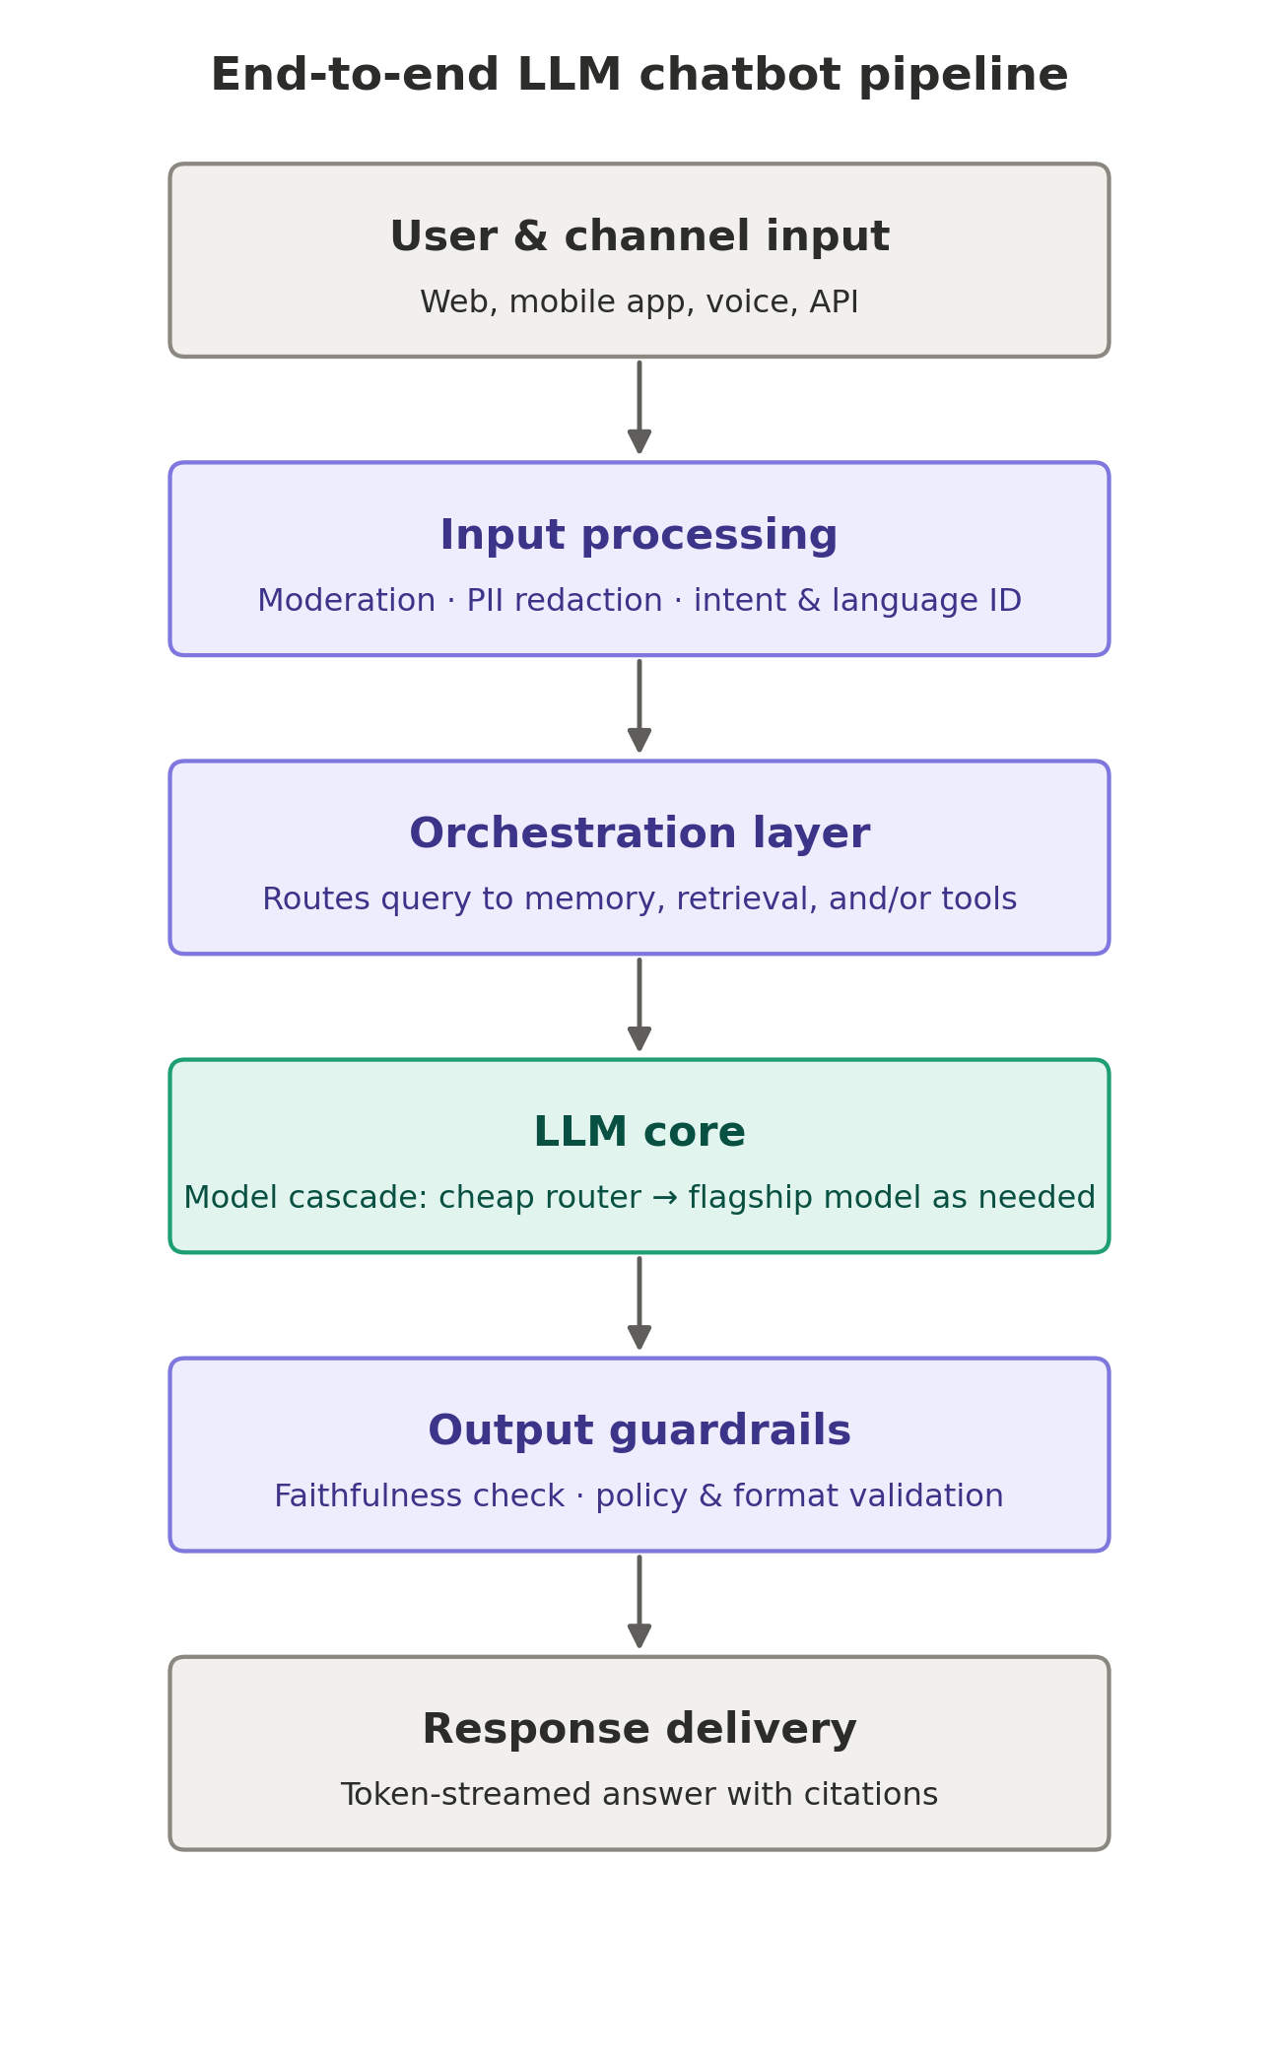
Figure 1. End-to-end LLM chatbot pipeline.
Design pressure | Architectural response
Model does not know private or recent data | Retrieval-augmented generation (RAG) pipeline
Conversations span many turns | Short-term + long-term memory management
Model cannot take real-world actions | Tool / function calling, agent loop
Users will try to jailbreak or misuse it | Input moderation + output guardrails
Cost scales with tokens × traffic | Model cascading, semantic caching, prompt budgeting
Quality can silently drift over time | Logging, offline eval sets, feedback loop

2. Orchestration layer
This is the actual “brain” of the system — and the part most naive implementations underweight. It decides, per query, whether retrieval is needed, whether a tool call is needed, and whether a cheap model can handle the turn or a flagship model is required. It is typically implemented as an explicit state machine or a ReAct-style loop (reason → act → observe → repeat), not as the LLM itself.
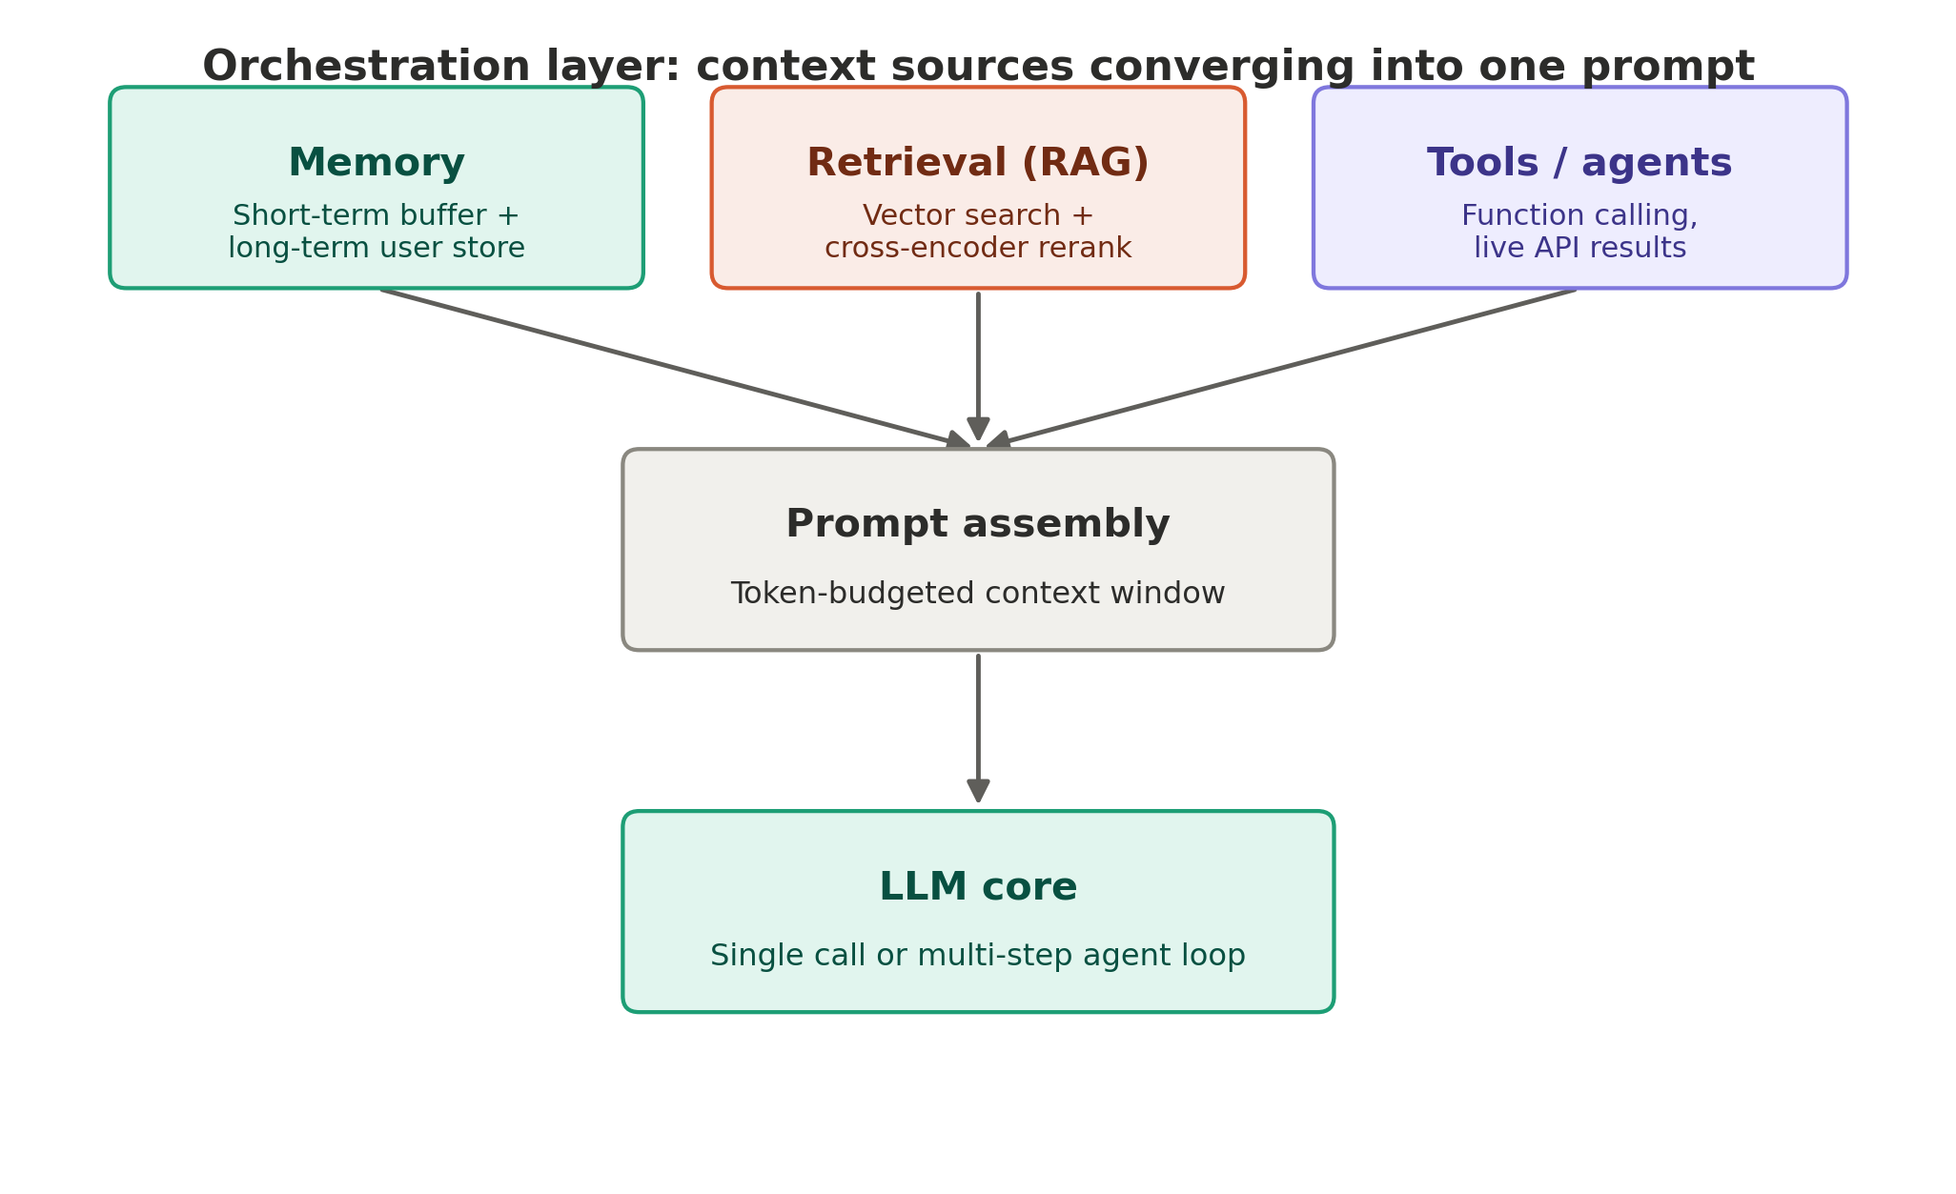
Figure 2. Orchestration layer: three context sources converging into a single prompt.
The ReAct loop, concretely, looks like this: the model emits a Thought, takes an Action (a tool call), receives an Observation (the tool's result), and repeats until it has enough information for a Final Answer. The orchestrator parses each action, executes the actual function against the backend, and re-injects the result into context for the next call.
A key engineering decision here is explicit vs. implicit control: an explicit graph (fixed nodes, bounded transitions) is more predictable and easier to guardrail; a fully free-form agent loop is more flexible but harder to keep reliable and cheap. Most production systems converge on explicit graphs with local LLM decision-making inside each node.
Model cascading also lives in this layer: a lightweight router (often a fine-tuned small classifier, near-zero cost) tags each query by complexity, and only “hard” queries reach the expensive model. Because real-world query distributions are heavily skewed toward simple, repetitive intents, this alone commonly cuts inference cost by 40–70%.

3. Memory architecture
- Short-term (working memory). Concatenating the full history breaks down fast — context windows fill and cost scales with every resent token. Production systems use a sliding window (keep the last N turns verbatim), rolling summarization (compress older turns via a separate LLM call every 5–10 turns), or token-budgeted truncation.
- Long-term (persistent memory). Stored outside the conversation, keyed by user ID. Structured facts (name, tier, preferences) belong in a key-value or relational store and are fetched deterministically — not put in a vector DB. Episodic memory (“user complained about billing last month”) is embedded and retrieved via similarity search, using the same mechanism as RAG.
- Write policy. Matters as much as read policy. A separate process — often an LLM call at the end of a conversation — decides what is actually worth remembering; without this, long-term memory fills with noise and retrieval precision degrades.

4. Retrieval-augmented generation (RAG)
This is usually the single highest-leverage component, and the one that determines whether the bot feels grounded or hallucinates. It runs in two distinct phases: an offline ingestion pipeline that builds the index, and an online query-time pipeline that uses it.
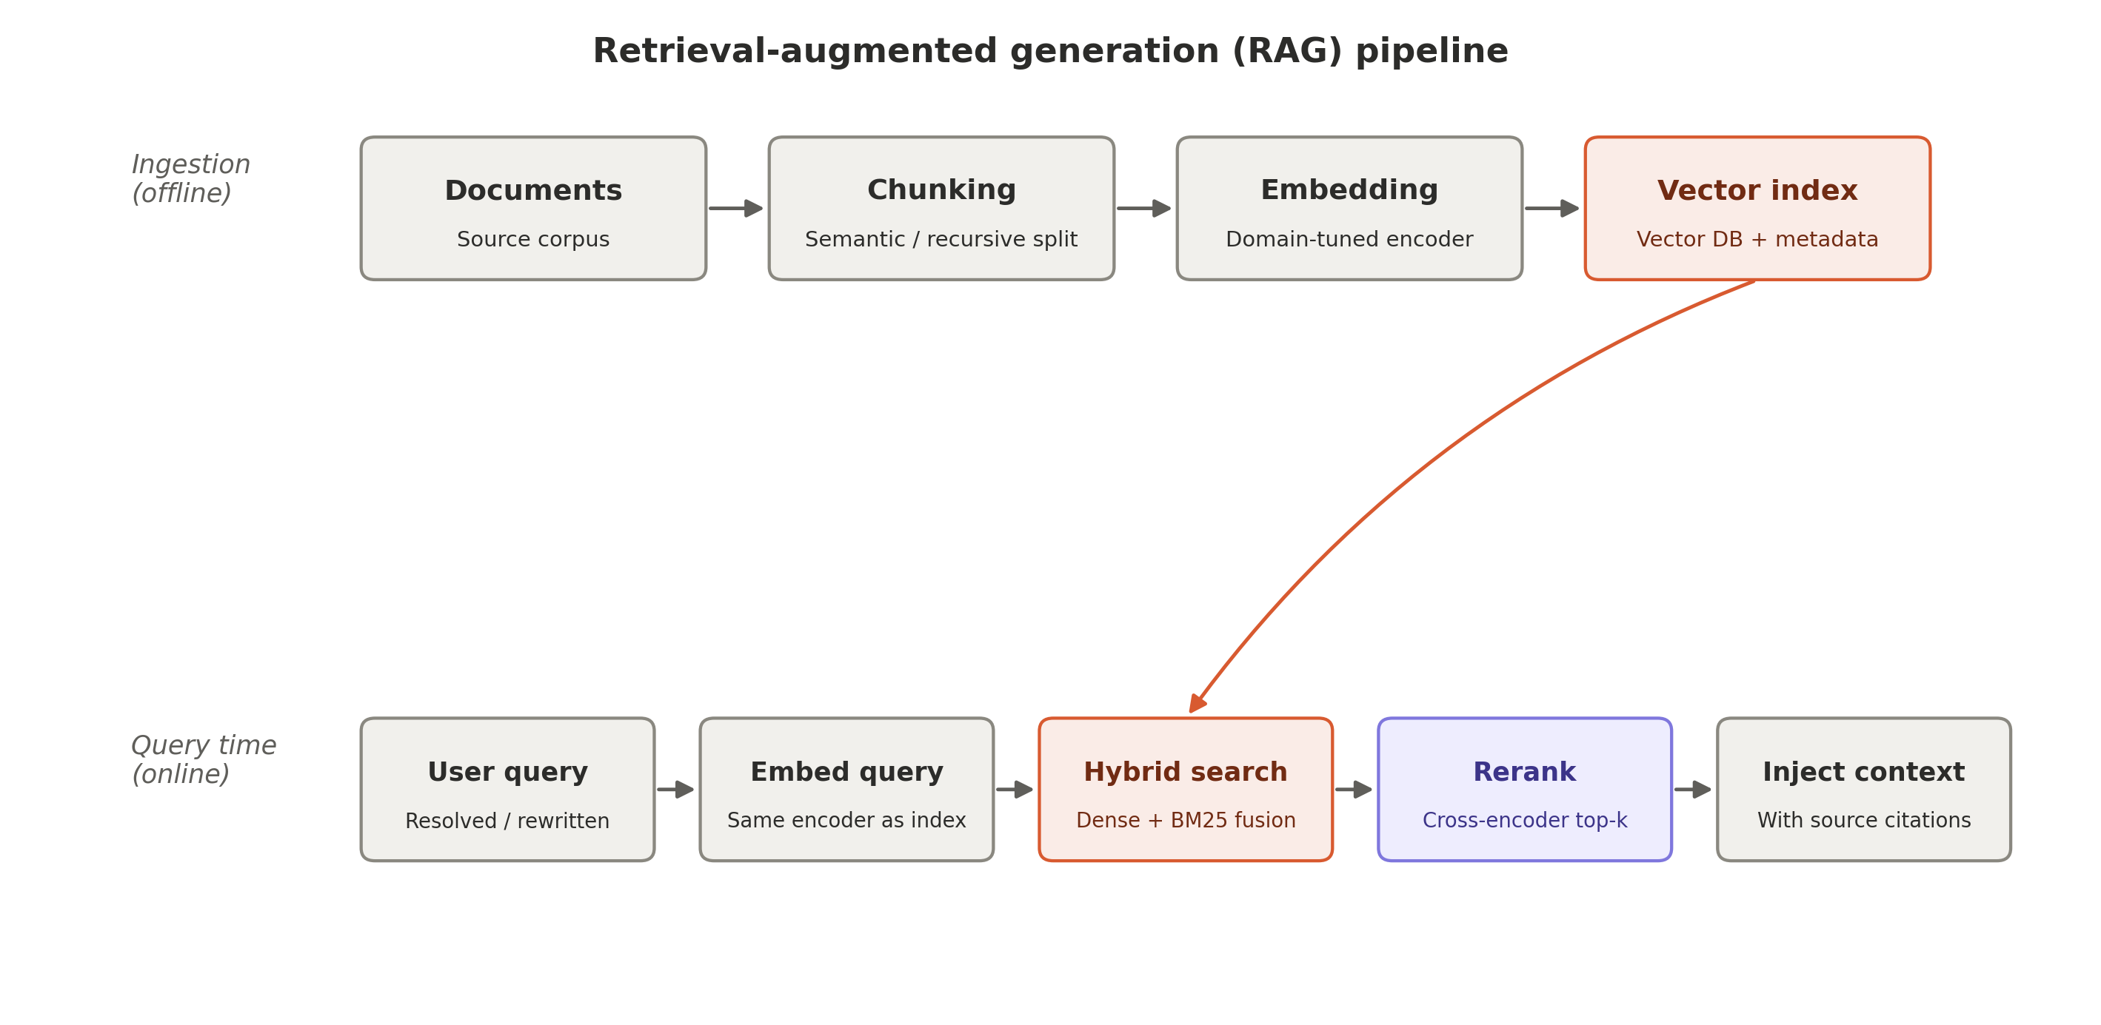
Figure 3. Retrieval-augmented generation pipeline — ingestion (offline) and query time (online).
Ingestion pipeline
- Chunking. Naive fixed-size chunking (e.g. 512 tokens) is a common baseline but hurts recall on structured documents. Semantic chunking (splitting on section/header boundaries) or recursive character splitting with 10–20% overlap avoids cutting facts mid-sentence.
- Embedding. Domain matters. General-purpose embedding models (OpenAI text-embedding-3, BGE-large, E5-Mistral) work for general text, but contrastive fine-tuning of the embedding model on the organization's own query-document pairs often gives bigger accuracy gains than swapping the generator model.
- Indexing. A vector database (pgvector at smaller scale; Pinecone, Weaviate, or Milvus at larger scale) stores vectors alongside metadata (source, timestamp, access permissions) for filtering.
Query-time pipeline
- Hybrid search. Dense vector similarity alone underperforms on exact-match cases (SKUs, names, numbers). Combining it with sparse retrieval (BM25) and fusing the rankings (Reciprocal Rank Fusion) is typically the single largest recall improvement available.
- Re-ranking. Retrieve the top-50 candidates cheaply via vector search, then re-rank with a cross-encoder (BGE-reranker, Cohere Rerank) to surface the true top-5. Cross-encoders score query and document jointly and are far more accurate than cosine similarity, but too slow to run over an entire corpus — hence the two-stage retrieve-then-rerank pattern.
- Context injection with citations. Retrieved chunks are injected with source tags, and the model is explicitly instructed to answer only from the provided context and cite its sources — this is what the output-side faithfulness check (Section 7) verifies against.
Failure mode to design against: retrieval can return chunks that are technically similar but contextually wrong, and models attend less reliably to content buried in the middle of a long prompt (the “lost in the middle” effect). The mitigation is to keep injected context short and highly relevant rather than maximizing how much is stuffed in.

5. Tool use / function calling
For anything the LLM cannot know or compute reliably — live data (order status, weather), calculators, code execution, third-party APIs — the model emits a structured call against a JSON schema, the orchestrator executes it, and the result is fed back into context.
- Schema validation. Always validate emitted arguments against the schema before execution; models hallucinate malformed or out-of-range arguments more often than expected.
- Confirmation checkpoints. For destructive or irreversible actions (cancel an order, send an email), insert a human-confirmation step — never let an agent loop execute side-effecting actions autonomously.
- Result truncation. API responses can be large (a full database row, a long log); summarize or filter before feeding back into context, or the token budget for the next turn is blown.

6. Prompt assembly
The unglamorous step that determines output quality more than people expect. Well-architected systems treat prompts as versioned, tested artifacts rather than inline strings: a system prompt template (persona, tone, hard constraints, refusal policy) versioned separately from application code, assembled in a deterministic order — system prompt, long-term memory facts, retrieved RAG chunks, conversation summary, recent turns, current query, tool schemas — with instructions closest to the query typically followed most reliably. Token budget allocation is a real constraint: of a 16K context window, a system might reserve 2K for the system prompt, 4K for RAG context, and 6K for history, leaving headroom for output.

7. LLM core — model selection and serving
Factor | Hosted API (GPT / Claude / Gemini) | Self-hosted open-weight (Llama, Mistral, Qwen)
Time to production | Fast | Slower — infra and serving stack required
Data residency / compliance | Depends on vendor | Full control
Cost at scale | Per-token, can get expensive at high volume | Fixed infra cost, cheaper at very high volume
Fine-tuning flexibility | Limited to API-based fine-tuning | Full — LoRA/QLoRA or full fine-tune
Quality ceiling | Generally higher on frontier models | Closing gap, still often behind on complex reasoning

Self-hosted serving uses inference engines built for throughput — vLLM or TGI — which implement continuous batching and PagedAttention against a shared KV cache; this is the difference between a naive Hugging Face generate() call and something that can actually serve production traffic.
The decision that gets confused most often is fine-tuning vs. prompting vs. RAG: use RAG when the model needs to know facts (fine-tuning does not reliably teach fact recall, and facts go stale); use light fine-tuning or strong system prompting when a specific tone or format is needed consistently; reserve fine-tuning for narrow task specialization, such as structured extraction from a fixed document type.

8. Output guardrails
Two failure modes are caught after generation, separately from input-side moderation: a faithfulness check, where a secondary (often cheaper) LLM call verifies that the answer's claims are actually entailed by the retrieved context (the technique behind evaluation frameworks such as RAGAS), and policy/format validation — schema validation for structured output plus a moderation pass on the generated text itself, since models can be jailbroken into producing bad output even from a clean input.

9. Observability and evaluation loop
Invisible in demos, decisive in production. An offline evaluation set — a curated collection of representative queries with expected behavior — is re-run against every prompt or model change as a regression test. Key metrics include retrieval precision/recall@k, answer faithfulness, and latency percentiles (p50/p99 matter more than the average for perceived quality). Online signals — thumbs up/down, conversation abandonment, rephrase rate — feed back into prompt iteration and retrieval tuning. Semantic caching (matching by embedding similarity rather than exact string) cuts cost and latency on repeat questions, which is common in FAQ-heavy deployments.

10. Latency budget
Architecture, not just model choice, drives perceived responsiveness. A single RAG-backed turn breaks down roughly as follows:
Stage | Typical latency
Moderation check | ~50 ms
Query embedding | ~30 ms
Vector search | ~50 ms
Re-ranking | ~100 ms
Prompt assembly | ~5 ms
LLM generation (first token, streamed) | ~300–800 ms
Time to first token (total) | ~600–1000 ms

Every retrieval, re-ranking, or tool-call step adds serial latency unless parallelized — which is why token streaming (rendering output as it is generated, rather than waiting for the full response) is a first-class architectural requirement rather than a UI nicety.

Summary judgment
In rough order of impact on perceived quality: retrieval quality (chunking, hybrid search, reranking) > orchestration logic (routing, memory management) > output guardrails > base model choice. Teams consistently overinvest in swapping the base model and underinvest in the retrieval and memory layers — which is backwards, since those layers are what actually determine whether a chatbot feels grounded, consistent, and trustworthy across a real, multi-turn conversation.

