**Assignment:1**

1. **Are the HTML tags and elements the same thing?**

* No, HTML tags and elements are not the same thing.
* HTML tags are used to markup content in an HTML document, while HTML elements consist of one or more tags and their enclosed content, representing a complete unit of content.

1. **What are tags and attributes in HTML?**

* In HTML, tags are used to mark up content and define its structure and appearance.
* They are enclosed in angle brackets and come in pairs, with an opening tag and a closing tag.
* Attributes are used to provide additional information about an HTML element, and are included within the opening tag.
* They specify things like the element's ID, class, style, or other properties.

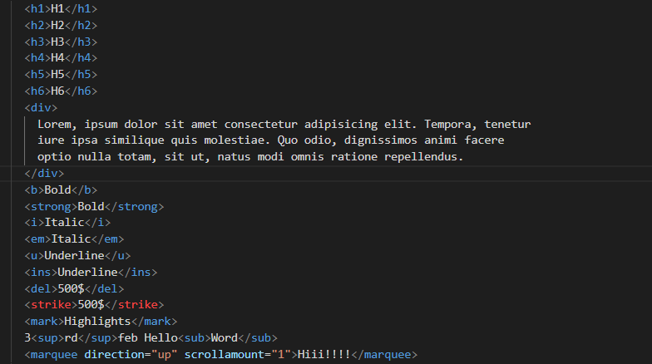

1. **What are void elements in HTML?**

* Void elements are HTML elements that don't have a closing tag and can't have any content inside them.
* They're self-closing tags that end with a forward slash, such as <br />, <img />, and <input />.
* Void elements are used to insert things like line breaks, images, and form elements into a web page.

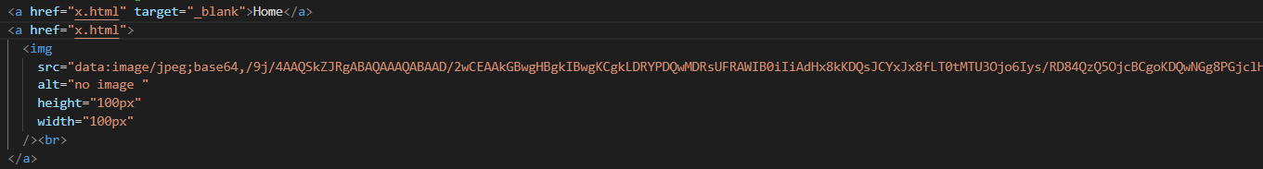

1. **What are HTML Entities?**

* HTML entities are special characters that have a reserved meaning in HTML, such as angle brackets, ampersands, and quotation marks.
* To display these characters in HTML code, you need to use their entity names or codes, such as < for "<" and & for "&". This ensures that the browser doesn't interpret them as part of the HTML code.

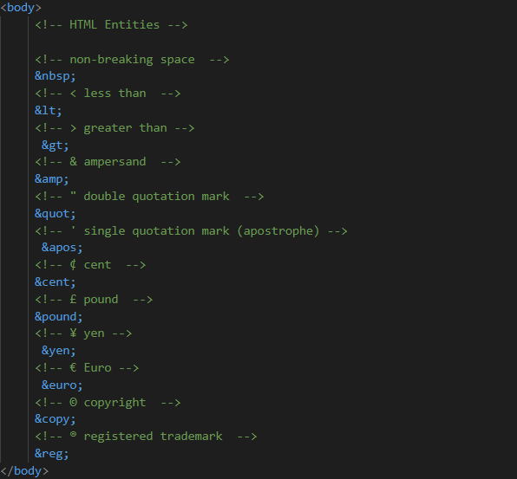

1. **What are different types of lists in HTML?**

* There are three types of lists in HTML: ordered lists, unordered lists, and definition lists.
* Ordered lists use numbers or letters to indicate the order of items.
* Unordered lists use bullets or other symbols.
* Definition lists consist of terms and their definitions.

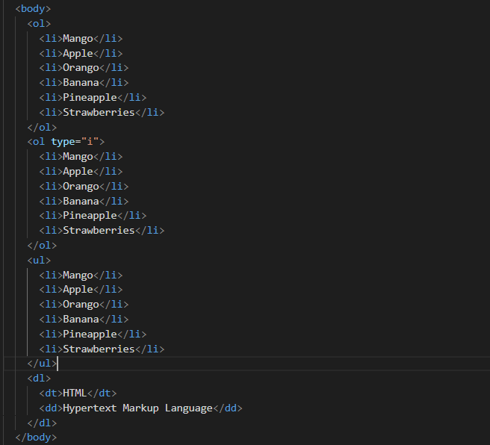

1. **What is the ‘class’ attribute in HTML?**

* The 'class' attribute in HTML is used to define a class of elements that share the same styling or behavior.
* It allows you to group elements together and apply styles or scripts to all elements with the same class name.
* Classes are defined using the 'class' attribute with a unique name.

1. **What is the difference between the ‘id’ attribute and the ‘class’ attribute of HTML elements?**

* The 'id' attribute is used to uniquely identify an element on a web page, while the 'class' attribute is used to group elements together based on their common characteristics.
* The 'id' attribute must be unique within the entire HTML document, while multiple elements can share the same 'class' attribute.
* Styles and scripts can be applied to both 'id' and 'class' attributes.

1. **What are the various formatting tags in HTML?**

* HTML provides various formatting tags to style and structure content on a web page, including:
* Heading tags: <h1> to <h6> tags for section headings
* Paragraph tags: <p> tag to define a paragraph
* Bold tags: <b> tag to make text bold
* Italic tags: <i> tag to make text italicized
* Underline tags: <u> tag to underline text
* Strikethrough tags: <strike> tag to strike through text
* Superscript tags: <sup> tag to display text as superscript
* Subscript tags: <sub> tag to display text as subscript
* Preformatted tags: <pre> tag to display preformatted text
* Blockquote tags: <blockquote> tag to display quoted text

1. **How is Cell Padding different from Cell Spacing?**

* Cell padding is the space between the content of a cell and its border, while cell spacing is the space between the borders of adjacent cells in a table.

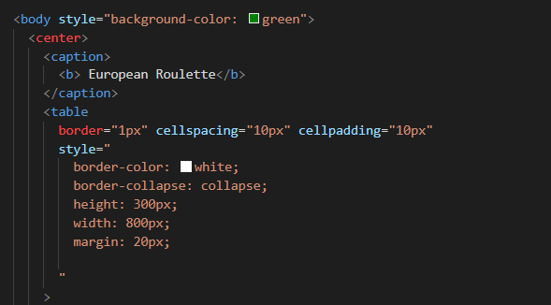

1. **How can we club two or more rows or columns into a single row or column in an HTML table?**

* To merge two or more rows or columns in an HTML table, use "rowspan" or "colspan" attributes on table cells.
* Set the attribute value to the number of rows or columns to merge.

1. **What is the difference between a block-level element and an inline element?**

|  |  |
| --- | --- |
| **Block-level Element** | **Inline Element** |
| Start on a new line and take up the full width available | Do not start on a new line and only take up as much width as necessary |
| Allow for width and height to be set | Do not allow for width and height to be set |
| Can have margin and padding set | Can only have horizontal margin and padding set |
| Eg: <div>, <p>, <h1> to <h6>, and <ul>. | Eg: <span>, <a>, <img>, and <strong>. |

1. **How to create a Hyperlink in HTML?**

* To create a hyperlink in HTML, use the anchor tag **<**a>.
* Set the href attribute to the URL you want to link to, and add the link text between the opening and closing tags.



1. **What is the use of an iframe tag?**

* The iframe tag in HTML is used to embed another HTML document or website within the current page, allowing for the integration of external content.

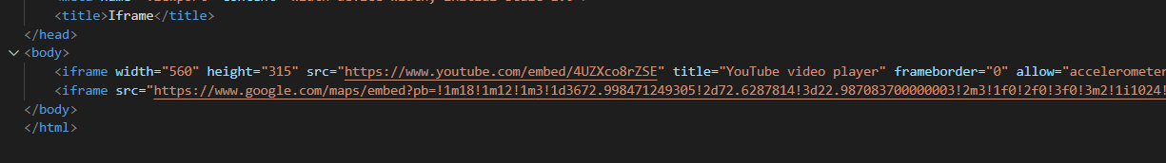

1. **What is the use of a span tag? Explain with example?**

* The span tag in HTML is used to apply styles or manipulate specific text within a larger block of content.
* It has no semantic meaning. Example: <p>This is a <span style="color: red;">red</span> word.</p> to style the word "red" in red color.

1. **How to insert a picture into a background image of a web page?**

* To insert a picture into a background image of a web page, use the CSS background-image property with the url() function.
* Example: background-image: url("image.jpg");

1. **How are active links different from normal links?**

* Active links, also known as hyperlinks, are clickable links that direct users to another web page or resource.
* Normal links are non-clickable text that provides information or context.

1. **What are the different tags to separate sections of text?**

* There are various HTML tags to separate sections of text, including:
* <h1> to <h6> for headings
* <p> for paragraphs
* <ul> and <ol> for unordered and ordered lists
* <blockquote> for quotes
* <hr> for horizontal lines

1. **What is SVG?**

* SVG stands for Scalable Vector Graphics.
* It is a markup language used to create vector graphics on the web, which are images that can be scaled to any size without losing their quality.
* SVG uses XML to define shapes, lines, curves, and colors, and can be manipulated using CSS and JavaScript.

1. **What is difference between HTML and XHTML?**

|  |  |
| --- | --- |
| **HTML** | **XHTML** |
| HTML stands for Hypertext Markup Language. | XHTML stands for Extensible Hypertext Markup Language. |
| It is extended from SGML. | It is extended from XML and HTML. |
| The format is a document file format. | The format is a markup language. |
| Doctype is not necessary to write at the top. | Doctype is very necessary to write at the top of the file. |
| Filename extension used are .html, .htm. | Filename extension are .xhtml, .xht, .xml. |

1. **What are logical and physical tags in HTML?**

* Logical tags, also known as semantic tags, describe the content within them, such as <header>, <nav>, and <footer>.
* Physical tags, on the other hand, define the appearance and layout of the content, such as <b>, <i>, <u>, and <img>.