Software Requirements Specification

for

CONVERTER

**Version 1.0 approved**

**Prepared by 21CE141**

**CSPIT-CE**

**12-10-22**

**Table of Contents**

**Table of Contents ii**

**Revision History ii**

**1.** **Introduction 1**

1.1Objective 1

1.2Document Conventions 1

1.3Intended Audience and Reading Suggestions 1

1.4Project Scope 1

1.5References 2

**2.** **Overall Description 2**

2.1Product Perspective 2

2.2Product Features 2

2.3User Classes and Characteristics 2

2.4Operating Environment 2

2.5Design and Implementation Constraints 3

2.6User Documentation 3

2.7Assumptions and Dependencies 3

**3.** **System Features 3**

3.1System Feature 1 3

**4.** **External Interface Requirements 4**

4.1User Interfaces 4

4.2Hardware Interfaces 5

4.3Software Interfaces 5

4.4Communications Interfaces 5

**5.** **Other Nonfunctional Requirements 5**

5.1Performance Requirements 5

5.2Safety Requirements 6

5.3Security Requirements 6

5.4Software Quality Attributes 6

**6.** **Other Requirements 6**

**Appendix A: Glossary 6**

**Appendix B: Analysis Models 7**

**Appendix C: Issues List 7**

# 1) Introduction

## 1.1 Introduction

*We are designing Converter website which helps the user to convert numbers to Roman numbers and Decimal to Binary number.*

* **1.2 Document Conventions**

We have chosen fonts and highlighted certain information which will be reader friendly.

## 1.3 Intended Audience and Reading Suggestions

*The students and other users who requires to convert numbers to Roman numbers and Decimal to Binary number are most intended audience.*

## 1.4 Project Scope

*This website can be used by many users and students who intends or requires to convert the number to Roman numbers and Decimal to Binary number are most intended audience for their personal purposes*

* **1.5 References**
* *Reference has been taken from the official website of the Converter like browserling, etc.*
* *Reference has also been taken from web designing and development tutorials.*

# 

# 2) Overall Description

## 2.1 Product Perspective

A Converter website contains the following information

* **Number to Roman Numbers:**By clicking on this button lets users to convert number to roman number.
* **Decimal to Binary Number:**

By clicking on this button lets users to convert number to roman number.

* **2.2 Product features**

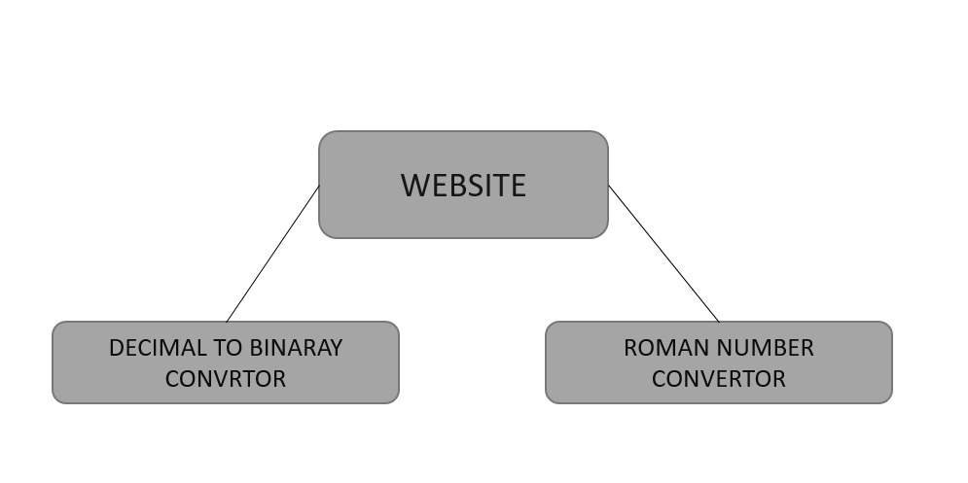

## 2.3 User Classes and Characteristics

*User of the system will be able to perform the conversion. Users can convert Numbers to Roman numbers and decimal to binary Numbers.*

## Operation performed by users:

1. Convert Numbers to Roman Numbers
2. Convert Decimal to Binary operation

## 2.4 Operating Environment

*Operating environment for our retailed website is as listed below.*

* *client/server system*
* *Operating system: Windows,MacOs.*
* *platform: HTML/Javascript/CSS*

## 2.5 Design and Implementation Constraints

*Issues that will limit the options available to the developers is that the conversion can only take place till 4000 in Roman numbers.*

|  |  |  |  |  |
| --- | --- | --- | --- | --- |
| **3rd Sem** | **4th Sem** | **5th Sem** | **6th Sem** | **7th Sem** |
| Not required | Not Required | Not Required | Mandatory | Mandatory |

## 2.6 User Documentation

*The homepage consist of two buttons helping users for conversion. The first button directs user to another page to convert Numbers to roman numbers and another button directs user to another page converts decimal to binary numbers.*

## 2.7 Assumptions and Dependencies

The main assumption of this project is that the user will be provided with two option.

1. Conversion from Decimal to Binary numbers.
2. Conversion from number to Roman numbers.

# 3) System Features

## 3.1 System Feature 1

3.1.1 **Description and Priority**

3.1.2 **Stimulus/Response Sequences**

* Users enters decimal number in response to which Binary number is provided.
* Users enters Number in response to which Roman number is provided.
  + 1. **Functional Requirements**
  + The website should be able to display the Binary number as output to users
  + The website should be able to display the Roman number as output to users.

# 4) External Interface Requirements

## 4.1User Interfaces

Front-end Software: Visual studio code, Bootstrap.

* ***4.2* Hardware Interfaces**

Personal computer

## 4.3 Software Interfaces

|  |  |
| --- | --- |
| ***Software used*** | ***Description*** |
| *Operating system* | *We have chosen Windows operating system for its best support and user-friendliness.* |
| *Visual studio code* | *To implement the project we have chosen HTML, CSS, JavaScript language for its more interactive support.* |

*Following are the software used for the our online showroom website.*

## 4.4 Communications Interfaces

This project supports all types of web browsers.

# 5) Other Nonfunctional Requirements

## 5.1 Performance Requirements

As the project is web based so there are no specifications for performance but in further updates of the project the user will be also be able to convert from binary to decimal numbers and from Roman to numbers.

## 5.2 Safety Requirements

*<Specify those requirements that are concerned with possible loss, damage, or harm that could result from the use of the product. Define any safeguards or actions that must be taken, as well as actions that must be prevented. Refer to any external policies or regulations that state safety issues that affect the product’s design or use. Define any safety certifications that must be satisfied.>*

|  |  |  |  |  |
| --- | --- | --- | --- | --- |
| **3rd Sem** | **4th Sem** | **5th Sem** | **6th Sem** | **7th Sem** |
| Not Required | Not Required | Required, if requirement needs | Required, if requirement needs | Required, if requirement needs |

## 5.3 Security Requirements

*<Specify any requirements regarding security or privacy issues surrounding use of the product or protection of the data used or created by the product. Define any user identity authentication requirements. Refer to any external policies or regulations containing security issues that affect the product. Define any security or privacy certifications that must be satisfied.>*

|  |  |  |  |  |
| --- | --- | --- | --- | --- |
| **3rd Sem** | **4th Sem** | **5th Sem** | **6th Sem** | **7th Sem** |
| Not Required | Not Required | Required, if requirement needs | Required, if requirement needs | Required, if requirement needs |

## 5.4 Software Quality Attributes

* ***AVAILABILITY:*** *Our retailed website is available 24*7.*
* ***CORRECTNESS:*** *As the number conversion happens based on formula provided and computated by computer*
* ***MAINTAINABILITY:*** *There is no complexity, hence maintainable.*
* ***USABILITY:*** *The Converter should satisfy a maximum number of customer’s needs.*

# Other Requirements

*<Define any other requirements not covered elsewhere in the SRS. This might include database requirements, internationalization requirements, legal requirements, reuse objectives for the project, and so on. Add any new sections that are pertinent to the project.>*

**Appendix A: Glossary**

*<Define all the terms necessary to properly interpret the SRS, including acronyms and abbreviations. You may wish to build a separate glossary that spans multiple projects or the entire organization, and just include terms specific to a single project in each SRS.>*

|  |  |  |  |  |
| --- | --- | --- | --- | --- |
| **3rd Sem** | **4th Sem** | **5th Sem** | **6th Sem** | **7th Sem** |
| If applicable | If applicable | If applicable | If applicable | If applicable |

**Appendix B: Analysis Models**

*<Optionally, include any pertinent analysis models, such as data flow diagrams, class diagrams, state-transition diagrams, or entity-relationship diagrams*.>

|  |  |  |  |  |
| --- | --- | --- | --- | --- |
| **3rd Sem** | **4th Sem** | **5th Sem** | **6th Sem** | **7th Sem** |
| If applicable | If applicable | If applicable | If applicable | If applicable |

**Appendix C: Issues List**

*< This is a dynamic list of the open requirements issues that remain to be resolved, including TBDs, pending decisions, information that is needed, conflicts awaiting resolution, and the like.>*

|  |  |  |  |  |
| --- | --- | --- | --- | --- |
| **3rd Sem** | **4th Sem** | **5th Sem** | **6th Sem** | **7th Sem** |
| If applicable | If applicable | If applicable | If applicable | If applicable |

*References*

[*https://krazytech.com/projects/sample-software-requirements-specificationsrs-report-airline-database*](https://krazytech.com/projects/sample-software-requirements-specificationsrs-report-airline-database)