Faculty of Computer Applications

Introduction To Data Analytics
HR Workforce Analytics

Master of Computer Applications

Submitted To: | Submitted By:
Mr. Divyank Chauhan | Team Name: 03 MCA Sec. A
Data Science Trainer | Group Leader: Priyanshi Gangwar
ShapemySkillsByDucat | Total Member: 9

Invertis University, Bareilly [UP]
(2026-27)

DECLARATION
I, Priyanshi Gangwar, hereby declare that the project entitled “HR Workforce Data Analytics”, submitted in partial fulfillment of the requirements for the degree of Master of Computer Applications (MCA), is our original work and has been carried out under the guidance of Mr. Divyank Chauhan, Data Science Trainer, Department of Computer Applications.
The work presented in this project has not been submitted elsewhere for the award of any other degree or diploma.
All sources of information used in this project have been duly acknowledged. This project was completed as a collaborative effort with my team members, and each member contributed to the successful completion of the project.
Team Members' Contribution:
S. No. | Student Name | Contribution
1 | Priyanshi Gangwar (Leader) | 100%
2 | Tripti Gangwar | 100%
3 | Gayatri Singh | 100%
4 | Saumya Patel | 100%
5 | Mohd Aazam | 100%
6 | Amit | 100%
7 | Anju | 100%
8 | Mohd Aamir | 100%
9 | Ashish Gangwar | 100%

Place:
Date:
Signature of Team Leader MCA Section A
.......................

CERTIFICATE
This is to certify that the project entitled “HR Workforce Data Analytics” is a bona fide work carried out by Priyanshi Gangwar (Team Leader) along with the team members of MCA Section A, during the academic year 2026–2027, in partial fulfillment of the requirements for the award of the Master of Computer Applications (MCA) degree.

The project work has been carried out under my guidance and supervision. The team has demonstrated excellent teamwork, technical skills, and dedication throughout the project duration.

I am satisfied with the quality of the work and recommend this project for evaluation.

_______________________

Mr. Divyank Chauhan
Data Science Trainer
Project Guide
External Examiner: _______________________
Date: _______________________
Signature: _______________________

ACKNOWLEDGMENT
We would like to express our sincere gratitude to all those who have contributed to the successful completion of our project entitled “HR Workforce Data Analytics.”
First and foremost, we extend our heartfelt thanks to our esteemed project guide, Mr. Divyank Chauhan, Data Science Trainer, Department of Computer Applications, for his invaluable guidance, constant encouragement, and insightful suggestions throughout the project. His expertise and mentorship were instrumental in the successful completion of this project.
We are deeply grateful to Dr. Akash Sanghi, Head of the Department of Computer Applications, for providing us with the necessary facilities, resources, and support to undertake this project.
We would also like to thank our college management for creating an environment conducive to learning, innovation, and research, which enabled us to explore new ideas and implement them effectively.
Our sincere appreciation goes to all the faculty members of the Department of Computer Applications who directly or indirectly supported us during the course of this project through their valuable inputs and suggestions.
We are thankful to our family members and friends for their unwavering support, motivation, and encouragement, which inspired us to put forth our best efforts.
Last but not least, we would like to acknowledge the collaborative efforts of our team members. Under the leadership of Priyanshi Gangwar, each member contributed their skills, knowledge, and efforts toward completing this project successfully. The teamwork, coordination, and cooperation among all members made this project a valuable learning experience.
Through this project, we gained practical knowledge of Excel, SQL, Python, and Power BI and learned how to analyze workforce data, identify trends, and present meaningful insights through dashboards to support data-driven human resource management decisions.
We hope that this project will serve as a useful reference for understanding workforce analytics and its role in improving organizational decision-making.
Team Members:
Priyanshi Gangwar, Tripti Gangwar, Gayatri Singh, Saumya Patel, Mohd Aazam, Amit, Anju, Mohd Aamir, Ashish Gangwar
MCA Section A

ABSTRACT
Project Title: HR Workforce Analytics Dashboard

Domain: Human Resource Analytics, Data Analytics

Technology Stack: Microsoft Excel, Power Query, Pivot Tables, Power Query, Charts, Slicers, KPI Visualization

This project focuses on developing an HR Workforce Analytics Dashboard to transform raw employee data into meaningful visual insights for effective human resource management. The main objective is to help organizations analyze workforce information, monitor employee performance, and support data-driven decision-making.

The dashboard is developed using Excel features such as Pivot Tables, Charts, Slicers, and Key Performance Indicators (KPIs). It displays important metrics, including total employees, active employees, resigned employees, average performance score, attrition rate, and average salary. It also provides visual analysis of employee count by department, employment status, salary distribution, age groups, monthly attendance trends, leave request status, recruitment sources, leave days by type, and departmental performance.

Interactive filters for department, location, gender, month, and leave type allow users to explore specific workforce segments and analyze data according to their requirements. These visualizations help identify employee distribution patterns, monitor attendance and leave trends, evaluate recruitment sources, and understand salary and performance differences across departments.

The project demonstrates that Microsoft Excel can be used as an effective tool for workforce analysis and reporting. The dashboard reduces manual reporting efforts, improves data visualization, and provides a user-friendly way to understand workforce trends. Overall, this project supports better HR planning and informed organizational decision-making.

Keywords: HR Workforce Analytics, Excel Dashboard, Data Visualization, Employee Attrition, Employee Performance, Recruitment Analysis, KPI, Pivot Tables, Slicers.

TABLE OF CONTENTS
CHAPTER 1: INTRODUCTION
1.1 Background .......................................................................................
1.2 Motivation ........................................................................................
1.3 Problem Statement ...........................................................................
1.4 Objectives ........................................................................................
1.5 Scope of the Project .........................................................................
1.6 Project Overview .............................................................................
CHAPTER 2: LITERATURE REVIEW
2.1 Existing System Analysis .................................................................
2.2 Research Gap ...................................................................................
CHAPTER 3: METHODOLOGY
3.1 Data Collection ...............................................................................
3.2 Data Cleaning & Preprocessing .....................................................
3.3 Data Modeling (Pivot Tables / Power Query) ...............................
3.4 Dashboard Designing Process ......................................................
CHAPTER 4: SYSTEM DESIGN
4.1 Tools & Technologies Used ............................................................ 4.2 Data Flow Diagram (DFD) ................................................................
4.3 Architecture of Dashboard ..............................................................
CHAPTER 5: IMPLEMENTATION
5.1 KPI (Key Performance Indicator) Setup .........................................
5.2 Department-wise Employee Distribution Chart ……………………
5.3 Age Group Distribution Chart .......................................................
5.4 Gender Distribution Chart ..............................................................
5.5 Employee Performance and Attendance Analysis ...........................
5.6 Salary and Employee Attrition Analysis ..........................................
CHAPTER 6: RESULTS & ANALYSIS
6.1 Dashboard Output Screenshots ......................................................
6.2 Insights / Observations ..................................................................
CHAPTER 7: CONCLUSION & FUTURE SCOPE
7.1 Conclusion ......................................................................................
7.2 Limitations .....................................................................................
7.3 Future Scope ..................................................................................
REFERENCES .....................................................................................
ANNEXURES / APPENDIX (Raw Data & Code) .............................

CHAPTER 1: INTRODUCTION

Background
In today’s digital era, organizations generate large amounts of employee data related to salaries, attendance, performance, recruitment, and employee turnover. Analyzing this data manually can be time-consuming and makes effective decision-making difficult.
Data Analytics and Business Intelligence tools help transform raw data into meaningful insights. An interactive dashboard enables HR managers to monitor workforce statistics and identify important trends.
This project focuses on developing an HR Workforce Analytics Dashboard. It presents key metrics such as total employees, active employees, attrition rate, average salary, and performance scores through charts, KPIs, Pivot Tables, and interactive Slicers. The dashboard helps simplify HR reporting and supports data-driven decision-making.

Motivation

Managing and analyzing employee data manually can be time-consuming and may make it difficult to identify important workforce trends. This motivated us to develop an HR Workforce Analytics Dashboard.
The main motivations behind this project are:
- To simplify workforce data analysis and interpretation.
- To reduce manual reporting efforts.
- To visualize employee performance, salary, attendance, and attrition.
- To support better HR planning and data-driven decisions.
Furthermore, this project helped us improve our practical skills in Excel, data analysis, and data visualization, which are valuable in the industry.

Problem Statement

Organizations maintain large amounts of employee data, but analyzing it manually makes it difficult to obtain useful workforce insights. The major problems identified are:

Employee data is difficult to analyze manually.

Limited visibility into employee attrition and performance trends.

Difficulty comparing departments, salaries, and attendance.

Manual reporting consumes time and may lead to errors.

Therefore, there is a need for an analytical dashboard that presents workforce data visually and helps HR managers make informed decisions.

Objectives
The main objectives of the HR Workforce Analytics Dashboard are:
- To convert raw employee data into meaningful visual insights.
- To develop an interactive dashboard using Microsoft Excel.
- To analyze workforce data by department, gender, location, and age group.
- To display key performance indicators (KPIs), such as total employees, active employees, attrition rate, average salary, and performance score.
- To analyze employee attendance, leave requests, recruitment sources, and performance.
- To support effective human resource planning and data-driven decision-making.

Scope of the Project
The scope of the HR Workforce Analytics Dashboard includes:
- Importing employee data into Microsoft Excel.
- Cleaning and organizing the workforce dataset.
- Creating Pivot Tables for workforce analysis.
- Designing an interactive dashboard using charts, KPIs, and Slicers.
- Analyzing employee attrition, salary, attendance, leave requests, recruitment, and performance.

Project Overview
In this project, employee data was organized and analyzed using Microsoft Excel. Pivot Tables, charts, and KPIs were created to analyze:
- Department-wise employee distribution.
- Active and resigned employee status.
- Average salary and performance scores.
- Employee age distribution.
- Monthly attendance trends.
- Leave request status and leave types.
- Recruitment sources and employee attrition.
Various visualizations, including bar charts, column charts, and other charts, were used to present the data clearly. Interactive Slicers were added to filter information by department, location, gender, month, and leave type, making the dashboard user-friendly and interactive.
The final dashboard provides a clear overview of workforce data, helping HR managers identify trends, monitor employee statistics, and make informed decisions for effective human resource management.

CHAPTER 2: LITERATURE REVIEW

2.1 Existing System Analysis
In many organizations, employee information is maintained using traditional methods such as manual records and basic Excel spreadsheets. These methods mainly focus on storing employee data rather than analyzing it to generate meaningful insights. As a result, HR managers may face difficulties in tracking employee performance, attendance, salaries, recruitment, and attrition.
Traditional systems require manual data processing and report preparation, which can be time-consuming and prone to errors. Analyzing workforce trends across different departments and locations also becomes difficult without proper visualization tools.

Characteristics of the Existing System
Parameter | Existing System Description
Data Handling | Employee data is stored in spreadsheets or manual records.
Reporting | Reports are prepared manually, consuming time and effort.
Data Analysis | Limited analysis of salary, attendance, and employee performance.
Decision-Making | Decisions may rely on basic reports rather than comprehensive data insights.
Accessibility | Data may be scattered across multiple files, making monitoring difficult.

Problems Identified in the Existing System

- Limited Insights: Employee data is stored but not analyzed effectively.
- Slow Decision-Making: HR managers may take more time to identify workforce issues.
- Difficulty Tracking Trends: Comparing departments, salaries, attendance, and attrition is challenging.
- Manual Reporting: Preparing and updating reports requires additional effort.
- Risk of Errors: Manual data entry and calculations may lead to inaccuracies.
Due to these limitations, organizations may find it difficult to monitor workforce performance and plan human resources efficiently. Therefore, there is a need for an interactive HR Workforce Analytics Dashboard that presents employee data through visualizations, KPIs, and filters to support efficient analysis and informed decision-making.

2.2 Research Gap
The analysis of existing workforce management methods shows that storing employee data alone is not sufficient for effective human resource management. Organizations need analytical tools to understand employee demographics, salary distribution, performance, attendance, recruitment, and attrition.

The dataset used in this project contains 300 employee records with information such as Employee ID, Gender, Age, Department, Position, Salary, Years of Service, Recruitment Source, Performance Score, Attendance Percentage, Absence Days, Leave Days, Employment Status, and Location. Analyzing these attributes manually can make it difficult to identify workforce patterns and compare HR performance across departments.

Existing Research Observations vs. Identified Gaps
Existing Tools / Methods | Identified Gap
Basic Excel Sheets | Difficult to identify workforce trends without organized visualizations.
Manual Reporting | Requires additional time and effort to prepare reports.
Employee Demographic Analysis | Difficult to compare age groups, gender, and employee distribution.
Salary and Performance Analysis | Limited visibility into salary patterns and performance scores across departments.
Attendance and Leave Records | Difficult to monitor attendance percentages, absences, and leave days together.
Employee Status Tracking | Challenges in monitoring active and resigned employees.

Existing methods may lack the following features:
- Clear visualization of workforce data.
- KPIs such as total employees, active employees, attrition rate, and average salary.
- Interactive filtering using Slicers.
- Integrated analysis of recruitment, attendance, leave requests, and performance.

Need Identified from Research Gap
The project aims to address these challenges by developing an interactive HR Workforce Analytics Dashboard using Microsoft Excel. The dashboard provides:
- Analysis of total, active, and resigned employees.
- Department-wise and gender-wise workforce distribution.
- Average salary and performance score analysis.
- Employee age group and experience analysis.
- Attendance, absence, and leave analysis.
- Recruitment source and employee attrition analysis.
- Interactive filtering to explore workforce information.
The dashboard uses visualizations and key performance indicators (KPIs) to present important information in a clear and understandable format.

Therefore, this project addresses the identified gap by transforming the employee dataset into an interactive HR Workforce Analytics Dashboard that supports workforce monitoring, improves reporting efficiency, and helps management make informed, data-driven decisions.

CHAPTER 3: METHODOLOGY

3.1 Data Collection
The first stage of this project involved collecting and organizing employee data for the development of the HR Workforce Analytics Dashboard. The dataset used in this project contains 300 employee records stored in Microsoft Excel. It includes employee information related to demographics, salary, experience, recruitment, performance, attendance, and employment status.

The dataset contains the following key attributes:

- Employee Details: Employee ID, Employee Name, Gender, and Age.
- Job Information: Department and Position.
- Salary and Experience: Salary, Hire Date, Years of Service, and Experience Group.
- Recruitment Information: Recruitment Source.
- Performance and Attendance: Performance Score, Attendance Percentage, Absence Days, and Leave Days.
- Employment Information: Employment Status and Termination Date.
- Location: Employee work location.

The collected data serves as the foundation for workforce analysis and dashboard development. It helps identify employee distribution, salary patterns, performance levels, attendance trends, recruitment sources, and employee attrition.
Microsoft Excel is used to organize and analyze the dataset through charts, Pivot Tables, KPIs, and interactive Slicers. The resulting dashboard presents workforce information in a clear and understandable format, supporting effective human resource planning and data-driven decision-making.

3.2 Data Cleaning & Preprocessing
After collecting the employee dataset, the data was reviewed and prepared for analysis. Data cleaning and preprocessing help improve data quality and ensure that the dashboard presents meaningful and reliable insights.
Steps involved in data cleaning and preprocessing:
Step | Action Performed
Duplicate Checking | Employee records were checked for duplicate entries.
Missing Values | Blank or missing values were identified and reviewed for appropriate handling.
Data Formatting | Columns such as Employee ID, Salary, Age, Hire Date, and Attendance Percentage were checked for correct data types.
Standardization | Department, Gender, Employment Status, and Recruitment Source values were checked for consistency.
Data Validation | Numeric fields, including Salary, Performance Score, Absence Days, and Leave Days, were checked for valid values.
Date Checking | Hire Date and Termination Date fields were reviewed for correct date formats.

These preprocessing steps help make the employee dataset suitable for analysis using Microsoft Excel. The prepared data is then used to create Pivot Tables, charts, KPIs, and interactive Slicers for the HR Workforce Analytics Dashboard.
The purpose of this process is to improve data consistency, reduce errors, and support accurate analysis of employee demographics, salary, performance, attendance, recruitment, and attrition.

3.3 Data Modeling (Pivot Tables / Power Query)
Data Modeling involves organizing employee data into a structured format for effective analysis. In this project, Microsoft Excel is used to summarize workforce information and present meaningful insights through an interactive dashboard.Steps involved:

Creating Pivot Tables: Pivot Tables are used to summarize employee data, including department-wise employee count, gender distribution, employment status, average salary, attendance, and performance.

Creating Charts: Charts are used to represent workforce information visually and make comparisons easier.

Adding KPIs: Key Performance Indicators display important metrics such as total employees, active employees, resigned employees, average salary, and attrition rate.

Connecting Slicers: Interactive Slicers allow users to filter the dashboard by available categories, such as department, location, gender, month, and leave type.

Pivot Tables, charts, KPIs, and Slicers work together to make the Excel dashboard interactive and easy to understand. The dashboard helps users analyze workforce trends and supports informed human resource management decisions.

3.4 Dashboard Designing Process

After preparing the Pivot Tables, charts and KPI indicators were added to design the HR Workforce Analytics Dashboard in Microsoft Excel. The dashboard was arranged to present employee information clearly and make workforce analysis easier.

Steps followed in dashboard design:

Step | Description
Chart Selection | Selected suitable charts, such as Pie, Donut, Bar, and Column charts, to represent workforce data.
KPI Display | Added key metrics such as Total Employees, Active Employees, Resigned Employees, Average Salary, and Attrition Rate.
Slicer Integration | Added interactive Slicers to filter employee data by available categories, such as Department, Location, and Gender.
Layout Design | Arranged charts, KPIs, and other visual elements in a clean and organized layout.
Formatting | Applied suitable colors, titles, labels, and formatting to improve readability and appearance.

The dashboard was designed to be visually appealing, easy to understand, and interactive. Users can apply available filters to view relevant workforce information and compare employee-related trends quickly. This helps simplify HR reporting and supports better decision-making.

CHAPTER 4: SYSTEM DESIGN

4.1 Tools & Technologies Used

The HR Workforce Analytics project was developed using Microsoft Excel, SQL, Python, and Power BI. These technologies helped transform raw employee data into meaningful insights through data cleaning, analysis, and visualization.

Tool / Technology | Purpose / Function
Microsoft Excel | Main platform used for data organization, analysis, Pivot Tables, and dashboard development.
SQL | Used to store, retrieve, filter, and analyze employee records from databases.
Python | Used for data cleaning, preprocessing, and analysis using libraries such as Pandas and NumPy.
Power BI | Used to create interactive dashboards, reports, and visualizations of workforce data.
Pivot Tables | Used to summarize, group, and analyze employee data.
Charts (Column, Bar, Pie, Donut, Line) | Convert analyzed workforce data into visual insights.
Slicers / Filters | Enable users to interact with dashboards and filter employee data dynamically.
Excel Formulas & Formatting | Used for KPI calculations and visual enhancement of dashboards.

These technologies were selected because they provide useful features for data management, analysis, and visualization. Together, Excel, SQL, Python, and Power BI help analyze workforce information and support better HR decision-making.

4.2 Data Flow Diagram (DFD)
The Data Flow Diagram (DFD) shows how raw employee data is processed and converted into meaningful insights in the HR Workforce Analytics Dashboard.

DFD Diagram:

RAW DATA (Excel Sheet
Employee Records

│
▼
DATA CLEANING
Remove duplicates, if any
Check data formats

│
▼
DATA MODELING
Pivot Tables and Formulas
Summaries and Calculations

│
▼
DASHBOARD VISUALIZATION
Charts, KPIs, and Slicers

│
▼
WORKFORCE INSIGHTS
Salary, Attendance,
Performance, and Attrition

Process Explanation:
- Raw Data: Employee records are stored in an Excel worksheet.
- Data Cleaning: Employee data is checked and organized for analysis.
- Data Modeling: Pivot Tables and formulas summarize workforce information.
- Dashboard Visualization: Charts and KPI cards present the results visually.
- Interactive Analysis: Slicers allow users to filter data and explore workforce trends.
The DFD explains how employee data is transformed into useful information for HR analysis and decision-making.

4.3 Architecture of Dashboard
The architecture of the HR Workforce Analytics Dashboard describes how employee data is processed and transformed into meaningful visual insights using Microsoft Excel.

Layer | Component | Function
Data Layer | Excel Dataset | Stores employee information such as age, gender, department, salary, attendance, and performance.
Processing Layer | Pivot Tables and Excel Formulas | Summarizes and analyzes employee data to generate useful insights.
Visualization Layer | Charts, KPI Cards, and Slicers | Presents workforce information through visualizations and interactive filters.

Dashboard Architecture Flow

Data Collection (Excel Dataset)
↓
Data Preparation and Organization
↓
Pivot Tables and Excel Formulas
↓
Dashboard (KPIs + Charts + Slicers)
↓
Workforce Insights and Analysis

This layered architecture makes employee data easier to analyze, improves data presentation, and helps HR users identify workforce trends for better decision-making.
Show less

CHAPTER 5: IMPLEMENTATION

5.1 KPI (Key Performance Indicator) Setup

The first step in implementing the HR Workforce Analytics Dashboard was to identify and display important Key Performance Indicators (KPIs). These KPIs provide a quick overview of employee information and help understand the overall workforce status.

KPIs used in the dashboard:

KPI Name | Dashboard Value | Purpose
Total Employees | 300 | Displays the total number of employee records.
Active Employees | 252 | Shows the number of currently active employees.
Resigned Employees | 48 | Displays the number of employees who have left the organization.
Average Performance | 75.71 | Shows the average performance score of employees.
Attrition Rate | 16.00% | Displays the percentage of employees who have left the organization.
Average Salary | ₹45,356.67 | Calculates the average salary of employees.

These KPIs are displayed at the top of the Excel dashboard using KPI cards. They are calculated using Excel formulas and Pivot Tables, where applicable.

The KPI section helps HR managers quickly understand employee strength, employee turnover, average salary, and overall performance. It supports effective workforce analysis and decision-making.

5.2 Department-wise Employee Distribution Chart
The Department-wise Employee Distribution Chart shows the number of employees working in different departments.
A chart is created using Pivot Table results to display:
- Employee count in each department.
- Departments with the highest and lowest number of employees.
- Differences in workforce distribution across departments.
Purpose:
- Helps understand employee distribution.
- Supports workforce planning.
- Helps identify departments that may require additional staff.
5.3 Age Group Distribution Chart
The Age Group Distribution Chart represents the distribution of employees across different age groups.
Employee age data is grouped into suitable categories, where applicable, and summarized using a Pivot Table. A chart displays the number of employees in each group.
Purpose:
- Helps understand the workforce's age distribution.
- Identifies the most common employee age group.
- Supports workforce planning and demographic analysis.
5.4 Gender Distribution Chart
The dashboard includes a Gender Slicer that allows users to filter employee information by Male and Female categories.
Component Type: Excel Slicer
Purpose:
- Filters employee data by gender.
- Helps analyze workforce information by gender.
- Makes the dashboard more interactive.

5.5 Employee Performance and Attendance Analysis
Employee performance and attendance are important factors in workforce management. The dashboard uses charts to analyze performance scores and attendance information.
The analysis includes:
- Average performance score of employees.
- Attendance percentage.
- Department-wise workforce comparisons, where available.
Purpose:
- Helps identify overall performance trends.
- Supports attendance monitoring.
- Provides useful information for workforce management and planning.
Interactive Excel Slicers allow users to filter available data by categories such as department, location, and gender.
5.6 Salary and Employee Attrition Analysis
Salary and employee attrition analysis helps understand compensation patterns and employee turnover.
Analysis | Purpose
Average Salary KPI | Displays the average salary of employees.
Salary by Department Chart | Compares salary information across departments.
Employment Status Chart | Shows the distribution of active and resigned employees.
Attrition Rate KPI | Indicates the percentage of employees who have left the organization.

Purpose of this analysis:
- Helps compare salary patterns across departments.
- Provides an overview of employee retention and attrition.
- Supports workforce planning and HR decision-making.

The dashboard combines KPIs, charts, Pivot Tables, and Slicers to present employee information in a clear and interactive format. This makes workforce analysis easier and helps management identify important HR trends.

CHAPTER 6: RESULTS & ANALYSIS

6.1 Dashboard Output Screenshots
After the successful implementation of the HR Workforce Analytics Dashboard, the final system provides a clear and interactive interface for analyzing employee data.
The dashboard consists of the following sections:
- KPI Indicators
- Department-wise Employee Distribution
- Age Group Distribution
- Gender Distribution
- Employee Performance and Attendance Analysis
- Salary and Employment Status Analysis
- Slicers for filtering available employee data

- KPI Section

The KPI section displays important workforce statistics:
- Total Employees
- Active Employees
- Resigned Employees
- Average Performance Score
- Attrition Rate
- Average Salary

These indicators help users understand the overall workforce status quickly.

(B) Employee Count by Department

Chart Type: Horizontal Bar Chart

This chart displays the number of employees in each department. It helps compare department-wise employee distribution and identify departments with higher or lower headcounts.

(C) Employee Employment Status
Chart Type: Pie Chart
This chart represents the proportion of active and resigned employees. It helps users understand the current employment status of the workforce.

(D) Average Salary by Department
Chart Type: Column Chart
This chart compares the average salary across departments. It helps users understand differences in departmental salary levels.

(E) Employee Age Distribution
Chart Type: Column Chart
This chart shows the distribution of employees across different age groups. It helps understand the age composition of the workforce.

(F) Monthly Attendance Trend
Chart Type: Line Chart
This chart shows monthly attendance trends and helps users compare attendance percentages across different months.

(G) Leave Request Status Analysis
Chart Type: Column Chart
This chart compares leave requests by their status, such as approved, rejected, and pending. It helps summarize leave request information.

(H) Employee Count by Recruitment Source
Chart Type: Horizontal Bar Chart
This chart compares the number of employees associated with different recruitment sources. It helps identify the sources contributing to employee hiring.

(I) Leave Days by Type
Chart Type: Donut Chart
This chart represents the distribution of leave days by leave type. It helps users compare the use of different leave categories.

(J) Average Performance Score by Department

Chart Type: Column Chart
This chart compares average employee performance scores across departments. It helps identify differences in departmental performance.

6.2 Insights / Observations
The dashboard provides the following observations based on the displayed KPI values and available charts:

Observation | Description
Workforce Size | The dashboard shows 162 total employee records.
Employment Status | There are 137 active employees and 25 resigned employees.
Attrition Rate | The displayed attrition rate is 15.43%.
Average Performance | The average performance score is 75.82.
Average Salary | The displayed average salary is ₹44,901.23.
Department Analysis | The department-wise charts help compare employee counts, salaries, and performance scores.
Attendance Analysis | The monthly line chart shows changes in attendance across the year.
Leave Analysis | The leave charts summarize leave request statuses and leave days by type.
Recruitment Analysis | The recruitment chart compares employee counts across recruitment sources.

Key Takeaways
- KPI cards summarize the overall workforce status.
- Charts make employee information easier to compare and understand.
- Slicers provide interactive filtering of available data.
- Salary, attendance, performance, recruitment, and leave analysis support HR reporting.

CHAPTER 7: CONCLUSION & FUTURE SCOPE

7.1 Conclusion
The HR Workforce Analytics Dashboard developed in Microsoft Excel demonstrates how raw employee data can be converted into meaningful insights through data analysis and visualization.
The project uses Excel features such as Pivot Tables, formulas, charts, KPI cards, and Slicers to analyze workforce information and present it in an organized dashboard.
The dashboard enables users to analyze:
- Total, active, and resigned employees.
- Department-wise employee distribution.
- Gender and age group distribution.
- Salary and employee performance.
- Attendance and absence patterns.
- Recruitment sources and employee attrition.

The interactive dashboard allows users to filter employee data using Slicers, making workforce analysis easier and more efficient. The project demonstrates that Microsoft Excel can be used not only for data entry but also for effective data analysis, visualization, and decision-making.
Overall, this project helped develop practical skills in data analysis, dashboard design, and workforce reporting. The dashboard can be further improved by adding advanced analytical features and updated employee data.

7.2 Limitations
Although the HR Workforce Analytics Dashboard works effectively for workforce analysis, it has some limitations.

Limitation Area | Description
Dataset Limitations | The analysis depends on the quality and accuracy of the employee dataset used.
Limited Automation | Updated data may require manual changes or refreshing in Excel.
Scalability | Excel may become slower when working with very large datasets or complex calculations.
No Predictive Analytics | The dashboard focuses on analyzing existing data and does not predict future workforce trends using machine learning.
User Access Control | Real-time collaboration and advanced access control depend on how the Excel file is shared and managed.
Despite these limitations, the dashboard provides useful workforce insights and demonstrates the practical use of Microsoft Excel for HR data analysis and visualization.

7.3 Future Scope
The HR Workforce Analytics Dashboard can be enhanced in several ways to improve its functionality and analytical capabilities.

Enhancement | Description
Integration with SQL Database | Employee data can be connected to an SQL database for easier data storage and retrieval.
Migration to Power BI | The dashboard can be developed in Power BI for advanced visualizations and interactive reporting.
Predictive Analytics | Machine learning can be used to predict employee attrition and analyze future workforce trends.
Multi-User Access | The dashboard can be shared with HR teams and management for collaborative analysis.
Automated Data Refresh | Data updates and dashboard refreshes can be automated to reduce manual work.
Advanced HR Analytics | Additional analysis can be introduced for employee performance, attendance, salary, and recruitment.

In the future, the project can be extended by integrating databases, automation, and advanced analytical tools. These improvements can make workforce analysis more efficient and support better human resource management decisions.

REFERENCES
- Microsoft Support. Create a PivotTable to Analyze Worksheet Data.
Available at: https://support.microsoft.com/en-us/excel/get-started/create-a-pivottable-to-analyze-worksheet-data
- Microsoft Support. Overview of PivotTables and Pivot Charts.
Available at: https://support.microsoft.com/en-us/excel/overview-of-pivottables-and-pivotcharts
- Microsoft Support. Use Slicers to Filter Data.
Available at: https://support.microsoft.com/en-us/excel/get-started/use-slicers-to-filter-data
- Microsoft Support. Learn to Use Power Query and Power Pivot in Excel.
Available at: https://support.microsoft.com/en-us/excel/learn-to-use-power-query-and-power-pivot-in-excel
- Microsoft Support. Calculate Values in a PivotTable.
Available at: https://support.microsoft.com/en-us/excel/calculate-values-in-a-pivottable
- Stack Overflow. Community Discussions on Excel Formulas and Data Analysis.
Available at: https://stackoverflow.com
- Excel Dashboard Tutorials. Online Learning Resources for Excel Charts and Dashboard Design.
Available at: https://www.youtube.com

ANNEXURES / APPENDIX

Appendix A – Raw Dataset (Excel Raw Dataset)
The raw dataset used in this project is maintained in Microsoft Excel and contains multiple sheets related to HR workforce management. It includes employee demographics, salary details, department information, attendance records, leave information, recruitment sources, performance scores, and employment status.
The dataset consists of:
- 300 Employee Records
- 3,600 Monthly Attendance Records
- 640 Leave Records
- Recruitment Source Summary
The dataset is used as the primary source for data cleaning, processing, analysis, and dashboard development.

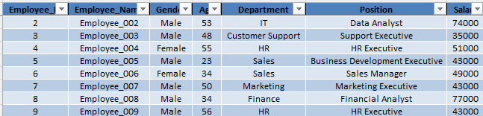
Table:1 Employee_Master

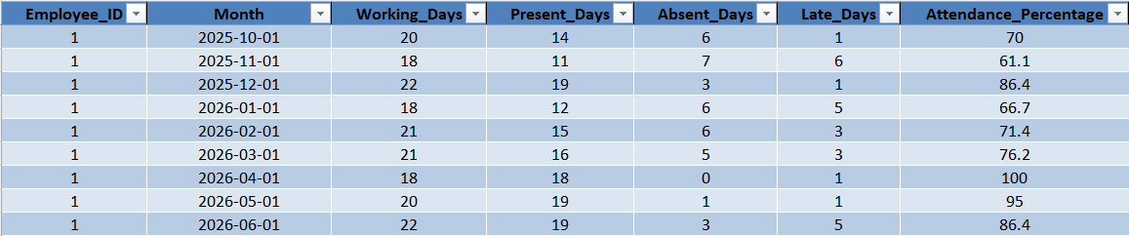
Table:2 Attendance

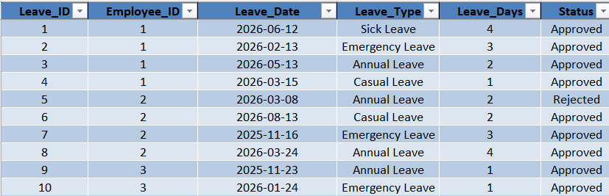
Table:3 Leave
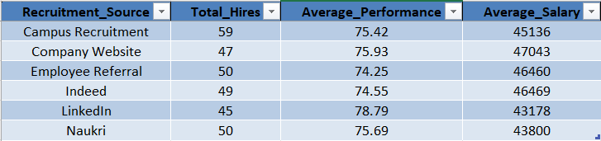
Table:4 Recruitment_Summary

Appendix B – Data Generation (Fake Dataset Logic)
The HR Workforce Analytics project uses a synthetically generated dataset created specifically for academic and analytical purposes. All employee names, records, and related information are fictitious and do not represent actual employees.
The dataset contains randomly generated and predefined values for different HR attributes, including:

Attribute | Description
Employee ID | Unique identification number
Employee Name | Synthetic employee names
Gender | Male / Female
Age | Employee age
Department | IT, HR, Sales, Marketing, etc.
Salary | Employee salary
Performance Score | Employee performance rating
Attendance | Attendance percentage and monthly records
Employment Status | Active / Resigned
Recruitment Source | LinkedIn, Naukri, Indeed, etc.

Synthetic data was used to avoid exposing confidential employee information while maintaining a realistic structure for workforce analysis.

Appendix – Final Dashboard Layout

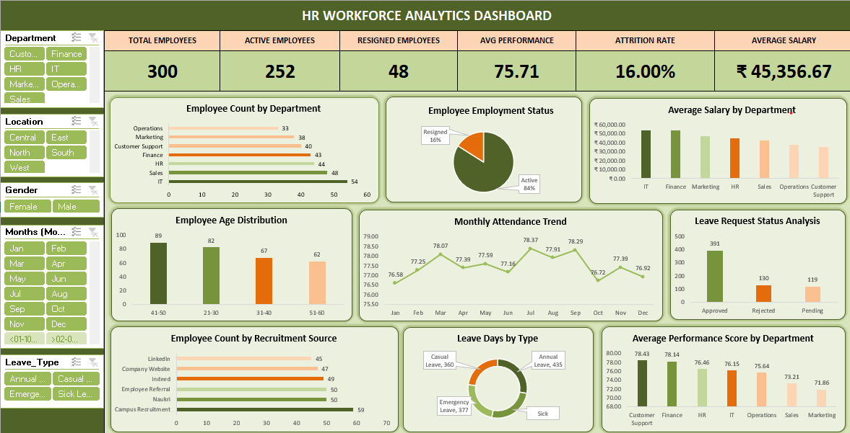

Fig:1 HR WORKFORCE DASHBOARD USING EXCEL

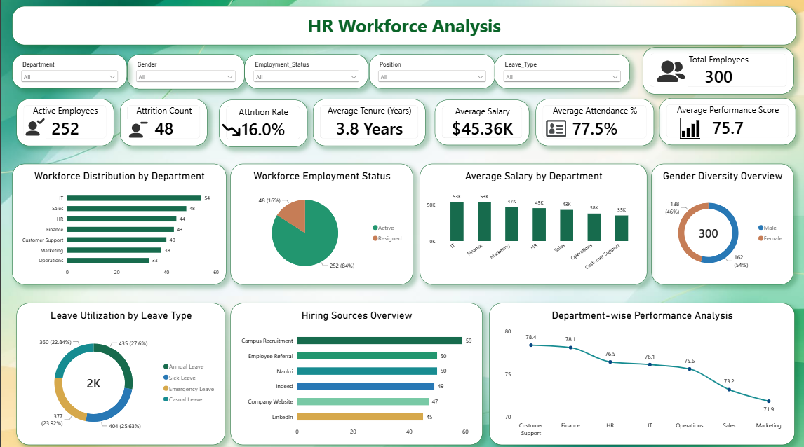

Fig:2 HR WORKFORCE DASHBOARD USING POWER BI

