Adaptive Staircase Experiment

PSY-310: LAB PSYCHOLOGY

NAME- PRIYANSHI SANJAY PATEL

AU2220101

INTODUCTION

The adaptive staircase method analyses the signal strength thresholds in visual, auditory, and other sensory perceptions. It is also known as the "method of ups and downs," creating a "staircase" pattern enabling us to diagnose sensory deficiencies or impairments in people. This technique benefits studies identifying the threshold for a stimulus's detection or differentiation from a baseline. This experiment's main objective was to use the adaptive staircase approach to test participants' thresholds for recognizing changes in stimulus intensity. This design has been extensively used to derive threshold values for research in psychophysical, speech recognition, perceptual learning, hearing, and so on. The approach required the presentation of far fewer stimuli, as after a few initial trials, the intensity operated on is very close to the threshold value. This method reduces stimulus intensity after a correct response (i.e., the participant detects the stimulus) and increases it after an incorrect response (i.e., the participant fails to detect the signal). This produces a staircase pattern in which stimulus intensity varies around the threshold level.

This repeated procedure continues till an initial criterion, when the percentage of correct responses, is achieved. The Adaptive Staircase Method is commonly used in audiology to determine individual hearing thresholds. This approach determines the minimal sound a person can hear at various frequencies. This information is essential for diagnosing hearing loss, developing hearing aids, and assessing the efficacy of hearing therapies. By carefully establishing hearing thresholds, audiologists may design hearing aids that amplify sounds in the user's hearing range, enhancing speech comprehension and overall hearing quality. (Moore et al., *Use of auditory learning to manage listening problems in children* 2008)

METHOD

The selected participant was a 20-year-old undergraduate student at Ahmedabad University. Before beginning the trial, the participants were instructed and informed consent. In this experiment, the adaptive staircase approach is used to determine the difference threshold, which allows the participant to distinguish whether the lines on a Gaussian grating are tilted to the left or right. The experiment involved 100 adaptive staircase trials in which participants were shown a fixation in the shape of a cross for 0.5 seconds, followed by the Gaussian Surface with a spatial frequency of 8 and a contrast of 0.5. Participants had to determine if the orientation of the Gaussian surface was tilted to the left or right and press the given keys. (Figure 2.) The orientation's initial value is 0.5, with a max-value of 1 and a min-value of 0. This implies that the lines will be tiled at 10 degrees to the left or right randomly. The staircase technique was one up and three down, with step sizes of 2, 1.5, 1, and 0.5. The step type is linear. The experiment was created with Psychopy, which allows us to conduct psychophysics experiments with Python. In each trial, data for orientation and correct response were recorded alongside other data using Psychopy's built-in functions. (Figure 1.) Following the experiment, the data was converted to comma-separated values (CSV) and entered into Microsoft Excel to determine the difference threshold.

Figure 1: image of Adaptive staircase method in Psychopy creating a "staircase" pattern





Figure 2. Image of stimulus used: a Sinusoid over a Gaussian mask tilted towards the left

RESULTS

Interpreting a reversal as an event in which the participant response changes from correct to incorrect and vice versa, and using the average orientation of the last five reversals to calculate a difference threshold. The final five thresholds occurred in the following trials: 89,85,75,65,61, with an average orientation value of 1.4. Thus, the difference threshold is 1.4 (Figure 3.) While using the last five reversals to compute threshold acknowledges that perceptual thresholds can fluctuate due to factors like adaptation and attentional shifts during an experiment. Adding these improvements to our threshold determination allows us to obtain a more in-depth and reliable depiction of perceptual sensitivity. The intricate approach helps to complete a knowledge of how participants interact with stimuli over time, which improves the ability to interpret of our findings.

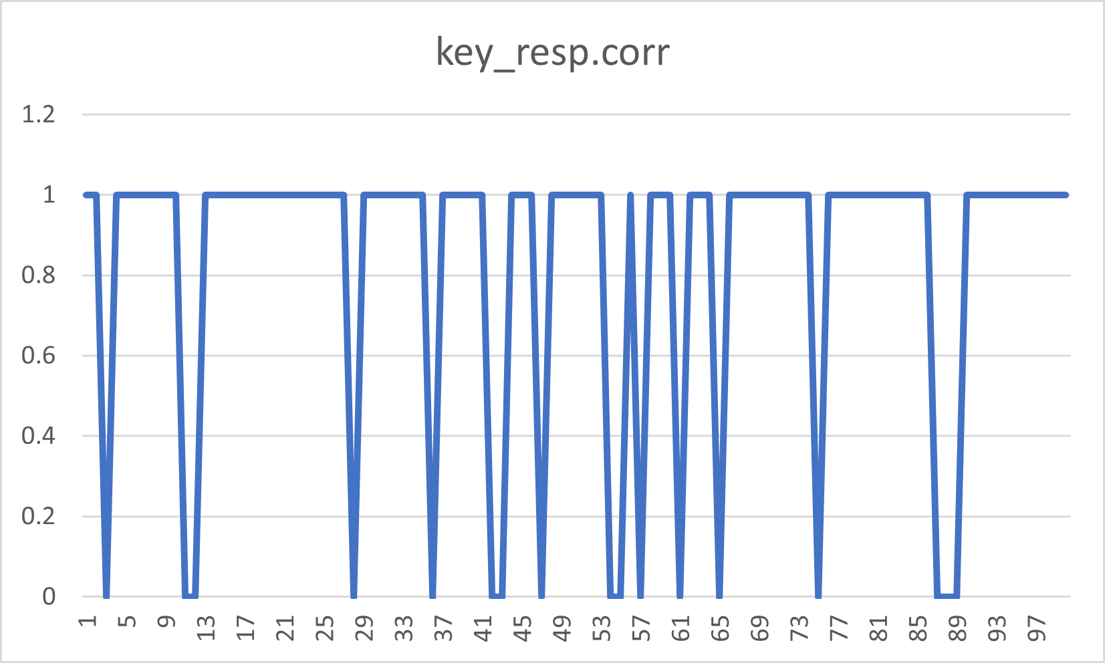

Figure 3. A graph representing the participant's responses to the stimuli over 200 trials on a binary scale, where 0 indicates an incorrect response and 1 indicates a correct response. The accuracy in discriminating the tilt of the stimuli was 82.5%.

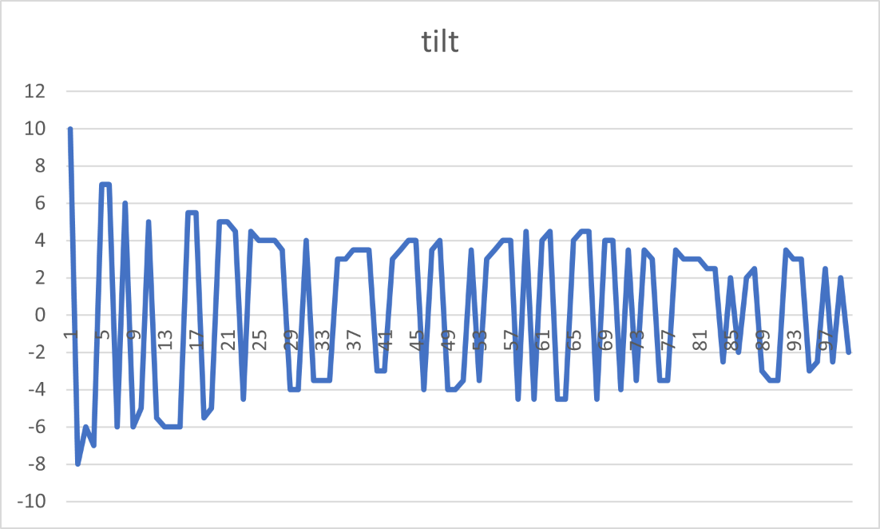

Figure 2. A line graph representing the one-up and three-down procedure in the tilt in the stimuli over the duration of the procedure (i.e., number of trials).

DISCUSSION

The staircase method is widely used but has drawbacks compared to other methods. One disadvantage is the ability to focus on a restricted range of stimulus intensities, thereby overlooking bigger perceptual nuances. Methods like constant stimuli throw a broader net throughout the sensory spectrum, providing a more complete perspective. Another disadvantage is the assumption of an unambiguous connection between stimulus intensity and perceived response, which may only sometimes be accurate. Alternative approaches like the PEST algorithm are more suited to non-monotonic response patterns. The staircase approach can be trial-inefficient, necessitating many trials to obtain a stable threshold estimate, mainly when dealing with complex inputs. (Leek, *Adaptive procedures in psychophysical research* 2001) On the other hand, adaptive Bayesian approaches, such as QUEST, use statistical models to reduce biases and trials better. Furthermore, the staircase approach is susceptible to participant response biases that may arise during the experiment. To sum up, the staircase approach is frequently used, it has disadvantages such as limited sample, assumptions, trial effectiveness, and bias susceptibility. It is also beneficial in using many experiments by addressing the limitations.

REFERENCES

Leek, M. R. (2001). Adaptive procedures in psychophysical research. *Perception &amp; Psychophysics*, *63*(8), 1279–1292. <https://doi.org/10.3758/bf03194543>

Moore, D. R., Halliday, L. F., & Amitay, S. (2008). Use of auditory learning to manage listening problems in children. *Philosophical Transactions of the Royal Society B: Biological Sciences*, *364*(1515), 409–420.

<https://doi.org/10.1098/rstb.2008.0187>