Cover Page
Project Title: Python Quiz Game
Student Name: Priyanshi Varshney
Course : Introduction to problem solving ( Python essentials)
Registration number : 26BAI10184
University : VIT Bhopal
Submitted To: Mr. Ashfaq Ahmad Najar
Academic Year : 2026-2027

1. Introduction
Python Quest is a simple text-based computer game made to help students learn Python programming easily. Learning from big textbooks can be boring and hard to understand. Python Quest changes syllabus topics into a fun game adventure.
In this game, the student becomes a 'Hero' . The student travels through 5 different units (like Unit 1: Problem Solving ). In each unit, the student reads small simple lessons and answers quiz questions. When the student answers correctly, they get score points immediately.
2. Problem Statement
Many students face difficulty while learning programming for the following reasons:
- Boring Textbooks: Reading long theory pages makes students tired and bored.
- No Quick Feedback: Practice tests are given at the end of chapters, so students do not know immediately if they understood the topic.
- Lack of Fun: Traditional study methods do not show scores or levels, so students lose interest quickly.
To solve this problem, we need a simple application that gives small lessons, asks instant questions, and gives points for correct answers.
3. Functional Requirements
Functional requirements describe what the software must do:
- Player Profile Setup: The system must create a player character with starting points set to 0.
- Display Lessons: The system must show lessons step-by-step from Unit 1 to Unit 5.
- Interactive Questions: The program must show questions
- Answer Checking: When the student picks an option, the system must check if it is right or wrong instantly.
- Score Updating: If the answer is correct, the system must add +50 points to the score.
- Display HUD: The system must show a top bar (HUD) displaying Hero Name, Score, and Location at all times.
4. Non-Functional Requirements
Non-functional requirements describe how well the software performs:
- Simple Interface: The text interface must be simple, clear, and easy to read on screen.
- Easy Maintenance: The code is divided into small separate files so it is easy to update or add new units.
- Fast Speed: The program runs instantly on any standard computer with Python installed.
- Reliability: The program does not crash even if the student types a wrong menu option.
5. System Architecture
The software is built using standard Python modular design. It splits the project into 5 clean files:
- main.py: The main entry file that starts and runs the game loop.
- lessons.py: Contains the lesson texts and teaching materials.
- content.py: Contains the questions, options, and correct answer keys.
- models.py: Stores data structures for the player hero, score, and questions.
- ui.py: Handles drawing top headers, HUD status bars, and line borders.
6. Design Diagrams
6.1 Use Case Diagram
This shows what the student can do in the system:
+-------------------------------------------------------+
| PYTHON QUEST SYSTEM |
| |
| [ Student ] ----> ( Enter Name & Start Game ) |
| | |
| +---------> ( Read Unit Lessons ) |
| | |
| +---------> ( Answer Quiz Questions ) |
| | |
| +---------> ( Earn Score & View HUD ) |
+-------------------------------------------------------+

6.2 Workflow Diagram
This shows step-by-step how the game works:
[Start Game]
|
v
[Show Title & Create Hero]
|
v
[Show Lesson]
|
v
[Show Challenge Question ]
|
v
[Student Types answer]
|
+------> Is answer Correct?
|-- YES --> [ Add +50 Points ] --> [ Update Score on HUD ]
|-- NO --> [ give another chance to answer and give hint ]
|
v
[Move to Next Topic / Unit]

6.3 Sequence Diagram
This shows how different Python files talk to each other:
Student main.py ui.py content.py
| | | |
|--- Run Game --->| | |
| |-- print_header()->| |
| |-- print_hud() --->| |
| |-- Get Question --------------------->|
| |<-- Return Question Data -------------|
|<-- Show Quiz ---| | |
|--- Type '2' --->| | |
| |-- Check Answer | |
|<-- 'SUCCESS!' --| | |

6.4 Component Diagram
This shows how the project files connect together:
+-------------------------------------------------------+
| main.py |
+-------------------------------------------------------+
| | |
v v v
+-------------+ +-------------+ +-------------+
| ui.py | | lessons.py | | models.py |
+-------------+ +-------------+ +-------------+
|
v
+-------------+ | content.py |
+-------------+

6.5 ER Diagram (Data Model)
This shows how player data and quiz data are stored in memory:
+-----------------------+ 1 : N +-----------------------+
| HERO |-----------------------| CHALLENGE |
+-----------------------+ +-----------------------+
| name : String | | question : String |
| score : Integer | | options : List |
| location : String | | correct_idx: Integer |
+-----------------------+ | explanation: String |
+-----------------------+

7. Design Decisions & Rationale
- Using Multiple Files: We used separate Python files so that if we want to change questions, we only edit content.py without touching game code.
- Text Terminal Interface: A terminal interface runs fast on every computer, uses low memory, and requires no special graphic setup.
- Instant Scoring System: Showing immediate scores and messages keeps students excited and focused on learning.
8. Implementation Details
The project uses simple standard Python functions. Here are main parts of the code:
1. Banner Printing Function (in ui.py):
def print_header():
print("\n" + "~" * 65)
print(" WELCOME TO PYTHON QUEST: ACADEMIC EDITION ")
print("~" * 65)

2. Top Status Display / HUD (in ui.py):
def print_hud(name, score, room_name):
print("\n" + "*" * 65)
print("HERO: " + name.upper() + " | SCORE: " + str(score) + " | LOCATION: " + room_name)
print("-" * 65)

3. Question Asking Function (in main.py):
def ask_interactive_question(question, options, correct_index, explanation):
print("[CHALLENGE]: " + question)
for idx, opt in enumerate(options, 1):
print(f" [{idx}] {opt}")
choice = int(input("Select your choice (1-4): "))
if choice == correct_index + 1:
print("[SUCCESS!] Correct answer! You earned +50 Score!")
return 50
else:
print("[TRY AGAIN] Incorrect choice.")
return 0

9. Screenshots & Results
Below are dedicated spaces for inserting project screenshots. You can easily paste your image directly into each box:
Screenshot 1: VS Code IDE Workspace & Project Structure
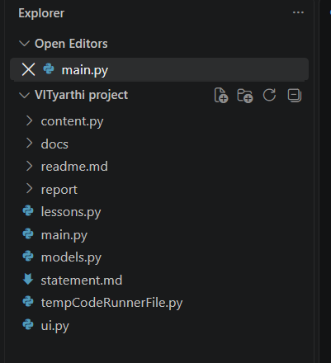

Screenshot 2: Terminal Launch & Lesson 1.1 Output
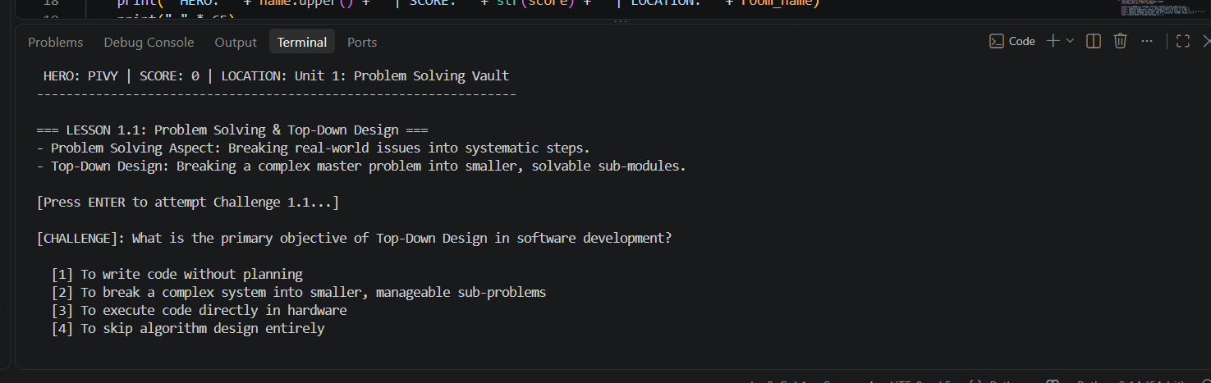

Screenshot 3: Question Prompt with Multiple Choice Options
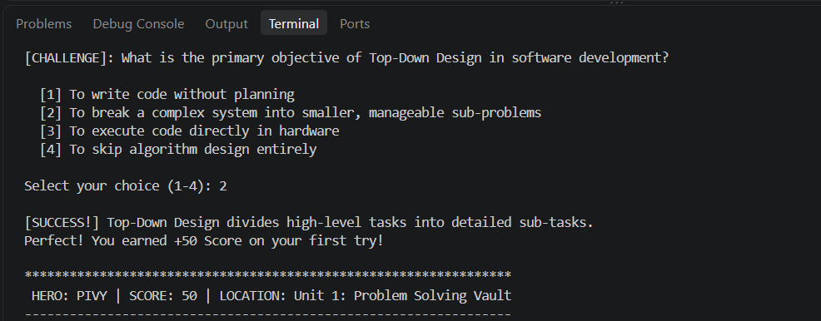

10. Testing Approach
We tested the program using simple checks:
- Unit Testing: Checked each function individually (like print_hud and ask_interactive_question).
- Input Testing: Typed wrong numbers (like 99) or empty inputs to make sure the game does not crash.
- Full Game Testing: Tested playing from Unit 1 to Unit 5 to verify score updates correctly.
11. Challenges Faced
- Formatting Screen Lines: Standard terminal windows have different width sizes. Fixed by keeping line width to 65 characters.
- Code File Linking: Preventing duplicate variable names across main.py and content.py. Fixed by using clear module imports.
- Lesson Text Size: Making sure theory lessons were easy to read without cluttering the screen.
12. Learnings & Key Takeaways
- Modular Coding: Learned how to divide a Python project into multiple organized files.
- Gamification: Understood how simple game mechanics (scores, hero names) make studying fun and easy.
- Input Handling: Practiced handling user inputs safely without crashing software.
13. Future Enhancements
- Add Graphical Interface (GUI): Add buttons, windows, and pictures using Tkinter or web forms.
- Database Storage: Save student names and scores in an SQLite file so progress is saved when closing.
- More Subjects: Add lessons for other college subjects like Data Structures or Java.
14. References
- Python Official Guide: Python Documentation (https://docs.python.org/3/)
- Project Code Base: VITyarthi Project Source Files (main.py, ui.py, content.py, models.py, lessons.py)
- Course Curriculum: Academic Syllabus Guidelines for B.Tech CSE (AI & ML), VIT Bhopal

