As for the recommendation system project we have gathered the datasets that will help to enable the customer engagement towards the product. The dataset we have collected is large .csv file which requires large computational resources in order to process, analyse the data. We have decided to export the dataset to the cloud platform. Amazon Personalize is highly recommended by other businesses such as Dominos.

The benefits of AWS Personalize are:

* Higher quality recommendation that respond to specific needs, preferences and changing behaviour.
* Work easily with complex machine learning tasks that requires build, train and deploy.
* Can be implemented to different platform to increase the person engagement.

The below figure shows the working of AWS Personalize:

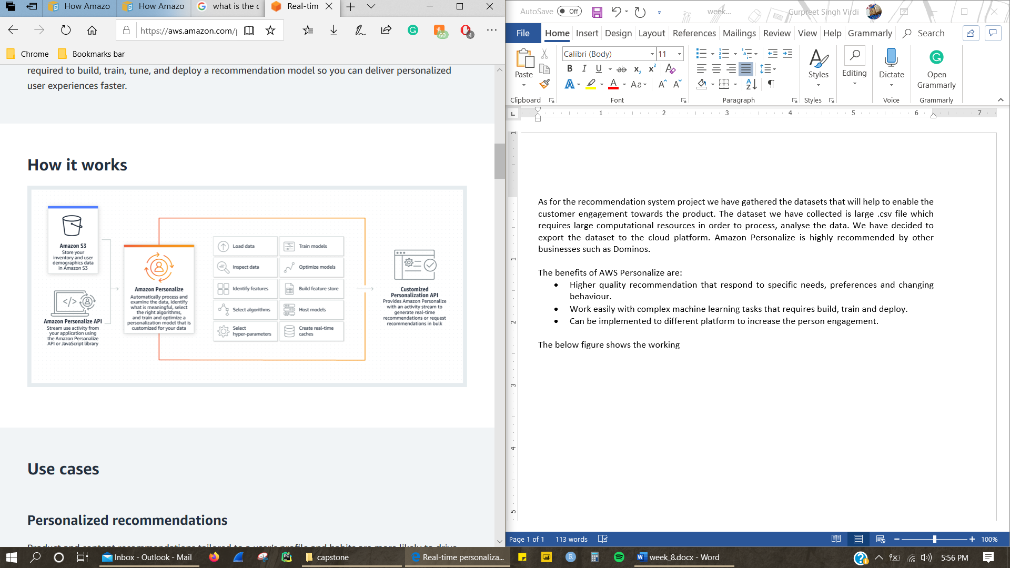

Figure (https://aws.amazon.com)