**Dataset: EmploymentData_5_years**

Number of persons in the farm population and the self-employed labour force population classified by educational attainment, sex and age for every 5 years

**Footnotes:**

1 The data in this table are derived from Agriculture–Population Linkage 25% sample data, which have been used to derive estimates for the entire population. These data will differ from corresponding data in the Farm and Farm Operator Data release tables, which were based on data collected for all farms.

2 Farm population refers to all persons who are members of a farm operator's household excluding those residing in Canada's three territories or in collective dwellings.

3 The Canada total excludes the Yukon, Northwest Territories and Nunavut.

4 This is a count of distinct operators; hence, operators of two or more separate farms were included only once in the total.

5 Educational attainment refers to the highest level of education that a person has successfully completed and is derived from the educational qualifications questions, which asked for all certificates, diplomas and degrees to be reported. Users are advised to consult data quality comments for "Highest certificate, diploma or degree", available in the "Education Reference Guide, Census of Population, 2016, Catalogue no. 98-500-X2016013.

6 "Secondary (high) school diploma or equivalency certificate" includes only people who have this as their highest educational qualification. It excludes persons with a postsecondary certificate, diploma or degree.

7 "Apprenticeship or trades certificate or diploma" includes Certificates of Apprenticeship, Certificates of Qualification and Journeyperson's designations, as well as other trades certificates or diplomas such as pre-employment or vocational certificates and diplomas from brief trade programs completed at community colleges, institutes of technology, vocational centres and similar institutions.

8 Persons who obtained qualifications from vocational training programs in the province of Quebec such as the Diplôme d'études professionnelles (DEP) and Diploma of Vocational Studies (DVS) are included in the "Apprenticeship or trades certificate or diploma" category, consistent with instructions in the help text of the questionnaire.

9 "University certificate, diploma or degree at bachelor level or above" includes the categories "Bachelor's degree", "University certificate or diploma above bachelor level", "Degree in medicine, dentistry, veterinary medicine or optometry", "Master's degree" and "Earned doctorate".

**Quotations:**

* Secondary (high) school diploma or equivalency certificate - Low
* Apprenticeship or trades certificate or diploma 7 8 - Medium
* College, CEGEP or other non-university certificate or diploma - Mediumhigh
* University certificate or diploma below bachelor level -High
* University certificate, diploma or degree at bachelor level or above 9 -Veryhigh
* All educational attainments - Full
* No Education – None

**Algorithm Used: Random Forest**

This algorithm is very stable. Even if a new data point is introduced in the dataset the overall algorithm is not affected much since new data may impact one tree, but it is very hard for it to impact all the trees.

The random forest algorithm works well when you have both categorical and numerical features.

**Code:**

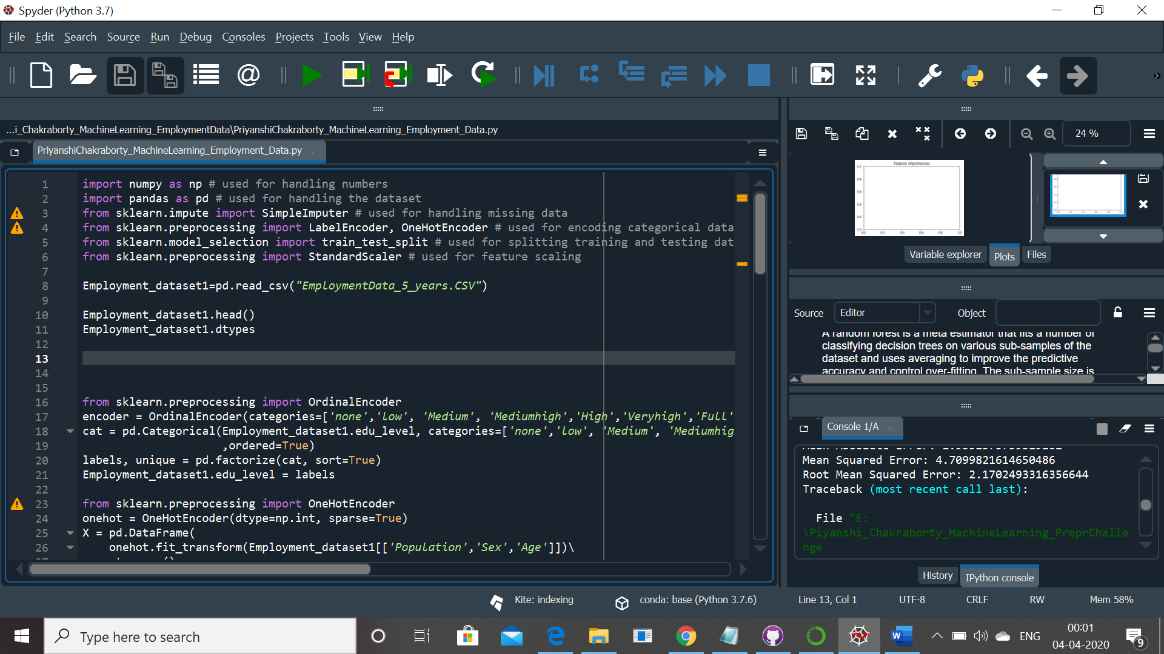

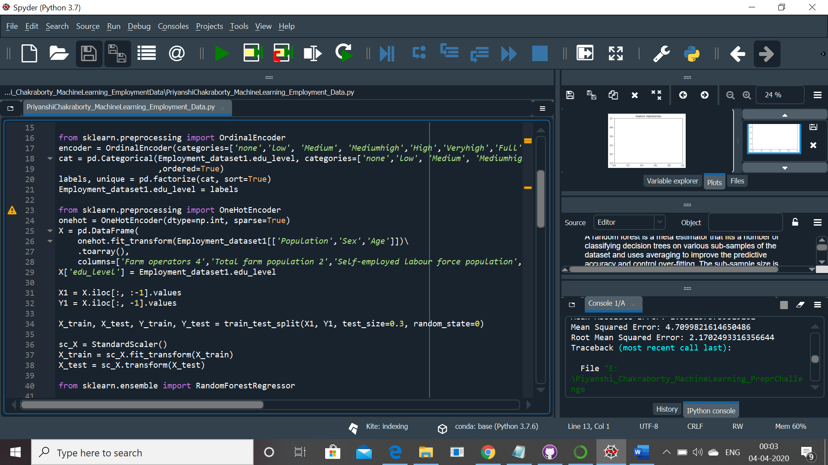

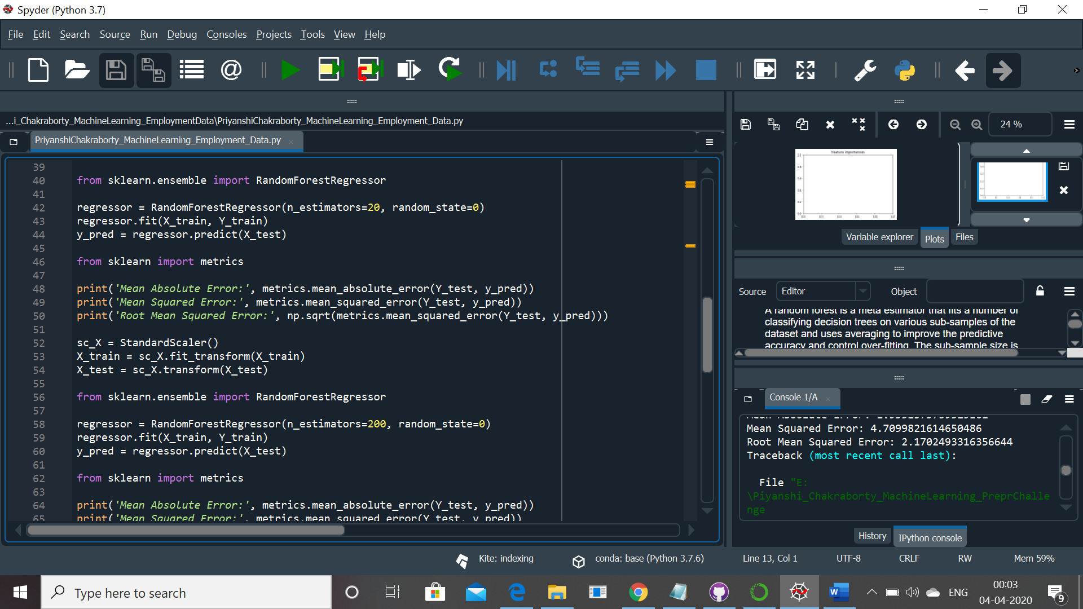

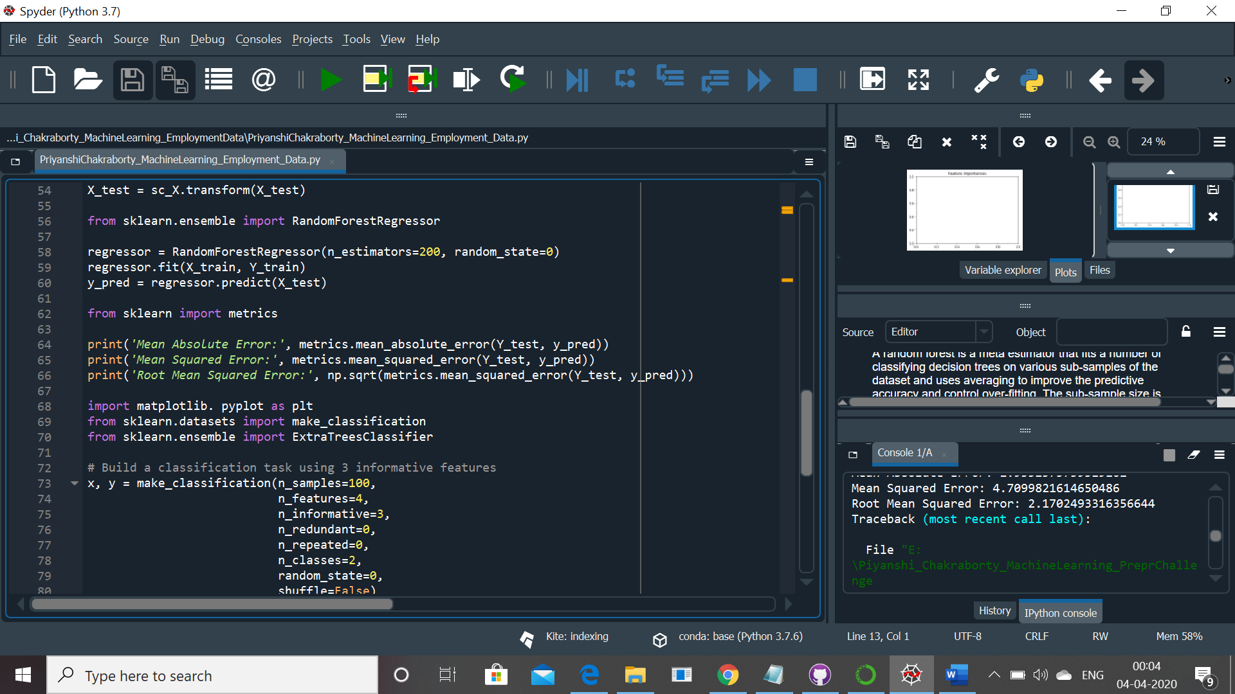

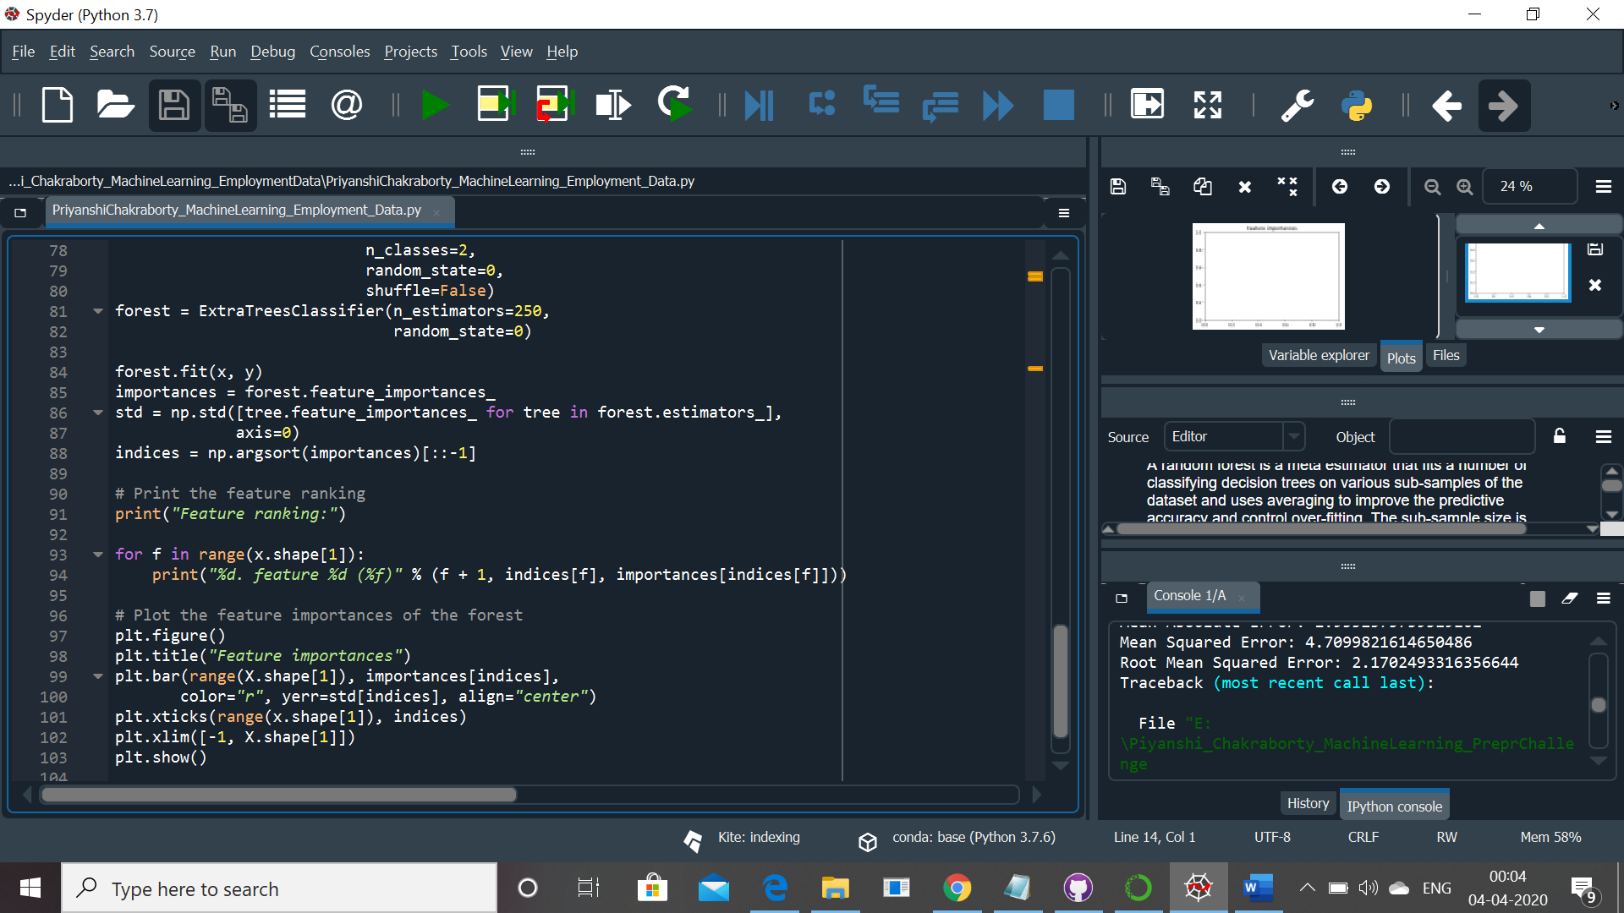

**Output:**

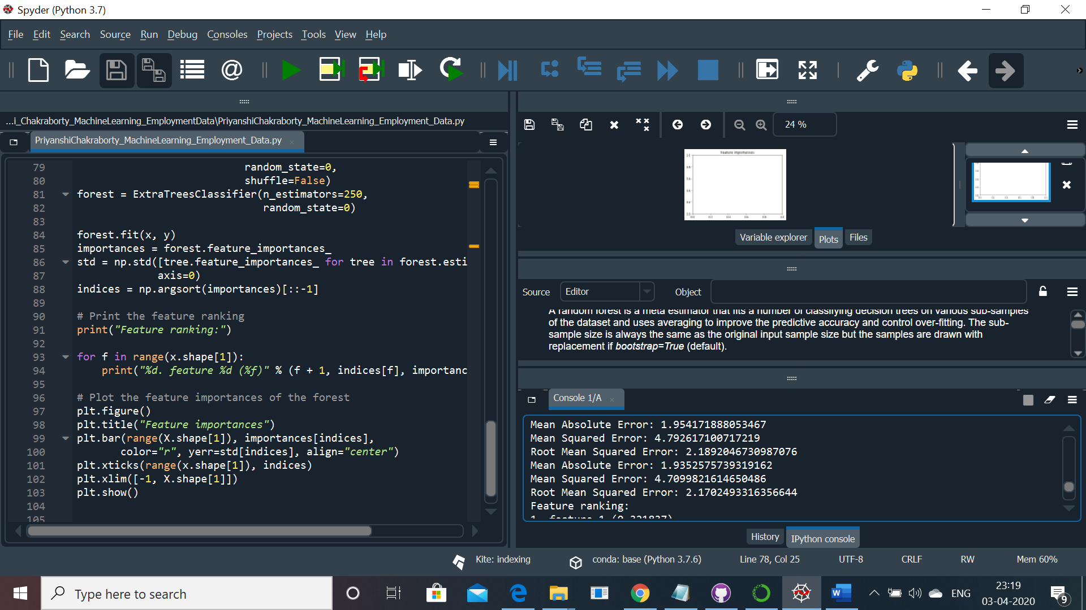

For n_Estimators =20 and n_estimators= 200 Root mean squared error does not changes much but lessens i.e. it shows that the accuracy of the model is high.

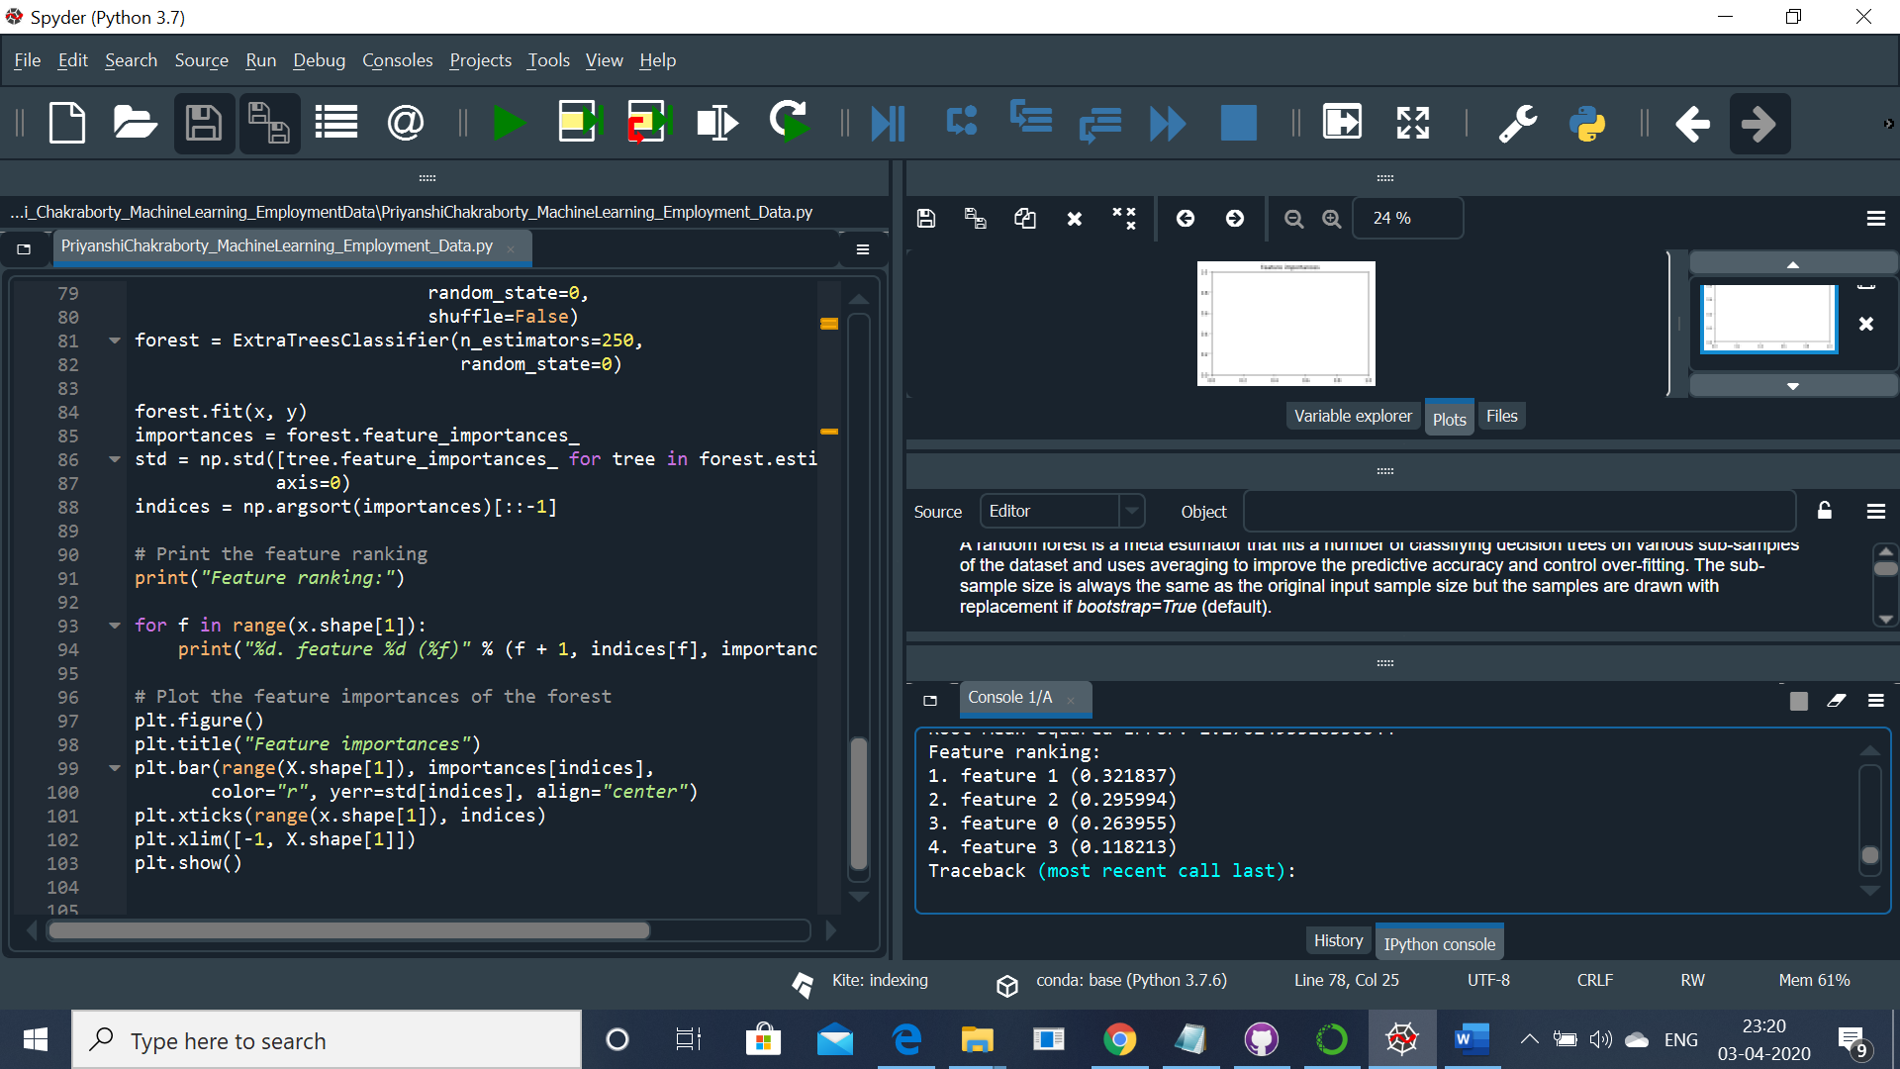

**Feature Ranking:**

The plotting of the graph shows that

Feature 1(Education Level) plays most important part in the employment percentage