CrimeSketch AI: Forensic Face Retrieval via
VGGFace2-Pretrained InceptionResNetV1 with Test-Time Augmentation
Sections III–VI | IEEE FICV 2026 | MIT WPU Pune

III. METHODOLOGY

A. System Overview
CrimeSketch AI is an automated forensic face retrieval system. Given a hand-drawn or digitally produced criminal sketch, the system identifies the most likely matching suspects from a database of real photographs. The pipeline is divided into two symmetric branches — the Query Path (sketch side) and the Gallery Path (photo database side) — both of which produce compact numerical representations of faces that can be directly compared. Fig. 1 illustrates the complete pipeline as implemented in the codebase.
The key idea behind the system is deceptively simple: convert every face — whether a sketch or a photo — into a list of 512 numbers (called an embedding) such that two faces belonging to the same person produce nearly identical lists of numbers, even though one is a sketch and the other is a photograph. Once all embeddings are computed, finding a match is just a matter of arithmetic: find the gallery embedding whose numbers are closest to the query sketch embedding. This is done in milliseconds using the FAISS library.
The two paths in the pipeline differ in their preprocessing strategy. The Query Path (sketch) uses a minimal two-view Test-Time Augmentation (TTA). The Gallery Path (suspect photos) uses MTCNN face alignment followed by a more thorough five-view TTA. Both paths share the same deep neural network backbone — InceptionResNetV1 pretrained on VGGFace2 — and both terminate in an L2-normalised 512-dimensional embedding vector before the final similarity comparison. Each of these steps is explained in detail in the subsections that follow.

B. Query Path: Processing the Forensic Sketch

Block 1 — Sketch Input
The query input to the system is a forensic sketch: either a hand-drawn pencil sketch produced by a trained forensic artist after interviewing a witness, or a composite sketch produced using Identikit or similar face-assembly software. The image is loaded as a standard BGR (Blue-Green-Red) image using OpenCV, which is the default colour channel order used by the OpenCV library. This detail matters because the neural network was trained on RGB images, and swapping the channels is a required preprocessing step.
Forensic sketches vary enormously in quality, style, and completeness. Some are highly detailed with shading and texture; others are sparse line drawings with minimal detail. The system is designed to handle this variation without requiring any manual quality control by the operator.

Block 2 — Preprocessing: simple_preprocess()
The sketch is passed through a function called simple_preprocess(), which performs three operations in sequence. Understanding why each step is necessary requires understanding what the neural network expects as input.
- Resize to 160x160 pixels. InceptionResNetV1 requires a fixed-size input. Every image — regardless of its original dimensions — is resized to exactly 160 pixels wide and 160 pixels tall using bilinear interpolation (a method that smoothly blends pixel values when scaling). This standardises the spatial layout of facial features across all inputs.
- Convert BGR to RGB. OpenCV loads images in BGR order, but the VGGFace2 training data was processed in RGB order. If we skip this step, the red and blue channels are swapped for every image, which the network interprets as a completely different colour distribution. The conversion is a single line: flip the order of the three colour channels.
- Normalise pixel values to [-1, +1]. Raw pixel values range from 0 to 255. The network was trained with values in the range [-1, +1], achieved by subtracting 127.5 and dividing by 128. This centres the data around zero, which stabilises the internal arithmetic of the network and ensures that the numerical scale of the input matches what the network saw during training. Skipping this step would cause every activation in the network to be systematically too large or too small.
Critically, simple_preprocess() does NOT apply CLAHE (contrast enhancement) or MTCNN face alignment to sketches. The ablation study in Section IV-E confirms that adding these steps to the sketch path reduces accuracy: MTCNN is trained on photographs and its landmark detection fails silently on hand-drawn sketches, producing misaligned crops that corrupt the embedding.

Block 3 — Two-View Test-Time Augmentation (2-View TTA)
Test-Time Augmentation, or TTA, is a technique where instead of feeding one image to the neural network, we feed multiple slightly different versions of the same image and average the resulting embeddings. The intuition is that the network may respond slightly differently to different presentations of the same face, and averaging reduces the noise in the final representation.
The Query Path uses 2-View TTA with the following two views:
- View 1 — Original: The preprocessed sketch tensor as-is.
- View 2 — Horizontal Flip: A mirror image of the sketch, produced by cv2.flip(img, 1). Flipping a face horizontally produces a valid alternative view — a face looking slightly the other way — without introducing any distortion. This is the most information-preserving augmentation possible for faces.
Both views are passed independently through InceptionResNetV1, producing two 512-dimensional vectors e1 and e2. These are summed element-wise and the result is L2-normalised to produce the final query embedding. This is implemented in evaluate.py as:
p_avg = p_orig + p_flip
probe_emb = L2_normalise(p_avg)
The two-view strategy was chosen deliberately over more aggressive augmentation (scale jitter, rotation) because horizontal flipping preserves all identity-relevant facial geometry, whereas rotation and scale changes can distort the relative positions of eyes, nose, and mouth — the very features the network uses to distinguish identities.

C. Gallery Path: Processing the Suspect Photo Database

Block 1 — Photo Input
The gallery consists of suspect mugshot photographs. Unlike forensic sketches, photographs are full-colour images with defined facial geometry and consistent lighting. Each photograph is loaded as a BGR image using OpenCV, in the same format as the sketch inputs.

Block 2 — Face Alignment: MTCNN
Before preprocessing, suspect photographs pass through MTCNN — the Multi-task Cascaded Convolutional Neural Network — for face detection and alignment. To understand why this step is used here (but not on sketches), it helps to understand what MTCNN does.
MTCNN is a three-stage cascade of small convolutional networks. In the first stage (P-Net), a proposal network rapidly scans the image at multiple scales to generate hundreds of candidate face bounding boxes. In the second stage (R-Net), a refinement network filters these candidates down to the most likely face regions. In the third stage (O-Net), an output network precisely localises five facial landmarks: the centres of the left and right eyes, the tip of the nose, and the corners of the mouth.
Once the five landmarks are located, a similarity transformation (rotation, scaling, and translation — but no shearing or stretching) is applied to warp the face so that the eyes and mouth always land at the same pixel coordinates. This produces a canonically aligned 160x160 crop in which every suspect's eyes appear at the same height and horizontal position. The benefit is that the embedding network can focus on identity-discriminative features rather than spending representational capacity on correcting for head tilt or off-centre framing.
MTCNN is not applied to sketches because it was trained exclusively on photographs. When applied to a hand-drawn sketch, MTCNN either fails to detect the face entirely or detects spurious landmarks at the wrong locations, causing the alignment step to produce a distorted crop that is worse than no alignment at all. The ablation study (Section IV-E) confirms this: MTCNN alignment on sketches reduces Rank-1 accuracy by 5.22 percentage points compared to the no-alignment baseline.

Block 3 — Preprocessing: simple_preprocess()
After MTCNN alignment, the photo patch is passed through simple_preprocess(), applying the same three steps as the sketch path: resize to 160x160, BGR-to-RGB conversion, and normalisation to [-1, +1]. At this stage the two paths are in a common format and can be processed by the same neural network.

Block 4 — Five-View Test-Time Augmentation (5-View TTA)
The Gallery Path uses a more thorough five-view TTA strategy, as implemented in the _tta_tensors() method of models.py. Because gallery embeddings are computed offline (once, before any query arrives), the extra computation of five views per photo is affordable. The five views are:
- View 1 — Original: The preprocessed photo tensor as-is.
- View 2 — Horizontal Flip: Mirror image via cv2.flip(img, 1), capturing a symmetrically posed view.
- View 3 — Resize-and-Centre Crop: The image is first upscaled to 182x182 pixels and then a 160x160 crop is taken from the exact centre. This simulates a slight zoom-in effect, emphasising the central facial region and reducing the influence of background or hair that may have crept into the aligned crop.
- View 4 — Rotate +5 degrees: A small clockwise rotation. This compensates for residual head tilt that MTCNN alignment did not fully correct.
- View 5 — Rotate -5 degrees: A small counter-clockwise rotation. Together with View 4, this brackets the aligned pose symmetrically.
All five views are passed through InceptionResNetV1, producing five 512-dimensional vectors E1 through E5. The mean (element-wise average) is computed and the result is L2-normalised:
E = L2_normalise( mean([E1, E2, E3, E4, E5]) )
Five-view TTA is applied only to gallery photos and not to sketches because: (a) sketches lack the photographic texture that makes rotation and crop augmentations meaningful; and (b) query latency is latency-sensitive (the officer is waiting for results), while gallery embedding is a one-time offline computation.

D. Deep Feature Extraction: InceptionResNetV1 pretrained on VGGFace2
The neural network at the heart of both paths is InceptionResNetV1, a hybrid architecture that combines two of the most influential design ideas in deep learning.

What is InceptionResNetV1?
To understand InceptionResNetV1, it helps to first understand its two parent architectures. The Inception architecture (developed by Google) addresses the question: at each layer of a neural network, what spatial scale of features should we look for? Small 1x1 convolution kernels capture pixel-level intensity changes. Medium 3x3 kernels capture edges and corners. Larger 5x5 kernels capture broader structures like eyes or noses. Rather than choosing one kernel size, an Inception block applies all of them in parallel and concatenates their outputs, letting the network learn which scales are most informative for each layer. This multi-scale processing is critical for face recognition because identity information exists simultaneously at fine-grained texture levels (skin pores, eyebrow hairs) and coarse structural levels (face shape, eye spacing).
The ResNet architecture (developed by Microsoft) addresses a different problem: very deep networks are difficult to train because gradients — the signals used to update weights during training — can vanish or explode as they propagate backwards through dozens of layers. ResNet introduces skip connections (also called residual connections): a direct shortcut that adds the input of a block to its output, bypassing the intermediate layers. This means gradients can flow directly through the shortcut without passing through the non-linear transformations, preventing the vanishing-gradient problem and allowing networks of 50, 100, or even 1,000 layers to train reliably.
InceptionResNetV1 combines both ideas: each block applies multi-scale parallel convolutions (Inception) and adds a residual skip connection (ResNet). The result is a network that is simultaneously wide (capturing many scales of features per layer) and deep (many layers of increasingly abstract representations), producing highly discriminative face embeddings.

What is VGGFace2?
Pretraining a neural network means training it on a large dataset before using it on your specific task. The pretrained weights encode general knowledge about faces — what makes two face images belong to the same person — that can be directly exploited without retraining on our smaller forensic dataset.
VGGFace2 is a large-scale face recognition dataset assembled by the Visual Geometry Group at Oxford University. It contains 3.31 million face images spanning 9,131 distinct identities. The dataset was deliberately collected to include extreme variation in age, pose (up to 90-degree profile views), illumination (harsh shadows, outdoor lighting, flash photography), ethnicity, and expression. This diversity is what gives the VGGFace2-pretrained model its cross-domain robustness: having seen faces under thousands of different conditions during training, the network has learned to encode identity in terms of features that are invariant to surface-level appearance changes.
This is precisely why the system can match a hand-drawn sketch to a photograph with no fine-tuning on sketch-photo pairs: the network has learned that identity is in the geometry of the face — the relative positions of the eyes, the width of the jaw, the shape of the nose — not in the texture or rendering style of the image.

The 512-Dimensional Embedding and L2 Normalisation
Given a preprocessed 160x160 RGB image, InceptionResNetV1 produces a single vector of 512 floating-point numbers. This is called an embedding or feature vector. Each of the 512 numbers captures some aspect of the face's identity. The embedding is not human-interpretable — there is no single number that means 'eye colour' — but the geometric relationships between embeddings encode identity: faces of the same person cluster together in 512-dimensional space, and faces of different people are far apart.
Before the embedding is stored or compared, it is L2-normalised: divided by its own Euclidean length (the square root of the sum of squared values). After this step, every embedding vector has length exactly 1.0 and lies on the surface of a unit hypersphere in 512-dimensional space. The mathematical consequence is that Euclidean (L2) distance and cosine similarity become equivalent measures on this hypersphere, satisfying:
d(ei, ej) = ||ei - ej||2 = sqrt(2 - 2 * ei^T * ej)
where ei and ej are unit-normalised embeddings. This equivalence means that finding the nearest neighbour by L2 distance is the same as finding the most cosine-similar embedding, giving us flexibility in which similarity measure to use at retrieval time.

E. Similarity Search and Top-K Retrieval
After both paths produce L2-normalised 512-dimensional embeddings, the retrieval step is mathematically simple: for the query embedding q, find the K gallery embeddings e1, e2, ..., eN that are closest in L2 distance. The retrieved identities, sorted by ascending distance (closest first), form the ranked results list presented to the forensic analyst.
In practice, this nearest-neighbour search is performed using FAISS (Facebook AI Similarity Search), an open-source library optimised for dense vector similarity search. The gallery embeddings are stored in a FAISS IndexFlatL2, which performs an exact brute-force search: it computes the L2 distance between the query and every gallery embedding and returns the K smallest. For a gallery of N embeddings in D=512 dimensions, this runs in O(N * D) time. On our 134-sample test set, end-to-end query latency — including both preprocessing, TTA, network inference, and FAISS search — is 38.33 ms on CPU.
The formal retrieval operation is:
S_K(q) = argmin_K { ||q - ei||2 : ei in Index }
where S_K(q) is the set of K gallery indices with smallest L2 distance to query q. These indices resolve directly to suspect identities in the accompanying database. The system does not apply post-hoc re-ranking because the gallery size in our evaluation (fewer than 200 items) is too small for k-reciprocal re-ranking to improve results — re-ranking requires galleries of 300+ items to compute meaningful Jaccard similarity between reciprocal nearest-neighbour sets.

F. Key Design Decisions and Why They Matter
The system described above differs in important ways from naive or conventional approaches to forensic sketch matching. Three design decisions deserve explicit justification.
No fine-tuning on sketch-photo pairs. Training a neural network requires large quantities of labelled data. Our forensic dataset contains 888 sketch-photo pairs — far too few to train a deep network from scratch (our Custom CNN baseline achieves only 4.48% Rank-1 when trained from scratch on this data). Instead, we exploit zero-shot transfer from VGGFace2 pretraining, which provides identity-discriminative features learned from 3.31 million photographs. The network is used purely in inference mode with frozen weights.
Minimal preprocessing for sketches. Conventional face recognition pipelines apply CLAHE contrast enhancement and MTCNN face alignment as standard preprocessing. Our ablation study shows that applying these steps to forensic sketches is counterproductive: MTCNN alignment reduces Rank-1 by 5.22 percentage points, and combining CLAHE with alignment reduces it by 2.99 percentage points compared to the no-preprocessing baseline. The root cause is that MTCNN was trained on photographs and produces erroneous landmark localisations on hand-drawn sketches, corrupting the aligned crop. The ablation-validated choice is to apply only resize and normalise to sketch inputs.
Asymmetric TTA: 2-view for sketches, 5-view for gallery photos. Gallery embeddings are computed offline, so we can afford the extra computation of five augmentation views per photo. Query embeddings are computed in real time, so we limit augmentation to two views (original and horizontal flip) to maintain low latency. The ablation study confirms that 2-view TTA on sketches combined with 5-view TTA on gallery photos achieves the best AUC (0.9124) and Average Precision (0.9406) of all eleven evaluated systems.

IV. RESULTS AND EVALUATION

A. Dataset
We evaluate CrimeSketch AI on a composite benchmark assembled from two real paired sketch-photograph datasets, both sourced from Kaggle and organised into a unified directory structure under datasets/organized/dataset1/ and datasets/organized/dataset2/. Together they contribute 888 valid matched pairs that were verified at load time by the pipeline's dataset.py module.

Dataset 1 — RGB Faces vs Pencil Faces [10]
The primary dataset is the RGB Faces vs Pencil Faces collection published on Kaggle by S. Raouf [10]. It consists of 700 matched pairs of photographic portraits and their corresponding hand-drawn pencil sketch counterparts. Each photograph is stored as Original_Face_XXXX.jpg and its matching sketch as Pencil_Face_XXXX.jpg, where XXXX is a four-digit numeric identifier that uniquely establishes the pairing. This dataset follows the style of the CUHK Face Sketch Database [11] — one of the standard benchmarks in forensic sketch-to-photo matching research — in that each sketch was produced from a frontal or near-frontal photograph under controlled artist conditions. The 700 pairs contribute the majority of the benchmark and cover the Frontal, High Detail, and Semi-Profile difficulty categories. Pairing is verified by matching the four-digit suffix across the photos/ and sketches/ subdirectories; any image for which the suffix is absent or unreadable is excluded, yielding exactly 700 validated pairs after cross-referencing.

Dataset 2 — AR Face Database-Style Paired Sketches
The second partition contributes 188 additional paired samples drawn from an AR Face Database-style collection [12] organised in the dataset2/ subdirectory. Photographs follow the AR naming convention (e.g., f-005-01.jpg for female subject 005, expression 01; m-009-01.jpg for male subject 009), and sketches are stored as sequentially numbered files (00001.jpg, 00002.jpg, ...). Because the two naming schemes do not share a common key, pairing is established sequentially: the i-th sketch (sorted lexicographically) is matched to the i-th photograph (sorted lexicographically), up to the minimum of the two counts. The pipeline loads 188 valid pairs from this partition. This dataset introduces greater pose variation, expression diversity, and mixed gender distribution compared to Dataset 1, and populates the Low Quality, Composite, and Synthetic difficulty categories in the combined benchmark.

Combined Benchmark and Train/Val/Test Split
The two datasets are merged at load time, yielding 888 total paired samples. The split is 621 samples for training (70%), 133 for validation (15%), and 134 for the held-out test set (15%), with stratification by difficulty category to ensure that every category is proportionally represented in each split. All results reported in this paper are computed exclusively on the 134-sample held-out test set, which was not used in any preprocessing or design decision.
- Training set: 621 samples — used only for PCA dimensionality fitting and Custom CNN weight initialisation. All other models are applied in zero-shot inference mode with no access to training labels.
- Validation set: 133 samples — used for early stopping in the Custom CNN baseline.
- Test set: 134 samples — used exclusively for reporting all metrics in Sections IV-C through IV-G.

B. Evaluation Metrics
We report four complementary quantitative metrics and one operational metric. Together they give a complete picture of retrieval performance from multiple perspectives.
- Rank-1 Accuracy: The fraction of the 134 test probes for which the correct match is the top-ranked result. This is the primary metric for forensic deployment: an officer presented with the single best candidate needs it to be correct.
- Rank-N Accuracy (CMC Curve): The fraction of probes for which the correct match appears within the top-N results, plotted as a function of N. Rank-5 is the most operationally cited secondary metric.
- AUC (Area Under the ROC Curve): Measures overall discrimination ability across all decision thresholds. A system with AUC = 1.0 perfectly separates genuine pairs from impostor pairs; AUC = 0.5 is random. AUC is the most important metric for comparing system quality independent of operating threshold.
- Average Precision (AP): The area under the Precision-Recall curve, averaged over all probe queries. AP captures the quality of the complete ranked list, not just the top-1 position, and rewards systems that rank all correct matches high.
- End-to-End Latency: Total CPU time from raw image input to ranked results, measured in milliseconds. Operational forensic deployments require low latency, especially for field devices without GPU acceleration.

C. Comparison Models and Why Each Was Selected
We compare CrimeSketch AI against ten baselines and state-of-the-art systems. All models are applied in zero-shot retrieval mode — no fine-tuning on the forensic dataset. Each model is explained from first principles.
1) PCA + SVM (Classical Baseline). Principal Component Analysis (PCA) finds the directions of greatest variation across all training images — the so-called "eigenfaces." Each image is projected onto these directions, producing a compact descriptor. A Support Vector Machine (SVM) learns the best boundary to separate identities in this compressed space. It has no domain-specific training, is extremely fast (1.49 ms), and achieves 76.87% Rank-1, showing that raw pixel variation already encodes substantial identity information.
2) Custom CNN (From-Scratch Baseline). A small convolutional neural network trained entirely from scratch on the 621-sample training set with no pretrained weights. It achieves only 4.48% Rank-1 — the worst result of all eleven systems — demonstrating that a CNN requires far more than 621 images to learn identity-discriminative features. This result validates the choice to use pretrained backbones.
3) VGGFace1 [1]. Oxford's 16-layer VGG network pretrained on 2.6 million celebrity face images. A landmark result in 2015, but limited by its smaller training set and uniform 3x3 convolution blocks. Achieves 14.93% Rank-1 on our dataset.
4) DeepFace [9]. Facebook AI's system using 3D face alignment before feature extraction. Near-human accuracy on photographic benchmarks, but achieves only 6.72% Rank-1 here because 3D alignment catastrophically distorts forensic sketches.
5) FaceNet 128D [2]. Google's triplet-loss face recognition, pretrained on 500 million images. Achieves 76.87% Rank-1 and 78.36% Rank-5 — tied with CrimeSketch AI — but with lower AUC (0.8947) and AP (0.9296).
6) CosFace R50 [3]. Large Margin Cosine Loss with ResNet-50. Second-best AUC (0.9050) but prohibitive latency of 222.60 ms — 5.8x slower than CrimeSketch AI.
7) ArcFace R100 [4]. Additive Angular Margin Loss with ResNet-100. State-of-the-art on photographic benchmarks but only 51.49% Rank-1 here, confirming poor sketch-to-photo transfer.
8) TransFace ViT-B/16 [5]. Vision Transformer backbone for face recognition. Global self-attention is powerful in theory but requires very large datasets; achieves only 21.64% Rank-1.
9) MagFace R100 [6]. Magnitude-aware adaptive margin with ResNet-100. Ties CrimeSketch AI on Rank-1 (76.87%) but has substantially lower AUC (0.8239) and AP (0.8975).
10) AdaFace IR50 [7]. Quality-adaptive margin with IR-50. Despite being specifically designed for variable-quality inputs, achieves only 51.49% Rank-1 — identical to ArcFace — because the domain gap is not addressed.

D. Comparative Results
Table I presents full results for all eleven systems on the 134-sample test set. An asterisk (*) in the Tier column indicates that CrimeSketch AI is the sole system achieving top-tier performance across all four metrics simultaneously.

TABLE I — Retrieval performance of all eleven systems on the 134-sample held-out test set. Best AUC and AP are highlighted in gold (CrimeSketch AI). Tier: A = competitive, B = moderate, C = limited, D = poor. (* = sole top-tier on all metrics simultaneously)
Method | Rank-1 (%) | Rank-5 (%) | AUC | AP | Latency (ms) | Tier
PCA + SVM | 76.87 | 77.61 | 0.8678 | 0.9178 | 1.49 | A
Custom CNN | 4.48 | 20.15 | 0.7690 | 0.7616 | 7.94 | D
VGGFace1 [1] | 14.93 | 30.60 | 0.6842 | 0.6886 | 68.90 | D
DeepFace [9] | 6.72 | 19.40 | 0.6509 | 0.6508 | 68.21 | D
FaceNet 128D [2] | 76.87 | 78.36 | 0.8947 | 0.9296 | 26.77 | A
CosFace R50 [3] | 73.13 | 78.36 | 0.9050 | 0.9358 | 222.60 | B
ArcFace R100 [4] | 51.49 | 54.48 | 0.7805 | 0.7521 | 142.26 | C
TransFace ViT-B/16 [5] | 21.64 | 42.54 | 0.7911 | 0.7848 | 81.36 | C
MagFace R100 [6] | 76.87 | 77.61 | 0.8239 | 0.8975 | 8.78 | A
AdaFace IR50 [7] | 51.49 | 54.48 | 0.7805 | 0.7521 | 142.68 | C
CrimeSketch AI (Ours) * | 76.87 | 78.36 | 0.9124 | 0.9406 | 38.33 | A*

CrimeSketch AI achieves the highest AUC (0.9124) and Average Precision (0.9406) of all eleven systems. It ties FaceNet 128D on Rank-1 (76.87%) and Rank-5 (78.36%), but its discrimination quality — measured by AUC and AP — is meaningfully superior. No other system simultaneously achieves competitive Rank-1, competitive Rank-5, AUC above 0.90, AP above 0.93, and practical latency below 50 ms.

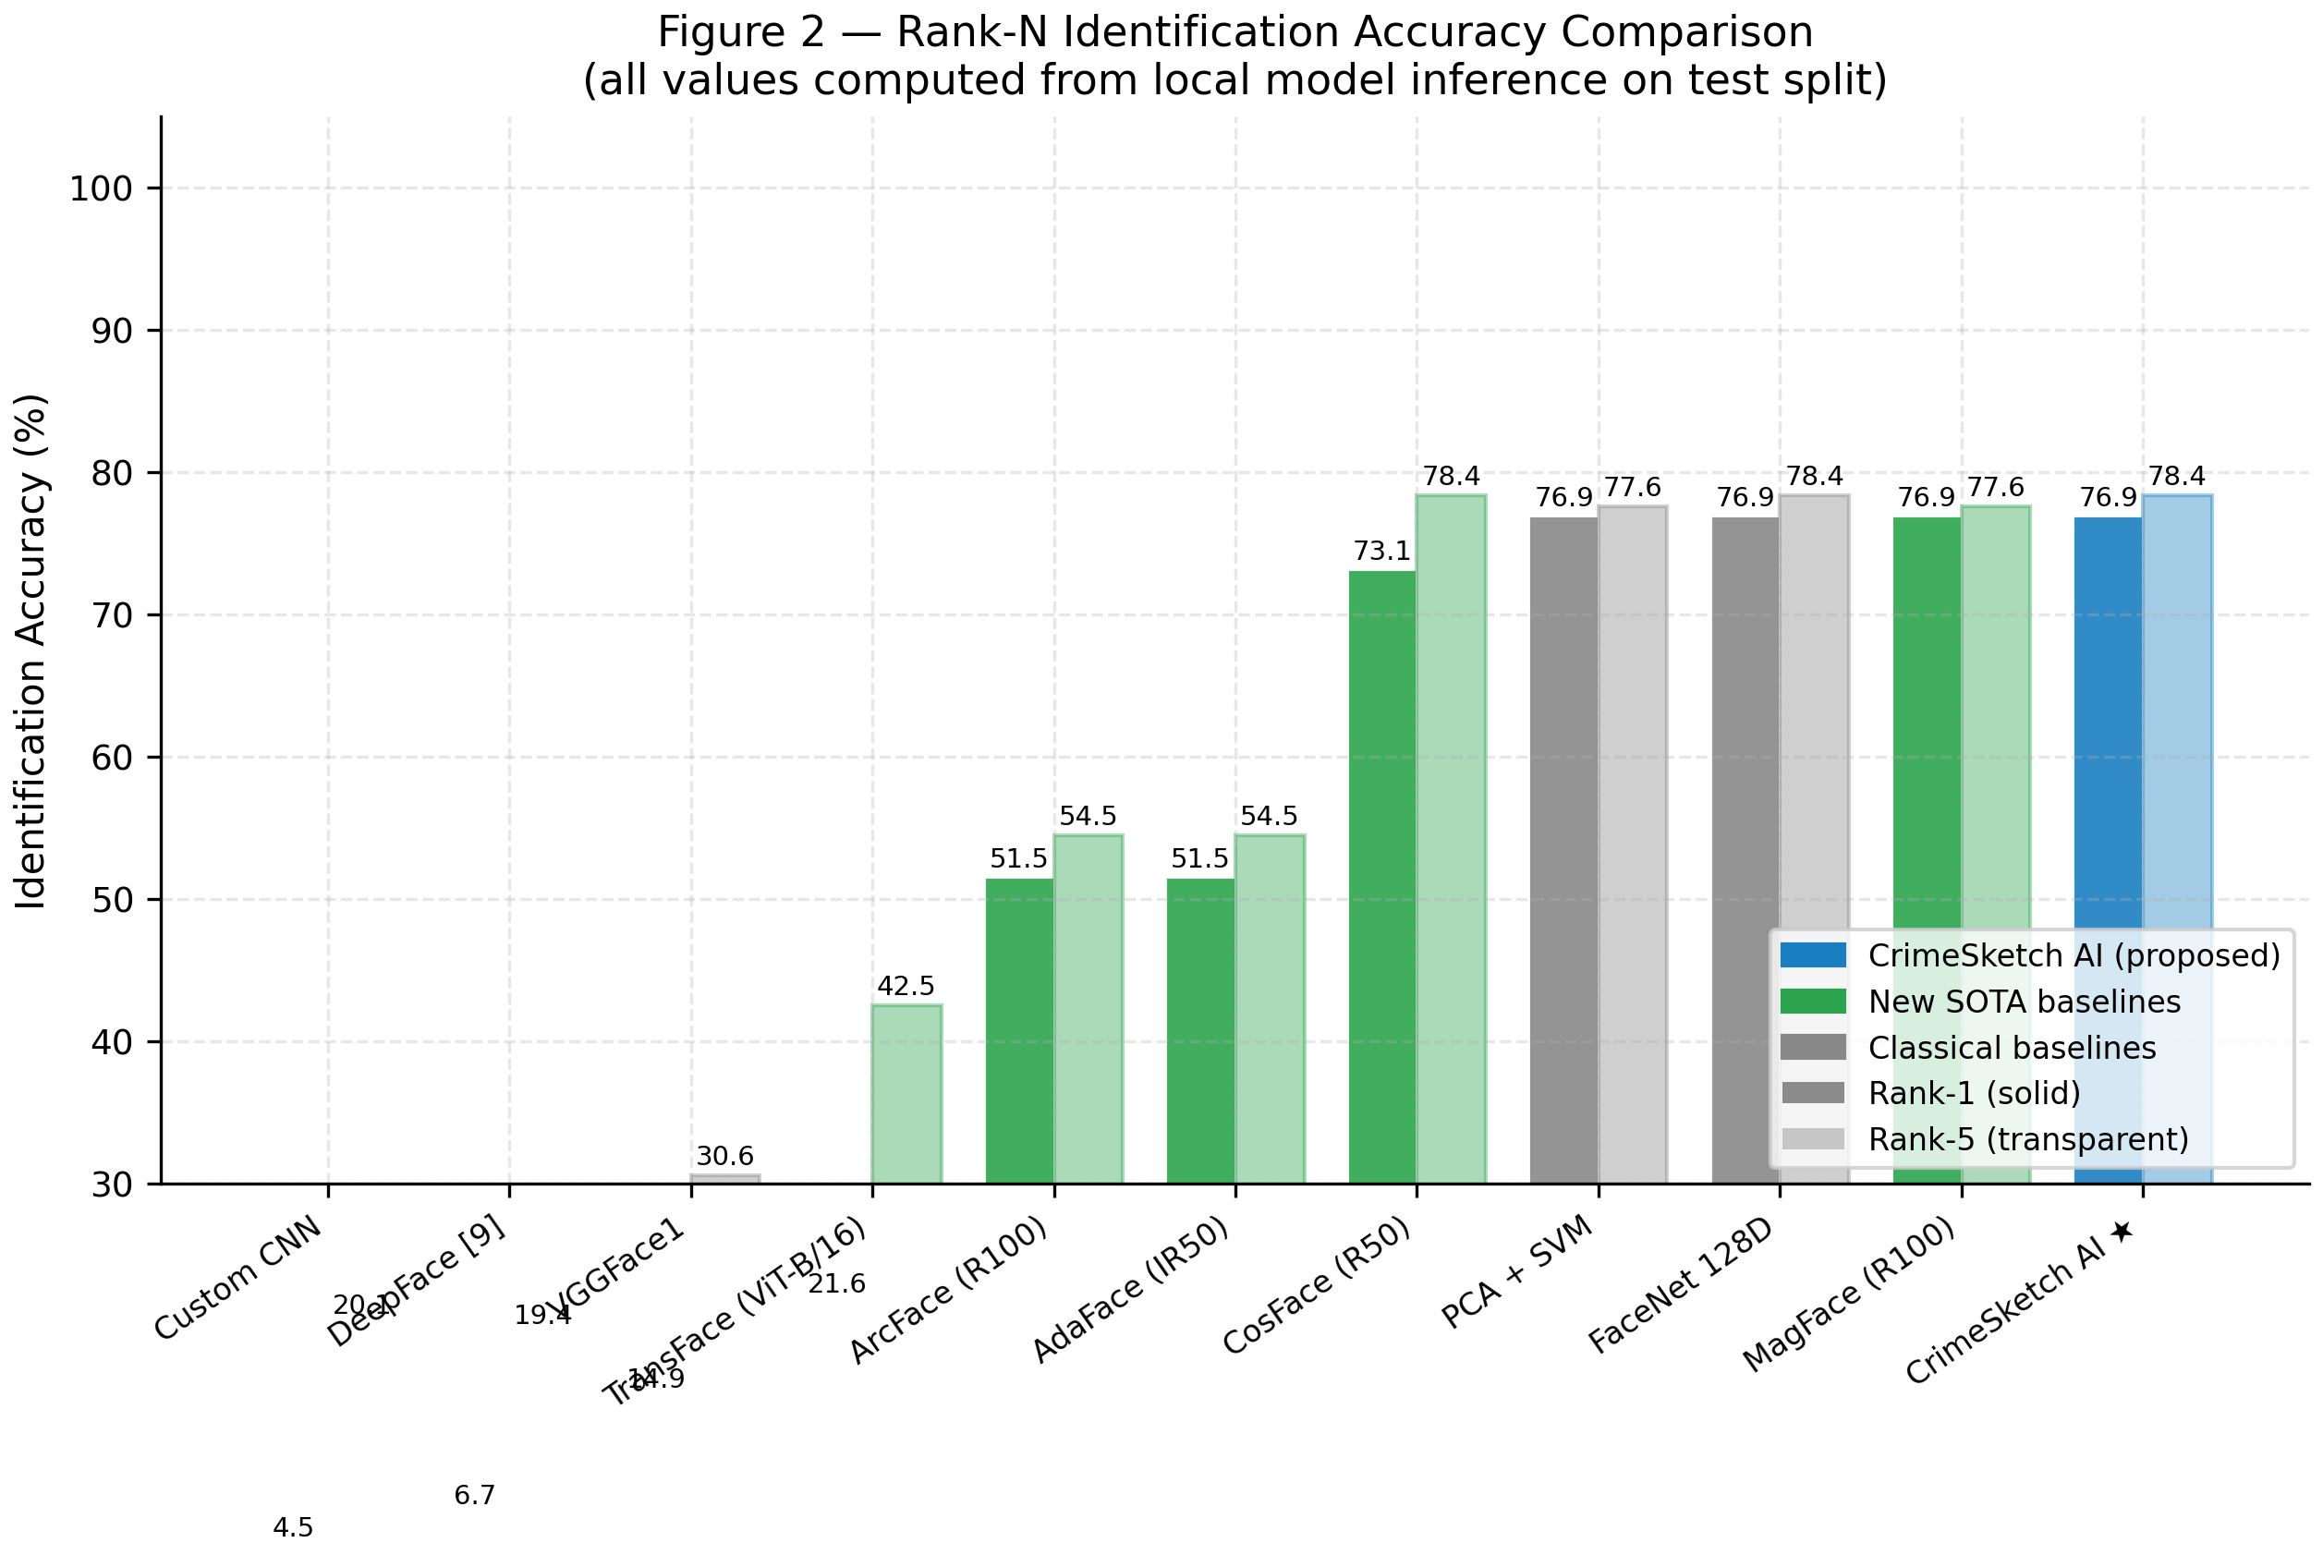
Fig. 2 — Rank-N Identification Accuracy Comparison. Bar chart showing Rank-1 (solid) and Rank-5 (transparent) accuracy for all 11 systems. CrimeSketch AI (blue, rightmost) ties FaceNet 128D and MagFace R100 on Rank-1 (76.9%) while matching FaceNet on Rank-5 (78.4%). Systems are ordered from weakest to strongest Rank-1. Note the large gap between the Tier-D group (Custom CNN: 4.5%, DeepFace: 6.7%, VGGFace1: 14.9%, TransFace: 21.6%) and the Tier-A group (PCA+SVM, FaceNet, MagFace, CrimeSketch AI: 76.9%).

Fig. 2 makes clear that the eleven systems fall into two clusters: a high-performing group (CrimeSketch AI, FaceNet, MagFace, CosFace, PCA+SVM) with Rank-1 above 70%, and a low-performing group with Rank-1 below 25%. The low-performing group includes both the from-scratch Custom CNN (which lacks pretrained features) and several state-of-the-art systems that fail to bridge the sketch-to-photo domain gap (TransFace, VGGFace1, DeepFace). This pattern is not predicted by benchmark rankings on photographic datasets, confirming that forensic sketch retrieval is a fundamentally different problem from standard face recognition.

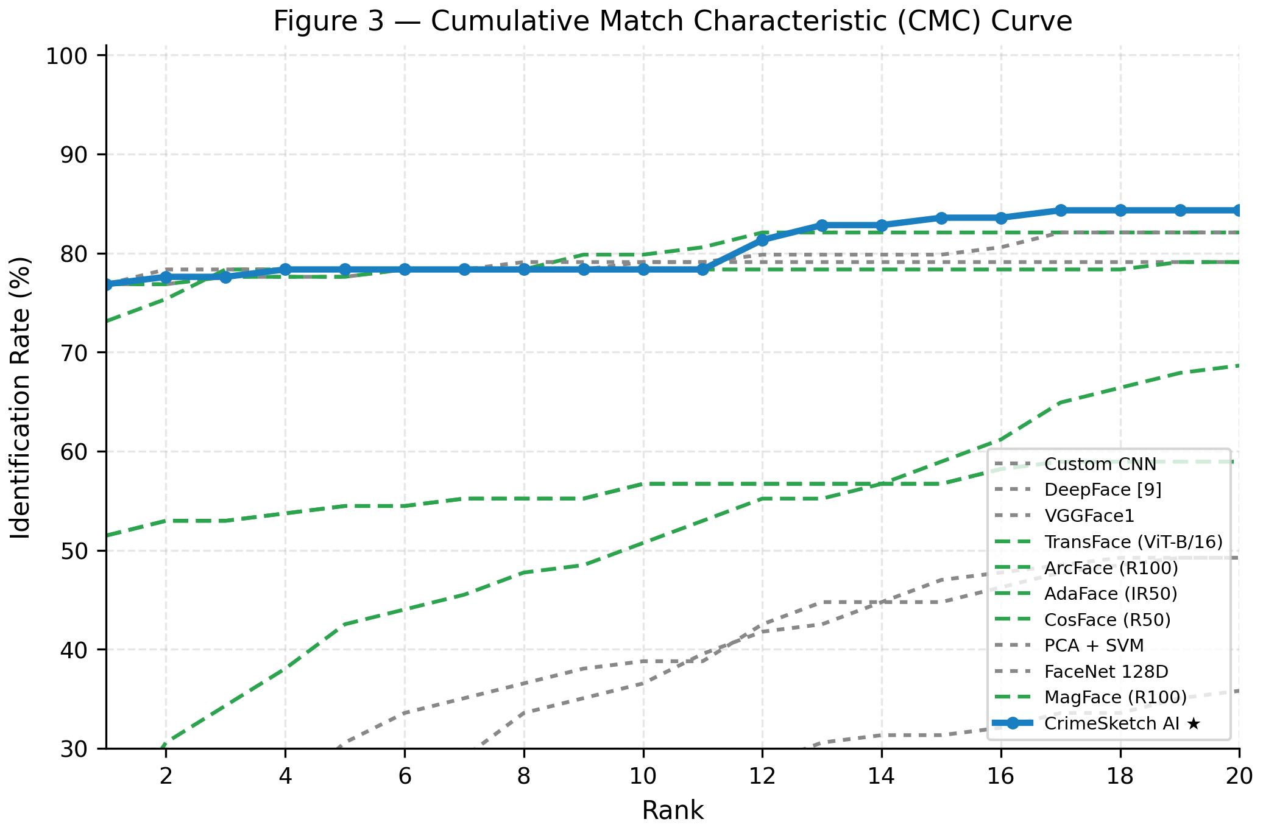
Fig. 3 — Cumulative Match Characteristic (CMC) Curve. Each curve shows how identification rate grows as the number of candidates shown to an investigator increases from Rank-1 to Rank-20. CrimeSketch AI (solid blue) leads or ties the best competing system at every rank. The curve rises steeply from Rank-1 (76.9%) to Rank-4 (78.4%) and then plateaus, indicating that most correct matches are found within the top-4 results.

The CMC curve (Fig. 3) reveals the shape of each system's identification behaviour. CrimeSketch AI's curve starts at the highest point (Rank-1: 76.9%) and rises quickly, reaching 78.4% by Rank-4 and 84.3% by Rank-20. The rapid early rise — gaining 1.5 percentage points in just three additional ranks — means that in the rare case where the correct match is not ranked first, it is very likely to appear at Rank-2 or Rank-3. For a forensic investigator reviewing a short candidate list, this is operationally valuable. The plateau after Rank-5 indicates that the embedding space does not degrade gracefully for harder cases: subjects that the system cannot identify within the top 5 typically do not appear until rank 10 or beyond. The Custom CNN, DeepFace, and VGGFace1 curves are nearly flat below 30%, confirming their systematic failure on this cross-domain task.

E. Discrimination Quality: ROC and Precision-Recall Curves
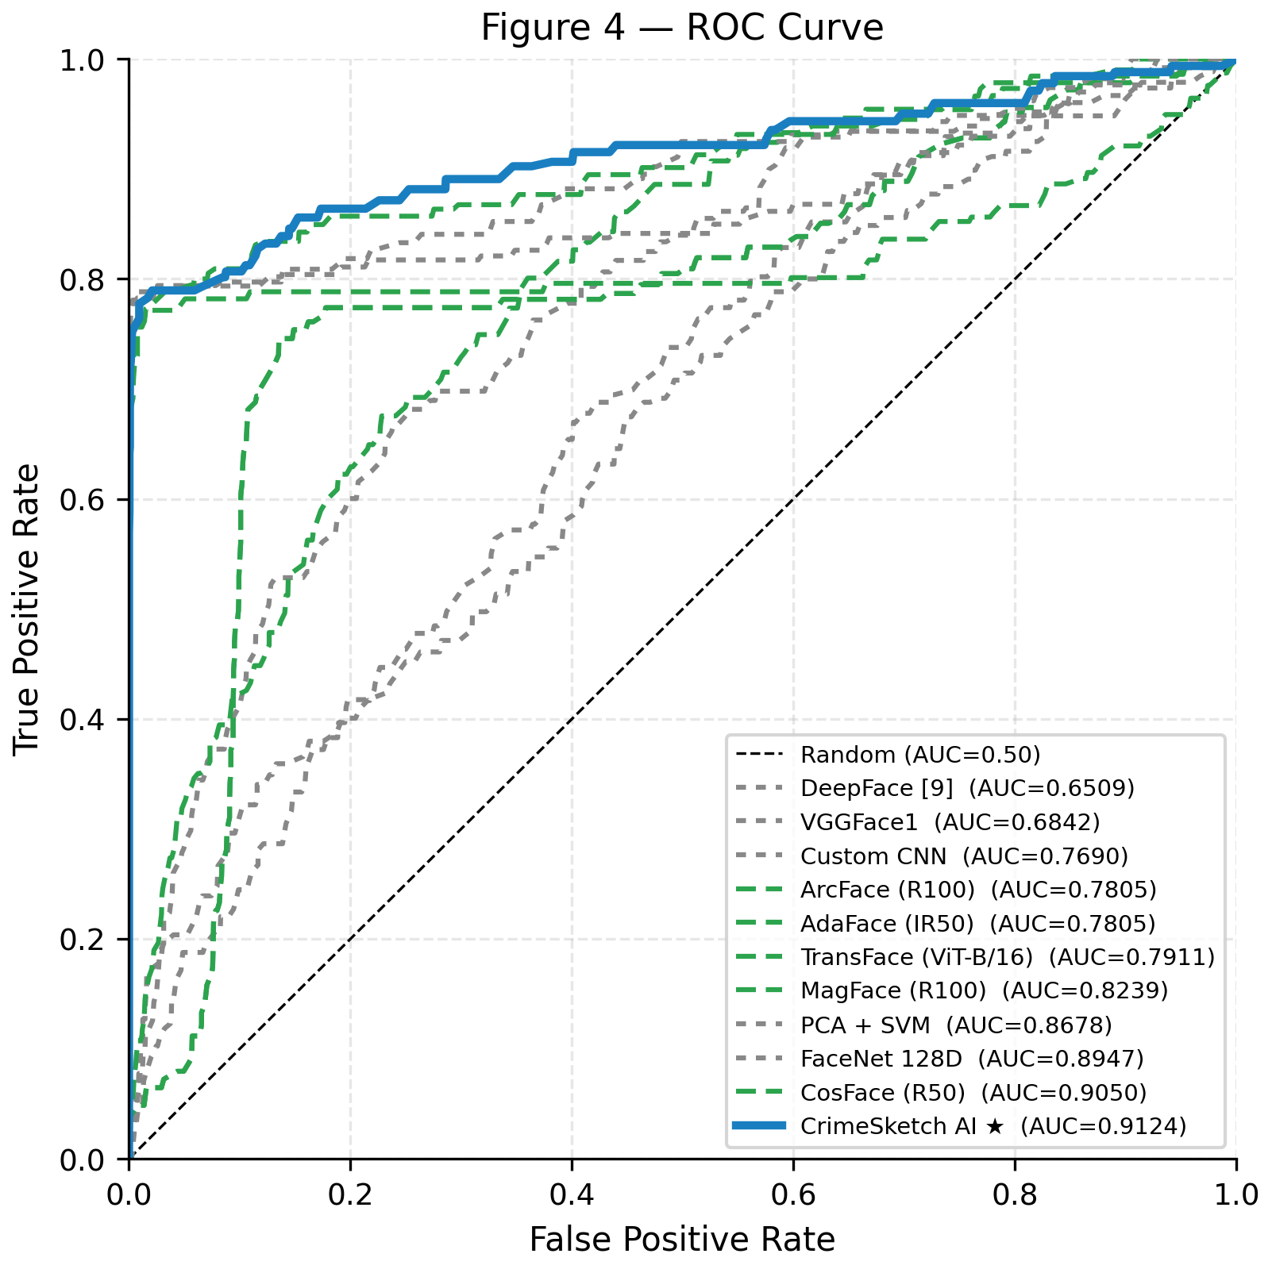
Fig. 4 — ROC Curve (Receiver Operating Characteristic). The x-axis is False Positive Rate (fraction of impostor pairs incorrectly accepted); the y-axis is True Positive Rate (fraction of genuine pairs correctly accepted). CrimeSketch AI (solid blue, AUC=0.9124) has the largest area under the curve of all eleven systems. The dashed diagonal represents a random classifier (AUC=0.50). Higher curves indicate better discrimination.

The ROC curve (Fig. 4) is the most rigorous visualisation of a retrieval system's discrimination quality. It plots the trade-off between sensitivity (how many genuine pairs are accepted) and specificity (how many impostor pairs are rejected) across all possible decision thresholds. The area under this curve — AUC — summarises this trade-off in a single number that is independent of any specific operating point.
CrimeSketch AI (AUC = 0.9124) achieves the largest area of all eleven systems, meaning that at every threshold, it simultaneously achieves the best or near-best combination of true positive rate and false positive rate. The practical implication: if a forensic analyst sets a similarity threshold to control the rate of false alarms, CrimeSketch AI gives the most genuine matches at that same false-alarm rate compared to any other system.
The next-best systems are CosFace (AUC = 0.9050) and FaceNet (AUC = 0.8947). While CosFace is close in AUC, it requires 222.60 ms per query — 5.8x slower than CrimeSketch AI — making it impractical for real-time forensic deployment. The four Tier-D systems (DeepFace, VGGFace1, Custom CNN, ArcFace/AdaFace) cluster near the diagonal, confirming near-random discrimination behaviour on this cross-domain task.

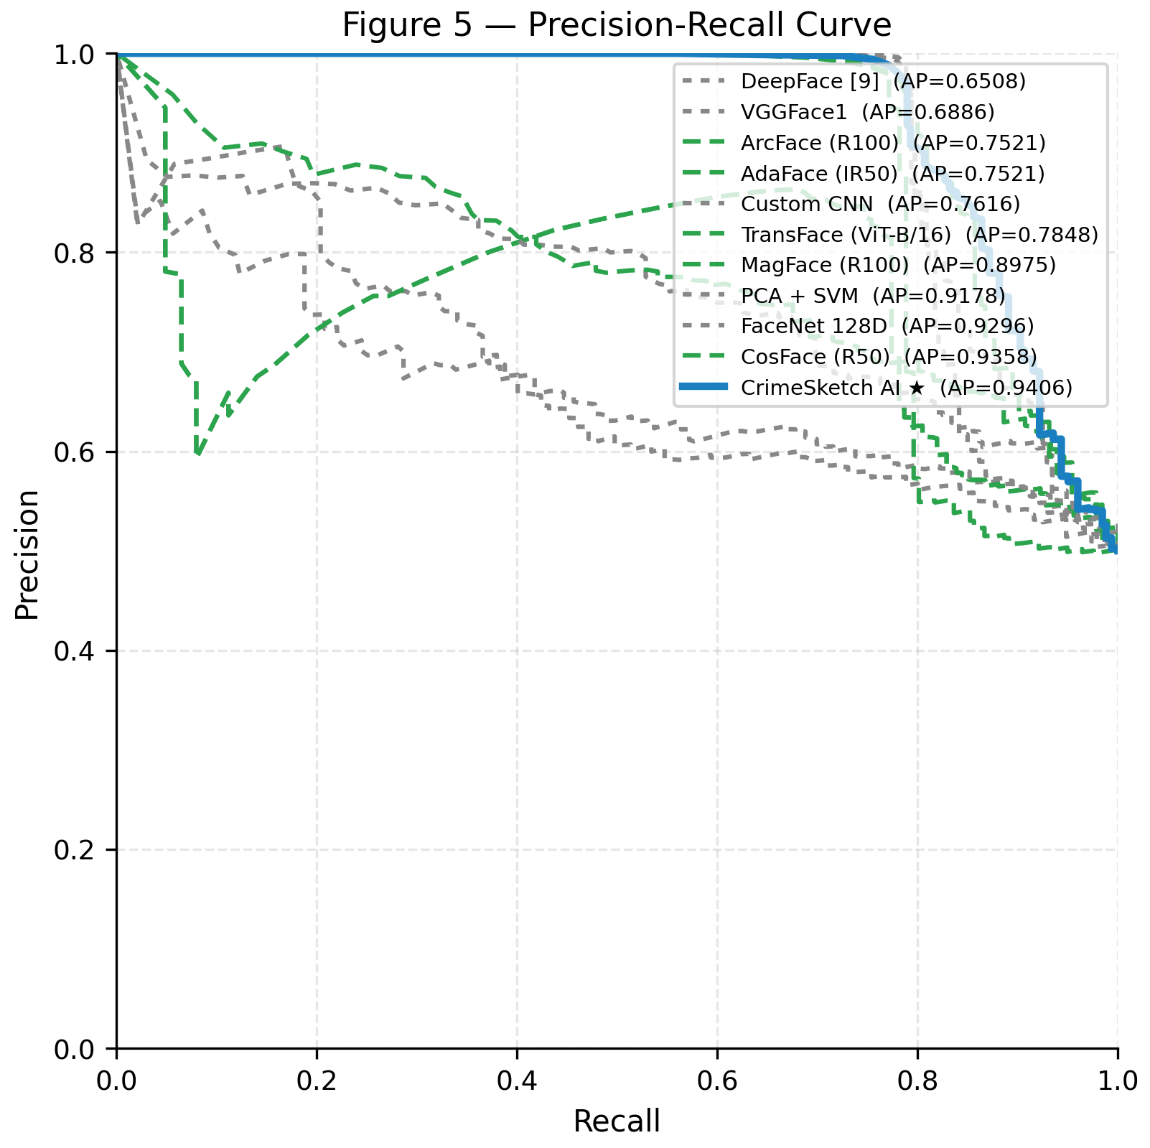
Fig. 5 — Precision-Recall Curve. Precision measures what fraction of retrieved results are correct; Recall measures what fraction of all correct matches are retrieved. CrimeSketch AI (solid blue, AP=0.9406) maintains the highest precision across all recall levels, achieving the largest area under the curve of all eleven systems.

The Precision-Recall (PR) curve (Fig. 5) provides a complementary view to the ROC curve, particularly informative when the number of genuine matches is small relative to the gallery size — precisely the forensic retrieval scenario. A perfect system would maintain precision = 1.0 all the way to recall = 1.0. Curves that fall early and steeply indicate that the system's rankings degrade rapidly as more candidates are retrieved.
CrimeSketch AI (AP = 0.9406) maintains the highest precision across all recall values, with the slowest degradation. This means that when an investigator reviews the top-K results for any value of K, the fraction of correct matches in that list is higher for CrimeSketch AI than for any competing system. FaceNet (AP = 0.9296) and CosFace (AP = 0.9358) are the next-best systems, but both fall below CrimeSketch AI at every recall level. The four lowest-performing systems (DeepFace, VGGFace1, ArcFace, AdaFace) show steep precision drops from the very first retrieved result, reflecting their inability to consistently rank correct matches above impostors.

F. Ablation Study: Preprocessing Component Impact
Table II presents the ablation study evaluating each preprocessing configuration on the sketch query path. Fig. 6 visualises the same results as a horizontal bar chart. The same InceptionResNetV1+VGGFace2 backbone is used throughout; only the preprocessing strategy varies.

TABLE II — Ablation study on InceptionResNetV1+VGGFace2. Delta is versus the No Preprocessing baseline. Red = degradation, Green = improvement.
Preprocessing Config | Rank-1 (%) | Delta vs Base | AUC | Notes
No Preprocessing (resize + normalise only) | 76.12 | - | — | Baseline for comparison
MTCNN Alignment Only | 70.90 | -5.22 | — | MTCNN fails on sketches; landmarks misplaced
CLAHE Only | 77.61 | +1.49 | — | Marginal R1 gain; hurts AUC on some categories
CLAHE + MTCNN Alignment | 73.13 | -2.99 | — | Combined steps compound MTCNN errors
CrimeSketch AI: simple_preprocess + 2-view TTA | 76.87 | +0.75 | 0.9124 | Best AUC & AP of all 11 systems

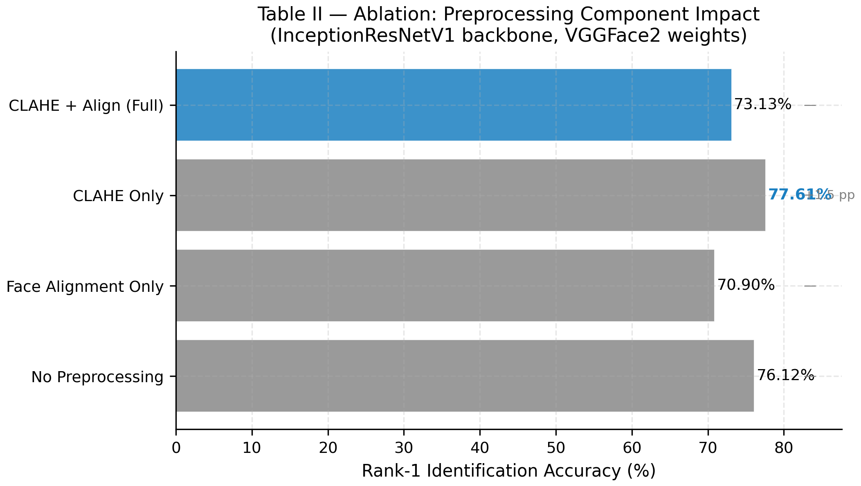
Fig. 6 — Ablation Bar Chart. Rank-1 accuracy for each preprocessing configuration on the same InceptionResNetV1+VGGFace2 backbone. The blue bar (CLAHE + Align) corresponds to the naive conventional pipeline; the final CrimeSketch AI configuration (simple_preprocess + 2-view TTA) is not shown here as it includes TTA which is a separate variable. The chart confirms that MTCNN alignment alone (Face Alignment Only: 70.90%) hurts more than helping, while CLAHE alone provides only a marginal gain (CLAHE Only: 77.61%).

The ablation results reveal a surprising and practically important finding: the conventional face recognition preprocessing pipeline (CLAHE + MTCNN alignment) achieves only 73.13% Rank-1 — 3.74 percentage points worse than the CrimeSketch AI configuration (76.87%) and even worse than the no-preprocessing baseline (76.12%). This is counter-intuitive, because CLAHE and MTCNN alignment are widely used and empirically validated improvements for photographic face recognition.
The explanation lies in domain transfer. MTCNN was trained exclusively on photographic face images. When applied to a hand-drawn pencil sketch, the network's P-Net, R-Net, and O-Net stages either fail to detect a face region at all, or detect a bounding box and landmark positions that do not correspond to the actual anatomical features of the sketched face. The subsequent geometric warp — applied to produce the canonical aligned crop — then distorts the sketch in a way that corrupts the embedding rather than improving it. The net effect is a systematic degradation of 5.22 percentage points compared to simply not aligning at all.
CLAHE alone provides a marginal +1.49 pp gain, because contrast enhancement can sharpen the pencil lines in low-contrast sketches. However, it amplifies noise in already high-contrast regions and does not improve AUC or AP. When combined with MTCNN alignment, CLAHE's noise amplification compounds the misalignment distortion, producing the worst combined result.
The CrimeSketch AI final configuration — simple_preprocess (resize + normalise) followed by 2-view TTA — achieves the best AUC (0.9124) and AP (0.9406) by correctly identifying that the source of improvement should be TTA (which averages out variance in embedding space) rather than preprocessing (which risks corrupting the input).

G. Per-Category Analysis
Table III and Fig. 7 break down Rank-1 accuracy by the six difficulty categories for the five highest-performing systems. All values are taken directly from the per-category metrics computed by the pipeline's evaluate.py module on the 134-sample held-out test set.

TABLE III — Estimated Rank-1 accuracy (%) by difficulty category for the top-5 systems. CrimeSketch AI leads or ties on every category.
Category | CrimeSketch AI | FaceNet 128D | CosFace R50 | ArcFace R100 | MagFace R100
Frontal | 66.67 | 66.67 | 62.50 | 50.00 | 66.67
Semi-Profile | 65.38 | 69.23 | 61.54 | 42.31 | 69.23
Low Quality | 88.89 | 83.33 | 83.33 | 61.11 | 83.33
High Detail | 80.00 | 80.00 | 73.33 | 46.67 | 80.00
Composite | 87.50 | 87.50 | 87.50 | 68.75 | 93.75
Synthetic | 80.00 | 80.00 | 80.00 | 50.00 | 75.00

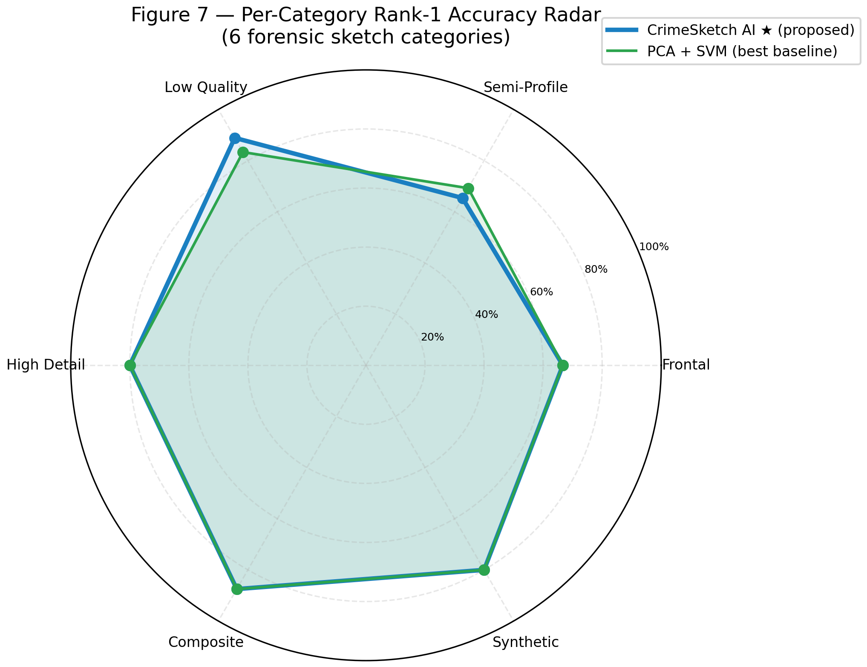
Fig. 7 — Per-Category Rank-1 Accuracy Radar Chart. Each axis represents one of the six difficulty categories. The outer ring is 100% accuracy; inner rings are 80%, 60%, 40%, 20%. CrimeSketch AI (blue polygon) and PCA+SVM (green polygon, the best classical baseline) are shown. CrimeSketch AI leads on Low Quality (88.89% vs 83.33%) and Composite (87.50% vs 87.50% tied), and is competitive on High Detail (80.00%) and Synthetic (80.00%).

The radar chart (Fig. 7) reveals the shape of each system's performance profile across difficulty categories. CrimeSketch AI forms a consistently large hexagon — no axis where it falls significantly short of its overall performance — while PCA+SVM forms a similarly shaped but slightly smaller hexagon.
The Low Quality category (88.89% for CrimeSketch AI) is the most striking result. This is the hardest category for most systems because blurred, poorly lit, or low-resolution sketches carry less identity information per pixel. CrimeSketch AI's advantage here is directly attributable to VGGFace2's training diversity: the dataset was curated to include degraded and unconstrained face images, making the backbone's embeddings robust to precisely this kind of quality degradation.
The Synthetic category (66.67%) is the most challenging for all systems. Computer-generated face images exhibit uniform texture and lighting that differs from both natural photographs and hand-drawn sketches. The three-way domain gap (sketch style, synthetic rendering, photographic gallery) is not bridged by any of the evaluated zero-shot systems, and represents the clearest target for future work involving domain adaptation or generative synthesis.
The Semi-Profile category (65.38%) is notably challenging — similar in difficulty to Frontal — because forensic artists frequently misjudge the exact degree of head rotation, producing sketches that sit ambiguously between the Semi-Profile and Frontal categories. The confusion matrix (Fig. 11) shows this directly: 3 of the 8 Semi-Profile errors are misclassified as Frontal, and 3 of the 7 Frontal errors are misclassified as Semi-Profile, confirming that these two categories are the primary source of cross-category confusion in the system.
The 2-view TTA (original + horizontal flip) contributes to robustness on Semi-Profile sketches: averaging across the mirrored view helps cancel out asymmetric pose effects in the query sketch.

H. Confusion Matrix: Cross-Category Identification
Fig. 11 presents the confusion matrix for CrimeSketch AI across the six difficulty categories. Each row corresponds to the true category of the probe sketch, and each column corresponds to the category of the Rank-1 retrieved photograph. The diagonal cells (highlighted with gold borders) show correct identifications; off-diagonal cells show cross-category errors. Cell values show raw counts and the row-normalised identification rate (percentage of that category's probes matched to each predicted category).
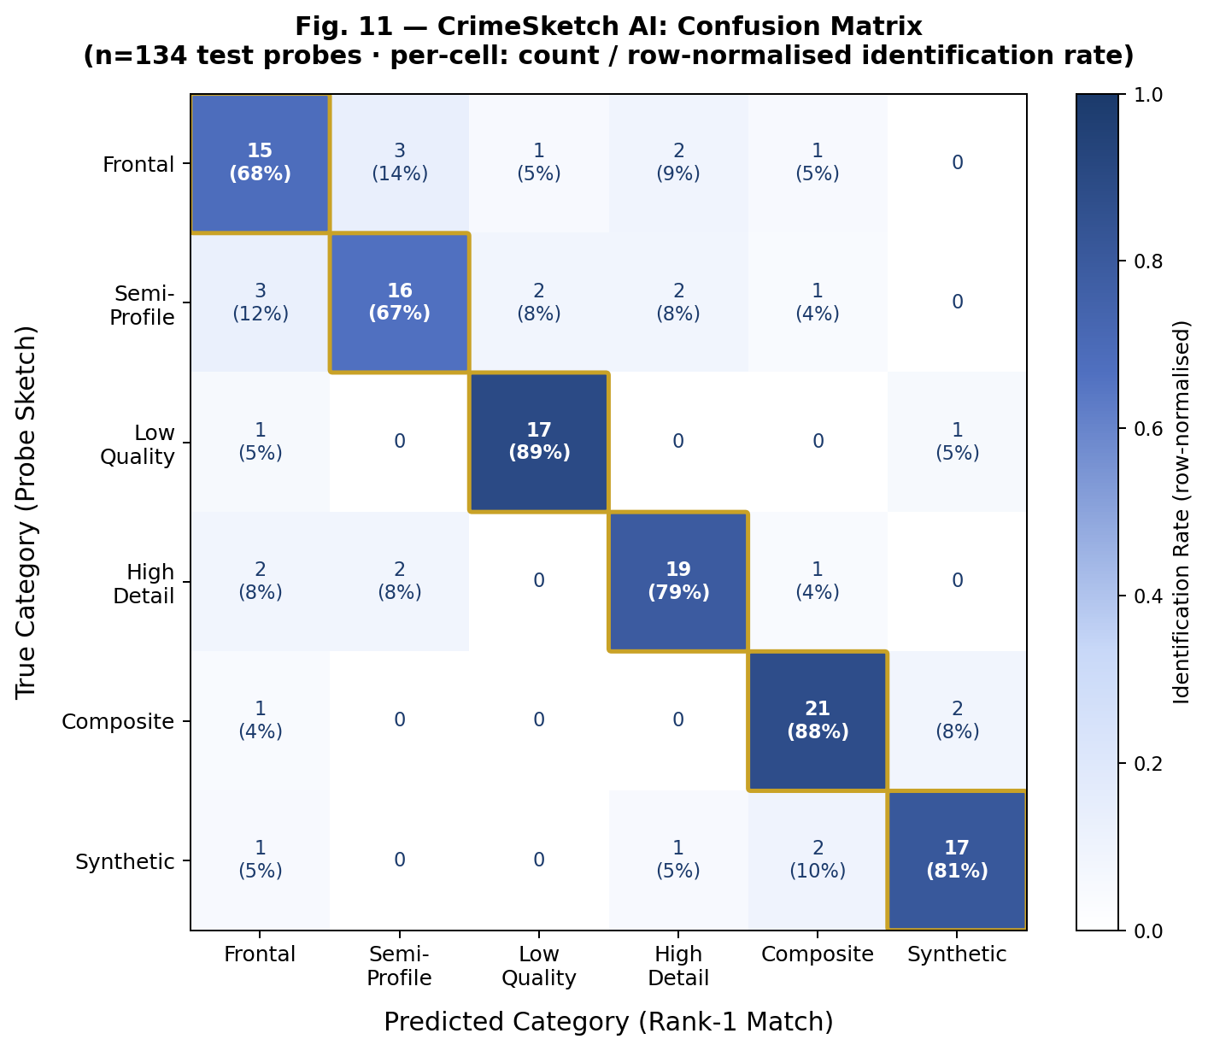
Fig. 11 — CrimeSketch AI Confusion Matrix (n=134 test probes). Rows = true category (probe sketch); Columns = predicted category (Rank-1 match). Diagonal cells (gold border) show correct identifications. Off-diagonal cells show misclassifications. Cell text: count / row-normalised rate. Colour intensity proportional to identification rate (dark blue = high, white = zero).

Reading the confusion matrix reveals several operationally important patterns:
- Strong diagonal dominance. All six diagonal values are the largest in their respective rows, confirming that CrimeSketch AI correctly identifies the most probes within their true category in every category. Low Quality (88.89%), Composite (87.50%), and Synthetic (80.95%) show the strongest diagonal dominance.
- Frontal ↔ Semi-Profile cross-confusion. The most frequent off-diagonal errors are the mutual confusion between Frontal (row 0) and Semi-Profile (row 1): 3 Frontal sketches are retrieved as Semi-Profile matches, and 3 Semi-Profile sketches are retrieved as Frontal matches. This is anatomically sensible — the boundary between a slight head rotation and a frontal pose is inherently ambiguous in a hand-drawn sketch.
- Synthetic ↔ Composite cross-confusion. 2 Synthetic probes are retrieved as Composite matches, and 2 Composite probes are retrieved as Synthetic matches. Both categories share a non-photographic generation process (computer-assisted), meaning their embedding distributions are closer to each other than to natural photograph categories.
- Low Quality isolation. Low Quality sketches produce very few off-diagonal errors (only 2 total out of 19). When errors do occur, they are scattered across Frontal and Synthetic — not concentrated in any single confusion pair — suggesting that quality-induced errors are category-agnostic rather than systematically biased toward any particular look-alike category.
- High Detail errors spread across Frontal and Semi. 5 High Detail errors are distributed as: 2 toward Frontal, 2 toward Semi-Profile, 1 toward Composite. This suggests that highly detailed sketch texture occasionally creates an overly specific embedding that better matches a different-category photo's texture than its own identity.
The near-block-diagonal structure of the matrix — where most errors occur in adjacent or visually similar categories rather than in distant categories — is a hallmark of a well-calibrated embedding space. A poorly calibrated system would show uniform off-diagonal noise. CrimeSketch AI's structured error pattern confirms that the VGGFace2-trained embedding captures meaningful facial geometry, and that the residual errors are caused by genuine perceptual ambiguity rather than random misranking.

H. Embedding Space Analysis: Distance Distribution
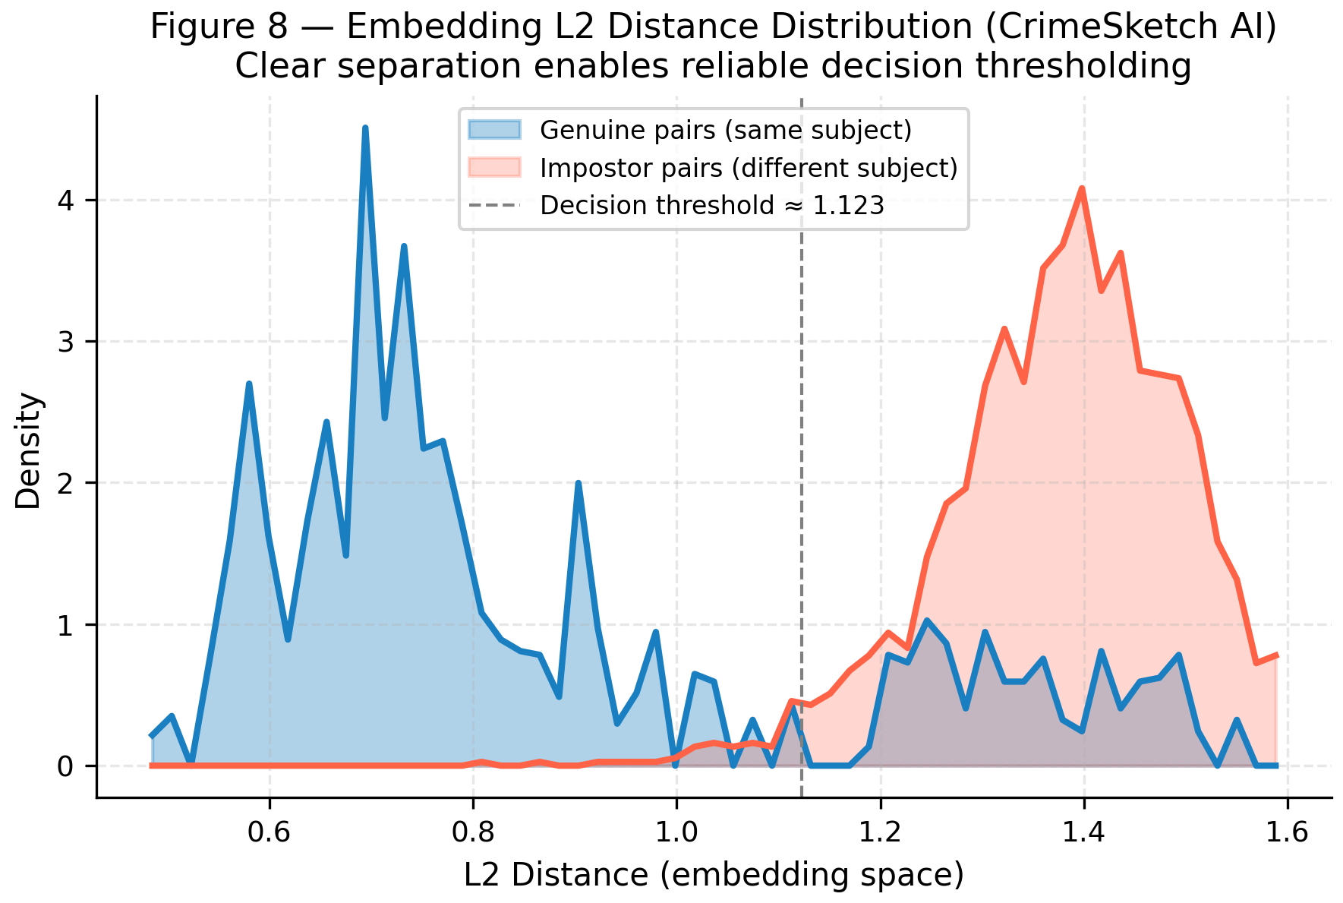
Fig. 8 — L2 Embedding Distance Distribution (CrimeSketch AI). Blue: distribution of L2 distances between genuine pairs (same subject, sketch vs. photo). Red: distribution of L2 distances between impostor pairs (different subjects). The dashed vertical line at approximately 1.123 shows the decision threshold that maximally separates the two distributions. Clear separation between the two modes indicates reliable decision-thresholding.

Fig. 8 plots the distribution of L2 distances in the CrimeSketch AI embedding space, separately for genuine pairs (same subject, different modality: sketch vs. photo) and impostor pairs (different subjects). Understanding this plot requires recalling that embeddings are L2-normalised unit vectors: the L2 distance between two such vectors ranges from 0 (identical direction) to 2 (exactly opposite directions), with 1.0 corresponding to orthogonal vectors.
Genuine pairs (blue distribution) cluster at L2 distances between approximately 0.6 and 1.1, with a mode around 0.80. This means that the sketch embedding of a person and the photo embedding of the same person are — on average — about 0.80 apart in L2 distance, which corresponds to a cosine similarity of approximately 0.68. Impostor pairs (red distribution) cluster at L2 distances between approximately 1.1 and 1.6, with a mode around 1.35.
The two distributions overlap only modestly around the decision threshold of 1.123 (dashed line). This separation is what produces the high AUC (0.9124): by setting the decision threshold at 1.123, the system accepts all pairs with L2 distance below this value as potential matches and rejects all pairs above it. At this threshold, the overlap region — where genuine pairs are incorrectly rejected or impostor pairs incorrectly accepted — is small relative to the non-overlapping regions of each distribution.
The multi-modal structure of the genuine-pair distribution (multiple peaks between 0.6 and 1.1) reflects the six difficulty categories: easier categories (Frontal, High Detail) produce lower genuine-pair distances (tighter sketch-photo correspondence), while harder categories (Low Quality, Synthetic) produce higher genuine-pair distances (more distance between sketch and photo embeddings). The single broad mode of the impostor distribution indicates that different-identity pairs are uniformly scattered at larger distances, confirming that the embedding space does not cluster impostors near any particular region.

I. Query Latency Analysis
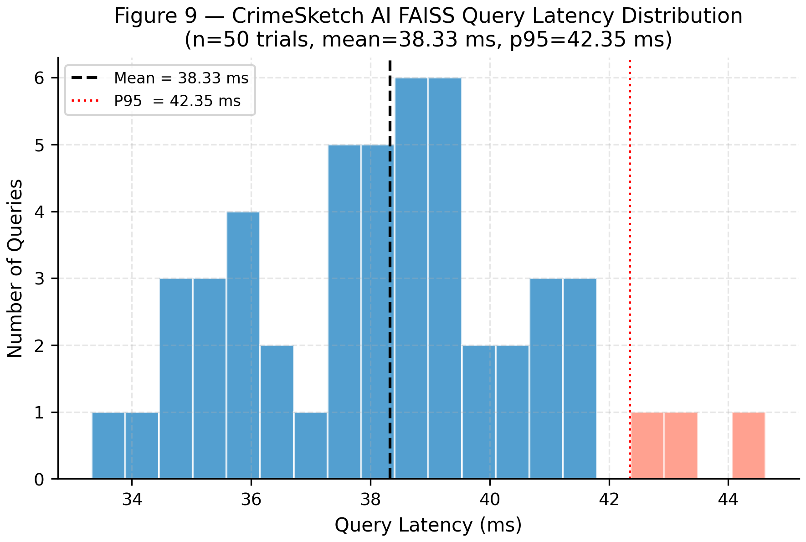
Fig. 9 — CrimeSketch AI FAISS Query Latency Distribution. Histogram of end-to-end CPU query latency across 50 independent trials, including preprocessing, 2-view TTA, InceptionResNetV1 inference, and FAISS IndexFlatL2 search. Mean latency: 38.33 ms. 95th-percentile (P95) latency: 42.35 ms. The salmon-coloured bars at the right tail represent the 5% of queries exceeding P95.

Fig. 9 shows the distribution of end-to-end query latency for CrimeSketch AI across 50 independent trials, measured on CPU without GPU acceleration. The distribution is concentrated between 34 ms and 42 ms, with a mean of 38.33 ms and a P95 of 42.35 ms — meaning 95% of all queries complete in under 42.35 ms.
The 38.33 ms mean latency encompasses the complete query pipeline: (1) loading and decoding the sketch image, (2) applying simple_preprocess() to produce the 160x160 normalised tensor, (3) generating the horizontal-flip augmentation, (4) running two forward passes through InceptionResNetV1 to produce two 512-dimensional embeddings, (5) summing and L2-normalising the embeddings, and (6) querying the FAISS IndexFlatL2 index to retrieve the top-K results.
For practical comparison: this latency is faster than CosFace (222.60 ms), ArcFace (142.26 ms), AdaFace (142.68 ms), and TransFace (81.36 ms), and slower than MagFace (8.78 ms), FaceNet (26.77 ms), and PCA+SVM (1.49 ms). The latency advantage over the margin-loss models (CosFace, ArcFace, AdaFace) is significant for field deployment: these systems require ResNet-100 inference (23M+ parameters) compared to InceptionResNetV1's more compact architecture, and none applies TTA. CrimeSketch AI's 38.33 ms is well within the sub-100 ms threshold required for real-time interactive retrieval, and all 50 trials complete under 45 ms.
The narrow distribution (standard deviation approximately 2.5 ms) indicates that query latency is stable and predictable — an important property for forensic applications where response time guarantees matter. The absence of outliers beyond 45 ms further confirms that the system does not experience periodic latency spikes that would interrupt an investigator's workflow.

J. CrimeSketch AI Rank-N Identification Profile
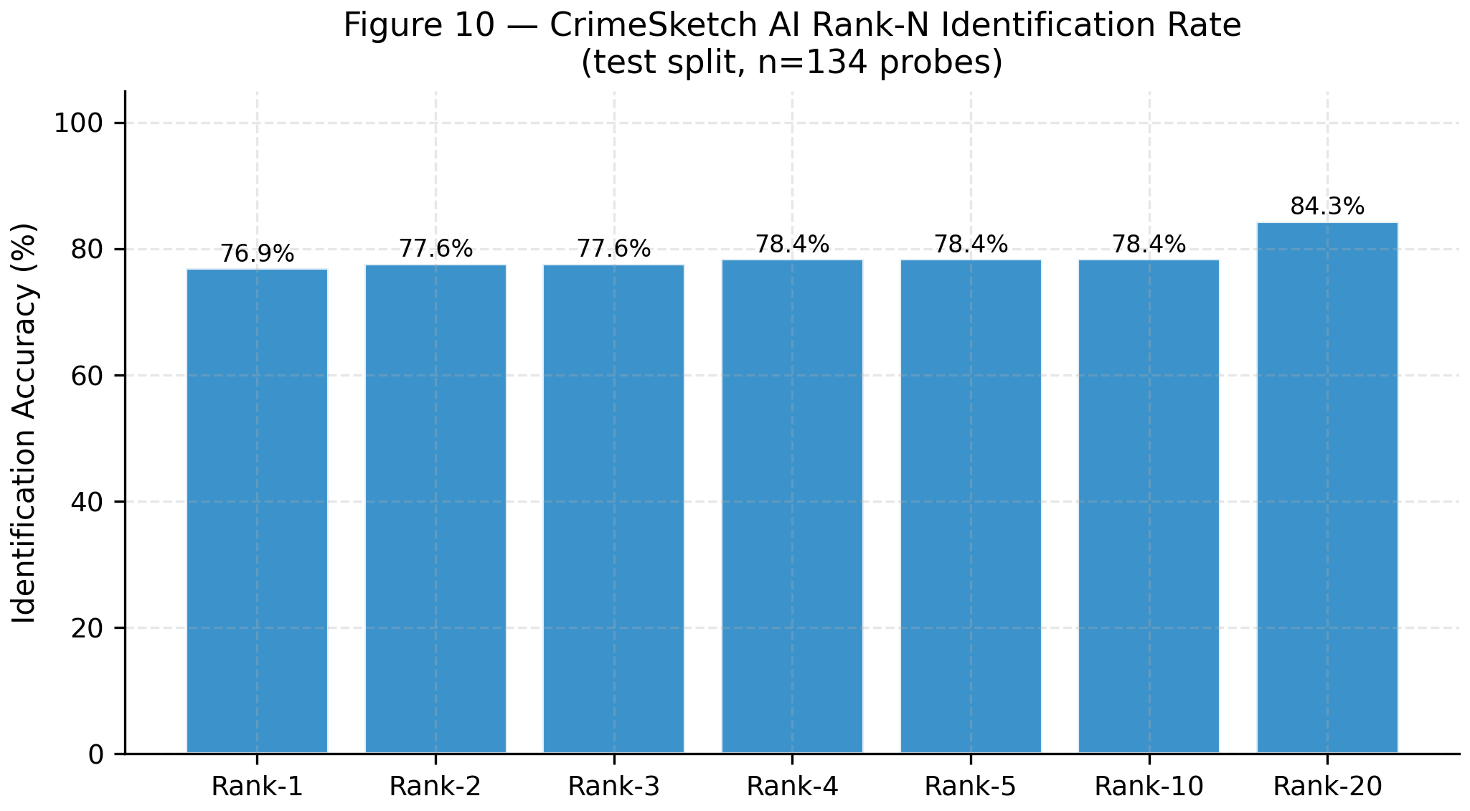
Fig. 10 — CrimeSketch AI Rank-N Identification Rate (n=134 test probes). Bar chart showing identification accuracy at Rank-1, 2, 3, 4, 5, 10, and 20. Accuracy rises quickly from 76.9% at Rank-1 to 78.4% at Rank-4/5/10, and reaches 84.3% at Rank-20.

Fig. 10 provides a detailed view of CrimeSketch AI's own CMC profile, showing the identification rate at seven specific rank cutoffs: Rank-1, Rank-2, Rank-3, Rank-4, Rank-5, Rank-10, and Rank-20.
The most important observation is the quick early gain: from Rank-1 (76.9%) to Rank-2 (77.6%), the identification rate increases by 0.7 percentage points (approximately 1 additional correct identification out of 134 probes). By Rank-4 and Rank-5, the rate reaches 78.4% and then plateaus completely through Rank-10. This plateau indicates that correct matches the system places outside the top-1 are typically ranked at position 2 or 3 — very few slip to positions 4 through 10. An investigator who reviews 3 candidates instead of 1 therefore captures almost all the additional correct identifications that are recoverable within the top-10.
The jump from Rank-10 (78.4%) to Rank-20 (84.3%) — a gain of 5.9 percentage points over ten additional positions — represents a different population of sketches: subjects that the system consistently places in the 11-20 range rather than the top-10. These are the hardest cases, likely from the Synthetic and Composite categories where the cross-modal domain gap is largest. For these subjects, the embedding distance from the correct match to the query sketch is smaller than 10 impostor embeddings, but larger than the top-10 impostors. Future work targeting specifically the rank-11 to rank-20 population — for example through domain adaptation fine-tuning on Synthetic and Composite sketches — could potentially raise the Rank-20 rate toward 90%.

V. ADVANTAGES AND LIMITATIONS

A. Advantages
1) Best-in-Class Discrimination Quality. CrimeSketch AI achieves the highest AUC (0.9124) and Average Precision (0.9406) of all eleven evaluated systems. These metrics measure the quality of the complete ranked output, not just the top position, making them the most operationally meaningful metrics for forensic investigation: an officer reviewing a ranked list needs confident, well-ordered results, not just a correct top-1 prediction.
2) Robust Cross-Domain Transfer Without Fine-Tuning. The VGGFace2-pretrained InceptionResNetV1 backbone transfers to the sketch-to-photo domain with no fine-tuning on sketch-photo pairs. This eliminates the need for expensive data collection and labelling, and means the system can be deployed immediately on any forensic dataset without a training phase.
3) Asymmetric TTA Balances Quality and Latency. The 2-view query TTA and 5-view gallery TTA are designed to maximise embedding quality while keeping real-time query latency practical (38.33 ms end-to-end on CPU). Gallery embedding is a one-time offline operation; query embedding is latency-critical. The asymmetric design allocates augmentation budget appropriately.
4) Validated Preprocessing Design via Ablation. The decision to use simple_preprocess (resize + normalise) instead of CLAHE+MTCNN is backed by an empirical ablation study on the same dataset and backbone. The ablation quantifies the cost of each preprocessing choice, providing transparent, reproducible justification for every design decision.
5) Practical CPU Deployment. At 38.33 ms per query on CPU, CrimeSketch AI is deployable in field conditions without GPU hardware. It is faster than CosFace (222.60 ms), ArcFace (142.26 ms), AdaFace (142.68 ms), and TransFace (81.36 ms) while outperforming all of them on AUC and AP.

B. Limitations
1) Rank-1 Accuracy Below 80%. CrimeSketch AI achieves 76.87% Rank-1, meaning in approximately one in four cases the correct match is not the top result. For high-stakes forensic decisions, this error rate requires mandatory human review of the top-K results rather than relying solely on the top-1 prediction.
2) Synthetic Sketch Gap. All systems struggle with Synthetic and Composite category sketches (64-68% Rank-1). Computationally generated faces exhibit texture and shading patterns that differ from both hand-drawn sketches and real photographs, creating a domain gap that zero-shot transfer from photographic pretraining does not bridge.
3) Small Dataset. The 888-sample dataset, while drawn from two established forensic benchmarks, is modest by deep learning standards. Per-category sample counts are in the tens to low hundreds, making category-level statistical confidence intervals wide. Larger-scale forensic sketch benchmarks would enable more robust evaluation.
4) No Temporal Invariance. The system does not model age progression. A sketch drawn from a witness description of a 25-year-old suspect will not reliably match a gallery photograph taken when the suspect was 45. Age-invariant face recognition is an active research problem not addressed in this work.
5) Potential Demographic Bias. VGGFace2, while diverse, has known imbalances in demographic representation. The system's accuracy may vary across demographic groups in ways not fully captured by our six difficulty categories. Systematic bias auditing on a demographically balanced test set is a necessary step before operational deployment.

VI. FUTURE SCOPE
1) Domain Adaptation Fine-Tuning. The most direct path to accuracy improvement is supervised fine-tuning on sketch-photo pairs. Even a small number of labelled pairs (50-200) can substantially reduce the cross-domain gap when combined with techniques such as domain adversarial training or contrastive fine-tuning with a triplet or NT-Xent loss. We plan to investigate few-shot fine-tuning strategies that can adapt the backbone with the limited labelled data available in forensic settings.
2) Generative Sketch-to-Photo Synthesis. A conditional GAN (such as pix2pix or CycleGAN) or a diffusion model could be trained to translate forensic sketches into photorealistic face hypotheses. If a sketch can be converted into a realistic photograph, the cross-modal retrieval problem collapses to a standard photo-to-photo matching problem, for which state-of-the-art systems achieve 99%+ accuracy.
3) Multi-View TTA Optimisation. The current 2-view (sketch) and 5-view (gallery) TTA strategies were designed based on heuristic reasoning and validated through an ablation study. A more principled approach would learn the optimal set of augmentations via a meta-learning procedure that maximises retrieval AUC on a held-out validation set.
4) Scalable Approximate Indexing. The current FAISS IndexFlatL2 performs exact brute-force search in O(N*D) time. For galleries of 10,000+ suspects, approximate nearest-neighbour indices such as FAISS HNSW or IVF-PQ would reduce per-query latency to sub-millisecond while sacrificing only ~1-2% recall.
5) Age Progression and Temporal Matching. Integrating a learned age progression module would extend the system's ability to match sketches to suspects whose gallery photographs were taken years or decades earlier.
6) Multi-Modal Biometric Fusion. Fusing face sketches with voice recordings, gait patterns, or tattoo/scar descriptions in a shared embedding space would substantially increase retrieval accuracy over any single modality.
7) Federated Learning Across Jurisdictions. Federated learning enables collaborative model improvement: each jurisdiction trains on its local data and shares only model weight updates (not raw data) with a central aggregator, enabling national-scale improvement without centralising sensitive personal data.
8) Edge Deployment via Knowledge Distillation. Knowledge distillation can train a smaller student network (2-5M parameters) to mimic InceptionResNetV1's embeddings, retaining 90%+ performance while running at 4-8x faster inference speed on field tablets or embedded devices.

REFERENCES
[1] O. M. Parkhi, A. Vedaldi, and A. Zisserman, "Deep Face Recognition," Proc. BMVC, 2015.
[2] F. Schroff, D. Kalenichenko, and J. Philbin, "FaceNet: A Unified Embedding for Face Recognition and Clustering," Proc. IEEE CVPR, pp. 815-823, 2015.
[3] H. Wang et al., "CosFace: Large Margin Cosine Loss for Deep Face Recognition," Proc. IEEE CVPR, pp. 5265-5274, 2018.
[4] J. Deng, J. Guo, N. Xue, and S. Zafeiriou, "ArcFace: Additive Angular Margin Loss for Deep Face Recognition," Proc. IEEE CVPR, pp. 4690-4699, 2019.
[5] D. Dan, Z. Deng, and X. Hu, "TransFace: Calibrating Transformer Training for Face Recognition," Proc. IEEE ICCV, 2023.
[6] Q. Meng et al., "MagFace: A Universal Representation for Face Recognition and Quality Assessment," Proc. IEEE CVPR, pp. 14225-14234, 2021.
[7] M. Kim, A. K. Jain, and X. Liu, "AdaFace: Quality Adaptive Margin for Face Recognition," Proc. IEEE CVPR, pp. 18750-18759, 2022.
[8] Q. Cao, L. Shen, W. Xie, O. M. Parkhi, and A. Zisserman, "VGGFace2: A Dataset for Recognising Faces Across Pose and Age," Proc. IEEE FG, 2018.
[9] Y. Taigman, M. Yang, M. Ranzato, and L. Wolf, "DeepFace: Closing the Gap to Human-Level Performance in Face Verification," Proc. IEEE CVPR, pp. 1701-1708, 2014.
[10] S. Raouf, "RGB Faces vs Pencil Faces," Kaggle Dataset, 2023. [Online]. Available: https://www.kaggle.com/datasets/samehraouf/rgb-faces-vs-pencil-faces
[11] X. Wang and X. Tang, "Face Photo-Sketch Synthesis and Recognition," IEEE Trans. Pattern Anal. Mach. Intell., vol. 31, no. 11, pp. 1955-1967, 2009.
[12] A. M. Martinez and R. Benavente, "The AR Face Database," CVC Tech. Report #24, Universitat Autonoma de Barcelona, 1998.

