PRIYANSHI MISHRA 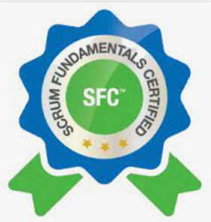 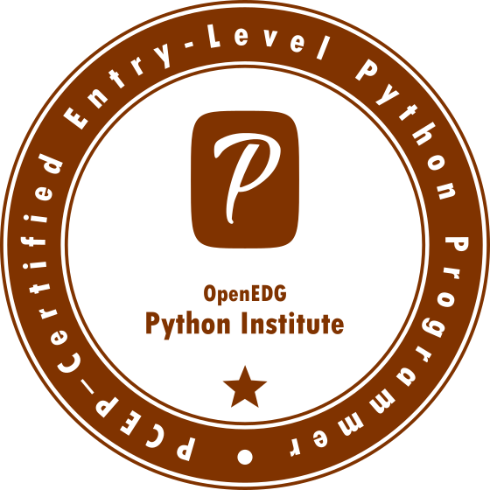

: +91 8565968552
: priyanshichaturvedi23@gmail.com

Objective

To work with an organization committed to growth, where I can use my technical and analytical skills and ability to communicate ideas and commitment to perform creative and quality work. I have a strong penchant for learning newer skills and enhance the old ones.

Professional Experience

Total Experience - 2.3+ years

Current Organisation: -
Organization : Capgemini Engineering
Position Title : Associated Consultant Developer
Duration : From Dec’2022– Till now
Industry : Software Development, Information Tech, Communication.
Role : Python API Development & Troubleshooting support to Client issues.

Previous Organisation: -
Organization : Beta Soft Technology
Position Title : Software Developer (Tool Development Dept).
Duration : 2.0+ years (From Dec’2016– Jan’2019)
Industry : Software Development, Information Tech, Communication.
Role : Tool Development using Python.
Description : Development of python based framework for major telecom giant ERICSSON Global, which quickly do the health check & KPI statistics check for telecom sites (2G,3G & 4G) using Ansible command playbook.

- Currently seeking for an opportunity in Tool/SW development domain using Python language.
- Immediate Joiner.

Job Role

- Involved in development of python-based framework for major telecom giant ERICSSON Global for Health-check & KPI check for telecom sites.
- Involved in creation of various Python script to makes use of the ansible_runner module to execute commands playbook and to retrieve the output for further processing.
- Creation of a Python virtual environment for the project and activate it for doing unit testing.
- Implemented continuous changes, various addon, enhancement as per customer feedback.
- Involved in various framework design & development related discussion with customer.
- Experience working in Agile Development model, focusing strongly on user experience and inputs.
- Extensive use of Software Development Life Cycle (SDLC) methodologies.
- Hands-on experience on basic Linux command line & knowledge of CI/CD.
- Tracking of issues related to framework and timely escalation as per pre-defined development matrix.
- Daily status reporting of module development activity performed.

Technical Skills

Operating Systems : Windows 98 / XP / 8/10, Linux
Language : Basic C, Python 3
Tools : PyCharm, IDE, Ansible (Open Source)
Office tools : MS Office-2007/2010, PowerPoint.
Other tools : GitHub, Putty, JIRA.
Achievements
- Earned PCEP™ – Certified Entry-Level Python Programmer (PCEP-30-02) in 2022 (by OpenEDGE Python Institute)
- Preparation of PCAP™ – Certified Associate in Python Programming (PCAP-31-02) certification is ongoing.
- Earned Scrum Fundamental Certified (SFC™) in 2022 (by Scrum Org)
- Certified Course in “ADVANCE EMBEDDED SYSTEM in C” from EMBEDRONICS.
- Got “Rising Star” award for in-time module delivery in BetaSoft Tech.

Academic Qualification

DEGREE/  CERTIFICATE | INSTITUTE | BOARD/UNIVERSITY | YEAR OF PASSING | MARKS (in %)
Bachelor of Technology. (Electronics & Comm.) | ITM, GIDA, GKP | A.P.J. ABDUL KALAM UNIVERSITY Lucknow | 2015 | 68.8
10TH | L.F.S, GKP | ICSE | 2008 | 65
12TH | N.E.Railway. GKP | CBSE | 2010 | 58.4

Trainings: -
- Project on “SMART STREET LIGHT SYSTEM” in final year.
- Participated in ELECTROTRAP in 2014 Tech-N-Gen 2k14 in ITM.
- Participated in “LINUX WORKSHOP” held by IIT Bombay in 2015.
- Participated in “ADVANCE C training” held by IIT Bombay in 2015.

Personal Details

Date of Birth : 3rd July 1992
Marital status : Married
Father’s Name : Mr. Ranjan Kumar Chaturvedi
Languages Known : English, Hindi, Basic Japanese
Nationality : Indian
Permanent Address : H.No- 480A/9, Sec-7, Gurgaon, HR, India.

I hereby declare that above furnished particulars are true to the best of my knowledge and belief.

Date:
(Priyanshi Mishra)

