Final Touchstone Report
Bloom Valley Nursery Website Project
Developed for: Web Development Fundamentals Course
Date: February 10, 2026

1. Introduction and Design Phase
Bloom Valley Nursery is a family-owned business focused on plants and community gardening. The website was designed with a "Leafy Green" palette to evoke growth and nature.

Desktop Wireframe (Figma Style)
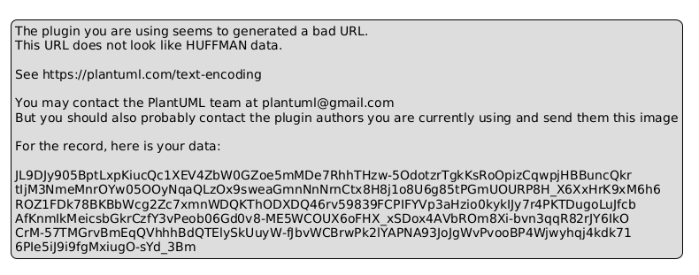
Fig 1: Desktop Wireframe UI/UX Design

Mobile Wireframe (Figma Style)
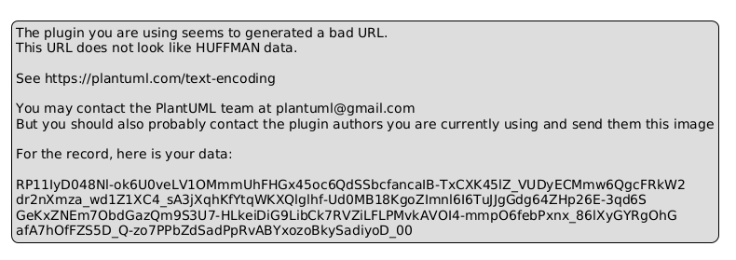
Fig 2: Mobile Responsive Wireframe Layout

2. Website Structure and Content
The website consists of four semantic HTML5 pages. Each page features a consistent navigation bar and responsive footer.

Homepage Layout
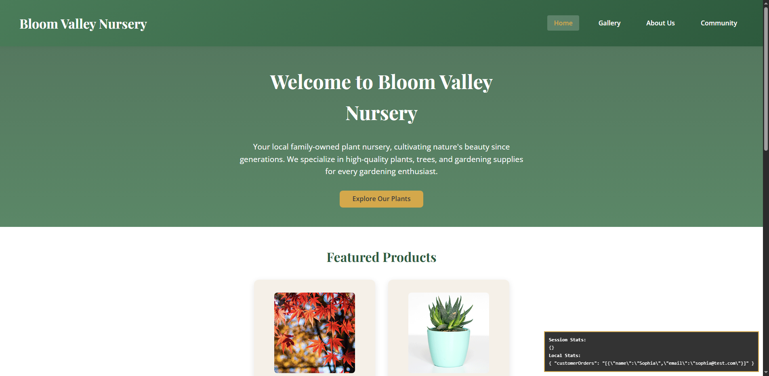
Fig 3: Homepage with Hero Section and Featured Products

Gallery Page (3x3 Grid)
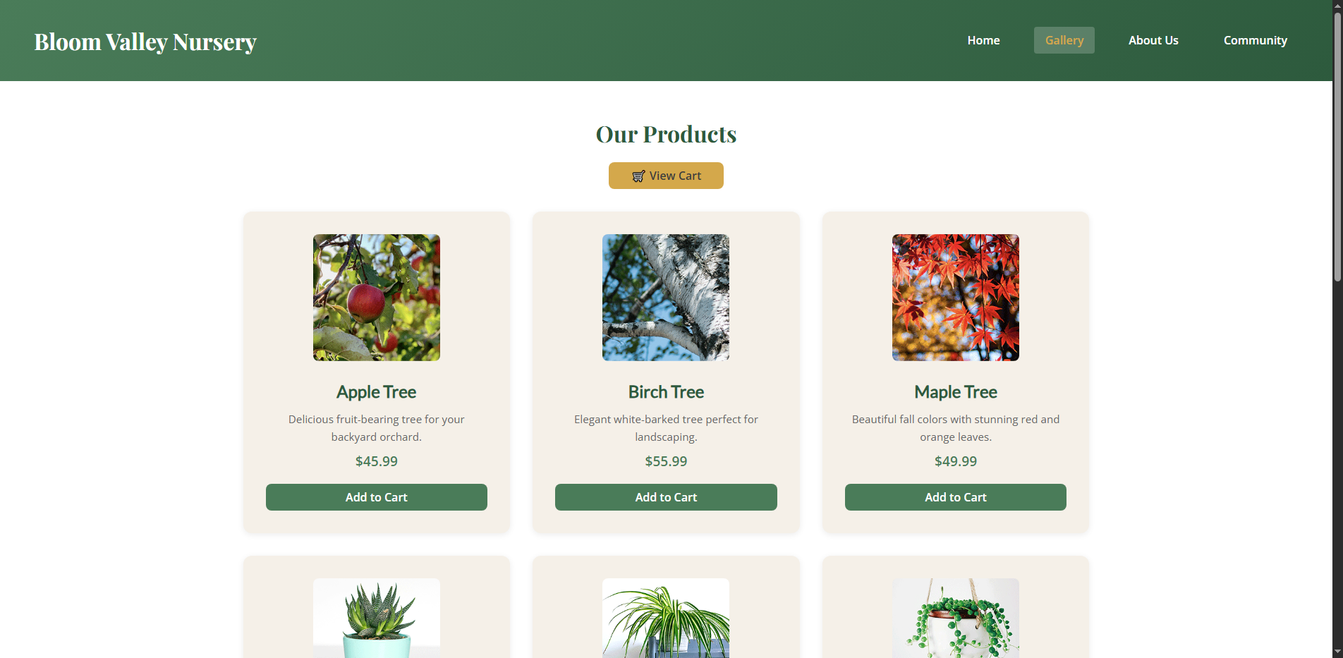
Fig 4: Gallery displaying automated product grid and "Add to Cart" interactions

3. Interaction and JavaScript Features
Dynamic features include a functional shopping cart and contact form system. Interactive alerts provide feedback for every user action.

About Us & Contact Form
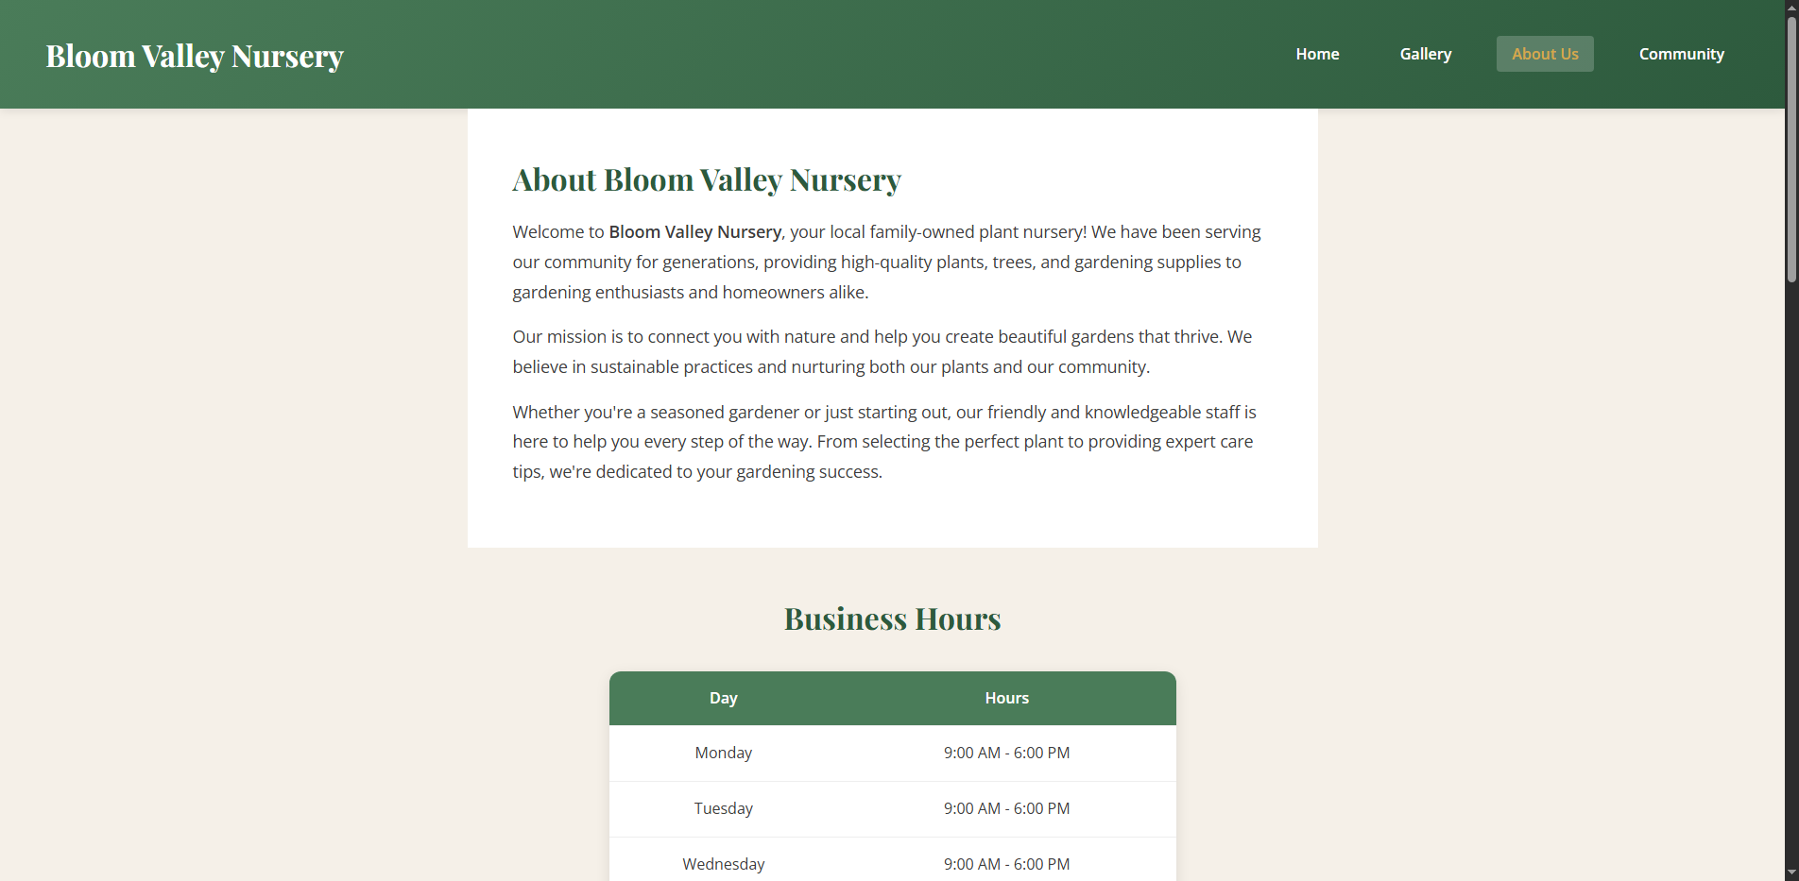
Fig 5: About Us page with business hours table and contact intake form

Community Corner
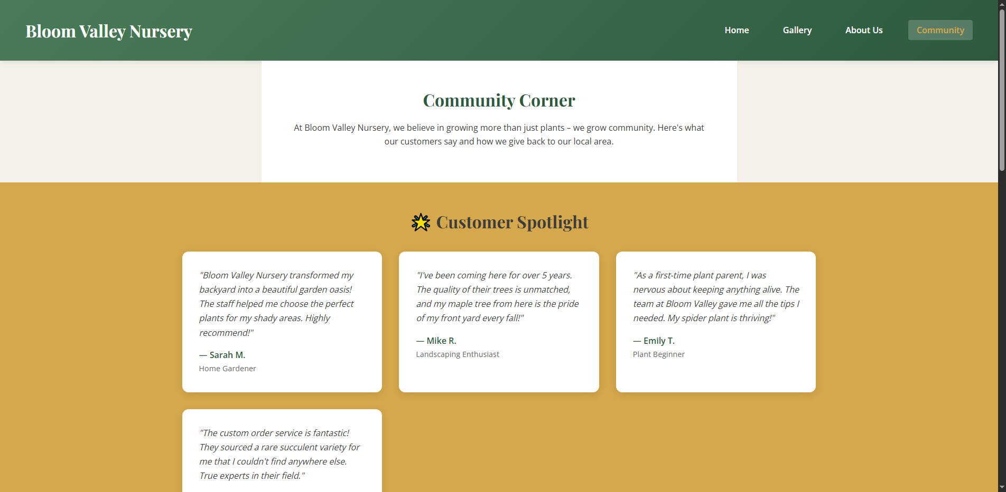
Fig 6: Custom Page showcasing testimonials and community events

4. Web Storage Evidence
The shopping cart utilizes sessionStorage to track items, while localStorage persists contact form metadata.

Shopping Cart View
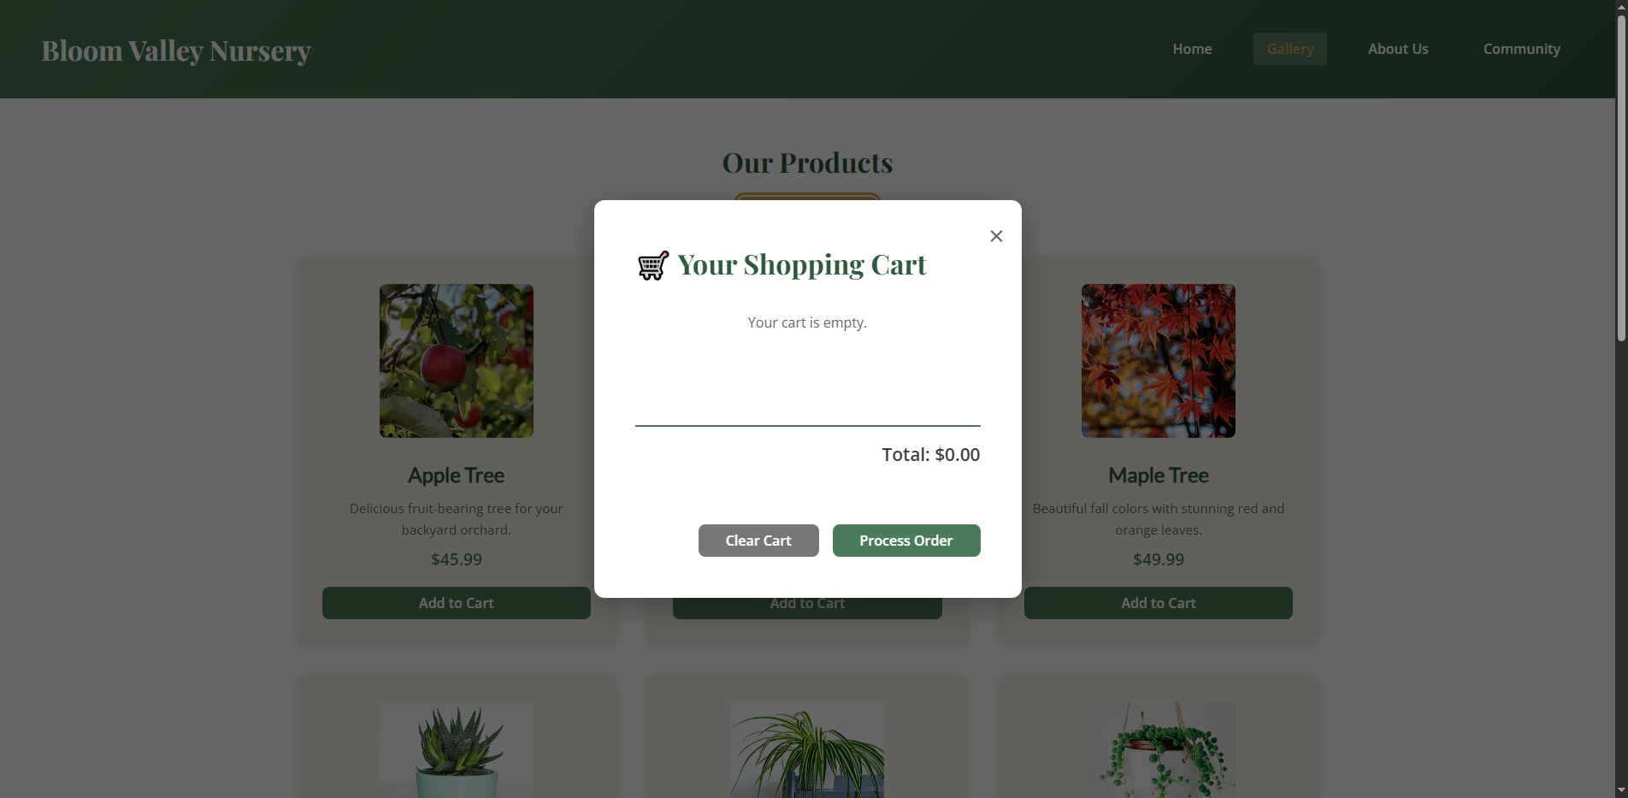
Fig 7: View Cart modal retrieving items from sessionStorage

Clear Cart Functionality
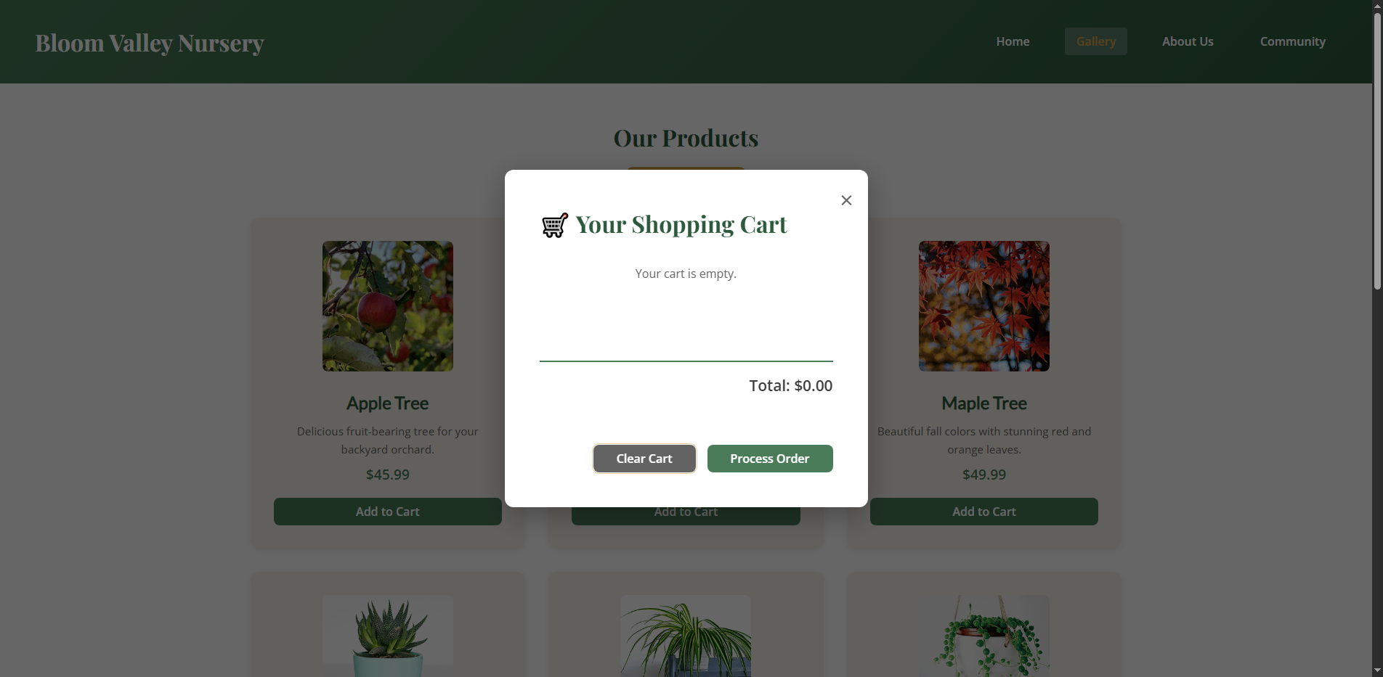
Fig 8: Modal state after clearing sessionStorage storage

5. Conclusion
The project successfully meets all Touchstone criteria. The final product is a professional, accessible, and interactive web presence for Bloom Valley Nursery.

