Touchstone Task 1: Selecting Your Client and Planning Your Website Design
Name:Priyanshi Yadav
Date: February 9, 2026

Client's Name
Bloom Valley Nursery

Wireframes

Mobile Wireframes
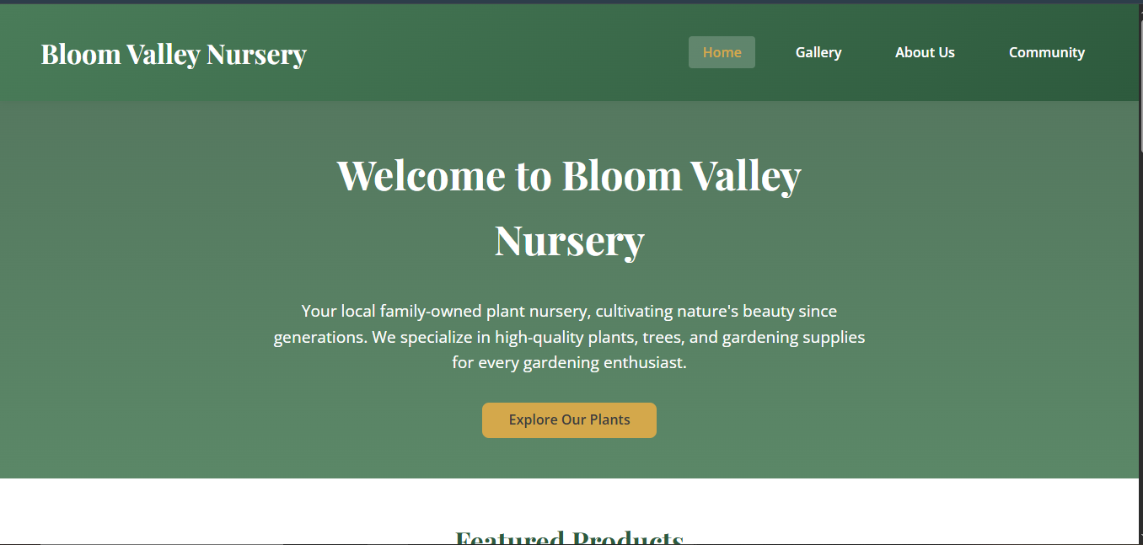
Mobile Wireframe Description:
The mobile wireframes show a single-column layout optimized for smaller screens. The navigation is stacked vertically below the logo. Product grids convert from 3 columns to a single column. All forms and content sections stack vertically for easy mobile scrolling.

Desktop Wireframes
Desktop Wireframe Description:
The desktop wireframes show a horizontal navigation bar in the header. Product grids display in a 3x3 layout. Content sections use multi-column layouts (2-4 columns for perks, testimonials, etc.). Forms have side-by-side buttons.

Color Palette Selection
Color Palette 1

Color Palette Analysis
To reflect the natural beauty of Bloom Valley Nursery's plant offerings, Color Palette 1 was selected for its earthy, organic tones. The Leafy Green (#4A7C59) serves as the primary color, representing growth, nature, and the core business of selling plants. The Deep Forest (#2D5A3D) provides depth and sophistication for headings and accents.
The Harvest Gold (#D4A84B) was chosen as an accent color to add warmth and energy, reminiscent of autumn harvests and the joy of gardening. The Light Cream (#F5F0E8) creates a clean, natural background that allows the green and gold colors to stand out without overwhelming the user. Together, these colors create a cohesive palette that communicates sustainability, nature, and the welcoming atmosphere of a local family-owned nursery.

Logo Selection
Logo matching Color Palette 1 - Deep Forest Green variant

Logo Selection Analysis
The Deep Forest Green (#2D5A3D) logo was selected as it harmonizes perfectly with the chosen color palette while providing excellent visibility against both light and dark backgrounds. The deep green color reinforces the nursery's connection to nature and plant life.
This logo variant offers a sophisticated, professional appearance that appeals to the target audience of gardening enthusiasts and homeowners. The darker green creates a sense of trust and stability, important qualities for a family-owned local business that wants to establish long-term relationships with customers.

Font Color Selection
Font Color 2 - Black Olive (#3D3D3D)

Font Color Analysis
Black Olive (#3D3D3D) was chosen as the primary font color because it provides excellent readability without the harshness of pure black (#000000) on digital screens. Pure black text on white backgrounds can cause eye strain, especially during extended reading sessions.
The Black Olive color offers sufficient contrast against all background colors in Color Palette 1, meeting WCAG accessibility guidelines for text readability. It works particularly well against the Light Cream background (#F5F0E8) and also provides good contrast when placed over the accent gold sections.

Typography Selection
Typography Option 2

Typography Analysis
Typography Option 2 was selected for its combination of elegance and readability:
Playfair Display (Display Font): This serif font is used for headings and the brand name. It provides a touch of elegance and sophistication that elevates the nursery's brand identity beyond a typical local business.
Open Sans (Body Font): This clean, modern sans-serif font is used for body text and navigation. It offers excellent on-screen readability at various sizes and weights.
Lato (Subtitle Font): Used for product names and secondary headings, Lato provides a lighter feel that complements the display and body fonts.
All selected fonts are web-safe with appropriate fallbacks (Georgia, Arial, Helvetica) specified in the CSS.

