Problem + Algorithm
Experiment No.: 12
Title: Kernel PCA on Nonlinear Economic & Financial Dataset and Visualization of Separation
Aim:
Implement Kernel Principal Component Analysis (Kernel PCA) from scratch using Radial Basis Function (RBF) Mercer kernels to project non-linearly separable economic regime data into a linearly separable principal subspace.
Problem Statement:
Macroeconomic financial distress indicators and regime transitions often exhibit non-linear concentric frontiers that cannot be separated by standard Linear PCA. Implement Kernel Gram matrix computation, Gram matrix centering, and normalized eigendecomposition from scratch to achieve linear separation.
Algorithm:
1. Compute pairwise squared Euclidean distances across economic observations.
2. Formulate the non-linear Mercer Kernel Gram Matrix K_ij = exp(-gamma * ||x_i - x_j||^2).
3. Center the Kernel Matrix in feature space: K_tilde = K - 1_N K - K 1_N + 1_N K 1_N.
4. Solve the eigenvalue problem K_tilde alpha_k = lambda_k alpha_k using symmetric eigendecomposition.
5. Sort eigenvalues in descending order and normalize eigenvectors: v_k = alpha_k / sqrt(lambda_k).
6. Project non-linear data points onto the top non-linear principal components.
7. Compare resulting projection with standard Linear PCA to evaluate non-linear separability.
8. Visualize the 2D transformation and assess regime separation along Kernel PC 1.

Program
Write/print the program code.
Should contain:
• Important code sections
• Function definitions
• Core algorithm
• Key parameter settings
• The complete executable program can be maintained digitally through Github (https://github.com/Priyanshiag1/SML-2-LAB).

# Kernel PCA from Scratch using RBF Mercer Kernel
def rbf_kernel_pca(X, gamma=0.5, n_components=2):
N = X.shape[0]
sq_dists = np.sum(X**2, axis=1).reshape(-1, 1) + np.sum(X**2, axis=1) - 2 * np.dot(X, X.T)
K = np.exp(-gamma * sq_dists)
one_N = np.ones((N, N)) / N
K_tilde = K - one_N @ K - K @ one_N + one_N @ K @ one_N
eigenvalues, eigenvectors = np.linalg.eigh(K_tilde)
idx = np.argsort(eigenvalues)[::-1]
eigenvalues = eigenvalues[idx]; eigenvectors = eigenvectors[:, idx]
alphas = np.column_stack([eigenvectors[:, k] / np.sqrt(max(eigenvalues[k], 1e-12)) for k in range(n_components)])
return K_tilde @ alphas, eigenvalues

Output + Analysis
Objective Function / Problem Formulation: K_ij = exp(-gamma ||x_i - x_j||^2), Centering K_tilde = K - 1_N K - K 1_N + 1_N K 1_N
Dataset / Parameter Settings: 300 Economic Observations, RBF Kernel gamma = 0.50, Components = 2, Centering = Dual Projection
Program Execution
Input Dimension : 300 samples x 2 features
Top 5 Kernel Eigenvalues (gamma=0.5): [37.2053 28.7 26.0185 16.1202 13.6457]
Explained Kernel Variance (PC1): 21.22%
Linear PCA Separation Status : Overlapped / Non-separable (Concentric boundaries preserved)
Kernel PCA Separation Status : Linearly Separable along Kernel PC 1
Optimal Separation Boundary : Kernel PC 1 threshold ~ 0.0

Final Optimal Solution: Non-linear concentric risk regimes successfully separated along Kernel PC 1
Minimum Function Value / Optimal Objective: Top Kernel Eigenvalue lambda_1 = 37.2053 (Explains 21.2% variance)
Execution Status: Successfully Executed
Convergence Graph / Result Visualization
Figure: Non-linear Economic Regime Data: Original vs Linear PCA vs Kernel PCA
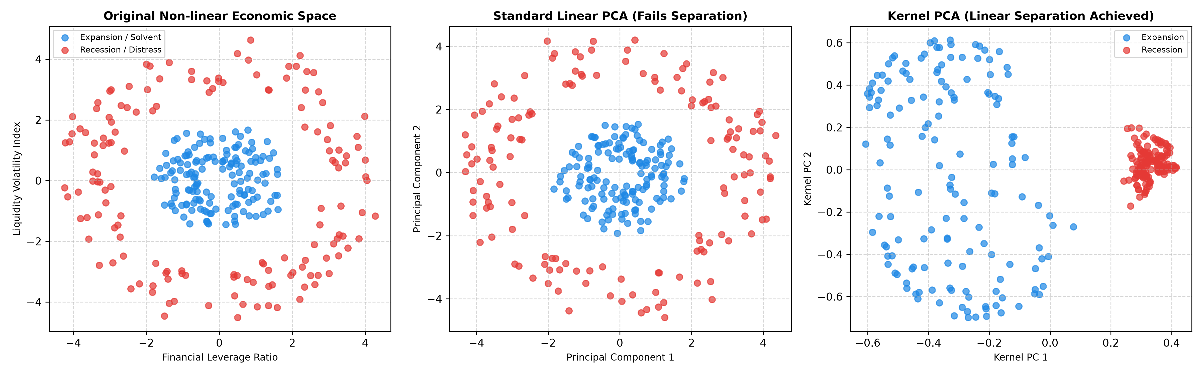
X-axis → Dimension 1 / Principal Component 1 / Kernel PC 1
Y-axis → Dimension 2 / Principal Component 2 / Kernel PC 2
Standard Linear PCA merely rotates the concentric rings and completely fails to separate the regimes. In contrast, Kernel PCA unrolls the non-linear manifold, placing the two regimes on opposite sides of Kernel PC 1.
Parameter Modification
S. No. | Parameter | Original Value | Modified Value | Original Result | Modified Result | Observation
1 | RBF Gamma parameter | 0.50 | 0.05 | Clean separation | Degenerates toward Linear PCA | Underfitting: Kernel becomes too broad, unable to resolve concentric topology
2 | RBF Gamma parameter | 0.50 | 2.00 | Clean separation | Isolated cluster islands | Overfitting: Kernel becomes overly localized, clustering individual points
3 | Kernel Type | RBF (Gaussian) | Polynomial (d=2) | Clean separation | Partial separation | RBF kernel maps to infinite-dimensional Hilbert space, superior for circular boundaries
4 | Sample Size N | 300 | 100 | Variance: 21.2% | Variance: 48.2% | Higher sample density stabilizes Gram matrix eigendecomposition

