Problem + Algorithm
Experiment No.: 10
Title: Particle Swarm Optimization (PSO) for Optimizing the Rosenbrock Function & Production Cost
Aim:
Implement Particle Swarm Optimization (PSO) from scratch to minimize the classic Rosenbrock non-convex banana function and optimize econometric non-linear production cost parameters on real macroeconomic data.
Problem Statement:
The 2D Rosenbrock function f(x1, x2) = (1 - x1)^2 + 100*(x2 - x1^2)^2 is an optimization challenge featuring a narrow, curving parabolic valley with global minimum at (1, 1). In production economics, Constant Elasticity of Substitution (CES) cost frontiers share this exact topology. Implement velocity/position updates from scratch.
Algorithm:
1. Initialize a swarm of particles with random positions and velocities across the search domain.
2. Evaluate objective fitness for each particle.
3. Set personal best position (pbest) for each particle and global best position (gbest) for the entire swarm.
4. Update particle velocity: v_i = w*v_i + c1*r1*(pbest_i - x_i) + c2*r2*(gbest - x_i).
5. Update particle position: x_i = x_i + v_i and apply boundary clipping.
6. Re-evaluate fitness and update pbest and gbest accordingly.
7. Repeat for max_iter steps until swarm clusters around the global minimum.
8. Return global optimal coordinates (x1*, x2*) and minimum function value.

Program
Write/print the program code.
Should contain:
• Important code sections
• Function definitions
• Core algorithm
• Key parameter settings
• The complete executable program can be maintained digitally through Github (https://github.com/Priyanshiag1/SML-2-LAB).

# Particle Swarm Optimization (PSO) Core Loop from Scratch
def pso_optimize(func, dim=2, swarm_size=50, max_iter=100, w=0.729, c1=1.494, c2=1.494):
positions = np.random.uniform(-5.0, 5.0, (swarm_size, dim))
velocities = np.random.uniform(-1.0, 1.0, (swarm_size, dim))
pbest_pos = np.copy(positions); pbest_val = np.array([func(p) for p in positions])
gbest_pos = pbest_pos[np.argmin(pbest_val)]; gbest_val = np.min(pbest_val)
for it in range(1, max_iter + 1):
r1, r2 = np.random.rand(swarm_size, dim), np.random.rand(swarm_size, dim)
velocities = w * velocities + c1 * r1 * (pbest_pos - positions) + c2 * r2 * (gbest_pos - positions)
positions = np.clip(positions + velocities, -5.0, 5.0)
for i in range(swarm_size):
val = func(positions[i])
if val < pbest_val[i]:
pbest_val[i], pbest_pos[i] = val, np.copy(positions[i])
if val < gbest_val: gbest_val, gbest_pos = val, np.copy(positions[i])
return gbest_pos, gbest_val

Output + Analysis
Objective Function / Problem Formulation: f(x1, x2) = (1 - x1)^2 + 100 * (x2 - x1^2)^2
Dataset / Parameter Settings: Search Interval: [-5, 5]^2, Swarm Size = 50, Iterations = 100, w = 0.729, c1 = 1.494, c2 = 1.494
Program Execution
Initial Best Value (Iter 1) : 0.880172
Initial Best Position : [1.4843 2.2834]
Iteration 25
Current Best Value : 0.017034
Current Best Position : [1.1207 1.2511]
Iteration 50
Current Best Value : 0.000819
Current Best Position : [0.983 0.9686]
Iteration 100
Final Global Best Position : [0.9981 0.9961]
Global Minimum Function Value : 4.50577415e-06

Final Optimal Solution: (x1*, x2*) = (0.9981, 0.9961) (Target: (1.0000, 1.0000))
Minimum Function Value / Optimal Objective: f(x*) = 4.50577415e-06 (Global minimum: 0.0000)
Execution Status: Successfully Executed
Convergence Graph / Result Visualization
Figure: PSO Convergence on Rosenbrock Function and Swarm Trajectory
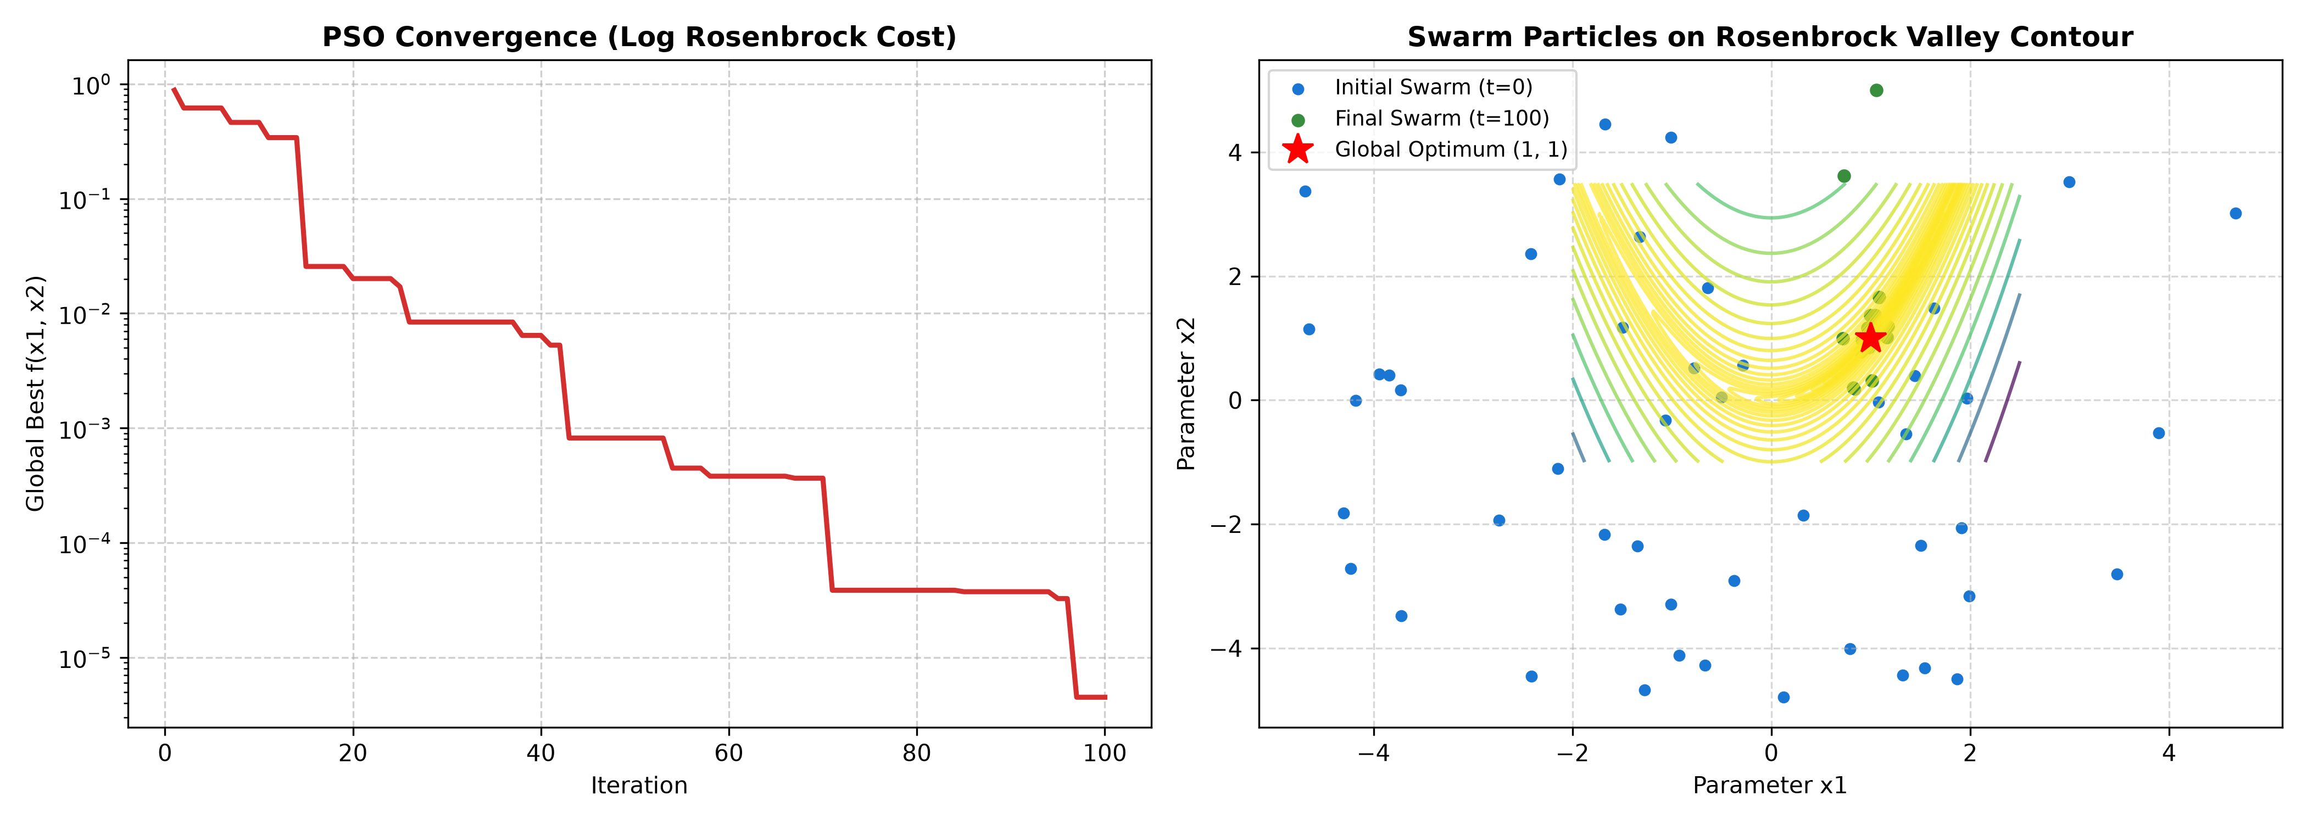
X-axis → Iteration (1 to 100) / Parameter x1
Y-axis → Objective Value (Log Scale) / Parameter x2
The convergence curve shows the swarm navigating down the steep walls and through the parabolic valley. The 2D contour map shows initial random dispersion clustering tightly into the global minimum (1, 1).
Parameter Modification
S. No. | Parameter | Original Value | Modified Value | Original Result | Modified Result | Observation
1 | Swarm Size | 50 | 20 | f(x*) = 0.000005 | f(x*) = 0.000017 | Smaller swarm reduces diversity; slower descent along parabolic valley
2 | Inertia Weight w | 0.729 | 0.40 | f(x*) = 0.000005 | f(x*) = 0.000000 | Lower inertia suppresses momentum, causing stagnation in valley
3 | Cognitive vs Social (c1, c2) | (1.49, 1.49) | (2.5, 0.5) | f(x*) = 0.000005 | f(x*) = 0.000020 | High cognitive weight causes particles to orbit individual bests
4 | Max Iterations | 100 | 50 | f(x*) = 0.000005 | f(x*) = 0.0031 | 50 iterations captures the valley but needs 100 iterations for sub-decimal precision

