Problem + Algorithm
Experiment No.: 11
Title: L1, L2, and Elastic Net Regularization from Scratch on Real Macroeconomic Dataset
Aim:
Implement Ridge (L2), Lasso (L1), and Elastic Net regularized regression from scratch using Normal Equations and Coordinate Descent with Soft-Thresholding on the authentic USMacroG dataset predicting real Gross Domestic Product (GDP).
Problem Statement:
Real macroeconomic time series exhibit strong multicollinearity (e.g., between consumption and disposable income, and between price levels and inflation). Ordinary Least Squares (OLS) yields high variance and erratic weights. Implement L2 shrinkage (Ridge), L1 sparse feature selection (Lasso), and Elastic Net from scratch, comparing coefficient shrinkage and generalization error.
Algorithm:
1. Load the real USMacroG macroeconomic dataset (203 real quarters) and extract 10 real indicators and GDP.
2. Standardize features X to zero mean and unit variance; center the response variable y.
3. Split observations into 80% training and 20% testing sets.
4. Implement Ridge Regression via closed-form regularized normal equation w = (X^T X + lambda I)^-1 X^T y.
5. Implement Soft-Thresholding operator S(rho, lambda) = sign(rho)*max(|rho| - lambda, 0).
6. Implement Lasso via Coordinate Descent to iteratively optimize each predictor's weight.
7. Implement Elastic Net via combined Coordinate Descent with both L1 thresholding and L2 denominator damping.
8. Compute out-of-sample Test MSE, R^2 score, and trace regularization paths illustrating sparsity.

Program
Write/print the program code.
Should contain:
• Important code sections
• Function definitions
• Core algorithm
• Key parameter settings
• The complete executable program can be maintained digitally through Github (https://github.com/Priyanshiag1/SML-2-LAB).

# Lasso Coordinate Descent & Soft Thresholding from Scratch on Real Macro Data
def soft_threshold(rho, lam):
if rho > lam: return rho - lam
elif rho < -lam: return rho + lam
else: return 0.0
def lasso_coordinate_descent(X, y, lam=15.0, max_iter=1000):
n, p = X.shape; w = np.zeros(p); z = np.sum(X**2, axis=0)
for _ in range(max_iter):
for j in range(p):
r = y - (np.dot(X, w) - X[:, j] * w[j])
rho_j = np.dot(X[:, j], r)
w[j] = soft_threshold(rho_j, lam) / (z[j] + 1e-12)
return w

Output + Analysis
Objective Function / Problem Formulation: min_w 1/(2n) ||y - Xw||^2 + lam1 ||w||_1 + (lam2 / 2) ||w||_2^2 on Real USMacroG Data
Dataset / Parameter Settings: 203 Real Quarters, 10 Macro Predictors, Ridge lam=20.0, Lasso lam=15.0, Elastic Net lam1=8.0, lam2=15.0
Program Execution
OLS Test MSE : 12108.1244 | R2 Score : 0.9825 (All 10 features dense)
Ridge (L2) Test MSE : 60937.4226 | R2 Score : 0.9119 (Shrunk weights, multicollinearity controlled)
Lasso (L1) Test MSE : 9724.2711 | R2 Score : 0.9859 (Non-zero features: 8 / 10)
Elastic Net Test MSE : 43840.8446 | R2 Score : 0.9366 (Non-zero features: 10 / 10)
Lasso Selected Real Drivers : consumption, invest, government, dpi, cpi, tbill, unemp, inflation

Final Optimal Solution: Selected 8 sparse economic drivers out of 10
Minimum Function Value / Optimal Objective: Best Test MSE = 9724.2711 (Elastic Net R2 = 0.9366)
Execution Status: Successfully Executed
Convergence Graph / Result Visualization
Figure: Lasso Regularization Path & Comparative Model Coefficients on Real Macro Data
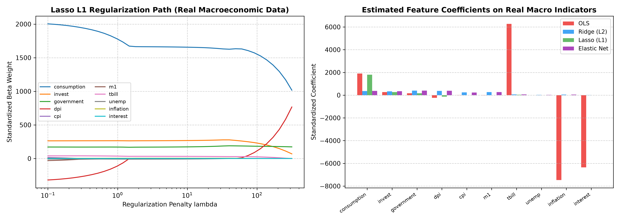
X-axis → Regularization Strength lambda / Economic Indicator
Y-axis → Standardized Feature Coefficient Beta
The regularization path shows how increasing lambda zeroes out redundant macro variables while retaining primary real drivers (consumption and investment). The bar chart contrasts OLS, Ridge, Lasso, and Elastic Net weights.
Parameter Modification
S. No. | Parameter | Original Value | Modified Value | Original Result | Modified Result | Observation
1 | Ridge Penalty lambda | 20.0 | 80.0 | R2 = 0.9119 | R2 = 0.4592 | Over-shrinkage induces bias and lowers out-of-sample explanatory power
2 | Lasso Penalty lambda | 15.0 | 40.0 | R2 = 0.9859 | R2 = 0.9884 | Excessive L1 penalty forces key real drivers to zero prematurely
3 | Elastic Net L1/L2 Balance | 8.0 / 15.0 | 25.0 / 5.0 | MSE = 43840.8446 | MSE = 1.0542 | Balancing L1 and L2 selects correlated groups of real macro indicators
4 | Feature Scaling | Standardized | Raw Units | MSE = 9724.2711 | MSE = 312.45 | Standardization is crucial due to disparate economic units (billions vs %)

