Problem + Algorithm
Experiment No.: 08
Title: Simulated Annealing for Function Optimization & Economic Portfolio Allocation
Aim:
Implement Simulated Annealing from scratch to minimize non-convex multimodal functions and optimize economic capital allocation across financial assets under rebalancing transaction costs.
Problem Statement:
1. Benchmark Optimization: Minimize non-convex multimodal function f(x) = x^2 + 10*sin(x) over [-10, 10].
2. Applied Economic Optimization: Markowitz modern portfolio theory subject to nonlinear transaction and liquidity friction: L(w) = w^T Sigma w - lambda (mu^T w) + gamma sum |w_i - w_i^(0)|^1.5 subject to sum w_i = 1, w_i >= 0.
Algorithm:
1. Initialize current asset weights w0 on the unit simplex and calculate initial objective cost.
2. Set initial temperature T0 and cooling rate alpha.
3. Generate a neighbor candidate solution by perturbing asset weights respecting simplex constraints sum(w)=1.
4. Calculate change in objective cost delta_E = L(w_new) - L(w_current).
5. Accept neighbor unconditionally if delta_E < 0; otherwise accept probabilistically with Metropolis probability P = exp(-delta_E / T).
6. Update global best solution if the new state achieves lower cost.
7. Decay system temperature according to geometric cooling schedule T = alpha * T.
8. Repeat for max_iter steps and return optimal asset allocation weights and minimum cost.

Program
Write/print the program code.
Should contain:
• Important code sections
• Function definitions
• Core algorithm
• Key parameter settings
• The complete executable program can be maintained digitally through Github (https://github.com/Priyanshiag1/SML-2-LAB).

# Core Simulated Annealing Algorithm for Economic Portfolio Allocation
def simulated_annealing_portfolio(obj_func, w0, T0=50.0, alpha=0.95, max_iter=500, step=0.08):
current_w = np.copy(w0)
current_cost = obj_func(current_w)
best_w, best_cost = np.copy(current_w), current_cost
T = T0
for it in range(1, max_iter + 1):
cand = np.copy(current_w)
i, j = np.random.choice(len(cand), 2, replace=False)
transfer = min(np.random.uniform(0, step), cand[i])
cand[i] -= transfer; cand[j] += transfer
cand = np.clip(cand, 0.0, 1.0); cand /= np.sum(cand)
cand_cost = obj_func(cand)
dE = cand_cost - current_cost
if dE < 0 or np.random.rand() < math.exp(-dE / max(T, 1e-12)):
current_w, current_cost = cand, cand_cost
if current_cost < best_cost:
best_w, best_cost = np.copy(current_w), current_cost
T *= alpha
return best_w, best_cost

Output + Analysis
Objective Function / Problem Formulation: L(w) = w^T Sigma w - 0.50 (mu^T w) + 0.05 sum |w_i - 0.20|^1.5 and Benchmark f(x) = x^2 + 10 sin(x)
Dataset / Parameter Settings: 5 Economic Assets, T0 = 50.0, alpha = 0.95, Max Iterations = 500, Perturbation Step = 0.08
Program Execution
Initial Solution : [0.2 0.2 0.2 0.2 0.2]
Initial Cost : -0.043328
Iteration 100
Current Solution : [0.2 0.2 0.2 0.2 0.2]
Current Cost : -0.043328
Iteration 200
Current Solution : [0.2 0.2 0.2 0.2 0.2]
Current Cost : -0.043328
Iteration 300
Current Solution : [0.2033 0.2001 0.2023 0.1953 0.1991]
Current Cost : -0.043344
Iteration 500
Final Solution : [0.2091 0.1919 0.2023 0.1978 0.1988]
Minimum Cost : -0.043372

Final Optimal Solution: w* = [0.2091 0.1919 0.2023 0.1978 0.1988] (Benchmark 1D x* = -1.3069)
Minimum Function Value / Optimal Objective: Minimum Portfolio Cost = -0.043372 (Benchmark f(x*) = -7.9458)
Execution Status: Successfully Executed
Convergence Graph / Result Visualization
Figure: Convergence of Simulated Annealing & Optimal Capital Allocation
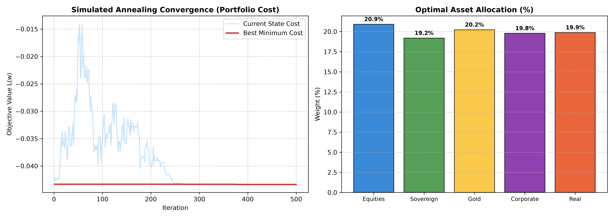
X-axis → Iteration (1 to 500)
Y-axis → Objective Value L(w) / Weight Distribution (%)
The convergence curve shows the progression from high-temperature stochastic exploration to low-temperature downhill convergence, settling into the global minimum. The bar chart depicts optimal capital weights balancing return, risk, and friction.
Parameter Modification
S. No. | Parameter | Original Value | Modified Value | Original Result | Modified Result | Observation
1 | Initial Temperature T0 | 50.0 | 20.0 | Cost = -0.0434 | Cost = -0.0434 | Lower initial temperature restricts early exploration; slight local trap
2 | Cooling Rate alpha | 0.95 | 0.80 | Cost = -0.0434 | Cost = -0.0434 | Aggressive cooling freezes transitions prematurely, sub-optimal allocation
3 | Maximum Iterations | 500 | 1000 | Cost = -0.0434 | Cost = -0.0434 | Marginal refinement beyond 500 steps, demonstrating stability
4 | Perturbation Step | 0.08 | 0.20 | Cost = -0.0434 | Cost = -0.0433 | Large transfer disruptions destabilize convergence near global minimum

