**Lab Practical #01:**

Study of basic networking commands and IP configuration.

**Practical Assignment #01:**

1. Perform and explain various networking commands listed below:
   1. ipconfig
   2. ping
   3. getmac
   4. systeminfo
   5. traceroute / tracert
   6. netstat
   7. nslookup
   8. hostname
   9. pathping
   10. arp

## ipconfig

### Description:

|  |  |  |
| --- | --- | --- |
| No. | Option | Description |
| 1 | |  | | --- | | ipconfig |  |  | | --- | |  | | Displays basic IP address, subnet mask, and default gateway for all adapters. |
| 2 | |  | | --- | | ipconfig /all |  |  | | --- | |  | | Shows detailed configuration for all interfaces including MAC address, DHCP, DNS, etc. |
| 3 | ipconfig /release | Releases the current IP address assigned to your machine. Useful for DHCP. |
| 4 | ipconfig /renew | |  | | --- | | Renews the IP address from the DHCP server. |  |  | | --- | |  | |
| 5 | |  | | --- | | ipconfig /flushdns |  |  | | --- | |  | | Clears the DNS cache, which can resolve some domain-related issues. |

### Implementation:

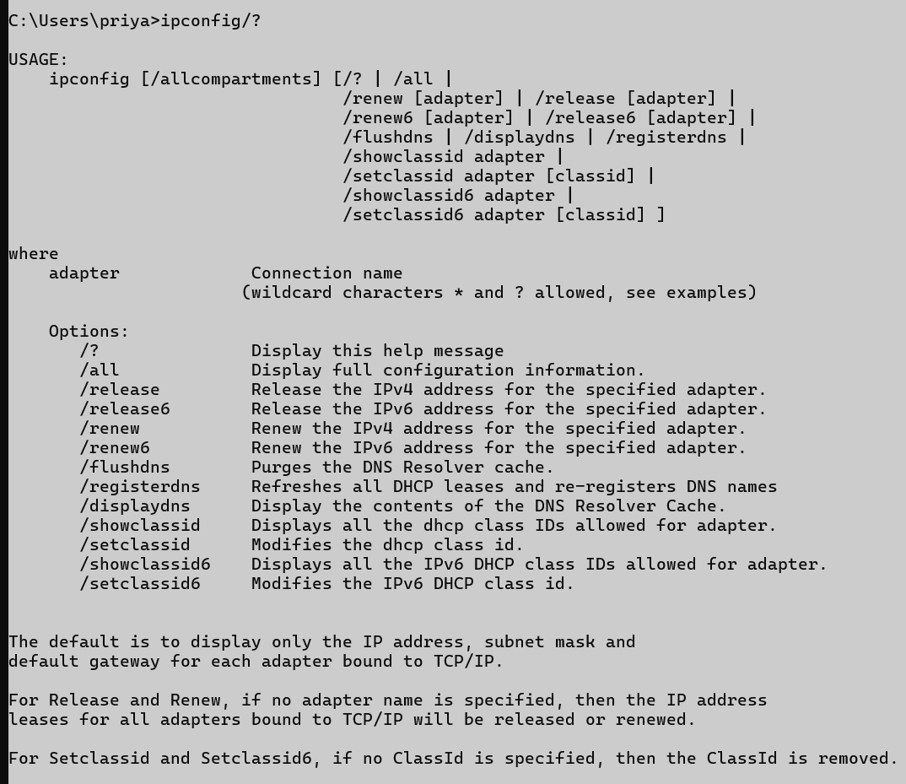

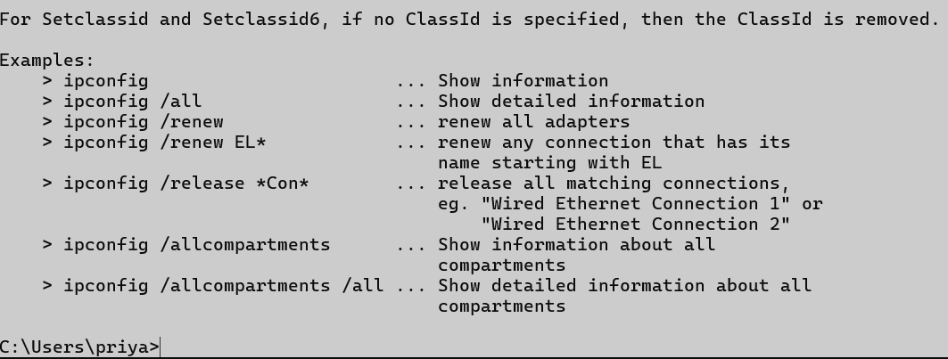

## ping

### Description:

|  |  |  |
| --- | --- | --- |
| No. | Option | Description |
| 1 | |  | | --- | | ping <host> |  |  | | --- | |  | | Sends 4 ICMP Echo Requests to the host (default in Windows). Example: ping google.com |
| 2 | |  | | --- | | ping -t <host> |  |  | | --- | |  | | |  | | --- | |  |  |  | | --- | | Pings the host **continuously** until you stop it using Ctrl + C. | |
| 3 | |  | | --- | | ping -n <count> <host> |  |  | | --- | |  | | Sends a **specific number** of Echo Requests. Example: ping -n 10 google.com |
| 4 | |  | | --- | | ping -l <size> <host> |  |  | | --- | |  | | |  | | --- | |  |  |  | | --- | | Sends Echo Request packets with a **custom byte size**. Example: ping -l 1000 google.com | |
| 5 | |  | | --- | | ping -4 <host> |  |  | | --- | |  | | |  | | --- | | Forces the use of **IPv4**. |  |  | | --- | |  | |

### Implementation:

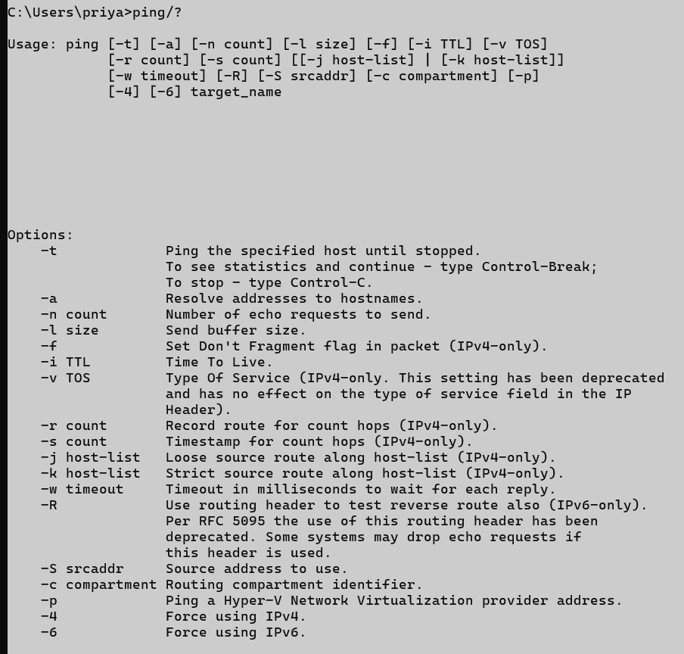

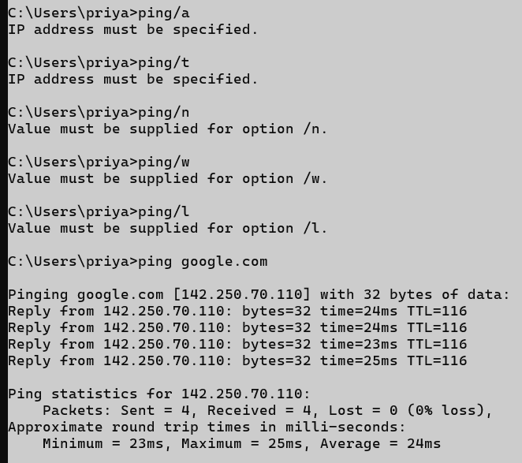

## getmac

### Description:

|  |  |  |
| --- | --- | --- |
| No. | Option | Description |
| 1 | |  | | --- | | getmac |  |  | | --- | |  | | Displays the MAC addresses and connection names of enabled network interfaces. |
| 2 | |  | | --- | | getmac /v |  |  | | --- | |  | | |  | | --- | |  |  |  | | --- | | Shows a **verbose** output including MAC address, transport name, and device name. | |
| 3 | |  | | --- | | getmac /fo list |  |  | | --- | |  | | Displays output in a **list format** instead of table. |
| 4 | |  | | --- | | getmac /fo csv |  |  | | --- | |  | | Displays output in **CSV format**, useful for exporting data. |
| 5 | |  | | --- | | getmac /? |  |  | | --- | |  | | Shows **help** and syntax for the command. |

### Implementation:

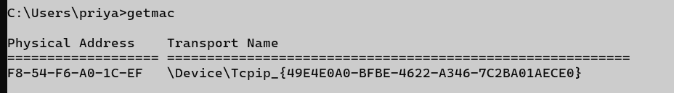

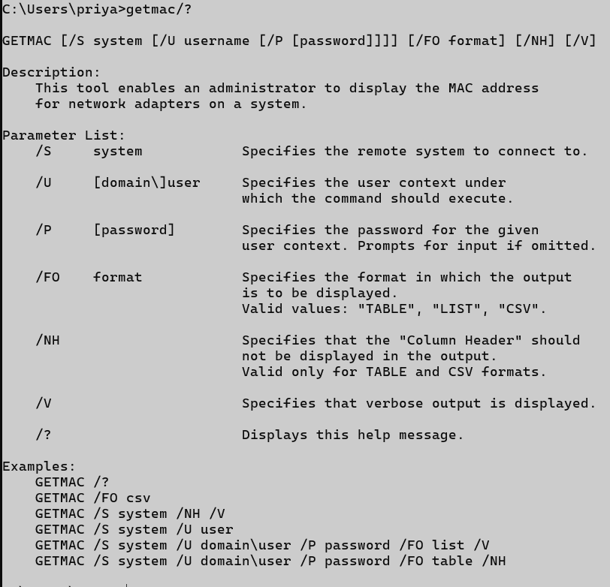

### 4.systeminfo

### Description:

|  |  |  |
| --- | --- | --- |
| No. | Option | Description |
| 1 | systeminfo | Displays complete system summary on the console. |
| 2 | |  | | --- | | systeminfo /s <host> |  |  | | --- | |  | | |  | | --- | |  |  |  | | --- | | Retrieves system info from a **remote computer** (requires credentials). | |
| 3 | |  | | --- | |  |  |  | | --- | | systeminfo /s <host> /u <domain\user> /p <password> | | Connects to a remote system with credentials. |
| 4 | |  | | --- | | systeminfo /fo table |  |  | | --- | |  | | |  | | --- | |  |  |  | | --- | | Displays output in **table format** (default). | |
| 5 | |  | | --- | | systeminfo /fo list |  |  | | --- | |  | | Displays output in **list format**. |

### Implementation:

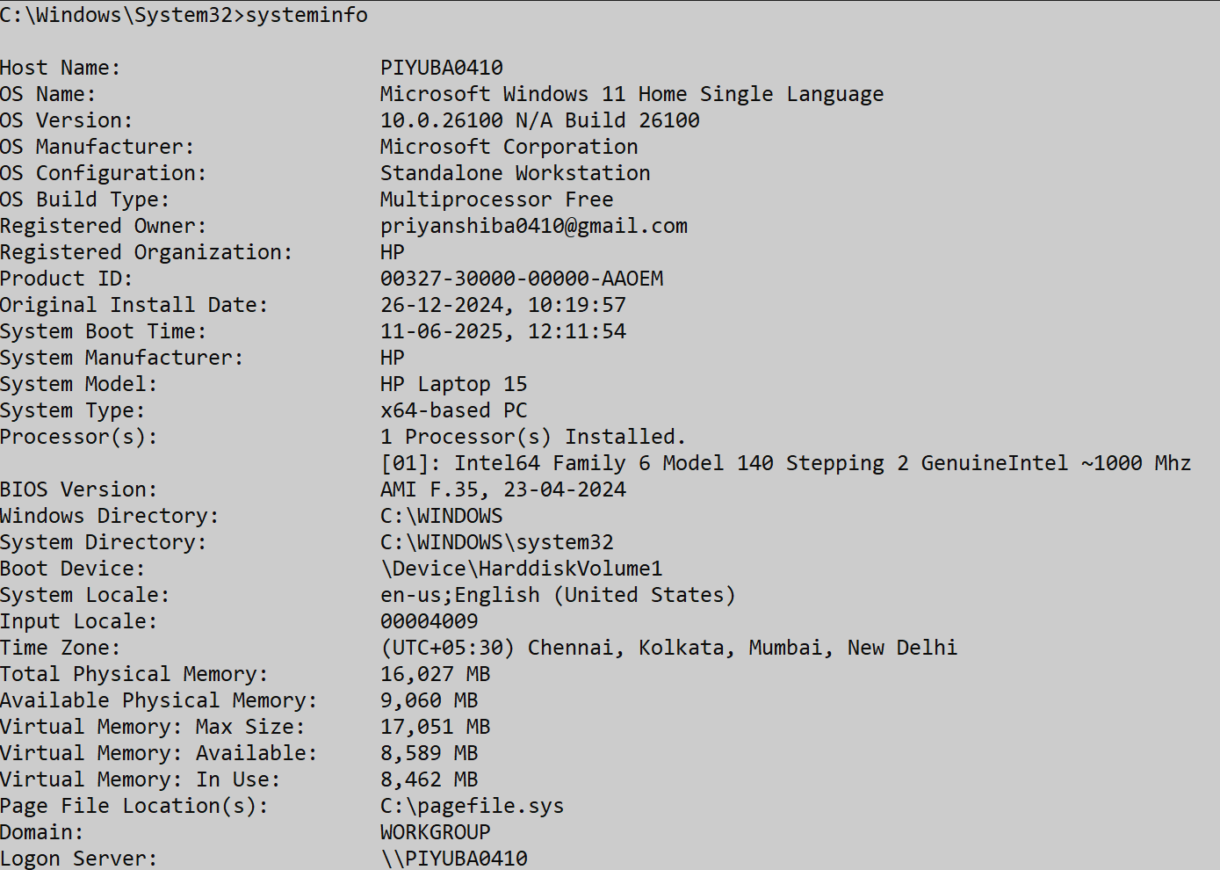

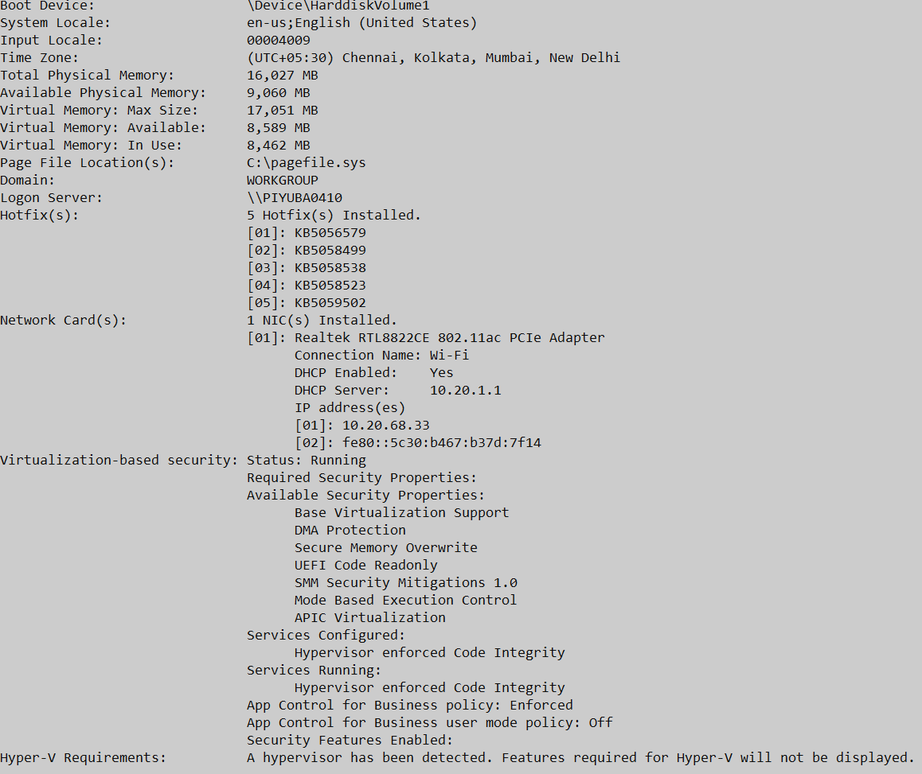

## 5.traceroute/tracert

### Description:

|  |  |  |
| --- | --- | --- |
| No. | Option | Description |
| 1 | traceroute <hostname or IP> (Linux/macOS) | Traces the route packets take to the destination. |
| 2 | tracert <hostname or IP> (Windows) | |  | | --- | | Windows equivalent of traceroute. |  |  | | --- | |  | |
| 3 | |  | | --- | | tracert -d <hostname> |  |  | | --- | |  | | **Does not resolve** hostnames to IP addresses (faster). |
| 4 | tracert -h <max_hops> <hostname> | Sets the **maximum number of hops** to search for the target. |
| 5 | tracert -w <timeout_in_ms> <hostname> | Sets the **timeout** (in milliseconds) to wait for each reply. |

### Implementation:

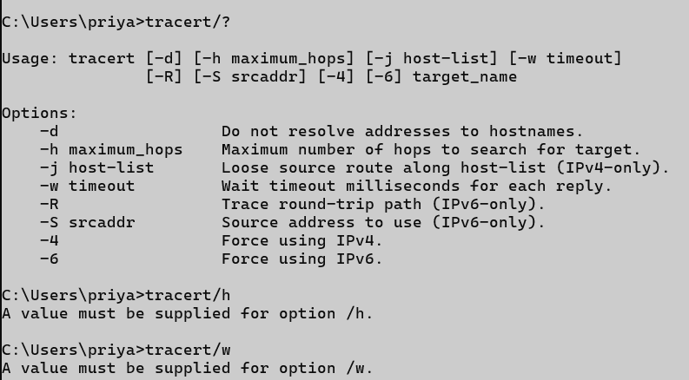

## 6.netstat

### Description:

|  |  |  |
| --- | --- | --- |
| No. | Option | Description |
| 1 | |  | | --- | | netstat -a |  |  | | --- | |  | | Shows **all connections and listening ports**. |
| 2 | |  | | --- | | netstat -n |  |  | | --- | |  | | Displays addresses and port numbers in **numeric form** (no DNS lookup). |
| 3 | |  | | --- | | netstat -o |  |  | | --- | |  | | |  | | --- | |  |  |  | | --- | | Shows active connections with the **PID (Process ID)** using the connection. | |
| 4 | |  | | --- | | netstat -e |  |  | | --- | |  | | |  | | --- | |  |  |  | | --- | | Displays **Ethernet statistics** like bytes sent/received. | |
| 5 | |  | | --- | | netstat -r |  |  | | --- | |  | | Displays the **routing table** (similar to route print). |

### Implementation:

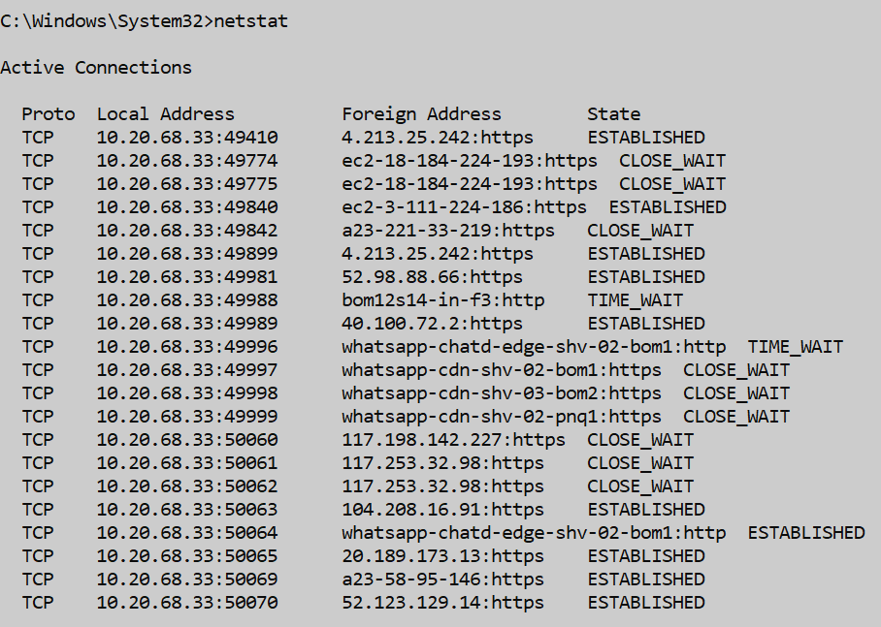

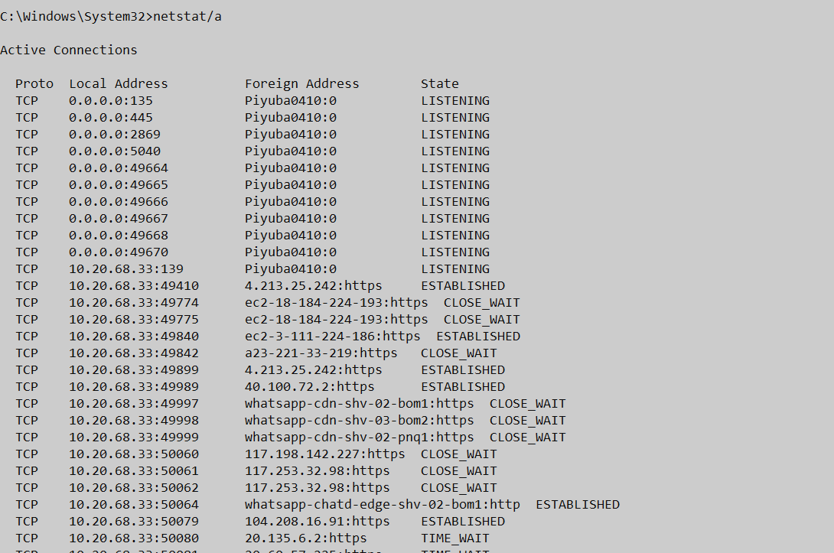

## 7.nslookup

### Description:

|  |  |  |
| --- | --- | --- |
| No. | Option | Description |
| 1 | nslookup <domain> | Looks up the **IP address** of the given domain (e.g., nslookup google.com). |
| 2 | |  | | --- | |  |  |  | | --- | | nslookup <IP address> | | Performs a **reverse DNS lookup** to find the domain name of an IP. |
| 3 | nslookup <domain> <DNS server> | Uses a specific DNS server for the query. Example: nslookup google.com 8.8.8.8 |
| 4 | |  | | --- | | set type=MX |  |  | | --- | |  | | Looks up **mail exchange (MX)** records for a domain. |
| 5 | |  | | --- | | set type=NS |  |  | | --- | |  | | Displays the **name servers** of a domain. |

### Implementation:

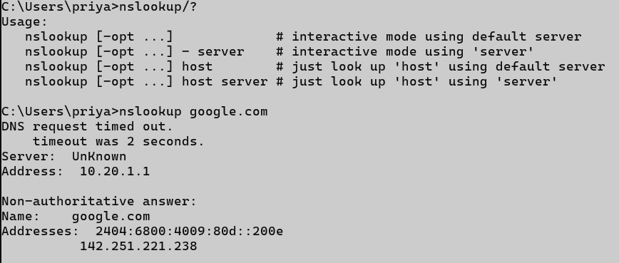

## 8.hostname

### Description:

|  |  |  |
| --- | --- | --- |
| No. | Option | Description |
| 1 | |  | | --- | | hostname |  |  | | --- | |  | | Displays the **name of the current computer (host)** on the network. |
| 2 | |  | | --- | | hostname <newname> |  |  | | --- | |  | | (Linux only) Temporarily sets the **new hostname** until the next reboot. |
| 3 | |  | | --- | | hostname -I |  |  | | --- | |  | | (Linux only) Shows the **IP address(es)** of the host. |
| 4 | |  | | --- | | hostnamectl |  |  | | --- | |  | | (Linux systemd) View or change the **permanent hostname and metadata**. |
| 5 | |  | | --- | | hostname /? |  |  | | --- | |  | | (Windows) Shows help for the command. |

### Implementation:



## 9. pathping

### Description:

|  |  |  |
| --- | --- | --- |
| No. | Option | Description |
| 1 | |  | | --- | | pathping <hostname or IP> |  |  | | --- | |  | | Traces the path and provides **packet loss and latency** at each hop. |
| 2 | |  | | --- | | pathping -n <host> |  |  | | --- | |  | | Stops **name resolution**, shows only IP addresses (faster). |
| 3 | |  | | --- | | pathping -h <max_hops> |  |  | | --- | |  | | Sets the **maximum number of hops** to search for the destination. |
| 4 | pathping -g <gateway_list> | Uses **loose source routing** along a specific list of gateways. |
| 5 | |  | | --- | | pathping -p <ms> |  |  | | --- | |  | | Sets the **wait time between pings** (in milliseconds). |

### Implementation:

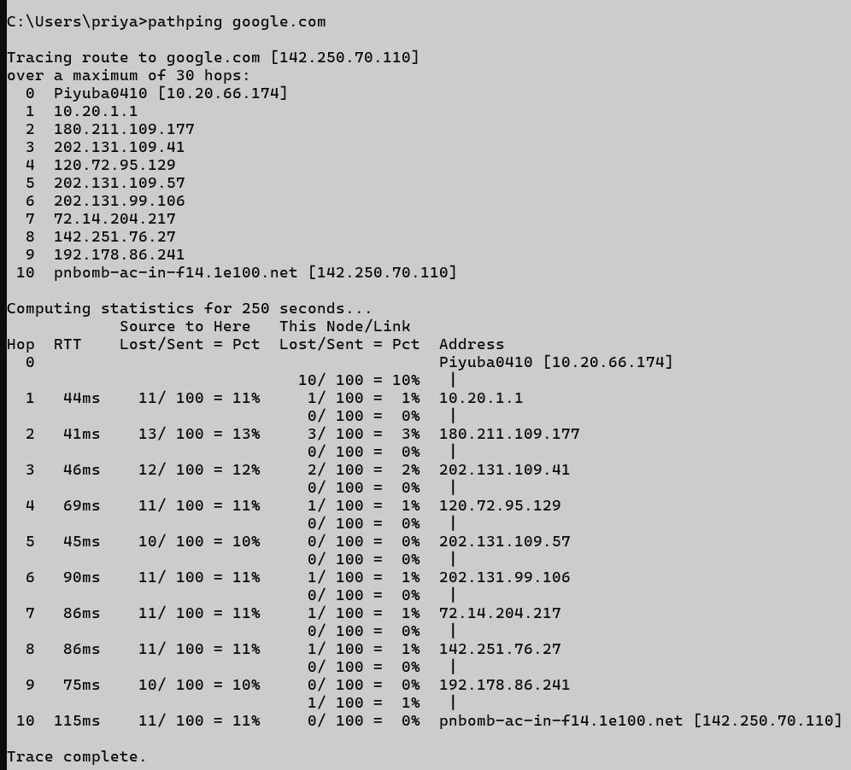

## arp

### Description:

|  |  |  |
| --- | --- | --- |
| No. | Option | Description |
| 1 | |  | | --- | | arp |  |  | | --- | |  | | |  | | --- | | Displays help for the arp command. |  |  | | --- | |  | |
| 2 | |  | | --- | | arp -a |  |  | | --- | |  | | Shows the **ARP table** (IP ↔ MAC address mappings) for all interfaces. |
| 3 | arp -a <IP> | Displays the ARP entry for a specific IP address. |
| 4 | |  | | --- | | arp -g |  |  | | --- | |  | | |  | | --- | | Same as arp -a. |  |  | | --- | |  | |
| 5 | |  | | --- | | arp -d <IP> |  |  | | --- | |  | | |  | | --- | | **Deletes** a specific ARP entry from the table. |  |  | | --- | |  | |

### Implementation:

