**Lab Practical #03:**

Study of different types of network cables & connectors and crimping a LAN.

**Practical Assignment #03:**

1. List various networks cable. Also, write short description.

**a) Twisted Pair Cable**

* **Description**: Consists of pairs of wires twisted together. Used for LAN connections.
* **Connector**: RJ45

**b) Coaxial Cable**

* **Description**: Consists of a central core conductor, insulating layer, metal shield, and outer jacket. Used in cable TV, CCTV.
* **Connector**: BNC Connector

**c) Fiber Optic Cable**

* **Description**: Uses light to transmit data. High-speed and long-distance. Immune to electromagnetic interference.
* **Connector**: SC, ST, LC

1. Difference between guided and unguided media.

| **Feature** | **Guided Media** | **Unguided Media** |
| --- | --- | --- |
| **Definition** | Uses physical path (cables) | Uses wireless transmission |
| **Medium** | Twisted pair, Coaxial, Fiber optic | Radio waves, Microwaves, Infrared |
| **Security** | More secure | Less secure |
| **Speed** | Generally higher | Generally lower |
| **Example** | Ethernet cables | Wi-Fi, Satellite, Bluetooth |

1. Give cross-wired cable and straight through cable diagram (Color Code wise).

**a)Cross-Wired Cable Diagram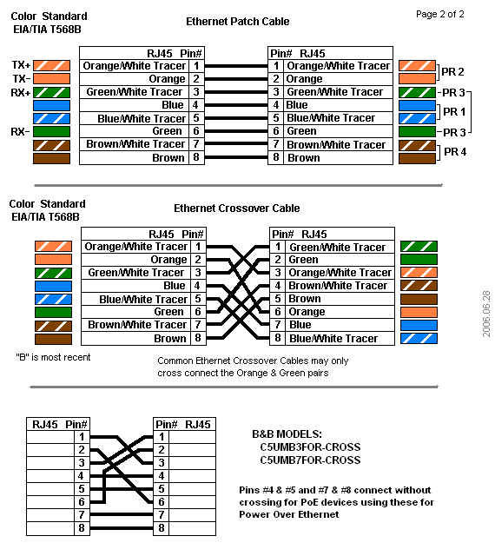 (Color Code)**

**Used for**: Connecting similar devices (e.g., PC to PC, switch to switch)

**b) Straight-Through Cable Diagram (Color Code)**

**Used for**: Connecting different devices (e.g., PC to Switch)



## List various networks cable and connectors. Also, write short description.

1. **Network Cable Name:** 
   * **Description**:
   * **Diagram**:

**a)Network Cable Name: Twisted Pair Cable (UTP)**

**Description:** Used in LANs; has 4 twisted pairs of wires to reduce crosstalk.

**Diagram:** 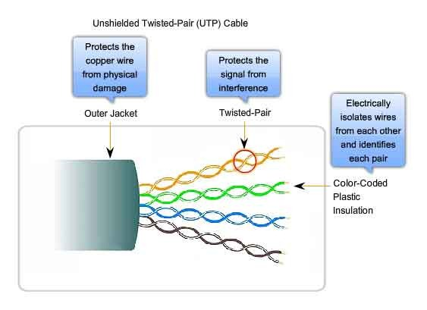

1. **Network Cable Name: Coaxial Cable**

**Description:** Used in cable internet and older Ethernet networks; has central copper core, insulating layer, and metallic shield.

**Diagram:**

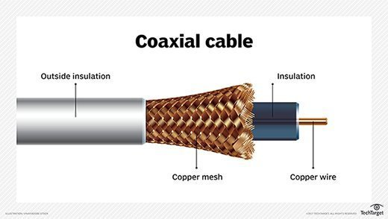

**c) Network Cable Name: Fiber Optic Cable**

**Description:** Transmits data using light; high speed and long distance; immune to EMI.

**Diagram:**

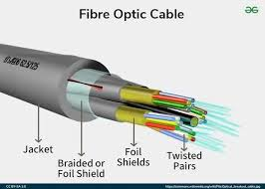

**d) Connector Name: RJ45**

**Description:** Common connector for Ethernet cables; used with twisted pair cables.

**Diagram:** 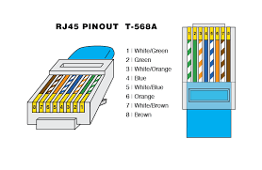

**e) Connector Name: BNC Connector**

**Description:** Used with coaxial cables in older Ethernet and video systems.

**Diagram:**

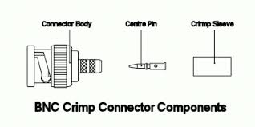

**f) Connector Name: SC/ST Connector**

**Description:** Used in fiber optic networks; SC is push-pull, ST is bayonet style.

**Diagram:**

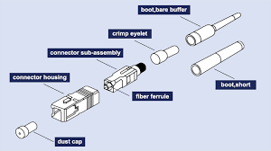

1. **Difference between guided and unguided media.**

| **Feature** | **Guided Media** | **Unguided Media** |
| --- | --- | --- |
| **Medium Type** | **Uses physical medium (cables)** | **Uses air or space (wireless)** |
| **Examples** | **Twisted pair, Coaxial, Fiber optic** | **Radio waves, Microwaves, Infrared** |
| **Direction Control** | **Direction can be controlled** | **Signal spreads freely** |
| **Security** | **More secure** | **Less secure** |
| **Installation** | **Needs physical setup** | **Easy to deploy** |

## Give cross-wired cable and straight through cable diagram (Color Code wise).

1. Cross-wired Cable Diagram (Color Code)



1. Straight Through Cable Diagram (Color Code)

