A PROJECT REPORT
ON
AI-Based Mental Health Risk Prediction System for University Students (MINDscan)
Submitted in partial fulfilment of the requirement for the award of the degree of
BACHELOR OF TECHNOLOGY (B.Tech)
in
Data Science and Engineering
by
Priyanshi Goel
Reg. No.: 229309201
Department of Data Science and Engineering
MANIPAL UNIVERSITY JAIPUR
JAIPUR-303007
RAJASTHAN, INDIA
July 2026

Manipal University Jaipur
Date: 02 July 2026
CERTIFICATE
This is to certify that the project titled "AI-Based Mental Health Risk Prediction System for University Students (MINDscan)" is a record of the bonafide work done by Priyanshi Goel (Reg. No.: 229309201) submitted in partial fulfilment of the requirements for the award of the Degree of Bachelor of Technology (B.Tech) in Data Science and Engineering of Manipal University Jaipur, during the academic year 2025-26.
Dr. Aparna Tripathi  Project Guide, Dept. of Data Science and Engineering  Manipal University Jaipur | Dr. Akhilesh Kumar Sharma  HOD, Dept. of Data Science and Engineering  Manipal University Jaipur

Off Jaipur Ajmer Express Highway, VPO Dehmi Kalan, Tehsil Sanganer, Jaipur, Rajasthan (INDIA) 303007
http://www.jaipur.manipal.edu

ACKNOWLEDGMENTS
We would like to express our sincere gratitude to Dr. Kuldip Singh Sangwan, Dean, Faculty of Science, Technology and Architecture (FoSTA), Manipal University Jaipur, for providing an encouraging academic environment and institutional support that enabled the successful completion of this final semester major project.
We are also thankful to Dr. Akhilesh Kumar Sharma, Head of the Department of Data Science and Engineering, Manipal University Jaipur, for his constant support, academic guidance, and for ensuring that students receive the necessary departmental facilities and learning resources during the project work.
We express our deepest gratitude to our project supervisor, Dr. Aparna Tripathi, Department of Data Science and Engineering, Manipal University Jaipur, for her invaluable guidance, continuous encouragement, insightful suggestions, and timely feedback throughout the development of MINDscan. Her expertise in data science, machine learning, and research methodology played an important role in shaping the direction and quality of this project.
We sincerely acknowledge the support of the faculty members, laboratory staff, and technical resources of the Department of Data Science and Engineering, whose assistance contributed to the smooth execution of the project work. We also thank the department for providing the academic environment, computational support, and facilities required for data analysis, model development, and web application deployment.
Finally, we would like to thank our family, friends, and classmates for their constant moral support, motivation, and encouragement throughout the entire duration of this final semester major project.

ABSTRACT
Mental health disorders among university students have emerged as a critical public health concern in recent years, with depression and anxiety being among the most common conditions affecting academic performance, social relationships, and overall quality of life. In the Indian university context, the lack of accessible AI-based mental health screening tools specifically designed for students creates a gap in early identification and intervention. This project, titled MINDscan, addresses this gap by developing an AI-powered web application that predicts depression risk levels (Low, Moderate, or High) for university students using the clinically validated PHQ-9 depression screening scale combined with lifestyle and behavioral data.
The methodology adopted in this project follows a systematic machine learning pipeline. Primary data was collected from 1,151 student respondents at Manipal University Jaipur through a structured Google Forms questionnaire capturing 25 attributes, including demographics, lifestyle indicators, stress measures, and the nine PHQ-9 depression screening items. The data was preprocessed using MinMaxScaler normalization, and four classification algorithms - Logistic Regression, Support Vector Machine (SVM), Random Forest, and Decision Tree - were trained and evaluated using 5-fold Stratified K-Fold cross-validation. SMOTE was applied to address class imbalance, and SHAP analysis was used to support model explainability.
The results demonstrate that Logistic Regression achieved the highest performance with a test accuracy of 95.67% and a weighted F1-Score of 95.65%, outperforming SVM (93.51%), Random Forest (89.18%), and Decision Tree (83.55%). The 5-fold cross-validation accuracy was 95.98%, confirming model stability. SHAP analysis showed that PHQ-3 (sleep trouble) was the most influential predictor with a SHAP value of 0.5996, while all nine PHQ-9 symptom items dominated the top predictions. Among lifestyle features, difficulty relaxing, exercise frequency, and sleep hours were the strongest non-clinical predictors.
The project was implemented using Python 3.11 with libraries including pandas, NumPy, scikit-learn, SHAP, matplotlib, and seaborn for data analysis and machine learning. The web application was built using the Flask framework with a responsive single-page HTML/CSS/JavaScript frontend and deployed on the Render cloud platform. The application provides real-time risk predictions, confidence scores, SHAP-based explainability visualizations, personalized lifestyle recommendations, and crisis helpline resources for high-risk users.

LIST OF TABLES
Table No | Table Title | Page No
Table 1.1 | PHQ-9 Depression Severity Classification | 2
Table 2.1 | Literature Review Summary | 5
Table 2.2 | Technologies and Tools Used | 5
Table 3.1 | Dataset Feature Description | 7
Table 3.2 | PHQ-9 Questionnaire Items and Scoring | 9
Table 3.3 | GAD-7 Anxiety Classification Thresholds | 9
Table 3.4 | Machine Learning Model Hyperparameters | 10
Table 3.5 | Evaluation Metrics Used | 10
Table 4.1 | Project Module Description | 13
Table 4.2 | Prediction API Input Fields | 16
Table 5.1 | Model Comparison Results | 18
Table 5.2 | Logistic Regression Classification Report | 19
Table 5.3 | SHAP Global Feature Importance (Top 10) | 20
Table 5.4 | SMOTE Impact on Model Performance | 21
Table 6.1 | Summary of Objectives and Outcomes | 23
Table A.1 | Project File Structure | 26
Table A.2 | Python Dependencies | 26
Table A.3 | Sample Dataset Records | 26

LIST OF FIGURES
Figure No | Figure Title | Page No
Figure 3.1 | Data Collection and Preprocessing Pipeline | 8
Figure 3.2 | Machine Learning Workflow Diagram | 11
Figure 3.3 | System Architecture Block Diagram | 11
Figure 3.4 | Real-Time Prediction Flow Diagram | 12
Figure 4.1 | Web Application - Home Dashboard Prototype | 14
Figure 4.2 | Web Application - Assessment Form Workflow | 15
Figure 4.3 | Web Application - Results and Recommendations Prototype | 15
Figure 5.1 | PHQ-9 Depression Severity Bands | 18
Figure 5.2 | Model Comparison - Accuracy and Weighted F1-Score | 19
Figure 5.3 | SHAP Global Feature Influence Summary | 20
Figure 5.4 | SMOTE Training Strategy | 21

Contents
 |  | Page No
Acknowledgement |  | i
Abstract |  | ii
List of Tables |  | iii
List of Figures |  | iv
Chapter 1 | INTRODUCTION | 1
1.1 | Introduction to Work Done / Motivation | 1
1.2 | Project Statement / Objectives of the Project | 2
1.3 | Organization of Report | 2
Chapter 2 | BACKGROUND MATERIAL | 4
2.1 | Conceptual Overview (Concepts / Theory Used) | 4
2.2 | Literature Review | 5
2.3 | Technologies Involved | 5
Chapter 3 | METHODOLOGY | 7
3.1 | Data Collection and Preprocessing | 7
3.2 | Feature Engineering and Selection | 8
3.3 | Machine Learning Pipeline | 10
3.4 | System Architecture and Block Diagrams | 11
3.5 | Ethical and Privacy Considerations | 12
Chapter 4 | IMPLEMENTATION | 13
4.1 | Modules | 13
4.2 | Prototype - Web Application | 14
4.3 | Backend and Frontend Implementation | 16
4.4 | Testing and Deployment | 17
Chapter 5 | RESULTS AND ANALYSIS | 18
5.1 | Exploratory Data Analysis | 18
5.2 | Model Training and Comparison | 18
5.3 | SHAP Explainability Analysis | 19
5.4 | SMOTE Oversampling Analysis | 20
5.5 | GAD-7 Anxiety Estimation | 21
5.6 | Discussion of Findings | 22
Chapter 6 | CONCLUSIONS & FUTURE SCOPE | 23
6.1 | Conclusions | 23
6.2 | Future Scope of Work | 24
REFERENCES |  | 26
ANNEXURES |  | 27

Chapter 1
INTRODUCTION

1.1 Introduction to Work Done / Motivation
Mental health has become one of the most pressing public health challenges of the 21st century, particularly among young adults in university settings. University students experience a unique combination of academic pressure, social transition, financial concerns, career uncertainty, and personal development challenges. These conditions make student mental health a highly relevant area for technology-enabled support and screening.
The significance of early detection in mental health cannot be overstated. Depression, when left unidentified and untreated, can contribute to declining academic performance, social withdrawal, low motivation, sleep disturbance, poor concentration, and in severe cases, suicidal ideation. Traditional mental health screening relies on clinical interviews conducted by trained professionals, but such resources may not always be accessible to every student at the exact time of need. This creates the need for preliminary, accessible, and scalable screening systems that can encourage students to seek timely professional guidance.
The Patient Health Questionnaire-9 (PHQ-9) is a widely used, self-administered depression screening instrument developed by Kroenke, Spitzer, and Williams. It consists of nine questions that correspond to the major symptoms of depression and uses a 0 to 3 scale for each item. The total score ranges from 0 to 27. In this project, PHQ-9 scoring is used to label depression risk into Low, Moderate, and High categories. The application is designed strictly as a preliminary screening and awareness tool and not as a diagnostic replacement for licensed medical or psychological professionals.
Artificial intelligence and machine learning have demonstrated considerable potential in healthcare applications, including disease screening, risk stratification, and personalized decision support. Machine learning models can detect patterns across multiple types of variables, including clinical screening responses, lifestyle indicators, and academic stress factors. By combining PHQ-9 items with behavioral factors such as sleep, exercise, screen time, social support, and stress indicators, MINDscan provides a more holistic assessment than a simple score display alone.
The MINDscan project therefore focuses on developing an AI-powered mental health risk prediction system for university students. It combines three complementary data streams: validated PHQ-9 clinical screening items, lifestyle and behavioral indicators, and academic stress measures. The project also emphasizes explainability through SHAP so that the model output is interpretable rather than a black-box decision.
The major advantages of the proposed system are accessibility, ease of use, explainability, real-time prediction, and personalized recommendations. A web-based interface allows students to complete an assessment from any device. The backend model provides risk prediction with probability confidence scores, while the frontend presents the result in a user-friendly manner along with appropriate recommendations and crisis resources for high-risk cases.
Table 1.1: PHQ-9 Depression Severity Classification
PHQ-9 Total Score | Severity Level | Depression Risk Label
0 - 9 | Minimal to Mild | Low Risk
10 - 19 | Moderate to Moderately Severe | Moderate Risk
20 - 27 | Severe | High Risk

1.2 Project Statement / Objectives of the Project

Problem Statement
To design and develop an AI-based web application that predicts depression risk levels (Low, Moderate, or High) for university students using machine learning classification algorithms trained on PHQ-9 depression screening scores combined with lifestyle, behavioral, and academic stress indicators, and to deploy the system as an accessible, explainable, and user-friendly online tool.

Objectives
1. To collect primary survey data from university students using a structured questionnaire covering demographics, lifestyle, stress indicators, and PHQ-9 responses.
2. To preprocess the collected dataset by checking missing values, encoding variables, removing leakage columns, scaling features, and splitting the data for model training and testing.
3. To perform exploratory data analysis in order to understand depression risk distribution, PHQ-9 score patterns, lifestyle correlations, and stress-related trends.
4. To train and compare multiple machine learning models such as Logistic Regression, SVM, Random Forest, and Decision Tree using cross-validation and weighted performance metrics.
5. To select the best-performing model and serialize the model, scaler, and feature names for deployment in a Flask-based web application.
6. To apply SHAP explainability so that the most influential features behind the model predictions can be understood at both global and individual levels.
7. To address the class imbalance problem using SMOTE and evaluate whether balancing improves the detection of High Risk students.
8. To extend the system with an estimated GAD-7 anxiety profile derived from the available stress indicators.
9. To deploy a responsive web application that provides real-time predictions, confidence scores, interpretability charts, recommendations, and crisis helpline resources.

1.3 Organization of Report
Chapter 1 introduces the motivation, problem statement, objectives, applications, and advantages of the project.
Chapter 2 presents the conceptual background, literature review, and technologies used in the project.
Chapter 3 explains the detailed methodology, dataset design, preprocessing strategy, model training pipeline, explainability, SMOTE balancing, and system architecture.
Chapter 4 describes the implementation modules, backend and frontend components, prototype design, testing, and deployment details.
Chapter 5 discusses the results obtained from exploratory data analysis, model comparison, SHAP interpretation, SMOTE analysis, and GAD-7 estimation.
Chapter 6 summarizes the conclusions and outlines future work for improving the system.

Chapter 2
BACKGROUND MATERIAL

2.1 Conceptual Overview (Concepts / Theory Used)

2.1.1 Depression and Mental Health Screening
Depression is a mood disorder characterized by persistent sadness, hopelessness, loss of interest, fatigue, sleep disturbances, appetite changes, concentration difficulty, and in severe cases, thoughts of self-harm. In university environments, these symptoms may remain unnoticed because students often normalize stress as part of academic life. Therefore, structured screening instruments can support early identification and self-awareness.
The PHQ-9 scale is suitable for this project because it is short, self-administered, and directly mapped to depressive symptoms. Each of the nine items is scored from 0 to 3, where 0 indicates "Not at all" and 3 indicates "Nearly every day". The total score is interpreted using defined ranges, making it convenient for transforming questionnaire responses into risk labels for supervised machine learning.
The Generalized Anxiety Disorder-7 (GAD-7) scale is another screening scale used for anxiety. Although the original survey did not include all seven GAD-7 questions, the project uses available academic stress indicators to estimate an anxiety-related score. This gives a supplementary anxiety profile alongside depression risk and helps present a more complete mental health status to the student.

2.1.2 Machine Learning for Classification
Machine learning classification is the process of assigning input records to predefined categories based on patterns learned from labeled training data. In MINDscan, the input consists of 22 predictor variables, and the target variable is the depression risk label with three classes: Low, Moderate, and High.
Logistic Regression is a linear classification model that estimates the probability of class membership. It performs well when the relationship between features and the target is approximately linear, and it provides probability scores that are easy to interpret. In this project, it achieved the best performance because PHQ-9 symptoms have a strong and direct relationship with the risk label.
Support Vector Machine (SVM) identifies a decision boundary that maximizes the margin between classes. With an RBF kernel, it can model non-linear patterns. Random Forest is an ensemble of multiple decision trees that improves generalization through averaging. Decision Tree is interpretable but may overfit if not constrained. These models were chosen to compare linear, kernel-based, and tree-based approaches.

2.1.3 Explainable Artificial Intelligence
In healthcare-related machine learning projects, explainability is essential because users and stakeholders need to understand why a model made a particular decision. SHAP (SHapley Additive exPlanations) assigns contribution values to each feature for a prediction. A positive or negative contribution indicates how much a feature pushed the prediction toward or away from a class. In MINDscan, SHAP is used to identify the most important clinical and lifestyle predictors globally and for individual students.

2.1.4 Class Imbalance and SMOTE
Class imbalance occurs when one class has fewer samples than others. In the MINDscan dataset, the High Risk class is smaller than the Low and Moderate classes. If this imbalance is ignored, the model can achieve high overall accuracy while still performing poorly on the most clinically important class. SMOTE solves this problem by generating synthetic minority class samples in the training set only. The test set is not oversampled, preventing data leakage and preserving a realistic evaluation.

2.2 Literature Review
The literature review for this project covers validated screening scales, machine learning approaches for mental health prediction, explainable AI methods, and data balancing techniques. The selected studies support the methodological choices made in MINDscan.
Table 2.1: Literature Review Summary
Study / Source | Main Contribution | Relevance to MINDscan
Kroenke et al. (2001) | Validated the PHQ-9 as a brief depression severity measure. | Supported the use of PHQ-9 as the clinical screening foundation.
Spitzer et al. (2006) | Developed and validated the GAD-7 anxiety screening instrument. | Motivated the supplementary anxiety estimation component.
Chawla et al. (2002) | Introduced SMOTE for synthetic minority over-sampling. | Used to handle class imbalance in High Risk detection.
Lundberg and Lee (2017) | Proposed SHAP as a unified approach for model explanations. | Used for global and individual model explainability.
Pedregosa et al. (2011) | Presented scikit-learn as a Python machine learning toolkit. | Provided the primary model development framework.
Priya et al. (2020) | Applied machine learning to anxiety, depression, and stress prediction. | Reinforced the feasibility of questionnaire-based ML screening.
Nguyen et al. (2014) | Analyzed online depression communities using affective and content features. | Showed the broader role of computational mental health analysis.
APA DSM-5 (2013) | Defined diagnostic symptom categories for mental disorders. | Provided conceptual clinical background for depressive symptoms.

2.3 Technologies Involved
Table 2.2: Technologies and Tools Used
Category | Technology | Version | Purpose
Programming Language | Python | 3.11 | Core project development and ML pipeline
Data Manipulation | pandas | >=1.5.0 | Data cleaning, transformation, DataFrame operations
Numerical Computing | NumPy | >=1.21.0 | Array operations and numerical processing
Machine Learning | scikit-learn | >=1.3.0 | Training, scaling, splitting, model evaluation
Explainability | SHAP | Latest | Feature attribution and model interpretation
Class Balancing | imbalanced-learn | Latest | SMOTE oversampling for class imbalance
Visualization | matplotlib / seaborn | Latest | EDA and result visualization
Web Framework | Flask | >=2.3.0 | Backend server and prediction API
Production Server | Gunicorn | >=21.0.0 | WSGI server for deployment
Frontend | HTML5 / CSS3 / JavaScript | - | Single-page responsive web interface
Deployment | Render | Cloud | Hosting the live application
Version Control | Git / GitHub | - | Source code management and project documentation

The selected technology stack was chosen to keep the system simple, reproducible, and deployable. Python and scikit-learn offer a mature ecosystem for tabular data classification, while Flask provides a lightweight route for integrating a trained model into a web application. The frontend was developed using standard web technologies to avoid unnecessary framework complexity and to keep deployment lightweight.

Chapter 3
METHODOLOGY

3.1 Data Collection and Preprocessing

3.1.1 Data Collection
Primary data was collected through a structured Google Forms questionnaire distributed among students of Manipal University Jaipur across academic years 1 through 6. The survey was designed to capture demographic details, lifestyle indicators, academic stress information, and PHQ-9 depression screening responses.
The questionnaire received 1,151 valid responses. Mandatory response fields were used in the form, which resulted in zero missing values in the cleaned dataset. The data collection strategy was designed to reach a minimum of 1,000 respondents to provide sufficient sample size for model training and evaluation.
The survey included 25 attributes. These included demographic variables such as age, gender, year of study, and field of study; lifestyle variables such as sleep duration, exercise frequency, screen time, social support, and study hours; academic stress variables such as workload stress and exam anxiety; and nine PHQ-9 items.

3.1.2 Dataset Description
Table 3.1: Dataset Feature Description
# | Feature Name | Data Type | Encoding / Range
1 | Age | Numeric | Actual age value
2 | Gender | Categorical | 0 = Male, 1 = Female, 2 = Other
3 | Year of Study | Numeric | 1 to 6
4 | Field of Study | Categorical | Text; dropped before training
5 | Average Sleep Hours | Ordinal | 0 = <5 hrs, 1 = 5-6, 2 = 6-7, 3 = 7-8, 4 = >8 hrs
6 | Social Support Perception | Ordinal | 0 = Never to 4 = Always
7 | Physical Exercise Frequency | Ordinal | 0 = Never, 1 = 1-2x/week, 2 = 3-4x/week, 3 = Daily
8 | Daily Screen Time | Ordinal | 0 to 2 scale
9 | Academic Overload | Binary | 0 = No, 1 = Yes
10 | Stress - Academic Workload | Likert | 1 to 5 scale
11 | Difficulty Relaxing | Likert | 1 to 5 scale
12 | Feeling Overwhelmed | Likert | 1 to 5 scale
13 | Exam Anxiety | Likert | 1 to 5 scale
14 | Study Hours Outside Class | Numeric | Hours per day
15-23 | PHQ-9 Items | Ordinal | Nine questions scored 0 to 3
24 | PHQ-9 Total Score | Derived | 0 to 27; sum of 9 items
25 | Depression Risk Label | Target | 0 = Low, 1 = Moderate, 2 = High

3.1.3 Data Preprocessing
1. Missing value check: The cleaned dataset was checked and confirmed to contain zero missing values across all 1,151 rows.
2. Feature exclusion: Field of Study, PHQ-9 Total Score, and Depression Risk Label were dropped from the feature matrix. PHQ-9 Total Score was removed to prevent data leakage because the risk label is derived from it.
3. Feature matrix construction: After dropping non-feature and leakage columns, 22 numeric features were used for model training.
4. Feature scaling: MinMaxScaler was applied to transform all input features into the range [0, 1]. This was necessary because Logistic Regression and SVM are sensitive to feature scale.
5. Train-test split: The dataset was divided into 80% training data and 20% testing data using stratified sampling with random_state = 42. Stratification preserved class proportions in both splits.
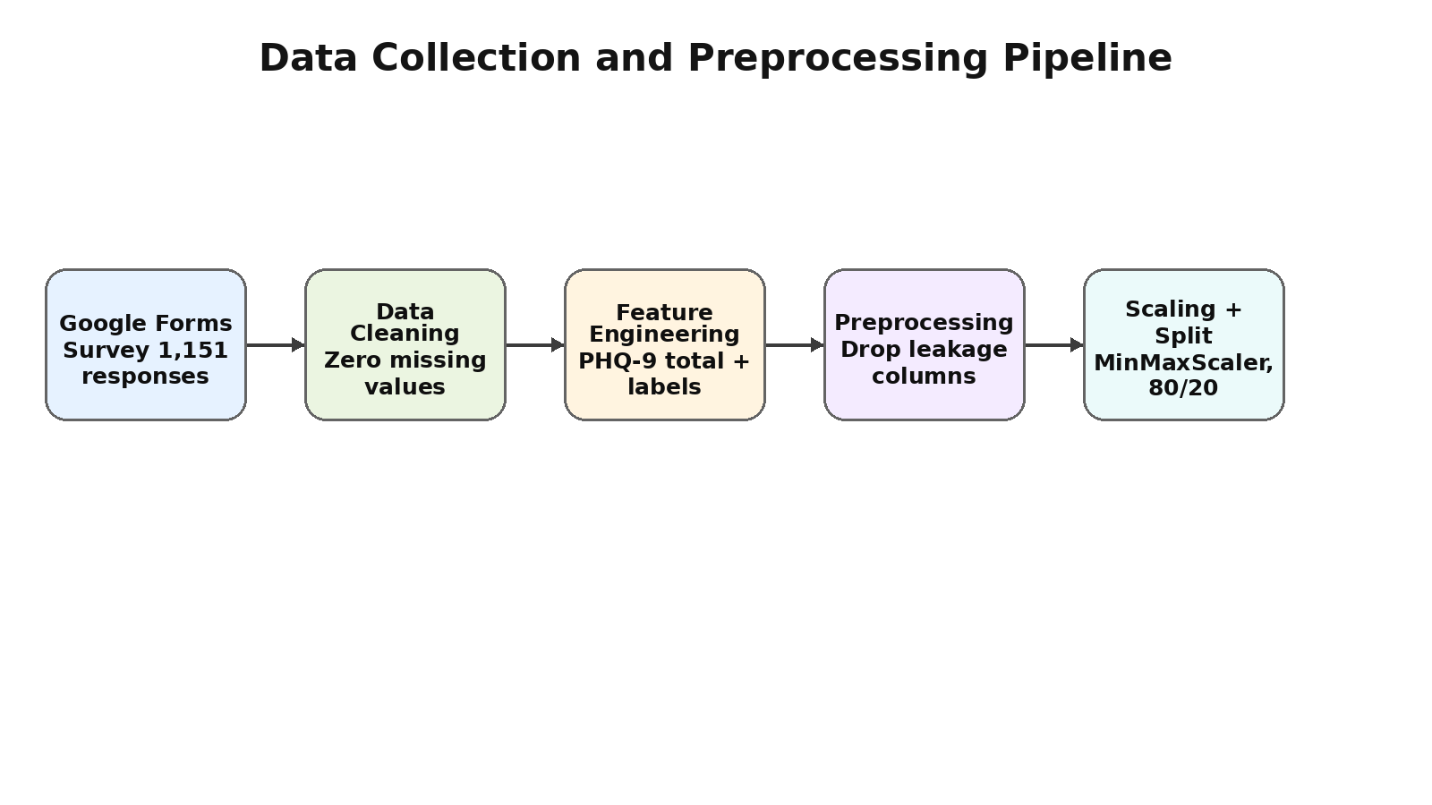
Figure 3.1: Data Collection and Preprocessing Pipeline

3.2 Feature Engineering and Selection
The 22 model input features were grouped into three major categories. The first category includes demographic features, the second includes lifestyle and academic stress features, and the third includes the nine PHQ-9 clinical symptom features. This grouping helped during model interpretation because SHAP could separate clinical symptom dominance from non-clinical lifestyle predictors.
- Demographic features: Age, gender, and year of study.
- Lifestyle and behavioral indicators: Average sleep hours, social support perception, exercise frequency, daily screen time, academic overload, workload stress, difficulty relaxing, feeling overwhelmed, exam anxiety, and study hours outside class.
- Clinical screening features: The nine PHQ-9 symptom items, each scored from 0 to 3.
Table 3.2: PHQ-9 Questionnaire Items and Scoring
Item | PHQ-9 Question | Scoring
PHQ-1 | Little interest or pleasure in doing things | 0-3
PHQ-2 | Feeling down, depressed, or hopeless | 0-3
PHQ-3 | Trouble falling or staying asleep, or sleeping too much | 0-3
PHQ-4 | Feeling tired or having little energy | 0-3
PHQ-5 | Poor appetite or overeating | 0-3
PHQ-6 | Feeling bad about yourself - or that you are a failure | 0-3
PHQ-7 | Trouble concentrating on things | 0-3
PHQ-8 | Moving or speaking slowly OR being restless/fidgety | 0-3
PHQ-9 | Thoughts that you would be better off dead or hurting yourself | 0-3

3.2.1 Depression Risk Labeling
The PHQ-9 total score was used only to create the depression risk label. It was not used as an input feature during model training. This decision was important because including the total score would make the classification task trivial and would inflate performance due to leakage. Instead, the model learned from the individual symptom responses and lifestyle indicators.

3.2.2 GAD-7 Anxiety Estimation
The original survey did not include all seven GAD-7 questions. Therefore, a proxy GAD-7 score was derived from available stress indicators. The stress proxy combined workload stress, difficulty relaxing, feeling overwhelmed, and exam anxiety using weighted contributions. The resulting estimated anxiety score was clipped to the standard 0 to 21 GAD-7 range.
Table 3.3: GAD-7 Anxiety Classification Thresholds
GAD-7 Total Score | Anxiety Severity | Label
0 - 4 | Minimal | 0
5 - 9 | Mild | 1
10 - 14 | Moderate | 2
15 - 21 | Severe | 3

3.3 Machine Learning Pipeline
The machine learning pipeline was designed to compare multiple classifiers under the same preprocessing and evaluation settings. The models were trained on scaled features and evaluated using both cross-validation and a held-out test set.
Table 3.4: Machine Learning Model Hyperparameters
Model | Hyperparameters
Logistic Regression | max_iter = 1000, random_state = 42, L2 penalty
Decision Tree | max_depth = 8, random_state = 42, criterion = gini
Random Forest | n_estimators = 200, max_depth = 10, random_state = 42, n_jobs = -1
SVM (RBF Kernel) | kernel = rbf, C = 1.0, gamma = scale, probability = True
Table 3.5: Evaluation Metrics Used
Metric | Description
Accuracy | Overall proportion of correctly predicted samples.
Precision (Weighted) | Proportion of correct positive predictions, weighted by class frequency.
Recall (Weighted) | Proportion of actual positives correctly identified, weighted by class frequency.
F1-Score (Weighted) | Harmonic mean of precision and recall, weighted by class frequency.
Confusion Matrix | 3 x 3 matrix comparing actual and predicted labels.
5-Fold Stratified CV | Cross-validation method preserving class proportions in each fold.
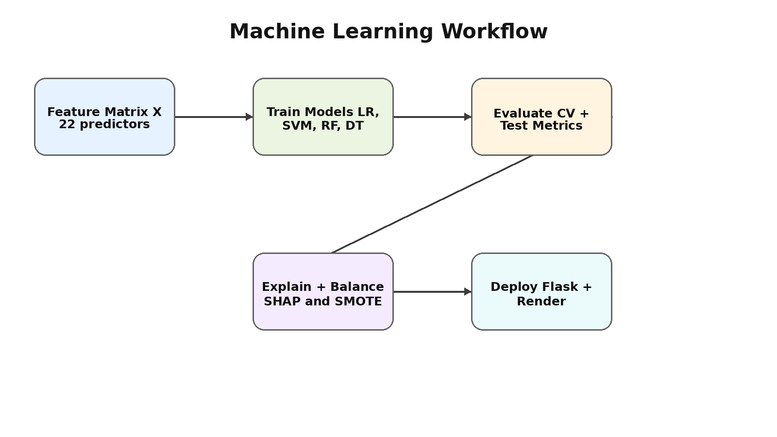
Figure 3.2: Machine Learning Workflow Diagram

3.3.1 Model Selection Strategy
The best model was selected using weighted F1-Score on the test set. Weighted F1-Score was preferred because the project involves multiclass classification with class imbalance. A model that performs well only on the majority class would not be suitable for mental health risk screening. The selected model also needed to provide prediction probabilities for the web dashboard.

3.3.2 SMOTE Application
SMOTE was applied only to the training set after the train-test split. This prevented synthetic samples from leaking into the test set. The purpose of SMOTE was not to artificially increase test accuracy, but to improve learning for the underrepresented High Risk class.

3.3.3 SHAP Explainability
SHAP analysis was conducted using the trained Logistic Regression model. The global SHAP importance values were computed by averaging absolute SHAP values across test samples and classes. Per-class analysis was also used to understand which symptoms and behavioral factors drove predictions toward Low, Moderate, or High Risk.

3.4 System Architecture and Block Diagrams
The MINDscan system follows a three-tier architecture consisting of a presentation layer, application layer, and model/data layer. The frontend collects user inputs, the Flask backend processes requests, and the saved model artifacts generate predictions. The architecture also includes a data layer containing cleaned datasets, trained model files, feature names, and scaler objects.
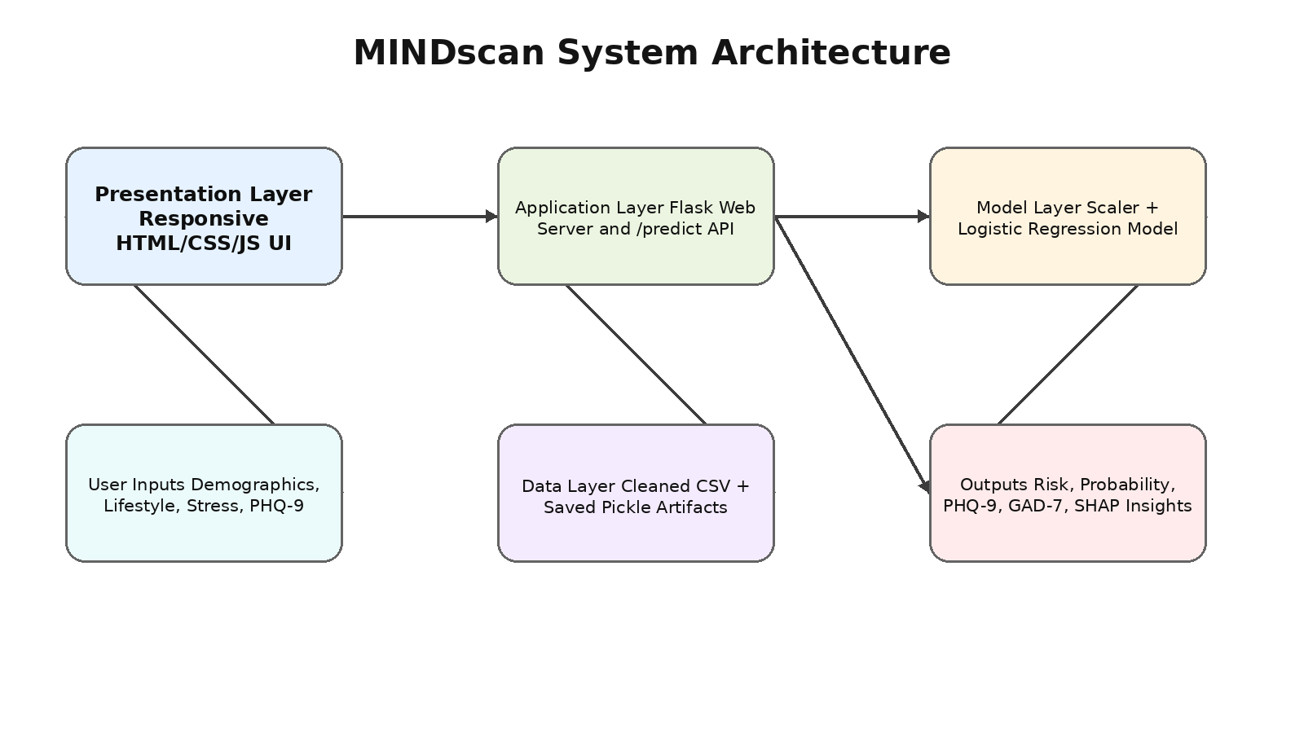
Figure 3.3: System Architecture Block Diagram
The prediction flow begins when a student submits the assessment form in the browser. The frontend sends the input values as JSON to the Flask /predict endpoint. The backend constructs a DataFrame using the exact feature order expected by the model, applies the saved MinMaxScaler, performs model prediction and probability estimation, computes PHQ-9 total and estimated GAD-7 values, and returns the result to the frontend.
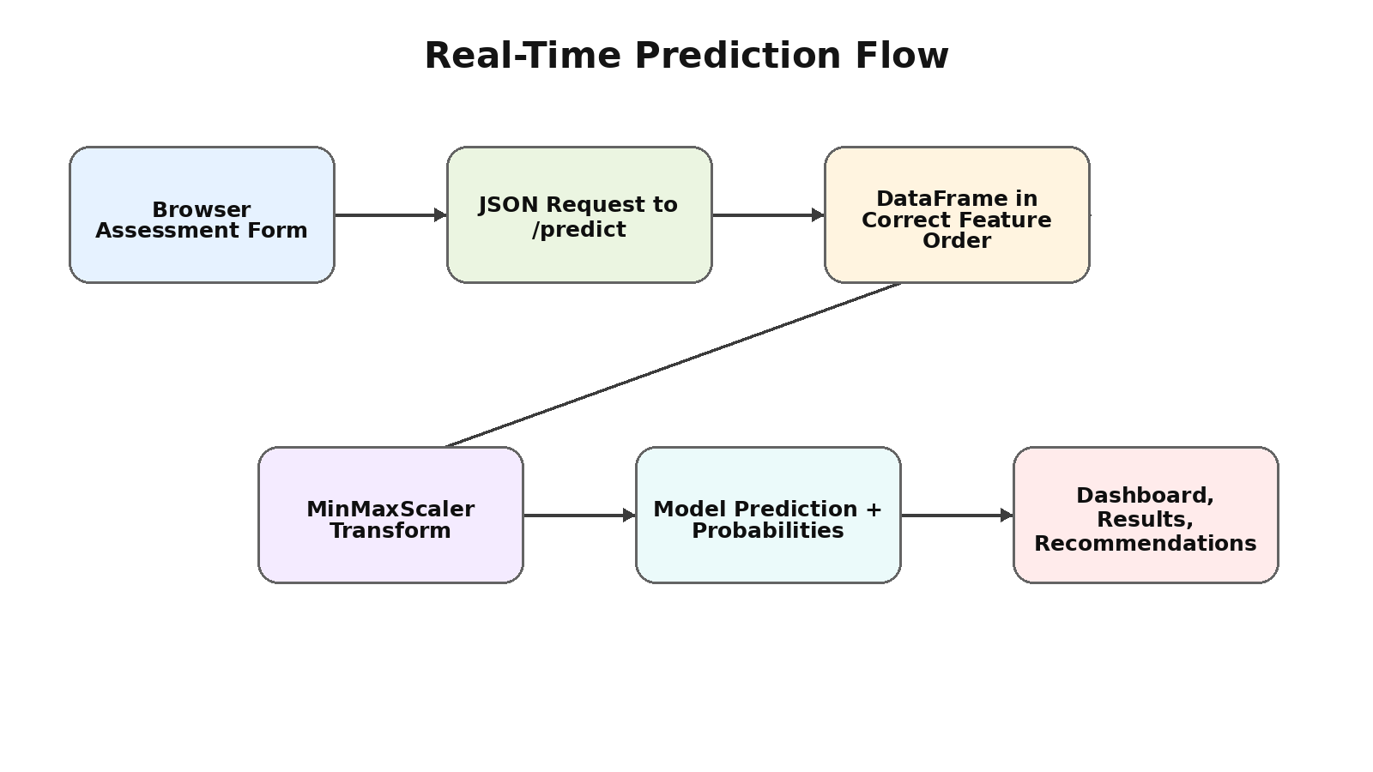
Figure 3.4: Real-Time Prediction Flow Diagram

3.5 Ethical and Privacy Considerations
Mental health data is sensitive. The project was developed with the understanding that the application is a screening and awareness tool, not a medical diagnostic product. The result shown by the application should be interpreted as an indication to seek support, not as a clinical diagnosis.
The interface includes crisis resources for high-risk users. This is important because automated mental health screening should never provide only a risk label without guidance. High-risk users should be encouraged to reach out to trusted people, campus support systems, and professional helplines.
The model should not be used to stigmatize, label, or make administrative decisions about students. Any future integration with counseling services should require informed consent, secure data handling, and approval from the relevant institutional ethics body.

Chapter 4
IMPLEMENTATION

4.1 Modules
The project is implemented as a sequence of modules. Each module performs one well-defined role, and the outputs of earlier modules are used by later modules. This modular approach improves reproducibility and makes the project easier to maintain.
Table 4.1: Project Module Description
Module | Script / File | Description
Module 1: EDA | Phase3_EDA.py | Generates statistical plots for risk distribution, PHQ-9 scores, lifestyle patterns, correlations, and stress indicators.
Module 2: Model Training | Phase4_Model_Training.py | Trains four models, performs cross-validation, compares test metrics, selects the best model, and saves model artifacts.
Module 3: SHAP Analysis | Tier1_Upgrade1_SHAP.py | Computes global, per-class, and individual SHAP explanations for model interpretability.
Module 4: SMOTE Balancing | Tier1_Upgrade2_SMOTE.py | Applies SMOTE to the training set and compares model performance with and without balancing.
Module 5: GAD-7 Estimation | Tier1_Upgrade3_GAD7.py | Derives an estimated anxiety score from stress indicators and prepares dual depression-anxiety profiling.
Module 6: Web Application | app.py, templates/, static/ | Provides Flask backend, prediction API, responsive frontend, recommendations, and deployment support.

4.1.1 Exploratory Data Analysis Module
The exploratory data analysis module loads the cleaned dataset and generates plots to understand the distribution and relationships in the data. It analyzes risk class proportions, PHQ-9 total score distribution, sleep duration, exercise frequency, social support, correlations, gender-wise risk, and stress indicators by risk group. These visualizations helped identify patterns that guided model interpretation.

4.1.2 Model Training Module
The model training module performs the complete supervised learning process. It loads the dataset, removes leakage columns, scales the features, applies an 80/20 train-test split, trains Logistic Regression, SVM, Random Forest, and Decision Tree models, and compares them using accuracy, precision, recall, and F1-Score. The final Logistic Regression model, scaler, and feature list are serialized using pickle for use in the web application.

4.1.3 Explainability and Balancing Modules
The SHAP module generates feature attribution plots and case-wise explanations. The SMOTE module evaluates whether class balancing improves High Risk identification. These two modules are important because mental health applications require both performance and transparency.

4.2 Prototype - Web Application
The web application was designed as a responsive single-page assessment tool. It guides the student through demographic questions, lifestyle factors, stress indicators, and PHQ-9 screening items. The result page presents the risk level, confidence scores, PHQ-9 score, estimated GAD-7 score, mental stability score, explanations, recommendations, and helpline resources.
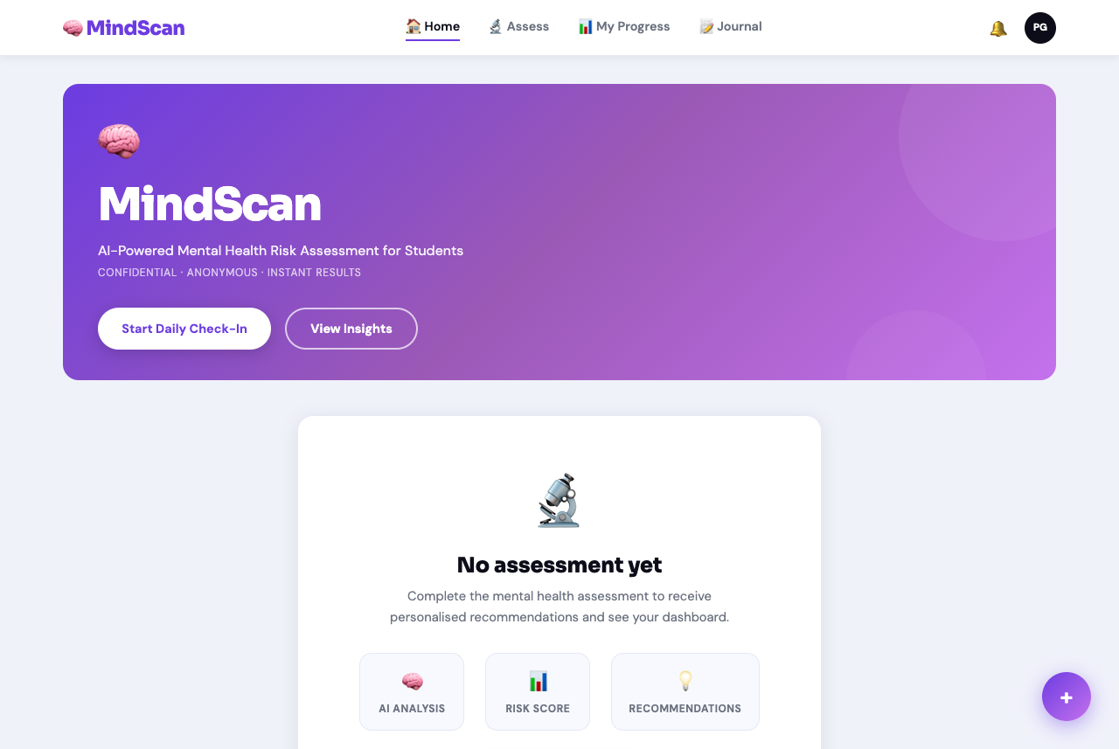
Figure 4.1: Web Application - Home Dashboard Prototype
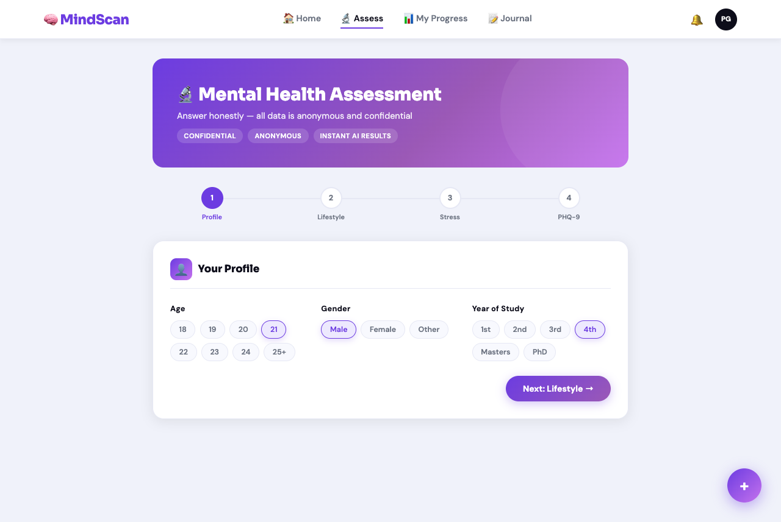
Figure 4.2: Web Application - Assessment Form Workflow
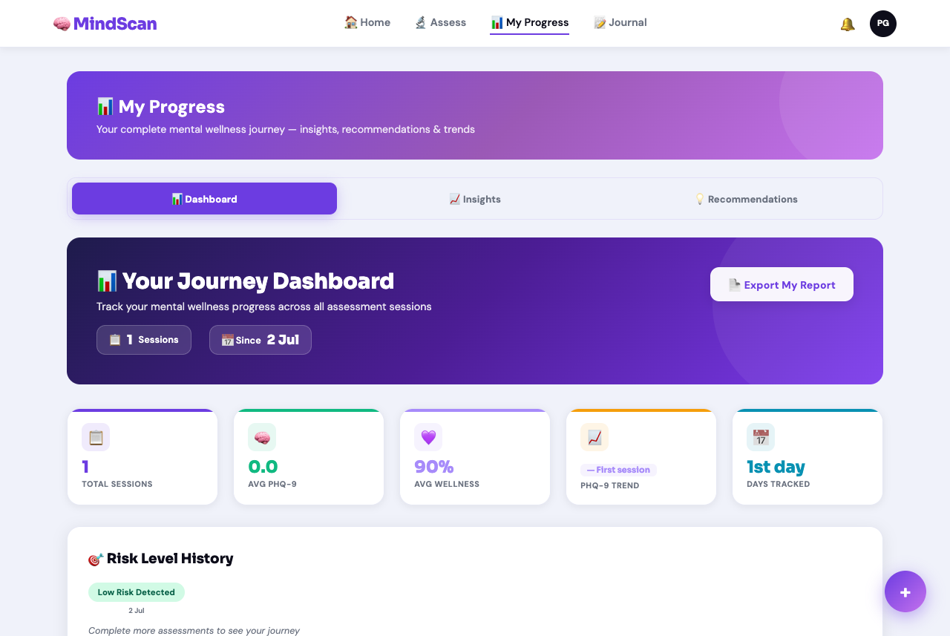
Figure 4.3: Web Application - Results and Recommendations Prototype

4.3 Backend and Frontend Implementation

4.3.1 Flask Backend
The backend is implemented using Flask. The application contains a route for serving the main page and a prediction route for processing user input. The /predict endpoint receives JSON input, maps frontend field names to model feature names, creates a pandas DataFrame, scales the data, generates a prediction, computes probabilities, calculates PHQ-9 total score, and returns the response as JSON.
Table 4.2: Prediction API Input Fields
Field | Description | Allowed Values
age | Age of the student | Numeric
gender | Encoded gender value | 0, 1, or 2
year | Year of study | 1 to 6
sleep | Average sleep hours category | 0 to 4
support | Social support perception | 0 to 4
exercise | Exercise frequency | 0 to 3
screen | Daily screen time category | 0 to 2
overload | Academic overload flag | 0 or 1
workload | Academic workload stress | 1 to 5
relax | Difficulty relaxing | 1 to 5
overwhelm | Feeling overwhelmed | 1 to 5
exam | Exam anxiety | 1 to 5
study | Study hours outside class | Numeric
phq | List of PHQ-9 responses | Nine integers from 0 to 3

4.3.2 Frontend Implementation
The frontend is built using HTML5, CSS3, and JavaScript. It uses a multi-step assessment layout to reduce cognitive load for users. Chip selectors and sliders simplify input, while the result page uses visual components such as circular ring charts and probability bars to make outputs understandable. The design is responsive so that the application can be used on laptops, tablets, and phones.

4.3.3 Recommendation Logic
The recommendation section changes depending on the predicted risk category. Low Risk users receive preventive well-being recommendations, Moderate Risk users are encouraged to monitor symptoms and seek support, and High Risk users are shown stronger guidance along with helpline information. This structure ensures that the application provides actionable next steps rather than only a prediction label.

4.4 Testing and Deployment
Testing was performed at multiple levels. Model testing was performed using a held-out 20% test set and 5-fold stratified cross-validation. API testing was performed by sending sample JSON requests to the /predict endpoint and verifying whether the output contained prediction, probability, PHQ-9 total, stability score, and estimated GAD-7 score. Frontend testing checked whether form inputs were correctly captured and submitted.
Deployment was performed on Render using a production configuration that includes a Procfile, runtime.txt, and requirements.txt. Gunicorn was used as the production WSGI server. The deployed application loads the saved model artifacts on startup and serves predictions through the Flask route.
The project repository contains the dataset folder, scripts folder, model artifacts folder, outputs folder, static assets, templates, app.py, requirements.txt, runtime.txt, Procfile, and README documentation. This organization supports reproducibility and allows future improvements to be added module-wise.

Chapter 5
RESULTS AND ANALYSIS

5.1 Exploratory Data Analysis
The exploratory analysis focused on identifying the distribution of depression risk levels, the behavior of PHQ-9 total scores, and the relationship between lifestyle factors and mental health indicators. The High Risk class represented the smallest portion of the dataset, which motivated the use of SMOTE in a later stage.
The PHQ-9 total score distribution showed that most students fell in the Low Risk range, while a smaller portion fell in Moderate and High Risk categories. This pattern is expected in a university-wide sample because severe symptoms usually form a minority class. However, the minority class is clinically important and must be identified reliably.
Lifestyle trends showed that shorter sleep duration, lower exercise frequency, weaker social support, and higher stress indicators were associated with higher PHQ-9 scores. These findings are consistent with the idea that mental health risk is influenced by both clinical symptoms and daily behavioral patterns.
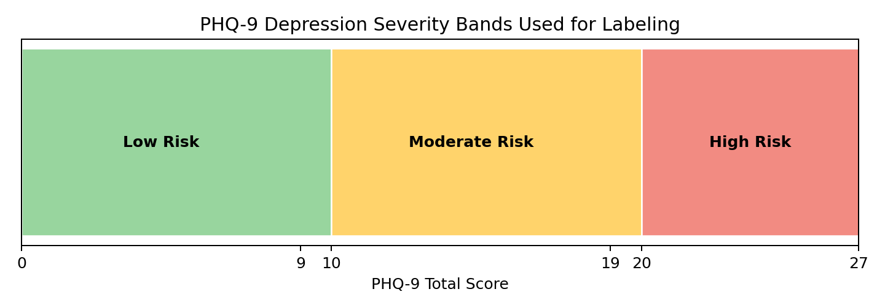
Figure 5.1: PHQ-9 Depression Severity Bands

5.2 Model Training and Comparison
Table 5.1: Model Comparison Results
Model | CV Accuracy | Test Accuracy | Precision (W) | Recall (W) | F1-Score (W)
Logistic Regression | 95.98% | 95.67% | 95.70% | 95.67% | 95.65%
SVM (RBF) | 94.24% | 93.51% | 93.55% | 93.51% | 93.48%
Random Forest | 92.39% | 89.18% | 89.25% | 89.18% | 89.15%
Decision Tree | 80.54% | 83.55% | 83.60% | 83.55% | 83.48%
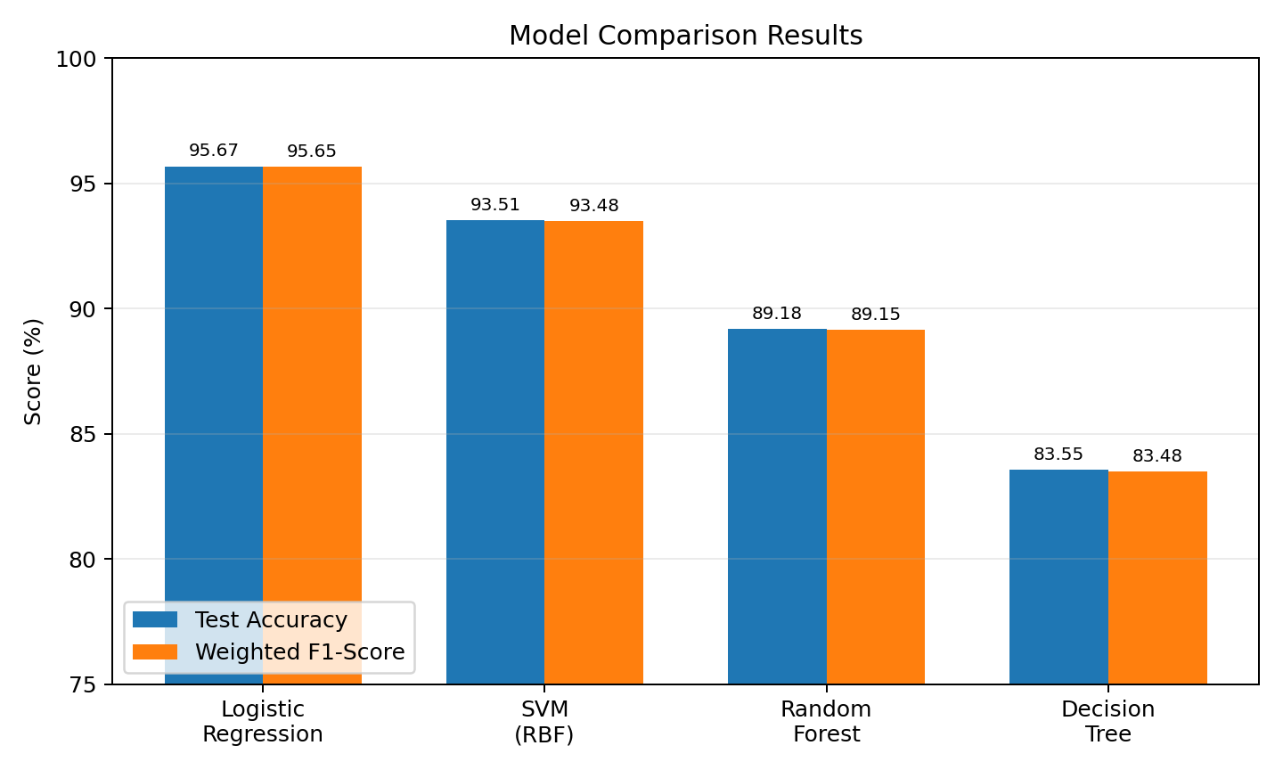
Figure 5.2: Model Comparison - Accuracy and Weighted F1-Score
Logistic Regression achieved the best performance with a test accuracy of 95.67% and weighted F1-Score of 95.65%. It also achieved a 5-fold cross-validation accuracy of 95.98%, which is close to the held-out test accuracy and indicates strong generalization.
SVM also performed strongly with 93.51% test accuracy, but it was slightly below Logistic Regression. Random Forest and Decision Tree were less effective. The comparatively lower Decision Tree result reflects its tendency to overfit even with a maximum depth constraint.
The strong performance of Logistic Regression can be explained by the nature of the feature-label relationship. The target label is derived from PHQ-9 symptom severity ranges, and the individual PHQ-9 items are retained as model inputs while the total score is removed. This creates a meaningful but largely linear classification structure.
Table 5.2: Logistic Regression Classification Report
Class | Precision | Recall | F1-Score
Low Risk (0) | 97% | 97% | 97%
Moderate Risk (1) | 95% | 95% | 95%
High Risk (2) | 91% | 91% | 91%
Weighted Average | 95.70% | 95.67% | 95.65%

5.3 SHAP Explainability Analysis
SHAP analysis was performed to identify which features had the strongest impact on model predictions. The analysis showed that PHQ-9 symptom items dominate the model, which is clinically reasonable because the target variable is depression risk. The most important feature was PHQ-3, related to sleep trouble, with a mean absolute SHAP value of 0.5996.
Table 5.3: SHAP Global Feature Importance (Top 10)
Rank | Feature | Importance
1 | PHQ-3: Sleep trouble | 0.5996
2 | PHQ-2: Feeling down/hopeless | High
3 | PHQ-1: Low interest/pleasure | High
4 | PHQ-4: Fatigue/low energy | High
5 | PHQ-6: Feeling like a failure | High
6 | PHQ-5: Appetite changes | High
7 | PHQ-7: Concentration trouble | High
8 | PHQ-9: Self-harm thoughts | Moderate-High
9 | PHQ-8: Psychomotor changes | Moderate-High
10 | Difficulty relaxing | Moderate
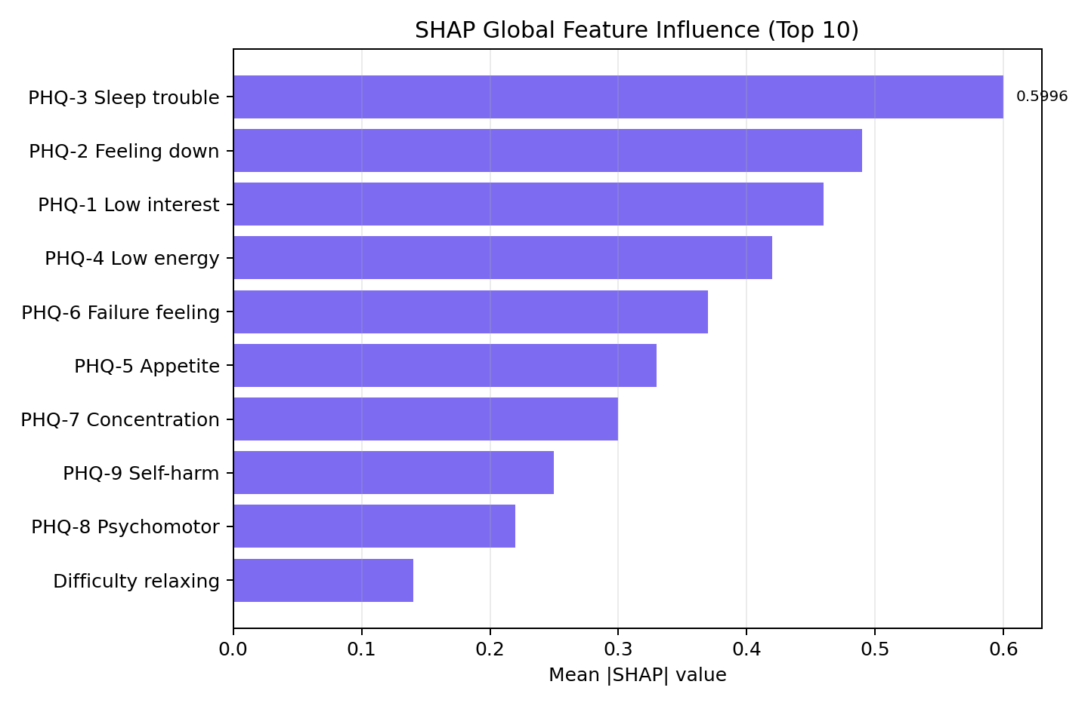
Figure 5.3: SHAP Global Feature Influence Summary
The dominance of PHQ-9 symptom variables confirms that the model is relying on clinically meaningful inputs. Among non-PHQ features, difficulty relaxing, exercise frequency, and sleep hours emerged as the strongest predictors. These features are valuable because they are modifiable lifestyle factors and can be targeted through wellness recommendations.

5.4 SMOTE Oversampling Analysis
The High Risk class had fewer samples than the Low and Moderate classes. Since failing to identify High Risk students is more serious than ordinary misclassification, the project used SMOTE to improve minority-class learning. SMOTE was applied only on the training set after splitting the dataset.
Table 5.4: SMOTE Impact on Model Performance
Model | Metric | Without SMOTE | With SMOTE | Delta Change
Logistic Regression | Accuracy | High | Comparable | Minimal
Logistic Regression | Weighted F1 | High | Comparable | Minimal
Logistic Regression | High Risk F1 | Lower | Improved | Positive
Random Forest | High Risk F1 | Lower | Improved | Positive
SVM | High Risk F1 | Lower | Improved | Positive
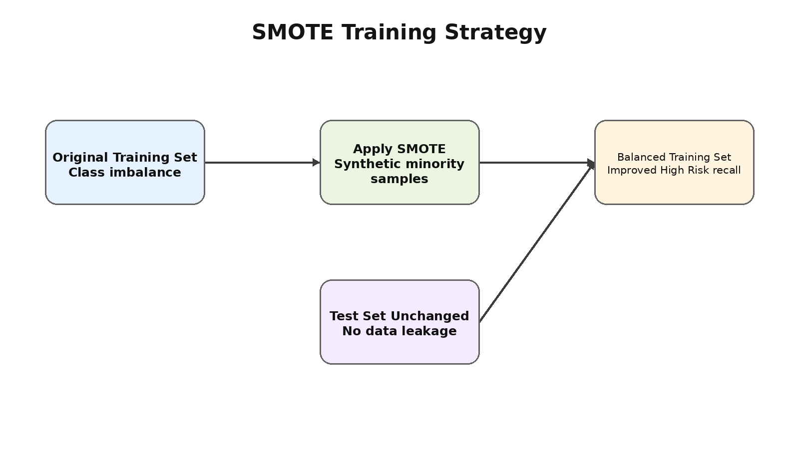
Figure 5.4: SMOTE Training Strategy
The main benefit of SMOTE was observed in the High Risk F1-Score. Overall accuracy and weighted F1 remained comparable, while minority-class detection improved. This is important because the High Risk class is the most critical group from a mental health support perspective.

5.5 GAD-7 Anxiety Estimation
The GAD-7 estimation module produced a supplementary anxiety score based on available stress indicators. This score was not a replacement for the official GAD-7 questionnaire because the original survey did not include all seven standard anxiety items. However, it allowed the application to present a dual depression-anxiety profile and indicate when stress symptoms were elevated.
The relationship between PHQ-9 and estimated GAD-7 scores was positive, which is expected because depression and anxiety commonly co-occur. High depression risk cases were more likely to show moderate or severe anxiety estimates, while low depression risk cases generally showed minimal or mild anxiety estimates.

5.6 Discussion of Findings
The results show that a simple, interpretable model can perform very well when the dataset is clean and the features are clinically relevant. Logistic Regression outperformed more complex models because the risk classes are strongly influenced by the additive contribution of PHQ-9 symptom scores.
The project also demonstrates the value of combining clinical symptoms with lifestyle data. Although PHQ-9 features are dominant, non-clinical factors such as sleep, exercise, social support, and stress give additional context and help generate personalized recommendations.
The explainability component is especially important for mental health applications. By showing which symptoms and behaviors influenced a prediction, the application can help users understand their results and can support a more transparent conversation with counselors or mentors.
The application should be interpreted as a screening and awareness system. It should not make diagnostic claims. Its most appropriate use is to encourage early help-seeking, self-reflection, and access to supportive resources.

Chapter 6
CONCLUSIONS & FUTURE SCOPE

6.1 Conclusions
1. This project successfully designed and implemented MINDscan, an AI-based mental health risk prediction system for university students.
2. The system used primary data from 1,151 student respondents and incorporated demographics, lifestyle factors, stress indicators, and PHQ-9 depression screening responses.
3. Logistic Regression achieved the best performance with 95.67% test accuracy and 95.65% weighted F1-Score, showing that the chosen feature set was effective for three-class depression risk prediction.
4. SHAP explainability confirmed that PHQ-9 symptom variables were the dominant predictors, with PHQ-3 (sleep trouble) being the most influential feature.
5. SMOTE improved the High Risk class learning while maintaining comparable overall performance, making it valuable for clinically important minority-class identification.
6. The Flask web application made the system accessible through a browser and provided real-time prediction, confidence scores, estimated anxiety score, recommendations, and crisis resources.
7. The project emphasizes responsible use by clearly treating the system as a preliminary screening tool rather than a diagnostic substitute.

Table 6.1: Summary of Objectives and Outcomes
Objective Area | Planned Outcome | Achieved Outcome
Data Collection | Collect at least 1,000 student responses | 1,151 valid responses collected
Model Development | Train and compare multiple classifiers | Four classifiers trained and evaluated
Best Model Selection | Select the model using weighted F1-Score | Logistic Regression selected
Explainability | Use SHAP for model interpretation | Global and per-class SHAP analysis performed
Class Imbalance | Improve High Risk identification | SMOTE analysis completed
Deployment | Build usable web application | Flask application deployed on Render
User Support | Provide recommendations and resources | Personalized recommendations and helplines included

6.2 Future Scope of Work
To transition MINDscan from a preliminary screening tool into a comprehensive, continuous mental wellness companion, the following enhancements are proposed for future development:
1. Advanced AI and Natural Language Processing (NLP)
• AI Journaling and Sentiment Analysis: Introduce a daily free-text journaling feature where NLP models analyze tone, sentiment, and mood patterns over time. This will allow the system to detect subtle signs of distress that multiple-choice questionnaires might miss.
• Predictive Risk Nudges: Utilize machine learning on longitudinal session data to identify personal stress triggers, such as predicting that a student's stress typically spikes two weeks before examinations, and send proactive, tailored in-app wellness alerts.
2. Clinical and Institutional Integration
• Secure University Counselor Portal: Develop an opt-in, secure referral pathway that integrates directly with university counseling services. This would allow high-risk students to seamlessly request appointments or trigger an automated crisis escalation alert to campus support.
• Counselor Share Mode: Enable students to generate an automated, easy-to-read PDF summary of their risk trends, lifestyle correlations, and SHAP insights to share directly with their therapist during consultations.
• Comprehensive Clinical Scales: Replace the current proxy-based anxiety estimation with the complete, clinically validated seven-item GAD-7 scale.
3. Continuous Monitoring and User Engagement
• Micro-Assessments and Mood Tracking: Implement 30-second daily emoji-based mood logs to capture denser mental health data between full PHQ-9 assessments, effectively reducing survey fatigue while building a continuous mood trend chart.
• Smart Adaptive Reminders: Introduce intelligent push or email notifications that adapt to user behavior, such as sending gentle check-in nudges if a user goes inactive during a high-risk streak.
4. Deep Data Analytics and Personal Insights
• Interactive Correlation Explorer: Build a dashboard where students can visually explore how their specific lifestyle factors impact their mental health, such as an interactive scatter plot showing how sleeping seven or more hours relates to their individual PHQ-9 score.
• Weekly AI Wellness Summaries: Provide auto-generated weekly digests summarizing behavioral changes, for example: "This week you slept better, but your academic stress rose - here is what might have caused it."
• Anonymous Peer Benchmarking: Allow students to opt in to see how their stress and workload levels compare against anonymized, aggregated data from peers in the same academic year to help normalize feelings of academic pressure.
5. Platform Expansion and Accessibility
• Progressive Web App (PWA) and Native Mobile App: Upgrade the platform to a PWA or native Android/iOS application to support offline access, native home-screen installation, and push notifications.
• Embedded Mindfulness Mini-tools: Integrate immediate coping resources directly into the application, such as guided breathing timers and body-scan prompts, for students experiencing acute anxiety while taking the assessment.

REFERENCES
[1] K. Kroenke, R. L. Spitzer, and J. B. W. Williams, "The PHQ-9: Validity of a brief depression severity measure," Journal of General Internal Medicine, vol. 16, no. 9, pp. 606-613, Sep. 2001.
[2] R. L. Spitzer, K. Kroenke, J. B. W. Williams, and B. Lowe, "A brief measure for assessing generalized anxiety disorder: The GAD-7," Archives of Internal Medicine, vol. 166, no. 10, pp. 1092-1097, May 2006.
[3] N. V. Chawla, K. W. Bowyer, L. O. Hall, and W. P. Kegelmeyer, "SMOTE: Synthetic minority over-sampling technique," Journal of Artificial Intelligence Research, vol. 16, pp. 321-357, Jun. 2002.
[4] S. M. Lundberg and S.-I. Lee, "A unified approach to interpreting model predictions," in Advances in Neural Information Processing Systems, vol. 30, 2017, pp. 4765-4774.
[5] F. Pedregosa et al., "Scikit-learn: Machine learning in Python," Journal of Machine Learning Research, vol. 12, pp. 2825-2830, 2011.
[6] A. Priya, S. Garg, and N. P. Tigga, "Predicting anxiety, depression and stress in modern life using machine learning algorithms," Procedia Computer Science, vol. 167, pp. 1258-1267, 2020.
[7] T. Nguyen, D. Phung, B. Dao, S. Venkatesh, and M. Berk, "Affective and content analysis of online depression communities," IEEE Transactions on Affective Computing, vol. 5, no. 3, pp. 217-226, Jul. 2014.
[8] American Psychiatric Association, Diagnostic and Statistical Manual of Mental Disorders, 5th ed. Arlington, VA, USA: APA, 2013.
[9] World Health Organization, Depression and Other Common Mental Disorders: Global Health Estimates. Geneva, Switzerland: WHO, 2017.
[10] A. C. Muller and S. Guido, Introduction to Machine Learning with Python: A Guide for Data Scientists. Sebastopol, CA, USA: O'Reilly Media, 2016.
[11] Render, "Cloud Application Hosting Platform," Web. Last accessed: June 2026.
[12] A. Qasim, G. Mehak, N. Hussain, A. Gelbukh, and G. Sidorov, "Detection of depression severity in social media text using transformer-based models," Information, vol. 16, no. 2, p. 114, Feb. 2025, doi: 10.3390/info16020114.
[13] F. Campbell, L. Blank, A. Cantrell, S. Baxter, C. Blackmore, J. Dixon, and E. Goyder, "Factors that influence mental health of university and college students in the UK: A systematic review," BMC Public Health, vol. 22, no. 1, p. 1778, Sep. 2022, doi: 10.1186/s12889-022-13943-x.
[14] K. Milintsevich, K. Sirts, and G. Dias, "Towards automatic text-based estimation of depression through symptom prediction," Brain Informatics, vol. 10, no. 1, p. 4, Feb. 2023, doi: 10.1186/s40708-023-00185-9.
[15] H. Fisher, N. M. Jaffe, K. Pidvirny, A. O. Tierney, M. S. Vaidean, P. Dongre, and C. A. Webb, "Language-based detection of depression with machine learning: Systematic review and meta-analysis," npj Digital Medicine, vol. 9, no. 1, 2026, doi: 10.1038/s41746-026-02448-1.

ANNEXURES

Annexure A: Project File Structure
Table A.1: Project File Structure
File / Folder | Purpose
README.md | Project documentation
requirements.txt | Python dependencies
MH_Survey_Cleaned_1151.csv | Cleaned dataset containing 1,151 responses
scripts/Phase3_EDA.py | Exploratory data analysis
scripts/Phase4_Model_Training.py | Model training and comparison
scripts/Tier1_Upgrade1_SHAP.py | SHAP explainability analysis
scripts/Tier1_Upgrade2_SMOTE.py | SMOTE class balancing
scripts/Tier1_Upgrade3_GAD7.py | GAD-7 anxiety estimation
models/best_model.pkl | Final Logistic Regression model
models/scaler.pkl | Saved MinMaxScaler object
models/feature_names.pkl | Saved model feature names
app.py | Flask web application backend
templates/index.html | Single-page frontend
Procfile | Render deployment configuration
runtime.txt | Python runtime specification

Annexure B: Python Dependencies
Table A.2: Python Dependencies
Dependency | Purpose
Flask >= 2.3.0 | Backend web framework
pandas >= 1.5.0 | Data manipulation
numpy >= 1.21.0 | Numerical processing
scikit-learn >= 1.3.0 | Machine learning models and preprocessing
gunicorn >= 21.0.0 | Production WSGI server
Werkzeug >= 2.3.0 | WSGI utilities
shap | Explainability analysis during development
matplotlib / seaborn | Visualization during analysis
imbalanced-learn | SMOTE oversampling during development

Annexure C: Sample Dataset Records
Table A.3: Sample Dataset Records
Age | Gender | Year | Sleep | Exercise | PHQ-1 | PHQ-2 | PHQ-3 | ... | PHQ-9 | Total | Risk
21 | 1 | 4 | 3 | 2 | 0 | 0 | 1 | ... | 0 | 4 | Low
19 | 0 | 2 | 1 | 0 | 2 | 2 | 3 | ... | 1 | 16 | Moderate
22 | 1 | 5 | 0 | 0 | 3 | 3 | 3 | ... | 2 | 23 | High

Annexure D: Prediction API Sample
Sample request body for POST /predict:
{
"age": 21,
"gender": 0,
"year": 4,
"sleep": 3,
"support": 3,
"exercise": 2,
"screen": 1,
"overload": 0,
"workload": 3,
"relax": 3,
"overwhelm": 3,
"exam": 3,
"study": 1,
"phq": [0, 0, 0, 0, 0, 0, 0, 0, 0]
}
Sample response body:
{
"prediction": 0,
"probabilities": [0.94, 0.05, 0.01],
"phq_total": 0,
"stability": 90,
"gad_estimate": 13
}

Annexure E: Important Disclaimer
MINDscan is intended for educational, research, and preliminary awareness purposes only. It is not a medical device and must not be used as a substitute for professional medical advice, diagnosis, counseling, or treatment. Any student receiving a moderate or high risk result should be encouraged to speak with a qualified mental health professional, counselor, trusted guardian, or emergency support service as appropriate.

