Global GDP Analysis: Executive Summary & Conclusions

Prepared on August 26, 2025 | Data through 2016

# Executive Summary

* The dataset contains 11,507 annual GDP records across countries and regions from 1960 to 2016.
* Global GDP expanded strongly over the period, with structural breaks visible around the oil shocks of the 1970s and the 2008–09 financial crisis.
* Advanced economies (United States, Japan, Germany) show steady, high-level GDPs; emerging economies (notably China and India) display rapid acceleration post-1990.
* By the latest year, the GDP distribution remains highly skewed: a few large economies account for a substantial share of global output.

# Key Findings

Global GDP has grown from low trillions in 1960 to several tens of trillions by the mid-2010s. The chart below shows the aggregate trajectory:

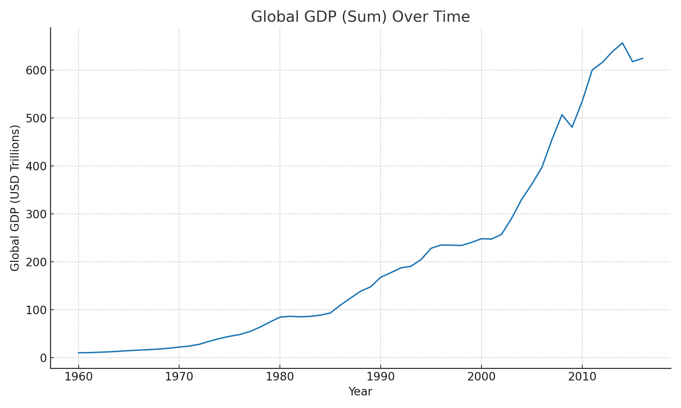

The sharpest year-on-year global contraction in this dataset occurred in 2015 at approximately -5.94% decline.

Selected country trajectories highlight differences in absolute size and growth dynamics:

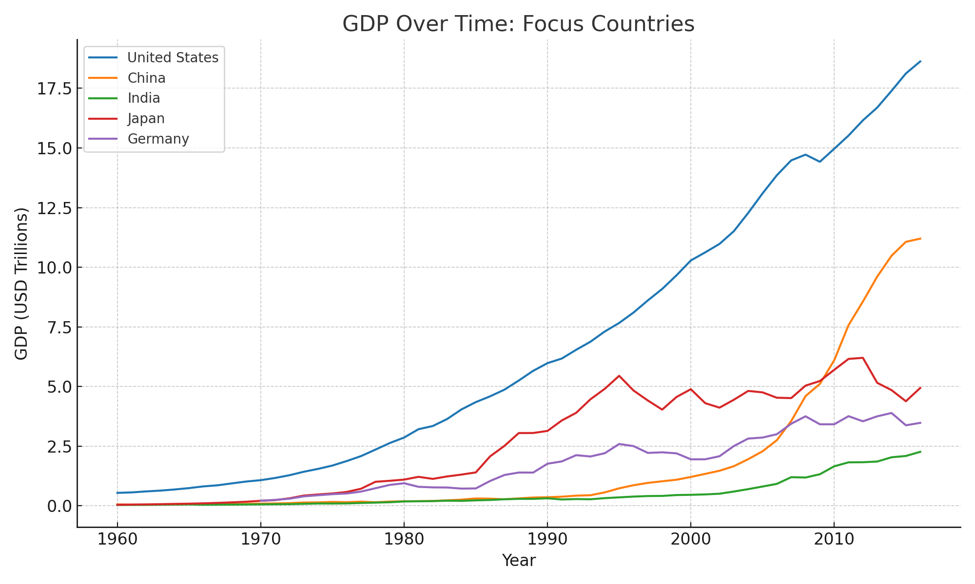

Compound annual growth rates (CAGR) between 1990 and 2016 for selected economies:

|  |  |
| --- | --- |
| Country | CAGR 1990-2016 (%) |
| United States | 4.47 |
| China | 14.12 |
| India | 7.86 |
| Japan | 1.76 |
| Germany | 2.64 |

Top 10 economies by GDP in 2016:

|  |  |  |
| --- | --- | --- |
| Country | Code | GDP 2016 (USD Trillions) |
| North America | NAC | 20.16 |
| United States | USA | 18.62 |
| Late-demographic dividend | LTE | 18.46 |
| China | CHN | 11.20 |
| Early-demographic dividend | EAR | 10.40 |
| Japan | JPN | 4.94 |
| Germany | DEU | 3.48 |
| United Kingdom | GBR | 2.65 |
| France | FRA | 2.47 |
| India | IND | 2.26 |

# Methodology (High-Level)

* Data Source: Provided CSV with columns Country Name, Country Code, Year, Value (current US$).
* Cleaning: Sorted by country and year; excluded broad regional aggregates for country-specific comparisons.
* Aggregation: Summed GDP across all entities to estimate global totals per year; computed year-over-year growth.
* Comparisons: Ranked countries by latest available GDP; computed CAGRs for selected countries from 1990 to latest year.
* Visualization: Created line charts for global totals and selected countries using matplotlib.

# Limitations & Notes

* GDP is in current US dollars; results reflect both real growth and price/currency effects.
* Regional aggregates were excluded from 'Top countries' solely via keyword heuristics; some edge cases may persist.
* Latest year in the dataset is limited to data through 2016; developments after that are not captured.

# Conclusions

* The period 1960–2016 demonstrates sustained global economic expansion, punctuated by identifiable downturns such as 2008–09.
* Economic scale remains concentrated among a handful of large economies, but convergence is observable in fast-growing emerging markets, led by China and India since the 1990s.
* Country-level growth paths differ markedly: mature economies grow steadily from a high base, while emerging economies can exhibit higher CAGRs with greater volatility.
* For policy and business decisions, complementary indicators (GDP per capita, inflation-adjusted GDP, sectoral composition) should be analyzed alongside total GDP levels.