Global GDP Analysis: Executive Summary & Conclusions
Prepared on August 26, 2025 | Data through 2016

Executive Summary
- The dataset contains 11,507 annual GDP records across countries and regions from 1960 to 2016.
- Global GDP expanded strongly over the period, with structural breaks visible around the oil shocks of the 1970s and the 2008–09 financial crisis.
- Advanced economies (United States, Japan, Germany) show steady, high-level GDPs; emerging economies (notably China and India) display rapid acceleration post-1990.
- By the latest year, the GDP distribution remains highly skewed: a few large economies account for a substantial share of global output.

Key Findings
Global GDP has grown from low trillions in 1960 to several tens of trillions by the mid-2010s. The chart below shows the aggregate trajectory:
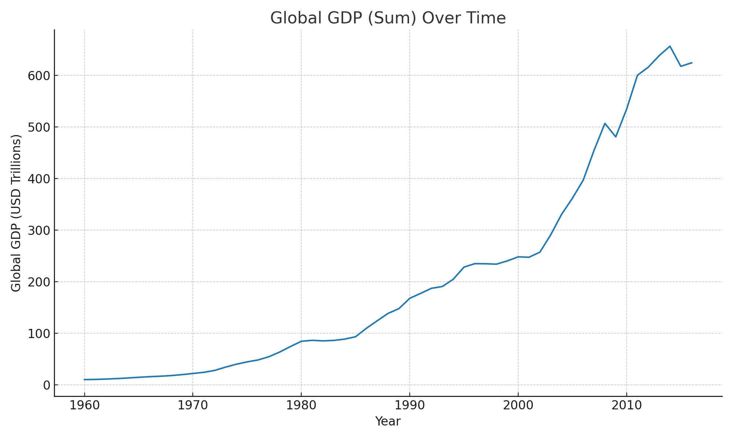
The sharpest year-on-year global contraction in this dataset occurred in 2015 at approximately -5.94% decline.
Selected country trajectories highlight differences in absolute size and growth dynamics:
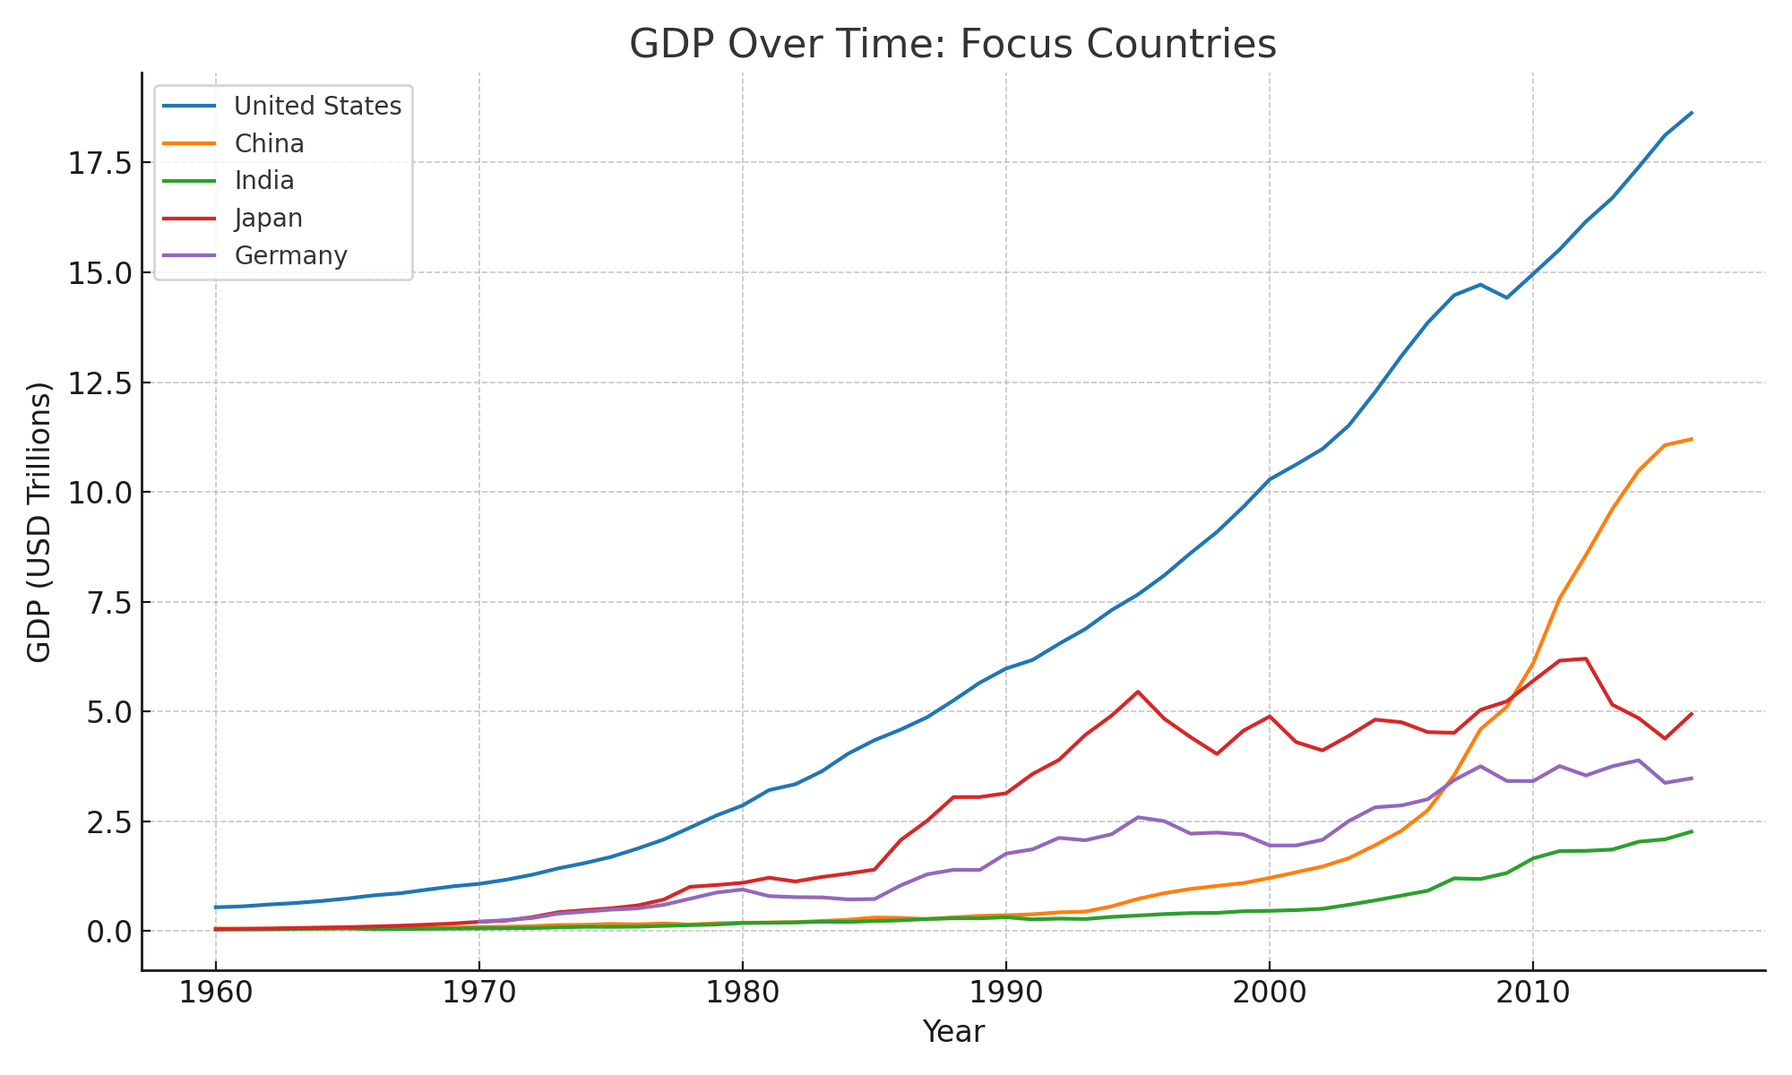
Compound annual growth rates (CAGR) between 1990 and 2016 for selected economies:
Country | CAGR 1990-2016 (%)
United States | 4.47
China | 14.12
India | 7.86
Japan | 1.76
Germany | 2.64

Top 10 economies by GDP in 2016:
Country | Code | GDP 2016 (USD Trillions)
North America | NAC | 20.16
United States | USA | 18.62
Late-demographic dividend | LTE | 18.46
China | CHN | 11.20
Early-demographic dividend | EAR | 10.40
Japan | JPN | 4.94
Germany | DEU | 3.48
United Kingdom | GBR | 2.65
France | FRA | 2.47
India | IND | 2.26

Methodology (High-Level)
- Data Source: Provided CSV with columns Country Name, Country Code, Year, Value (current US$).
- Cleaning: Sorted by country and year; excluded broad regional aggregates for country-specific comparisons.
- Aggregation: Summed GDP across all entities to estimate global totals per year; computed year-over-year growth.
- Comparisons: Ranked countries by latest available GDP; computed CAGRs for selected countries from 1990 to latest year.
- Visualization: Created line charts for global totals and selected countries using matplotlib.

Limitations & Notes
- GDP is in current US dollars; results reflect both real growth and price/currency effects.
- Regional aggregates were excluded from 'Top countries' solely via keyword heuristics; some edge cases may persist.
- Latest year in the dataset is limited to data through 2016; developments after that are not captured.

Conclusions
- The period 1960–2016 demonstrates sustained global economic expansion, punctuated by identifiable downturns such as 2008–09.
- Economic scale remains concentrated among a handful of large economies, but convergence is observable in fast-growing emerging markets, led by China and India since the 1990s.
- Country-level growth paths differ markedly: mature economies grow steadily from a high base, while emerging economies can exhibit higher CAGRs with greater volatility.
- For policy and business decisions, complementary indicators (GDP per capita, inflation-adjusted GDP, sectoral composition) should be analyzed alongside total GDP levels.

