GOVERNMENT ENGINEERING COLLEGE, RAIPUR
(Chhattisgarh)
Department of Computer Science & Engineering

A VOCATIONAL TRAINING REPORT
on
HTPS KORBA POWER PLANT INTELLIGENCE PLATFORM
A Web-Based Analytics, Monitoring and Machine-Learning Platform
developed during Vocational Training at
Hasdeo Thermal Power Station (HTPS), Korba
Chhattisgarh State Power Generation Company Limited (CSPGCL)

Submitted in partial fulfilment of the requirement of vocational training for
Bachelor of Technology (B.Tech) — Computer Science & Engineering, 3rd Year

Submitted by:  Priyansh Sao  Roll No.: 301602223042 | Under the guidance of:  Anjum Khan (College Guide)  [Company Guide Name], MS-IT Dept., HTPS Korba

Training Duration: 10 June 2026 – 10 July 2026
Place of Submission: PGTI, Korba
Date: 02 July 2026

DEPARTMENT OF COMPUTER SCIENCE & ENGINEERING
GOVERNMENT ENGINEERING COLLEGE, RAIPUR (C.G.)

CERTIFICATE

This is to certify that Mr. Priyansh Sao, Roll No. 301602223042, a bona fide student of Bachelor of Technology (B.Tech), 3rd Year, Computer Science & Engineering, Government Engineering College, Raipur, has successfully completed one month of vocational/industrial training at Hasdeo Thermal Power Station (HTPS), Korba, a unit of Chhattisgarh State Power Generation Company Limited (CSPGCL), from 10 June 2026 to 10 July 2026.
During the course of this training, he worked in the MS-IT Department and independently designed and developed a project titled “HTPS Korba Power Plant Intelligence Platform” — a full-stack web application for plant performance analytics, DPR automation and machine-learning-based generation forecasting.
His conduct, sincerity and technical performance throughout the training period were found to be satisfactory. This report is submitted in partial fulfilment of the vocational training requirement of the B.Tech curriculum.

Anjum Khan  College Guide  Department of CSE, GEC Raipur | Ravi Kumar  Head of Department  Department of CSE, GEC Raipur

Place: PGTI, Korba
Date: 02 July 2026

CHHATTISGARH STATE POWER GENERATION COMPANY LIMITED
(CSPGCL)
Hasdeo Thermal Power Station (HTPS), Korba
MS-IT Department

CERTIFICATE

This is to certify that Mr. Priyansh Sao, a student of B.Tech (Computer Science & Engineering), 3rd Year, Government Engineering College, Raipur, has undergone vocational/industrial training in the MS-IT Department of Hasdeo Thermal Power Station (HTPS), Korba, from 10.06.2026 to 10.07.2026.
During this period, he worked on a project titled “HTPS Korba Power Plant Intelligence Platform”, involving the design and development of a web-based dashboard for monitoring daily plant performance parameters such as generation, coal consumption, heat rate, plant efficiency and generation losses, along with an automated Daily Progress Report (DPR) parsing pipeline and a machine-learning-based generation prediction module.
His conduct during the training period was satisfactory. We wish him success in his future academic and professional endeavours.

_______________________________
[Company Guide Name]
[Designation], MS-IT Department
HTPS Korba, CSPGCL
(Guide’s name, designation and office seal to be filled in before submission)

Place: HTPS Korba
Date: 10 July 2026

DECLARATION

I, Priyansh Sao, Roll No. 301602223042, student of Bachelor of Technology (B.Tech), 3rd Year, Computer Science & Engineering, Government Engineering College, Raipur, hereby declare that the vocational training report entitled “HTPS Korba Power Plant Intelligence Platform” is a record of authentic work carried out by me during my one-month vocational training at Hasdeo Thermal Power Station (HTPS), Korba, Chhattisgarh State Power Generation Company Limited (CSPGCL), from 10 June 2026 to 10 July 2026.
This report has been prepared under the guidance of Ms. Anjum Khan (College Guide, Department of CSE, GEC Raipur) and [Company Guide Name] (Industry Guide, MS-IT Department, HTPS Korba). The work presented here is original and has not been submitted, in part or full, for the award of any other degree, diploma or certificate of this or any other institute.

Place: PGTI, Korba
Date: 02 July 2026

Priyansh Sao
Roll No. 301602223042

ACKNOWLEDGEMENT

I would like to express my sincere gratitude to the management of Chhattisgarh State Power Generation Company Limited (CSPGCL) and Hasdeo Thermal Power Station (HTPS), Korba, for granting me the opportunity to undergo vocational training and for providing valuable exposure to real-world plant operations and digital systems used in a thermal power station.
I am deeply thankful to my Industry Guide, [Company Guide Name], MS-IT Department, HTPS Korba, for continuous guidance, technical inputs and encouragement throughout the development of this project. I am equally grateful to my College Guide, Ms. Anjum Khan, and to Mr. Ravi Kumar, Head of Department, Computer Science & Engineering, Government Engineering College, Raipur, for their support, review and academic mentorship.
I also extend my thanks to the staff of the MS-IT Department at HTPS Korba for patiently answering my queries about plant parameters and daily progress reporting practices, which directly shaped the design of this project. Finally, I thank my family and friends for their constant support and motivation during this training period.

Priyansh Sao

Table of Contents
Certificate (College) 2
Certificate (Organization) 3
Declaration 4
Acknowledgement 5
List of Figures 7
Abstract 8
Chapter 1: Introduction 9
Chapter 2: Objectives and Problem Statement 11
Chapter 3: Technology Stack 13
Chapter 4: System Architecture and Database Design 15
Chapter 5: Frontend Design and Implementation 17
Chapter 6: Backend Development 21
Chapter 7: AI/ML-Based Prediction and DPR Parsing 23
Chapter 8: Data Analysis, Visualisation and Anomaly Detection 25
Chapter 9: Testing and Validation 27
Chapter 10: Conclusion and Future Scope 28
References 29

List of Figures
Figure 1: Main Dashboard — KPI cards and generation/coal trend charts
Figure 2: DPR Upload page showing file processing in progress
Figure 3: Analytics page — Generation & PLF trend over a 30-day window
Figure 4: Efficiency Monitor — boiler, turbine, plant efficiency and heat-rate cards
Figure 5: Reports page — report-type selection and generation summary
Figure 6: Generation Prediction page — model comparison and forecast
Figure 7: Loss Analysis — expected vs. actual generation and loss breakdown
Figure 8: Anomaly Detection — alert summary and severity distribution

Abstract
Hasdeo Thermal Power Station (HTPS), Korba — operated by Chhattisgarh State Power Generation Company Limited (CSPGCL) — like most thermal power stations, records its daily operational parameters (generation, coal consumption, heat rate, water usage, efficiency, etc.) in the form of Daily Progress Reports (DPRs), traditionally maintained and analysed in spreadsheets. This manual approach makes it difficult for plant personnel to quickly visualise trends, compare key performance indicators (KPIs) across time periods, or detect abnormal operating conditions.
This report documents the design and development of the HTPS Korba Power Plant Intelligence Platform, a full-stack web application built during a one-month vocational training programme in the MS-IT Department of HTPS Korba. The platform is built using Next.js 16 (React 19, TypeScript, Tailwind CSS) on the frontend and backend API layer, PostgreSQL (hosted on Supabase) as the relational data store, and a supporting Python FastAPI microservice for machine-learning-based generation forecasting and automated document parsing.
The system provides eight functional modules — a real-time Dashboard, DPR Upload with automated PDF/Excel/CSV parsing, Analytics, Efficiency Monitor, Loss Analysis, Anomaly Detection, ML-based Generation Prediction, and Reports — covering the complete lifecycle from raw data ingestion to visual analytics and predictive insight. Three regression models (Linear Regression, Random Forest and XGBoost) were trained to forecast daily generation, PLF and heat rate from operational inputs, with XGBoost achieving the highest prediction accuracy. A rule-based insight engine automatically flags anomalies such as low PLF, high heat rate, coal quality degradation and excessive generation loss, and suggests corrective actions.
The resulting platform replaces static, manually updated spreadsheets with a centralised, automatically updating, visually rich system that helps plant personnel identify trends and anomalies faster and make more informed operational decisions.

Chapter 1: Introduction

1.1 About CSPGCL
Chhattisgarh State Power Generation Company Limited (CSPGCL) is a state government undertaking responsible for the generation of electric power in the state of Chhattisgarh. It operates a number of thermal power stations across the state and plays a central role in meeting the power demand of the region through coal-based generation.

1.2 About Hasdeo Thermal Power Station (HTPS), Korba
Hasdeo Thermal Power Station (HTPS), Korba is one of the coal-based thermal generating stations operated by CSPGCL, situated in Korba district — widely regarded as the power hub of Chhattisgarh due to its abundant coal reserves and concentration of power plants. The station's day-to-day operation is monitored through a range of parameters such as gross/net generation, Plant Load Factor (PLF), coal consumption and calorific value (GCV), boiler and turbine efficiency, heat rate, auxiliary power consumption and water consumption, which are compiled into Daily Progress Reports (DPRs).
For reference, the design/benchmark values used within this project (as configured in the platform's efficiency and anomaly-detection modules) include a design gross heat rate of approximately 2350–2400 kcal/kWh, a design boiler efficiency of about 88%, a design turbine efficiency of about 42%, and a design plant efficiency of about 36%. These values were used as thresholds for status indicators (“good/fair/poor”) and anomaly alerts throughout the platform.

1.3 About Vocational Training
As part of the B.Tech curriculum, students are required to undergo vocational/industrial training to gain first-hand exposure to real-world engineering practices outside the classroom. This training was carried out over one month (10 June 2026 to 10 July 2026) in the MS-IT (Management Services – Information Technology) Department of HTPS Korba, with the objective of applying software engineering and data-analytics skills to an actual operational problem faced by the plant.

1.4 About the Project
The project undertaken during this training was the design and development of the “HTPS Korba Power Plant Intelligence Platform” — a web-based system to digitise and automate the analysis of the plant's daily operational data. The project began as a simple browser-based dashboard for visualising a handful of KPIs from a cleaned spreadsheet, and was progressively developed into a full-stack platform with a relational database, automated report parsing, multiple analytics modules and a machine-learning-based forecasting engine, described in detail in the chapters that follow.

Chapter 2: Objectives and Problem Statement

2.1 Objectives
- To enable effective analysis and visualisation of the plant's operational data, giving users interactive tools to explore trends and patterns in generation, fuel, water and efficiency parameters over time.
- To automate the ingestion of Daily Progress Reports (DPRs) submitted in PDF, Excel or CSV format, extracting key fields automatically instead of requiring manual data entry.
- To design a centralised relational database capable of storing historical plant data in a structured, queryable form.
- To build a machine-learning-based forecasting module that predicts generation, PLF and heat rate from operational input parameters.
- To implement an automated insight/anomaly-detection engine that flags abnormal parameters (e.g., low PLF, high heat rate, coal quality degradation, excessive loss) and suggests corrective actions.
- To present all of the above through a single, responsive, easy-to-navigate web dashboard suitable for day-to-day use by plant personnel.

2.2 Problem Statement
Plant personnel at HTPS Korba traditionally record daily operational data in DPRs and spreadsheets. While functional, this approach makes it difficult to quickly visualise trends, compare multiple KPIs simultaneously, or identify the root cause of a sudden drop in generation or a rise in heat rate. Each new DPR has to be manually transcribed into a spreadsheet before any analysis is possible, and there is no automated way to flag values that fall outside acceptable operating ranges.

2.3 How the Platform Differs from a Traditional Spreadsheet-Based Approach
Aspect | Spreadsheet-Based Approach | HTPS Korba Intelligence Platform
Data entry | Manual transcription from DPR into Excel | Automated parsing of PDF / Excel / CSV DPRs
Visualisation | Static charts, manually refreshed | Interactive, automatically updating charts
Anomaly detection | Relies on manual inspection | Rule-based automated alerts with severity levels
Forecasting | Not available | ML-based generation, PLF and heat-rate prediction
Multi-parameter comparison | Requires juggling multiple sheets/files | Centralised dashboard across all KPIs
Accessibility | Local file, single user at a time | Web-based, accessible from any browser

Chapter 3: Technology Stack
The platform is built as a modern full-stack web application, combining a JavaScript/TypeScript-based web layer with a Python-based machine-learning microservice and a PostgreSQL database. The technologies used are summarised below.

3.1 Frontend
Technology | Purpose
Next.js 16 (App Router, Turbopack) | React framework providing routing, server/client components and API routes
React 19 + TypeScript | Component-based UI development with static typing
Tailwind CSS v4 | Utility-first styling for the dark, control-room-style dashboard theme
shadcn/ui (Radix-based components) | Accessible UI primitives — cards, tabs, dialogs, tables, badges, etc.
Recharts | Interactive line, bar, area, pie and composed charts
lucide-react | Icon set used throughout the dashboard
sonner | Toast notifications for upload/status feedback

3.2 Backend / API Layer
Technology | Purpose
Next.js Route Handlers (app/api/*) | 9 REST-style API endpoints for dashboard, analytics, efficiency, loss, anomalies, predictions, reports, DPR upload and insights
node-postgres (pg) | Connection pooling and querying of the PostgreSQL database
papaparse / xlsx / exceljs | CSV and Excel parsing on the Node.js side
pdf-parse / tesseract.js | PDF text extraction, with OCR fallback for scanned DPRs

3.3 Database
PostgreSQL (hosted on Supabase) is used as the primary data store, with ten relational tables covering DPR uploads, daily generation, fuel, water, boiler, turbine and efficiency data, loss analysis, ML predictions and alerts. The schema is described in detail in Chapter 4.

3.4 Machine-Learning Microservice
Technology | Purpose
Python 3 + FastAPI | Lightweight ASGI microservice exposing prediction, training and parsing endpoints
scikit-learn | Linear Regression and Random Forest Regressor models
XGBoost | Gradient-boosted regression model — best-performing predictor
pandas / NumPy | Data preparation, feature engineering and synthetic data generation
pdfplumber | Text and field extraction from PDF-format DPRs
joblib | Persisting and reloading trained ML models
uvicorn | ASGI server for running the FastAPI service

3.5 Development Tooling
- Git — version control
- ESLint + TypeScript (strict mode) — static analysis and type safety
- Visual Studio Code — primary development environment

Chapter 4: System Architecture and Database Design

4.1 High-Level Architecture
The platform follows a three-tier architecture. The presentation and application tier is a single Next.js application that serves both the React-based frontend and its own REST-style API routes. This tier communicates with a PostgreSQL database for all persistent storage, and separately calls a Python FastAPI microservice for machine-learning predictions and advanced document parsing. Daily Progress Reports (in PDF, Excel or CSV form) are uploaded through the frontend, parsed into a normalised structure, and written into the appropriate PostgreSQL tables, from where every analytics module reads its data.

4.2 Database Schema
The database consists of the following tables, all indexed on report_date for efficient time-range queries:
Table | Purpose
dpr_uploads | Metadata and raw JSON payload of every uploaded DPR file
daily_generation | Unit-wise and total generation, scheduled generation, PLF, availability
fuel_data | Coal consumption, GCV, specific coal consumption, oil consumption, coal stock
water_data | DM water, raw water, feed water and cooling water consumption
boiler_data | Per-unit boiler pressure, steam/reheater temperature, O2%, flue-gas temperature
turbine_data | Per-unit turbine pressure, condenser pressure, vacuum, exhaust temperature
efficiency_data | Gross/net/station heat rate, auxiliary consumption, boiler/turbine/plant efficiency
loss_analysis | Expected vs. actual generation and a breakdown of loss factors
predictions | ML-predicted generation, PLF and heat rate, with model name and confidence score
alerts | Auto-generated anomaly alerts with type, severity, threshold and resolution status

4.3 Data Flow
- A DPR file (PDF / Excel / CSV) is uploaded via the DPR Upload page.
- The corresponding parser (PDF via pdfplumber/pdf-parse, Excel via exceljs/xlsx, CSV via papaparse) extracts key-value fields using an alias-matching system (e.g., “gross heat rate”, “ghr” and “heat rate (kcal/kwh)” all map to the same canonical field).
- Extracted values are normalised into the standard DPR structure and inserted into the relevant PostgreSQL tables.
- Next.js API routes query and aggregate this data (e.g., last 30 days, monthly totals) on request.
- The frontend renders the aggregated data using Recharts-based visual components.

Chapter 5: Frontend Design and Implementation

5.1 UI/UX Overview
The frontend uses a fixed left sidebar (branded “HTPS Korba — CSPGCL Analytics”) for navigation between eight modules — Dashboard, DPR Upload, Analytics, Loss Analysis, Efficiency, Predictions, Anomalies and Reports — and a dark, control-room-style theme designed for continuous on-screen monitoring. KPI values are presented as colour-coded cards (green/amber/red) based on how close each parameter is to its design/benchmark value, and every page follows a consistent header + content layout built with the PageHeader component.

5.2 Dashboard Module
The Dashboard is the landing page of the platform. It shows eight real-time KPI cards (Generation Today, Coal Consumed, DM Water, Oil Consumed, PLF, Heat Rate, Efficiency, Total Loss), followed by a Daily Generation Trend chart, a Coal Consumption & GCV chart, Water Consumption and Heat Rate trend charts, an Efficiency Trends chart, and an AI Insights panel that lists automatically generated recommendations.
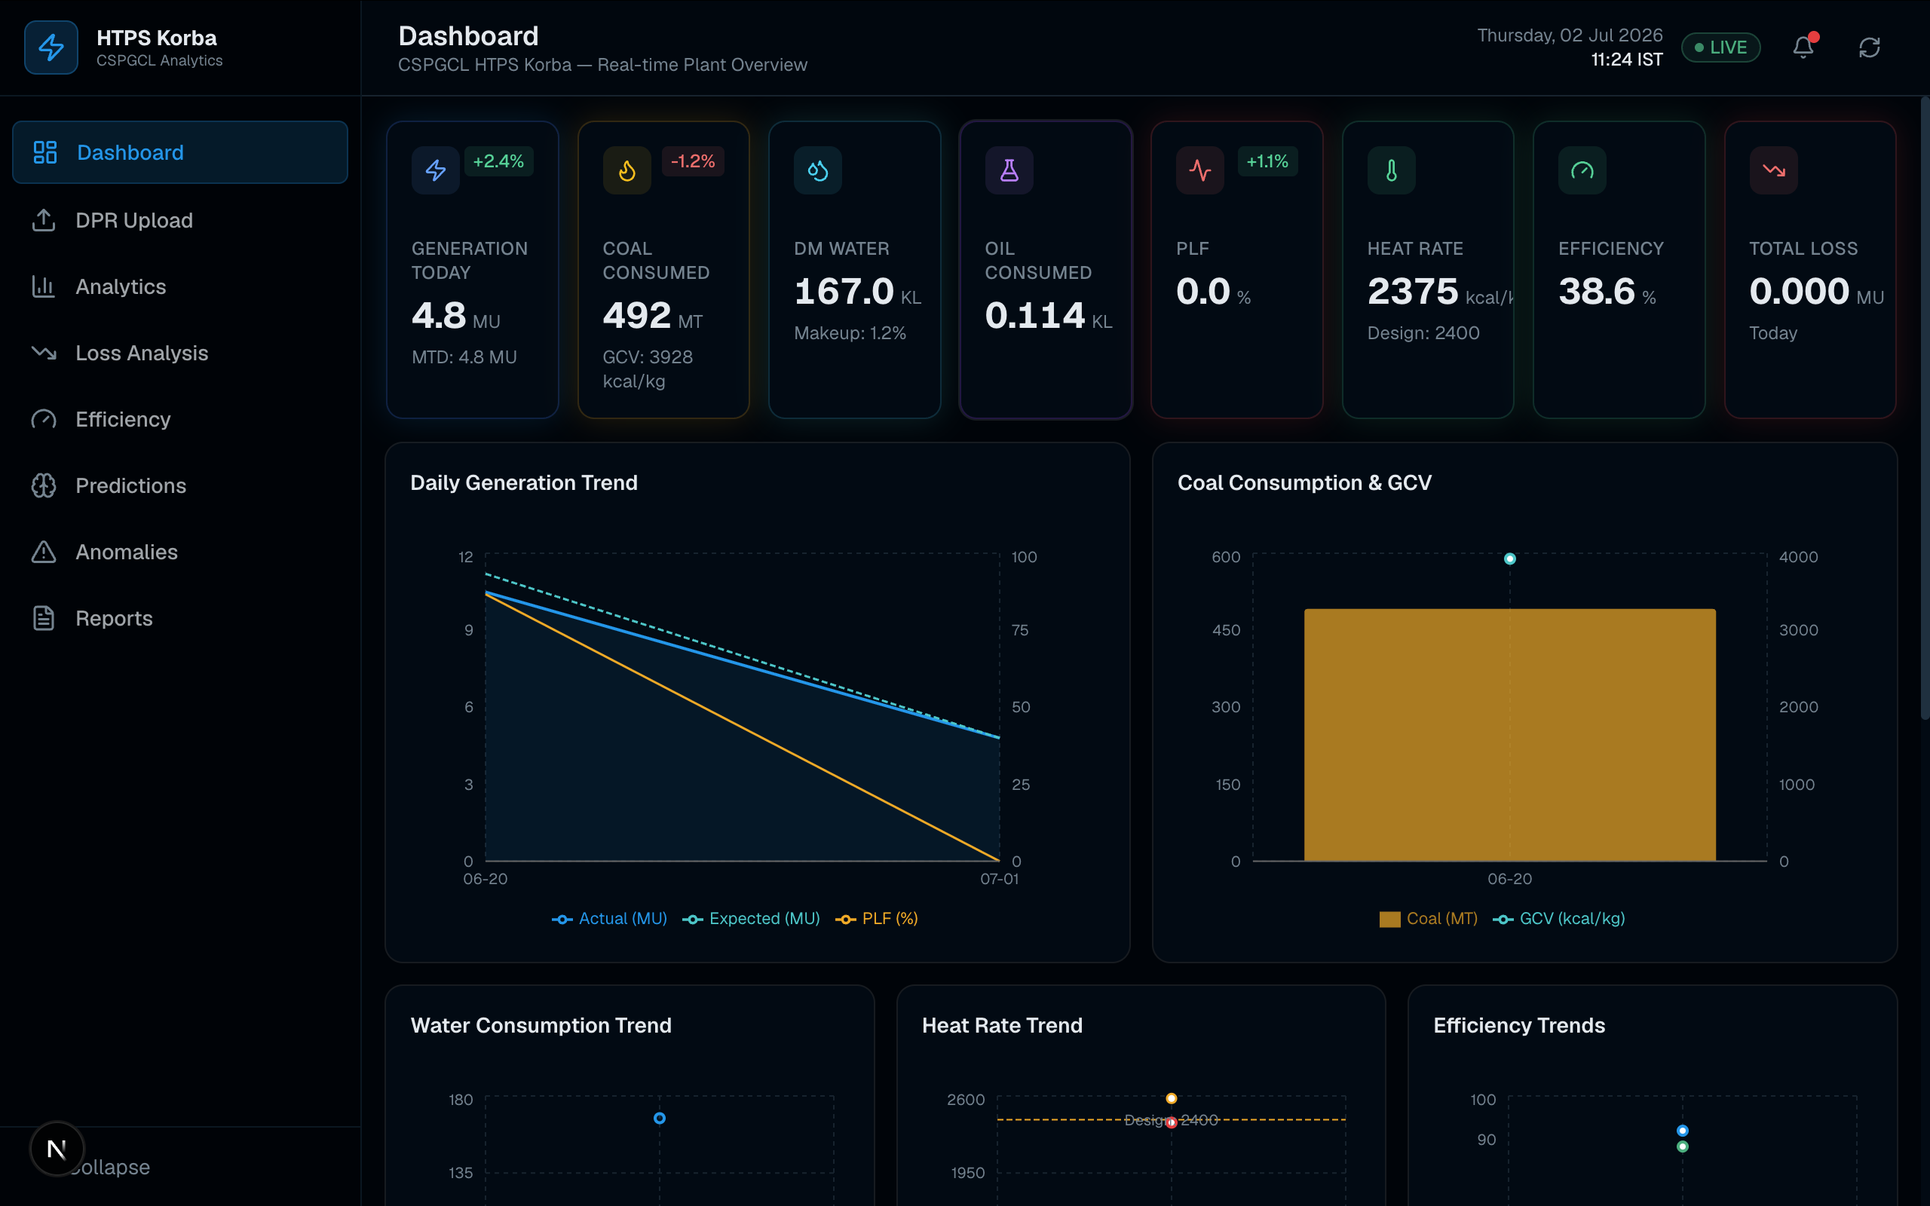
Figure 1: Main Dashboard — KPI cards and generation/coal trend charts

5.3 DPR Upload Module
This module allows plant personnel to drag-and-drop or browse for a DPR file (PDF, Excel or CSV, up to 50 MB). On upload, a progress bar tracks the parsing status, and an “Extracted Data Preview” panel displays the parsed report date, filename, file type and any fields flagged for manual review. A running Upload History table records every file processed.
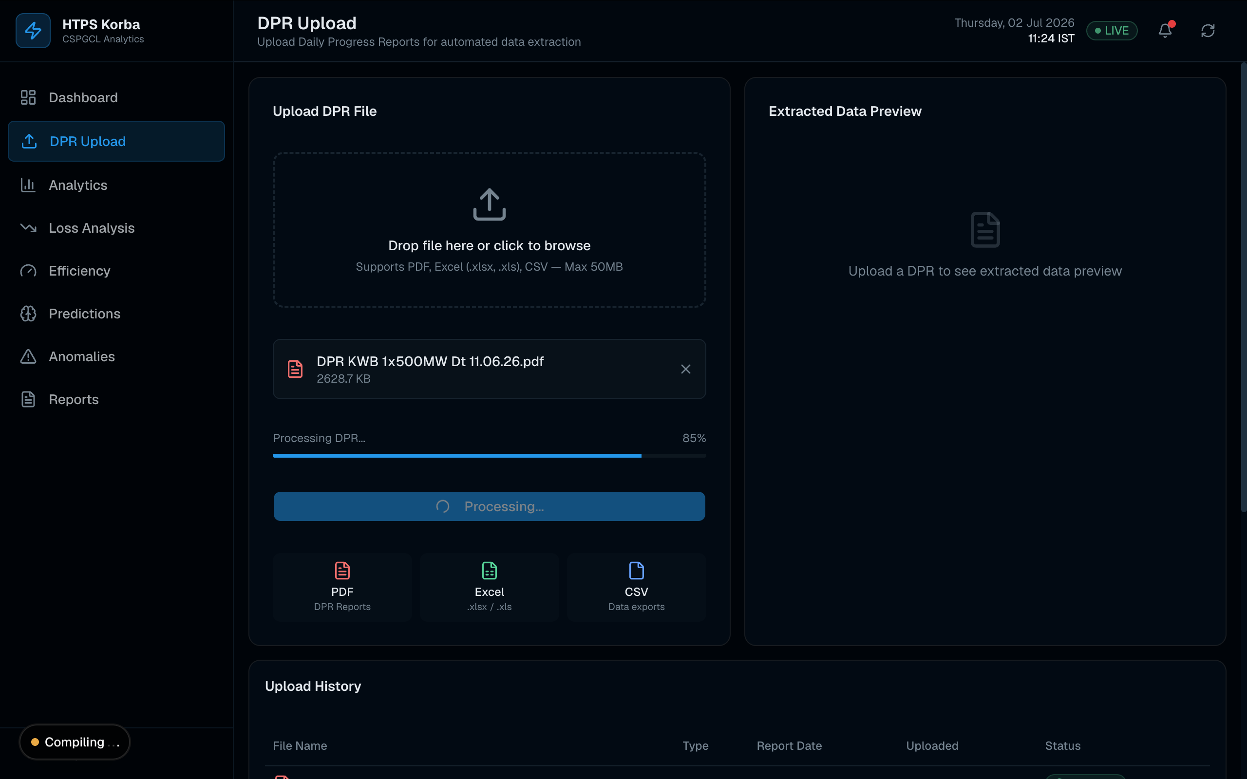
Figure 2: DPR Upload page showing file processing in progress

5.4 Analytics Module
The Analytics page provides deeper exploration through a date-range filter (Today / 7 Days / 30 Days / 1 Year / Custom) and six tabs — Generation, Fuel, Water, Efficiency, Monthly and Distribution — each rendering the relevant Recharts visualisation (line, area, bar or pie charts) for the selected period.
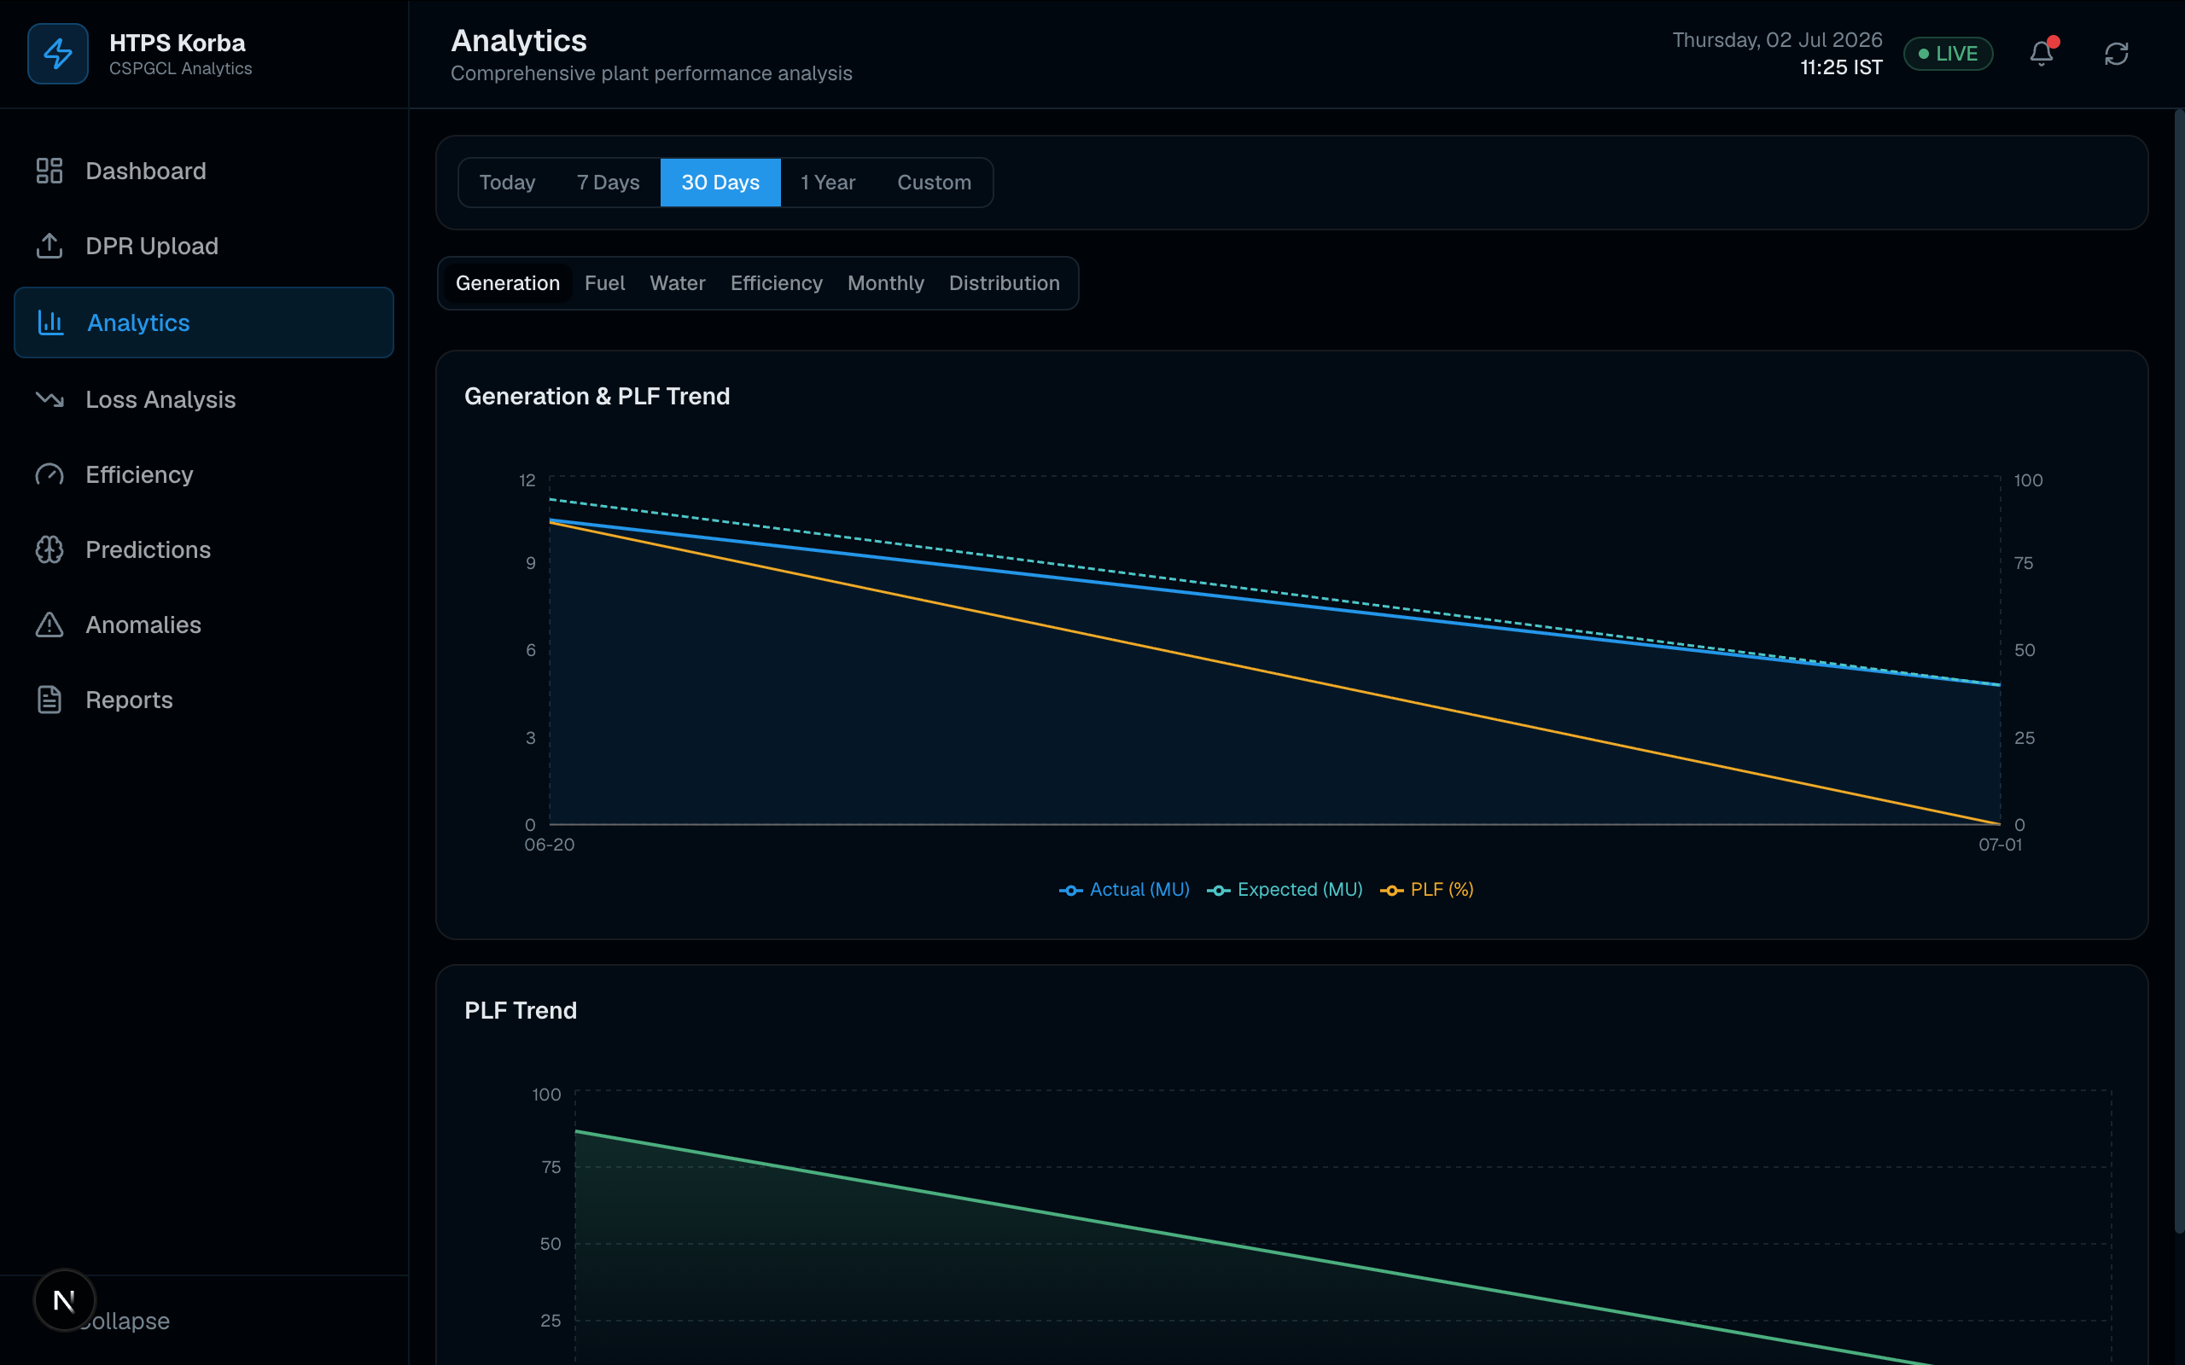
Figure 3: Analytics page — Generation & PLF trend over a 30-day window

5.5 Efficiency Monitor Module
This page tracks boiler, turbine and plant efficiency alongside gross heat rate and auxiliary consumption, each displayed as a status card (GOOD / FAIR / POOR) relative to its design target, followed by a current-vs-monthly-vs-yearly-vs-design comparison table and tabbed efficiency/heat-rate/auxiliary trend charts.
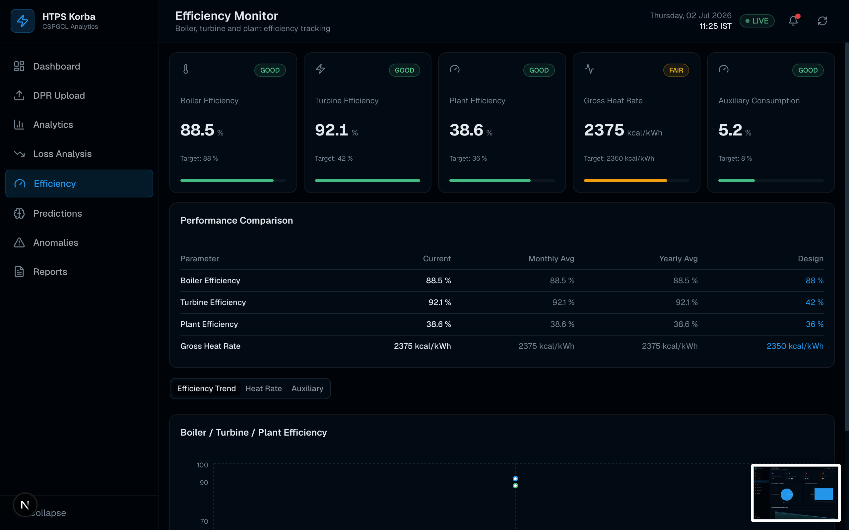
Figure 4: Efficiency Monitor — boiler, turbine, plant efficiency and heat-rate cards

5.6 Reports Module
The Reports page lets users generate Daily, Weekly, Monthly or Annual summary reports across Generation, Fuel, Efficiency and Water categories, with options to export the result as PDF or Excel.
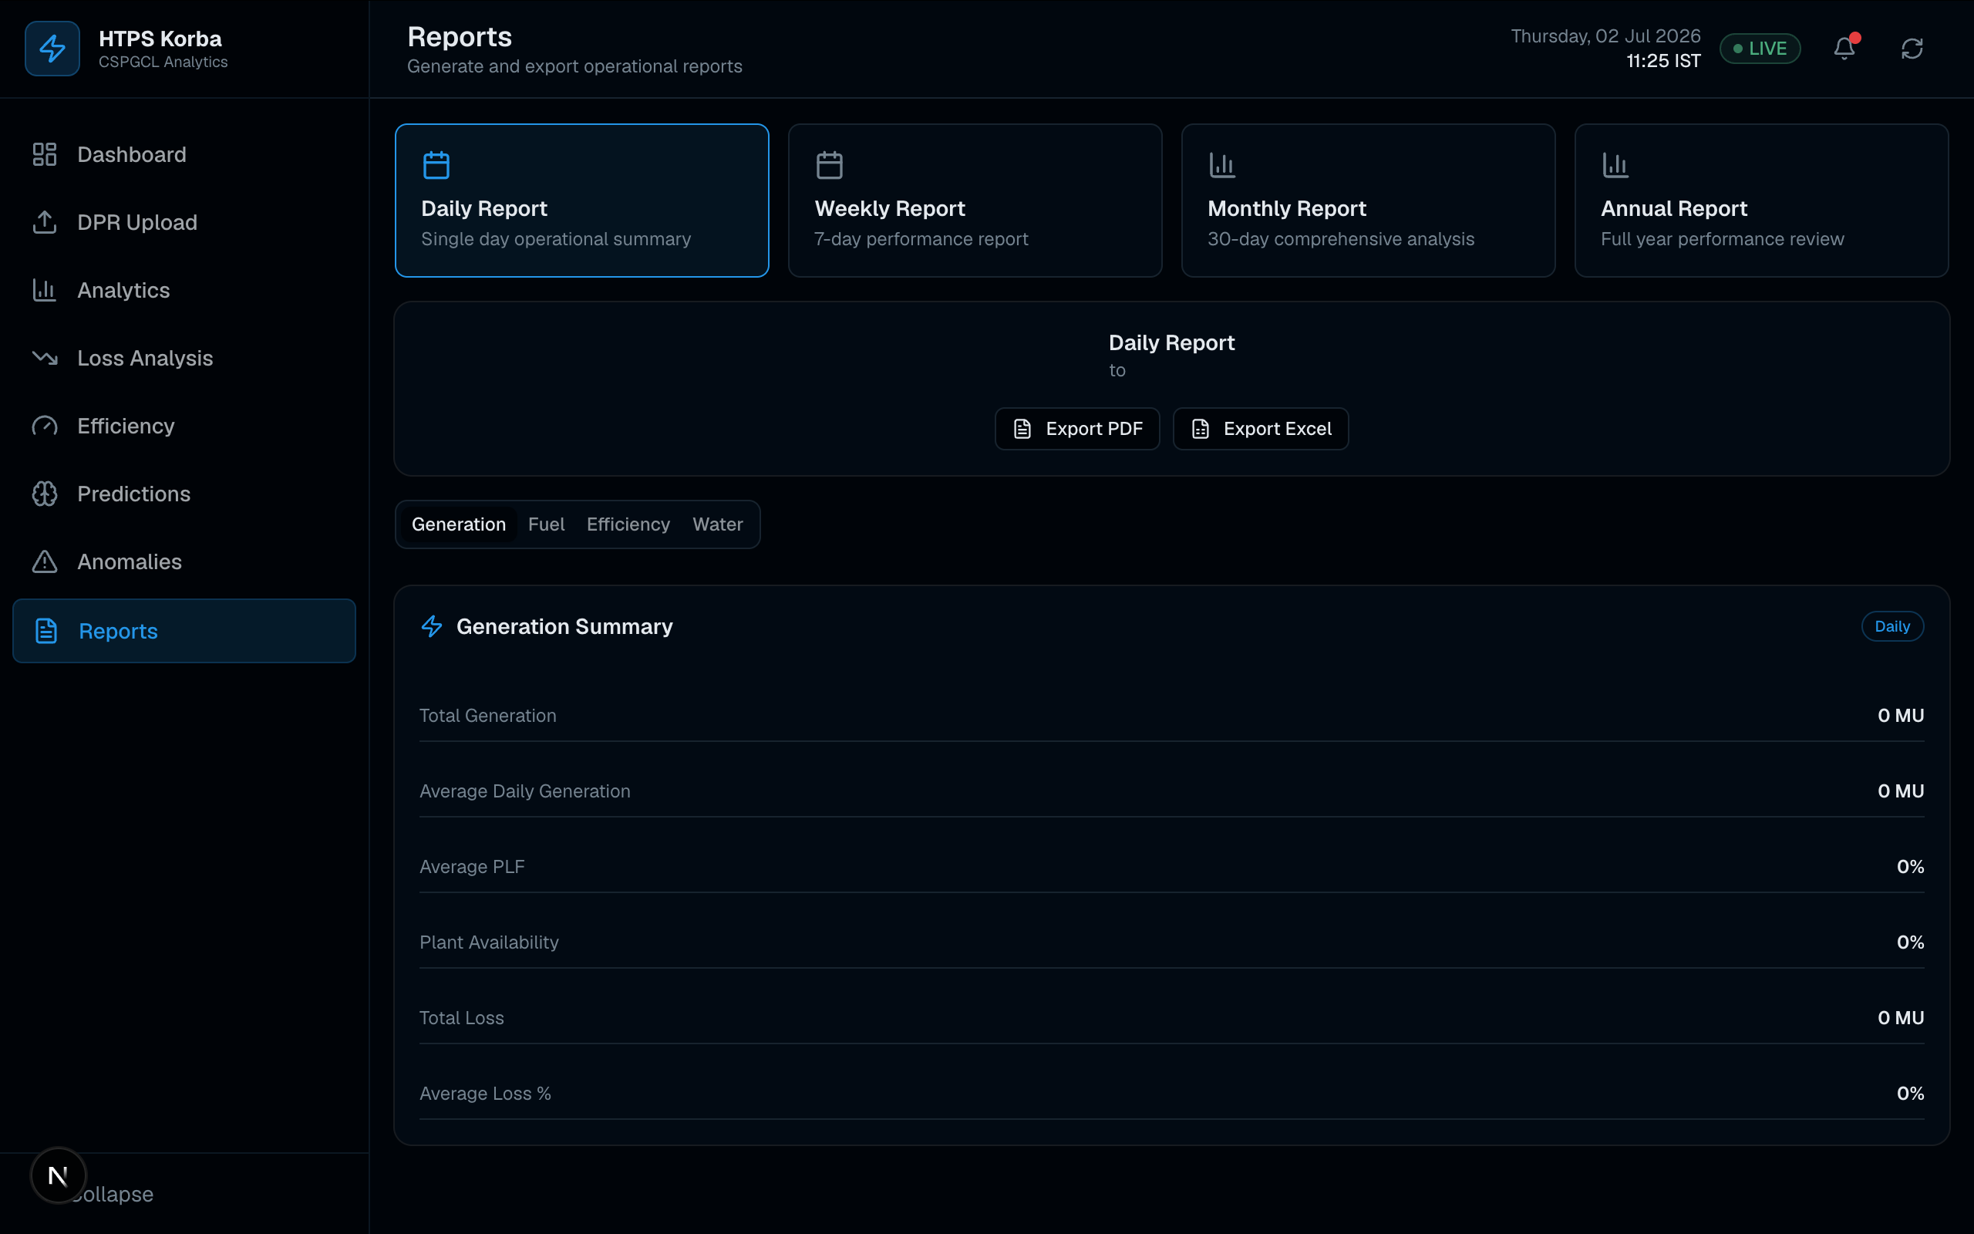
Figure 5: Reports page — report-type selection and generation summary

Chapter 6: Backend Development

6.1 API Route Design
The backend is implemented entirely within the Next.js application using Route Handlers under app/api/, giving nine REST-style endpoints: /api/dashboard, /api/analytics, /api/efficiency, /api/loss, /api/anomalies, /api/predictions, /api/reports, /api/upload and /api/dpr. Each route is responsible for querying the database, computing derived metrics (e.g., month-to-date totals, loss percentages) and returning JSON to the frontend.

6.2 Database Connectivity and Resilience
Database access is centralised in a single connection-pool module (lib/db.ts) built on node-postgres, configured via a DATABASE_URL / Supabase connection string with SSL enabled, or individual host/port/user/password environment variables as a fallback. An isDbAvailable() health-check function allows API routes to detect whether the database is reachable and, where implemented, gracefully fall back to representative sample data — which meant the dashboard remained fully demonstrable during development even before the production database was fully populated.
A representative snippet of the connection-pool logic used in the project is shown below:
const pool = new Pool({
connectionString: process.env.DATABASE_URL,
ssl: { rejectUnauthorized: false },
max: 10,
});
export async function isDbAvailable() {
try { await query('SELECT 1'); return true; }
catch { return false; }
}

6.3 File Upload and Parsing Pipeline
The /api/upload endpoint accepts multipart form uploads of up to 50 MB and dispatches the file to the appropriate parser based on its extension — lib/parsers/pdf-parser.ts, excel-parser.ts or csv-parser.ts. PDF parsing includes an OCR fallback (tesseract.js) for scanned documents that contain no extractable text layer. Every upload, along with its parsing status (pending / processing / completed / failed), is recorded in the dpr_uploads table.

6.4 Automated Insight Engine
The insight engine (lib/insights.ts) inspects the most recent generation, fuel, efficiency and loss records against a fixed set of operational thresholds and produces structured recommendations. The main rules implemented are summarised below.
Condition | Severity | Example Recommendation
Generation change > 5% day-on-day | Info / Warning | Review unit loading schedule; check for forced outages
PLF < 60% (critical if < 50%) | Warning / Critical | Inspect boiler pressure control; review turbine operating conditions
Coal GCV < 3400 kcal/kg (critical < 3200) | Warning / Critical | Notify coal procurement team; consider coal blending
Specific coal consumption > 0.78 kg/kWh | Warning | Check boiler combustion optimisation; verify excess-air settings
Gross heat rate > 2450 kcal/kWh (critical > 2550) | Warning / Critical | Inspect condenser tubes for fouling; check cooling water flow
Auxiliary power > 8.5% | Warning | Audit auxiliary equipment loading and pump/fan efficiency
Generation loss > 8% of expected (critical > 15%) | Warning / Critical | Address top-ranked loss factor; review operating procedures

Chapter 7: AI/ML-Based Prediction and DPR Parsing

7.1 Overview of the AI Microservice
In addition to the Next.js backend, the platform includes a standalone Python FastAPI microservice (ai-service/) exposing endpoints for model training, prediction and advanced document parsing. It runs independently on port 8000 and is called by the Next.js prediction and upload routes.

7.2 Generation Prediction Models
Three regression models are trained on eight operational input features — coal consumption, coal GCV, steam pressure, steam temperature, DM water, oil consumption, auxiliary consumption and load — to predict total generation, from which PLF and heat rate are derived:
- Linear Regression — trained on standardised features as a baseline model
- Random Forest Regressor (100 estimators) — captures non-linear relationships between parameters
- XGBoost Regressor (200 estimators, learning rate 0.05, max depth 6) — the best-performing model, reaching the highest accuracy on the Predictions page
Models are trained with an 80/20 train-test split and evaluated using RMSE, MAE, R² score and a derived accuracy percentage. Trained models are persisted with joblib and reloaded on service startup, retraining automatically only if no saved model is found.
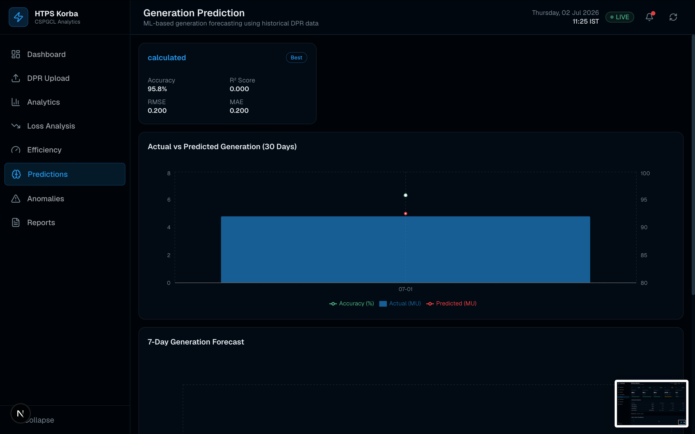
Figure 6: Generation Prediction page — model comparison, actual-vs-predicted chart and 7-day forecast

7.3 Manual and Batch Prediction
The Predictions page allows a user to manually enter operating parameters (coal consumption, GCV, steam pressure/temperature, DM water, oil consumption, auxiliary consumption, load) and instantly obtain a predicted generation, PLF, heat rate and model confidence score. The same models also power a rolling 30-day actual-vs-predicted comparison and a 7-day generation forecast shown on the same page.

7.4 Automated DPR Parsing
The ai-service also exposes /parse/csv, /parse/excel, /parse/pdf and /parse/auto endpoints. Parsing uses a field-alias dictionary mapping over 20 canonical fields (e.g., total_generation, gross_heat_rate, coal_gcv) to the many different labels used across real DPR formats (e.g., “ghr”, “heat rate (kcal/kwh)” and “heat rate” all resolve to gross_heat_rate). PDF parsing uses pdfplumber to extract raw text, locate a report date using regular expressions, and scan each line for a recognised field label followed by a numeric value.

Chapter 8: Data Analysis, Visualisation and Anomaly Detection

8.1 Loss Analysis Module
The Loss Analysis page quantifies the gap between expected and actual generation over a rolling 90-day window, breaking the total loss down into contributing factors — partial loading, coal quality, steam pressure deviation, O2 deviation, ash handling and auxiliary power increase — shown as both a pie chart (contribution share) and a ranked bar chart, alongside an expected-vs-actual generation area chart and a daily loss-percentage chart with an 8% threshold reference line.
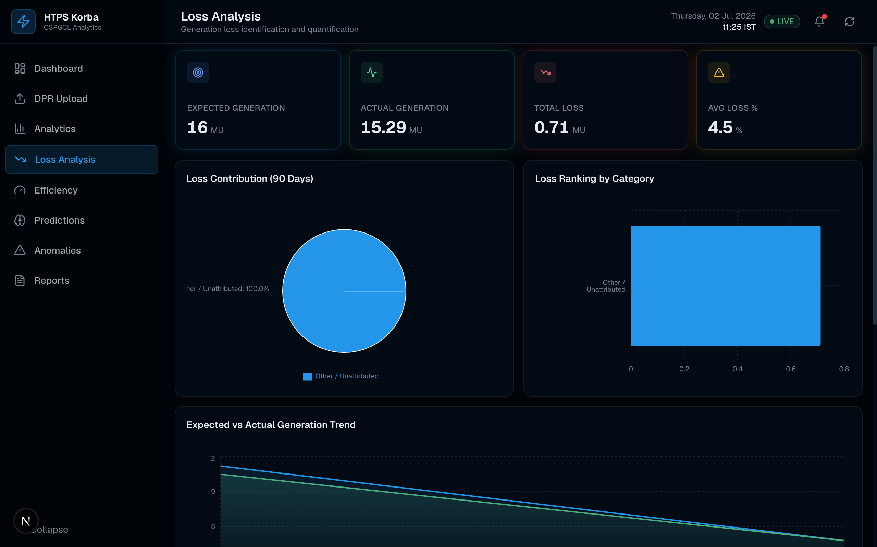
Figure 7: Loss Analysis — expected vs. actual generation and loss contribution breakdown

8.2 Anomaly Detection Module
The Anomaly Detection page summarises alerts by total count, active count, critical count and resolved count, visualises alerts by type and severity, and plots a heat-rate anomaly chart with design (2400 kcal/kWh) and alert (2500 kcal/kWh) reference lines — flagging any data point that crosses the alert threshold. A searchable alert log lists the date, type, severity, description and resolution status of every recorded alert. Alert types recognised by the schema include efficiency_drop, excess_coal, excess_oil, abnormal_water, heat_rate_spike and plf_decline, each assigned a severity of low, medium, high or critical.
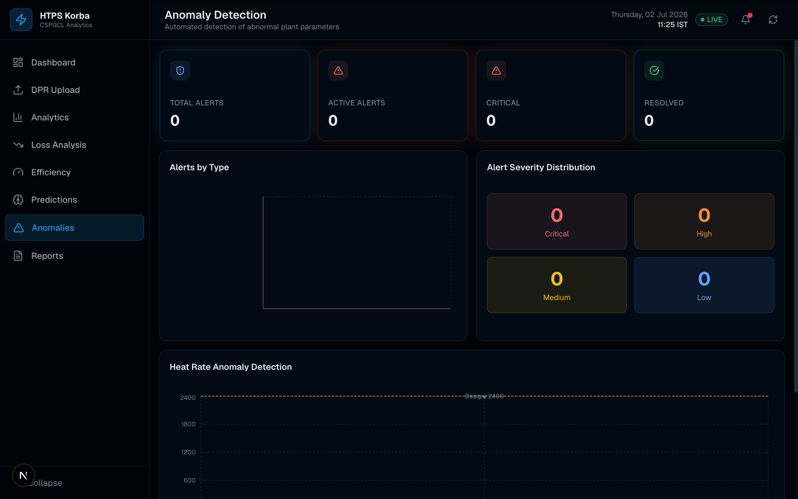
Figure 8: Anomaly Detection — alert summary and severity distribution

8.3 AI Insights Panel
On the Dashboard, the AI Insights panel surfaces the top five insights generated by the rule-based engine described in Section 6.4, each tagged with a type (generation / fuel / efficiency / loss), a severity level, a short description of the anomaly, and up to two concrete recommended actions — giving plant personnel an at-a-glance summary of what needs attention without having to interpret raw charts.

Chapter 9: Testing and Validation
A structured testing process was followed to validate both the web application and the machine-learning microservice before the platform was considered stable:
- Unit Testing — verified individual API route handlers and parser functions (CSV/Excel/PDF field extraction) for correct output on sample DPR files.
- Integration Testing — confirmed correct data flow from file upload → parsing → database insertion → API aggregation → chart rendering.
- Functional Testing — verified that every interactive feature (date filters, tab switching, manual prediction form, report-type selection) behaves as intended.
- Database Testing — validated schema constraints (e.g., unit_no between 1 and 4, unique report_date per table) and confirmed accurate query results across date ranges.
- Resilience Testing — confirmed that API routes fall back to representative sample data when the PostgreSQL database is unreachable, rather than crashing the dashboard.
- Model Validation — compared RMSE, MAE and R² across Linear Regression, Random Forest and XGBoost to confirm XGBoost as the best-performing model before setting it as the default.
- UI & Cross-Browser Testing — checked layout, responsiveness and chart rendering across different window sizes and browsers.
- User Acceptance — walked through each module with MS-IT department staff at HTPS Korba to confirm the terminology, thresholds and workflow matched real DPR practice.

9.1 Outcome
All eight modules were verified to load and render correctly, the parsing pipeline correctly extracted key fields from sample DPR files, and the prediction models produced consistent, sensible outputs across the tested input ranges. The platform was found to be stable, responsive and ready for demonstration to plant personnel.

Chapter 10: Conclusion and Future Scope

10.1 Conclusion
This vocational training project resulted in a working, full-stack Power Plant Intelligence Platform for HTPS Korba that replaces manual, spreadsheet-based DPR analysis with an automated, centralised and visually rich web application. The platform successfully integrates a modern Next.js/React frontend, a PostgreSQL relational database, and a Python-based machine-learning microservice into a single coherent system covering data ingestion, analytics, efficiency and loss monitoring, anomaly detection and generation forecasting. The training provided practical, hands-on experience in full-stack web development, database design, REST API design, and applied machine learning, all grounded in a real operational problem faced by a thermal power station.

10.2 Future Scope
- Direct integration with the plant's SCADA/DCS systems for true real-time (rather than DPR-based) data ingestion.
- Role-based access control and authentication so that different plant departments see relevant views and edit permissions.
- Deep-learning time-series models (e.g., LSTM) to improve long-horizon generation and heat-rate forecasting.
- Fully automated PDF/Excel report generation and email distribution for the Reports module (currently a client-side export stub).
- A mobile-friendly companion app for on-the-floor monitoring by shift engineers.
- Extending the platform to support multiple CSPGCL generating stations from a single consolidated dashboard.

References
- Next.js Documentation — https://nextjs.org/docs
- React Documentation — https://react.dev
- PostgreSQL Documentation — https://www.postgresql.org/docs/
- Supabase Documentation — https://supabase.com/docs
- FastAPI Documentation — https://fastapi.tiangolo.com
- scikit-learn Documentation — https://scikit-learn.org/stable/
- XGBoost Documentation — https://xgboost.readthedocs.io
- Recharts Documentation — https://recharts.org
- Chhattisgarh State Power Generation Company Limited (CSPGCL) — official records and plant operational practice, Hasdeo Thermal Power Station, Korba
- Project source code and internal documentation — HTPS Korba Power Plant Intelligence Platform (developed during this vocational training)

