Name: Priyanshu Ranjan
Reg no.:210905100
Roll no.:18
Section: C

LAB II
PYTHON BASIC PRACTICE-II
import pandas as pd
import numpy as np
import matplotlib.pyplot as plt

pip3 install lxml html5lib openpyxl

s = pd.Series([3,9,-2,10,5])
print(s.sum(),s.min(),s.max())
data = [['Dinesh',10],['Nithya',12],['Raji',13]]
df = pd.DataFrame(data,columns=['Name','Age'])
print(df)
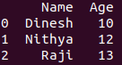

data = {'Name':['Kavitha', 'Sudha', 'Raju','Vignesh'],'Age':[28,34,29,42]}
df = pd.DataFrame(data, index=['rank1','rank2','rank3','rank4'])
print(df)
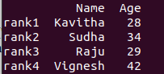

df1=pd.DataFrame({'A':pd.Timestamp('20130102'),'B':np.array([3]*4,dtype='int32'),
'C':pd.Categorical(['Male','Female','Male','Female'])})
print(df1)
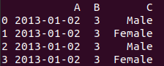

print(df1.shape)
print(df1.dtypes)
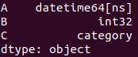

print(df1.head())
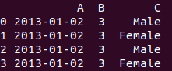

print(df1.tail())

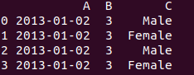

print(df1.describe())
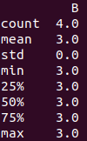

dates=pd.date_range('20130101', periods=100)

print(dates)

print(df.head())
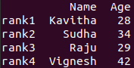

print(df.tail())

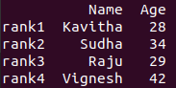

print(df.index)

print(df.columns)

print(df.T)
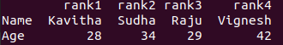
print(df.sort_index(axis=1,ascending=False))
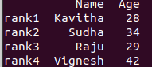

print(df.sort_values(by='Name'))
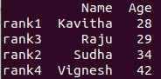

print(df[0:3])
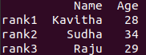

print(df.iloc[0:2])
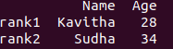

print(df[df['Age']>30])
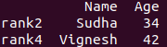

df['Gender']=['Male','Female','Female','Male']
print(df)
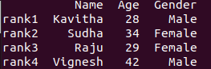

df.drop('Gender',axis=1,inplace=True)
print(df)
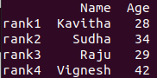

df.drop('rank1',axis=0,inplace=True)
print(df)
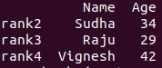

df = pd.read_csv('Lab2-files/xyz.csv',header=None)
df.columns=['preg','glu','bp','sft','ins','bmi','dpf','age','class']

print(df.head())
print(df.tail())

plt.scatter(df['bmi'],df['glu'])
plt.xlabel('bmi')
plt.ylabel('Glucose')

plt.hist(df['preg'])

plt.boxplot(df)

plt.show()

W = pd.read_csv('Lab2-files/wine_for_Week2.xls',header=None)
print(W.head())

D = np.loadtxt('Lab2-files/xyz.txt',delimiter=',')
print(D[:5,:])

G=pd.read_excel('Lab2-files/German_Credit_for_Week2.xlsx',sheet_name='Sheet1')
print(G.head())

B = pd.read_html('Lab2-files/Test runs-1.html')
print(B)

H = pd.read_table('Lab2-files/HR.txt')
print(H.head())

f = H['Department'].value_counts()
print(f)

f.plot(kind='bar')

f.plot(kind='pie')

plt.show()

