Name: Priyanshu Ranjan
Roll no.: 18
Reg no.:210905100
Sec: C

Lab-3
Python Basic Practice III

import numpy as np
A = np.array ([2,5,10])
print(A.dtype)
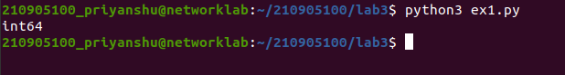

import numpy as np
B=np.array ([2.4,10.6,5.2])
print(B.dtype)

import numpy as np
A=np.array([(3,4,5),(12,6,1)])
print(A)
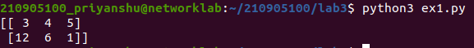

import numpy as np
Z=np.zeros((2,4))
print(Z)

U=np.ones((3,3))
print(U)

S=np.arange(10,30,5)
print(S)

A=np.arange( 0, 2, 0.3 )
print(A)

S1=np.linspace(0,2,9)
print(S1)
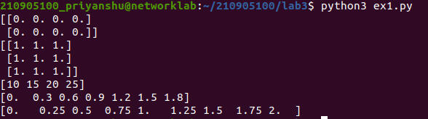

import numpy as np
import random
print(random.choice([1,2,3,4,5]))
print(random.choice('python'))
print(random.randrange(25,50))
print(random.randrange(25,50,2))
print(random.random())
print(random.uniform(5,10))
mylist=[1,2,3,4,5]
random.shuffle(mylist)
print(mylist)
random.seed(10)
print("Seed set")

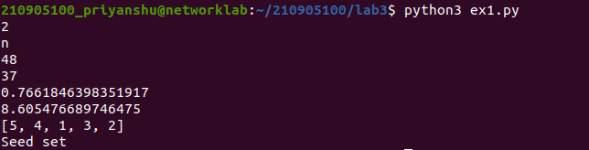
import numpy as np
a = np.arange(15).reshape(3, 5)
print(a)
print(a.shape)
print(a.size)
print(a.T)
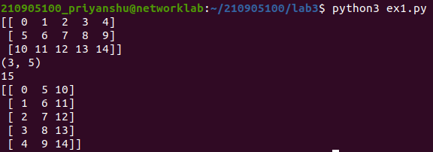
import numpy as np
c = np.arange(24).reshape(2,3,4)
print(c)
print(c.shape)
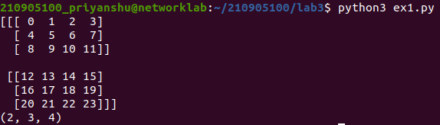

import numpy as np
a = np.array( [20,30,40,50] )
b = np.arange(4)
print(b)
c = a-b
print(c)
print(b**2)
10*np.sin(a)
print(a<35)
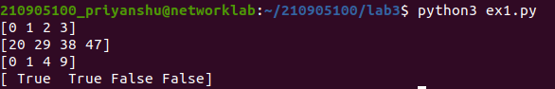

import numpy as np
A = np.array( [[1,1],[0,1]] )
B = np.array( [[2,0],[3,4]] )
print(A*B)
print(A.dot(B))
print(np.dot(A,B))

b = np.arange(12).reshape(3,4)
print(b)
print(b.sum(axis=0))
print(b.sum(axis=1))
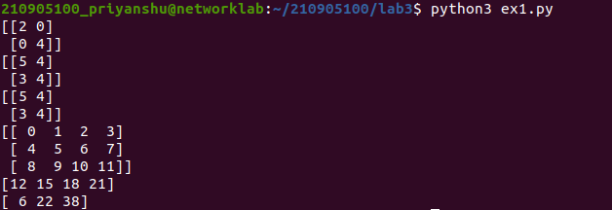

import numpy as np
a = np.arange(10)**3
print(a)
print(a[2:5])
print(a[0:6:2])
b=[[ 0, 1, 2, 3],
[10, 11, 12, 13],
[20, 21, 22, 23],
[30, 31, 32, 33],
[40, 41, 42, 43]]
b=np.array(b)
print(b[2,3])
print(b[0:5,1])
print(b[:5,1])
print(b[:,1])
print(b[-1,:])
print(b[:,-1])

for row in b:
print(row)
for element in b.flat:
print(element)
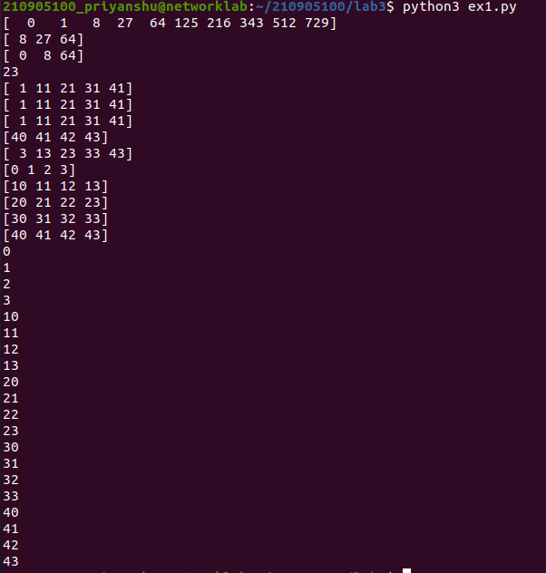
import numpy as np
b=[[ 0, 1, 2, 3],
[10, 11, 12, 13],
[20, 21, 22, 23],
[30, 31, 32, 33],
[40, 41, 42, 43]]
b=np.array(b)
flatarr=b.ravel()
print(flatarr)
B1=b.reshape(4,5)
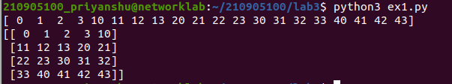
print(B1)
import numpy as np
A1=np.array([(3,4,5),(12,6,1)])
print(A1)
A2=np.array([(1,2,6),(-4,3,8)])
print(A2)
D1=np.vstack((A1,A2))
print(D1)
D2=np.hstack((A1,A2))
print(D2)
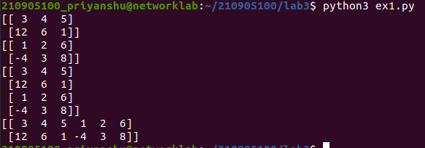
import numpy as np
a = np.array([4.,2.])
b = np.array([3.,8.])
print(np.column_stack((a,b)))
print(np.hstack((a,b)))
print(np.hstack((a[:,np.newaxis],b[:,np.newaxis])))

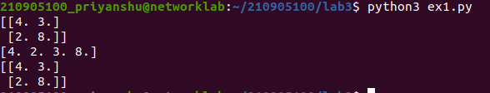
import numpy as np
a = np.arange(12)**2
i = np.array( [ 1,1,3,8,5 ] )
print(a[i])
j = np.array( [ [ 3, 4], [ 9, 7 ] ] )
print(a[j])
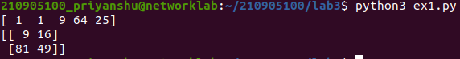
import numpy as np
a=np.array([(3,2,9),(1,6,7)])
s1=0
for row in a:
for col in row:
s1+=col
print(s1)
import numpy as np
a=np.array([(3,2,9),(1,6,7)])
s=0
for i in range(a.shape[0]):
for j in range(a.shape[1]):
s+=a[i,j]
print(s)

