Name: Priyanshu Ranjan
Roll no.: 18
Reg no.:210905100
Sec: C

Lab-4
Socket Programming using Python
1.Connection Oriented
server.py

import socket
host=socket.gethostname()
port=1112
s=socket.socket()
s.bind((host,port))
s.listen(5)
conn,addr=s.accept()
print('Got connection from',addr[0],'(',addr[1],')')
print('Thank you for connecting')
while True:
data=conn.recv(1024)
if not data:break
conn.sendall(data)
print('Received message is sent back to client')
conn.close

client.py
import socket
host=socket.gethostname()
port=1112
s=socket.socket()
s.connect((host,port))
s.sendall(b'Welcome user!')
print('Client is connected to server and it has sent the message to server')
data=s.recv(1024)
print('This is printing the message received back by the server')
print(repr(data))
s.close()

Output:
server
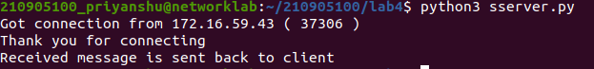
client
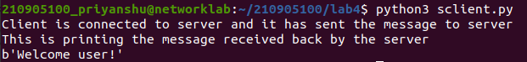

2.Connection-less approach
server.py
import socket
sock = socket.socket(socket.AF_INET,socket.SOCK_DGRAM)
udp_host = socket.gethostname()
udp_port = 12345
sock.bind((udp_host, udp_port))
while True:
print('Waiting for client...')
data,addr = sock.recvfrom(1024)
print('Received Messages:',data.decode(),'from',addr)
sock.close()

client.py
import socket
sock = socket.socket(socket.AF_INET,socket.SOCK_DGRAM)
udp_host = socket.gethostname()
udp_port = 12345
msg = "UDP Program third time!"
print('UDP target IP:', udp_host)
print('UDP target Port:', udp_port)
sock.sendto(msg.encode(),(udp_host,udp_port))
sock.sendto(msg.encode(),(udp_host,udp_port))
sock.close()

server:
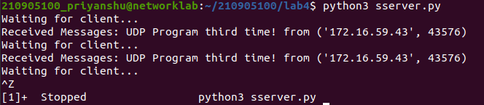
client:

3:
Write a program where client can send a message to the server and the server an
receive the message and send, or echo, it back to the client.

server.py
import socket
HOST = '127.0.0.1'
PORT = 2053
with socket.socket(socket.AF_INET, socket.SOCK_STREAM) as s:
s.bind((HOST, PORT))
s.listen()
conn, addr = s.accept()
with conn:
print('Connected by', addr)
while True:
data = conn.recv(1024)
if data:
print("Client: ",data.decode())
data = input("Enter message to client:");
if not data:
break;
conn.sendall(bytearray(data,'utf-8'));
conn.close()

client.py
import socket
HOST = '127.0.0.1'
PORT = 2053
with socket.socket(socket.AF_INET, socket.SOCK_STREAM) as s:
s.connect((HOST, PORT))
s.sendall(b'Hello, world')
data = s.recv(1024)
print('Received Connection')
print('Server:', data.decode())

server
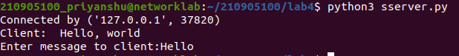
client
4:
Write a program to create TCP time server in Python
server.py
import socket
import time
serversocket = socket.socket(socket.AF_INET, socket.SOCK_STREAM)
host = socket.gethostname()
port = 9991
serversocket.bind((host, port))
serversocket.listen(5)
while True:
clientsocket,addr = serversocket.accept()
print("Got a connection from %s" % str(addr))
currentTime = time.ctime(time.time()) + "\r\n"
clientsocket.send(currentTime.encode('ascii'))
clientsocket.close()

client.py
import socket
s = socket.socket(socket.AF_INET, socket.SOCK_STREAM)
host = socket.gethostname()
port = 9991
s.connect((host, port))
tm = s.recv(1024)
print(' Current time from Sever :', tm.decode())
s.close()

server:
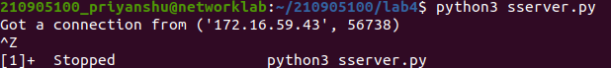
client:

5:
Write a TCP chat server in python using socket programming.
server.py
import socket
HOST = '127.0.0.1'
PORT = 31621
s = socket.socket()
s.bind((HOST, PORT))
s.listen()
print("\nWaiting for incoming connections...\n")
conn, addr = s.accept()
print("Received connection from ", addr[0], "(", addr[1], ")\n")
s_name = conn.recv(1024)
s_name = s_name.decode()
print(s_name, "has connected to the chat room\nEnter [e] to exit chat room\n")
name = input(str("Enter your name: "))
conn.send(name.encode())
while True:
message = input(str("Me : "))
if message == "[e]":
message = "Left chat room!"
conn.send(message.encode())
print("\n")
break
conn.send(message.encode())
message = conn.recv(1024)
message = message.decode()
print(s_name, ":", message)

client.py
import socket
HOST = '127.0.0.1'
PORT = 31621
s = socket.socket()
name = input(str("\nEnter your name: "))
print("\nTrying to connect to ", HOST, "(", PORT, ")\n")
s.connect((HOST, PORT))
print("Connected...\n")
s.send(name.encode())
s_name = s.recv(1024)
s_name = s_name.decode()
print(s_name, "has joined the chat room\nEnter [e] to exit chat room\n")
while True:
message = s.recv(1024)
message = message.decode()
print(s_name, ":", message)
message = input(str("Me : "))
if message == "[e]":
message = "Left chat room!"
s.send(message.encode())
print("\n")
break
s.send(message.encode())
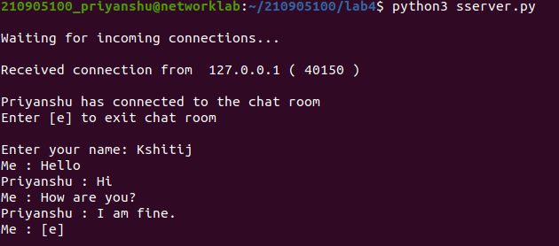
server:

client:
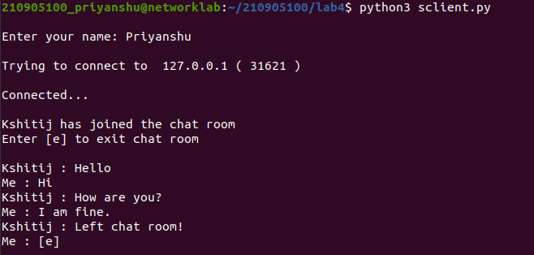

6:
Forking/ Threading (Concurrent Server)
server.py
import socket
import os
from _thread import *
ServerSocket = socket.socket()
host = '127.0.0.1'
port = 1233
ThreadCount = 0
try:
ServerSocket.bind((host, port))
except socket.error as e:
print(str(e))
print('Waitiing for a Connection..')
ServerSocket.listen(5)
def threaded_client(connection):
connection.send(str.encode('Welcome to the Servern'))
while True:
data = connection.recv(2048)
reply = 'Server Says: ' + data.decode('utf-8')
if not data:
break
connection.sendall(str.encode(reply))
connection.close()
while True:
Client, address = ServerSocket.accept()
print('Connected to: ' + address[0] + ':' + str(address[1]))
start_new_thread(threaded_client, (Client, ))
ThreadCount += 1
print('Thread Number: ' + str(ThreadCount))
ServerSocket.close()

client.py
import socket
ClientSocket = socket.socket()
host = '127.0.0.1'
port = 1233
print('Waiting for connection')
try:
ClientSocket.connect((host, port))
except socket.error as e:
print(str(e))
Response = ClientSocket.recv(1024)
while True:
Input = input('Say Something: ')
ClientSocket.send(str.encode(Input))
Response = ClientSocket.recv(1024)
print(Response.decode('utf-8'))
ClientSocket.close()

server:
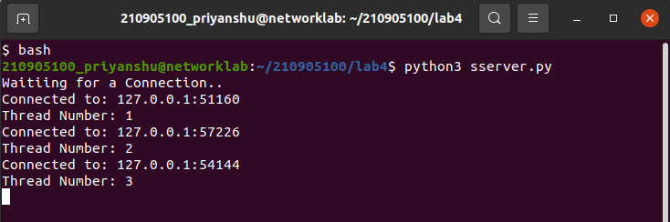
client:
1-
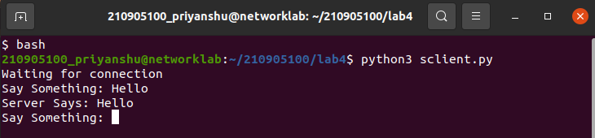
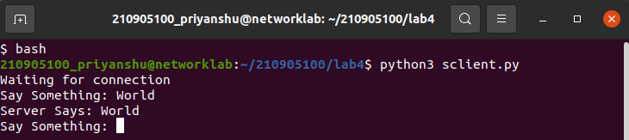
2-

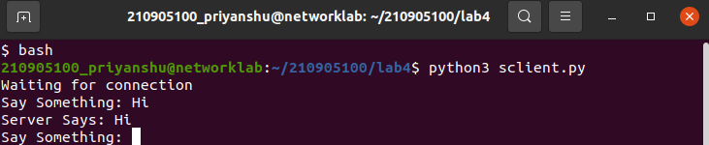
3-

