What is the output on PC1 when the ping commands are issued?
• Which packets, if any, are captured by Wireshark?
• Do you observe any ARP packets? If so, what do they indicate?1)
1. Switching Cisco IOS Command Modes
This exercise demonstrates how to log into a router and how to work with the different Cisco
IOS command modes. It is important to understand the different modes so you know where you
are and what commands are accepted at any time.
i. Connect the Ethernet interfaces of the Linux PCs and the Cisco router as shown in Figure 6.7.
Do not turn on the Linux PCs yet.
ii. Right-click on Router1 and choose Start.
iii. Right-click on Router1 and choose Console. Wait a few seconds until the router is initialized.
If everything is fine, you should see the prompt shown below. This is the User EXEC mode. If
the prompt does not appear, try to restart GNS3 and repeat the setup again.

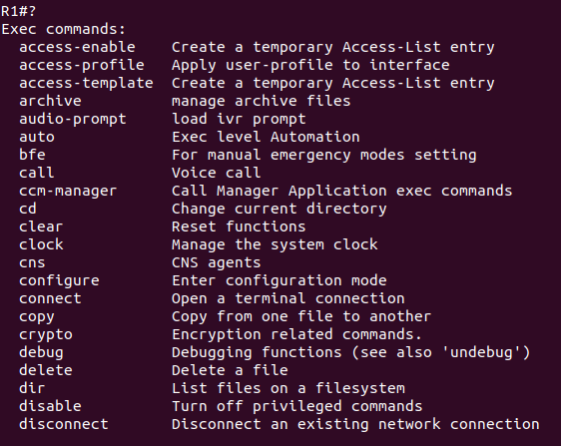
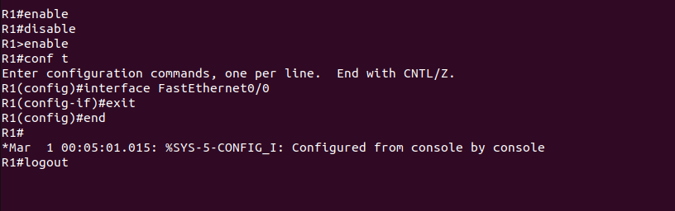
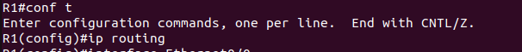
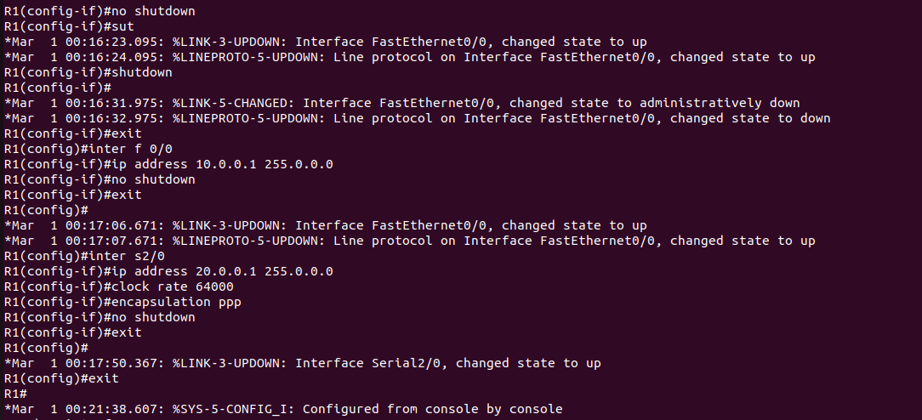
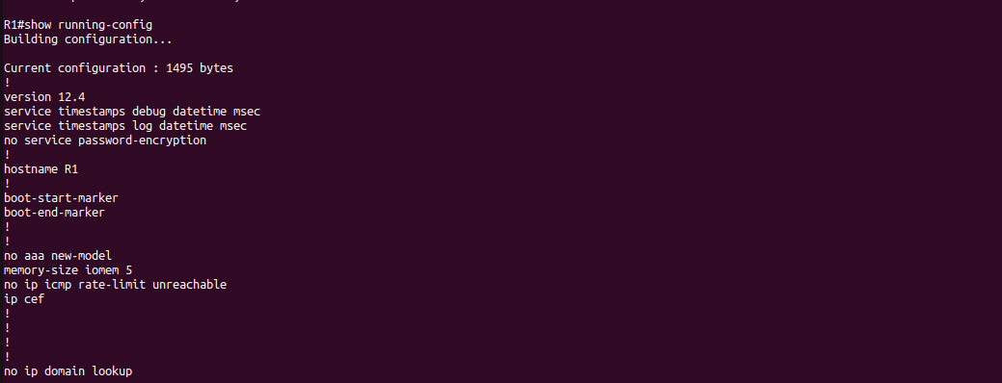

i. Issue a ping command from PC1 to PC2, Router1 and PC4, respectively

Pc1 to pc2
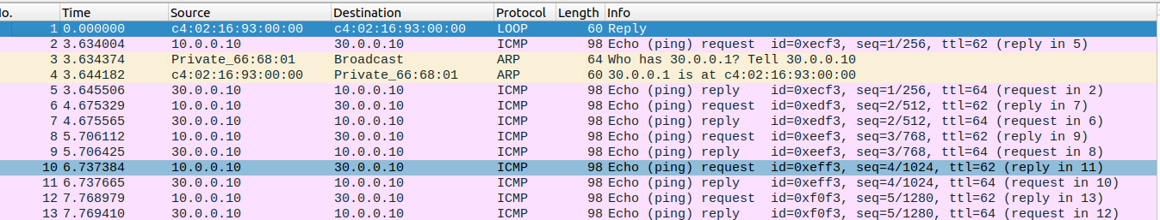
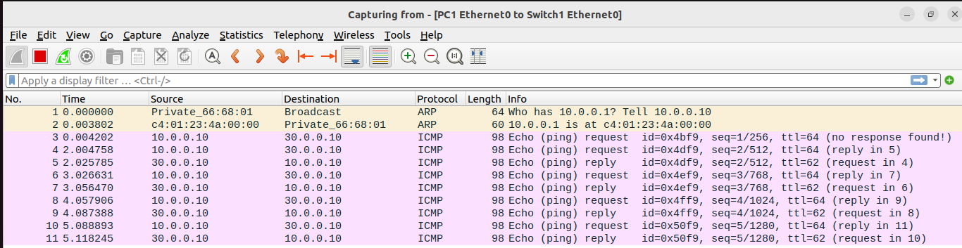
pc1 to r1
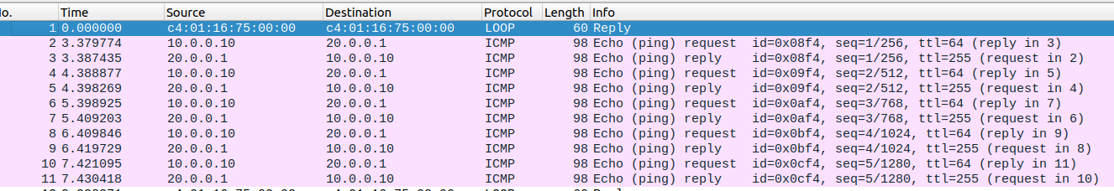
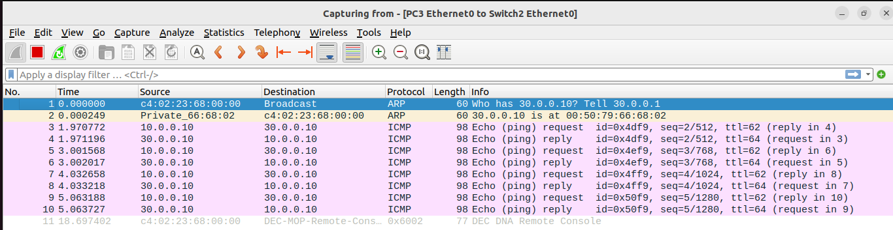
• Which packets, if any, are captured by Wireshark?
ARP & ICMP
• Do you observe any ARP packets? If so, what do they indicate?
ARP Packet is observed in the ping from pc1 to pc2. ARP broadcasts a request packet to find the destination IP address.

2. In the CSE department, two students sitting in two different labs want to establish a
connection and send the data. So, configure the below network topology as shown in Figure.
6.8 and check the connectivity by pinging from PC0 to PC2.

