Name: Priyanshu Ranjan
Roll no.: 18
Reg no.: 210905100
LAB 6
Computer Network Design using SWITCH and ROUTERS in GNS3
II.
LAB EXERCISES
1. Switching Cisco IOS Command Modes
This exercise demonstrates how to log into a router and how to work with the different Cisco
IOS command modes. It is important to understand the different modes so you know where you
are and what commands are accepted at any time.
i. Connect the Ethernet interfaces of the Linux PCs and the Cisco router as shown in Figure 6.7.
Do not turn on the Linux PCs yet.
ii. Right-click on Router1 and choose Start.
iii. Right-click on Router1 and choose Console. Wait a few seconds until the router is initialized.
If everything is fine, you should see the prompt shown below. This is the User EXEC mode. If
the prompt does not appear, try to restart GNS3 and repeat the setup again.
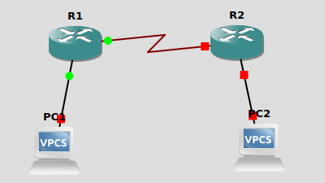

Router1>
iv. To see which commands are available in this mode, type ?:
-->Router1>?
R1#?
Exec commands:
access-enable Create a temporary Access-List entry
access-profile Apply user-profile to interface
access-template Create a temporary Access-List entry
archive manage archive files
audio-prompt load ivr prompt
auto Exec level Automation
bfe For manual emergency modes setting
call Voice call
ccm-manager Call Manager Application exec commands
cd Change current directory
clear Reset functions
clock Manage the system clock
cns CNS agents
configure Enter configuration mode
connect Open a terminal connection
copy Copy from one file to another
crypto Encryption related commands.
debug Debugging functions (see also 'undebug')
delete Delete a file
dir List files on a filesystem
disable Turn off privileged commands

v. To view and change system parameters of a Cisco router, you must enter the Privileged EXEC
mode by typing:
-->R1>enable
R1#

vi. Type the following command to disable the Privileged EXEC mode
-->R1# disable

vii. To modify system wide configuration parameters, you must enter the global configuration
mode. This mode is entered by typing:
Router1#configure terminal
Router1(config)#
or
Router1#conf t
Router1(config)#
-->R1>enable
R1#configure terminal
Enter configuration commands, one per line. End with CNTL/Z.

viii. To make changes to a network interface, enter the interface configuration mode, with the
command:
Router1(config)#interface FastEthernet0/0
Router1(config-if)#
-->R1(config)#interface FastEthernet0/0
R1(config-if)#

The name of the interface is provided as an argument. Here, the network interface that is
configured is FastEthernet0/0.

ix. To return from the interface configuration to the global configuration mode, or from the
global configuration mode to the Privileged EXEC mode, use the exit command:
Router1(config-if)#exit
Router1(config)#exit
Router1#
-->R1(config-if)#exit
R1(config)#exit
R1#

The exit command takes you one step up in the command hierarchy. To directly return to the
Privileged EXEC mode from any configuration mode, use the end command:
Router1(config-if)#end
Router1#
-->R1(config-if)#end
R1#
x. To terminate the console session from the User EXEC mode, type logout or exit:
Router1>logout
Router con0 is now available
Press RETURN to get started
-->R1#logout
R1 con0 is now available
Press RETURN to get started.

2. Configuring a Cisco Router via the console
The following exercises use basic commands from the Cisco IOS that are needed to configure a
Cisco router.
i. Right-click on Router1 and choose Start.
ii. Right-click on Router1 and choose Console. Wait some seconds until the initial console
window is set up. When the router is ready to receive commands, proceed to the next step.
iii. Configure Router1 and Router 2 with the IP addresses given in Figure 6.7.
--->ROUTER 1
R1(config)#inter f 0/0
R1(config-if)#ip address 10.0.0.1 255.0.0.0
R1(config-if)#no shutdown
R1(config-if)#exit

R1(config)#inter s2/0
R1(config-if)#ip address 20.0.0.1 255.0.0.0
R1(config-if)#clock rate 64000
R1(config-if)#encapsulation ppp
R1(config-if)#no shutdown
R1(config-if)#exit

ROUTER 2
R2#configure terminal
Enter configuration commands, one per line. End with CNTL/Z.
R2(config)#inter f0/0
R2(config-if)#ip address 30.0.0.1 255.0.0.0
R2(config-if)#no shutdown
R2(config-if)#exit

R2(config)#inter s2/0
R2(config-if)#ip address 20.0.0.2 255.0.0.0
R2(config-if)#encapsulation ppp
R2(config-if)#no shutdown
R2(config-if)#exit

iv. When you are done, use the following command to check the changes you made to the router configuration, and save the outputs:
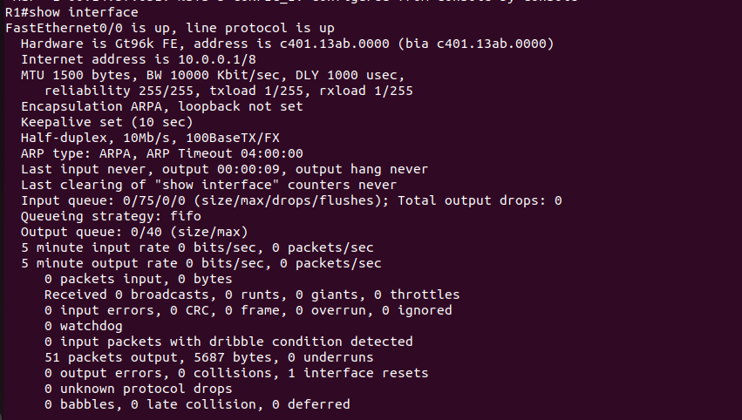

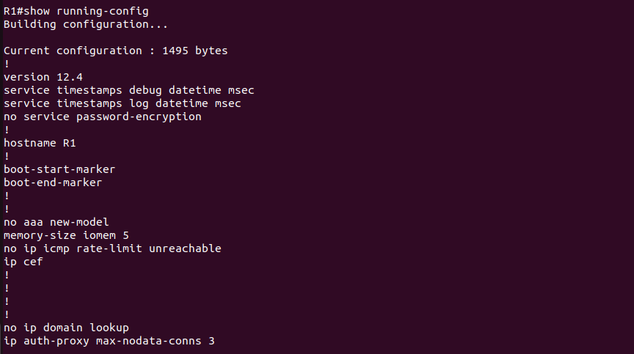

3. Setting static routing table entries on a Cisco router
In this exercise, you will add static routes to the routing table of Router1. The routing table must
be configured so that it conforms to the network topology shown in Figure 6.7. The routes are
configured manually, which is also referred to as static routing.
The IOS command to configure static routing is ip route.

-->R1(config)#ip route 30.0.0.0 255.0.0.0 20.0.0.2
R2(config)#ip route 10.0.0.0 255.0.0.0 20.0.0.1

Now both routers know all the networks.
i. Issue a ping command from PC1 to PC2, Router1 and PC4, respectively
ii. Save the captured Wireshark output.
PC1->PC2
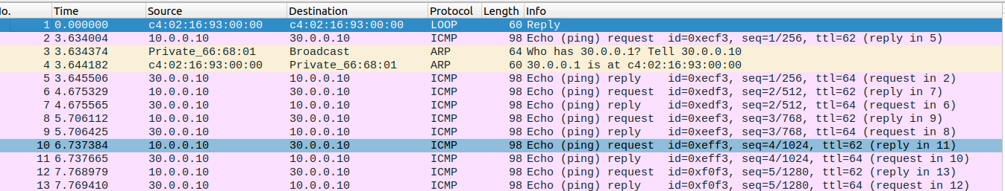
pc1 to r1
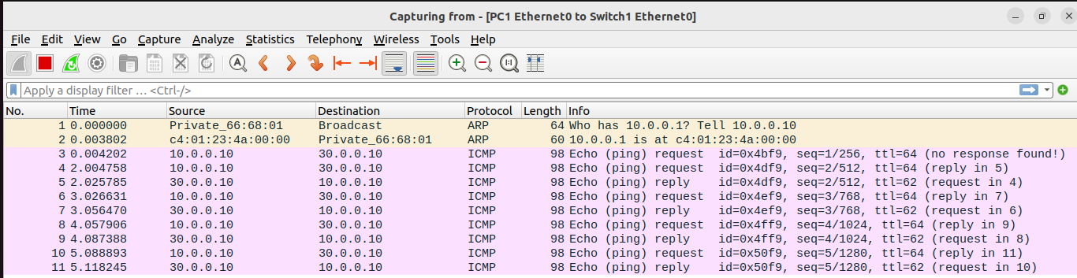

iii. Use the saved data to answer the following questions:
• What is the output on PC1 when the ping commands are issued?
• Which packets, if any, are captured by Wireshark?
• Do you observe any ARP packets? If so, what do they indicate?

II. In the CSE department, two students sitting in two different labs want to establish a
connection and send the data. So, configure the below network topology as shown in Figure.
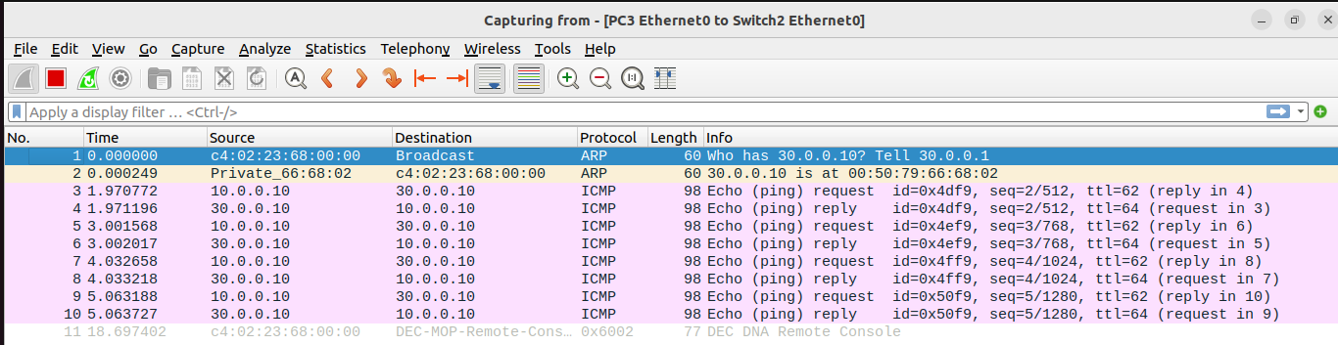
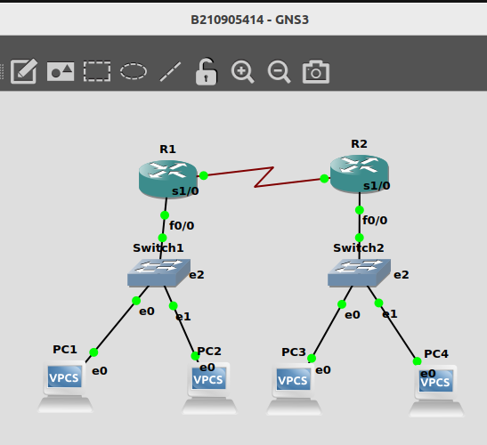
6.8 and check the connectivity by pinging from PC0 to PC2.

