
Operations Suite
User and technical documentation

What this document explains: what every tool in the Suite does, why it is there, and how to use it step by step - with diagrams, tables and screenshots of the real program.
Item | Detail
Program | LATRICS Operations Suite - latrics_suite.py (one Python / tkinter file, seven tools inside)
Company | Latrics India Pvt Ltd | LatricsAI Operations Team
Document version | 2.0 (replaces version 1.0 of 14 October 2026)
Date | 20 October 2026
Suite version | 1.0
Audience | Operations and processing staff; developers who maintain the Suite (Chapter 8)

What is new in version 2.0
New white and red look with the LATRICS logo.
Image Enhancer added as a tool.
Hidden Settings box in every tool - open it only when you need to change something.
Same tick column (Use), Tick all / Tick none, Scan and RUN TICKED FLIGHTS behaviour in every multi-flight tool.
Flight preview, Files found and Result ring panels.
GNSS Pre-Check drop box and Geotag "Process automatically" tick box removed.

Contents
Chapter | Title
1 | Overview - what, why and who
2 | Requirements and installation
3 | The Suite window
4 | Features you will see in every tool
5 | Tool guide
 | 5.1 GNSS Pre-Check 5.2 Data Pre-Check 5.3 Image Enhancer 5.4 Event Generation
 | 5.5 Geotag Pipeline 5.6 Ortho Launcher 5.7 LiDAR Tool
6 | Reading the results
7 | Troubleshooting
8 | How it is built and how to maintain it
9 | Quick reference
A | Glossary

Tip: figures with red numbered circles are explained in the table directly under them. Read the circle number, then find the same number in the table.

1. Overview - what, why and who

1.1 What the Suite is
The LATRICS Operations Suite is one desktop window that brings together every tool the operations team uses to take drone survey data from raw flight files to processed output. You pick a tool in the left sidebar and work inside the same window, with the same look, the same buttons and the same saved settings.
The Suite only provides the window, the sidebar, the dashboard, projects and team defaults. Each tool keeps its own code and its own processing - the Suite does not change how a tool calculates anything.

1.2 Why it exists
Before | With the Suite
Seven separate programs, each with its own window and layout | One window, one sidebar, one look
Settings typed again for every job | Projects remember every field; team defaults give everyone the same start values
Different buttons for the same action (Scan, Run, select flights) | The same Scan, tick column and RUN button in every tool
Problems found late, after hours of processing | Checks (GNSS Pre-Check, Data Pre-Check, Files found) show missing data before you run
Results only in text and tables | Result rings and bars show the answer at a glance

1.3 The tools
Group | Tool | Purpose | Input / Output
CHECKS | GNSS Pre-Check | Scores satellites and constellations, checks take-off and landing coverage, compares base and rover. | IN: base + rover RINEX  OUT: Word report + CSV
CHECKS | Data Pre-Check | Three stages: before events (disk, image quality), after events (events vs images, solution colours), after geotagging (GCP check). | IN: images, events, POS, GCP  OUT: one Word report + CSV
PHOTO PROCESSING | Image Enhancer | Finds dark, over-exposed and blurry photos and writes a new folder with corrected copies. Originals are never changed. | IN: flight folder(s)  OUT: <flight>\Enhanced + Enhancement_Report.csv
PHOTO PROCESSING | Event Generation | Batch PPK for many flights: decodes KQ .dat, runs RTKLIB, matches photos to camera events. | IN: Base, Pos (.dat), Image folders  OUT: Pos_Camera.txt + Event_Report.csv
PHOTO PROCESSING | Geotag Pipeline | Septentrio SBF + base to RINEX, PPK, event matching and geotagged JPG copies. | IN: <DATE>\BASE DATA + FLIGHT DATA  OUT: GEOTAG\ CSV / Excel + *_Geotagged JPG
PHOTO PROCESSING | Ortho Launcher | Prepares and submits the Metashape network ortho pipeline and shows the live log. | IN: main folder with flights + event files  OUT: Metashape project / ortho
LIDAR PROCESSING | LiDAR Tool | POS trajectory, automatic strip division, PointsCreator .lip, Start Calc. | IN: POS / Pos *.dat + base  OUT: <Name>.lip + stripinfo.json

Note
The GCP Planner (target placement from KML) is a separate stand-alone program, LATRICS_GCP_Planner.py. It is not part of the Suite.

1.4 How the work flows
The numbers 1 to 7 in the sidebar follow the usual order of a job. Check the data first, make the camera positions, check again, then produce the deliverable.
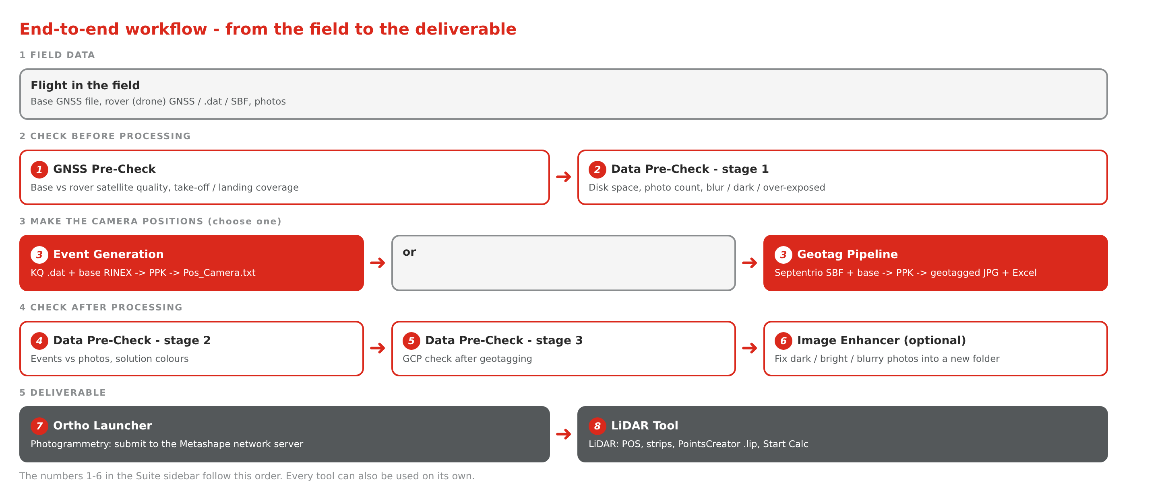
Figure 1 - End-to-end workflow, from field data to deliverable

2. Requirements and installation

2.1 What you need
Item | Requirement
Operating system | Windows (LiDAR Start Calc automation and the administrator restart are Windows features). The other tools also run on Linux / macOS for development.
Python | 3.8 or newer, with tkinter (included in the standard Windows installer).
External software | Metashape (Ortho Launcher) and PointsCreator (LiDAR Tool). RTKLIB is built into the tools - no separate install.
Disk space | Enough free space for processing; Data Pre-Check checks it for you (it needs about three times the image size).

2.2 Python packages
Package (pip name) | Used by | Required?
numpy | All tools except Ortho Launcher | Yes
matplotlib | GNSS Pre-Check, Data Pre-Check | Yes
python-docx | GNSS Pre-Check, Data Pre-Check (Word report) | Yes
pillow | Data Pre-Check, Geotag Pipeline, Image Enhancer | Yes
piexif | Geotag Pipeline (write GPS to JPG) | Yes
openpyxl | Geotag Pipeline (Excel) | Yes
pywinauto | LiDAR Tool - Start Calc | Yes on Windows
pyproj | Event Generation, LiDAR Tool | Optional
tkinterdnd2 | Drag and drop in the pre-checks | Optional

2.3 Install and start
- Copy latrics_suite.py to a folder on the PC, for example C:\LATRICS\Suite.
- Start it: python latrics_suite.py
- Open the Dashboard. It lists every package as installed or missing.
- Use the install button on the Dashboard for missing packages (needs internet).
- For LiDAR Start Calc, click Restart as admin at the bottom of the sidebar.
To open one tool directly: python latrics_suite.py --page lidar (also gnss, data, enhancer, events, geotag, ortho).

3. The Suite window
The window always has the same four parts. Figure 2 shows the Dashboard with the parts numbered.
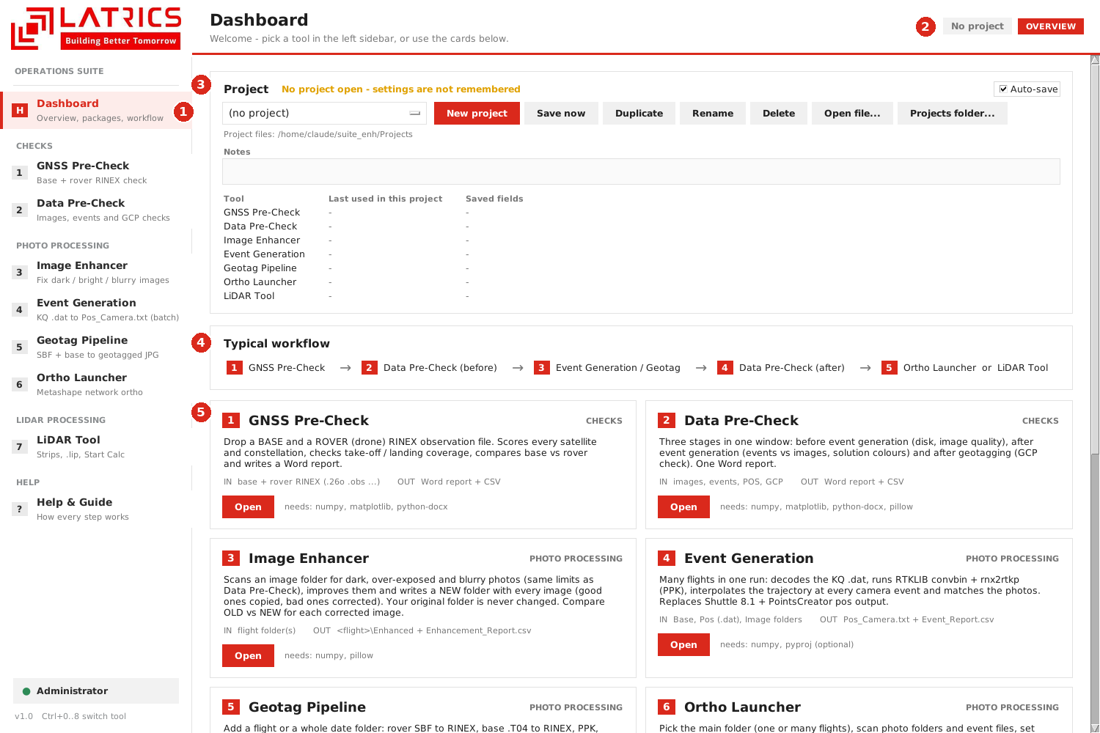
Figure 2 - The Dashboard (opening page of the Suite)
1 | Sidebar - the tools in the order of the work (Dashboard, 1-7, Help & Guide). The red bar marks the tool you are in. At the bottom, a chip shows whether the Suite runs as Administrator.
2 | Header bar - tool name, the open project, Save as default, Reset tool and the group tag (CHECKS, PHOTO PROCESSING, LIDAR PROCESSING).
3 | Project card - create, open, save, duplicate, rename or delete a project; Auto-save tick box; Notes.
4 | Typical workflow - the five usual steps of a job.
5 | Tool cards - short description, input and output, the packages needed, and an Open button.

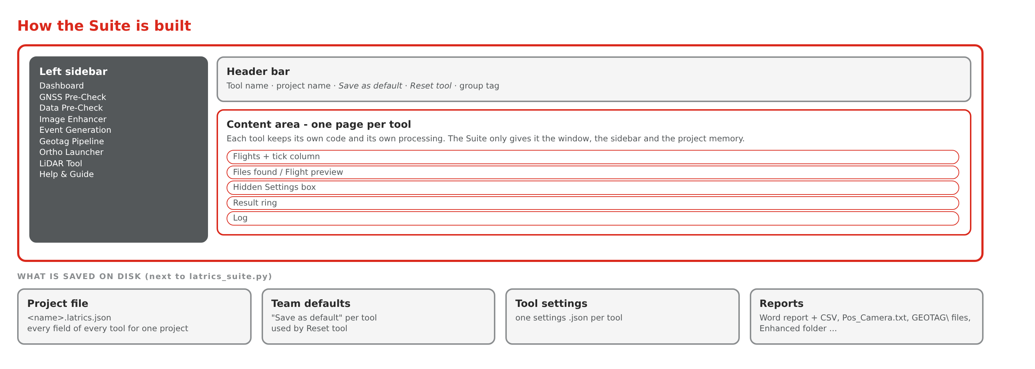
Figure 3 - How the Suite window is organised and what it saves on disk

3.1 Projects
What it does | Stores every field of every tool (folders, numbers, options) in one file, <ProjectName>.latrics.json.
Why you need it | You can close a job and reopen it later exactly as it was. Nobody has to retype folders and settings.
You need | Click New project on the Dashboard and type a name, for example UP Ganga.

- Dashboard > New project, type the name.
- Work in any tool - with Auto-save ticked every change is saved automatically.
- Next day: pick the project in the list; all tools come back with their values.
- Use Save now, Duplicate (start a similar job), Rename or Delete as needed.

3.2 Save as default and Reset tool
Save as default (header bar) stores the current values of the tool as the team default - the values everyone starts with. Reset tool puts every field back to those defaults. A project value always wins over a team default.

3.3 Administrator mode
LiDAR Start Calc controls PointsCreator, which needs Administrator rights. Click Restart as admin (bottom of the sidebar): the Suite restarts with elevated rights and returns to the same page.

3.4 Keyboard
Key | Action
Ctrl+0 ... Ctrl+8 | Switch to Dashboard, tool 1-7, Help & Guide
F1 | Open Help & Guide

4. Features you will see in every tool
The tools were built at different times. In version 2.0 they were made to look and behave the same, so once you know one tool you know them all. This chapter explains each shared feature: what it is, why it is there and how to use it.
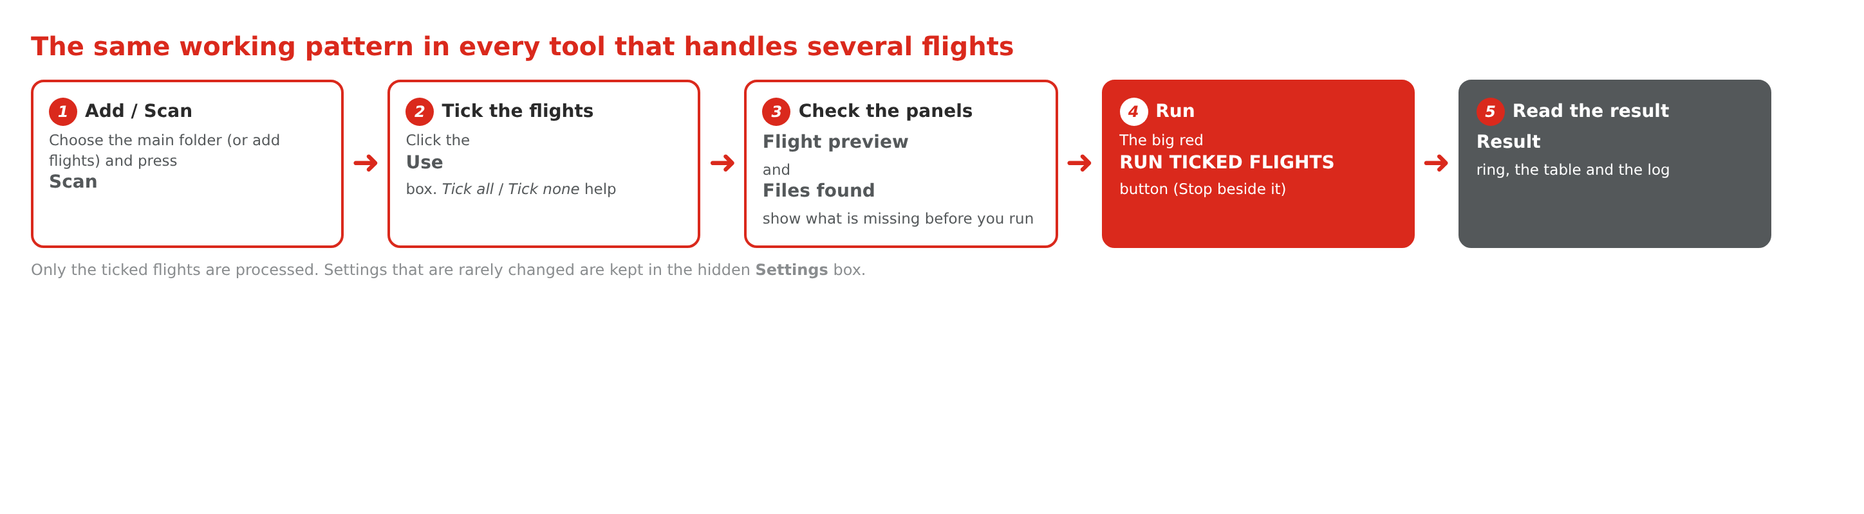
Figure 4 - The same five-step pattern in every tool that handles several flights

4.1 Scan
What it does | Reads the folder you chose and lists every flight it finds, with its photos, event file and base data.
Why you need it | You see at once which flights exist and which are complete, before anything is processed.
You need | A main folder (or, in the Image Enhancer, flight folders you add).

Where it is: a grey Scan button right next to the folder buttons, on the first row of the Flights box - the same in Image Enhancer, Event Generation, Ortho Launcher and LiDAR Tool. (GNSS Pre-Check, Data Pre-Check and Geotag Pipeline have no Scan: you choose files or add flights directly.)

4.2 Tick column (Use) - choose which flights run
What it does | Every flight in the list has a Use box. A ticked flight is processed; an unticked flight is left alone.
Why you need it | A job often has many flights but you may only want some of them now. The tick box makes the choice visible and safe.
You need | Nothing - click the box.

- Press Scan (or add flights).
- Click the Use box of a flight to tick or untick it. Tick all and Tick none change every flight at once.
- Press the big red RUN TICKED FLIGHTS button (or the tool's own run button).
Good to know
Only ticked flights are processed. If nothing is ticked, Event Generation, Ortho Launcher and LiDAR Tool show a message; Geotag Pipeline runs all flights.
After Scan, Event Generation ticks the flights that are ready (photos, Pos and base found).

4.3 Flight preview and Files found
What it does | Two small cards under the flights list. Flight preview shows numbers for the ticked flights (flights ticked, photos, ...). Files found is a checklist of what the ticked flights contain.
Why you need it | A missing file is the most common reason for a failed run. The checklist shows it in red before you start, so you can fix it first.
You need | Nothing - the cards update by themselves when you tick or untick.

Mark | Meaning
green tick | Found for every ticked flight
red warning | Missing for at least one ticked flight - the text says how many flights have it, for example "Base RINEX (4 of 5 flights)"
grey dot | Not needed or not chosen yet

Tool | What the Files found card checks
Event Generation | Photos, Pos .dat, Base RINEX, Base coordinates
Geotag Pipeline | Rover SBF, Base data, Camera folders (A D S W X)
Ortho Launcher (called Ready check) | Photos, Event file, photos match the event file (90 % or more), GCP file selected
LiDAR Tool | LiDAR .lid files, POS, Base RINEX, Base coordinates
Data Pre-Check | Images folder, Events file, POS file, Geotag file, GCP file

4.4 Hidden Settings box
What it does | Settings that you rarely change (limits, server, default base coordinates, options) sit in a collapsed box with a red Show / change Settings link.
Why you need it | The screen stays clean and short. The tool still uses the settings - they are only hidden, not switched off.
You need | Click the red link to open the box, click again to hide it.

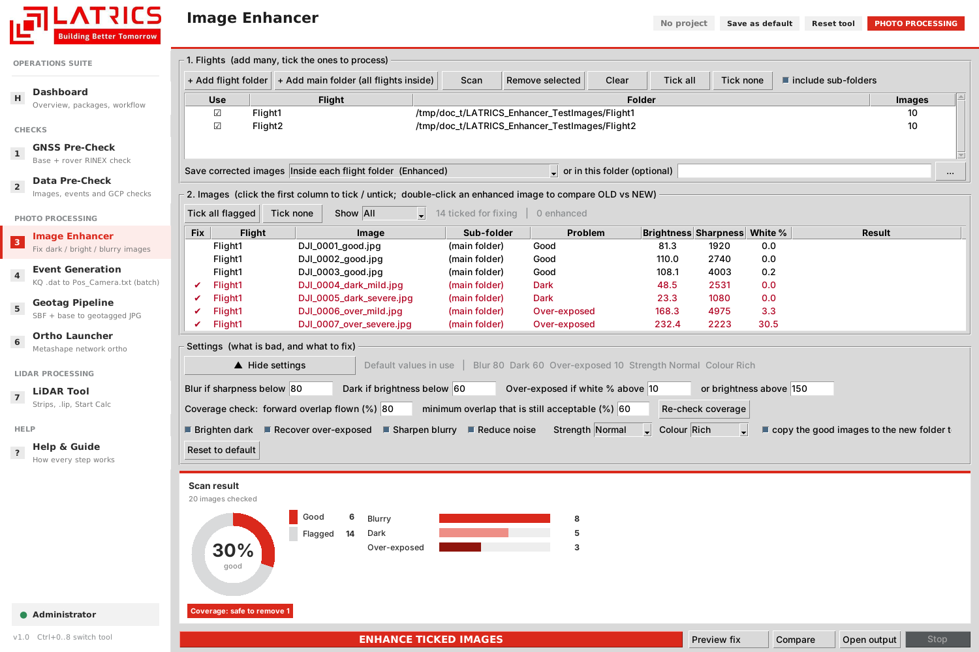
Figure 5 - The Settings box of the Image Enhancer, opened
When hidden, the Image Enhancer shows a one-line summary: "Default values in use" (grey) or "Custom values in use" (red) followed by the main values.

4.5 Result ring and bars
What it does | After a run, a panel shows the answer as a ring (percentage in the middle), a legend with counts and, where useful, bars per category or per flight.
Why you need it | You can judge a flight in two seconds instead of reading a table. It is also the first thing to look at when you send a screenshot to a colleague.
You need | Nothing - it fills itself after the run. Before a run it shows an empty ring.

Tool | Ring shows | Bars show
GNSS Pre-Check | Satellite match, with a verdict badge | GPS / GLONASS / Galileo / BeiDou, rated Excellent / Good / Fair / Poor
Data Pre-Check | Stage 1: % good images. Stages 2 and 3: PASS / WARN / FAIL | Blur / Dark / Over-exposed counts
Image Enhancer | After Scan: % good. After Enhance: % OK now (good already + fixed) | Blurry / Dark / Over-exposed counts; tags for coverage advice
Event Generation | Fix photos vs Not fix photos | Each flight
Geotag Pipeline | Fix events vs Not fix, all finished flights | Fix % per flight
Ortho Launcher | Flights submitted or failed | -
LiDAR Tool | Strips used vs excluded (current flight) | -

4.6 Run and Stop
Every tool has one large red button that starts the work (RUN TICKED FLIGHTS, ENHANCE TICKED IMAGES, SUBMIT TICKED FLIGHTS ...) and a Stop button beside it. Stop finishes the current flight or step cleanly instead of killing the program.

4.7 Log
The text box at the bottom lists every step with times and any problem. When something goes wrong, the answer is nearly always in the last lines of the log.

5. Tool guide
Every tool section follows the same order: what it does, why you need it, what you need, how to use it, what you get. The screenshots are from the real program; the numbered circles are explained under each figure.

5.1 GNSS Pre-Check
What it does | Scores every satellite and constellation in the BASE and ROVER (drone) RINEX files, checks take-off and landing coverage and compares base with rover.
Why you need it | Bad GNSS data ruins PPK. Finding it before processing saves hours and avoids a re-flight decision made too late.
You need | BASE RINEX observation file and ROVER RINEX observation file (RINEX 2.x, 3.x or 4.x; .26o, .obs, .rnx).
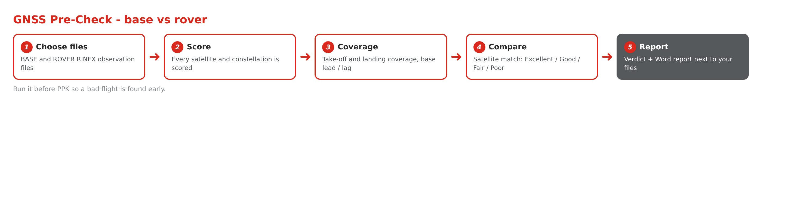
Figure 6 - GNSS Pre-Check flow
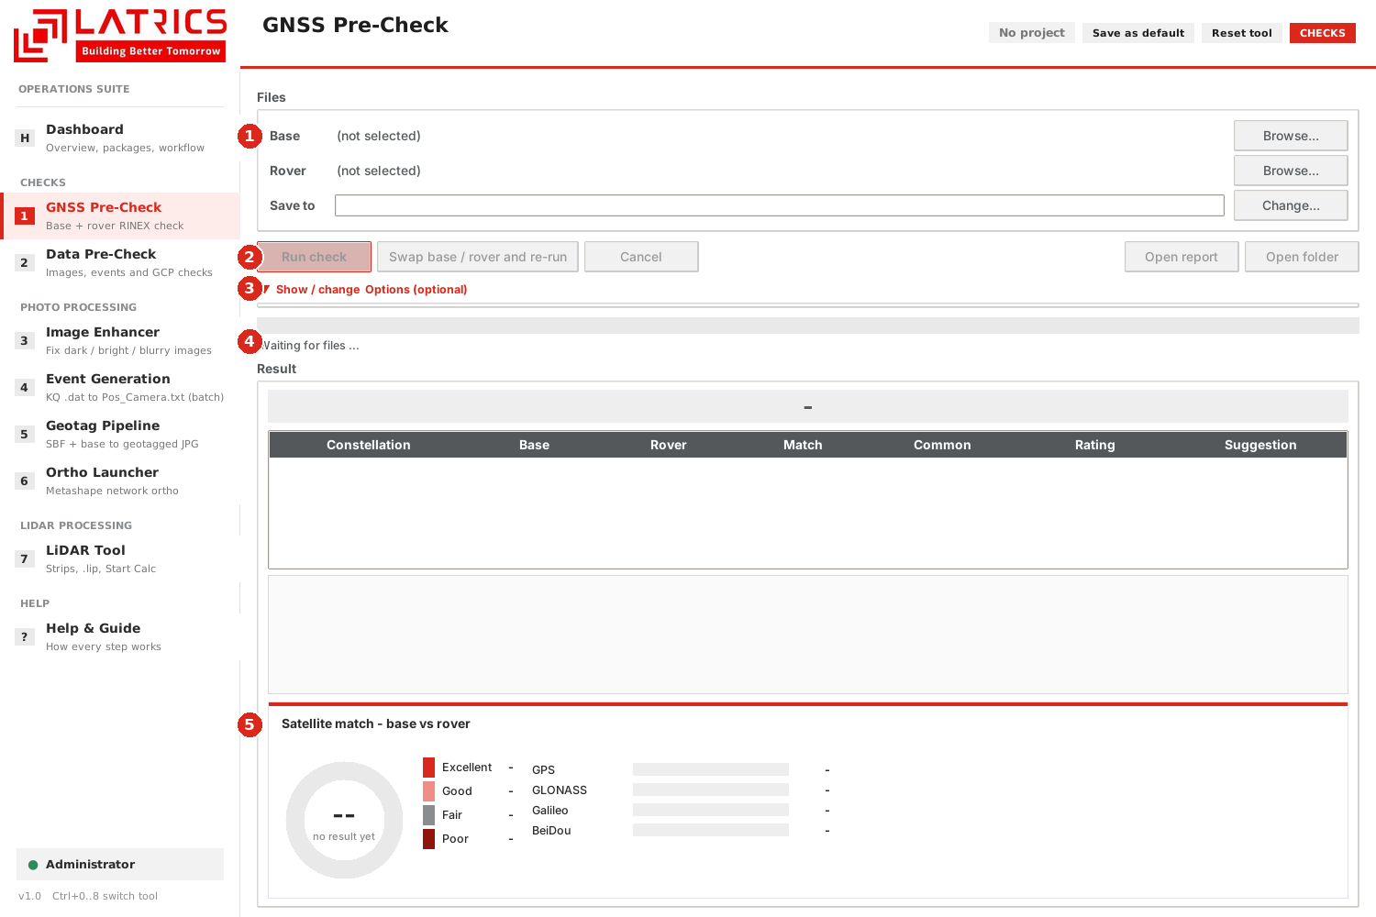
Figure 7 - GNSS Pre-Check, ready for files
1 | Files - choose the BASE and the ROVER file with the two Browse buttons; Save to is the report folder (filled in automatically next to your files).
2 | Run check, Swap base / rover and re-run (if you picked them the wrong way round), Cancel, Open report, Open folder.
3 | Options (optional) - hidden. Minimum base lead / lag in minutes and a flight window (HH:MM:SS to HH:MM:SS). An empty window means the whole rover log.
4 | Result table - one row per constellation: Base, Rover, Match, Common, Rating, Suggestion.
5 | Satellite match ring - base vs rover per constellation with the rating Excellent / Good / Fair / Poor.

How to use
- Choose the Base and Rover files.
- Open Options only if you need a lead / lag or a flight window.
- Press Run check and watch the progress bar.
- Read the verdict, the table and the ring. A Word report and CSV files are saved next to your files.

5.2 Data Pre-Check
What it does | One window with three stages. Each stage adds a section to the same Word report and CSV files.
Why you need it | You check the photos before event generation, the events after it, and the GCPs after geotagging - so a problem is caught at the earliest stage.
You need | Stage 1: images folder. Stage 2: events file, POS file (optional before / after comparison). Stage 3: geotag file and GCP file.
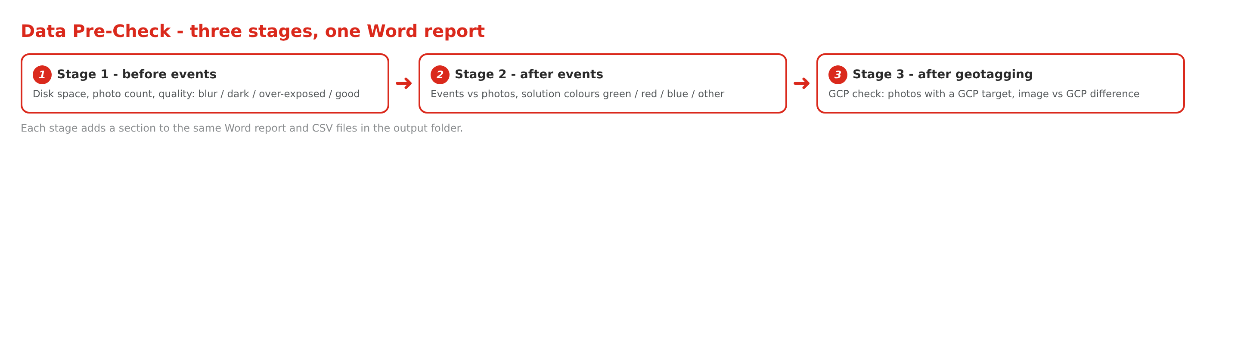
Figure 8 - The three stages of the Data Pre-Check
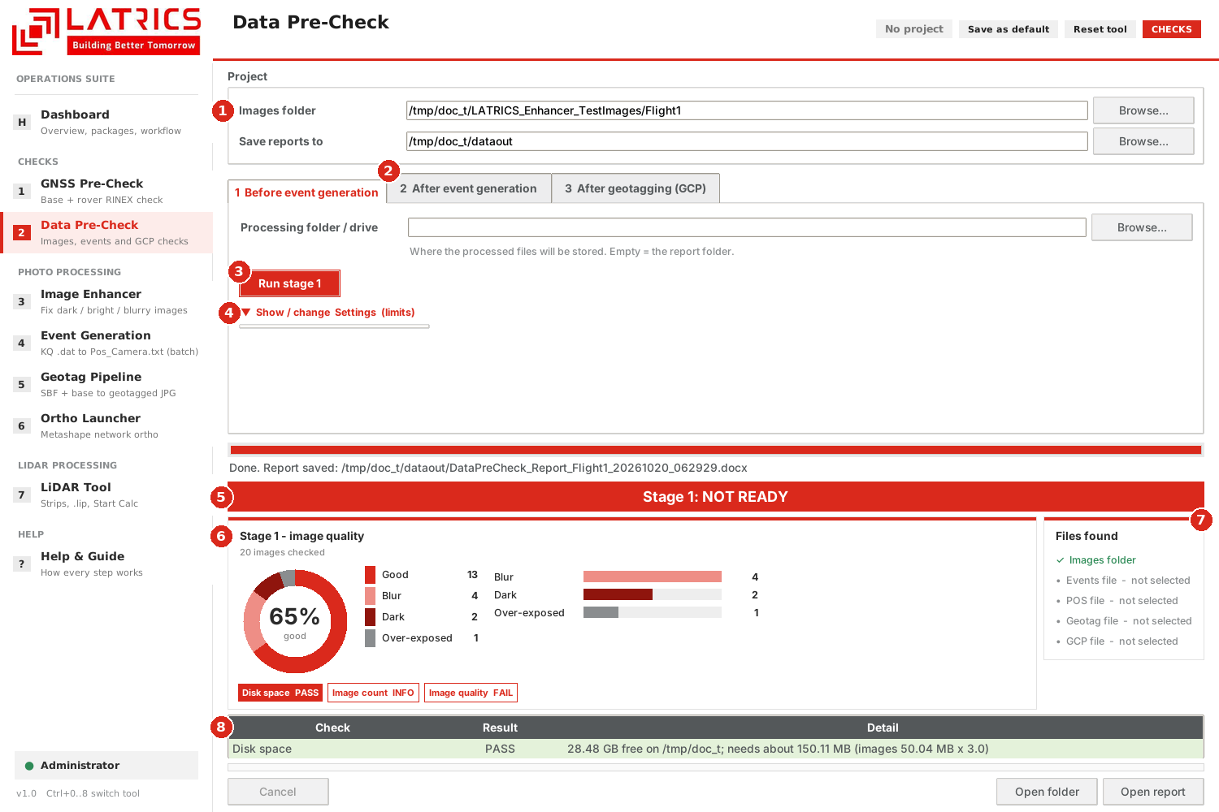
Figure 9 - Data Pre-Check after a stage 1 run on 20 test photos
1 | Project - the images folder and the folder where reports are saved.
2 | Stage tabs - 1 Before event generation, 2 After event generation, 3 After geotagging (GCP).
3 | Run stage 1 (each tab has its own Run button).
4 | Settings (limits) - hidden. Space factor 3.0, blur limit 40, dark limit 60, over-exposed 10 % white or mean above 210, gap 120 s.
5 | Verdict banner - READY or NOT READY for the stage.
6 | Result ring - % good photos with the counts Good / Blur / Dark / Over-exposed, and PASS / WARN / FAIL tags.
7 | Files found - which of the project files are chosen and exist.
8 | Check table - each check with PASS, WARN, FAIL or INFO and the detail.

How to use
- Choose the Images folder; the report folder is suggested automatically.
- Pick the tab for the stage you are at and fill its files.
- Press Run stage N.
- Read the banner, the ring and the table; press Open report for the Word report.
Why stage 1 says NOT READY in Figure 9
The 20 test photos were made to contain bad images on purpose (blur, dark, over-exposed). With real, good flights the banner is READY.

5.3 Image Enhancer
What it does | Finds dark, over-exposed and blurry photos, improves them and writes a new folder with every image: good ones copied unchanged, bad ones corrected. You can compare OLD and NEW.
Why you need it | Bad photos break image matching and reduce the quality of the orthomosaic. This fixes what can be fixed and tells you what cannot (re-fly or remove).
You need | One or many flight folders. Nothing else.
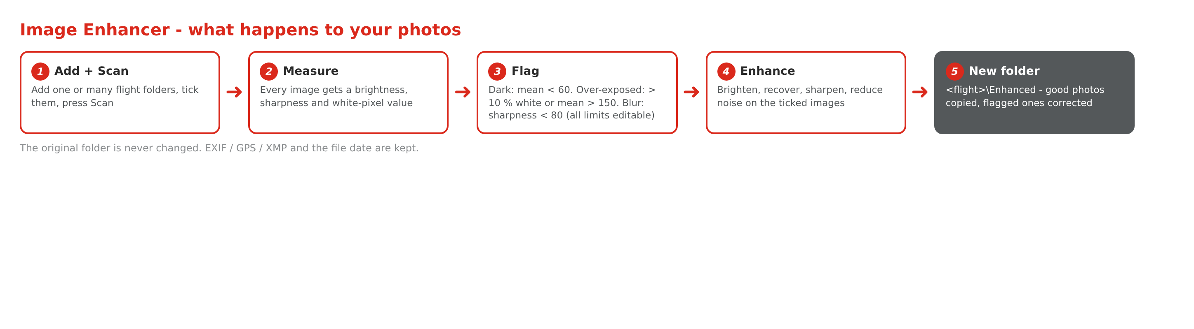
Figure 10 - What happens to your photos
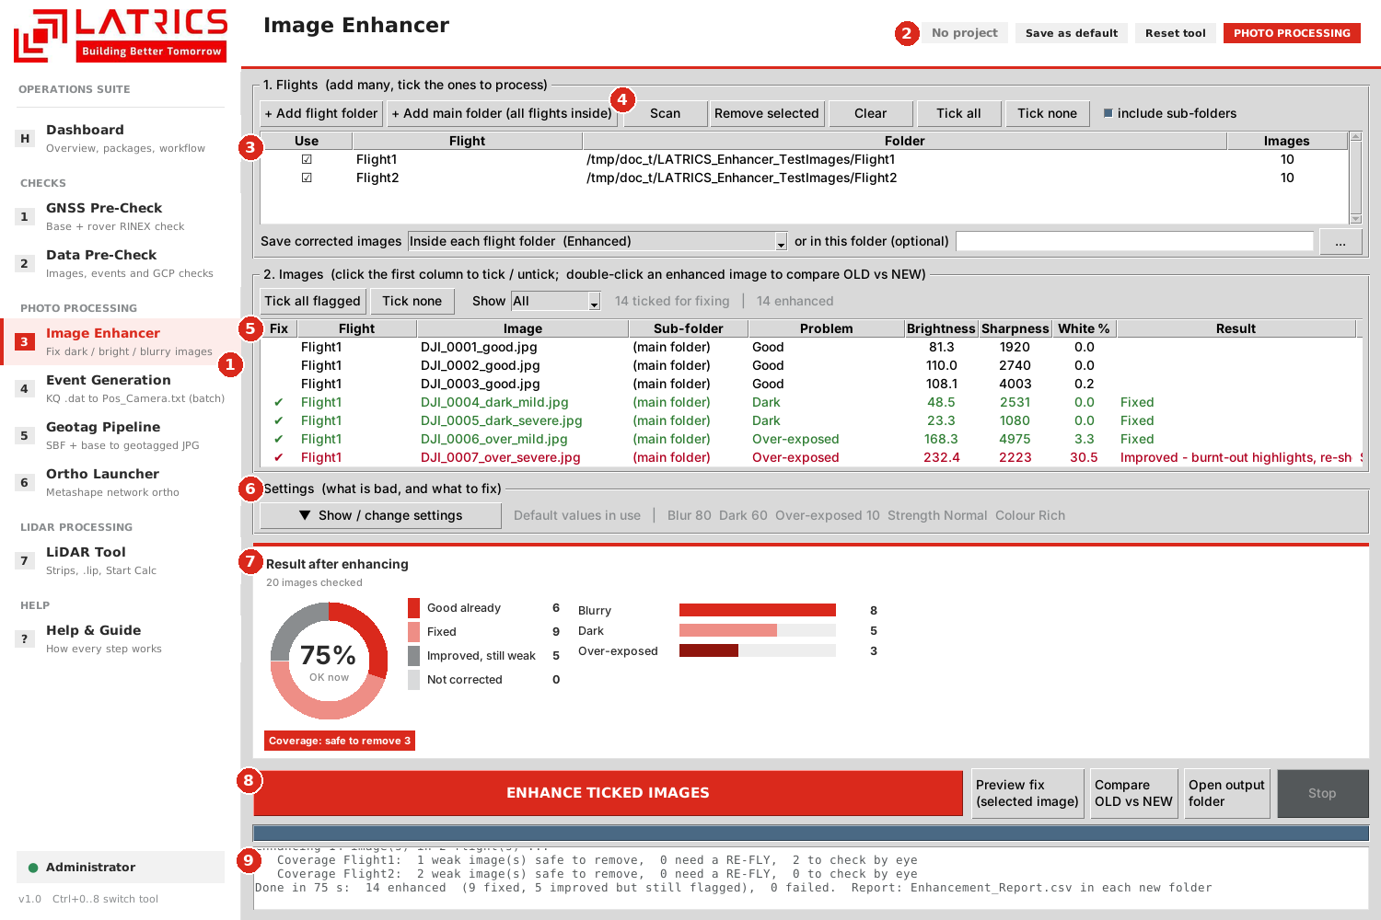
Figure 11 - Image Enhancer after Scan and Enhance on 2 test flights (20 photos)
1 | Sidebar - Image Enhancer is tool 3.
2 | Header bar - Save as default / Reset tool for this tool.
3 | Flights list - Use column: tick the flights to process. Buttons: Add flight folder, Add main folder (all flights inside), Scan, Remove selected, Clear, Tick all, Tick none, include sub-folders.
4 | Scan - measures every photo of the ticked flights.
5 | Images table - one row per photo with Brightness, Sharpness, White %, Problem and Result. Flagged photos are red and ticked in the Fix column; click that column to tick or untick a photo. Double-click an enhanced photo to compare OLD vs NEW.
6 | Settings - hidden (see below).
7 | Result ring - after Scan: % good; after Enhance: % OK now. Red tags give the coverage advice.
8 | ENHANCE TICKED IMAGES with Preview fix, Compare OLD vs NEW, Open output folder and Stop.
9 | Log - what was done and how long it took.

How to use
- Add flight folder (or Add main folder if all flights are inside one folder).
- Tick the flights, press Scan. Every photo is measured and flagged.
- Untick the photos you do not want to change in the Fix column.
- Optional: Preview fix shows the result for one selected photo before the whole batch.
- Press ENHANCE TICKED IMAGES. Each flight gets a new folder <flight>\Enhanced (or next to it / in a folder you choose).
- Double-click an enhanced photo - or press Compare OLD vs NEW - to see old and new side by side or with a slider.

How a photo is judged
Problem | Default rule | Where to change it
Dark | Mean brightness below 60 (of 255) | Settings - Dark if brightness below
Over-exposed | More than 10 % pure white pixels, or brightness above 150 | Settings - Over-exposed if white % above / or brightness above
Blur | Sharpness (Laplacian variance) below 80 | Settings - Blur if sharpness below
Different limits in Data Pre-Check
Data Pre-Check uses blur 40 and over-exposed brightness 210 by default; the Image Enhancer uses blur 80 and brightness 150 because drone ground images look bright from about 160. Both can be changed in their Settings box.

What the fixes do
Fix | Effect
Brighten dark | Lifts shadows and mid-tones (colour kept), then removes the extra noise
Recover over-exposed | Pulls brightness down, softens blown highlights, adds a little local contrast
Sharpen blurry | Luminance-only sharpening. A slightly soft photo improves a lot; a very blurry one cannot be rescued and the Result column says so
Reduce noise | Removes colour noise and noise in flat areas; edges are kept

Settings (hidden box)
Setting | Default | Meaning
Blur if sharpness below | 80 | Photos below this sharpness are flagged as blurry
Dark if brightness below | 60 | Photos darker than this are flagged
Over-exposed if white % above | 10 | Share of pure white pixels that makes a photo over-exposed
... or brightness above | 150 | Mean brightness that also counts as over-exposed
Forward overlap flown (%) | 80 | Used for the coverage advice
Minimum overlap still acceptable (%) | 60 | Below this a removed photo means RE-FLY
Brighten / Recover / Sharpen / Reduce noise | all ticked | Which fixes are applied
Strength | Normal | Light, Normal or Strong
Colour | Rich | Natural, Rich or Vivid
Copy the good images to the new folder too | ticked | The Enhanced folder then holds every photo

Coverage advice
A weak photo that stays weak after enhancing gets an advice: Safe to remove (the overlap between its neighbours stays above the minimum) or RE-FLY this strip (the overlap would drop too low). At a strip end the advice is "Strip end - check side overlap". The numbers appear as red tags under the ring.

What you get
File / folder | Content
<flight>\Enhanced\ | Every photo: good ones copied unchanged, flagged ones corrected. Same file names and sub-folders; EXIF, GPS, XMP and the file date are kept.
Enhancement_Report.csv | What was done to each photo, with the before and after values

5.4 Event Generation
What it does | Batch PPK for many flights in one run: decodes the KQ .dat, runs RTKLIB, interpolates the trajectory at every camera event and matches the photos. Replaces Shuttle 8.1 plus the PointsCreator "Output pos file" step.
Why you need it | The photogrammetry software needs a position and attitude for every photo. This tool makes them for all flights without manual work.
You need | A main folder with flights: Pos\*.dat, Image\*.JPG and a Base folder (RINEX + Coordinates.txt), plus convbin.exe and rnx2rtkp.exe in the bin folder.
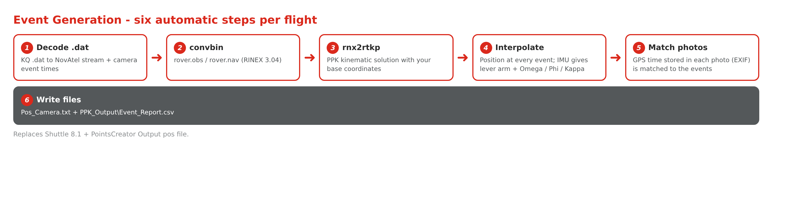
Figure 12 - The six automatic steps per flight
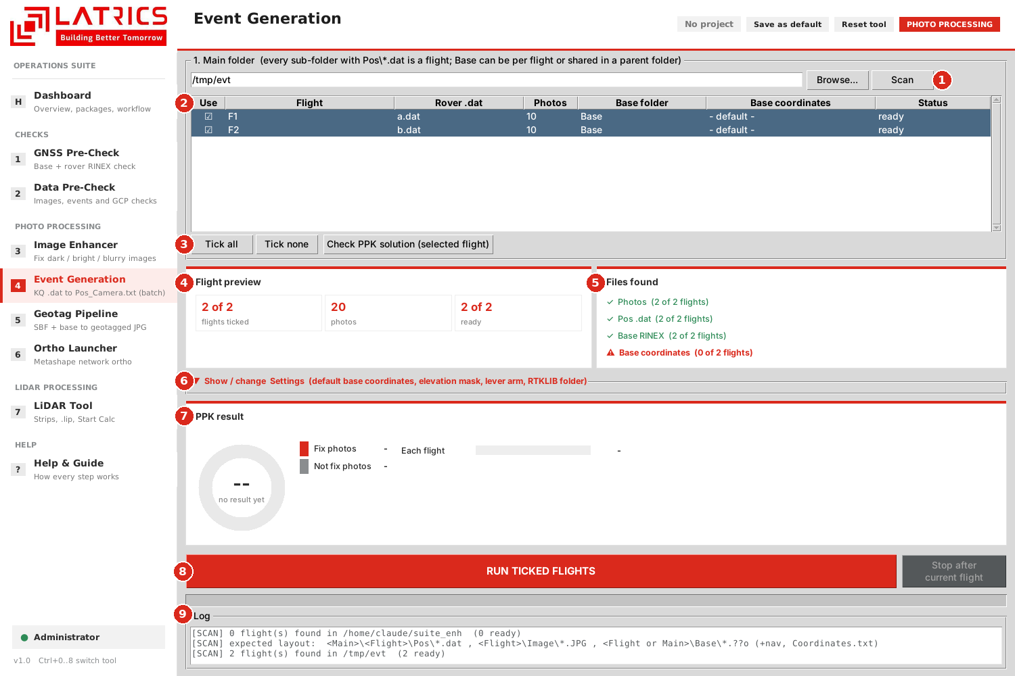
Figure 13 - Event Generation after Scan (two example flights)
1 | Main folder with Browse and Scan.
2 | Flights list - Use column, Rover .dat, Photos, Base folder, Base coordinates, Status. Double-click a flight to enter or change its base coordinates.
3 | Tick all / Tick none and Check PPK solution for the highlighted flight.
4 | Flight preview - flights ticked, photos, flights ready.
5 | Files found - Photos, Pos .dat, Base RINEX, Base coordinates. The red line shows that no base coordinates are set yet.
6 | Settings - hidden: default base coordinates, elevation mask, lever arm, solution type, EPSG, RTKLIB folder.
7 | PPK result ring - Fix vs Not fix photos, with a bar per flight.
8 | RUN TICKED FLIGHTS and Stop.
9 | Log.

How to use
- Choose the Main folder and press Scan. Ready flights are ticked automatically.
- Check Files found. If Base coordinates is red, enter the default base in Settings or double-click the flight.
- Tick or untick flights, then press RUN TICKED FLIGHTS.
- Read the PPK result ring and the log. Open each flight folder for Pos_Camera.txt.
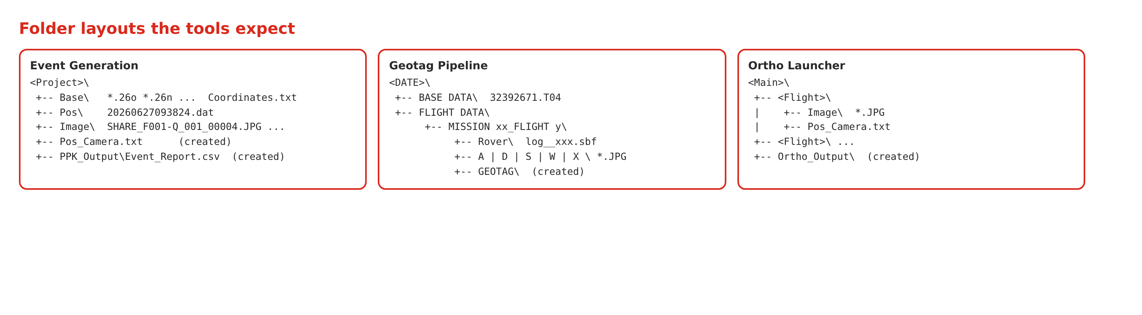
Figure 14 - Folder layouts the tools expect
Output | Content
<Project>\Pos_Camera.txt | ImgName, East, North, Height, Omega, Phi, Kappa for every photo
PPK_Output\Event_Report.csv | Time, fix quality and standard deviation per photo

5.5 Geotag Pipeline
What it does | Takes a flight (or a whole date folder) from raw Septentrio SBF and base data to geotagged JPG copies: RINEX, PPK, event matching and geotagging, all automatic.
Why you need it | It produces geotagged photos and Excel / CSV tables for every camera without any manual step in between.
You need | <DATE>\BASE DATA (.T04 or RINEX) and <DATE>\FLIGHT DATA\MISSION ...\Rover (.sbf) with camera folders A | D | S | W | X.
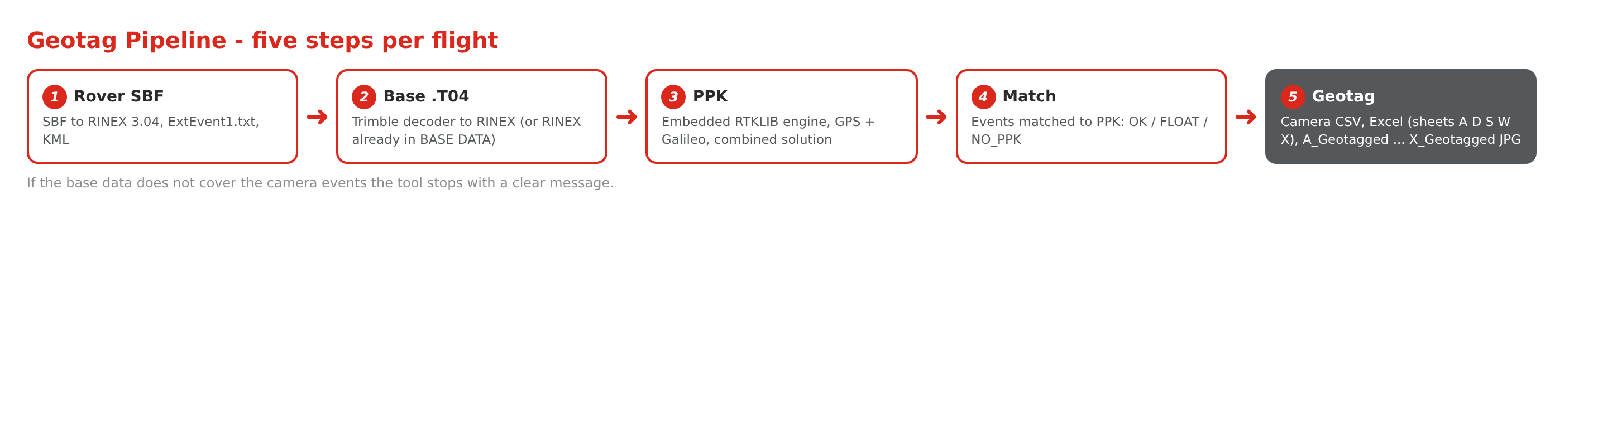
Figure 15 - The five steps of the Geotag Pipeline
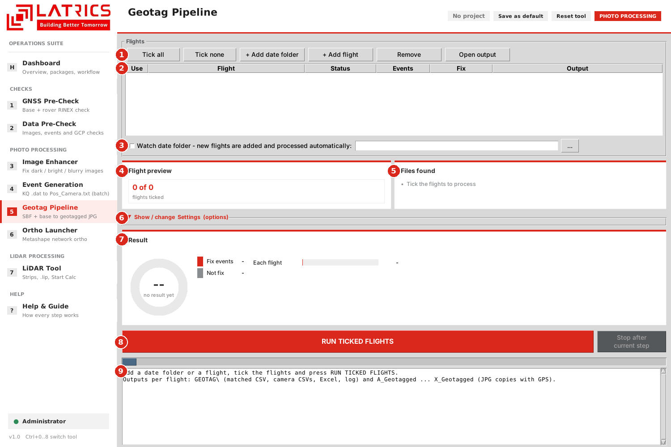
Figure 16 - Geotag Pipeline, ready for flights
1 | Buttons - Tick all, Tick none, + Add date folder, + Add flight, Remove, Open output.
2 | Flights list - Use, Flight, Status, Events, Fix, Output.
3 | Watch date folder - optional: when ticked, new flights that appear in the folder are added and processed by themselves.
4 | Flight preview - flights ticked, camera folders found.
5 | Files found - Rover SBF, Base data, Camera folders.
6 | Settings - hidden: geotagged JPG copies, Excel per camera, re-run every step, use existing Emlid .pos, elevation mask (15), base antenna height, Trimble T04 decoder.
7 | Result ring - Fix events vs Not fix, with a bar per finished flight.
8 | RUN TICKED FLIGHTS and Stop. If no flight is ticked, all flights run.
9 | Log.

How to use
- Press + Add date folder (all flights) or + Add flight. New flights are ticked.
- Check Files found.
- Press RUN TICKED FLIGHTS. The steps run in order; the base data must cover the camera events, otherwise the tool stops with a clear message.
- Press Open output to see the results.
Step | Action | Result
1 | Rover SBF to RINEX 3.04 obs + mixed nav (pure Python) | RINEX, ExtEvent1.txt, KML
2 | Base .T04 to RINEX (Trimble decoder, run hidden), or base RINEX already in BASE DATA. Time check: the base must cover the camera events. | Base RINEX
3 | PPK with the embedded RTKLIB engine; base antenna height applied; GPS + Galileo, combined solution | SEPTxxxx_ppk.pos
4 | Match PPK to camera events | GEOTAG\SEPTxxxx_eventpos_matched.csv (OK / FLOAT / NO_PPK)
5 | Geotag the cameras | GEOTAG\<cam>_geotag.csv, SEPTxxxx_Cameras.xlsx (sheets A D S W X), <flight>\A_Geotagged ... X_Geotagged (JPG copies, GPS written losslessly)
Changed in version 2.0
The "Process automatically when added" tick box was removed. A flight is now only added to the list; you start the work with RUN TICKED FLIGHTS, as in every other tool. The separate "Watch date folder" option still processes new flights by itself when you switch it on.

5.6 Ortho Launcher
What it does | Prepares the Metashape network ortho pipeline for one or many flights, submits it to the Metashape server and shows the Metashape log live.
Why you need it | You set up and start a whole batch from one screen instead of preparing every project by hand in Metashape.
You need | A main folder with flights (photos + event file), a running Metashape network server, optional GCP file and LiDAR DEM.
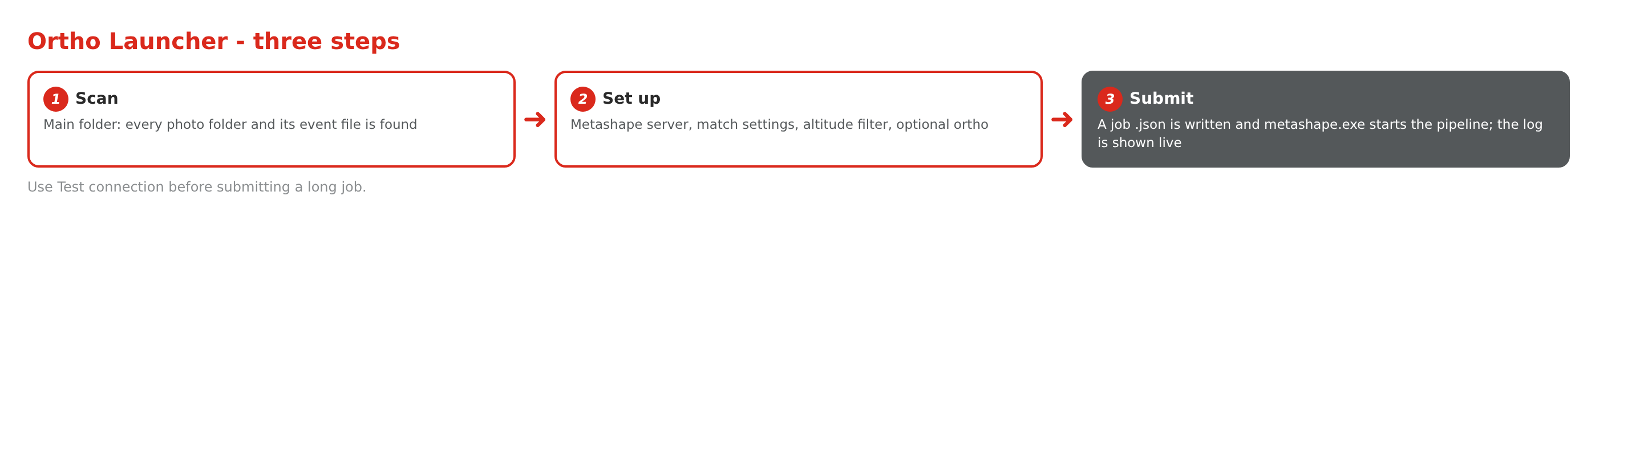
Figure 17 - The three steps of the Ortho Launcher
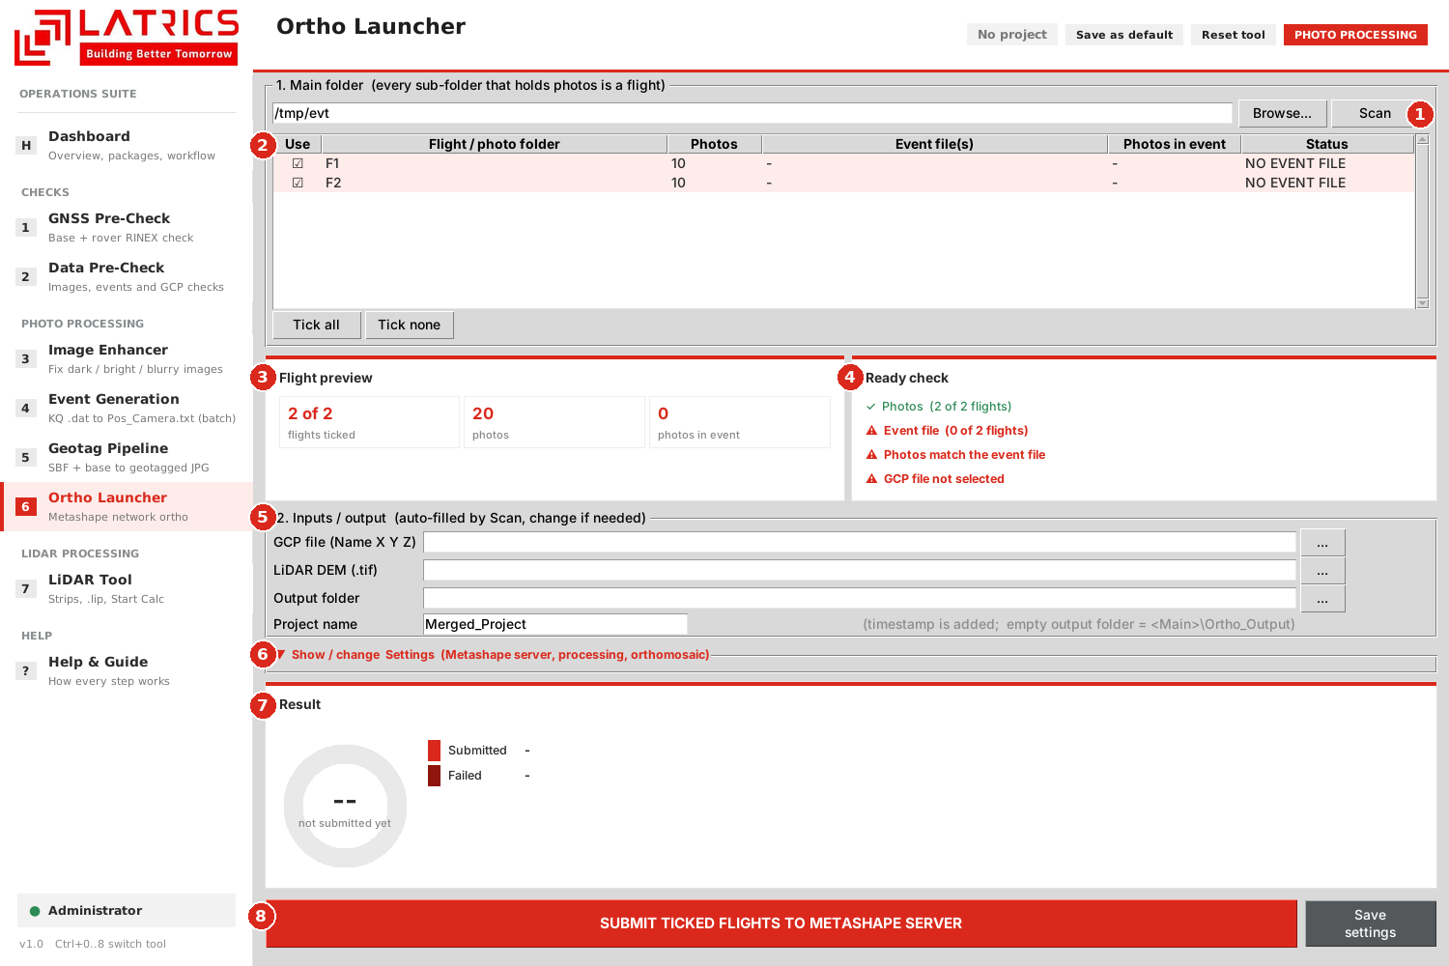
Figure 18 - Ortho Launcher after Scan (test photos without event files)
1 | Main folder, Browse and Scan.
2 | Flights list - Use, photos, event files, photos in event, status. Double-click a flight to choose its event file.
3 | Flight preview - flights ticked, photos, photos in event.
4 | Ready check - Photos, Event file, photos match the event file, GCP file selected. Here the red lines show that these test flights have no event file and no GCP file.
5 | Inputs / output - GCP file (Name X Y Z), LiDAR DEM (.tif), output folder, project name.
6 | Settings - hidden: Metashape server IP and port with Test connection, metashape.exe, output EPSG, minimum flight altitude, match accuracy, point limits, optional orthomosaic.
7 | Result ring - flights submitted or failed.
8 | SUBMIT TICKED FLIGHTS TO METASHAPE SERVER and Save settings.

How to use
- Choose the Main folder and press Scan.
- Tick the flights to include. Check Ready check.
- Fill GCP file, optional DEM, output folder and project name.
- Open Settings once to check the server (use Test connection), EPSG and options.
- Press SUBMIT TICKED FLIGHTS .... A job .json is written, Metashape starts the pipeline and its log appears in the Log box.
Supported layouts (scanned at any depth): A) <Main>\<Flight>\Image\*.JPG with <Flight>\Pos_Camera*.txt; B) old layout <Main>\Image\<FlightN>\*.JPG with <Main>\Events\**\*N*.txt.

5.7 LiDAR Tool
What it does | Builds the PointsCreator project for LiDAR flights: POS trajectory, automatic strip division, the .lip project file and, if you want, Start Calc for one flight or a queue.
Why you need it | It replaces many manual clicks in PointsCreator and makes every flight use the same settings.
You need | Shuttle GNSS\POS.txt (recommended) or, for BETA POS, Pos\*.dat + base RINEX + base coordinates; Lidar\*.lid files.
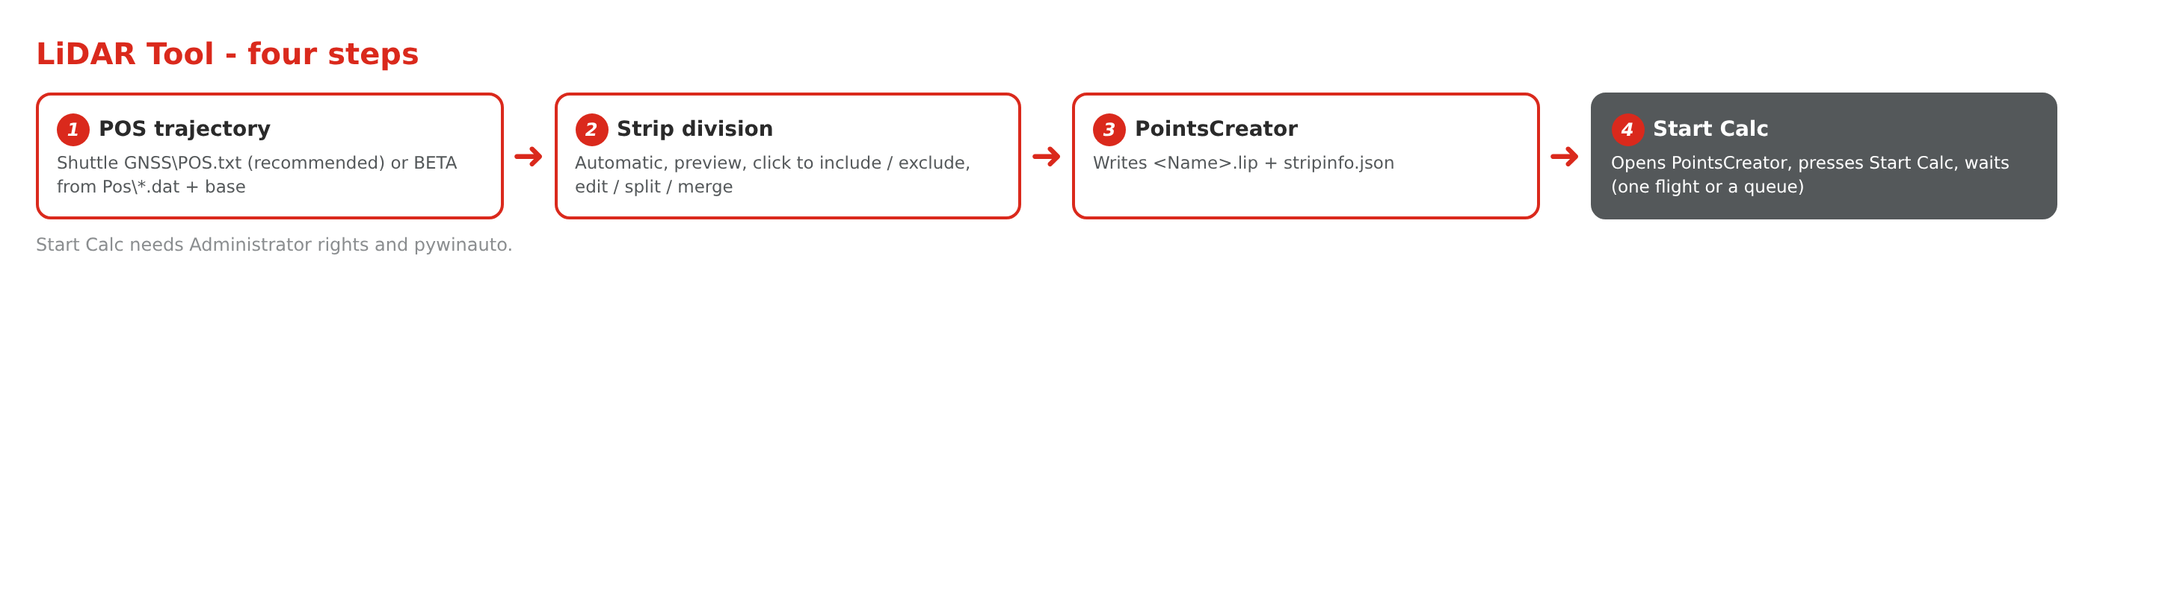
Figure 19 - The four steps of the LiDAR Tool
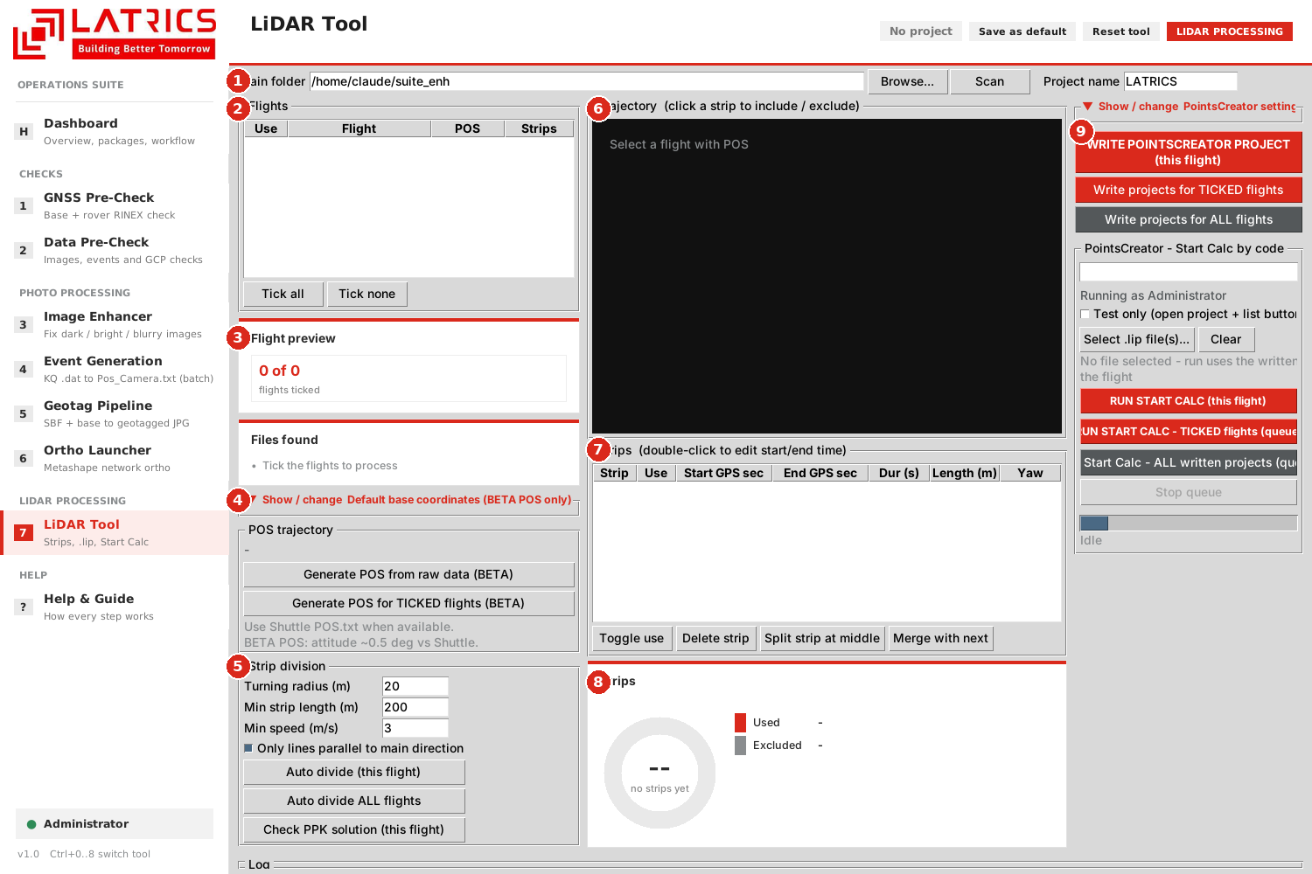
Figure 20 - LiDAR Tool, ready for flights
1 | Main folder, Browse, Scan and the project name.
2 | Flights list - Use, Flight, POS, Strips. Tick all / Tick none.
3 | Flight preview and Files found - flights ticked, .lid files, strips; .lid, POS, Base RINEX, Base coordinates.
4 | Default base coordinates - hidden; used only for BETA POS when Base\Coordinates.txt is missing.
5 | Strip division - turning radius (20 m), minimum strip length (200 m), minimum speed (3 m/s), automatic divide for this flight or all flights.
6 | Trajectory - click a strip to include or exclude it.
7 | Strips table - start / end GPS time, duration, length, yaw; edit, split, merge or delete strips.
8 | Strips ring - strips used vs excluded for the current flight.
9 | PointsCreator settings (hidden) and the red buttons that write the project and run Start Calc.

Multi-flight workflow
- Press Scan. Tick the flights in the Use column (clicking a row only highlights it for review).
- Generate POS for TICKED flights (BETA) if you have no Shuttle POS.txt.
- Review the strips of each flight and adjust if needed.
- Write projects for TICKED flights - writes <Name>.lip and stripinfo.json.
- RUN START CALC - TICKED flights (queue) - flights are calculated one after another.

Coordinate systems
The coordinate system is written into the .lip file as a list position, so the order must match PointsCreator.
Index | Name in tool | Notes
0 | WGS84 Gauss Local | Standard PointsCreator entry
1 | WGS84 Gauss 3-Degree | Standard PointsCreator entry
2 | WGS84 Gauss 6-Degree | Standard PointsCreator entry
3 | WGS84 UTM | Standard PointsCreator entry
4 | UTM ZONE44 | Custom PointsCreator configuration
5 | UTM ZONE43 | Custom PointsCreator configuration
6 | UTM ZONE45 | Custom PointsCreator configuration
7 | UTM ZONE46 | Custom PointsCreator configuration
Important
Indexes 4 to 7 depend on the order of the custom systems in the PointsCreator installed on the PC. After installing on a new machine, confirm the order and check one .lip in PointsCreator.

Start Calc
PointsCreator shows a "Calculate finished" box after each flight. The tool watches for it and closes it automatically, so the queue moves on without anyone clicking. Start Calc needs Administrator rights, pywinauto and a visible PointsCreator window - do not lock the PC during the run.

6. Reading the results
All tools use the same visual language, so a result can be read at a glance without opening a report.

6.1 The result ring
Colour | Meaning
Green | Good / Fix / OK - nothing to do
Amber | Warning or Float / improved but still weak - check it
Red | Problem / Not fix / failed - action needed
Grey | Not measured or excluded

6.2 Per-tool results
Tool | What you will see | What to do
GNSS Pre-Check | Rating per constellation: Excellent, Good, Fair, Poor | Poor or a large base / rover mismatch: check the files, use Swap base / rover, or re-fly
Data Pre-Check | Banner READY / NOT READY; checks PASS, WARN, FAIL, INFO | Fix all FAIL lines before the next stage; read WARN lines
Image Enhancer | Result per photo: Fixed, Improved - still weak; coverage advice Safe to remove / RE-FLY this strip | Use the Enhanced folder; re-fly only where the advice says so
Event Generation | PPK ring: Fix vs Not fix photos per flight | Many Not fix photos: check base coordinates, base RINEX and elevation mask
Geotag Pipeline | Matched CSV flag per event: OK, FLOAT, NO_PPK | FLOAT is usable with care; NO_PPK photos have no position
Ortho Launcher | Flights submitted / failed, live Metashape log | Read the log for the first error line
LiDAR Tool | Strips used vs excluded; Start Calc queue progress | Review the excluded strips before writing the project

7. Troubleshooting
Problem | Cause | Solution
Suite does not start | Python or a package is missing | Install Python 3.10+ and the packages in chapter 2, then start again
A tool shows a blank page | Tool code failed to load | Close and restart; if it repeats, send the red error text in the Log
Nothing happens after Scan | Folder has a different layout | Check the folder layouts in Figure 14; the Log lists what was looked for
Run button does nothing | No flight ticked | Click the Use column of the flights (or Tick all). Clicking a row only highlights it
Files found shows a red line | The file is missing or in the wrong folder | Add the file to the shown location or choose it by hand
Result ring is empty | The tool has not run yet | Run Scan or the main action; the ring fills after the run
Event Generation: Not fix photos | Wrong base coordinates or too short base data | Enter the correct base coordinates; check the base RINEX times cover the flight
Geotag stops at the base step | Base data does not cover the camera events | Add the correct base data for that date and run again
Ortho: cannot submit | Metashape server not reachable | Settings - Test connection; check IP, port and that the server is running
LiDAR: wrong coordinate system in .lip | List order in PointsCreator differs | Confirm the custom entries (indexes 4 to 7) on this PC
Start Calc does not click | Not run as administrator, pywinauto missing or PC locked | Run the Suite as administrator, install pywinauto and keep the screen unlocked
Settings changed but forgotten on next start | Not saved | Use Save as default in the header, or save the project

8. Maintenance (for the developer)

8.1 How the single file is built
The Suite is one Python file. Each tool source is compressed (lzma), encoded (base64) and stored in the dictionary _SRC. At start, the Suite decodes the source of the tool you open and runs it inside the shared window. The shell code (navigation, projects, defaults, admin restart, help) is plain text in the same file.

8.2 Updating a tool
- Keep the seven tool sources (gnss, data, enhancer, events, geotag, ortho, lidar) in one folder.
- Edit the source file you need.
- Run embed.py <suite.py> <new_suite.py> <source folder>. It re-embeds all seven sources.
- Start the new suite, open every tool once and check the Log for errors.
- Replace the old file and tell the team.

8.3 Shared interface helpers
Helper | Purpose
VizPanel | The result ring with legend, bars and tags
InfoCard | Small card with a title and a list of lines
FlightInfo | The Flight preview and Files found pair; show(facts, checks) fills it
tick_setup(tree) | Adds the Use column, Tick all / Tick none behaviour; the tick equals the tree selection so the processing code needs no change
CollapseBox | The hidden Settings box
Rule for changes
Interface changes must not touch the processing code. After any change run one real flight in each affected tool and compare the outputs with the previous version.

9. Quick reference

9.1 Keyboard
Keys | Action
Ctrl+0 | Dashboard
Ctrl+1 to Ctrl+7 | Open tool 1 to 7
Ctrl+8 | Settings / admin
F1 | Help

9.2 Typical daily flow
- GNSS Pre-Check - are the base and rover files good?
- Data Pre-Check stage 1 - are the photos good?
- Image Enhancer - fix weak photos.
- Event Generation or Geotag Pipeline - positions for every photo.
- Data Pre-Check stages 2 and 3 - events and GCP check.
- LiDAR Tool and Ortho Launcher - produce the final data.

9.3 Same steps in every tool
Step | Action
1 | Choose the folder(s)
2 | Press Scan
3 | Tick the flights in the Use column
4 | Check Flight preview and Files found
5 | Open Settings only if needed
6 | Press the red run button
7 | Read the Result ring and the Log

Appendix A - Glossary
Term | Meaning
PPK | Post-Processed Kinematic: the drone position is corrected after the flight using base data
RINEX | Standard text format for GNSS observation and navigation data
Base / Rover | Fixed ground receiver / receiver on the drone
Fix / Float | Quality of the PPK solution: Fix is centimetre level, Float is less certain
Event | The exact time a photo was taken
GCP | Ground Control Point with known coordinates
Strip | One straight flight line of a LiDAR or photo flight
Overlap | Share of a photo that is also seen in the next photo
Orthomosaic | Map-accurate image made from many photos
EPSG | Numeric code of a coordinate system
.lip | PointsCreator project file

