Program-17 Write a Program to implement the Linear Search

import java.io.\*;

class LinearSearch{

  public static void main(String args[]) throws IOException {

    BufferedReader br = new BufferedReader(new InputStreamReader(System.in));

    System.out.print("Enter the amount of numbers: ");

    int n = Integer.parseInt(br.readLine());

    int arr[] = new int[n];

    boolean flag = false;

    for(int i = 0; i<n; i++){

      System.out.print("Enter number: ");

      arr[i] = Integer.parseInt(br.readLine());

    }

    System.out.println("");

    System.out.print("Enter number to search: ");

    int num = Integer.parseInt(br.readLine());

    for(int i = 0; i<n; i++){

      if(arr[i] == num) System.out.println("Number found at index: "+(i+1));

      flag = true;

    }

    if(!flag) System.out.print(num + " not found" );

  }

}

Output-

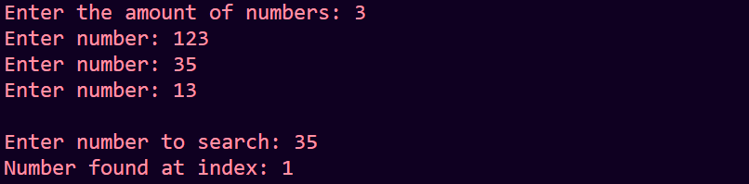

Program-18 Write a Program to implement the Binary Search

import java.io.\*;

import java.util.\*;

class BinarySearch{

  public static void main(String args[]) throws IOException {

    BufferedReader br = new BufferedReader(new InputStreamReader(System.in));

    System.out.print("Enter the amount of numbers: ");

    int n = Integer.parseInt(br.readLine());

    int arr[] = new int[n];

    boolean flag = false;

    for(int i = 0; i<n; i++){

      System.out.print("Enter number: ");

      arr[i] = Integer.parseInt(br.readLine());

    }

    Arrays.sort(arr);

    System.out.println("");

    System.out.print("Enter number to search: ");

    int num = Integer.parseInt(br.readLine());

    int low = 0, high = n-1;

    while(low <= high){

      int mid = (low+high)/2;

      if(arr[mid] == num){

        System.out.print(num + " found at index " + mid);

        flag = true;

        break;

      }

      else if(arr[mid] > num) high = mid-1;

      else low = mid+1;

    }

    if(!flag) System.out.print(num + " not found" );

  }

}

Output-

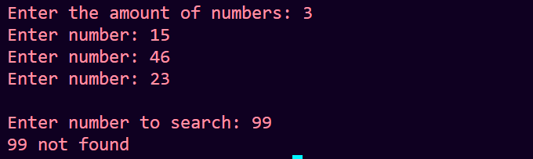

Program-19 Write a program to sort numbers using Bubble Sort Algorithm

import java.io.\*;

class BubbleSort{

  public static void main(String args[]) throws IOException {

    BufferedReader br = new BufferedReader(new InputStreamReader(System.in));

    System.out.print("Enter the amount of data: ");

    int n = Integer.parseInt(br.readLine());

    int arr[] = new int[n];

    for(int i = 0; i<n; i++){

      System.out.print("Enter number: ");

      arr[i] = Integer.parseInt(br.readLine());

    }

    for(int i = 0; i < n-1; i++){

      for(int j = 0; j < n-1-i; j++){

        if(arr[j] > arr[j+1]){

    int temp = arr[j];

    arr[j] = arr[j+1];

    arr[j+1] = temp;

        }

      }

    }

    for(int i = 0; i<n; i++){

      System.out.println(arr[i]);

    }

  }

}

Output-

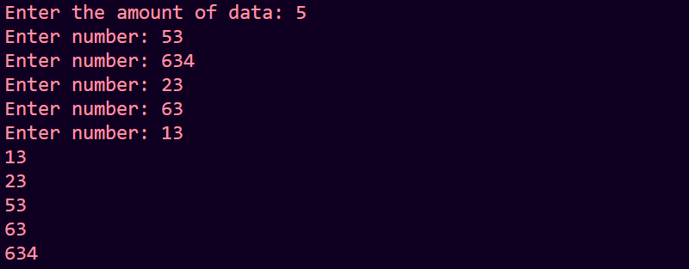

Program-20 Write a Program to sort numbers using Selection Sort Algorithm

import java.io.\*;

class SelectionSort{

  public static void main(String args[]) throws IOException {

    BufferedReader br = new BufferedReader(new InputStreamReader(System.in));

    System.out.print("Enter the amount of data: ");

    int n = Integer.parseInt(br.readLine());

    int arr[] = new int[n];

    for(int i = 0; i<n; i++){

      System.out.print("Enter the number: ");

      arr[i] = Integer.parseInt(br.readLine());

    }

    for(int i = 0; i < n-1; i++){

      for(int j = i+1; j<n; j++){

        if(arr[i] > arr[j]){

    int temp = arr[i];

    arr[i] = arr[j];

    arr[j] = temp;

        }

      }

    }

    for(int i = 0; i<n; i++){

      System.out.println(arr[i]);

    }

  }

}

Output-

